DE, JP topic models

Charlie J. Gomez, Harshvardhan Singh

2023-08-27

library('stm')

## stm v1.3.6 successfully loaded. See ?stm for help.   
## Papers, resources, and other materials at structuraltopicmodel.com

library(dplyr)

##   
## Attaching package: 'dplyr'

## The following objects are masked from 'package:stats':  
##   
## filter, lag

## The following objects are masked from 'package:base':  
##   
## intersect, setdiff, setequal, union

library(stringr)  
library(wordcloud)

## Loading required package: RColorBrewer

#Read csv file  
data = read.csv("preprocessed_data_Jul14.csv")  
  
  
##Topic generation for DE (in collaboration) publications  
  
data_collab <- data[data[["DE"]] != 0,]  
  
# Save the original title data for future use  
data_collab$original_concatenated_title_abstract <- data_collab$concatenated_title_abstract  
  
#pre-processing the titles using textProcessor from the stm package  
processed_text <- textProcessor(data_collab$concatenated_title_abstract, metadata = data_collab)

## Building corpus...   
## Converting to Lower Case...   
## Removing punctuation...   
## Removing stopwords...   
## Removing numbers...   
## Stemming...   
## Creating Output...

# Further prepare the data by removing low-frequency terms  
out_text <- prepDocuments(processed_text$documents, processed_text$vocab, processed_text$meta)

## Removing 4638 of 16647 terms (4638 of 476346 tokens) due to frequency   
## Your corpus now has 5572 documents, 12009 terms and 471708 tokens.

docs_text <- out_text$documents  
vocab_text <- out_text$vocab  
meta_text <- out_text$meta  
  
  
#Prepare data  
plotRemoved(processed_text$documents, lower.thresh = seq(1, 200, by = 100))

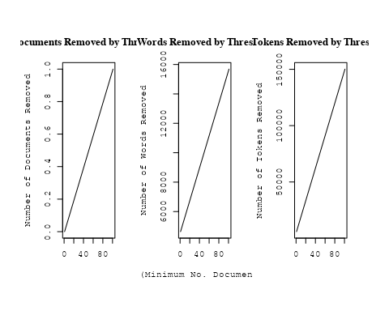

out_text <- prepDocuments(processed_text$documents, processed_text$vocab, processed_text$meta, lower.thresh = 8)

## Removing 13112 of 16647 terms (32265 of 476346 tokens) due to frequency   
## Your corpus now has 5572 documents, 3535 terms and 444081 tokens.

str(out_text$meta)

## 'data.frame': 5572 obs. of 39 variables:  
## $ concept_id : chr "https://openalex.org/C44870925" "https://openalex.org/C44870925" "https://openalex.org/C44870925" "https://openalex.org/C1276947" ...  
## $ work_id : chr "https://openalex.org/W2073719541" "https://openalex.org/W3102133339" "https://openalex.org/W3101291558" "https://openalex.org/W2153493790" ...  
## $ publication_year : int 1997 2006 2005 2011 1997 2014 2021 2005 2005 2017 ...  
## $ title : chr "Effects of Disks on Gravitational Lensing by Spiral Galaxies" "The hierarchical formation of the brightest cluster galaxies" "The Formation of Fossil Galaxy Groups in the hierarchical Universe" "Effects of the explosion asymmetry and viewing angle on the Type Ia supernova colour and luminosity calibration" ...  
## $ paperabstract : chr "Gravitational lensing of a quasar by a spiral galaxy should often be accompanied by damped Lyα absorption and d"| __truncated__ "We use semi-analytic techniques to study the formation and evolution of brightest cluster galaxies (BCGs). We s"| __truncated__ "We use a set of 12 high-resolution N-body/hydrodynamical simulations in the ΛCDM cosmology to investigate the o"| __truncated__ "Phenomenological relations exist between the peak luminosity and other observables of type Ia supernovae (SNe I"| __truncated__ ...  
## $ country : chr "US DE" "DE DE DE DE" "GB DE" "JP DE JP DE" ...  
## $ year_concept : chr "1997+https://openalex.org/C44870925" "2006+https://openalex.org/C44870925" "2005+https://openalex.org/C44870925" "2011+https://openalex.org/C1276947" ...  
## $ concatenated_title_abstract : chr "Effects of Disks on Gravitational Lensing by Spiral Galaxies Gravitational lensing of a quasar by a spiral gala"| __truncated__ "The hierarchical formation of the brightest cluster galaxies We use semi-analytic techniques to study the forma"| __truncated__ "The Formation of Fossil Galaxy Groups in the hierarchical Universe We use a set of 12 high-resolution N-body/hy"| __truncated__ "Effects of the explosion asymmetry and viewing angle on the Type Ia supernova colour and luminosity calibration"| __truncated__ ...  
## $ US : num 50 0 0 0 0 0 0 50 0 0 ...  
## $ IN : num 0 0 0 0 0 0 0 0 0 0 ...  
## $ DE : num 50 100 50 50 100 100 100 50 50 100 ...  
## $ CH : num 0 0 0 0 0 0 0 0 0 0 ...  
## $ GB : num 0 0 50 0 0 0 0 0 0 0 ...  
## $ CN : num 0 0 0 0 0 0 0 0 0 0 ...  
## $ FR : num 0 0 0 0 0 0 0 0 0 0 ...  
## $ IT : num 0 0 0 0 0 0 0 0 0 0 ...  
## $ RU : num 0 0 0 0 0 0 0 0 0 0 ...  
## $ CA : num 0 0 0 0 0 0 0 0 0 0 ...  
## $ NL : num 0 0 0 0 0 0 0 0 0 0 ...  
## $ AU : num 0 0 0 0 0 0 0 0 50 0 ...  
## $ JP : num 0 0 0 50 0 0 0 0 0 0 ...  
## $ ES : num 0 0 0 0 0 0 0 0 0 0 ...  
## $ IL : num 0 0 0 0 0 0 0 0 0 0 ...  
## $ Americas : num 0 0 0 0 0 0 0 0 0 0 ...  
## $ Europe : num 0 0 0 0 0 0 0 0 0 0 ...  
## $ Africa : num 0 0 0 0 0 0 0 0 0 0 ...  
## $ AsiaAndOceania : num 0 0 0 0 0 0 0 0 0 0 ...  
## $ pub_interval_2020_2022 : int 0 0 0 0 0 0 1 0 0 0 ...  
## $ pub_interval_2015_2019 : int 0 0 0 0 0 0 0 0 0 1 ...  
## $ pub_interval_2010_2014 : int 0 0 0 1 0 1 0 0 0 0 ...  
## $ pub_interval_2005_2009 : int 0 1 1 0 0 0 0 1 1 0 ...  
## $ pub_interval_2000_2004 : int 0 0 0 0 0 0 0 0 0 0 ...  
## $ pub_interval_1995_1999 : int 1 0 0 0 1 0 0 0 0 0 ...  
## $ pub_interval_1985_1994 : int 0 0 0 0 0 0 0 0 0 0 ...  
## $ pub_interval_1975_1984 : int 0 0 0 0 0 0 0 0 0 0 ...  
## $ pub_interval_1965_1974 : int 0 0 0 0 0 0 0 0 0 0 ...  
## $ pub_interval_1900_1964 : int 0 0 0 0 0 0 0 0 0 0 ...  
## $ pub_interval_1824_1899 : int 0 0 0 0 0 0 0 0 0 0 ...  
## $ original_concatenated_title_abstract: chr "Effects of Disks on Gravitational Lensing by Spiral Galaxies Gravitational lensing of a quasar by a spiral gala"| __truncated__ "The hierarchical formation of the brightest cluster galaxies We use semi-analytic techniques to study the forma"| __truncated__ "The Formation of Fossil Galaxy Groups in the hierarchical Universe We use a set of 12 high-resolution N-body/hy"| __truncated__ "Effects of the explosion asymmetry and viewing angle on the Type Ia supernova colour and luminosity calibration"| __truncated__ ...

# Initialize an empty formula string  
prevalence_formula_str <- "~"  
  
# Define the publication intervals  
pub_intervals <- c("pub_interval_2020_2022", "pub_interval_2015_2019", "pub_interval_2010_2014",   
 "pub_interval_2005_2009", "pub_interval_2000_2004", "pub_interval_1995_1999",  
 "pub_interval_1985_1994", "pub_interval_1975_1984", "pub_interval_1965_1974",  
 "pub_interval_1900_1964", "pub_interval_1824_1899")  
  
# Add each publication interval to the formula string  
for (interval in pub_intervals) {  
 # add an if statement to handle the first addition (without '+')  
 if (prevalence_formula_str == "~") {  
 prevalence_formula_str <- paste(prevalence_formula_str, interval)  
 } else {  
 prevalence_formula_str <- paste(prevalence_formula_str, "+", interval)  
 }  
}  
  
  
# Convert the string to a formula  
prevalence_formula <- as.formula(prevalence_formula_str)  
print(prevalence_formula)

## ~pub_interval_2020_2022 + pub_interval_2015_2019 + pub_interval_2010_2014 +   
## pub_interval_2005_2009 + pub_interval_2000_2004 + pub_interval_1995_1999 +   
## pub_interval_1985_1994 + pub_interval_1975_1984 + pub_interval_1965_1974 +   
## pub_interval_1900_1964 + pub_interval_1824_1899

# Run STM model  
Research_topics <- stm(documents = out_text$documents,   
 vocab = out_text$vocab,   
 K = 44,   
 prevalence = prevalence_formula,   
 data = out_text$meta,   
 init.type = "Spectral",  
 max.em.its = 1000,  
 gamma.prior = 'L1')

## Beginning Spectral Initialization   
## Calculating the gram matrix...  
## Finding anchor words...  
## ............................................  
## Recovering initialization...  
## ...................................  
## Initialization complete.  
## .....................................................................................................  
## Completed E-Step (7 seconds).   
## Completed M-Step.   
## Completing Iteration 1 (approx. per word bound = -6.742)   
## .....................................................................................................  
## Completed E-Step (6 seconds).   
## Completed M-Step.   
## Completing Iteration 2 (approx. per word bound = -6.495, relative change = 3.657e-02)   
## .....................................................................................................  
## Completed E-Step (5 seconds).   
## Completed M-Step.   
## Completing Iteration 3 (approx. per word bound = -6.431, relative change = 9.790e-03)   
## .....................................................................................................  
## Completed E-Step (5 seconds).   
## Completed M-Step.   
## Completing Iteration 4 (approx. per word bound = -6.405, relative change = 4.157e-03)   
## .....................................................................................................  
## Completed E-Step (5 seconds).   
## Completed M-Step.   
## Completing Iteration 5 (approx. per word bound = -6.390, relative change = 2.284e-03)   
## Topic 1: magnetospher, jupit, measur, ring, data   
## Topic 2: radiat, emiss, sourc, ioniz, photon   
## Topic 3: orbit, period, variabl, star, observ   
## Topic 4: hole, black, galaxi, supermass, host   
## Topic 5: region, use, method, estim, determin   
## Topic 6: per, cent, nova, fraction, mass   
## Topic 7: cluster, star, stellar, ngc, popul   
## Topic 8: supernova, explos, remnant, type, model   
## Topic 9: flare, neutrino, observ, flux, event   
## Topic 10: solar, scale, spectrum, measur, data   
## Topic 11: galaxi, emiss, imag, radio, seyfert   
## Topic 12: imf, initi, stellar, ucd, star   
## Topic 13: galaxi, format, star, massiv, popul   
## Topic 14: halo, dark, matter, mass, galaxi   
## Topic 15: star, dust, abund, giant, observ   
## Topic 16: turbul, pressur, field, time, gas   
## Topic 17: galact, way, milki, energi, spectrum   
## Topic 18: planet, format, system, disk, star   
## Topic 19: star, mass, binari, accret, neutron   
## Topic 20: gravit, wave, time, detect, observ   
## Topic 21: simul, model, dark, matter, cosmolog   
## Topic 22: pulsar, neutron, star, radio, magnet   
## Topic 23: galaxi, disc, rotat, kinemat, angular   
## Topic 24: field, magnet, observ, review, astrophys   
## Topic 25: x-ray, sourc, luminos, emiss, detect   
## Topic 26: dwarf, binari, system, companion, white   
## Topic 27: redshift, galaxi, quasar, survey, sampl   
## Topic 28: disk, accret, can, binari, rate   
## Topic 29: star, magnet, field, stellar, rotat   
## Topic 30: lens, imag, model, gravit, mass   
## Topic 31: type, light, observ, curv, luminos   
## Topic 32: radio, cluster, galaxi, x-ray, observ   
## Topic 33: agn, gas, feedback, galact, activ   
## Topic 34: metal, gas, medium, galaxi, enrich   
## Topic 35: galaxi, mass, stellar, function, relat   
## Topic 36: galaxi, satellit, spiral, veloc, kpc   
## Topic 37: line, veloc, abund, ratio, model   
## Topic 38: cluster, galaxi, mass, globular, function   
## Topic 39: cosmic, ray, energi, acceler, particl   
## Topic 40: gamma-ray, telescop, burst, grb, use   
## Topic 41: univers, year, galaxi, young, star   
## Topic 42: jet, radio, activ, nuclei, observ   
## Topic 43: molecular, cloud, emiss, gas, line   
## Topic 44: publish, astronom, first, structur, observ   
## .....................................................................................................  
## Completed E-Step (4 seconds).   
## Completed M-Step.   
## Completing Iteration 6 (approx. per word bound = -6.381, relative change = 1.462e-03)   
## .....................................................................................................  
## Completed E-Step (4 seconds).   
## Completed M-Step.   
## Completing Iteration 7 (approx. per word bound = -6.374, relative change = 1.012e-03)   
## .....................................................................................................  
## Completed E-Step (5 seconds).   
## Completed M-Step.   
## Completing Iteration 8 (approx. per word bound = -6.370, relative change = 7.397e-04)   
## .....................................................................................................  
## Completed E-Step (4 seconds).   
## Completed M-Step.   
## Completing Iteration 9 (approx. per word bound = -6.366, relative change = 5.626e-04)   
## .....................................................................................................  
## Completed E-Step (4 seconds).   
## Completed M-Step.   
## Completing Iteration 10 (approx. per word bound = -6.363, relative change = 4.794e-04)   
## Topic 1: magnetospher, measur, jupit, ring, data   
## Topic 2: radiat, emiss, ioniz, electron, photon   
## Topic 3: orbit, period, star, variabl, observ   
## Topic 4: hole, black, supermass, accret, galaxi   
## Topic 5: use, estim, method, region, determin   
## Topic 6: per, cent, fraction, nova, mass   
## Topic 7: star, cluster, ngc, stellar, popul   
## Topic 8: supernova, explos, remnant, type, ejecta   
## Topic 9: flare, neutrino, flux, observ, event   
## Topic 10: solar, data, spectrum, scale, measur   
## Topic 11: galaxi, emiss, imag, seyfert, ngc   
## Topic 12: imf, stellar, initi, mass, star   
## Topic 13: galaxi, format, star, popul, massiv   
## Topic 14: halo, dark, matter, mass, simul   
## Topic 15: star, dust, abund, giant, observ   
## Topic 16: turbul, field, pressur, collaps, magnet   
## Topic 17: galact, way, energi, milki, spectrum   
## Topic 18: planet, format, system, planetari, solar   
## Topic 19: star, binari, mass, neutron, accret   
## Topic 20: gravit, wave, detect, time, pulsar   
## Topic 21: simul, model, matter, dark, cosmolog   
## Topic 22: pulsar, neutron, star, rotat, radio   
## Topic 23: galaxi, disc, kinemat, rotat, angular   
## Topic 24: field, magnet, review, observ, astrophys   
## Topic 25: x-ray, sourc, luminos, kev, emiss   
## Topic 26: dwarf, system, binari, companion, white   
## Topic 27: redshift, galaxi, survey, quasar, sampl   
## Topic 28: disk, accret, can, rate, binari   
## Topic 29: star, magnet, field, stellar, rotat   
## Topic 30: lens, imag, model, gravit, galaxi   
## Topic 31: type, light, curv, observ, luminos   
## Topic 32: radio, cluster, galaxi, observ, relic   
## Topic 33: gas, agn, feedback, galact, cool   
## Topic 34: gas, metal, medium, format, observ   
## Topic 35: galaxi, mass, stellar, function, relat   
## Topic 36: galaxi, satellit, spiral, stream, kpc   
## Topic 37: line, veloc, ratio, abund, model   
## Topic 38: cluster, mass, galaxi, globular, function   
## Topic 39: cosmic, ray, acceler, particl, energi   
## Topic 40: burst, telescop, gamma-ray, grb, detect   
## Topic 41: univers, galaxi, year, report, star   
## Topic 42: radio, jet, activ, observ, nuclei   
## Topic 43: molecular, cloud, emiss, region, gas   
## Topic 44: publish, one, astronom, first, observ   
## .....................................................................................................  
## Completed E-Step (4 seconds).   
## Completed M-Step.   
## Completing Iteration 11 (approx. per word bound = -6.360, relative change = 4.060e-04)   
## .....................................................................................................  
## Completed E-Step (4 seconds).   
## Completed M-Step.   
## Completing Iteration 12 (approx. per word bound = -6.358, relative change = 3.583e-04)   
## .....................................................................................................  
## Completed E-Step (4 seconds).   
## Completed M-Step.   
## Completing Iteration 13 (approx. per word bound = -6.356, relative change = 3.215e-04)   
## .....................................................................................................  
## Completed E-Step (5 seconds).   
## Completed M-Step.   
## Completing Iteration 14 (approx. per word bound = -6.354, relative change = 2.979e-04)   
## .....................................................................................................  
## Completed E-Step (5 seconds).   
## Completed M-Step.   
## Completing Iteration 15 (approx. per word bound = -6.352, relative change = 2.628e-04)   
## Topic 1: dust, magnetospher, measur, ring, jupit   
## Topic 2: radiat, emiss, electron, ioniz, model   
## Topic 3: orbit, period, star, variabl, observ   
## Topic 4: hole, black, mass, supermass, accret   
## Topic 5: use, estim, method, measur, determin   
## Topic 6: per, cent, fraction, nova, mass   
## Topic 7: star, ngc, age, popul, stellar   
## Topic 8: supernova, explos, type, remnant, ejecta   
## Topic 9: flare, flux, neutrino, observ, event   
## Topic 10: solar, spectrum, scale, coron, data   
## Topic 11: galaxi, emiss, ngc, seyfert, starburst   
## Topic 12: imf, mass, stellar, initi, star   
## Topic 13: galaxi, format, star, popul, stellar   
## Topic 14: halo, dark, matter, mass, simul   
## Topic 15: star, abund, dust, chemic, element   
## Topic 16: turbul, field, magnet, pressur, instabl   
## Topic 17: galact, energi, spectrum, observ, gamma-ray   
## Topic 18: planet, format, system, planetari, solar   
## Topic 19: star, binari, mass, neutron, accret   
## Topic 20: gravit, wave, detect, time, pulsar   
## Topic 21: simul, model, cosmolog, densiti, energi   
## Topic 22: pulsar, neutron, star, spin, rotat   
## Topic 23: disc, galaxi, kinemat, rotat, bulg   
## Topic 24: field, magnet, review, observ, discuss   
## Topic 25: x-ray, sourc, luminos, kev, emiss   
## Topic 26: dwarf, system, binari, companion, white   
## Topic 27: redshift, galaxi, survey, sampl, quasar   
## Topic 28: disk, accret, rate, flow, can   
## Topic 29: star, magnet, field, stellar, rotat   
## Topic 30: lens, imag, gravit, model, galaxi   
## Topic 31: type, light, curv, observ, luminos   
## Topic 32: radio, galaxi, cluster, observ, relic   
## Topic 33: gas, feedback, agn, galact, cool   
## Topic 34: gas, metal, medium, format, densiti   
## Topic 35: galaxi, mass, stellar, relat, function   
## Topic 36: galaxi, satellit, way, milki, spiral   
## Topic 37: line, veloc, ratio, model, spectra   
## Topic 38: cluster, mass, globular, galaxi, function   
## Topic 39: cosmic, ray, acceler, particl, energi   
## Topic 40: burst, telescop, gamma-ray, grb, sky   
## Topic 41: univers, galaxi, year, report, object   
## Topic 42: radio, jet, activ, sourc, observ   
## Topic 43: molecular, cloud, emiss, region, core   
## Topic 44: observ, astronom, one, first, group   
## .....................................................................................................  
## Completed E-Step (5 seconds).   
## Completed M-Step.   
## Completing Iteration 16 (approx. per word bound = -6.351, relative change = 2.425e-04)   
## .....................................................................................................  
## Completed E-Step (5 seconds).   
## Completed M-Step.   
## Completing Iteration 17 (approx. per word bound = -6.349, relative change = 2.341e-04)   
## .....................................................................................................  
## Completed E-Step (5 seconds).   
## Completed M-Step.   
## Completing Iteration 18 (approx. per word bound = -6.348, relative change = 2.180e-04)   
## .....................................................................................................  
## Completed E-Step (5 seconds).   
## Completed M-Step.   
## Completing Iteration 19 (approx. per word bound = -6.347, relative change = 1.991e-04)   
## .....................................................................................................  
## Completed E-Step (5 seconds).   
## Completed M-Step.   
## Completing Iteration 20 (approx. per word bound = -6.346, relative change = 1.906e-04)   
## Topic 1: dust, measur, magnetospher, ring, impact   
## Topic 2: radiat, emiss, electron, ioniz, model   
## Topic 3: orbit, period, star, variabl, observ   
## Topic 4: hole, black, mass, accret, supermass   
## Topic 5: use, measur, estim, method, determin   
## Topic 6: per, cent, fraction, rate, nova   
## Topic 7: star, age, ngc, popul, stellar   
## Topic 8: supernova, explos, type, remnant, ejecta   
## Topic 9: flare, flux, neutrino, observ, event   
## Topic 10: solar, coron, spectrum, scale, data   
## Topic 11: galaxi, emiss, ngc, seyfert, starburst   
## Topic 12: mass, stellar, imf, function, initi   
## Topic 13: galaxi, format, star, popul, stellar   
## Topic 14: halo, dark, matter, mass, simul   
## Topic 15: abund, star, dust, chemic, element   
## Topic 16: field, turbul, magnet, instabl, pressur   
## Topic 17: galact, energi, spectrum, observ, gamma-ray   
## Topic 18: planet, format, system, planetari, solar   
## Topic 19: star, binari, mass, neutron, accret   
## Topic 20: gravit, wave, detect, time, pulsar   
## Topic 21: simul, model, densiti, cosmolog, energi   
## Topic 22: pulsar, neutron, star, spin, rotat   
## Topic 23: disc, galaxi, kinemat, rotat, bulg   
## Topic 24: field, review, physic, observ, discuss   
## Topic 25: x-ray, sourc, luminos, kev, emiss   
## Topic 26: dwarf, system, binari, companion, white   
## Topic 27: redshift, galaxi, sampl, survey, quasar   
## Topic 28: disk, accret, rate, can, flow   
## Topic 29: star, magnet, field, stellar, rotat   
## Topic 30: lens, imag, gravit, galaxi, model   
## Topic 31: type, light, curv, observ, spectra   
## Topic 32: radio, galaxi, cluster, observ, large-scal   
## Topic 33: gas, feedback, cool, galact, accret   
## Topic 34: gas, metal, medium, densiti, molecular   
## Topic 35: galaxi, mass, stellar, relat, function   
## Topic 36: galaxi, way, milki, satellit, galact   
## Topic 37: line, veloc, absorpt, ratio, profil   
## Topic 38: cluster, mass, globular, galaxi, distribut   
## Topic 39: cosmic, ray, acceler, particl, energi   
## Topic 40: telescop, burst, gamma-ray, grb, sky   
## Topic 41: galaxi, univers, year, report, discoveri   
## Topic 42: radio, jet, activ, sourc, observ   
## Topic 43: molecular, cloud, emiss, region, core   
## Topic 44: astronom, first, observ, group, one   
## .....................................................................................................  
## Completed E-Step (5 seconds).   
## Completed M-Step.   
## Completing Iteration 21 (approx. per word bound = -6.344, relative change = 1.714e-04)   
## .....................................................................................................  
## Completed E-Step (5 seconds).   
## Completed M-Step.   
## Completing Iteration 22 (approx. per word bound = -6.343, relative change = 1.608e-04)   
## .....................................................................................................  
## Completed E-Step (5 seconds).   
## Completed M-Step.   
## Completing Iteration 23 (approx. per word bound = -6.343, relative change = 1.462e-04)   
## .....................................................................................................  
## Completed E-Step (5 seconds).   
## Completed M-Step.   
## Completing Iteration 24 (approx. per word bound = -6.342, relative change = 1.376e-04)   
## .....................................................................................................  
## Completed E-Step (5 seconds).   
## Completed M-Step.   
## Completing Iteration 25 (approx. per word bound = -6.341, relative change = 1.383e-04)   
## Topic 1: dust, measur, magnetospher, observ, ring   
## Topic 2: radiat, emiss, electron, model, ioniz   
## Topic 3: orbit, star, period, variabl, observ   
## Topic 4: hole, black, mass, accret, supermass   
## Topic 5: use, measur, estim, method, determin   
## Topic 6: per, cent, fraction, rate, distribut   
## Topic 7: star, age, popul, ngc, stellar   
## Topic 8: supernova, explos, type, remnant, ejecta   
## Topic 9: flare, neutrino, flux, observ, event   
## Topic 10: solar, coron, scale, spectrum, region   
## Topic 11: galaxi, emiss, ngc, seyfert, dust   
## Topic 12: mass, function, stellar, initi, imf   
## Topic 13: galaxi, format, star, stellar, popul   
## Topic 14: halo, dark, matter, mass, simul   
## Topic 15: abund, star, chemic, metal, dust   
## Topic 16: field, turbul, magnet, instabl, pressur   
## Topic 17: energi, galact, spectrum, observ, gamma-ray   
## Topic 18: planet, format, system, planetari, exoplanet   
## Topic 19: star, binari, mass, neutron, observ   
## Topic 20: gravit, wave, detect, time, pulsar   
## Topic 21: model, simul, densiti, cosmolog, numer   
## Topic 22: pulsar, neutron, star, spin, rotat   
## Topic 23: disc, galaxi, kinemat, rotat, bulg   
## Topic 24: physic, review, discuss, observ, astrophys   
## Topic 25: x-ray, sourc, luminos, kev, emiss   
## Topic 26: dwarf, system, binari, companion, white   
## Topic 27: redshift, galaxi, sampl, survey, quasar   
## Topic 28: disk, accret, rate, can, inner   
## Topic 29: star, magnet, field, stellar, rotat   
## Topic 30: lens, imag, gravit, galaxi, len   
## Topic 31: type, light, spectra, curv, observ   
## Topic 32: radio, galaxi, cluster, observ, large-scal   
## Topic 33: gas, feedback, cool, star, galact   
## Topic 34: gas, metal, medium, densiti, molecular   
## Topic 35: galaxi, mass, stellar, relat, function   
## Topic 36: way, milki, galaxi, satellit, galact   
## Topic 37: line, veloc, absorpt, profil, ratio   
## Topic 38: cluster, globular, mass, galaxi, system   
## Topic 39: cosmic, ray, acceler, particl, energi   
## Topic 40: telescop, burst, gamma-ray, grb, imag   
## Topic 41: galaxi, univers, year, report, discoveri   
## Topic 42: radio, jet, activ, sourc, observ   
## Topic 43: molecular, cloud, emiss, region, core   
## Topic 44: astronom, first, group, observ, one   
## .....................................................................................................  
## Completed E-Step (5 seconds).   
## Completed M-Step.   
## Completing Iteration 26 (approx. per word bound = -6.340, relative change = 1.348e-04)   
## .....................................................................................................  
## Completed E-Step (5 seconds).   
## Completed M-Step.   
## Completing Iteration 27 (approx. per word bound = -6.339, relative change = 1.208e-04)   
## .....................................................................................................  
## Completed E-Step (5 seconds).   
## Completed M-Step.   
## Completing Iteration 28 (approx. per word bound = -6.338, relative change = 1.233e-04)   
## .....................................................................................................  
## Completed E-Step (5 seconds).   
## Completed M-Step.   
## Completing Iteration 29 (approx. per word bound = -6.338, relative change = 1.229e-04)   
## .....................................................................................................  
## Completed E-Step (4 seconds).   
## Completed M-Step.   
## Completing Iteration 30 (approx. per word bound = -6.337, relative change = 9.329e-05)   
## Topic 1: dust, comet, measur, magnetospher, observ   
## Topic 2: radiat, emiss, electron, model, ioniz   
## Topic 3: orbit, star, period, variabl, observ   
## Topic 4: hole, black, mass, accret, supermass   
## Topic 5: use, measur, estim, method, data   
## Topic 6: per, cent, fraction, rate, distribut   
## Topic 7: star, age, popul, ngc, stellar   
## Topic 8: supernova, explos, type, remnant, ejecta   
## Topic 9: flare, neutrino, flux, observ, event   
## Topic 10: solar, coron, scale, spectrum, region   
## Topic 11: galaxi, emiss, dust, ngc, seyfert   
## Topic 12: mass, function, stellar, star, initi   
## Topic 13: galaxi, format, star, stellar, popul   
## Topic 14: halo, dark, matter, mass, simul   
## Topic 15: abund, star, metal, chemic, element   
## Topic 16: turbul, field, magnet, pressur, instabl   
## Topic 17: energi, spectrum, gamma-ray, galact, observ   
## Topic 18: planet, format, planetari, system, star   
## Topic 19: star, binari, mass, neutron, observ   
## Topic 20: gravit, wave, detect, time, pulsar   
## Topic 21: model, simul, densiti, numer, energi   
## Topic 22: pulsar, neutron, star, spin, rotat   
## Topic 23: disc, kinemat, galaxi, rotat, bulg   
## Topic 24: physic, review, observ, discuss, astrophys   
## Topic 25: x-ray, sourc, luminos, kev, emiss   
## Topic 26: dwarf, system, companion, binari, white   
## Topic 27: redshift, galaxi, sampl, survey, quasar   
## Topic 28: disk, accret, rate, can, inner   
## Topic 29: star, magnet, field, stellar, rotat   
## Topic 30: lens, imag, gravit, galaxi, len   
## Topic 31: type, light, spectra, curv, observ   
## Topic 32: radio, galaxi, cluster, observ, large-scal   
## Topic 33: gas, feedback, cool, star, format   
## Topic 34: gas, metal, densiti, molecular, medium   
## Topic 35: galaxi, mass, stellar, relat, luminos   
## Topic 36: way, milki, galaxi, satellit, galact   
## Topic 37: line, veloc, absorpt, profil, model   
## Topic 38: cluster, globular, mass, system, galaxi   
## Topic 39: cosmic, ray, acceler, particl, energi   
## Topic 40: telescop, burst, imag, grb, gamma-ray   
## Topic 41: galaxi, univers, year, report, discoveri   
## Topic 42: radio, jet, sourc, activ, observ   
## Topic 43: molecular, region, cloud, emiss, core   
## Topic 44: group, astronom, first, one, observ   
## .....................................................................................................  
## Completed E-Step (4 seconds).   
## Completed M-Step.   
## Completing Iteration 31 (approx. per word bound = -6.336, relative change = 1.288e-04)   
## .....................................................................................................  
## Completed E-Step (4 seconds).   
## Completed M-Step.   
## Completing Iteration 32 (approx. per word bound = -6.336, relative change = 9.667e-05)   
## .....................................................................................................  
## Completed E-Step (4 seconds).   
## Completed M-Step.   
## Completing Iteration 33 (approx. per word bound = -6.335, relative change = 6.680e-05)   
## .....................................................................................................  
## Completed E-Step (4 seconds).   
## Completed M-Step.   
## Completing Iteration 34 (approx. per word bound = -6.334, relative change = 1.122e-04)   
## .....................................................................................................  
## Completed E-Step (4 seconds).   
## Completed M-Step.   
## Completing Iteration 35 (approx. per word bound = -6.334, relative change = 7.084e-05)   
## Topic 1: dust, comet, measur, observ, magnetospher   
## Topic 2: radiat, emiss, model, electron, temperatur   
## Topic 3: orbit, star, period, variabl, motion   
## Topic 4: hole, black, mass, accret, supermass   
## Topic 5: use, measur, estim, data, method   
## Topic 6: per, cent, fraction, rate, distribut   
## Topic 7: star, age, popul, ngc, stellar   
## Topic 8: supernova, explos, type, remnant, mass   
## Topic 9: flare, neutrino, flux, observ, event   
## Topic 10: solar, coron, spectrum, scale, region   
## Topic 11: galaxi, dust, emiss, ngc, seyfert   
## Topic 12: mass, function, stellar, star, initi   
## Topic 13: galaxi, format, star, stellar, popul   
## Topic 14: halo, dark, matter, mass, simul   
## Topic 15: abund, star, metal, chemic, element   
## Topic 16: turbul, field, pressur, instabl, magnet   
## Topic 17: energi, gamma-ray, spectrum, observ, galact   
## Topic 18: planet, format, planetari, system, star   
## Topic 19: star, binari, mass, neutron, observ   
## Topic 20: gravit, wave, detect, time, pulsar   
## Topic 21: model, simul, densiti, numer, energi   
## Topic 22: pulsar, neutron, star, spin, rotat   
## Topic 23: disc, kinemat, galaxi, rotat, bar   
## Topic 24: physic, review, observ, discuss, astrophys   
## Topic 25: x-ray, sourc, luminos, kev, emiss   
## Topic 26: dwarf, system, companion, white, mass   
## Topic 27: redshift, galaxi, sampl, survey, quasar   
## Topic 28: disk, accret, rate, inner, can   
## Topic 29: star, magnet, field, rotat, stellar   
## Topic 30: lens, imag, gravit, galaxi, len   
## Topic 31: type, light, spectra, curv, spectral   
## Topic 32: radio, galaxi, cluster, observ, large-scal   
## Topic 33: gas, feedback, star, format, cool   
## Topic 34: gas, metal, densiti, molecular, cloud   
## Topic 35: galaxi, mass, stellar, relat, luminos   
## Topic 36: way, milki, galaxi, satellit, galact   
## Topic 37: line, veloc, absorpt, profil, model   
## Topic 38: cluster, globular, mass, system, dynam   
## Topic 39: cosmic, ray, acceler, particl, energi   
## Topic 40: telescop, burst, imag, grb, gamma-ray   
## Topic 41: galaxi, univers, year, report, discoveri   
## Topic 42: radio, jet, sourc, activ, galaxi   
## Topic 43: molecular, region, cloud, core, emiss   
## Topic 44: group, first, astronom, one, observ   
## .....................................................................................................  
## Completed E-Step (4 seconds).   
## Completed M-Step.   
## Completing Iteration 36 (approx. per word bound = -6.333, relative change = 7.832e-05)   
## .....................................................................................................  
## Completed E-Step (4 seconds).   
## Completed M-Step.   
## Completing Iteration 37 (approx. per word bound = -6.333, relative change = 7.340e-05)   
## .....................................................................................................  
## Completed E-Step (4 seconds).   
## Completed M-Step.   
## Completing Iteration 38 (approx. per word bound = -6.333, relative change = 6.422e-05)   
## .....................................................................................................  
## Completed E-Step (4 seconds).   
## Completed M-Step.   
## Completing Iteration 39 (approx. per word bound = -6.332, relative change = 5.486e-05)   
## .....................................................................................................  
## Completed E-Step (4 seconds).   
## Completed M-Step.   
## Completing Iteration 40 (approx. per word bound = -6.332, relative change = 5.592e-05)   
## Topic 1: dust, comet, measur, observ, magnetospher   
## Topic 2: radiat, emiss, temperatur, model, electron   
## Topic 3: star, orbit, period, variabl, motion   
## Topic 4: hole, black, mass, accret, supermass   
## Topic 5: use, measur, estim, data, model   
## Topic 6: per, cent, fraction, distribut, rate   
## Topic 7: star, age, popul, ngc, stellar   
## Topic 8: supernova, explos, type, remnant, mass   
## Topic 9: flare, neutrino, flux, observ, event   
## Topic 10: solar, coron, spectrum, scale, region   
## Topic 11: galaxi, dust, emiss, ngc, seyfert   
## Topic 12: mass, function, stellar, star, initi   
## Topic 13: galaxi, format, star, stellar, popul   
## Topic 14: halo, dark, matter, mass, simul   
## Topic 15: abund, star, metal, chemic, element   
## Topic 16: turbul, pressur, instabl, collaps, flow   
## Topic 17: energi, gamma-ray, spectrum, observ, galact   
## Topic 18: planet, format, planetari, system, star   
## Topic 19: star, binari, mass, massiv, neutron   
## Topic 20: gravit, wave, detect, time, pulsar   
## Topic 21: model, simul, densiti, numer, energi   
## Topic 22: pulsar, neutron, star, spin, rotat   
## Topic 23: disc, kinemat, galaxi, rotat, bulg   
## Topic 24: physic, review, observ, discuss, astrophys   
## Topic 25: x-ray, sourc, luminos, kev, emiss   
## Topic 26: dwarf, system, companion, white, mass   
## Topic 27: redshift, galaxi, survey, sampl, luminos   
## Topic 28: disk, accret, rate, inner, can   
## Topic 29: magnet, star, field, rotat, activ   
## Topic 30: lens, imag, gravit, galaxi, len   
## Topic 31: type, spectra, light, curv, spectral   
## Topic 32: galaxi, radio, cluster, observ, large-scal   
## Topic 33: gas, feedback, star, format, cool   
## Topic 34: gas, densiti, metal, molecular, cloud   
## Topic 35: galaxi, mass, stellar, relat, luminos   
## Topic 36: way, milki, galaxi, satellit, galact   
## Topic 37: line, veloc, absorpt, emiss, profil   
## Topic 38: cluster, globular, system, mass, dynam   
## Topic 39: cosmic, ray, acceler, particl, energi   
## Topic 40: telescop, burst, imag, grb, instrument   
## Topic 41: galaxi, univers, year, report, discoveri   
## Topic 42: radio, jet, sourc, activ, galaxi   
## Topic 43: molecular, region, cloud, core, emiss   
## Topic 44: group, first, astronom, one, observ   
## .....................................................................................................  
## Completed E-Step (4 seconds).   
## Completed M-Step.   
## Completing Iteration 41 (approx. per word bound = -6.332, relative change = 5.681e-05)   
## .....................................................................................................  
## Completed E-Step (4 seconds).   
## Completed M-Step.   
## Completing Iteration 42 (approx. per word bound = -6.331, relative change = 5.387e-05)   
## .....................................................................................................  
## Completed E-Step (4 seconds).   
## Completed M-Step.   
## Completing Iteration 43 (approx. per word bound = -6.331, relative change = 4.885e-05)   
## .....................................................................................................  
## Completed E-Step (4 seconds).   
## Completed M-Step.   
## Completing Iteration 44 (approx. per word bound = -6.331, relative change = 5.015e-05)   
## .....................................................................................................  
## Completed E-Step (4 seconds).   
## Completed M-Step.   
## Completing Iteration 45 (approx. per word bound = -6.330, relative change = 4.892e-05)   
## Topic 1: dust, comet, measur, observ, grain   
## Topic 2: radiat, emiss, temperatur, model, electron   
## Topic 3: star, orbit, period, variabl, motion   
## Topic 4: hole, black, mass, accret, supermass   
## Topic 5: use, measur, estim, data, model   
## Topic 6: per, cent, fraction, distribut, rate   
## Topic 7: star, age, popul, ngc, stellar   
## Topic 8: supernova, explos, type, remnant, mass   
## Topic 9: flare, neutrino, flux, observ, event   
## Topic 10: solar, coron, spectrum, scale, region   
## Topic 11: galaxi, dust, emiss, ngc, seyfert   
## Topic 12: mass, function, stellar, star, initi   
## Topic 13: galaxi, format, star, stellar, popul   
## Topic 14: halo, dark, matter, mass, simul   
## Topic 15: abund, star, metal, chemic, element   
## Topic 16: turbul, pressur, instabl, collaps, flow   
## Topic 17: energi, gamma-ray, spectrum, observ, galact   
## Topic 18: planet, planetari, format, system, star   
## Topic 19: star, binari, mass, massiv, observ   
## Topic 20: gravit, wave, detect, time, binari   
## Topic 21: model, simul, densiti, numer, energi   
## Topic 22: pulsar, neutron, star, spin, rotat   
## Topic 23: disc, kinemat, galaxi, rotat, bulg   
## Topic 24: physic, observ, review, discuss, astrophys   
## Topic 25: x-ray, sourc, luminos, kev, emiss   
## Topic 26: dwarf, system, companion, white, mass   
## Topic 27: redshift, galaxi, survey, sampl, luminos   
## Topic 28: disk, accret, rate, inner, can   
## Topic 29: magnet, field, star, rotat, activ   
## Topic 30: lens, imag, gravit, galaxi, len   
## Topic 31: type, spectra, light, curv, spectral   
## Topic 32: galaxi, radio, cluster, observ, polar   
## Topic 33: gas, star, feedback, format, cool   
## Topic 34: gas, densiti, molecular, cloud, metal   
## Topic 35: galaxi, mass, stellar, relat, luminos   
## Topic 36: way, milki, galaxi, satellit, galact   
## Topic 37: line, veloc, absorpt, emiss, profil   
## Topic 38: cluster, globular, system, dynam, mass   
## Topic 39: cosmic, ray, acceler, particl, energi   
## Topic 40: telescop, imag, burst, instrument, observatori   
## Topic 41: galaxi, univers, year, report, discoveri   
## Topic 42: radio, jet, sourc, activ, galaxi   
## Topic 43: molecular, region, core, cloud, emiss   
## Topic 44: group, first, astronom, one, observ   
## .....................................................................................................  
## Completed E-Step (4 seconds).   
## Completed M-Step.   
## Completing Iteration 46 (approx. per word bound = -6.330, relative change = 4.030e-05)   
## .....................................................................................................  
## Completed E-Step (4 seconds).   
## Completed M-Step.   
## Completing Iteration 47 (approx. per word bound = -6.330, relative change = 5.258e-05)   
## .....................................................................................................  
## Completed E-Step (4 seconds).   
## Completed M-Step.   
## Completing Iteration 48 (approx. per word bound = -6.329, relative change = 4.347e-05)   
## .....................................................................................................  
## Completed E-Step (4 seconds).   
## Completed M-Step.   
## Completing Iteration 49 (approx. per word bound = -6.329, relative change = 1.437e-05)   
## .....................................................................................................  
## Completed E-Step (4 seconds).   
## Completed M-Step.   
## Completing Iteration 50 (approx. per word bound = -6.329, relative change = 6.404e-05)   
## Topic 1: dust, comet, measur, grain, observ   
## Topic 2: radiat, emiss, temperatur, model, electron   
## Topic 3: star, orbit, period, variabl, veloc   
## Topic 4: hole, black, mass, accret, supermass   
## Topic 5: use, measur, data, estim, model   
## Topic 6: per, cent, fraction, distribut, rate   
## Topic 7: star, age, popul, ngc, stellar   
## Topic 8: supernova, explos, type, remnant, mass   
## Topic 9: flare, neutrino, flux, event, observ   
## Topic 10: solar, coron, spectrum, scale, region   
## Topic 11: dust, galaxi, emiss, ngc, seyfert   
## Topic 12: mass, function, stellar, star, initi   
## Topic 13: galaxi, format, star, stellar, popul   
## Topic 14: halo, dark, matter, mass, simul   
## Topic 15: abund, star, metal, chemic, element   
## Topic 16: turbul, instabl, pressur, collaps, flow   
## Topic 17: energi, gamma-ray, spectrum, observ, galact   
## Topic 18: planet, planetari, format, system, star   
## Topic 19: star, binari, mass, massiv, observ   
## Topic 20: gravit, wave, detect, time, binari   
## Topic 21: model, simul, densiti, numer, energi   
## Topic 22: pulsar, neutron, star, spin, rotat   
## Topic 23: disc, kinemat, galaxi, rotat, bulg   
## Topic 24: physic, observ, discuss, review, astrophys   
## Topic 25: x-ray, sourc, luminos, kev, emiss   
## Topic 26: dwarf, system, companion, white, mass   
## Topic 27: redshift, galaxi, survey, sampl, luminos   
## Topic 28: disk, accret, rate, inner, can   
## Topic 29: magnet, field, star, rotat, activ   
## Topic 30: lens, imag, gravit, galaxi, len   
## Topic 31: type, spectra, light, spectral, curv   
## Topic 32: galaxi, radio, cluster, observ, polar   
## Topic 33: gas, star, format, feedback, cool   
## Topic 34: gas, densiti, molecular, cloud, medium   
## Topic 35: galaxi, mass, stellar, relat, luminos   
## Topic 36: way, milki, galaxi, satellit, galact   
## Topic 37: line, emiss, veloc, absorpt, profil   
## Topic 38: cluster, globular, system, dynam, veloc   
## Topic 39: cosmic, ray, acceler, particl, energi   
## Topic 40: telescop, imag, burst, instrument, observatori   
## Topic 41: galaxi, univers, year, report, discoveri   
## Topic 42: radio, jet, sourc, activ, galaxi   
## Topic 43: molecular, region, core, cloud, emiss   
## Topic 44: group, first, astronom, one, author   
## .....................................................................................................  
## Completed E-Step (4 seconds).   
## Completed M-Step.   
## Completing Iteration 51 (approx. per word bound = -6.329, relative change = 2.162e-05)   
## .....................................................................................................  
## Completed E-Step (4 seconds).   
## Completed M-Step.   
## Completing Iteration 52 (approx. per word bound = -6.329, relative change = 3.957e-05)   
## .....................................................................................................  
## Completed E-Step (4 seconds).   
## Completed M-Step.   
## Completing Iteration 53 (approx. per word bound = -6.328, relative change = 3.865e-05)   
## .....................................................................................................  
## Completed E-Step (4 seconds).   
## Completed M-Step.   
## Completing Iteration 54 (approx. per word bound = -6.328, relative change = 3.306e-05)   
## .....................................................................................................  
## Completed E-Step (4 seconds).   
## Completed M-Step.   
## Completing Iteration 55 (approx. per word bound = -6.328, relative change = 3.766e-05)   
## Topic 1: dust, comet, grain, measur, observ   
## Topic 2: radiat, temperatur, emiss, model, electron   
## Topic 3: star, orbit, period, veloc, motion   
## Topic 4: hole, black, mass, accret, supermass   
## Topic 5: use, measur, data, estim, model   
## Topic 6: per, cent, fraction, rate, distribut   
## Topic 7: star, age, popul, ngc, stellar   
## Topic 8: supernova, explos, type, remnant, ejecta   
## Topic 9: flare, neutrino, flux, event, observ   
## Topic 10: solar, coron, spectrum, region, scale   
## Topic 11: dust, galaxi, emiss, ngc, seyfert   
## Topic 12: mass, function, stellar, star, initi   
## Topic 13: galaxi, format, star, popul, stellar   
## Topic 14: halo, dark, matter, mass, simul   
## Topic 15: abund, metal, star, chemic, element   
## Topic 16: turbul, pressur, instabl, collaps, flow   
## Topic 17: energi, gamma-ray, spectrum, observ, galact   
## Topic 18: planet, planetari, format, system, star   
## Topic 19: star, binari, massiv, mass, observ   
## Topic 20: gravit, wave, detect, time, binari   
## Topic 21: model, simul, densiti, numer, energi   
## Topic 22: pulsar, neutron, star, spin, rotat   
## Topic 23: disc, kinemat, galaxi, rotat, bulg   
## Topic 24: physic, observ, discuss, review, astrophys   
## Topic 25: x-ray, sourc, luminos, kev, emiss   
## Topic 26: dwarf, companion, system, mass, white   
## Topic 27: redshift, galaxi, survey, sampl, luminos   
## Topic 28: disk, accret, rate, inner, can   
## Topic 29: magnet, field, star, rotat, activ   
## Topic 30: lens, imag, gravit, galaxi, len   
## Topic 31: type, spectra, light, spectral, curv   
## Topic 32: galaxi, radio, cluster, observ, emiss   
## Topic 33: gas, star, format, feedback, cool   
## Topic 34: gas, densiti, molecular, cloud, medium   
## Topic 35: galaxi, mass, stellar, relat, luminos   
## Topic 36: way, milki, galaxi, satellit, galact   
## Topic 37: line, emiss, veloc, absorpt, profil   
## Topic 38: cluster, globular, system, dynam, veloc   
## Topic 39: cosmic, ray, particl, acceler, energi   
## Topic 40: telescop, imag, burst, space, observatori   
## Topic 41: galaxi, univers, year, report, discoveri   
## Topic 42: radio, jet, sourc, activ, galaxi   
## Topic 43: molecular, region, core, cloud, emiss   
## Topic 44: group, first, astronom, one, author   
## .....................................................................................................  
## Completed E-Step (4 seconds).   
## Completed M-Step.   
## Completing Iteration 56 (approx. per word bound = -6.328, relative change = 4.356e-05)   
## .....................................................................................................  
## Completed E-Step (4 seconds).   
## Completed M-Step.   
## Completing Iteration 57 (approx. per word bound = -6.327, relative change = 3.981e-05)   
## .....................................................................................................  
## Completed E-Step (4 seconds).   
## Completed M-Step.   
## Completing Iteration 58 (approx. per word bound = -6.327, relative change = 3.849e-05)   
## .....................................................................................................  
## Completed E-Step (4 seconds).   
## Completed M-Step.   
## Completing Iteration 59 (approx. per word bound = -6.327, relative change = 4.074e-05)   
## .....................................................................................................  
## Completed E-Step (4 seconds).   
## Completed M-Step.   
## Completing Iteration 60 (approx. per word bound = -6.327, relative change = 4.083e-05)   
## Topic 1: dust, comet, grain, observ, measur   
## Topic 2: radiat, temperatur, emiss, model, electron   
## Topic 3: star, orbit, veloc, period, motion   
## Topic 4: hole, black, mass, accret, supermass   
## Topic 5: use, measur, data, estim, model   
## Topic 6: per, cent, fraction, rate, distribut   
## Topic 7: star, age, popul, ngc, stellar   
## Topic 8: supernova, explos, type, remnant, ejecta   
## Topic 9: flare, neutrino, flux, event, observ   
## Topic 10: solar, coron, spectrum, region, scale   
## Topic 11: dust, galaxi, emiss, ngc, seyfert   
## Topic 12: mass, function, stellar, star, initi   
## Topic 13: galaxi, format, star, popul, stellar   
## Topic 14: halo, dark, matter, mass, simul   
## Topic 15: abund, metal, star, chemic, element   
## Topic 16: turbul, pressur, instabl, collaps, flow   
## Topic 17: energi, gamma-ray, observ, spectrum, sourc   
## Topic 18: planet, planetari, format, system, star   
## Topic 19: star, binari, massiv, mass, observ   
## Topic 20: gravit, wave, detect, time, binari   
## Topic 21: model, simul, densiti, numer, energi   
## Topic 22: pulsar, neutron, star, spin, rotat   
## Topic 23: disc, kinemat, galaxi, rotat, stellar   
## Topic 24: physic, observ, discuss, review, astrophys   
## Topic 25: x-ray, sourc, luminos, kev, emiss   
## Topic 26: dwarf, companion, system, mass, white   
## Topic 27: redshift, galaxi, survey, sampl, luminos   
## Topic 28: disk, accret, rate, inner, can   
## Topic 29: magnet, field, star, rotat, activ   
## Topic 30: lens, imag, gravit, galaxi, len   
## Topic 31: spectra, type, light, spectral, curv   
## Topic 32: galaxi, radio, cluster, observ, gas   
## Topic 33: gas, star, format, feedback, cool   
## Topic 34: gas, densiti, molecular, cloud, system   
## Topic 35: galaxi, mass, stellar, relat, luminos   
## Topic 36: way, milki, galaxi, satellit, galact   
## Topic 37: line, emiss, veloc, absorpt, profil   
## Topic 38: cluster, globular, system, dynam, veloc   
## Topic 39: cosmic, ray, particl, acceler, energi   
## Topic 40: telescop, imag, space, observatori, instrument   
## Topic 41: galaxi, univers, year, report, discoveri   
## Topic 42: radio, jet, sourc, galaxi, activ   
## Topic 43: molecular, region, core, cloud, emiss   
## Topic 44: group, first, astronom, one, author   
## .....................................................................................................  
## Completed E-Step (4 seconds).   
## Completed M-Step.   
## Completing Iteration 61 (approx. per word bound = -6.326, relative change = 3.953e-05)   
## .....................................................................................................  
## Completed E-Step (4 seconds).   
## Completed M-Step.   
## Completing Iteration 62 (approx. per word bound = -6.326, relative change = 4.289e-05)   
## .....................................................................................................  
## Completed E-Step (4 seconds).   
## Completed M-Step.   
## Completing Iteration 63 (approx. per word bound = -6.326, relative change = 3.009e-05)   
## .....................................................................................................  
## Completed E-Step (4 seconds).   
## Completed M-Step.   
## Completing Iteration 64 (approx. per word bound = -6.325, relative change = 5.321e-05)   
## .....................................................................................................  
## Completed E-Step (4 seconds).   
## Completed M-Step.   
## Completing Iteration 65 (approx. per word bound = -6.325, relative change = 3.578e-05)   
## Topic 1: dust, comet, grain, observ, measur   
## Topic 2: radiat, temperatur, emiss, model, electron   
## Topic 3: star, orbit, veloc, motion, period   
## Topic 4: hole, black, mass, accret, supermass   
## Topic 5: use, measur, data, model, estim   
## Topic 6: per, cent, fraction, rate, distribut   
## Topic 7: star, age, popul, ngc, stellar   
## Topic 8: supernova, explos, type, remnant, ejecta   
## Topic 9: flare, neutrino, flux, event, observ   
## Topic 10: solar, coron, spectrum, region, scale   
## Topic 11: dust, galaxi, emiss, ngc, seyfert   
## Topic 12: mass, function, stellar, star, initi   
## Topic 13: galaxi, format, star, popul, merger   
## Topic 14: halo, dark, matter, mass, simul   
## Topic 15: abund, metal, star, chemic, element   
## Topic 16: turbul, pressur, instabl, collaps, flow   
## Topic 17: energi, gamma-ray, observ, spectrum, sourc   
## Topic 18: planet, planetari, format, star, system   
## Topic 19: star, binari, massiv, mass, observ   
## Topic 20: gravit, wave, detect, time, binari   
## Topic 21: model, simul, densiti, numer, energi   
## Topic 22: pulsar, neutron, star, spin, rotat   
## Topic 23: disc, kinemat, galaxi, rotat, stellar   
## Topic 24: physic, observ, discuss, review, astrophys   
## Topic 25: x-ray, sourc, luminos, kev, emiss   
## Topic 26: dwarf, companion, system, mass, white   
## Topic 27: redshift, galaxi, survey, sampl, luminos   
## Topic 28: disk, accret, rate, inner, can   
## Topic 29: magnet, field, star, rotat, activ   
## Topic 30: lens, imag, gravit, galaxi, len   
## Topic 31: spectra, type, light, spectral, curv   
## Topic 32: galaxi, radio, cluster, observ, gas   
## Topic 33: gas, star, format, feedback, cool   
## Topic 34: gas, densiti, molecular, cloud, system   
## Topic 35: galaxi, mass, stellar, relat, luminos   
## Topic 36: way, milki, satellit, galaxi, galact   
## Topic 37: line, emiss, veloc, absorpt, profil   
## Topic 38: cluster, globular, system, dynam, veloc   
## Topic 39: cosmic, ray, particl, acceler, energi   
## Topic 40: telescop, imag, space, observatori, instrument   
## Topic 41: galaxi, univers, year, report, discoveri   
## Topic 42: radio, jet, sourc, galaxi, activ   
## Topic 43: molecular, region, core, cloud, emiss   
## Topic 44: group, first, astronom, one, author   
## .....................................................................................................  
## Completed E-Step (4 seconds).   
## Completed M-Step.   
## Completing Iteration 66 (approx. per word bound = -6.325, relative change = 3.124e-05)   
## .....................................................................................................  
## Completed E-Step (4 seconds).   
## Completed M-Step.   
## Completing Iteration 67 (approx. per word bound = -6.325, relative change = 2.974e-05)   
## .....................................................................................................  
## Completed E-Step (4 seconds).   
## Completed M-Step.   
## Completing Iteration 68 (approx. per word bound = -6.325, relative change = 2.794e-05)   
## .....................................................................................................  
## Completed E-Step (4 seconds).   
## Completed M-Step.   
## Completing Iteration 69 (approx. per word bound = -6.324, relative change = 3.171e-05)   
## .....................................................................................................  
## Completed E-Step (4 seconds).   
## Completed M-Step.   
## Completing Iteration 70 (approx. per word bound = -6.324, relative change = 3.270e-05)   
## Topic 1: dust, comet, grain, observ, surfac   
## Topic 2: radiat, temperatur, emiss, model, electron   
## Topic 3: star, orbit, veloc, motion, period   
## Topic 4: hole, black, mass, accret, supermass   
## Topic 5: use, measur, data, model, estim   
## Topic 6: per, cent, fraction, rate, distribut   
## Topic 7: star, age, popul, ngc, stellar   
## Topic 8: supernova, explos, type, remnant, ejecta   
## Topic 9: flare, neutrino, event, flux, observ   
## Topic 10: solar, coron, spectrum, region, scale   
## Topic 11: dust, galaxi, emiss, ngc, seyfert   
## Topic 12: mass, function, stellar, initi, star   
## Topic 13: galaxi, format, star, popul, merger   
## Topic 14: halo, dark, matter, mass, simul   
## Topic 15: abund, metal, star, chemic, element   
## Topic 16: turbul, instabl, pressur, collaps, flow   
## Topic 17: gamma-ray, energi, observ, spectrum, sourc   
## Topic 18: planet, planetari, format, star, system   
## Topic 19: star, binari, massiv, mass, observ   
## Topic 20: gravit, wave, detect, time, binari   
## Topic 21: model, simul, densiti, numer, energi   
## Topic 22: pulsar, neutron, star, spin, rotat   
## Topic 23: disc, kinemat, galaxi, rotat, stellar   
## Topic 24: physic, observ, discuss, review, astrophys   
## Topic 25: x-ray, sourc, luminos, kev, emiss   
## Topic 26: dwarf, companion, system, mass, white   
## Topic 27: redshift, survey, galaxi, sampl, luminos   
## Topic 28: disk, accret, rate, inner, can   
## Topic 29: magnet, field, star, rotat, activ   
## Topic 30: lens, imag, gravit, galaxi, len   
## Topic 31: spectra, type, light, spectral, curv   
## Topic 32: galaxi, radio, cluster, observ, gas   
## Topic 33: gas, format, star, feedback, cool   
## Topic 34: gas, densiti, molecular, cloud, system   
## Topic 35: galaxi, mass, stellar, relat, luminos   
## Topic 36: way, milki, satellit, galaxi, galact   
## Topic 37: line, emiss, veloc, absorpt, profil   
## Topic 38: cluster, globular, system, veloc, dynam   
## Topic 39: cosmic, ray, particl, acceler, energi   
## Topic 40: telescop, imag, space, observatori, instrument   
## Topic 41: galaxi, univers, year, report, discoveri   
## Topic 42: radio, jet, sourc, galaxi, activ   
## Topic 43: molecular, region, core, cloud, emiss   
## Topic 44: group, first, astronom, one, author   
## .....................................................................................................  
## Completed E-Step (4 seconds).   
## Completed M-Step.   
## Completing Iteration 71 (approx. per word bound = -6.324, relative change = 3.200e-05)   
## .....................................................................................................  
## Completed E-Step (4 seconds).   
## Completed M-Step.   
## Completing Iteration 72 (approx. per word bound = -6.324, relative change = 3.128e-05)   
## .....................................................................................................  
## Completed E-Step (4 seconds).   
## Completed M-Step.   
## Completing Iteration 73 (approx. per word bound = -6.324, relative change = 2.791e-05)   
## .....................................................................................................  
## Completed E-Step (4 seconds).   
## Completed M-Step.   
## Completing Iteration 74 (approx. per word bound = -6.324, relative change = 2.769e-05)   
## .....................................................................................................  
## Completed E-Step (4 seconds).   
## Completed M-Step.   
## Completing Iteration 75 (approx. per word bound = -6.323, relative change = 2.783e-05)   
## Topic 1: dust, comet, grain, observ, surfac   
## Topic 2: radiat, temperatur, emiss, model, electron   
## Topic 3: star, orbit, veloc, motion, period   
## Topic 4: hole, black, mass, accret, supermass   
## Topic 5: use, measur, data, model, estim   
## Topic 6: per, cent, fraction, rate, distribut   
## Topic 7: star, age, popul, ngc, stellar   
## Topic 8: supernova, explos, type, remnant, ejecta   
## Topic 9: flare, neutrino, event, flux, observ   
## Topic 10: solar, coron, spectrum, region, power   
## Topic 11: dust, galaxi, emiss, ngc, seyfert   
## Topic 12: mass, function, stellar, initi, star   
## Topic 13: galaxi, format, star, popul, merger   
## Topic 14: halo, dark, matter, mass, simul   
## Topic 15: abund, metal, star, chemic, element   
## Topic 16: turbul, collaps, instabl, pressur, flow   
## Topic 17: gamma-ray, energi, observ, spectrum, sourc   
## Topic 18: planet, planetari, star, format, system   
## Topic 19: star, binari, massiv, mass, observ   
## Topic 20: gravit, wave, detect, time, binari   
## Topic 21: model, simul, densiti, numer, energi   
## Topic 22: pulsar, neutron, star, spin, rotat   
## Topic 23: disc, kinemat, galaxi, rotat, stellar   
## Topic 24: physic, observ, discuss, review, understand   
## Topic 25: x-ray, sourc, luminos, kev, emiss   
## Topic 26: dwarf, companion, system, mass, white   
## Topic 27: redshift, survey, galaxi, sampl, luminos   
## Topic 28: disk, accret, rate, inner, can   
## Topic 29: magnet, field, star, rotat, activ   
## Topic 30: lens, gravit, imag, galaxi, mass   
## Topic 31: spectra, type, light, spectral, curv   
## Topic 32: galaxi, radio, gas, observ, cluster   
## Topic 33: gas, format, star, feedback, cool   
## Topic 34: gas, densiti, molecular, cloud, system   
## Topic 35: galaxi, mass, stellar, relat, luminos   
## Topic 36: way, milki, satellit, galaxi, galact   
## Topic 37: line, emiss, veloc, absorpt, profil   
## Topic 38: cluster, globular, system, veloc, dynam   
## Topic 39: cosmic, ray, particl, acceler, energi   
## Topic 40: telescop, imag, space, observatori, instrument   
## Topic 41: galaxi, univers, year, report, discoveri   
## Topic 42: radio, jet, sourc, galaxi, activ   
## Topic 43: molecular, region, cloud, core, emiss   
## Topic 44: group, first, astronom, one, author   
## .....................................................................................................  
## Completed E-Step (4 seconds).   
## Completed M-Step.   
## Completing Iteration 76 (approx. per word bound = -6.323, relative change = 2.736e-05)   
## .....................................................................................................  
## Completed E-Step (4 seconds).   
## Completed M-Step.   
## Completing Iteration 77 (approx. per word bound = -6.323, relative change = 3.038e-05)   
## .....................................................................................................  
## Completed E-Step (4 seconds).   
## Completed M-Step.   
## Completing Iteration 78 (approx. per word bound = -6.323, relative change = 3.251e-05)   
## .....................................................................................................  
## Completed E-Step (4 seconds).   
## Completed M-Step.   
## Completing Iteration 79 (approx. per word bound = -6.323, relative change = 3.140e-05)   
## .....................................................................................................  
## Completed E-Step (4 seconds).   
## Completed M-Step.   
## Completing Iteration 80 (approx. per word bound = -6.322, relative change = 2.808e-05)   
## Topic 1: dust, comet, grain, observ, surfac   
## Topic 2: radiat, temperatur, model, emiss, electron   
## Topic 3: star, orbit, veloc, motion, period   
## Topic 4: hole, black, mass, accret, supermass   
## Topic 5: use, measur, data, model, estim   
## Topic 6: per, cent, fraction, rate, distribut   
## Topic 7: star, age, ngc, popul, stellar   
## Topic 8: supernova, explos, type, remnant, mass   
## Topic 9: flare, neutrino, event, flux, observ   
## Topic 10: solar, coron, spectrum, power, region   
## Topic 11: dust, galaxi, emiss, seyfert, starburst   
## Topic 12: mass, function, stellar, initi, star   
## Topic 13: galaxi, format, star, popul, merger   
## Topic 14: halo, dark, matter, mass, simul   
## Topic 15: abund, metal, star, chemic, element   
## Topic 16: turbul, collaps, instabl, pressur, flow   
## Topic 17: gamma-ray, energi, observ, sourc, spectrum   
## Topic 18: planet, planetari, star, format, system   
## Topic 19: star, binari, massiv, mass, observ   
## Topic 20: gravit, wave, detect, time, binari   
## Topic 21: model, simul, densiti, energi, numer   
## Topic 22: pulsar, neutron, star, spin, rotat   
## Topic 23: disc, kinemat, galaxi, rotat, stellar   
## Topic 24: physic, observ, discuss, review, studi   
## Topic 25: x-ray, sourc, luminos, kev, emiss   
## Topic 26: dwarf, companion, system, mass, white   
## Topic 27: redshift, survey, galaxi, sampl, luminos   
## Topic 28: disk, accret, rate, inner, can   
## Topic 29: magnet, field, star, rotat, activ   
## Topic 30: lens, gravit, imag, galaxi, mass   
## Topic 31: spectra, type, light, spectral, curv   
## Topic 32: galaxi, radio, gas, observ, cluster   
## Topic 33: gas, format, star, feedback, cool   
## Topic 34: gas, densiti, molecular, cloud, system   
## Topic 35: galaxi, mass, stellar, relat, luminos   
## Topic 36: way, milki, satellit, galaxi, galact   
## Topic 37: line, emiss, veloc, absorpt, profil   
## Topic 38: cluster, globular, system, veloc, dynam   
## Topic 39: cosmic, ray, particl, energi, acceler   
## Topic 40: telescop, imag, space, observatori, instrument   
## Topic 41: galaxi, univers, year, report, discoveri   
## Topic 42: radio, jet, sourc, galaxi, activ   
## Topic 43: region, molecular, cloud, core, emiss   
## Topic 44: group, first, astronom, one, author   
## .....................................................................................................  
## Completed E-Step (4 seconds).   
## Completed M-Step.   
## Model Converged

# Plot the STM model summary  
plot(Research_topics, type = "summary", xlim = c(0, 0.3))

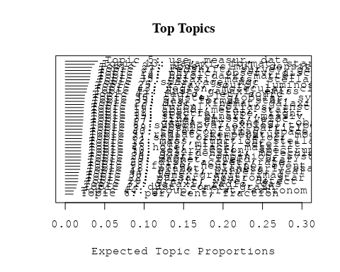

# Print the top 10 labels for each topic  
topic_labels <- labelTopics(Research_topics, n=10)  
print(topic_labels)

## Topic 1 Top Words:  
## Highest Prob: dust, comet, grain, observ, surfac, measur, magnetospher, activ, impact, particl   
## FREX: comet, cometari, saturn, magnetospher, belt, uranus, grain, ice, rosetta, asteroid   
## Lift: comet, saturn, cometari, die, magnetopaus, pchuryumov-gerasimenko, ptempel, perihelion, uranus, ici   
## Score: comet, dust, grain, magnetospher, saturn, cometari, die, belt, uranus, voyag   
## Topic 2 Top Words:  
## Highest Prob: radiat, temperatur, model, emiss, electron, ioniz, spectral, thermal, effect, photon   
## FREX: radiat, electron, photon, reioniz, thermal, ioniz, temperatur, scatter, synchrotron, compton   
## Lift: jupiter’, thomson, inverse-compton, recombin, ginga, bremsstrahlung, radiat, reioniz, opac, glast   
## Score: radiat, electron, reioniz, ioniz, photon, temperatur, synchrotron, compton, recombin, emiss   
## Topic 3 Top Words:  
## Highest Prob: star, orbit, veloc, motion, period, variabl, sgr, observ, radial, transit   
## FREX: sgr, motion, variabl, proper, lyra, radial, orbit, period, mas, parsec   
## Lift: con, kgaa, verlag, weinheim, wiley-vch, hip, gmbh, sgr, ephemeri, lyra   
## Score: sgr, orbit, lyra, motion, star, variabl, period, con, veloc, mas   
## Topic 4 Top Words:  
## Highest Prob: hole, black, mass, accret, supermass, central, agn, activ, quasar, galact   
## FREX: hole, black, supermass, smbh, mbh, eddington, nls, smbhs, horizon, bulg   
## Lift: mbh, american, black, black-hol, hole, smbh, supermass, coevolut, smbhs, nls   
## Score: black, hole, supermass, smbh, accret, agn, nls, quasar, mbh, bulg   
## Topic 5 Top Words:  
## Highest Prob: use, measur, data, model, estim, determin, method, paramet, obtain, result   
## FREX: method, error, uncertainti, determin, estim, accur, correct, systemat, use, paramet   
## Lift: focal, galfit, non-parametr, trigonometr, nonetheless, error, interpol, procedur, softwar, parallax   
## Score: method, parallax, error, focal, calibr, measur, uncertainti, accuraci, data, bias   
## Topic 6 Top Words:  
## Highest Prob: per, cent, fraction, rate, distribut, outburst, nova, model, peak, mass   
## FREX: cent, per, nova, outburst, fraction, post-starburst, intermedi, peak, synthesi, lfs   
## Lift: cent, grand, post-starburst, per, lfs, nova, one-half, bandwidth, euclid, percentag   
## Score: cent, per, grand, nova, outburst, post-starburst, lfs, psf, o-typ, fraction   
## Topic 7 Top Words:  
## Highest Prob: star, age, ngc, popul, stellar, giant, red, young, branch, myr   
## FREX: branch, age, diagram, ngc, mag, color-magnitud, red, myr, rgb, magellan   
## Lift: architectur, cmds, cmd, tip, straggler, pms, rgb, telescopeadvanc, scorpius, color-magnitud   
## Score: ngc, branch, star, age, architectur, rgb, color-magnitud, mag, red, diagram   
## Topic 8 Top Words:  
## Highest Prob: supernova, explos, type, remnant, mass, ejecta, progenitor, model, sne, time   
## FREX: explos, ejecta, supernova, core-collaps, thermonuclear, remnant, radioact, progenitor, csm, deton   
## Lift: breakout, deflagr, non-standard, stripped-envelop, csm, iib, neutrino-driven, pre-supernova, explos, thermonuclear   
## Score: supernova, explos, ejecta, deton, remnant, sne, csm, thermonuclear, progenitor, radioact   
## Topic 9 Top Words:  
## Highest Prob: flare, neutrino, event, flux, observ, burst, variabl, time, blazar, emiss   
## FREX: flare, blazar, lag, neutrino, cmes, high-energi, erupt, event, reconnect, burst   
## Lift: cmes, lag, recommend, cme, reconnect, icecub, sea, markarian, flare, erupt   
## Score: flare, neutrino, blazar, cmes, γray, high-energi, burst, reconnect, lag, recommend   
## Topic 10 Top Words:  
## Highest Prob: solar, coron, spectrum, power, region, scale, observ, structur, polar, measur   
## FREX: wmap, cmb, coron, corona, microwav, loop, non-gaussian, solar, sunspot, chromospher   
## Lift: helioseismolog, quiet-sun, recognit, represent, wmap, helioseism, cmb, magnetogram, soho, stoke   
## Score: coron, represent, wmap, cmb, sunspot, solar, chromospher, corona, limb, polar   
## Topic 11 Top Words:  
## Highest Prob: dust, galaxi, emiss, seyfert, starburst, ngc, infrar, luminos, nuclear, agn   
## FREX: seyfert, ulirg, spitzer, far-infrar, starburst, qsos, infrar, mid-infrar, ira, fir   
## Lift: pah, aromat, caltech, pdrs, sing, ulirg, polycycl, palomar-green, liner, seyfert   
## Score: seyfert, dust, starburst, ulirg, ngc, agn, pah, qsos, mid-infrar, spitzer   
## Topic 12 Top Words:  
## Highest Prob: mass, function, stellar, initi, star, imf, distribut, densiti, evolut, ratio   
## FREX: function, imf, ucd, initi, slope, law, power-law, germani, mass, top-heavi   
## Lift: top-heavi, usa, garch, heidelberg, max-planck-institut, ucd, germani, sfe, imf, für   
## Score: imf, function, ucd, mass, stellar, heidelberg, top-heavi, germani, mass--light, für   
## Topic 13 Top Words:  
## Highest Prob: galaxi, format, star, popul, merger, stellar, rate, evolut, massiv, histori   
## FREX: histori, sfr, format, merger, galaxi, assembl, star-form, merg, passiv, hierarch   
## Lift: consensus, dsc, smgs, morgana, bcgs, sfrs, dri, sfr, downsiz, uv-select   
## Score: galaxi, merger, format, star, sfr, dsc, star-form, bcgs, histori, smgs   
## Topic 14 Top Words:  
## Highest Prob: halo, dark, matter, mass, simul, cosmolog, model, predict, structur, distribut   
## FREX: dark, matter, halo, subhalo, cdm, cosmolog, λcdm, n-bodi, baryon, cold   
## Lift: aquarius, millennium-ii, quasi-stellar, self-interact, λcdm, subhalo, acdm, dark, cdm, galaxy-s   
## Score: halo, dark, matter, subhalo, cdm, cosmolog, substructur, n-bodi, cold, mass   
## Topic 15 Top Words:  
## Highest Prob: abund, metal, star, chemic, element, ratio, stellar, solar, enrich, observ   
## FREX: abund, chemic, metal, element, enrich, r-process, metal-poor, isotop, oxygen, agb   
## Lift: dredge-, presolar, r-process, amorph, dsphs, s-process, heh, low-metal, nitrogen, abund   
## Score: metal, abund, chemic, element, r-process, enrich, isotop, metal-poor, agb, grain   
## Topic 16 Top Words:  
## Highest Prob: turbul, collaps, instabl, pressur, flow, gravit, region, simul, cloud, shock   
## FREX: turbul, instabl, pressur, collaps, forc, viscos, flow, stabil, unstabl, hydrodynam   
## Lift: ask, turbul, subson, magnetorot, instabl, mach, viscos, self-grav, amplif, self-gravit   
## Score: turbul, instabl, pressur, viscos, collaps, flow, ask, hydrodynam, gravit, unstabl   
## Topic 17 Top Words:  
## Highest Prob: gamma-ray, energi, observ, sourc, spectrum, emiss, galact, tev, ray, high   
## FREX: gamma-ray, gev, positron, tev, gamma, annihil, egret, hess, magic, vhe   
## Lift: egret, stat, hegra, itali, tev-, positron, cms, vhe, cerenkov, magic   
## Score: gamma-ray, tev, gev, egret, magic, vhe, ray, positron, hess, γray   
## Topic 18 Top Words:  
## Highest Prob: planet, planetari, star, format, system, exoplanet, orbit, giant, around, solar   
## FREX: planet, exoplanet, planetari, extrasolar, habit, planetesim, migrat, super-earth, rocki, protoplanetari   
## Lift: extrasolar, melt, ozon, super-earth, lost, rocki, habit, earth-lik, planet, chondrit   
## Score: planet, exoplanet, planetari, lost, planetesim, habit, extrasolar, super-earth, protoplanetari, orbit   
## Topic 19 Top Words:  
## Highest Prob: star, binari, massiv, mass, observ, stellar, format, neutron, system, form   
## FREX: binari, bds, collis, eject, onc, massiv, neutron, star, protostar, fragment   
## Lift: bds, hyperon, onc, quark, galactic-field, chiral, pleiad, pre-main, sub-stellar, neutron-star   
## Score: binari, star, quark, neutron, onc, bds, merger, massiv, protostar, neutron-star   
## Topic 20 Top Words:  
## Highest Prob: gravit, wave, detect, time, binari, pulsar, will, array, use, gravitational-wav   
## FREX: gravitational-wav, wave, lisa, array, antenna, ligo, graviti, gravit, detector, interferomet   
## Lift: lisa, astron, ligo, usepackageamsfont, usepackageamsmath, usepackageamssymb, pta, ptas, navig, gravitational-wav   
## Score: pulsar, gravitational-wav, wave, lisa, gravit, binari, astron, detector, array, ligo   
## Topic 21 Top Words:  
## Highest Prob: model, simul, densiti, energi, numer, use, code, equat, differ, present   
## FREX: code, equat, analyt, numer, implement, approach, non-linear, solut, scheme, comput   
## Lift: gadget-, solver, focuss, eulerian, mesh, axion, gadget, non-linear, boson, code   
## Score: code, equat, simul, hydrodynam, analyt, non-linear, sph, numer, implement, energi   
## Topic 22 Top Words:  
## Highest Prob: pulsar, neutron, star, spin, rotat, millisecond, psr, period, time, puls   
## FREX: psr, pulsar, millisecond, neutron, spin-, puls, spin, magnetar, pulsat, crust   
## Lift: cyclotron, msps, pin, qpos, pulsar’, psr, effelsberg, spin-, magnetar, accretion-pow   
## Score: pulsar, neutron, millisecond, psr, puls, spin, spin-, msps, pulsat, pin   
## Topic 23 Top Words:  
## Highest Prob: disc, kinemat, galaxi, rotat, stellar, bulg, bar, spiral, veloc, angular   
## FREX: disc, kinemat, bar, bulg, momentum, gradient, warp, spiral, ellipt, angular   
## Lift: atlasd, boxi, axisymmetri, counter-rot, diski, scalelength, pseudo-bulg, sauron, warp, disc   
## Score: disc, kinemat, bulg, bar, rotat, spiral, momentum, atlasd, warp, boxi   
## Topic 24 Top Words:  
## Highest Prob: physic, observ, discuss, review, studi, understand, astrophys, properti, process, import   
## FREX: review, astrophys, understand, progress, futur, physic, key, question, research, knowledg   
## Lift: devic, eht, overview, review, art, technic, avenu, summaris, lesson, learn   
## Score: review, astrophys, devic, overview, understand, research, futur, progress, astronomi, learn   
## Topic 25 Top Words:  
## Highest Prob: x-ray, sourc, luminos, kev, emiss, detect, erg, flux, observ, optic   
## FREX: kev, x-ray, erg, rosat, chandra, hard, xmm-newton, sourc, counterpart, count   
## Lift: pspc, unabsorb, xlf, mcrab, -ks, lxlbol, rass, kev, serendipit, ibi   
## Score: x-ray, kev, sourc, chandra, rosat, erg, luminos, xmm-newton, hard, mcrab   
## Topic 26 Top Words:  
## Highest Prob: dwarf, companion, system, mass, white, binari, star, orbit, brown, secondari   
## FREX: companion, white, dwarf, brown, secondari, eclips, transfer, sdss, binari, system   
## Lift: subdwarf, shortest, carbon–oxygen, alto, calar, inth, ultracool, companion, wds, common-envelop   
## Score: dwarf, white, companion, binari, brown, sdss, orbit, eclips, shortest, secondari   
## Topic 27 Top Words:  
## Highest Prob: redshift, survey, galaxi, sampl, luminos, agn, quasar, select, sky, sdss   
## FREX: redshift, survey, select, sloan, digit, sampl, sdss, rest-fram, catalog, quasar   
## Lift: eb-v, flp, gama, lbg, udf, lyman-break, multicolor, unobscur, gem, lbgs   
## Score: redshift, agn, quasar, sdss, survey, galaxi, sloan, digit, sampl, lbgs   
## Topic 28 Top Words:  
## Highest Prob: disk, accret, rate, inner, can, system, region, mass, rotat, radius   
## FREX: disk, accret, thick, torqu, thin, inner, gap, outer, top, corot   
## Lift: top, disk, herbig, torqu, sub-parsec, kuiper, irac, mgii, pericent, settl   
## Score: disk, accret, top, protoplanetari, torqu, inner, rotat, corot, thick, circumstellar   
## Topic 29 Top Words:  
## Highest Prob: magnet, field, star, rotat, activ, stellar, surfac, strength, wind, dynamo   
## FREX: magnet, dynamo, field, imbh, runaway, convect, strength, mhd, rotat, hyad   
## Lift: polarimet, poloid, dynamo, imbh, seismic, tube, non-id, magnet, hyperveloc, hyad   
## Score: magnet, field, dynamo, rotat, imbh, runaway, star, polarimet, convect, chromospher   
## Topic 30 Top Words:  
## Highest Prob: lens, gravit, imag, galaxi, mass, len, model, weak, sourc, system   
## FREX: lens, len, microlens, magnif, shear, weak, gravit, distort, kernel, reconstruct   
## Lift: lens, magnif, quadrupl, microlens, pariti, len, weak-lens, multipli, kernel, strong-lens   
## Score: lens, len, microlens, gravit, magnif, quadrupl, quasar, imag, shear, galaxi   
## Topic 31 Top Words:  
## Highest Prob: spectra, type, light, spectral, curv, observ, sne, optic, maximum, featur   
## FREX: curv, spectra, sne, light, maximum, type, near-infrar, spectral, normal, declin   
## Lift: post-maximum, ii-p, well-observ, fluoresc, underlumin, iron-group, opticalnear-infrar, early-tim, ime, curv   
## Score: sne, spectra, curv, spectral, type, light, supernova, near-infrar, post-maximum, ii-p   
## Topic 32 Top Words:  
## Highest Prob: galaxi, radio, gas, observ, cluster, shock, emiss, diffus, region, medium   
## FREX: relic, intraclust, filament, subclust, bubbl, ram, abel, icm, front, large-scal   
## Lift: relic, invis, sunyaev-zeldovich, icm, subclust, superclust, ram, bubbl, abel, intraclust   
## Score: relic, radio, subclust, galaxi, cluster, intraclust, icm, ram, bubbl, shock   
## Topic 33 Top Words:  
## Highest Prob: gas, format, star, feedback, cool, wind, simul, model, rate, accret   
## FREX: feedback, cool, outflow, wind, gas, regul, effici, cold, format, drive   
## Lift: feedback, realiti, circumgalact, sam, blown, self-regul, regul, pop, multiphas, lab   
## Score: feedback, gas, wind, outflow, cool, star, accret, format, agn, cold   
## Topic 34 Top Words:  
## Highest Prob: gas, densiti, molecular, cloud, system, hydrogen, medium, column, interstellar, observ   
## FREX: column, lyα, ism, absorb, hydrogen, igm, molecular, atom, lyman, warm   
## Lift: contemporari, dla, dlas, whim, lyα, metal-fre, lya, igm, column, warm-hot   
## Score: molecular, gas, lyα, dla, ism, column, igm, whim, cloud, hydrogen   
## Topic 35 Top Words:  
## Highest Prob: galaxi, mass, stellar, relat, luminos, colour, group, correl, early-typ, find   
## FREX: colour, early-typ, dot, group, dispers, sloan, relat, fix, digit, red   
## Lift: light-weight, mass-siz, yang, gass, harass, overproduc, fire, mass-metal, disk-domin, arecibo   
## Score: galaxi, colour, early-typ, satellit, sloan, dot, sdss, mass, digit, stellar   
## Topic 36 Top Words:  
## Highest Prob: way, milki, satellit, galaxi, galact, tidal, stream, orbit, structur, dwarf   
## FREX: milki, way, stream, satellit, tidal, disrupt, strip, andromeda, sagittarius, tail   
## Lift: fuzzi, way’, apocentr, milki, andromeda, dos, ursa, stream, cluster-lik, way   
## Score: milki, satellit, fuzzi, stream, tidal, way, galaxi, halo, dwarf, orbit   
## Topic 37 Top Words:  
## Highest Prob: line, emiss, veloc, absorpt, profil, observ, ratio, model, width, compon   
## FREX: line, width, absorpt, broad, profil, iii, sight, balmer, narrow, intens   
## Lift: lvg, aur, underabund, line, blueshift, balmer, magnetocentrifug, eta, width, forbidden   
## Score: line, lvg, absorpt, emiss, width, balmer, blueshift, sight, profil, veloc   
## Topic 38 Top Words:  
## Highest Prob: cluster, globular, system, veloc, dynam, field, result, also, within, distribut   
## FREX: cluster, globular, virgo, gcs, relax, segreg, infal, des, dissolut, disrupt   
## Lift: blur, nucleat, self-enrich, cluster, segreg, dissolut, fractal, dissolv, globular, omega   
## Score: cluster, globular, gcs, virgo, dissolut, des, segreg, blur, perseus, half-mass   
## Topic 39 Top Words:  
## Highest Prob: cosmic, ray, particl, energi, acceler, shock, proton, cosmic-ray, galact, neutrino   
## FREX: proton, cosmic-ray, acceler, ray, cosmic, ion, charg, shower, particl, inject   
## Lift: keep, knee, pevatron, pierr, uhecr, crs, ultra-high-energi, shower, p-p, ultrarelativist   
## Score: ray, cosmic-ray, cosmic, acceler, proton, particl, neutrino, keep, shock, shower   
## Topic 40 Top Words:  
## Highest Prob: telescop, imag, space, observatori, instrument, resolut, system, optic, grb, data   
## FREX: grb, instrument, design, afterglow, telescop, program, pne, grbs, observatori, mission   
## Lift: comptel, erosita, fiber, academi, afterglow, microarcsecond, pne, leap, space-born, revolut   
## Score: grb, comptel, telescop, imag, afterglow, grbs, instrument, pne, mission, observatori   
## Topic 41 Top Words:  
## Highest Prob: galaxi, univers, year, report, discoveri, massiv, earli, reveal, star-form, solar   
## FREX: discoveri, distant, billion, big, year, million, bang, univers, star-form, rare   
## Lift: instituto, bang, lymanα, big, billion, deep-sea, constitu, protoclust, million, discoveri   
## Score: galaxi, billion, bang, quasar, star-form, big, discoveri, univers, year, starburst   
## Topic 42 Top Words:  
## Highest Prob: radio, jet, sourc, galaxi, activ, observ, emiss, nuclei, agn, ghz   
## FREX: jet, radio, radio-loud, ghz, lobe, collim, vlbi, relativist, nuclei, arcsec   
## Lift: label, microquasar, flat-spectrum, parsec-scal, high-pow, jet, radio-loud, satisfactorili, multifrequ, collim   
## Score: radio, jet, radio-loud, agn, ghz, lobe, sourc, vlbi, relativist, label   
## Topic 43 Top Words:  
## Highest Prob: region, molecular, cloud, core, emiss, sourc, gas, observ, star, massiv   
## FREX: maser, molecular, cloud, outflow, embed, protostar, millimet, core, toward, continuum   
## Lift: choh, irdc, pdbi, methanol, prestellar, bure, ammonia, subarcsecond, millimet, maser   
## Score: molecular, maser, methanol, irdc, cloud, protostar, outflow, core, emiss, polar   
## Topic 44 Top Words:  
## Highest Prob: group, first, astronom, one, author, observ, also, use, two, sever   
## FREX: author, astronom, figur, compil, tabl, version, draw, celesti, record, definit   
## Lift: journal, ras, royal, eye, manuscript, societi, draw, author, book, green   
## Score: sunspot, ras, astronom, royal, author, societi, aurora, figur, celesti, tabl

# Match the processed documents with the original titles  
matched_titles <- out_text$meta$original_concatenated_title_abstract  
  
# Print top 5 documents for each topic  
top_docs <- findThoughts(Research_topics, texts = matched_titles, n = 5)$docs[[1]]  
print(top_docs)

## [1] "Die Eismonde von Uranus, Neptun und Pluto Die Eismonde von Uranus, Neptun und Pluto wurden bislang nur von zwei Raumsonden erforscht: Voyager 2 und New Horizons. Ihre Aufnahmen zeigen eine große Vielfalt an Oberflächenformationen. Diese Eismonde weisen Ähnlichkeiten mit denen von Jupiter und Saturn auf. So gibt es offensichtlich auch im äußersten Bereich des Sonnensystems Kryovulkanismus. Auch Dehnungsstrukturen und mögliche Auswirkungen von planetaren Kollisionen sind erkennbar. Mehr als 50 Jahre nach Voyager 2 gibt es Pläne für eine neue Mission ins Uranus‐ und Neptunsystem. Noch weitgehend unerforscht sind die Zwergplaneten und kleineren Körper im Kuiper‐Gürtel. Der Vorbeiflug an Pluto und Charon im Juli 2015 war ein erster Blick in diese noch sehr fremde Welt. Entwürfe für weitere Missionen in den Kuiper‐Gürtel, zumindest seitens der NASA, existieren bereits auf dem Reißbrett für die Zeit nach 2040."   
## [2] "Eismonde von Jupiter und Saturn Seit 40 Jahren erforschen Sonden die Eismonde im äußeren Sonnensystem. Die Vielfalt dieser Körper, die mögliche Existenz von verborgenen Ozeanen und ihr Kryovulkanismus machen sie zu äußerst spannenden Himmelskörpern. Teil 1 dieses Zweiteilers stellt die Eismonde von Jupiter und Saturn vor. Jeder dieser Eismonde zeigt sich geologisch als eigene Welt. Bei den Jupitertrabanten ist die Oberfläche von Europa im Vergleich zu Ganymed geologisch sehr jung. Magnetfeldmessungen der Galileo‐Mission lassen unter der festen Eiskruste auf einen tiefen Ozean mit salzhaltigem Wasser schließen. Ein solcher Ozean existiert ebenfalls auf Callisto in größerer Tiefe, mutmaßlich auch auf Ganymed. Ganymed besitzt als einziger Eismond einen eisenhaltigen Kern, dessen starkes Magnetfeld das eines Ozeans überdeckt. Der Saturnmond Enceladus zeichnet sich durch aktiven Kryovulkanismus aus, der durch Gezeitenkräfte angetrieben ist."   
## [3] "Galileo in-situ dust measurements in Jupiter's gossamer rings Abstract Galileo was the first artificial satellite to orbit Jupiter. During its late orbital mission the spacecraft made two passages through the giant planet’s gossamer ring system. The impact-ionization dust detector on board successfully recorded dust impacts during both ring passages and provided the first in-situ measurements from a dusty planetary ring. During the first passage—on 5 November 2002 while Galileo was approaching Jupiter—dust measurements were collected until a spacecraft anomaly at 2.33 R J (Jupiter radii) just 16 min after a close flyby of Amalthea put the spacecraft into a safing mode. The second ring passage on 21 September 2003 provided ring dust measurements down to about 2.5 R J and the Galileo spacecraft was destroyed shortly thereafter in a planned impact with Jupiter. In all, a few thousand dust impacts were counted with the instrument accumulators during both ring passages, but only a total of 110 complete data sets of dust impacts were transmitted to Earth. Detected particle sizes range from about 0.2 to 5 μm, extending the known size distribution by an order of magnitude towards smaller particles than previously derived from optical imaging [Showalter, M.R., de Pater, I., Verbanac, G., Hamilton, D.P., Burns, J.A., 2008. Icarus 195, 361–377; de Pater, I., Showalter, M.R., Macintosh, B., 2008. Icarus 195, 348–360]. The grain size distribution increases towards smaller particles and shows an excess of these tiny motes in the Amalthea gossamer ring compared to the Thebe ring. The size distribution for the Amalthea ring derived from our in-situ measurements for the small grains agrees very well with the one obtained from images for large grains. Our analysis shows that particles contributing most to the optical cross-section are about 5 μm in radius, in agreement with imaging results. The measurements indicate a large drop in particle flux immediately interior to Thebe’s orbit and some detected particles seem to be on highly-tilted orbits with inclinations up to 20°. Finally, the faint Thebe ring extension was detected out to at least 5 R J , indicating that grains attain higher eccentricities than previously thought. The drop interior to Thebe, the excess of submicron grains at Amalthea, and the faint ring extension indicate that grain dynamics is strongly influenced by electromagnetic forces. These findings can all be explained by a shadow resonance as detailed by Hamilton and Kruger [Hamilton, D.P., Kruger, H., 2008. Nature 453, 72–75]."  
## [4] "A Dynamic, Rotating Ring Current Around Saturn The concept of an electrical current encircling the Earth at high altitudes was first proposed in 1917 to explain the depression of the horizontal component of the Earth’s magnetic field during geomagnetic storms. In situ measurements of the extent and composition of this current were made some 50 years later and an image was obtained in 2001 (ref. 6). Ring currents of a different nature were observed at Jupiter and their presence inferred at Saturn. Here we report images of the ring current at Saturn, together with a day–night pressure asymmetry and tilt of the planet’s plasma sheet, based on measurements using the magnetospheric imaging instrument (MIMI) on board Cassini. The ring current can be highly variable with strong longitudinal asymmetries that corotate nearly rigidly with the planet. This contrasts with the Earth’s ring current, where there is no rotational modulation and initial asymmetries are organized by local time effects."   
## [5] "A Dynamic, Rotating Ring Current Around Saturn The concept of an electrical current encircling the Earth at high altitudes was first proposed in 1917 to explain the depression of the horizontal component of the Earth’s magnetic field during geomagnetic storms. In situ measurements of the extent and composition of this current were made some 50 years later and an image was obtained in 2001 (ref. 6). Ring currents of a different nature were observed at Jupiter and their presence inferred at Saturn. Here we report images of the ring current at Saturn, together with a day–night pressure asymmetry and tilt of the planet’s plasma sheet, based on measurements using the magnetospheric imaging instrument (MIMI) on board Cassini. The ring current can be highly variable with strong longitudinal asymmetries that corotate nearly rigidly with the planet. This contrasts with the Earth’s ring current, where there is no rotational modulation and initial asymmetries are organized by local time effects."

# Find and plot the key "thoughts" or documents for selected topics  
thoughts6 <- findThoughts(Research_topics, texts = matched_titles, n = 3, topics = 6)$docs[[1]]  
thoughts18 <- findThoughts(Research_topics, texts = matched_titles, n = 3, topics = 18)$docs[[1]]  
par(mfrow = c(1, 2), mar = c(0.5, 0.5, 1, 0.5))  
plotQuote(thoughts6, width = 30, main = "Topic 6")  
plotQuote(thoughts18, width = 30, main = "Topic 18")

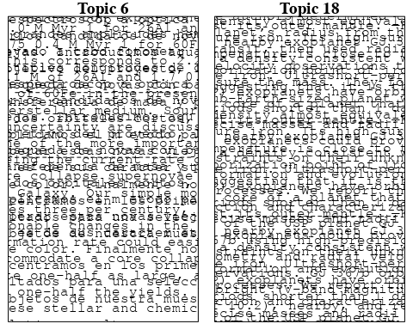

# Calculate and plot the correlation between topics  
mod.out.corr <- topicCorr(Research_topics)  
plot(mod.out.corr, cex = 1.5)  
  
  
# For each topic  
for (topic_num in 1:44) {  
 # Plot the word cloud  
 cloud(Research_topics, topic = topic_num, scale = c(2, 0.25))  
 Sys.sleep(2)  
}

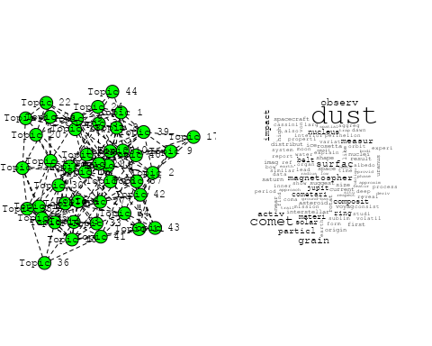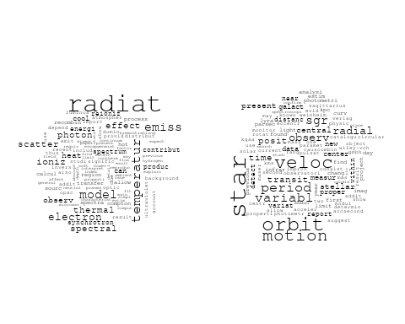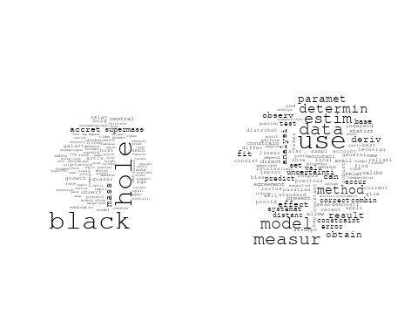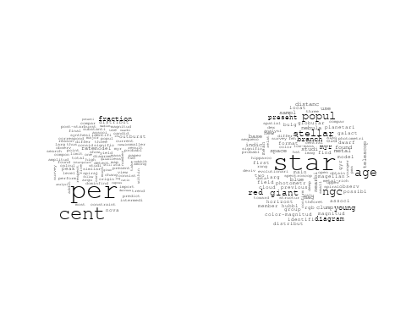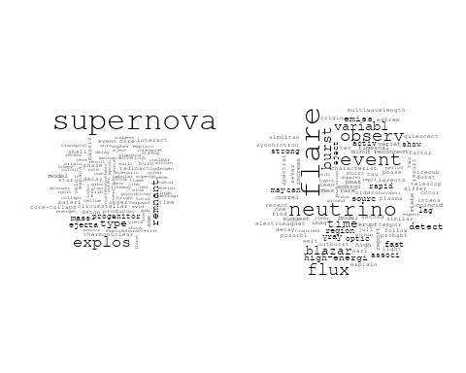

## Warning in wordcloud::wordcloud(words = vocab, freq = vec, max.words =  
## max.words, : dust could not be fit on page. It will not be plotted.

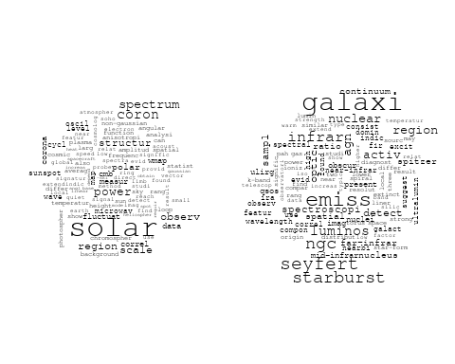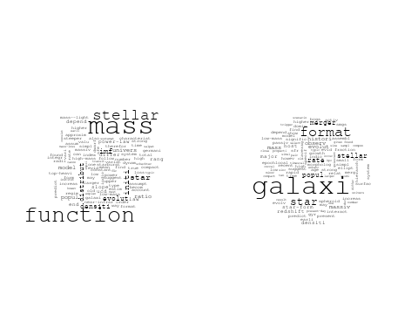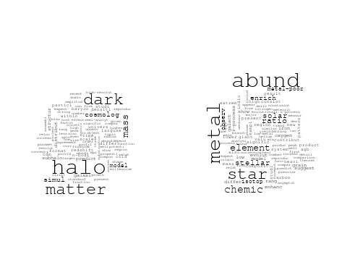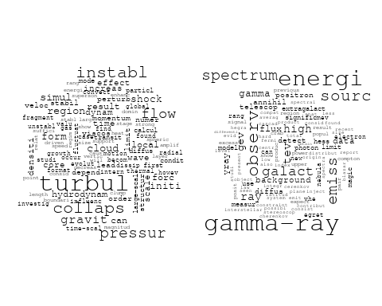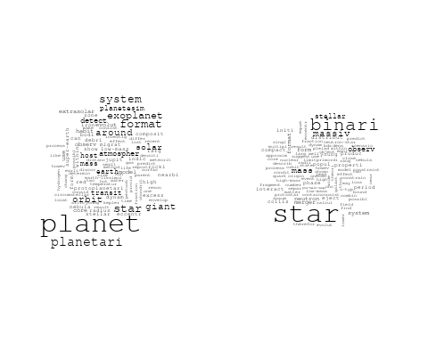

## Warning in wordcloud::wordcloud(words = vocab, freq = vec, max.words =  
## max.words, : gravit could not be fit on page. It will not be plotted.

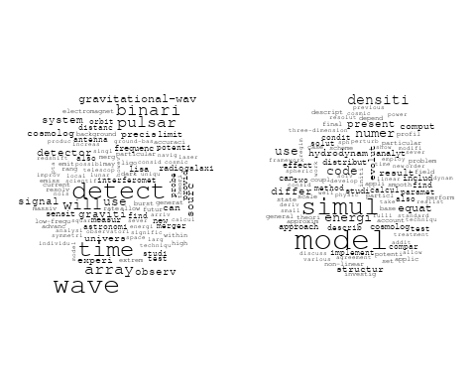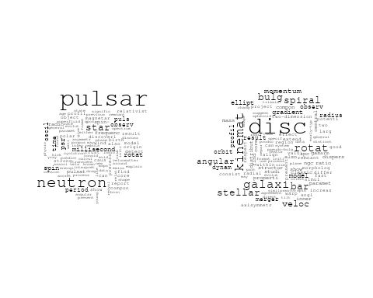

## Warning in wordcloud::wordcloud(words = vocab, freq = vec, max.words =  
## max.words, : discuss could not be fit on page. It will not be plotted.

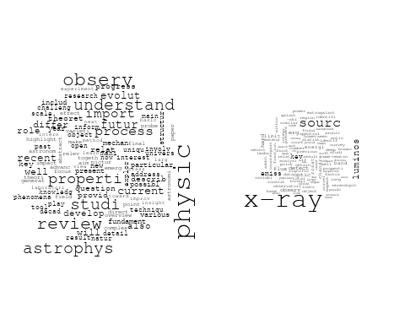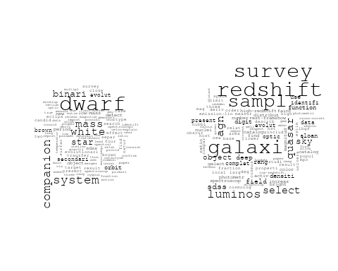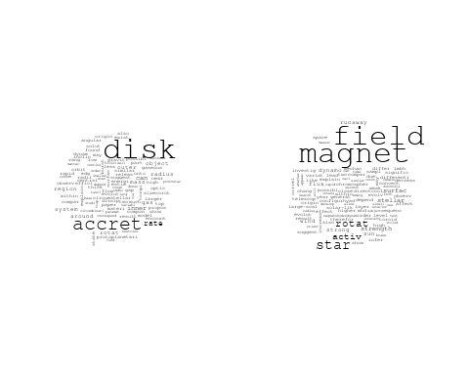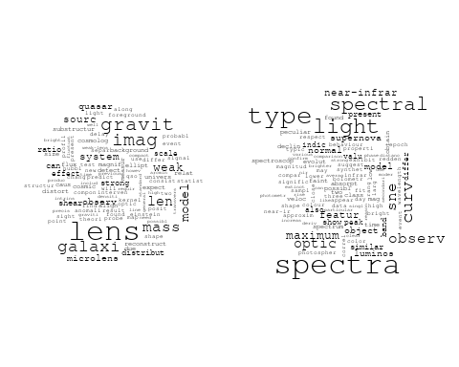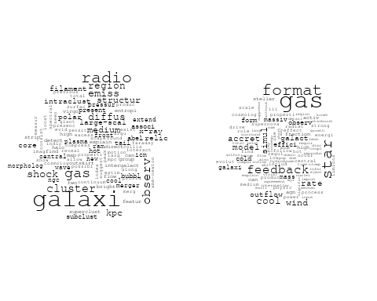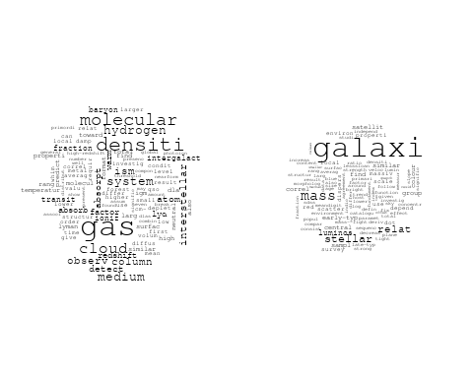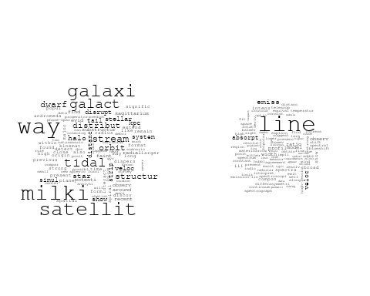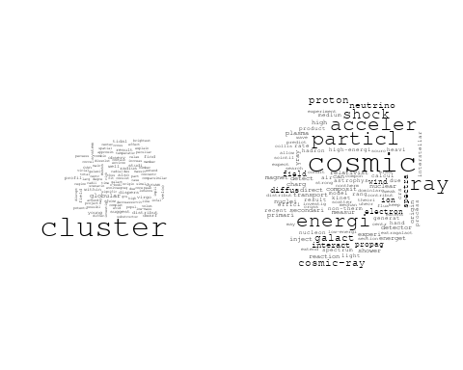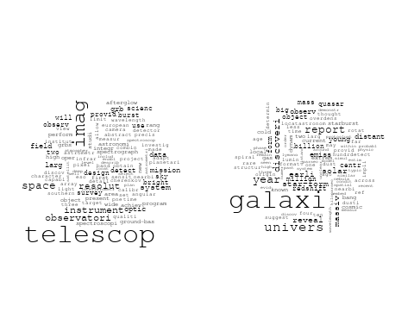

## Warning in wordcloud::wordcloud(words = vocab, freq = vec, max.words =  
## max.words, : core could not be fit on page. It will not be plotted.

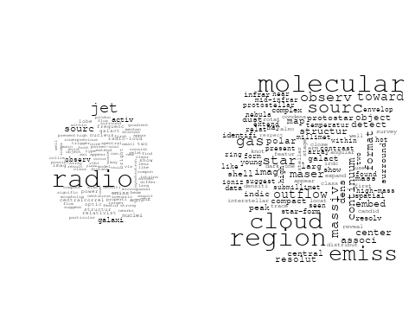

# Get the topic proportions for each document  
topic_proportions <- Research_topics$theta  
  
# Find the index of the topic with the highest proportion for each document  
# This will be the topic that each document is most likely to belong to  
max_topic_idx <- apply(topic_proportions, 1, which.max)  
  
# Add this as a new column to your data  
data_collab$topic <- max_topic_idx  
  
library(ggplot2)  
  
# Define the intervals  
intervals <- c('1824_1899', '1900_1964', '1965_1974', '1975_1984', '1985_1994', '1995_1999', '2000_2004', '2005_2009', '2010_2014', '2015_2019', '2020_2022')  
colors <- c('pink', 'blue', 'purple', 'yellow', 'green', 'pink', 'orange', 'violet', 'green', 'blue', 'pink')  
  
# Loop through the intervals and plot  
for(i in seq_along(intervals)){  
 # Filter data for when the pub_interval is equal to 1  
 data_filtered <- data_collab[data_collab[[paste0('pub_interval_', intervals[i])]] == 1,]  
   
 # Make the histogram  
   
 p <- ggplot(data_filtered, aes(x = topic)) +  
 geom_histogram(binwidth = 1, fill = colors[i], color = "black") +  
 xlab("Topic") +  
 ylab("Count") +  
 ggtitle(paste0("Topics from year ", gsub("_", " to ", intervals[i])))  
   
 print(p)  
}  
  
  
##Topic generation for DE (independent) publications  
  
data_independent <- data[data[["DE"]] == 100,]  
  
# Save the original title data for future use  
data_independent$original_concatenated_title_abstract <- data_independent$concatenated_title_abstract  
  
#pre-processing the titles using textProcessor from the stm package  
processed_text <- textProcessor(data_independent$concatenated_title_abstract, metadata = data_independent)

## Building corpus...   
## Converting to Lower Case...   
## Removing punctuation...   
## Removing stopwords...   
## Removing numbers...   
## Stemming...   
## Creating Output...

# Further prepare the data by removing low-frequency terms  
out_text <- prepDocuments(processed_text$documents, processed_text$vocab, processed_text$meta)

## Removing 2962 of 9574 terms (2962 of 162847 tokens) due to frequency   
## Your corpus now has 1901 documents, 6612 terms and 159885 tokens.

docs_text <- out_text$documents  
vocab_text <- out_text$vocab  
meta_text <- out_text$meta  
  
  
#Prepare data  
plotRemoved(processed_text$documents, lower.thresh = seq(1, 200, by = 100))

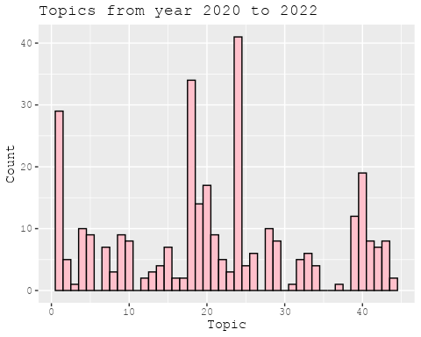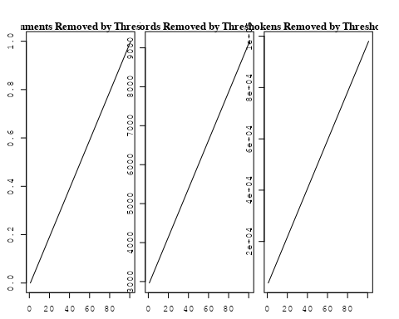

out_text <- prepDocuments(processed_text$documents, processed_text$vocab, processed_text$meta, lower.thresh = 8)

## Removing 7435 of 9574 terms (17734 of 162847 tokens) due to frequency   
## Your corpus now has 1901 documents, 2139 terms and 145113 tokens.

str(out_text$meta)

## 'data.frame': 1901 obs. of 39 variables:  
## $ concept_id : chr "https://openalex.org/C44870925" "https://openalex.org/C44870925" "https://openalex.org/C44870925" "https://openalex.org/C44870925" ...  
## $ work_id : chr "https://openalex.org/W3102133339" "https://openalex.org/W3102325152" "https://openalex.org/W3122713741" "https://openalex.org/W3114533047" ...  
## $ publication_year : int 2006 1997 2014 2021 2017 2020 2003 2005 2003 2011 ...  
## $ title : chr "The hierarchical formation of the brightest cluster galaxies" "Beyond genus statistics: a unifying approach to the morphology of cosmic structure" "Modelling the Magnetic Field Configuration of Neutron Stars" "Steady-state nucleosynthesis throughout the Galaxy" ...  
## $ paperabstract : chr "We use semi-analytic techniques to study the formation and evolution of brightest cluster galaxies (BCGs). We s"| __truncated__ "The genus statistics of isodensity contours has become a well-established tool in cosmology. In this Letter we "| __truncated__ "The properties of the extremely strong magnetic fields of neu tron stars affect in a unique way their evolution"| __truncated__ "Measurement and astrophysical interpretation of characteristic gamma-ray lines from nucleosynthesis was one of "| __truncated__ ...  
## $ country : chr "DE DE DE DE" "DE DE DE DE DE DE" "DE DE" "DE DE" ...  
## $ year_concept : chr "2006+https://openalex.org/C44870925" "1997+https://openalex.org/C44870925" "2014+https://openalex.org/C44870925" "2021+https://openalex.org/C44870925" ...  
## $ concatenated_title_abstract : chr "The hierarchical formation of the brightest cluster galaxies We use semi-analytic techniques to study the forma"| __truncated__ "Beyond genus statistics: a unifying approach to the morphology of cosmic structure The genus statistics of isod"| __truncated__ "Modelling the Magnetic Field Configuration of Neutron Stars The properties of the extremely strong magnetic fie"| __truncated__ "Steady-state nucleosynthesis throughout the Galaxy Measurement and astrophysical interpretation of characterist"| __truncated__ ...  
## $ US : num 0 0 0 0 0 0 0 0 0 0 ...  
## $ IN : num 0 0 0 0 0 0 0 0 0 0 ...  
## $ DE : num 100 100 100 100 100 100 100 100 100 100 ...  
## $ CH : num 0 0 0 0 0 0 0 0 0 0 ...  
## $ GB : num 0 0 0 0 0 0 0 0 0 0 ...  
## $ CN : num 0 0 0 0 0 0 0 0 0 0 ...  
## $ FR : num 0 0 0 0 0 0 0 0 0 0 ...  
## $ IT : num 0 0 0 0 0 0 0 0 0 0 ...  
## $ RU : num 0 0 0 0 0 0 0 0 0 0 ...  
## $ CA : num 0 0 0 0 0 0 0 0 0 0 ...  
## $ NL : num 0 0 0 0 0 0 0 0 0 0 ...  
## $ AU : num 0 0 0 0 0 0 0 0 0 0 ...  
## $ JP : num 0 0 0 0 0 0 0 0 0 0 ...  
## $ ES : num 0 0 0 0 0 0 0 0 0 0 ...  
## $ IL : num 0 0 0 0 0 0 0 0 0 0 ...  
## $ Americas : num 0 0 0 0 0 0 0 0 0 0 ...  
## $ Europe : num 0 0 0 0 0 0 0 0 0 0 ...  
## $ Africa : num 0 0 0 0 0 0 0 0 0 0 ...  
## $ AsiaAndOceania : num 0 0 0 0 0 0 0 0 0 0 ...  
## $ pub_interval_2020_2022 : int 0 0 0 1 0 1 0 0 0 0 ...  
## $ pub_interval_2015_2019 : int 0 0 0 0 1 0 0 0 0 0 ...  
## $ pub_interval_2010_2014 : int 0 0 1 0 0 0 0 0 0 1 ...  
## $ pub_interval_2005_2009 : int 1 0 0 0 0 0 0 1 0 0 ...  
## $ pub_interval_2000_2004 : int 0 0 0 0 0 0 1 0 1 0 ...  
## $ pub_interval_1995_1999 : int 0 1 0 0 0 0 0 0 0 0 ...  
## $ pub_interval_1985_1994 : int 0 0 0 0 0 0 0 0 0 0 ...  
## $ pub_interval_1975_1984 : int 0 0 0 0 0 0 0 0 0 0 ...  
## $ pub_interval_1965_1974 : int 0 0 0 0 0 0 0 0 0 0 ...  
## $ pub_interval_1900_1964 : int 0 0 0 0 0 0 0 0 0 0 ...  
## $ pub_interval_1824_1899 : int 0 0 0 0 0 0 0 0 0 0 ...  
## $ original_concatenated_title_abstract: chr "The hierarchical formation of the brightest cluster galaxies We use semi-analytic techniques to study the forma"| __truncated__ "Beyond genus statistics: a unifying approach to the morphology of cosmic structure The genus statistics of isod"| __truncated__ "Modelling the Magnetic Field Configuration of Neutron Stars The properties of the extremely strong magnetic fie"| __truncated__ "Steady-state nucleosynthesis throughout the Galaxy Measurement and astrophysical interpretation of characterist"| __truncated__ ...

# Initialize an empty formula string  
prevalence_formula_str <- "~"  
  
# Define the publication intervals  
pub_intervals <- c("pub_interval_2020_2022", "pub_interval_2015_2019", "pub_interval_2010_2014",   
 "pub_interval_2005_2009", "pub_interval_2000_2004", "pub_interval_1995_1999",  
 "pub_interval_1985_1994", "pub_interval_1975_1984", "pub_interval_1965_1974",  
 "pub_interval_1900_1964", "pub_interval_1824_1899")  
  
# Add each publication interval to the formula string  
for (interval in pub_intervals) {  
 # add an if statement to handle the first addition (without '+')  
 if (prevalence_formula_str == "~") {  
 prevalence_formula_str <- paste(prevalence_formula_str, interval)  
 } else {  
 prevalence_formula_str <- paste(prevalence_formula_str, "+", interval)  
 }  
}  
  
  
# Convert the string to a formula  
prevalence_formula <- as.formula(prevalence_formula_str)  
print(prevalence_formula)

## ~pub_interval_2020_2022 + pub_interval_2015_2019 + pub_interval_2010_2014 +   
## pub_interval_2005_2009 + pub_interval_2000_2004 + pub_interval_1995_1999 +   
## pub_interval_1985_1994 + pub_interval_1975_1984 + pub_interval_1965_1974 +   
## pub_interval_1900_1964 + pub_interval_1824_1899

# Run STM model  
Research_topics <- stm(documents = out_text$documents,   
 vocab = out_text$vocab,   
 K = 44,   
 prevalence = prevalence_formula,   
 data = out_text$meta,   
 init.type = "Spectral",  
 max.em.its = 1000,  
 gamma.prior = 'L1')

## Beginning Spectral Initialization   
## Calculating the gram matrix...  
## Finding anchor words...  
## ............................................  
## Recovering initialization...  
## .....................  
## Initialization complete.  
## ....................................................................................................  
## Completed E-Step (2 seconds).   
## Completed M-Step.   
## Completing Iteration 1 (approx. per word bound = -6.496)   
## ....................................................................................................  
## Completed E-Step (2 seconds).   
## Completed M-Step.   
## Completing Iteration 2 (approx. per word bound = -6.217, relative change = 4.300e-02)   
## ....................................................................................................  
## Completed E-Step (1 seconds).   
## Completed M-Step.   
## Completing Iteration 3 (approx. per word bound = -6.143, relative change = 1.191e-02)   
## ....................................................................................................  
## Completed E-Step (1 seconds).   
## Completed M-Step.   
## Completing Iteration 4 (approx. per word bound = -6.112, relative change = 5.048e-03)   
## ....................................................................................................  
## Completed E-Step (1 seconds).   
## Completed M-Step.   
## Completing Iteration 5 (approx. per word bound = -6.096, relative change = 2.617e-03)   
## Topic 1: des, ancient, der, juli, insight   
## Topic 2: orbit, variabl, time, period, transit   
## Topic 3: spectrum, solar, model, galact, electron   
## Topic 4: star, format, planet, system, metal   
## Topic 5: flare, observ, blazar, neutrino, γray   
## Topic 6: region, line, coron, gas, measur   
## Topic 7: supernova, type, sne, spectra, light   
## Topic 8: ray, cosmic, acceler, supernova, remnant   
## Topic 9: paper, neutron, strong, can, galaxi   
## Topic 10: dark, matter, halo, model, mass   
## Topic 11: physic, astrophys, univers, discuss, radiat   
## Topic 12: star, observ, neutron, massiv, stellar   
## Topic 13: observ, sunspot, present, calibr, veloc   
## Topic 14: galaxi, cluster, satellit, milki, star   
## Topic 15: mission, imag, observ, will, telescop   
## Topic 16: halo, model, use, simul, distribut   
## Topic 17: radio, sourc, galaxi, extragalact, emiss   
## Topic 18: agn, activ, nuclei, jet, galact   
## Topic 19: disc, mass, accret, jupit, rate   
## Topic 20: bulg, galaxi, bar, classic, disc   
## Topic 21: jet, wind, shock, emiss, x-ray   
## Topic 22: cluster, mass, star, stellar, function   
## Topic 23: chemic, abund, model, star, solar   
## Topic 24: galaxi, survey, sky, redshift, sdss   
## Topic 25: star, age, dwarf, veloc, new   
## Topic 26: sourc, x-ray, observ, emiss, correl   
## Topic 27: explos, burst, supernova, model, grb   
## Topic 28: x-ray, luminos, galaxi, cluster, sampl   
## Topic 29: disk, accret, star, dust, rotat   
## Topic 30: star, giant, metal, branch, observ   
## Topic 31: period, star, short, observ, variabl   
## Topic 32: galaxi, star, format, gas, feedback   
## Topic 33: galaxi, mass, stellar, metal, relat   
## Topic 34: dust, grain, ratio, abund, solar   
## Topic 35: mass, stellar, galaxi, format, star   
## Topic 36: field, magnet, model, observ, turbul   
## Topic 37: system, format, core, solar, planet   
## Topic 38: line, temperatur, model, emiss, hydrogen   
## Topic 39: hole, black, accret, mass, central   
## Topic 40: light, cloud, len, sky, use   
## Topic 41: gas, cluster, galaxi, pressur, simul   
## Topic 42: energi, neutrino, gamma-ray, tev, cosmic   
## Topic 43: pulsar, time, gravit, array, wave   
## Topic 44: potenti, minim, extern, mass, state   
## ....................................................................................................  
## Completed E-Step (1 seconds).   
## Completed M-Step.   
## Completing Iteration 6 (approx. per word bound = -6.086, relative change = 1.608e-03)   
## ....................................................................................................  
## Completed E-Step (1 seconds).   
## Completed M-Step.   
## Completing Iteration 7 (approx. per word bound = -6.079, relative change = 1.084e-03)   
## ....................................................................................................  
## Completed E-Step (1 seconds).   
## Completed M-Step.   
## Completing Iteration 8 (approx. per word bound = -6.074, relative change = 8.348e-04)   
## ....................................................................................................  
## Completed E-Step (1 seconds).   
## Completed M-Step.   
## Completing Iteration 9 (approx. per word bound = -6.070, relative change = 6.412e-04)   
## ....................................................................................................  
## Completed E-Step (1 seconds).   
## Completed M-Step.   
## Completing Iteration 10 (approx. per word bound = -6.067, relative change = 4.811e-04)   
## Topic 1: des, bodi, insight, ancient, radius   
## Topic 2: orbit, variabl, transit, time, chang   
## Topic 3: spectrum, model, electron, galact, energi   
## Topic 4: star, format, cloud, planet, metal   
## Topic 5: flare, observ, blazar, γray, neutrino   
## Topic 6: region, line, coron, spiral, measur   
## Topic 7: supernova, type, sne, spectra, light   
## Topic 8: ray, cosmic, acceler, supernova, energi   
## Topic 9: neutron, galaxi, strong, rotat, paper   
## Topic 10: dark, matter, halo, mass, model   
## Topic 11: physic, discuss, astrophys, review, radiat   
## Topic 12: star, galact, form, stellar, observ   
## Topic 13: observ, sunspot, profil, present, veloc   
## Topic 14: galaxi, cluster, satellit, way, milki   
## Topic 15: mission, imag, observ, will, telescop   
## Topic 16: model, use, simul, halo, distribut   
## Topic 17: radio, sourc, galaxi, extragalact, popul   
## Topic 18: agn, activ, nuclei, galact, jet   
## Topic 19: disc, accret, mass, rate, binari   
## Topic 20: bulg, galaxi, bar, host, classic   
## Topic 21: jet, wind, emiss, shock, x-ray   
## Topic 22: cluster, mass, star, stellar, function   
## Topic 23: solar, atmospher, abund, chemic, model   
## Topic 24: galaxi, survey, sky, redshift, sdss   
## Topic 25: star, age, dwarf, veloc, associ   
## Topic 26: sourc, x-ray, spectral, observ, emiss   
## Topic 27: explos, burst, supernova, grb, model   
## Topic 28: x-ray, luminos, galaxi, mass, cluster   
## Topic 29: disk, accret, star, dust, region   
## Topic 30: star, giant, cluster, branch, metal   
## Topic 31: star, period, short, activ, variabl   
## Topic 32: galaxi, format, star, gas, feedback   
## Topic 33: galaxi, mass, stellar, relat, metal   
## Topic 34: dust, grain, ratio, abund, solar   
## Topic 35: mass, galaxi, stellar, star, format   
## Topic 36: field, magnet, turbul, simul, strength   
## Topic 37: format, core, system, solar, form   
## Topic 38: line, temperatur, emiss, model, hydrogen   
## Topic 39: hole, black, mass, central, accret   
## Topic 40: light, imag, len, sky, night   
## Topic 41: gas, cluster, galaxi, pressur, simul   
## Topic 42: energi, neutrino, gamma-ray, tev, cosmic   
## Topic 43: pulsar, time, gravit, array, detect   
## Topic 44: potenti, studi, minim, state, case   
## ....................................................................................................  
## Completed E-Step (1 seconds).   
## Completed M-Step.   
## Completing Iteration 11 (approx. per word bound = -6.065, relative change = 3.989e-04)   
## ....................................................................................................  
## Completed E-Step (1 seconds).   
## Completed M-Step.   
## Completing Iteration 12 (approx. per word bound = -6.062, relative change = 3.957e-04)   
## ....................................................................................................  
## Completed E-Step (1 seconds).   
## Completed M-Step.   
## Completing Iteration 13 (approx. per word bound = -6.060, relative change = 3.412e-04)   
## ....................................................................................................  
## Completed E-Step (1 seconds).   
## Completed M-Step.   
## Completing Iteration 14 (approx. per word bound = -6.058, relative change = 3.379e-04)   
## ....................................................................................................  
## Completed E-Step (1 seconds).   
## Completed M-Step.   
## Completing Iteration 15 (approx. per word bound = -6.056, relative change = 3.364e-04)   
## Topic 1: bodi, des, main, metal, age   
## Topic 2: orbit, transit, variabl, time, chang   
## Topic 3: spectrum, electron, model, galact, energi   
## Topic 4: star, cloud, format, planet, molecular   
## Topic 5: flare, observ, blazar, γray, neutrino   
## Topic 6: region, coron, line, spiral, distanc   
## Topic 7: supernova, type, sne, curv, spectra   
## Topic 8: cosmic, ray, acceler, supernova, energi   
## Topic 9: neutron, galaxi, rotat, strong, solut   
## Topic 10: dark, matter, halo, mass, model   
## Topic 11: physic, discuss, review, astrophys, radiat   
## Topic 12: star, galact, stellar, form, observ   
## Topic 13: observ, sunspot, solar, veloc, galaxi   
## Topic 14: galaxi, cluster, satellit, way, milki   
## Topic 15: mission, imag, will, observ, telescop   
## Topic 16: model, use, simul, distribut, densiti   
## Topic 17: radio, sourc, galaxi, extragalact, popul   
## Topic 18: agn, activ, nuclei, galact, observ   
## Topic 19: disc, accret, mass, rate, binari   
## Topic 20: bulg, galaxi, bar, host, classic   
## Topic 21: jet, wind, emiss, x-ray, shock   
## Topic 22: cluster, mass, star, stellar, function   
## Topic 23: solar, atmospher, abund, chemic, model   
## Topic 24: galaxi, survey, sky, redshift, cluster   
## Topic 25: star, age, dwarf, veloc, associ   
## Topic 26: sourc, x-ray, spectral, observ, emiss   
## Topic 27: explos, supernova, burst, grb, model   
## Topic 28: x-ray, luminos, galaxi, mass, star   
## Topic 29: disk, accret, star, dust, region   
## Topic 30: star, giant, cluster, branch, ngc   
## Topic 31: star, period, short, activ, variabl   
## Topic 32: galaxi, format, gas, star, feedback   
## Topic 33: galaxi, mass, stellar, relat, merger   
## Topic 34: dust, grain, ratio, abund, solar   
## Topic 35: mass, galaxi, stellar, star, format   
## Topic 36: field, magnet, turbul, simul, strength   
## Topic 37: core, format, system, gas, form   
## Topic 38: line, emiss, temperatur, hydrogen, model   
## Topic 39: hole, black, mass, central, accret   
## Topic 40: light, imag, len, sky, night   
## Topic 41: gas, cluster, pressur, galaxi, simul   
## Topic 42: energi, neutrino, gamma-ray, tev, cosmic   
## Topic 43: pulsar, time, gravit, detect, array   
## Topic 44: potenti, model, studi, differ, surfac   
## ....................................................................................................  
## Completed E-Step (1 seconds).   
## Completed M-Step.   
## Completing Iteration 16 (approx. per word bound = -6.054, relative change = 2.929e-04)   
## ....................................................................................................  
## Completed E-Step (1 seconds).   
## Completed M-Step.   
## Completing Iteration 17 (approx. per word bound = -6.053, relative change = 2.728e-04)   
## ....................................................................................................  
## Completed E-Step (1 seconds).   
## Completed M-Step.   
## Completing Iteration 18 (approx. per word bound = -6.051, relative change = 2.454e-04)   
## ....................................................................................................  
## Completed E-Step (1 seconds).   
## Completed M-Step.   
## Completing Iteration 19 (approx. per word bound = -6.050, relative change = 2.217e-04)   
## ....................................................................................................  
## Completed E-Step (1 seconds).   
## Completed M-Step.   
## Completing Iteration 20 (approx. per word bound = -6.049, relative change = 2.201e-04)   
## Topic 1: metal, gradient, bodi, des, popul   
## Topic 2: orbit, transit, variabl, time, chang   
## Topic 3: spectrum, electron, model, galact, energi   
## Topic 4: star, cloud, format, planet, metal   
## Topic 5: flare, observ, blazar, γray, neutrino   
## Topic 6: region, coron, line, spiral, distanc   
## Topic 7: type, supernova, sne, curv, spectra   
## Topic 8: cosmic, ray, acceler, energi, supernova   
## Topic 9: rotat, neutron, galaxi, solut, strong   
## Topic 10: dark, matter, halo, mass, cosmolog   
## Topic 11: physic, discuss, review, astrophys, radiat   
## Topic 12: star, galact, form, stellar, observ   
## Topic 13: observ, sunspot, solar, two, veloc   
## Topic 14: galaxi, satellit, way, milki, cluster   
## Topic 15: mission, imag, will, observ, measur   
## Topic 16: use, model, simul, distribut, densiti   
## Topic 17: radio, sourc, galaxi, extragalact, main   
## Topic 18: agn, activ, nuclei, galact, observ   
## Topic 19: disc, accret, mass, rate, binari   
## Topic 20: bulg, galaxi, bar, ellipt, classic   
## Topic 21: jet, wind, emiss, x-ray, outflow   
## Topic 22: cluster, mass, star, stellar, function   
## Topic 23: solar, atmospher, abund, chemic, stellar   
## Topic 24: galaxi, survey, sky, cluster, redshift   
## Topic 25: star, age, dwarf, veloc, new   
## Topic 26: sourc, x-ray, spectral, observ, emiss   
## Topic 27: supernova, explos, burst, grb, model   
## Topic 28: x-ray, luminos, galaxi, mass, star   
## Topic 29: disk, accret, star, dust, protostar   
## Topic 30: star, giant, cluster, ngc, metal   
## Topic 31: star, period, short, activ, variabl   
## Topic 32: galaxi, format, gas, star, feedback   
## Topic 33: galaxi, mass, relat, stellar, merger   
## Topic 34: dust, grain, solar, ratio, abund   
## Topic 35: mass, galaxi, stellar, star, format   
## Topic 36: field, magnet, turbul, simul, strength   
## Topic 37: core, format, system, gas, molecular   
## Topic 38: line, emiss, hydrogen, model, absorpt   
## Topic 39: hole, black, mass, central, accret   
## Topic 40: light, imag, len, sky, gravit   
## Topic 41: gas, cluster, pressur, galaxi, simul   
## Topic 42: energi, neutrino, gamma-ray, tev, observ   
## Topic 43: pulsar, time, gravit, detect, array   
## Topic 44: model, potenti, differ, temperatur, surfac   
## ....................................................................................................  
## Completed E-Step (1 seconds).   
## Completed M-Step.   
## Completing Iteration 21 (approx. per word bound = -6.047, relative change = 2.048e-04)   
## ....................................................................................................  
## Completed E-Step (1 seconds).   
## Completed M-Step.   
## Completing Iteration 22 (approx. per word bound = -6.046, relative change = 1.825e-04)   
## ....................................................................................................  
## Completed E-Step (1 seconds).   
## Completed M-Step.   
## Completing Iteration 23 (approx. per word bound = -6.045, relative change = 1.688e-04)   
## ....................................................................................................  
## Completed E-Step (1 seconds).   
## Completed M-Step.   
## Completing Iteration 24 (approx. per word bound = -6.044, relative change = 1.579e-04)   
## ....................................................................................................  
## Completed E-Step (1 seconds).   
## Completed M-Step.   
## Completing Iteration 25 (approx. per word bound = -6.043, relative change = 1.815e-04)   
## Topic 1: metal, gradient, nuclei, bodi, des   
## Topic 2: orbit, transit, time, variabl, chang   
## Topic 3: spectrum, electron, model, galact, energi   
## Topic 4: star, cloud, format, planet, massiv   
## Topic 5: flare, observ, blazar, γray, neutrino   
## Topic 6: region, coron, line, spiral, distanc   
## Topic 7: type, supernova, sne, curv, spectra   
## Topic 8: cosmic, ray, acceler, energi, particl   
## Topic 9: neutron, rotat, galaxi, solut, strong   
## Topic 10: dark, halo, matter, mass, cosmolog   
## Topic 11: discuss, physic, review, astrophys, radiat   
## Topic 12: star, galact, form, binari, stellar   
## Topic 13: observ, sunspot, solar, two, veloc   
## Topic 14: galaxi, satellit, way, milki, cluster   
## Topic 15: mission, imag, will, measur, observ   
## Topic 16: use, simul, distribut, densiti, model   
## Topic 17: radio, sourc, galaxi, extragalact, main   
## Topic 18: agn, activ, nuclei, galact, observ   
## Topic 19: disc, accret, mass, rate, binari   
## Topic 20: bulg, galaxi, bar, ellipt, classic   
## Topic 21: jet, wind, emiss, x-ray, outflow   
## Topic 22: cluster, mass, star, stellar, function   
## Topic 23: solar, atmospher, abund, chemic, stellar   
## Topic 24: galaxi, survey, cluster, sky, sampl   
## Topic 25: star, age, dwarf, veloc, new   
## Topic 26: sourc, x-ray, spectral, observ, emiss   
## Topic 27: supernova, explos, burst, grb, type   
## Topic 28: x-ray, luminos, galaxi, mass, star   
## Topic 29: disk, accret, star, dust, protostar   
## Topic 30: star, giant, cluster, ngc, metal   
## Topic 31: star, period, short, activ, rotat   
## Topic 32: galaxi, gas, format, star, feedback   
## Topic 33: galaxi, mass, relat, stellar, merger   
## Topic 34: dust, grain, solar, ratio, system   
## Topic 35: mass, galaxi, stellar, star, format   
## Topic 36: field, magnet, turbul, simul, strength   
## Topic 37: core, format, gas, system, molecular   
## Topic 38: line, emiss, hydrogen, absorpt, model   
## Topic 39: hole, black, central, mass, accret   
## Topic 40: light, imag, len, sky, gravit   
## Topic 41: gas, cluster, pressur, galaxi, tail   
## Topic 42: energi, neutrino, gamma-ray, tev, detector   
## Topic 43: pulsar, time, gravit, detect, wave   
## Topic 44: model, potenti, differ, surfac, studi   
## ....................................................................................................  
## Completed E-Step (1 seconds).   
## Completed M-Step.   
## Completing Iteration 26 (approx. per word bound = -6.042, relative change = 1.443e-04)   
## ....................................................................................................  
## Completed E-Step (1 seconds).   
## Completed M-Step.   
## Completing Iteration 27 (approx. per word bound = -6.042, relative change = 1.192e-04)   
## ....................................................................................................  
## Completed E-Step (1 seconds).   
## Completed M-Step.   
## Completing Iteration 28 (approx. per word bound = -6.041, relative change = 1.092e-04)   
## ....................................................................................................  
## Completed E-Step (1 seconds).   
## Completed M-Step.   
## Completing Iteration 29 (approx. per word bound = -6.040, relative change = 1.082e-04)   
## ....................................................................................................  
## Completed E-Step (1 seconds).   
## Completed M-Step.   
## Completing Iteration 30 (approx. per word bound = -6.040, relative change = 1.224e-04)   
## Topic 1: metal, nuclei, gradient, bodi, popul   
## Topic 2: orbit, transit, time, variabl, observ   
## Topic 3: spectrum, electron, model, galact, energi   
## Topic 4: star, cloud, format, planet, massiv   
## Topic 5: flare, observ, blazar, neutrino, γray   
## Topic 6: region, coron, spiral, line, distanc   
## Topic 7: type, sne, supernova, curv, spectra   
## Topic 8: cosmic, ray, acceler, energi, particl   
## Topic 9: neutron, rotat, galaxi, solut, strong   
## Topic 10: dark, halo, matter, mass, cosmolog   
## Topic 11: discuss, physic, review, astrophys, radiat   
## Topic 12: star, galact, form, binari, stellar   
## Topic 13: observ, sunspot, solar, two, veloc   
## Topic 14: galaxi, satellit, way, milki, cluster   
## Topic 15: mission, imag, will, measur, observ   
## Topic 16: use, densiti, distribut, simul, scale   
## Topic 17: radio, sourc, galaxi, extragalact, main   
## Topic 18: agn, activ, nuclei, galact, observ   
## Topic 19: accret, disc, mass, rate, binari   
## Topic 20: bulg, galaxi, bar, ellipt, classic   
## Topic 21: jet, wind, emiss, x-ray, outflow   
## Topic 22: cluster, mass, star, stellar, function   
## Topic 23: solar, atmospher, abund, chemic, stellar   
## Topic 24: galaxi, survey, cluster, sky, sampl   
## Topic 25: star, age, dwarf, veloc, new   
## Topic 26: sourc, x-ray, spectral, observ, emiss   
## Topic 27: supernova, explos, burst, grb, type   
## Topic 28: x-ray, luminos, galaxi, mass, star   
## Topic 29: disk, accret, star, dust, protostar   
## Topic 30: star, giant, cluster, ngc, branch   
## Topic 31: star, period, short, activ, rotat   
## Topic 32: galaxi, gas, format, star, feedback   
## Topic 33: galaxi, mass, relat, stellar, merger   
## Topic 34: dust, grain, solar, ratio, system   
## Topic 35: mass, galaxi, stellar, star, format   
## Topic 36: field, magnet, turbul, simul, strength   
## Topic 37: core, format, gas, system, molecular   
## Topic 38: line, emiss, hydrogen, absorpt, temperatur   
## Topic 39: hole, black, central, mass, supermass   
## Topic 40: light, imag, len, sky, gravit   
## Topic 41: gas, cluster, pressur, galaxi, tail   
## Topic 42: energi, neutrino, gamma-ray, tev, detector   
## Topic 43: pulsar, time, gravit, wave, detect   
## Topic 44: model, differ, potenti, studi, effect   
## ....................................................................................................  
## Completed E-Step (1 seconds).   
## Completed M-Step.   
## Completing Iteration 31 (approx. per word bound = -6.039, relative change = 1.074e-04)   
## ....................................................................................................  
## Completed E-Step (1 seconds).   
## Completed M-Step.   
## Completing Iteration 32 (approx. per word bound = -6.038, relative change = 9.976e-05)   
## ....................................................................................................  
## Completed E-Step (1 seconds).   
## Completed M-Step.   
## Completing Iteration 33 (approx. per word bound = -6.038, relative change = 8.758e-05)   
## ....................................................................................................  
## Completed E-Step (1 seconds).   
## Completed M-Step.   
## Completing Iteration 34 (approx. per word bound = -6.037, relative change = 9.510e-05)   
## ....................................................................................................  
## Completed E-Step (1 seconds).   
## Completed M-Step.   
## Completing Iteration 35 (approx. per word bound = -6.037, relative change = 8.512e-05)   
## Topic 1: metal, nuclei, gradient, age, popul   
## Topic 2: orbit, transit, time, variabl, observ   
## Topic 3: spectrum, electron, model, galact, energi   
## Topic 4: star, format, cloud, planet, massiv   
## Topic 5: flare, observ, blazar, neutrino, γray   
## Topic 6: region, coron, spiral, line, distanc   
## Topic 7: type, sne, supernova, curv, spectra   
## Topic 8: cosmic, ray, acceler, energi, particl   
## Topic 9: neutron, rotat, galaxi, solut, strong   
## Topic 10: dark, halo, matter, mass, cosmolog   
## Topic 11: discuss, physic, review, astrophys, describ   
## Topic 12: star, galact, binari, form, stellar   
## Topic 13: observ, sunspot, two, veloc, calibr   
## Topic 14: galaxi, satellit, way, milki, cluster   
## Topic 15: mission, will, measur, imag, observ   
## Topic 16: use, densiti, distribut, simul, scale   
## Topic 17: radio, sourc, galaxi, extragalact, main   
## Topic 18: agn, activ, nuclei, galact, observ   
## Topic 19: accret, disc, mass, rate, binari   
## Topic 20: bulg, galaxi, bar, ellipt, host   
## Topic 21: jet, wind, emiss, x-ray, outflow   
## Topic 22: cluster, mass, star, stellar, function   
## Topic 23: solar, atmospher, abund, chemic, stellar   
## Topic 24: galaxi, survey, cluster, sky, sampl   
## Topic 25: star, age, veloc, dwarf, new   
## Topic 26: sourc, x-ray, spectral, observ, emiss   
## Topic 27: supernova, explos, burst, grb, type   
## Topic 28: x-ray, luminos, galaxi, mass, star   
## Topic 29: disk, accret, star, dust, protostar   
## Topic 30: star, giant, cluster, ngc, red   
## Topic 31: star, period, short, activ, rotat   
## Topic 32: galaxi, gas, format, star, feedback   
## Topic 33: galaxi, mass, relat, stellar, merger   
## Topic 34: dust, grain, solar, system, ratio   
## Topic 35: mass, galaxi, stellar, star, format   
## Topic 36: magnet, field, turbul, simul, strength   
## Topic 37: core, format, gas, molecular, system   
## Topic 38: line, emiss, hydrogen, absorpt, temperatur   
## Topic 39: hole, black, central, mass, supermass   
## Topic 40: light, imag, len, sky, gravit   
## Topic 41: cluster, gas, pressur, galaxi, tail   
## Topic 42: energi, neutrino, gamma-ray, tev, detector   
## Topic 43: pulsar, time, gravit, detect, wave   
## Topic 44: model, differ, potenti, effect, studi   
## ....................................................................................................  
## Completed E-Step (1 seconds).   
## Completed M-Step.   
## Completing Iteration 36 (approx. per word bound = -6.036, relative change = 7.575e-05)   
## ....................................................................................................  
## Completed E-Step (1 seconds).   
## Completed M-Step.   
## Completing Iteration 37 (approx. per word bound = -6.036, relative change = 7.140e-05)   
## ....................................................................................................  
## Completed E-Step (1 seconds).   
## Completed M-Step.   
## Completing Iteration 38 (approx. per word bound = -6.035, relative change = 6.322e-05)   
## ....................................................................................................  
## Completed E-Step (1 seconds).   
## Completed M-Step.   
## Completing Iteration 39 (approx. per word bound = -6.035, relative change = 6.746e-05)   
## ....................................................................................................  
## Completed E-Step (1 seconds).   
## Completed M-Step.   
## Completing Iteration 40 (approx. per word bound = -6.035, relative change = 8.050e-05)   
## Topic 1: metal, nuclei, gradient, age, popul   
## Topic 2: orbit, transit, time, variabl, observ   
## Topic 3: spectrum, electron, model, galact, energi   
## Topic 4: star, format, cloud, massiv, metal   
## Topic 5: flare, observ, blazar, neutrino, γray   
## Topic 6: region, coron, spiral, line, distanc   
## Topic 7: type, sne, supernova, curv, spectra   
## Topic 8: cosmic, ray, acceler, energi, particl   
## Topic 9: neutron, rotat, galaxi, solut, strong   
## Topic 10: dark, halo, matter, mass, cosmolog   
## Topic 11: discuss, physic, review, astrophys, describ   
## Topic 12: star, galact, binari, form, stellar   
## Topic 13: observ, sunspot, two, calibr, veloc   
## Topic 14: galaxi, satellit, way, milki, cluster   
## Topic 15: mission, will, measur, imag, observ   
## Topic 16: use, densiti, distribut, simul, scale   
## Topic 17: radio, sourc, galaxi, extragalact, main   
## Topic 18: agn, activ, nuclei, galact, observ   
## Topic 19: accret, disc, mass, rate, binari   
## Topic 20: bulg, galaxi, bar, ellipt, classic   
## Topic 21: jet, wind, emiss, x-ray, outflow   
## Topic 22: cluster, mass, stellar, star, function   
## Topic 23: solar, atmospher, abund, stellar, chemic   
## Topic 24: galaxi, survey, cluster, sky, sampl   
## Topic 25: star, age, veloc, dwarf, new   
## Topic 26: sourc, x-ray, spectral, observ, emiss   
## Topic 27: supernova, explos, burst, type, grb   
## Topic 28: x-ray, luminos, galaxi, mass, star   
## Topic 29: disk, accret, star, dust, protostar   
## Topic 30: star, giant, cluster, red, ngc   
## Topic 31: star, period, short, activ, rotat   
## Topic 32: galaxi, gas, format, feedback, star   
## Topic 33: galaxi, mass, relat, stellar, merger   
## Topic 34: dust, grain, system, solar, ratio   
## Topic 35: mass, galaxi, stellar, star, format   
## Topic 36: magnet, field, simul, turbul, strength   
## Topic 37: core, format, gas, molecular, system   
## Topic 38: line, emiss, hydrogen, absorpt, temperatur   
## Topic 39: hole, black, central, mass, supermass   
## Topic 40: light, imag, len, sky, gravit   
## Topic 41: cluster, gas, pressur, galaxi, tail   
## Topic 42: energi, neutrino, gamma-ray, tev, detector   
## Topic 43: pulsar, time, gravit, detect, wave   
## Topic 44: model, differ, potenti, effect, studi   
## ....................................................................................................  
## Completed E-Step (1 seconds).   
## Completed M-Step.   
## Completing Iteration 41 (approx. per word bound = -6.034, relative change = 8.170e-05)   
## ....................................................................................................  
## Completed E-Step (1 seconds).   
## Completed M-Step.   
## Completing Iteration 42 (approx. per word bound = -6.034, relative change = 6.589e-05)   
## ....................................................................................................  
## Completed E-Step (1 seconds).   
## Completed M-Step.   
## Completing Iteration 43 (approx. per word bound = -6.033, relative change = 6.304e-05)   
## ....................................................................................................  
## Completed E-Step (1 seconds).   
## Completed M-Step.   
## Completing Iteration 44 (approx. per word bound = -6.033, relative change = 6.227e-05)   
## ....................................................................................................  
## Completed E-Step (1 seconds).   
## Completed M-Step.   
## Completing Iteration 45 (approx. per word bound = -6.033, relative change = 5.591e-05)   
## Topic 1: metal, nuclei, age, gradient, popul   
## Topic 2: orbit, transit, time, planet, variabl   
## Topic 3: spectrum, electron, galact, model, energi   
## Topic 4: star, format, cloud, massiv, metal   
## Topic 5: flare, observ, blazar, neutrino, γray   
## Topic 6: region, coron, spiral, line, distanc   
## Topic 7: type, sne, supernova, curv, spectra   
## Topic 8: cosmic, ray, acceler, energi, particl   
## Topic 9: neutron, rotat, galaxi, solut, strong   
## Topic 10: dark, halo, matter, mass, cosmolog   
## Topic 11: discuss, physic, review, astrophys, describ   
## Topic 12: star, galact, binari, form, stellar   
## Topic 13: observ, sunspot, two, veloc, calibr   
## Topic 14: galaxi, satellit, way, milki, cluster   
## Topic 15: mission, will, measur, imag, observ   
## Topic 16: use, densiti, distribut, simul, scale   
## Topic 17: radio, sourc, galaxi, extragalact, main   
## Topic 18: agn, activ, nuclei, galact, observ   
## Topic 19: accret, disc, mass, rate, binari   
## Topic 20: bulg, galaxi, bar, ellipt, classic   
## Topic 21: jet, wind, x-ray, emiss, outflow   
## Topic 22: cluster, mass, stellar, star, function   
## Topic 23: solar, atmospher, abund, stellar, chemic   
## Topic 24: galaxi, survey, cluster, sampl, sky   
## Topic 25: star, age, veloc, dwarf, binari   
## Topic 26: sourc, x-ray, spectral, observ, emiss   
## Topic 27: supernova, explos, burst, type, grb   
## Topic 28: x-ray, luminos, galaxi, mass, star   
## Topic 29: disk, accret, star, dust, protostar   
## Topic 30: star, giant, cluster, red, ngc   
## Topic 31: star, period, short, activ, rotat   
## Topic 32: galaxi, gas, format, feedback, star   
## Topic 33: galaxi, mass, relat, stellar, merger   
## Topic 34: dust, grain, system, solar, abund   
## Topic 35: galaxi, mass, stellar, star, format   
## Topic 36: magnet, field, simul, turbul, strength   
## Topic 37: core, format, gas, molecular, system   
## Topic 38: line, emiss, hydrogen, absorpt, temperatur   
## Topic 39: hole, black, central, mass, supermass   
## Topic 40: light, imag, len, sky, gravit   
## Topic 41: cluster, gas, pressur, galaxi, tail   
## Topic 42: energi, neutrino, gamma-ray, tev, detector   
## Topic 43: pulsar, time, gravit, detect, wave   
## Topic 44: model, differ, potenti, effect, studi   
## ....................................................................................................  
## Completed E-Step (1 seconds).   
## Completed M-Step.   
## Completing Iteration 46 (approx. per word bound = -6.032, relative change = 4.416e-05)   
## ....................................................................................................  
## Completed E-Step (1 seconds).   
## Completed M-Step.   
## Completing Iteration 47 (approx. per word bound = -6.032, relative change = 3.937e-05)   
## ....................................................................................................  
## Completed E-Step (1 seconds).   
## Completed M-Step.   
## Completing Iteration 48 (approx. per word bound = -6.032, relative change = 3.934e-05)   
## ....................................................................................................  
## Completed E-Step (1 seconds).   
## Completed M-Step.   
## Completing Iteration 49 (approx. per word bound = -6.032, relative change = 4.358e-05)   
## ....................................................................................................  
## Completed E-Step (1 seconds).   
## Completed M-Step.   
## Completing Iteration 50 (approx. per word bound = -6.031, relative change = 4.717e-05)   
## Topic 1: metal, nuclei, age, gradient, popul   
## Topic 2: orbit, transit, planet, time, variabl   
## Topic 3: spectrum, electron, galact, model, energi   
## Topic 4: star, format, cloud, massiv, metal   
## Topic 5: flare, observ, blazar, neutrino, γray   
## Topic 6: region, coron, spiral, line, distanc   
## Topic 7: type, sne, supernova, curv, spectra   
## Topic 8: cosmic, ray, acceler, energi, particl   
## Topic 9: neutron, rotat, galaxi, solut, star   
## Topic 10: dark, halo, matter, mass, cosmolog   
## Topic 11: discuss, physic, review, astrophys, describ   
## Topic 12: star, galact, binari, form, stellar   
## Topic 13: observ, sunspot, two, veloc, calibr   
## Topic 14: galaxi, satellit, way, milki, cluster   
## Topic 15: will, measur, mission, imag, observ   
## Topic 16: use, distribut, densiti, simul, scale   
## Topic 17: radio, sourc, galaxi, extragalact, main   
## Topic 18: agn, activ, nuclei, galact, observ   
## Topic 19: accret, disc, mass, rate, binari   
## Topic 20: bulg, galaxi, bar, ellipt, classic   
## Topic 21: jet, wind, x-ray, emiss, outflow   
## Topic 22: cluster, mass, stellar, star, function   
## Topic 23: solar, atmospher, stellar, abund, chemic   
## Topic 24: galaxi, survey, cluster, sampl, sky   
## Topic 25: star, veloc, age, dwarf, binari   
## Topic 26: sourc, x-ray, spectral, observ, emiss   
## Topic 27: supernova, explos, burst, type, grb   
## Topic 28: x-ray, luminos, galaxi, mass, star   
## Topic 29: disk, accret, star, dust, protostar   
## Topic 30: star, giant, cluster, red, ngc   
## Topic 31: star, period, activ, short, rotat   
## Topic 32: galaxi, gas, format, feedback, star   
## Topic 33: galaxi, mass, relat, stellar, merger   
## Topic 34: dust, grain, system, solar, abund   
## Topic 35: galaxi, mass, stellar, star, format   
## Topic 36: magnet, field, simul, turbul, strength   
## Topic 37: core, format, gas, molecular, system   
## Topic 38: line, emiss, hydrogen, absorpt, temperatur   
## Topic 39: hole, black, central, mass, supermass   
## Topic 40: light, imag, len, sky, gravit   
## Topic 41: cluster, gas, pressur, galaxi, orbit   
## Topic 42: energi, neutrino, tev, gamma-ray, detector   
## Topic 43: pulsar, time, gravit, detect, wave   
## Topic 44: model, differ, potenti, effect, studi   
## ....................................................................................................  
## Completed E-Step (1 seconds).   
## Completed M-Step.   
## Completing Iteration 51 (approx. per word bound = -6.031, relative change = 4.568e-05)   
## ....................................................................................................  
## Completed E-Step (1 seconds).   
## Completed M-Step.   
## Completing Iteration 52 (approx. per word bound = -6.031, relative change = 4.515e-05)   
## ....................................................................................................  
## Completed E-Step (1 seconds).   
## Completed M-Step.   
## Completing Iteration 53 (approx. per word bound = -6.030, relative change = 4.347e-05)   
## ....................................................................................................  
## Completed E-Step (1 seconds).   
## Completed M-Step.   
## Completing Iteration 54 (approx. per word bound = -6.030, relative change = 4.857e-05)   
## ....................................................................................................  
## Completed E-Step (1 seconds).   
## Completed M-Step.   
## Completing Iteration 55 (approx. per word bound = -6.030, relative change = 4.689e-05)   
## Topic 1: metal, nuclei, gradient, age, popul   
## Topic 2: orbit, transit, planet, time, variabl   
## Topic 3: spectrum, electron, galact, model, energi   
## Topic 4: star, format, cloud, massiv, metal   
## Topic 5: flare, observ, blazar, neutrino, γray   
## Topic 6: region, coron, spiral, line, distanc   
## Topic 7: type, sne, supernova, curv, spectra   
## Topic 8: cosmic, ray, acceler, energi, particl   
## Topic 9: neutron, rotat, star, galaxi, solut   
## Topic 10: dark, halo, matter, mass, cosmolog   
## Topic 11: discuss, physic, review, astrophys, describ   
## Topic 12: star, galact, binari, form, stellar   
## Topic 13: observ, sunspot, two, veloc, present   
## Topic 14: galaxi, satellit, way, milki, cluster   
## Topic 15: will, measur, mission, imag, observ   
## Topic 16: use, distribut, densiti, simul, scale   
## Topic 17: radio, sourc, galaxi, extragalact, main   
## Topic 18: agn, activ, nuclei, galact, observ   
## Topic 19: accret, disc, mass, rate, binari   
## Topic 20: bulg, galaxi, bar, ellipt, classic   
## Topic 21: jet, wind, x-ray, emiss, outflow   
## Topic 22: cluster, mass, stellar, star, function   
## Topic 23: solar, atmospher, stellar, abund, chemic   
## Topic 24: galaxi, survey, cluster, sampl, sky   
## Topic 25: star, veloc, dwarf, age, binari   
## Topic 26: x-ray, sourc, spectral, observ, emiss   
## Topic 27: supernova, explos, burst, type, grb   
## Topic 28: x-ray, luminos, galaxi, mass, star   
## Topic 29: disk, accret, star, dust, protostar   
## Topic 30: star, giant, cluster, red, ngc   
## Topic 31: star, period, activ, short, rotat   
## Topic 32: galaxi, gas, format, feedback, star   
## Topic 33: galaxi, mass, relat, stellar, merger   
## Topic 34: dust, grain, system, solar, abund   
## Topic 35: galaxi, mass, stellar, star, format   
## Topic 36: magnet, field, turbul, simul, star   
## Topic 37: core, format, gas, molecular, system   
## Topic 38: line, emiss, hydrogen, absorpt, temperatur   
## Topic 39: hole, black, central, mass, supermass   
## Topic 40: light, imag, len, sky, gravit   
## Topic 41: cluster, gas, pressur, galaxi, orbit   
## Topic 42: energi, neutrino, tev, gamma-ray, detector   
## Topic 43: pulsar, time, gravit, detect, wave   
## Topic 44: model, differ, potenti, effect, profil   
## ....................................................................................................  
## Completed E-Step (1 seconds).   
## Completed M-Step.   
## Completing Iteration 56 (approx. per word bound = -6.030, relative change = 4.122e-05)   
## ....................................................................................................  
## Completed E-Step (1 seconds).   
## Completed M-Step.   
## Completing Iteration 57 (approx. per word bound = -6.030, relative change = 1.471e-05)   
## ....................................................................................................  
## Completed E-Step (1 seconds).   
## Completed M-Step.   
## Completing Iteration 58 (approx. per word bound = -6.029, relative change = 6.167e-05)   
## ....................................................................................................  
## Completed E-Step (1 seconds).   
## Completed M-Step.   
## Completing Iteration 59 (approx. per word bound = -6.029, relative change = 3.979e-05)   
## ....................................................................................................  
## Completed E-Step (1 seconds).   
## Completed M-Step.   
## Completing Iteration 60 (approx. per word bound = -6.029, relative change = 3.495e-05)   
## Topic 1: metal, nuclei, gradient, popul, age   
## Topic 2: orbit, planet, transit, time, observ   
## Topic 3: spectrum, electron, galact, model, energi   
## Topic 4: star, format, cloud, massiv, metal   
## Topic 5: flare, observ, blazar, neutrino, γray   
## Topic 6: region, coron, spiral, line, distanc   
## Topic 7: type, sne, supernova, curv, spectra   
## Topic 8: cosmic, ray, acceler, energi, particl   
## Topic 9: neutron, rotat, star, galaxi, solut   
## Topic 10: dark, halo, matter, mass, cosmolog   
## Topic 11: discuss, physic, review, astrophys, describ   
## Topic 12: star, galact, binari, form, stellar   
## Topic 13: observ, sunspot, two, veloc, present   
## Topic 14: galaxi, satellit, way, milki, cluster   
## Topic 15: will, measur, mission, imag, observ   
## Topic 16: distribut, use, densiti, simul, scale   
## Topic 17: radio, sourc, galaxi, extragalact, main   
## Topic 18: agn, activ, nuclei, galact, observ   
## Topic 19: accret, disc, mass, rate, binari   
## Topic 20: bulg, galaxi, bar, ellipt, classic   
## Topic 21: jet, wind, x-ray, emiss, outflow   
## Topic 22: cluster, mass, stellar, star, function   
## Topic 23: solar, atmospher, stellar, star, planet   
## Topic 24: galaxi, survey, cluster, sampl, sky   
## Topic 25: star, veloc, dwarf, age, binari   
## Topic 26: x-ray, sourc, spectral, observ, emiss   
## Topic 27: supernova, explos, burst, type, grb   
## Topic 28: x-ray, luminos, galaxi, mass, star   
## Topic 29: disk, accret, star, dust, protostar   
## Topic 30: star, giant, cluster, red, ngc   
## Topic 31: star, period, activ, short, rotat   
## Topic 32: galaxi, gas, format, feedback, star   
## Topic 33: galaxi, mass, relat, stellar, merger   
## Topic 34: dust, grain, system, solar, abund   
## Topic 35: galaxi, mass, stellar, star, format   
## Topic 36: magnet, field, turbul, simul, star   
## Topic 37: core, format, gas, molecular, system   
## Topic 38: line, emiss, hydrogen, absorpt, temperatur   
## Topic 39: hole, black, central, mass, supermass   
## Topic 40: light, imag, len, sky, gravit   
## Topic 41: cluster, gas, pressur, galaxi, orbit   
## Topic 42: energi, neutrino, tev, gamma-ray, detector   
## Topic 43: pulsar, time, gravit, detect, wave   
## Topic 44: model, differ, profil, use, potenti   
## ....................................................................................................  
## Completed E-Step (1 seconds).   
## Completed M-Step.   
## Completing Iteration 61 (approx. per word bound = -6.029, relative change = 3.447e-05)   
## ....................................................................................................  
## Completed E-Step (1 seconds).   
## Completed M-Step.   
## Completing Iteration 62 (approx. per word bound = -6.028, relative change = 3.982e-05)   
## ....................................................................................................  
## Completed E-Step (1 seconds).   
## Completed M-Step.   
## Completing Iteration 63 (approx. per word bound = -6.028, relative change = 4.082e-05)   
## ....................................................................................................  
## Completed E-Step (1 seconds).   
## Completed M-Step.   
## Completing Iteration 64 (approx. per word bound = -6.028, relative change = 4.263e-05)   
## ....................................................................................................  
## Completed E-Step (1 seconds).   
## Completed M-Step.   
## Completing Iteration 65 (approx. per word bound = -6.028, relative change = 4.103e-05)   
## Topic 1: metal, nuclei, popul, gradient, age   
## Topic 2: orbit, planet, transit, time, observ   
## Topic 3: spectrum, electron, galact, model, energi   
## Topic 4: star, format, cloud, massiv, metal   
## Topic 5: flare, observ, blazar, neutrino, γray   
## Topic 6: region, coron, line, spiral, distanc   
## Topic 7: type, sne, supernova, curv, spectra   
## Topic 8: cosmic, ray, acceler, energi, particl   
## Topic 9: neutron, star, rotat, galaxi, solut   
## Topic 10: dark, halo, matter, mass, cosmolog   
## Topic 11: discuss, physic, review, astrophys, describ   
## Topic 12: star, binari, galact, form, stellar   
## Topic 13: observ, sunspot, two, veloc, present   
## Topic 14: galaxi, satellit, way, milki, cluster   
## Topic 15: will, measur, mission, imag, observ   
## Topic 16: distribut, use, densiti, simul, scale   
## Topic 17: radio, sourc, galaxi, extragalact, main   
## Topic 18: agn, activ, nuclei, galact, observ   
## Topic 19: accret, disc, mass, rate, binari   
## Topic 20: bulg, galaxi, bar, ellipt, classic   
## Topic 21: jet, wind, x-ray, emiss, outflow   
## Topic 22: cluster, mass, stellar, star, function   
## Topic 23: solar, atmospher, stellar, star, planet   
## Topic 24: galaxi, survey, cluster, sampl, sky   
## Topic 25: star, veloc, dwarf, age, binari   
## Topic 26: x-ray, sourc, spectral, observ, emiss   
## Topic 27: supernova, explos, burst, type, grb   
## Topic 28: x-ray, luminos, galaxi, mass, star   
## Topic 29: disk, accret, star, dust, protostar   
## Topic 30: star, giant, cluster, red, ngc   
## Topic 31: star, period, activ, short, rotat   
## Topic 32: galaxi, gas, format, feedback, star   
## Topic 33: galaxi, mass, relat, stellar, merger   
## Topic 34: dust, grain, solar, abund, system   
## Topic 35: galaxi, mass, stellar, star, format   
## Topic 36: magnet, field, turbul, simul, star   
## Topic 37: core, format, gas, molecular, system   
## Topic 38: line, emiss, hydrogen, absorpt, detect   
## Topic 39: hole, black, central, mass, supermass   
## Topic 40: light, imag, len, sky, gravit   
## Topic 41: cluster, gas, pressur, galaxi, orbit   
## Topic 42: energi, neutrino, tev, gamma-ray, detector   
## Topic 43: pulsar, time, gravit, detect, wave   
## Topic 44: model, differ, use, profil, potenti   
## ....................................................................................................  
## Completed E-Step (1 seconds).   
## Completed M-Step.   
## Completing Iteration 66 (approx. per word bound = -6.027, relative change = 3.873e-05)   
## ....................................................................................................  
## Completed E-Step (1 seconds).   
## Completed M-Step.   
## Completing Iteration 67 (approx. per word bound = -6.027, relative change = 3.662e-05)   
## ....................................................................................................  
## Completed E-Step (1 seconds).   
## Completed M-Step.   
## Completing Iteration 68 (approx. per word bound = -6.027, relative change = 3.623e-05)   
## ....................................................................................................  
## Completed E-Step (1 seconds).   
## Completed M-Step.   
## Completing Iteration 69 (approx. per word bound = -6.027, relative change = 3.436e-05)   
## ....................................................................................................  
## Completed E-Step (1 seconds).   
## Completed M-Step.   
## Completing Iteration 70 (approx. per word bound = -6.026, relative change = 3.108e-05)   
## Topic 1: metal, popul, gradient, nuclei, stellar   
## Topic 2: orbit, planet, transit, time, observ   
## Topic 3: spectrum, electron, galact, model, energi   
## Topic 4: star, format, cloud, massiv, metal   
## Topic 5: flare, observ, blazar, neutrino, γray   
## Topic 6: region, coron, line, spiral, distanc   
## Topic 7: type, sne, supernova, curv, spectra   
## Topic 8: cosmic, ray, acceler, energi, particl   
## Topic 9: neutron, star, rotat, galaxi, solut   
## Topic 10: dark, halo, matter, mass, cosmolog   
## Topic 11: discuss, physic, review, astrophys, describ   
## Topic 12: star, binari, galact, form, stellar   
## Topic 13: observ, sunspot, two, veloc, present   
## Topic 14: galaxi, satellit, way, milki, cluster   
## Topic 15: will, measur, mission, imag, observ   
## Topic 16: distribut, use, densiti, simul, scale   
## Topic 17: radio, sourc, galaxi, extragalact, main   
## Topic 18: agn, activ, nuclei, galact, observ   
## Topic 19: accret, disc, mass, rate, angular   
## Topic 20: bulg, galaxi, bar, ellipt, classic   
## Topic 21: jet, wind, x-ray, emiss, outflow   
## Topic 22: cluster, mass, stellar, star, function   
## Topic 23: solar, atmospher, stellar, star, planet   
## Topic 24: galaxi, survey, cluster, sampl, sky   
## Topic 25: star, veloc, dwarf, age, companion   
## Topic 26: x-ray, sourc, spectral, observ, emiss   
## Topic 27: supernova, explos, burst, type, grb   
## Topic 28: x-ray, luminos, galaxi, mass, star   
## Topic 29: disk, accret, star, dust, protostar   
## Topic 30: star, giant, cluster, red, ngc   
## Topic 31: star, period, activ, short, rotat   
## Topic 32: galaxi, gas, format, feedback, star   
## Topic 33: galaxi, mass, relat, stellar, merger   
## Topic 34: dust, grain, solar, abund, system   
## Topic 35: galaxi, mass, stellar, star, format   
## Topic 36: magnet, field, turbul, simul, star   
## Topic 37: core, format, gas, molecular, system   
## Topic 38: line, emiss, hydrogen, absorpt, detect   
## Topic 39: hole, black, central, mass, supermass   
## Topic 40: light, imag, len, sky, gravit   
## Topic 41: cluster, gas, pressur, galaxi, orbit   
## Topic 42: energi, neutrino, tev, gamma-ray, detector   
## Topic 43: pulsar, time, gravit, detect, wave   
## Topic 44: model, use, differ, profil, densiti   
## ....................................................................................................  
## Completed E-Step (1 seconds).   
## Completed M-Step.   
## Completing Iteration 71 (approx. per word bound = -6.026, relative change = 2.852e-05)   
## ....................................................................................................  
## Completed E-Step (1 seconds).   
## Completed M-Step.   
## Completing Iteration 72 (approx. per word bound = -6.026, relative change = 2.755e-05)   
## ....................................................................................................  
## Completed E-Step (1 seconds).   
## Completed M-Step.   
## Completing Iteration 73 (approx. per word bound = -6.026, relative change = 2.917e-05)   
## ....................................................................................................  
## Completed E-Step (1 seconds).   
## Completed M-Step.   
## Completing Iteration 74 (approx. per word bound = -6.026, relative change = 3.220e-05)   
## ....................................................................................................  
## Completed E-Step (1 seconds).   
## Completed M-Step.   
## Completing Iteration 75 (approx. per word bound = -6.026, relative change = 3.321e-05)   
## Topic 1: metal, popul, stellar, gradient, age   
## Topic 2: orbit, planet, transit, time, observ   
## Topic 3: spectrum, electron, galact, model, energi   
## Topic 4: star, format, cloud, massiv, metal   
## Topic 5: flare, observ, blazar, neutrino, γray   
## Topic 6: region, coron, line, spiral, distanc   
## Topic 7: type, sne, supernova, curv, spectra   
## Topic 8: cosmic, ray, acceler, energi, particl   
## Topic 9: neutron, star, rotat, galaxi, solut   
## Topic 10: dark, halo, matter, mass, cosmolog   
## Topic 11: discuss, physic, review, astrophys, radiat   
## Topic 12: star, binari, galact, form, stellar   
## Topic 13: observ, sunspot, two, veloc, present   
## Topic 14: galaxi, satellit, way, milki, cluster   
## Topic 15: will, measur, mission, imag, observ   
## Topic 16: distribut, use, scale, densiti, simul   
## Topic 17: radio, sourc, galaxi, extragalact, sky   
## Topic 18: agn, activ, nuclei, galact, observ   
## Topic 19: accret, disc, mass, rate, angular   
## Topic 20: bulg, galaxi, bar, ellipt, classic   
## Topic 21: jet, wind, x-ray, emiss, outflow   
## Topic 22: cluster, mass, stellar, function, star   
## Topic 23: solar, atmospher, stellar, star, planet   
## Topic 24: galaxi, survey, cluster, sampl, sky   
## Topic 25: star, veloc, dwarf, age, companion   
## Topic 26: x-ray, sourc, spectral, observ, emiss   
## Topic 27: supernova, explos, burst, type, grb   
## Topic 28: x-ray, luminos, galaxi, mass, star   
## Topic 29: disk, accret, star, dust, protostar   
## Topic 30: star, giant, cluster, red, ngc   
## Topic 31: star, period, activ, short, rotat   
## Topic 32: galaxi, gas, format, feedback, star   
## Topic 33: galaxi, mass, relat, stellar, merger   
## Topic 34: dust, grain, abund, solar, system   
## Topic 35: galaxi, mass, stellar, star, format   
## Topic 36: magnet, field, turbul, simul, star   
## Topic 37: core, format, gas, molecular, system   
## Topic 38: line, emiss, hydrogen, absorpt, detect   
## Topic 39: hole, black, central, mass, supermass   
## Topic 40: light, imag, len, sky, gravit   
## Topic 41: cluster, gas, pressur, galaxi, orbit   
## Topic 42: energi, neutrino, tev, detector, gamma-ray   
## Topic 43: pulsar, time, gravit, detect, wave   
## Topic 44: model, use, profil, densiti, differ   
## ....................................................................................................  
## Completed E-Step (1 seconds).   
## Completed M-Step.   
## Completing Iteration 76 (approx. per word bound = -6.025, relative change = 2.882e-05)   
## ....................................................................................................  
## Completed E-Step (1 seconds).   
## Completed M-Step.   
## Completing Iteration 77 (approx. per word bound = -6.025, relative change = 2.746e-05)   
## ....................................................................................................  
## Completed E-Step (1 seconds).   
## Completed M-Step.   
## Completing Iteration 78 (approx. per word bound = -6.025, relative change = 2.764e-05)   
## ....................................................................................................  
## Completed E-Step (1 seconds).   
## Completed M-Step.   
## Completing Iteration 79 (approx. per word bound = -6.025, relative change = 2.236e-05)   
## ....................................................................................................  
## Completed E-Step (1 seconds).   
## Completed M-Step.   
## Completing Iteration 80 (approx. per word bound = -6.025, relative change = 2.253e-05)   
## Topic 1: metal, popul, stellar, age, nuclei   
## Topic 2: orbit, planet, transit, time, observ   
## Topic 3: spectrum, electron, galact, model, energi   
## Topic 4: star, format, cloud, massiv, metal   
## Topic 5: flare, observ, blazar, neutrino, γray   
## Topic 6: region, coron, line, spiral, distanc   
## Topic 7: type, sne, supernova, curv, spectra   
## Topic 8: cosmic, ray, acceler, energi, particl   
## Topic 9: neutron, star, rotat, galaxi, solut   
## Topic 10: dark, halo, matter, mass, cosmolog   
## Topic 11: discuss, physic, review, astrophys, radiat   
## Topic 12: star, binari, galact, form, stellar   
## Topic 13: observ, sunspot, two, veloc, present   
## Topic 14: galaxi, satellit, way, milki, cluster   
## Topic 15: will, measur, mission, imag, observ   
## Topic 16: distribut, use, scale, densiti, method   
## Topic 17: radio, sourc, galaxi, extragalact, sky   
## Topic 18: agn, activ, nuclei, galact, observ   
## Topic 19: accret, disc, mass, rate, angular   
## Topic 20: bulg, galaxi, bar, ellipt, classic   
## Topic 21: jet, wind, x-ray, emiss, outflow   
## Topic 22: cluster, mass, stellar, function, star   
## Topic 23: solar, atmospher, stellar, star, planet   
## Topic 24: galaxi, survey, cluster, sampl, sky   
## Topic 25: star, veloc, dwarf, age, companion   
## Topic 26: x-ray, sourc, spectral, observ, emiss   
## Topic 27: supernova, explos, burst, type, grb   
## Topic 28: x-ray, luminos, galaxi, mass, star   
## Topic 29: disk, accret, star, dust, region   
## Topic 30: star, giant, cluster, red, ngc   
## Topic 31: star, period, activ, short, rotat   
## Topic 32: galaxi, gas, format, feedback, simul   
## Topic 33: galaxi, mass, relat, stellar, merger   
## Topic 34: dust, grain, abund, solar, system   
## Topic 35: galaxi, mass, stellar, star, format   
## Topic 36: magnet, field, turbul, star, simul   
## Topic 37: core, format, gas, molecular, system   
## Topic 38: line, emiss, hydrogen, absorpt, detect   
## Topic 39: hole, black, central, mass, supermass   
## Topic 40: light, imag, len, sky, gravit   
## Topic 41: cluster, gas, pressur, galaxi, orbit   
## Topic 42: energi, neutrino, tev, detector, gamma-ray   
## Topic 43: pulsar, time, gravit, detect, wave   
## Topic 44: model, use, densiti, profil, differ   
## ....................................................................................................  
## Completed E-Step (1 seconds).   
## Completed M-Step.   
## Completing Iteration 81 (approx. per word bound = -6.025, relative change = 2.218e-05)   
## ....................................................................................................  
## Completed E-Step (1 seconds).   
## Completed M-Step.   
## Completing Iteration 82 (approx. per word bound = -6.025, relative change = 2.122e-05)   
## ....................................................................................................  
## Completed E-Step (1 seconds).   
## Completed M-Step.   
## Completing Iteration 83 (approx. per word bound = -6.024, relative change = 2.110e-05)   
## ....................................................................................................  
## Completed E-Step (1 seconds).   
## Completed M-Step.   
## Completing Iteration 84 (approx. per word bound = -6.024, relative change = 2.197e-05)   
## ....................................................................................................  
## Completed E-Step (1 seconds).   
## Completed M-Step.   
## Completing Iteration 85 (approx. per word bound = -6.024, relative change = 2.245e-05)   
## Topic 1: metal, popul, stellar, age, nuclei   
## Topic 2: orbit, planet, transit, time, observ   
## Topic 3: spectrum, electron, galact, model, energi   
## Topic 4: star, format, cloud, massiv, metal   
## Topic 5: flare, observ, blazar, neutrino, γray   
## Topic 6: region, coron, line, spiral, distanc   
## Topic 7: type, sne, supernova, curv, spectra   
## Topic 8: cosmic, ray, acceler, energi, particl   
## Topic 9: neutron, star, rotat, galaxi, solut   
## Topic 10: dark, halo, matter, mass, cosmolog   
## Topic 11: discuss, physic, review, astrophys, radiat   
## Topic 12: star, binari, galact, form, stellar   
## Topic 13: observ, sunspot, two, veloc, present   
## Topic 14: galaxi, satellit, way, milki, cluster   
## Topic 15: will, measur, mission, imag, observ   
## Topic 16: distribut, scale, use, densiti, method   
## Topic 17: radio, sourc, galaxi, extragalact, sky   
## Topic 18: agn, activ, nuclei, galact, observ   
## Topic 19: accret, disc, mass, rate, angular   
## Topic 20: bulg, galaxi, bar, ellipt, classic   
## Topic 21: jet, wind, x-ray, emiss, outflow   
## Topic 22: cluster, mass, stellar, function, star   
## Topic 23: solar, atmospher, stellar, planet, star   
## Topic 24: galaxi, survey, cluster, sampl, sky   
## Topic 25: star, veloc, dwarf, age, companion   
## Topic 26: x-ray, sourc, spectral, observ, emiss   
## Topic 27: supernova, explos, burst, type, grb   
## Topic 28: x-ray, luminos, galaxi, mass, star   
## Topic 29: disk, accret, star, dust, region   
## Topic 30: star, giant, cluster, red, ngc   
## Topic 31: star, period, activ, short, rotat   
## Topic 32: galaxi, gas, format, feedback, simul   
## Topic 33: galaxi, mass, relat, stellar, merger   
## Topic 34: dust, grain, abund, solar, system   
## Topic 35: galaxi, mass, stellar, star, format   
## Topic 36: magnet, field, turbul, star, simul   
## Topic 37: core, format, gas, molecular, system   
## Topic 38: line, emiss, hydrogen, absorpt, detect   
## Topic 39: hole, black, central, mass, supermass   
## Topic 40: light, imag, len, sky, gravit   
## Topic 41: cluster, gas, pressur, galaxi, orbit   
## Topic 42: energi, neutrino, tev, detector, gamma-ray   
## Topic 43: pulsar, time, gravit, detect, wave   
## Topic 44: model, use, densiti, profil, differ   
## ....................................................................................................  
## Completed E-Step (1 seconds).   
## Completed M-Step.   
## Completing Iteration 86 (approx. per word bound = -6.024, relative change = 2.262e-05)   
## ....................................................................................................  
## Completed E-Step (1 seconds).   
## Completed M-Step.   
## Completing Iteration 87 (approx. per word bound = -6.024, relative change = 2.291e-05)   
## ....................................................................................................  
## Completed E-Step (1 seconds).   
## Completed M-Step.   
## Completing Iteration 88 (approx. per word bound = -6.024, relative change = 2.153e-05)   
## ....................................................................................................  
## Completed E-Step (1 seconds).   
## Completed M-Step.   
## Completing Iteration 89 (approx. per word bound = -6.024, relative change = 2.505e-05)   
## ....................................................................................................  
## Completed E-Step (1 seconds).   
## Completed M-Step.   
## Completing Iteration 90 (approx. per word bound = -6.023, relative change = 2.717e-05)   
## Topic 1: metal, popul, stellar, nuclei, age   
## Topic 2: orbit, planet, transit, time, observ   
## Topic 3: spectrum, electron, galact, model, energi   
## Topic 4: star, format, cloud, massiv, metal   
## Topic 5: flare, observ, blazar, neutrino, γray   
## Topic 6: region, coron, line, spiral, distanc   
## Topic 7: type, sne, supernova, spectra, curv   
## Topic 8: cosmic, ray, acceler, energi, particl   
## Topic 9: neutron, star, rotat, galaxi, solut   
## Topic 10: dark, halo, matter, mass, cosmolog   
## Topic 11: discuss, physic, review, radiat, astrophys   
## Topic 12: star, binari, galact, form, stellar   
## Topic 13: observ, sunspot, two, veloc, present   
## Topic 14: galaxi, satellit, way, milki, cluster   
## Topic 15: will, measur, mission, imag, observ   
## Topic 16: distribut, scale, use, densiti, method   
## Topic 17: radio, sourc, galaxi, extragalact, sky   
## Topic 18: agn, activ, nuclei, galact, observ   
## Topic 19: accret, disc, mass, rate, angular   
## Topic 20: bulg, galaxi, bar, ellipt, classic   
## Topic 21: jet, wind, x-ray, emiss, outflow   
## Topic 22: cluster, mass, stellar, function, star   
## Topic 23: solar, atmospher, stellar, planet, star   
## Topic 24: galaxi, survey, cluster, sampl, sky   
## Topic 25: star, veloc, dwarf, age, companion   
## Topic 26: x-ray, sourc, spectral, observ, emiss   
## Topic 27: supernova, explos, burst, type, grb   
## Topic 28: x-ray, luminos, galaxi, mass, star   
## Topic 29: disk, accret, star, dust, region   
## Topic 30: star, giant, cluster, red, ngc   
## Topic 31: star, period, activ, short, rotat   
## Topic 32: galaxi, gas, format, feedback, simul   
## Topic 33: galaxi, mass, relat, stellar, merger   
## Topic 34: dust, grain, abund, solar, system   
## Topic 35: galaxi, mass, stellar, star, format   
## Topic 36: magnet, field, turbul, star, simul   
## Topic 37: core, format, gas, molecular, system   
## Topic 38: line, emiss, hydrogen, absorpt, detect   
## Topic 39: hole, black, central, mass, supermass   
## Topic 40: light, imag, len, sky, gravit   
## Topic 41: cluster, gas, pressur, galaxi, orbit   
## Topic 42: energi, neutrino, tev, detector, observ   
## Topic 43: pulsar, time, gravit, detect, wave   
## Topic 44: model, use, densiti, profil, differ   
## ....................................................................................................  
## Completed E-Step (1 seconds).   
## Completed M-Step.   
## Completing Iteration 91 (approx. per word bound = -6.023, relative change = 1.853e-05)   
## ....................................................................................................  
## Completed E-Step (1 seconds).   
## Completed M-Step.   
## Completing Iteration 92 (approx. per word bound = -6.023, relative change = 1.415e-05)   
## ....................................................................................................  
## Completed E-Step (1 seconds).   
## Completed M-Step.   
## Completing Iteration 93 (approx. per word bound = -6.023, relative change = 1.529e-05)   
## ....................................................................................................  
## Completed E-Step (1 seconds).   
## Completed M-Step.   
## Completing Iteration 94 (approx. per word bound = -6.023, relative change = 1.746e-05)   
## ....................................................................................................  
## Completed E-Step (1 seconds).   
## Completed M-Step.   
## Completing Iteration 95 (approx. per word bound = -6.023, relative change = 1.873e-05)   
## Topic 1: metal, popul, stellar, nuclei, age   
## Topic 2: orbit, planet, transit, time, observ   
## Topic 3: spectrum, electron, galact, model, energi   
## Topic 4: star, format, cloud, massiv, metal   
## Topic 5: flare, observ, blazar, neutrino, γray   
## Topic 6: region, coron, line, spiral, distanc   
## Topic 7: type, sne, supernova, spectra, curv   
## Topic 8: cosmic, ray, acceler, energi, particl   
## Topic 9: neutron, star, rotat, galaxi, solut   
## Topic 10: dark, halo, matter, mass, cosmolog   
## Topic 11: discuss, physic, review, radiat, astrophys   
## Topic 12: star, binari, galact, form, stellar   
## Topic 13: observ, sunspot, two, veloc, present   
## Topic 14: galaxi, satellit, way, milki, cluster   
## Topic 15: will, measur, mission, imag, observ   
## Topic 16: distribut, scale, use, method, densiti   
## Topic 17: radio, sourc, galaxi, extragalact, sky   
## Topic 18: agn, activ, nuclei, galact, observ   
## Topic 19: accret, disc, mass, rate, angular   
## Topic 20: bulg, galaxi, bar, ellipt, classic   
## Topic 21: jet, wind, x-ray, emiss, outflow   
## Topic 22: cluster, mass, stellar, function, star   
## Topic 23: solar, atmospher, stellar, planet, star   
## Topic 24: galaxi, survey, cluster, sampl, sky   
## Topic 25: star, veloc, dwarf, age, companion   
## Topic 26: x-ray, sourc, spectral, observ, emiss   
## Topic 27: supernova, explos, burst, type, grb   
## Topic 28: x-ray, luminos, galaxi, mass, star   
## Topic 29: disk, accret, star, dust, region   
## Topic 30: star, giant, cluster, red, ngc   
## Topic 31: star, period, activ, short, rotat   
## Topic 32: galaxi, gas, format, feedback, simul   
## Topic 33: galaxi, mass, relat, stellar, merger   
## Topic 34: dust, grain, abund, solar, system   
## Topic 35: galaxi, mass, stellar, star, format   
## Topic 36: magnet, field, turbul, star, simul   
## Topic 37: core, format, gas, molecular, system   
## Topic 38: line, emiss, hydrogen, absorpt, detect   
## Topic 39: hole, black, central, mass, supermass   
## Topic 40: light, imag, len, sky, gravit   
## Topic 41: cluster, gas, pressur, galaxi, orbit   
## Topic 42: energi, neutrino, tev, detector, observ   
## Topic 43: pulsar, time, gravit, detect, wave   
## Topic 44: model, use, densiti, profil, differ   
## ....................................................................................................  
## Completed E-Step (1 seconds).   
## Completed M-Step.   
## Completing Iteration 96 (approx. per word bound = -6.023, relative change = 1.700e-05)   
## ....................................................................................................  
## Completed E-Step (1 seconds).   
## Completed M-Step.   
## Completing Iteration 97 (approx. per word bound = -6.023, relative change = 1.637e-05)   
## ....................................................................................................  
## Completed E-Step (1 seconds).   
## Completed M-Step.   
## Completing Iteration 98 (approx. per word bound = -6.023, relative change = 1.632e-05)   
## ....................................................................................................  
## Completed E-Step (1 seconds).   
## Completed M-Step.   
## Completing Iteration 99 (approx. per word bound = -6.023, relative change = 1.706e-05)   
## ....................................................................................................  
## Completed E-Step (1 seconds).   
## Completed M-Step.   
## Completing Iteration 100 (approx. per word bound = -6.022, relative change = 1.838e-05)   
## Topic 1: metal, popul, stellar, nuclei, age   
## Topic 2: orbit, planet, transit, time, observ   
## Topic 3: spectrum, electron, galact, model, energi   
## Topic 4: star, format, cloud, massiv, metal   
## Topic 5: observ, flare, blazar, neutrino, γray   
## Topic 6: region, coron, line, spiral, distanc   
## Topic 7: type, sne, supernova, spectra, curv   
## Topic 8: cosmic, ray, acceler, energi, particl   
## Topic 9: neutron, star, rotat, solut, galaxi   
## Topic 10: dark, halo, matter, mass, cosmolog   
## Topic 11: discuss, physic, review, radiat, astrophys   
## Topic 12: star, binari, galact, form, stellar   
## Topic 13: observ, sunspot, two, present, veloc   
## Topic 14: galaxi, satellit, way, milki, cluster   
## Topic 15: will, measur, mission, imag, observ   
## Topic 16: distribut, scale, method, densiti, use   
## Topic 17: radio, sourc, galaxi, extragalact, sky   
## Topic 18: agn, activ, nuclei, galact, observ   
## Topic 19: accret, disc, mass, rate, angular   
## Topic 20: bulg, galaxi, bar, ellipt, classic   
## Topic 21: jet, wind, x-ray, emiss, outflow   
## Topic 22: cluster, mass, stellar, function, star   
## Topic 23: solar, atmospher, stellar, planet, star   
## Topic 24: galaxi, survey, cluster, sampl, sky   
## Topic 25: star, veloc, dwarf, age, companion   
## Topic 26: x-ray, sourc, spectral, observ, emiss   
## Topic 27: supernova, explos, burst, type, grb   
## Topic 28: x-ray, luminos, galaxi, mass, star   
## Topic 29: disk, accret, dust, star, region   
## Topic 30: star, giant, cluster, red, ngc   
## Topic 31: star, period, activ, short, rotat   
## Topic 32: galaxi, gas, format, feedback, simul   
## Topic 33: galaxi, mass, relat, stellar, merger   
## Topic 34: dust, grain, abund, solar, system   
## Topic 35: galaxi, mass, stellar, star, format   
## Topic 36: magnet, field, turbul, star, simul   
## Topic 37: core, format, gas, molecular, system   
## Topic 38: line, emiss, hydrogen, absorpt, detect   
## Topic 39: hole, black, central, mass, supermass   
## Topic 40: light, imag, len, sky, gravit   
## Topic 41: cluster, gas, pressur, galaxi, orbit   
## Topic 42: energi, neutrino, tev, detector, observ   
## Topic 43: pulsar, time, gravit, detect, wave   
## Topic 44: model, use, densiti, profil, differ   
## ....................................................................................................  
## Completed E-Step (1 seconds).   
## Completed M-Step.   
## Completing Iteration 101 (approx. per word bound = -6.022, relative change = 1.877e-05)   
## ....................................................................................................  
## Completed E-Step (1 seconds).   
## Completed M-Step.   
## Completing Iteration 102 (approx. per word bound = -6.022, relative change = 1.899e-05)   
## ....................................................................................................  
## Completed E-Step (1 seconds).   
## Completed M-Step.   
## Completing Iteration 103 (approx. per word bound = -6.022, relative change = 1.574e-05)   
## ....................................................................................................  
## Completed E-Step (1 seconds).   
## Completed M-Step.   
## Completing Iteration 104 (approx. per word bound = -6.022, relative change = 1.537e-05)   
## ....................................................................................................  
## Completed E-Step (1 seconds).   
## Completed M-Step.   
## Completing Iteration 105 (approx. per word bound = -6.022, relative change = 1.376e-05)   
## Topic 1: metal, popul, stellar, nuclei, age   
## Topic 2: orbit, planet, transit, time, observ   
## Topic 3: spectrum, electron, galact, model, energi   
## Topic 4: star, format, cloud, massiv, metal   
## Topic 5: observ, flare, blazar, neutrino, γray   
## Topic 6: region, coron, line, spiral, distanc   
## Topic 7: type, sne, supernova, spectra, curv   
## Topic 8: cosmic, ray, acceler, energi, particl   
## Topic 9: neutron, star, rotat, solut, galaxi   
## Topic 10: dark, halo, matter, mass, cosmolog   
## Topic 11: discuss, physic, review, radiat, astrophys   
## Topic 12: star, binari, galact, form, stellar   
## Topic 13: observ, sunspot, two, present, veloc   
## Topic 14: galaxi, satellit, way, milki, cluster   
## Topic 15: will, measur, mission, imag, observ   
## Topic 16: distribut, scale, method, densiti, use   
## Topic 17: radio, sourc, galaxi, extragalact, sky   
## Topic 18: agn, activ, nuclei, galact, observ   
## Topic 19: accret, disc, mass, rate, angular   
## Topic 20: bulg, galaxi, bar, ellipt, classic   
## Topic 21: jet, wind, x-ray, emiss, outflow   
## Topic 22: cluster, mass, stellar, function, star   
## Topic 23: solar, atmospher, stellar, planet, star   
## Topic 24: galaxi, survey, cluster, sampl, sky   
## Topic 25: star, veloc, dwarf, age, companion   
## Topic 26: x-ray, sourc, spectral, observ, emiss   
## Topic 27: supernova, explos, burst, type, grb   
## Topic 28: x-ray, luminos, galaxi, mass, star   
## Topic 29: disk, accret, dust, star, region   
## Topic 30: star, giant, cluster, red, ngc   
## Topic 31: star, period, activ, short, rotat   
## Topic 32: galaxi, gas, format, feedback, simul   
## Topic 33: galaxi, mass, relat, stellar, merger   
## Topic 34: dust, grain, abund, solar, system   
## Topic 35: galaxi, mass, stellar, star, format   
## Topic 36: magnet, field, star, turbul, simul   
## Topic 37: core, format, gas, molecular, system   
## Topic 38: line, emiss, hydrogen, absorpt, detect   
## Topic 39: hole, black, central, mass, supermass   
## Topic 40: light, imag, len, sky, system   
## Topic 41: cluster, gas, pressur, galaxi, orbit   
## Topic 42: energi, neutrino, tev, detector, observ   
## Topic 43: pulsar, time, gravit, detect, wave   
## Topic 44: model, use, densiti, profil, can   
## ....................................................................................................  
## Completed E-Step (1 seconds).   
## Completed M-Step.   
## Completing Iteration 106 (approx. per word bound = -6.022, relative change = 1.426e-05)   
## ....................................................................................................  
## Completed E-Step (1 seconds).   
## Completed M-Step.   
## Completing Iteration 107 (approx. per word bound = -6.022, relative change = 1.487e-05)   
## ....................................................................................................  
## Completed E-Step (1 seconds).   
## Completed M-Step.   
## Completing Iteration 108 (approx. per word bound = -6.022, relative change = 1.525e-05)   
## ....................................................................................................  
## Completed E-Step (1 seconds).   
## Completed M-Step.   
## Completing Iteration 109 (approx. per word bound = -6.022, relative change = 1.781e-05)   
## ....................................................................................................  
## Completed E-Step (1 seconds).   
## Completed M-Step.   
## Completing Iteration 110 (approx. per word bound = -6.021, relative change = 1.530e-05)   
## Topic 1: metal, popul, stellar, nuclei, age   
## Topic 2: orbit, planet, transit, time, star   
## Topic 3: spectrum, electron, galact, model, energi   
## Topic 4: star, format, cloud, massiv, metal   
## Topic 5: flare, observ, blazar, neutrino, γray   
## Topic 6: region, coron, line, spiral, distanc   
## Topic 7: type, sne, supernova, spectra, curv   
## Topic 8: cosmic, ray, acceler, energi, particl   
## Topic 9: neutron, star, rotat, solut, galaxi   
## Topic 10: dark, halo, matter, mass, cosmolog   
## Topic 11: discuss, physic, review, radiat, astrophys   
## Topic 12: star, binari, galact, form, stellar   
## Topic 13: observ, sunspot, two, present, galaxi   
## Topic 14: galaxi, satellit, way, milki, cluster   
## Topic 15: will, measur, mission, imag, observ   
## Topic 16: distribut, scale, method, densiti, use   
## Topic 17: radio, sourc, galaxi, extragalact, sky   
## Topic 18: agn, activ, nuclei, galact, observ   
## Topic 19: accret, disc, mass, rate, angular   
## Topic 20: bulg, galaxi, bar, ellipt, classic   
## Topic 21: jet, wind, x-ray, emiss, outflow   
## Topic 22: cluster, mass, stellar, function, star   
## Topic 23: solar, atmospher, planet, stellar, star   
## Topic 24: galaxi, survey, cluster, sampl, sky   
## Topic 25: star, veloc, dwarf, age, companion   
## Topic 26: x-ray, sourc, spectral, observ, emiss   
## Topic 27: supernova, explos, burst, type, grb   
## Topic 28: x-ray, luminos, galaxi, mass, star   
## Topic 29: disk, accret, dust, star, region   
## Topic 30: star, giant, cluster, red, ngc   
## Topic 31: star, period, activ, short, rotat   
## Topic 32: galaxi, gas, format, feedback, simul   
## Topic 33: galaxi, mass, relat, stellar, merger   
## Topic 34: dust, abund, grain, solar, system   
## Topic 35: galaxi, mass, stellar, star, format   
## Topic 36: magnet, field, star, turbul, simul   
## Topic 37: core, format, gas, molecular, system   
## Topic 38: line, emiss, hydrogen, absorpt, detect   
## Topic 39: hole, black, central, mass, supermass   
## Topic 40: light, imag, len, sky, system   
## Topic 41: cluster, gas, pressur, galaxi, orbit   
## Topic 42: energi, neutrino, tev, detector, observ   
## Topic 43: pulsar, time, gravit, detect, wave   
## Topic 44: model, use, densiti, profil, can   
## ....................................................................................................  
## Completed E-Step (1 seconds).   
## Completed M-Step.   
## Completing Iteration 111 (approx. per word bound = -6.021, relative change = 1.257e-05)   
## ....................................................................................................  
## Completed E-Step (1 seconds).   
## Completed M-Step.   
## Completing Iteration 112 (approx. per word bound = -6.021, relative change = 1.169e-05)   
## ....................................................................................................  
## Completed E-Step (1 seconds).   
## Completed M-Step.   
## Completing Iteration 113 (approx. per word bound = -6.021, relative change = 1.333e-05)   
## ....................................................................................................  
## Completed E-Step (1 seconds).   
## Completed M-Step.   
## Completing Iteration 114 (approx. per word bound = -6.021, relative change = 1.256e-05)   
## ....................................................................................................  
## Completed E-Step (1 seconds).   
## Completed M-Step.   
## Completing Iteration 115 (approx. per word bound = -6.021, relative change = 1.364e-05)   
## Topic 1: metal, popul, stellar, nuclei, age   
## Topic 2: orbit, planet, transit, star, time   
## Topic 3: spectrum, electron, galact, model, energi   
## Topic 4: star, format, cloud, massiv, molecular   
## Topic 5: observ, flare, blazar, neutrino, jet   
## Topic 6: region, coron, line, spiral, distanc   
## Topic 7: type, sne, supernova, spectra, curv   
## Topic 8: cosmic, ray, acceler, energi, particl   
## Topic 9: neutron, star, rotat, solut, galaxi   
## Topic 10: dark, halo, matter, mass, cosmolog   
## Topic 11: discuss, physic, review, radiat, astrophys   
## Topic 12: star, binari, galact, form, stellar   
## Topic 13: observ, sunspot, two, present, galaxi   
## Topic 14: galaxi, satellit, way, milki, cluster   
## Topic 15: will, measur, mission, imag, observ   
## Topic 16: scale, distribut, method, densiti, use   
## Topic 17: radio, sourc, galaxi, extragalact, sky   
## Topic 18: agn, activ, nuclei, galact, observ   
## Topic 19: accret, disc, mass, rate, angular   
## Topic 20: bulg, galaxi, bar, ellipt, classic   
## Topic 21: jet, wind, x-ray, emiss, outflow   
## Topic 22: cluster, mass, stellar, function, star   
## Topic 23: solar, atmospher, planet, stellar, star   
## Topic 24: galaxi, survey, cluster, sampl, sky   
## Topic 25: star, veloc, dwarf, age, companion   
## Topic 26: x-ray, sourc, spectral, observ, emiss   
## Topic 27: supernova, explos, burst, type, grb   
## Topic 28: x-ray, luminos, galaxi, mass, star   
## Topic 29: disk, accret, dust, star, region   
## Topic 30: star, giant, cluster, red, ngc   
## Topic 31: star, period, activ, short, pulsat   
## Topic 32: galaxi, gas, format, feedback, simul   
## Topic 33: galaxi, mass, relat, stellar, merger   
## Topic 34: dust, abund, grain, solar, system   
## Topic 35: galaxi, mass, stellar, star, format   
## Topic 36: magnet, field, star, turbul, simul   
## Topic 37: core, format, gas, system, molecular   
## Topic 38: line, emiss, hydrogen, absorpt, detect   
## Topic 39: hole, black, central, mass, supermass   
## Topic 40: light, imag, len, sky, system   
## Topic 41: cluster, gas, pressur, galaxi, orbit   
## Topic 42: energi, neutrino, tev, detector, observ   
## Topic 43: pulsar, time, gravit, detect, wave   
## Topic 44: model, use, densiti, profil, can   
## ....................................................................................................  
## Completed E-Step (1 seconds).   
## Completed M-Step.   
## Completing Iteration 116 (approx. per word bound = -6.021, relative change = 1.602e-05)   
## ....................................................................................................  
## Completed E-Step (1 seconds).   
## Completed M-Step.   
## Completing Iteration 117 (approx. per word bound = -6.021, relative change = 1.508e-05)   
## ....................................................................................................  
## Completed E-Step (1 seconds).   
## Completed M-Step.   
## Completing Iteration 118 (approx. per word bound = -6.021, relative change = 1.341e-05)   
## ....................................................................................................  
## Completed E-Step (1 seconds).   
## Completed M-Step.   
## Completing Iteration 119 (approx. per word bound = -6.021, relative change = 1.183e-05)   
## ....................................................................................................  
## Completed E-Step (1 seconds).   
## Completed M-Step.   
## Completing Iteration 120 (approx. per word bound = -6.021, relative change = 1.119e-05)   
## Topic 1: metal, popul, stellar, nuclei, age   
## Topic 2: orbit, planet, transit, star, time   
## Topic 3: spectrum, electron, galact, model, energi   
## Topic 4: star, format, cloud, massiv, molecular   
## Topic 5: observ, flare, blazar, neutrino, jet   
## Topic 6: region, coron, line, spiral, distanc   
## Topic 7: type, sne, supernova, spectra, curv   
## Topic 8: cosmic, ray, acceler, energi, particl   
## Topic 9: neutron, star, rotat, solut, galaxi   
## Topic 10: dark, halo, matter, mass, cosmolog   
## Topic 11: discuss, physic, review, radiat, astrophys   
## Topic 12: star, binari, galact, form, stellar   
## Topic 13: observ, sunspot, two, present, galaxi   
## Topic 14: galaxi, satellit, way, milki, cluster   
## Topic 15: will, measur, mission, imag, observ   
## Topic 16: scale, distribut, method, densiti, use   
## Topic 17: radio, sourc, galaxi, extragalact, sky   
## Topic 18: agn, activ, nuclei, galact, observ   
## Topic 19: accret, disc, mass, rate, angular   
## Topic 20: bulg, galaxi, bar, ellipt, classic   
## Topic 21: jet, wind, x-ray, emiss, outflow   
## Topic 22: cluster, mass, stellar, function, star   
## Topic 23: solar, atmospher, planet, stellar, star   
## Topic 24: galaxi, survey, cluster, sampl, sky   
## Topic 25: star, veloc, dwarf, age, companion   
## Topic 26: x-ray, sourc, spectral, observ, emiss   
## Topic 27: supernova, explos, burst, type, grb   
## Topic 28: x-ray, luminos, galaxi, mass, star   
## Topic 29: disk, accret, dust, star, region   
## Topic 30: star, giant, cluster, red, ngc   
## Topic 31: star, period, activ, short, pulsat   
## Topic 32: galaxi, gas, format, feedback, simul   
## Topic 33: galaxi, mass, relat, stellar, merger   
## Topic 34: dust, abund, grain, solar, system   
## Topic 35: galaxi, mass, stellar, star, format   
## Topic 36: magnet, field, star, turbul, simul   
## Topic 37: core, format, gas, system, molecular   
## Topic 38: line, emiss, hydrogen, absorpt, detect   
## Topic 39: hole, black, central, mass, supermass   
## Topic 40: light, imag, len, sky, system   
## Topic 41: cluster, gas, pressur, galaxi, orbit   
## Topic 42: energi, neutrino, tev, detector, observ   
## Topic 43: pulsar, time, gravit, detect, wave   
## Topic 44: model, use, densiti, profil, can   
## ....................................................................................................  
## Completed E-Step (1 seconds).   
## Completed M-Step.   
## Completing Iteration 121 (approx. per word bound = -6.021, relative change = 1.074e-05)   
## ....................................................................................................  
## Completed E-Step (1 seconds).   
## Completed M-Step.   
## Completing Iteration 122 (approx. per word bound = -6.021, relative change = 1.147e-05)   
## ....................................................................................................  
## Completed E-Step (1 seconds).   
## Completed M-Step.   
## Completing Iteration 123 (approx. per word bound = -6.020, relative change = 1.203e-05)   
## ....................................................................................................  
## Completed E-Step (1 seconds).   
## Completed M-Step.   
## Completing Iteration 124 (approx. per word bound = -6.020, relative change = 1.194e-05)   
## ....................................................................................................  
## Completed E-Step (1 seconds).   
## Completed M-Step.   
## Completing Iteration 125 (approx. per word bound = -6.020, relative change = 1.045e-05)   
## Topic 1: metal, popul, stellar, age, nuclei   
## Topic 2: orbit, planet, transit, star, time   
## Topic 3: spectrum, electron, galact, model, energi   
## Topic 4: star, format, cloud, massiv, molecular   
## Topic 5: observ, flare, blazar, neutrino, jet   
## Topic 6: region, coron, line, spiral, distanc   
## Topic 7: type, sne, supernova, spectra, curv   
## Topic 8: cosmic, ray, acceler, energi, particl   
## Topic 9: neutron, star, rotat, solut, galaxi   
## Topic 10: dark, halo, matter, mass, cosmolog   
## Topic 11: discuss, physic, review, radiat, astrophys   
## Topic 12: star, binari, galact, form, stellar   
## Topic 13: observ, sunspot, two, present, galaxi   
## Topic 14: galaxi, satellit, way, milki, cluster   
## Topic 15: will, measur, mission, imag, observ   
## Topic 16: scale, distribut, method, densiti, use   
## Topic 17: radio, sourc, galaxi, extragalact, sky   
## Topic 18: agn, activ, nuclei, galact, observ   
## Topic 19: accret, disc, mass, rate, angular   
## Topic 20: bulg, galaxi, bar, ellipt, classic   
## Topic 21: jet, wind, x-ray, emiss, outflow   
## Topic 22: cluster, mass, stellar, function, star   
## Topic 23: solar, atmospher, planet, stellar, star   
## Topic 24: galaxi, survey, cluster, sampl, sky   
## Topic 25: star, veloc, dwarf, age, companion   
## Topic 26: x-ray, sourc, spectral, observ, emiss   
## Topic 27: supernova, explos, burst, type, grb   
## Topic 28: x-ray, luminos, galaxi, mass, star   
## Topic 29: disk, accret, dust, star, region   
## Topic 30: star, giant, cluster, red, ngc   
## Topic 31: star, period, activ, short, pulsat   
## Topic 32: galaxi, gas, format, feedback, simul   
## Topic 33: galaxi, mass, relat, stellar, merger   
## Topic 34: dust, abund, grain, solar, system   
## Topic 35: galaxi, mass, stellar, star, format   
## Topic 36: magnet, field, star, turbul, simul   
## Topic 37: core, format, gas, system, molecular   
## Topic 38: line, emiss, hydrogen, absorpt, detect   
## Topic 39: hole, black, central, mass, supermass   
## Topic 40: light, imag, len, sky, system   
## Topic 41: cluster, gas, pressur, galaxi, orbit   
## Topic 42: energi, neutrino, tev, detector, observ   
## Topic 43: pulsar, time, gravit, detect, wave   
## Topic 44: model, use, densiti, profil, can   
## ....................................................................................................  
## Completed E-Step (1 seconds).   
## Completed M-Step.   
## Model Converged

# Plot the STM model summary  
plot(Research_topics, type = "summary", xlim = c(0, 0.3))  
  
# Print the top 10 labels for each topic  
topic_labels <- labelTopics(Research_topics, n=10)  
print(topic_labels)

## Topic 1 Top Words:  
## Highest Prob: metal, popul, stellar, age, nuclei, galaxi, early-typ, gradient, ratio, des   
## FREX: gradient, des, metal, early-typ, bodi, age, nuclei, popul, der, strength   
## Lift: der, des, gradient, subsolar, depress, bodi, colour-magnitud, early-typ, younger, subset   
## Score: des, metal, der, gradient, early-typ, bodi, nuclei, age, abund, popul   
## Topic 2 Top Words:  
## Highest Prob: orbit, planet, transit, star, time, observ, evolut, properti, period, chang   
## FREX: transit, planet, orbit, tempor, anisotropi, exoplanet, chang, jena, andor, intern   
## Lift: tempor, jena, tangenti, tilt, planet, march, flatten, exoplanet, anisotropi, transit   
## Score: planet, orbit, tempor, transit, jena, exoplanet, period, planetari, anisotropi, satellit   
## Topic 3 Top Words:  
## Highest Prob: spectrum, electron, galact, model, energi, spectra, diffus, observ, ray, propag   
## FREX: electron, proton, annihil, propag, egret, spectrum, positron, cosmic-ray, mev, background   
## Lift: represent, egret, mev, proton, electron, positron, nucleon, antiproton, propag, annihil   
## Score: egret, electron, positron, cosmic-ray, annihil, proton, ray, spectrum, gev, mev   
## Topic 4 Top Words:  
## Highest Prob: star, format, cloud, massiv, molecular, metal, region, gas, rate, popul   
## FREX: cloud, molecular, iii, star-form, massiv, format, critic, threshold, star, metal   
## Lift: lost, low-metal, unbound, iii, cloud, semimajor, critic, threshold, compet, molecular   
## Score: cloud, star, molecular, metal, format, iii, massiv, lost, low-metal, cool   
## Topic 5 Top Words:  
## Highest Prob: observ, flare, blazar, neutrino, jet, γray, emiss, sourc, optic, high-energi   
## FREX: blazar, flare, high-energi, γray, neutrino, multimesseng, jet, synchrotron, electromagnet, timescal   
## Lift: multimesseng, blazar, magnetar, brighten, flare, high-energi, septemb, beam, minut, multiwavelength   
## Score: blazar, flare, neutrino, γray, jet, high-energi, multimesseng, icecub, synchrotron, relativist   
## Topic 6 Top Words:  
## Highest Prob: region, coron, line, spiral, distanc, measur, direct, emiss, observ, arm   
## FREX: coron, arm, spiral, loop, ring, side, call, broad, far, parallax   
## Lift: call, coron, loop, kiloparsec, arm, chromospher, heliospher, quiet, soho, side   
## Score: coron, call, loop, arm, chromospher, spiral, ring, parallax, line, side   
## Topic 7 Top Words:  
## Highest Prob: type, sne, supernova, spectra, curv, light, observ, maximum, veloc, line   
## FREX: sne, curv, maximum, type, normal, spectra, declin, ejecta, element, synthet   
## Lift: nebular, early-tim, triplet, sne, templat, light-curv, synthet, late-tim, curv, near-ir   
## Score: sne, supernova, nebular, spectra, curv, ejecta, type, maximum, early-tim, element   
## Topic 8 Top Words:  
## Highest Prob: cosmic, ray, acceler, energi, particl, supernova, galact, remnant, sourc, detect   
## FREX: cosmic, acceler, ray, remnant, particl, non-therm, gamma, cosmic-ray, shock, diffus   
## Lift: keep, non-therm, acceler, ray, cosmic, knee, remnant, fermi, perpendicular, difficulti   
## Score: ray, cosmic, acceler, remnant, γray, supernova, particl, cosmic-ray, keep, hess   
## Topic 9 Top Words:  
## Highest Prob: neutron, star, rotat, solut, galaxi, oscil, strong, dynam, equat, properti   
## FREX: solut, neutron, oscil, equat, paper, newtonian, rotat, solv, access, problem   
## Lift: access, solut, oscil, newtonian, finit, harmon, neutron, solv, drift, frame   
## Score: neutron, access, oscil, solut, rotat, equat, newtonian, relativist, star, instabl   
## Topic 10 Top Words:  
## Highest Prob: dark, halo, matter, mass, cosmolog, simul, cluster, model, structur, format   
## FREX: dark, matter, halo, cosmolog, cdm, virial, subhalo, cold, n-bodi, baryon   
## Lift: acdm, popular, λcdm, cdm, dark, subhalo, matter, halo, stringent, dark-matt   
## Score: dark, halo, matter, cdm, cosmolog, subhalo, cluster, substructur, cold, virial   
## Topic 11 Top Words:  
## Highest Prob: discuss, physic, review, radiat, astrophys, describ, process, particl, present, theori   
## FREX: experiment, review, ion, symmetri, sph, laboratori, discuss, research, astrophys, reaction   
## Lift: institut, setup, experiment, facil, collid, sph, quantum, ion, symmetri, research   
## Score: experiment, sph, ion, institut, review, symmetri, reaction, astrophys, research, quantum   
## Topic 12 Top Words:  
## Highest Prob: star, binari, galact, form, stellar, format, observ, year, may, massiv   
## FREX: ago, binari, singl, bound, disrupt, eccentr, tidal, smbh, million, year   
## Lift: eventu, precess, smbh, closest, eccentr, tighter, ago, discret, aforement, min   
## Score: binari, star, eventu, smbh, tidal, ago, milki, disrupt, eccentr, bound   
## Topic 13 Top Words:  
## Highest Prob: observ, sunspot, two, present, galaxi, veloc, calibr, solar, cycl, data   
## FREX: sunspot, calibr, cycl, tabl, spectrograph, draw, astronom, absorption-lin, ancient, made   
## Lift: draw, sunspot, tabl, manuscript, absorption-lin, overlap, viii, histor, chile, spanish   
## Score: sunspot, draw, cycl, tabl, calibr, absorption-lin, manuscript, spectrograph, ancient, kinemat   
## Topic 14 Top Words:  
## Highest Prob: galaxi, satellit, way, milki, cluster, dwarf, stream, structur, veloc, halo   
## FREX: stream, satellit, milki, way, tidal, globular, substructur, kpc, dwarf, sagittarius   
## Lift: lenticular, phase-spac, stream, vast, galactocentr, subpopul, debri, milki, sub-structur, sagittarius   
## Score: satellit, milki, stream, globular, gcs, tidal, cluster, halo, lenticular, substructur   
## Topic 15 Top Words:  
## Highest Prob: will, measur, mission, imag, observ, telescop, instrument, astrophys, provid, scienc   
## FREX: mission, instrument, scienc, nucleosynthesi, astronomi, radioact, will, astrophys, cometari, passag   
## Lift: nasa, era, revolut, esa, mission, theme, technolog, voyag, occult, radioact   
## Score: mission, nucleosynthesi, astronomi, cometari, scienc, instrument, nasa, esa, radioact, gamma-ray   
## Topic 16 Top Words:  
## Highest Prob: scale, distribut, method, densiti, use, data, function, simul, measur, field   
## FREX: wmap, gaussian, method, scale, shear, reconstruct, fluctuat, mpc, statist, microwav   
## Lift: cube, stochast, wmap, microwav, gaussian, lognorm, nois, planck, non-gaussian, weight   
## Score: wmap, stochast, gaussian, lens, non-gaussian, method, cube, reconstruct, mpc, cosmic   
## Topic 17 Top Words:  
## Highest Prob: radio, sourc, galaxi, extragalact, sky, main, astronomi, survey, faint, telescop   
## FREX: radio, extragalact, astronomi, sourc, faint, doubl, array, main, distant, sky   
## Lift: doubl, radio, ska, extragalact, wing, upcom, irrespect, radio-quiet, emitt, astronomi   
## Score: radio, sourc, doubl, extragalact, astronomi, ska, sky, array, survey, faint   
## Topic 18 Top Words:  
## Highest Prob: agn, activ, nuclei, galact, observ, mid-infrar, differ, jet, obscur, ulirg   
## FREX: agn, mid-infrar, obscur, ulirg, nuclei, activ, torus, starburst, ultralumin, pah   
## Lift: pah, wrong, mid-infrar, agn, obscur, low-resolut, torus, ulirg, ultralumin, vlbi   
## Score: agn, ulirg, mid-infrar, nuclei, obscur, vlbi, jet, ultralumin, activ, pah   
## Topic 19 Top Words:  
## Highest Prob: accret, disc, mass, rate, angular, momentum, binari, system, paramet, state   
## FREX: disc, momentum, accret, jupit, spin, angular, state, rate, outburst, torqu   
## Lift: jupit, spin, torqu, momentum, disc, warp, gap, trap, schwarzschild, corot   
## Score: disc, accret, jupit, momentum, binari, spin, outburst, angular, torqu, corot   
## Topic 20 Top Words:  
## Highest Prob: bulg, galaxi, bar, ellipt, classic, host, kinemat, result, disc, stellar   
## FREX: bulg, bar, classic, ellipt, kinemat, pseudo-bulg, host, secular, size, two-dimension   
## Lift: pseudo-bulg, bulg, bar, secular, classic, long-slit, exchang, decoupl, beta, disentangl   
## Score: bar, bulg, pseudo-bulg, kinemat, secular, classic, ellipt, disc, host, galaxi   
## Topic 21 Top Words:  
## Highest Prob: jet, wind, x-ray, emiss, outflow, observ, shock, object, sourc, origin   
## FREX: wind, outflow, jet, collim, snr, sgr, bipolar, vela, lobe, shock   
## Lift: bow, bipolar, vela, collim, snr, wind, bubbl, supergi, superson, knot   
## Score: jet, wind, x-ray, outflow, bow, collim, sgr, vela, lobe, bipolar   
## Topic 22 Top Words:  
## Highest Prob: cluster, mass, stellar, function, star, imf, galaxi, initi, popul, ucd   
## FREX: imf, ucd, cluster, function, initi, mass--light, top-heavi, mass, index, high-mass   
## Lift: salpet, segreg, top-heavi, ucd, half-mass, imf, sfe, expuls, unseen, ultra   
## Score: imf, cluster, ucd, function, top-heavi, mass--light, segreg, mass, globular, gcs   
## Topic 23 Top Words:  
## Highest Prob: solar, atmospher, planet, stellar, star, earth, chemic, water, model, surfac   
## FREX: atmospher, water, earth, solar, earth-lik, habit, ozon, move, chemic, corona   
## Lift: earth-lik, ozon, ingredi, know, water, habit, corona, famili, atmospher, life   
## Score: atmospher, planet, habit, solar, water, earth-lik, ozon, ingredi, earth, planetari   
## Topic 24 Top Words:  
## Highest Prob: galaxi, survey, cluster, sampl, sky, redshift, group, sdss, use, digit   
## FREX: survey, digit, sloan, sdss, group, catalogu, sky, redshift, quasar, sampl   
## Lift: joint, psf, void, sloan, protoclust, radio-loud, catalog, digit, survey, rare   
## Score: survey, sloan, sdss, digit, cluster, sky, psf, catalogu, redshift, agn   
## Topic 25 Top Words:  
## Highest Prob: star, veloc, dwarf, age, companion, binari, associ, new, young, object   
## FREX: runaway, companion, brown, proper, age, myr, associ, gaia, scorpius, dwarf   
## Lift: lithium, scorpius, runaway, nearest, redetermin, gaia, brown, share, hipparco, june   
## Score: runaway, companion, brown, lithium, scorpius, star, binari, dwarf, gaia, age   
## Topic 26 Top Words:  
## Highest Prob: x-ray, sourc, spectral, observ, emiss, variabl, optic, spectra, correl, kev   
## FREX: kev, spectral, x-ray, puls, near-infrar, index, sourc, xmm-newton, counterpart, compact   
## Lift: easi, x‐ray, serendipit, puls, harden, xmm-newton, deepli, reprocess, quasi-period, kev   
## Score: x-ray, sourc, spectral, kev, easi, synchrotron, puls, variabl, emiss, xmm-newton   
## Topic 27 Top Words:  
## Highest Prob: supernova, explos, burst, type, grb, white, mass, time, dwarf, produc   
## FREX: grb, explos, burst, thermonuclear, white, aspher, supernova, core-collaps, progenitor, grbs   
## Lift: deton, thermonuclear, aspher, grb, explod, core-collaps, afterglow, explos, burst, grbs   
## Score: explos, supernova, grb, aspher, burst, thermonuclear, deton, white, grbs, core-collaps   
## Topic 28 Top Words:  
## Highest Prob: x-ray, luminos, galaxi, mass, star, observ, limit, emiss, erg, sourc   
## FREX: erg, luminos, x-ray, sfr, rosat, chandra, hmxbs, lmxbs, -ski, bolometr   
## Lift: divis, hmxbs, x-ray-select, pspc, lmxbs, erg, hmxb, chandra, census, flux-limit   
## Score: x-ray, hmxbs, luminos, lmxbs, sfr, rosat, erg, chandra, hmxb, divis   
## Topic 29 Top Words:  
## Highest Prob: disk, accret, dust, star, region, inner, protostar, stellar, heat, find   
## FREX: disk, protostar, protoplanetari, boundari, inner, migrat, layer, outer, heat, dust   
## Lift: migrat, magnetospher, protoplanetari, disk, protostar, roch, boundari, rim, circumbinari, irradi   
## Score: disk, migrat, protoplanetari, protostar, dust, accret, roch, layer, shadow, rim   
## Topic 30 Top Words:  
## Highest Prob: star, giant, cluster, red, ngc, branch, stellar, observ, metal, model   
## FREX: branch, rgb, giant, red, mag, ngc, globular, diagram, feh, horizont   
## Lift: rgb, redden, feh, tip, branch, bump, agb, overshoot, metal-rich, horizont   
## Score: rgb, branch, globular, ngc, mag, redden, agb, feh, red, tip   
## Topic 31 Top Words:  
## Highest Prob: star, period, activ, short, pulsat, rotat, sun, variabl, mode, observ   
## FREX: short, pulsat, period, mode, sun, kepler, ccd, monitor, photometr, variat   
## Lift: short, pulsat, kepler, solar-typ, ccd, period, time-seri, januari, aboard, mode   
## Score: short, pulsat, period, sun, kepler, flare, ccd, photometr, star, solar-typ   
## Topic 32 Top Words:  
## Highest Prob: galaxi, gas, format, feedback, simul, star, model, observ, mass, evolut   
## FREX: feedback, outflow, gas, baryon, regul, cold, effici, simul, cool, spheroid   
## Lift: controversi, feedback, regul, vigor, irregular, inhibit, low-dens, disc-lik, lose, protogalaxi   
## Score: feedback, gas, outflow, regul, galaxi, cold, baryon, controversi, dwarf, format   
## Topic 33 Top Words:  
## Highest Prob: galaxi, mass, relat, stellar, merger, satellit, massiv, colour, format, major   
## FREX: colour, merger, primari, sequenc, dot, quench, major, satellit, red, pair   
## Lift: red-sequ, bulge-domin, quench, build-, cosmogoni, virtual, circl, redder, millennium, sequenc   
## Score: galaxi, colour, satellit, merger, quench, bulge-domin, redder, red-sequ, dot, millennium   
## Topic 34 Top Words:  
## Highest Prob: dust, abund, grain, solar, system, element, ratio, isotop, observ, silic   
## FREX: grain, silic, comet, isotop, element, dust, meteorit, presolar, abund, iron   
## Lift: silic, presolar, silicon, sublim, grain, refractori, meteorit, volatil, comet, aggreg   
## Score: grain, silic, dust, isotop, comet, presolar, meteorit, abund, silicon, element   
## Topic 35 Top Words:  
## Highest Prob: galaxi, mass, stellar, star, format, univers, redshift, densiti, function, local   
## FREX: rest-fram, redshift, univers, break, histori, color, high-redshift, local, mpc, colour   
## Lift: overpredict, rest-fram, autocorrel, librari, lock, strike, concord, perfect, lyman, monoton   
## Score: redshift, overpredict, galaxi, dust, metal, color, lens, rest-fram, stellar, univers   
## Topic 36 Top Words:  
## Highest Prob: magnet, field, star, turbul, simul, strength, dynamo, flux, observ, develop   
## FREX: magnet, field, dynamo, mhd, strength, turbul, magnetohydrodynam, convect, instabl, amplif   
## Lift: fed, mhd, magnet, toroid, dynamo, magnetohydrodynam, amplif, field, satur, configur   
## Score: magnet, field, dynamo, mhd, turbul, convect, amplif, fed, instabl, magnetohydrodynam   
## Topic 37 Top Words:  
## Highest Prob: core, format, gas, system, molecular, form, densiti, turbul, collaps, fragment   
## FREX: core, molecul, fragment, protostellar, molecular, collaps, planetesim, turbul, dens, terrestri   
## Lift: terrestri, molecul, isotherm, protostellar, cm−, planetesim, fragment, core, rout, destruct   
## Score: core, molecular, terrestri, molecul, planetesim, fragment, turbul, protostellar, gas, collaps   
## Topic 38 Top Words:  
## Highest Prob: line, emiss, hydrogen, absorpt, detect, temperatur, ioniz, observ, excit, hot   
## FREX: hydrogen, ioniz, line, absorpt, excit, absorb, reioniz, intens, neutral, intergalact   
## Lift: balmer, vibrat, far-ultraviolet, neutral, igm, reioniz, hydrogen, brγ, absorb, photoion   
## Score: line, hydrogen, absorpt, ioniz, reioniz, balmer, excit, temperatur, igm, neutral   
## Topic 39 Top Words:  
## Highest Prob: hole, black, central, mass, supermass, accret, quasar, model, veloc, rotat   
## FREX: hole, black, supermass, quasar, central, sgr, mbh, qsos, centr, horizon   
## Lift: mbh, high-precis, hole, black, cusp, supermass, cen, model-independ, horizon, sinfoni   
## Score: black, hole, supermass, quasar, mbh, accret, qsos, sgr, high-precis, orbit   
## Topic 40 Top Words:  
## Highest Prob: light, imag, len, sky, system, gravit, night, test, relat, theori   
## FREX: len, night, camera, light, lens, graviti, design, orient, polar, pollut   
## Lift: night, len, remot, camera, deflect, zenith, weather, worldwid, design, space-tim   
## Score: night, len, lens, camera, pollut, light, imag, graviti, remot, sky   
## Topic 41 Top Words:  
## Highest Prob: cluster, gas, pressur, galaxi, orbit, tail, simul, strip, core, hydrodynam   
## FREX: pressur, tail, strip, ram, virgo, icm, hydrodynam, viscos, entropi, length   
## Lift: icm, ram, pressur, tail, subclust, strip, entropi, virgo, chain, anisotrop   
## Score: ram, pressur, tail, cluster, strip, icm, viscos, virgo, orbit, gas   
## Topic 42 Top Words:  
## Highest Prob: energi, neutrino, tev, detector, observ, gamma-ray, detect, measur, flux, telescop   
## FREX: detector, tev, neutrino, air, shower, hess, energi, hegra, cherenkov, gamma-ray   
## Lift: hegra, pev, stat, vhe, air, shower, detector, cerenkov, muon, stereoscop   
## Score: neutrino, tev, detector, hess, air, shower, hegra, ray, energi, stereoscop   
## Topic 43 Top Words:  
## Highest Prob: pulsar, time, gravit, detect, wave, array, observ, limit, binari, data   
## FREX: pulsar, array, wave, millisecond, gravit, psr, low-frequ, multi-messeng, speed, dissip   
## Lift: low-frequ, pulsar, millisecond, psr, multi-messeng, array, circumbinari, dipol, persist, lorentz   
## Score: pulsar, array, low-frequ, millisecond, wave, psr, multi-messeng, gravit, binari, crab   
## Topic 44 Top Words:  
## Highest Prob: model, use, densiti, profil, can, differ, studi, distribut, compar, potenti   
## FREX: model, profil, approach, potenti, approxim, simpl, code, scatter, spheric, shape   
## Lift: minim, equilibrium, approach, three-dimension, profil, adiabat, analyt, spheric, opac, vertic   
## Score: minim, profil, model, densiti, approach, code, scatter, spheric, temperatur, potenti

# Match the processed documents with the original titles  
matched_titles <- out_text$meta$original_concatenated_title_abstract  
  
# Print top 5 documents for each topic  
top_docs <- findThoughts(Research_topics, texts = matched_titles, n = 5)$docs[[1]]  
print(top_docs)

## [1] "Nuclei of early-type dwarf galaxies: insights from stellar populations ? We present a comprehensive analysis of the spatially resolved stellar population properties of 26 early-type dwarf galaxies (dEs) in the Virgo cluster. Using Lick/IDS absorption line indices we derive simple stellar population (SSP) equivalent age, metallicity and [α/Fe] abundance ratio. In particular, we focus on the comparison of the stellar populations between the central nucleus and the surrounding galactic main body. The stellar populations of the nuclei are, for most dEs, significantly younger than those of the respective galactic main bodies, with an average difference of 3.5 Gyr. We find only five dEs with significantly older nuclei than their galactic main bodies. Furthermore, we observe most dE nuclei to be more metal rich compared to their host galaxies. These age and metallicity behaviours are shown by almost all dEs brighter than Mr=−17 mag. \n \n \n \nThe metallicity of both nuclei and galactic main bodies correlates with the total luminosity of the dEs. However, the metallicity of the nuclei covers a larger range (+0.18 to −1.22 dex) than that of the galactic main bodies, which all have subsolar metallicity. The ages of dE nuclei show a statistically significant correlation with the local projected galaxy density within the cluster, such that younger ages are predominantly observed outside of the high-density central cluster region. The α-element abundance ratios are consistent with solar for both nuclei and galactic main bodies. \n \n \n \nWe also examine the presence of radial gradients in the SSP parameters for a subset of 13 dEs (up to 1.2 kpc or 15 arcsec radius). We notice two different types of gradients, namely smooth profiles that include the nucleus, and profiles where a break occurs between the nucleus and the rest of the galaxy. Nevertheless, an overall trend of increasing age and decreasing metallicity with radius exists, consistent with earlier studies. The α-abundance ratio as function of radius is consistent with no gradient. \n \n \n \nPossible formation scenarios for the nuclei of dEs are discussed. The young and metal-enhanced population of nuclei suggests that these might have formed at later epochs, or the termination of star formation activity in the nuclei might have occurred relatively late, perhaps due to continuous infall of gas into the central potential well. Our stellar population analysis suggests that the merging of globular clusters is not an appropriate scenario for the formation of most dE nuclei, at least not for the brighter dEs. We speculate that there might be different formation processes which are responsible for the formation of dEs and their nuclei depending on their luminosity."   
## [2] "Nuclei of early-type dwarf galaxies: insights from stellar populations We present a comprehensive analysis of the spatially resolved stellar population properties of 26 early-type dwarf galaxies (dEs) in the Virgo cluster. Using Lick/IDS absorption line indices we derive simple stellar population (SSP) equivalent age, metallicity and [α/Fe] abundance ratio. In particular, we focus on the comparison of the stellar populations between the central nucleus and the surrounding galactic main body. The stellar populations of the nuclei are, for most dEs, significantly younger than those of the respective galactic main bodies, with an average difference of 3.5 Gyr. We find only five dEs with significantly older nuclei than their galactic main bodies. Furthermore, we observe most dE nuclei to be more metal rich compared to their host galaxies. These age and metallicity behaviours are shown by almost all dEs brighter than Mr=−17 mag. \n \n \n \nThe metallicity of both nuclei and galactic main bodies correlates with the total luminosity of the dEs. However, the metallicity of the nuclei covers a larger range (+0.18 to −1.22 dex) than that of the galactic main bodies, which all have subsolar metallicity. The ages of dE nuclei show a statistically significant correlation with the local projected galaxy density within the cluster, such that younger ages are predominantly observed outside of the high-density central cluster region. The α-element abundance ratios are consistent with solar for both nuclei and galactic main bodies. \n \n \n \nWe also examine the presence of radial gradients in the SSP parameters for a subset of 13 dEs (up to 1.2 kpc or 15 arcsec radius). We notice two different types of gradients, namely smooth profiles that include the nucleus, and profiles where a break occurs between the nucleus and the rest of the galaxy. Nevertheless, an overall trend of increasing age and decreasing metallicity with radius exists, consistent with earlier studies. The α-abundance ratio as function of radius is consistent with no gradient. \n \n \n \nPossible formation scenarios for the nuclei of dEs are discussed. The young and metal-enhanced population of nuclei suggests that these might have formed at later epochs, or the termination of star formation activity in the nuclei might have occurred relatively late, perhaps due to continuous infall of gas into the central potential well. Our stellar population analysis suggests that the merging of globular clusters is not an appropriate scenario for the formation of most dE nuclei, at least not for the brighter dEs. We speculate that there might be different formation processes which are responsible for the formation of dEs and their nuclei depending on their luminosity."   
## [3] "Nuclei of early-type dwarf galaxies: insights from stellar populations We present a comprehensive analysis of the spatially resolved stellar population properties of 26 early-type dwarf galaxies (dEs) in the Virgo cluster. Using Lick/IDS absorption line indices we derive simple stellar population (SSP) equivalent age, metallicity and [α/Fe] abundance ratio. In particular, we focus on the comparison of the stellar populations between the central nucleus and the surrounding galactic main body. The stellar populations of the nuclei are, for most dEs, significantly younger than those of the respective galactic main bodies, with an average difference of 3.5 Gyr. We find only five dEs with significantly older nuclei than their galactic main bodies. Furthermore, we observe most dE nuclei to be more metal rich compared to their host galaxies. These age and metallicity behaviours are shown by almost all dEs brighter than Mr=−17 mag. \n \n \n \nThe metallicity of both nuclei and galactic main bodies correlates with the total luminosity of the dEs. However, the metallicity of the nuclei covers a larger range (+0.18 to −1.22 dex) than that of the galactic main bodies, which all have subsolar metallicity. The ages of dE nuclei show a statistically significant correlation with the local projected galaxy density within the cluster, such that younger ages are predominantly observed outside of the high-density central cluster region. The α-element abundance ratios are consistent with solar for both nuclei and galactic main bodies. \n \n \n \nWe also examine the presence of radial gradients in the SSP parameters for a subset of 13 dEs (up to 1.2 kpc or 15 arcsec radius). We notice two different types of gradients, namely smooth profiles that include the nucleus, and profiles where a break occurs between the nucleus and the rest of the galaxy. Nevertheless, an overall trend of increasing age and decreasing metallicity with radius exists, consistent with earlier studies. The α-abundance ratio as function of radius is consistent with no gradient. \n \n \n \nPossible formation scenarios for the nuclei of dEs are discussed. The young and metal-enhanced population of nuclei suggests that these might have formed at later epochs, or the termination of star formation activity in the nuclei might have occurred relatively late, perhaps due to continuous infall of gas into the central potential well. Our stellar population analysis suggests that the merging of globular clusters is not an appropriate scenario for the formation of most dE nuclei, at least not for the brighter dEs. We speculate that there might be different formation processes which are responsible for the formation of dEs and their nuclei depending on their luminosity."   
## [4] "Nuclei of early-type dwarf galaxies: insights from stellar populations ? We present a comprehensive analysis of the spatially resolved stellar population properties of 26 early-type dwarf galaxies (dEs) in the Virgo cluster. Using Lick/IDS absorption line indices we derive simple stellar population (SSP) equivalent age, metallicity and [α/Fe] abundance ratio. In particular, we focus on the comparison of the stellar populations between the central nucleus and the surrounding galactic main body. The stellar populations of the nuclei are, for most dEs, significantly younger than those of the respective galactic main bodies, with an average difference of 3.5 Gyr. We find only five dEs with significantly older nuclei than their galactic main bodies. Furthermore, we observe most dE nuclei to be more metal rich compared to their host galaxies. These age and metallicity behaviours are shown by almost all dEs brighter than Mr=−17 mag. \n \n \n \nThe metallicity of both nuclei and galactic main bodies correlates with the total luminosity of the dEs. However, the metallicity of the nuclei covers a larger range (+0.18 to −1.22 dex) than that of the galactic main bodies, which all have subsolar metallicity. The ages of dE nuclei show a statistically significant correlation with the local projected galaxy density within the cluster, such that younger ages are predominantly observed outside of the high-density central cluster region. The α-element abundance ratios are consistent with solar for both nuclei and galactic main bodies. \n \n \n \nWe also examine the presence of radial gradients in the SSP parameters for a subset of 13 dEs (up to 1.2 kpc or 15 arcsec radius). We notice two different types of gradients, namely smooth profiles that include the nucleus, and profiles where a break occurs between the nucleus and the rest of the galaxy. Nevertheless, an overall trend of increasing age and decreasing metallicity with radius exists, consistent with earlier studies. The α-abundance ratio as function of radius is consistent with no gradient. \n \n \n \nPossible formation scenarios for the nuclei of dEs are discussed. The young and metal-enhanced population of nuclei suggests that these might have formed at later epochs, or the termination of star formation activity in the nuclei might have occurred relatively late, perhaps due to continuous infall of gas into the central potential well. Our stellar population analysis suggests that the merging of globular clusters is not an appropriate scenario for the formation of most dE nuclei, at least not for the brighter dEs. We speculate that there might be different formation processes which are responsible for the formation of dEs and their nuclei depending on their luminosity."   
## [5] "The SAURON project – XVII. Stellar population analysis of the absorption line strength maps of 48 early-type galaxies We present a stellar population analysis of the absorption line strength maps for 48 early-type galaxies from the SAURON sample. Using the line strength index maps of H beta, Fe5015 and Mgb, measured in the Lick/IDS system and spatially binned to a constant signal-to-noise ratio, together with predictions from up-to-date stellar population models, we estimate the simple stellar population-equivalent (SSP-equivalent) age, metallicity and abundance ratio [alpha/Fe] over a two-dimensional field extending up to approximately one effective radius. A discussion of calibrations and differences between model predictions is given. Maps of SSP-equivalent age, metallicity and abundance ratio [alpha/Fe] are presented for each galaxy. We find a large range of SSP-equivalent ages in our sample, of which similar to 40 per cent of the galaxies show signs of a contribution from a young stellar population. The most extreme cases of post-starburst galaxies, with SSP-equivalent ages of The flattened components with disc-like kinematics previously identified in all fast rotators are shown to be connected to regions of distinct stellar populations. These range from the young, still star-forming circumnuclear discs and rings with increased metallicity preferentially found in intermediate-mass fast rotators, to apparently old structures with extended disc-like kinematics, which are observed to have an increased metallicity and mildly depressed [alpha/Fe] ratio compared to the main body of the galaxy. The slow rotators, often harbouring kinematically decoupled components (KDC) in their central regions, generally show no stellar population signatures over and above the well-known metallicity gradients in early-type galaxies and are largely consistent with old (>= 10 Gyr) stellar populations. Using radially averaged stellar population gradients we find in agreement with Spolaor et al. a mass-metallicity gradient relation where low-mass fast rotators form a sequence of increasing metallicity gradient with increasing mass. For more massive systems (above similar to 3.5 x 10(10) M-circle dot) there is an overall downturn such that metallicity gradients become shallower with increased scatter at a given mass leading to the most massive systems being slow rotators with relatively shallow metallicity gradients. The observed shallower metallicity gradients and increased scatter could be a consequence of the competition between different star formation and assembly scenarios following a general trend of diminishing gas fractions and more equal-mass mergers with increasing mass, leading to the most massive systems being devoid of ordered motion and signs of recent star formation."

# Find and plot the key "thoughts" or documents for selected topics  
thoughts6 <- findThoughts(Research_topics, texts = matched_titles, n = 3, topics = 6)$docs[[1]]  
thoughts18 <- findThoughts(Research_topics, texts = matched_titles, n = 3, topics = 18)$docs[[1]]  
par(mfrow = c(1, 2), mar = c(0.5, 0.5, 1, 0.5))

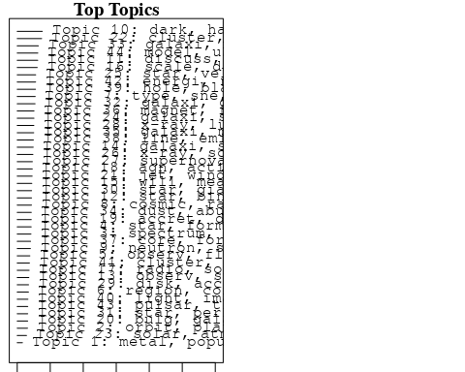

plotQuote(thoughts6, width = 30, main = "Topic 6")  
plotQuote(thoughts18, width = 30, main = "Topic 18")

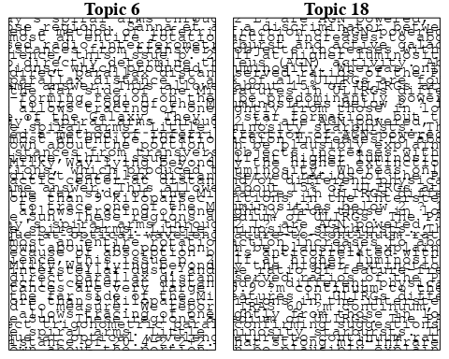

# Calculate and plot the correlation between topics  
mod.out.corr <- topicCorr(Research_topics)  
plot(mod.out.corr, cex = 1.5)  
  
  
# For each topic  
for (topic_num in 1:44) {  
 # Plot the word cloud  
 cloud(Research_topics, topic = topic_num, scale = c(2, 0.25))  
 Sys.sleep(2)  
}

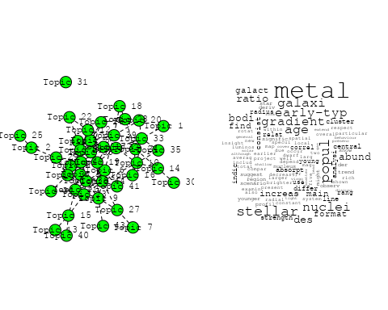

## Warning in wordcloud::wordcloud(words = vocab, freq = vec, max.words =  
## max.words, : spectrum could not be fit on page. It will not be plotted.

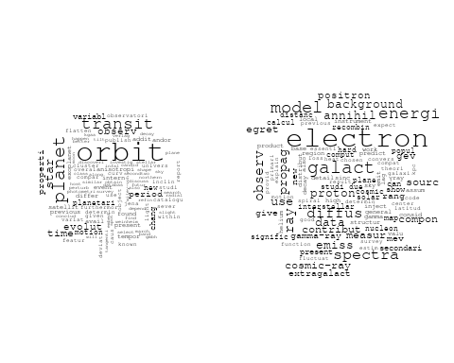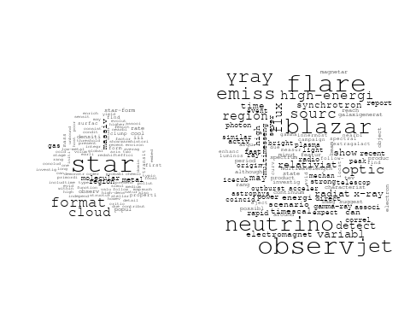

## Warning in wordcloud::wordcloud(words = vocab, freq = vec, max.words =  
## max.words, : supernova could not be fit on page. It will not be plotted.

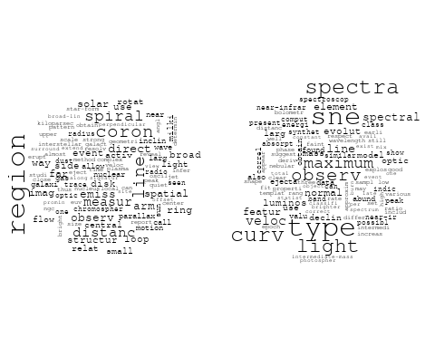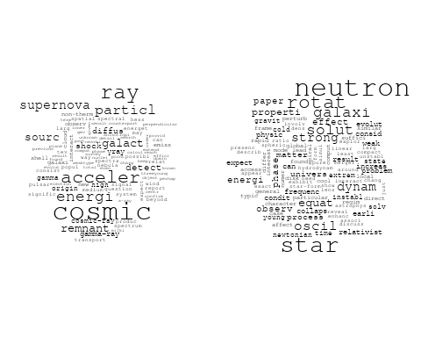

## Warning in wordcloud::wordcloud(words = vocab, freq = vec, max.words =  
## max.words, : experiment could not be fit on page. It will not be plotted.

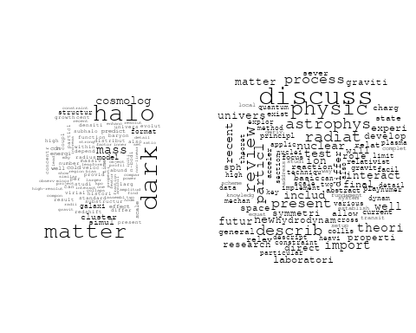

## Warning in wordcloud::wordcloud(words = vocab, freq = vec, max.words =  
## max.words, : early-typ could not be fit on page. It will not be plotted.

## Warning in wordcloud::wordcloud(words = vocab, freq = vec, max.words =  
## max.words, : kinemat could not be fit on page. It will not be plotted.

## Warning in wordcloud::wordcloud(words = vocab, freq = vec, max.words =  
## max.words, : observ could not be fit on page. It will not be plotted.

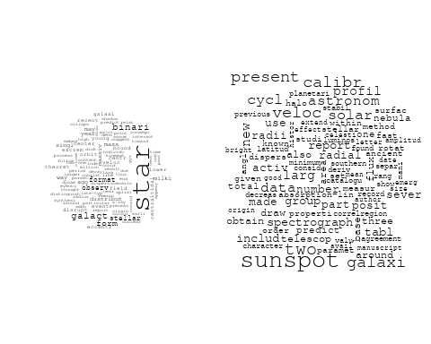

## Warning in wordcloud::wordcloud(words = vocab, freq = vec, max.words =  
## max.words, : astronom could not be fit on page. It will not be plotted.

## Warning in wordcloud::wordcloud(words = vocab, freq = vec, max.words =  
## max.words, : telescop could not be fit on page. It will not be plotted.

## Warning in wordcloud::wordcloud(words = vocab, freq = vec, max.words =  
## max.words, : spectroscopi could not be fit on page. It will not be plotted.

## Warning in wordcloud::wordcloud(words = vocab, freq = vec, max.words =  
## max.words, : imag could not be fit on page. It will not be plotted.

## Warning in wordcloud::wordcloud(words = vocab, freq = vec, max.words =  
## max.words, : galaxi could not be fit on page. It will not be plotted.

## Warning in wordcloud::wordcloud(words = vocab, freq = vec, max.words =  
## max.words, : studi could not be fit on page. It will not be plotted.

## Warning in wordcloud::wordcloud(words = vocab, freq = vec, max.words =  
## max.words, : will could not be fit on page. It will not be plotted.

## Warning in wordcloud::wordcloud(words = vocab, freq = vec, max.words =  
## max.words, : discoveri could not be fit on page. It will not be plotted.

## Warning in wordcloud::wordcloud(words = vocab, freq = vec, max.words =  
## max.words, : interferometri could not be fit on page. It will not be plotted.

## Warning in wordcloud::wordcloud(words = vocab, freq = vec, max.words =  
## max.words, : astronomi could not be fit on page. It will not be plotted.

## Warning in wordcloud::wordcloud(words = vocab, freq = vec, max.words =  
## max.words, : nucleosynthesi could not be fit on page. It will not be plotted.

## Warning in wordcloud::wordcloud(words = vocab, freq = vec, max.words =  
## max.words, : data could not be fit on page. It will not be plotted.

## Warning in wordcloud::wordcloud(words = vocab, freq = vec, max.words =  
## max.words, : interpret could not be fit on page. It will not be plotted.

## Warning in wordcloud::wordcloud(words = vocab, freq = vec, max.words =  
## max.words, : cometari could not be fit on page. It will not be plotted.

## Warning in wordcloud::wordcloud(words = vocab, freq = vec, max.words =  
## max.words, : rang could not be fit on page. It will not be plotted.

## Warning in wordcloud::wordcloud(words = vocab, freq = vec, max.words =  
## max.words, : scienc could not be fit on page. It will not be plotted.

## Warning in wordcloud::wordcloud(words = vocab, freq = vec, max.words =  
## max.words, : first could not be fit on page. It will not be plotted.

## Warning in wordcloud::wordcloud(words = vocab, freq = vec, max.words =  
## max.words, : relat could not be fit on page. It will not be plotted.

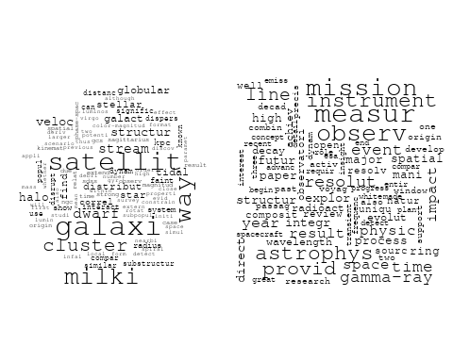

## Warning in wordcloud::wordcloud(words = vocab, freq = vec, max.words =  
## max.words, : measur could not be fit on page. It will not be plotted.

## Warning in wordcloud::wordcloud(words = vocab, freq = vec, max.words =  
## max.words, : spectrum could not be fit on page. It will not be plotted.

## Warning in wordcloud::wordcloud(words = vocab, freq = vec, max.words =  
## max.words, : field could not be fit on page. It will not be plotted.

## Warning in wordcloud::wordcloud(words = vocab, freq = vec, max.words =  
## max.words, : method could not be fit on page. It will not be plotted.

## Warning in wordcloud::wordcloud(words = vocab, freq = vec, max.words =  
## max.words, : distribut could not be fit on page. It will not be plotted.

## Warning in wordcloud::wordcloud(words = vocab, freq = vec, max.words =  
## max.words, : data could not be fit on page. It will not be plotted.

## Warning in wordcloud::wordcloud(words = vocab, freq = vec, max.words =  
## max.words, : effect could not be fit on page. It will not be plotted.

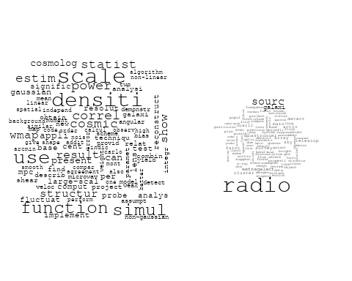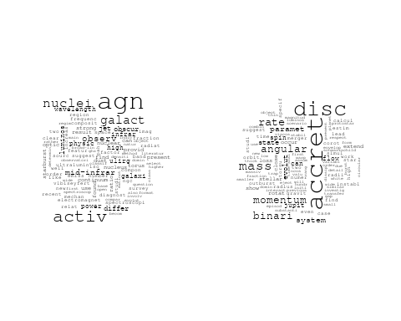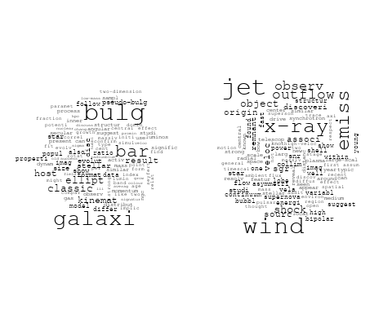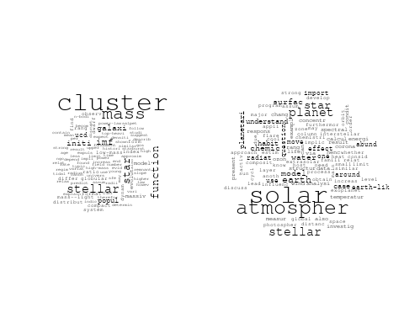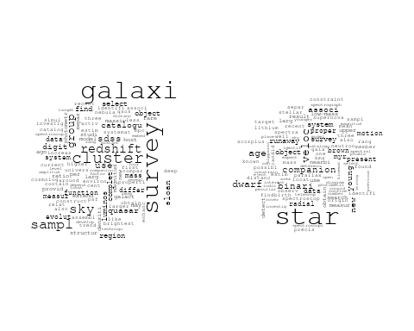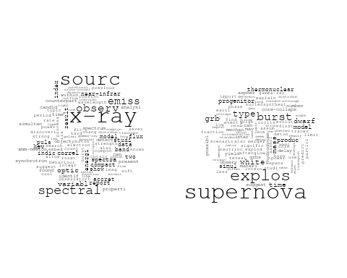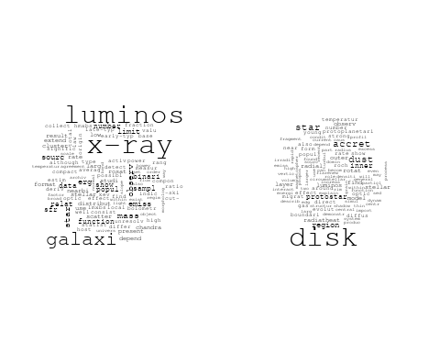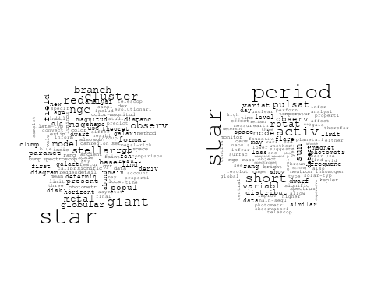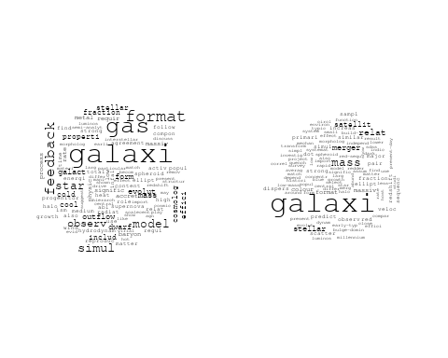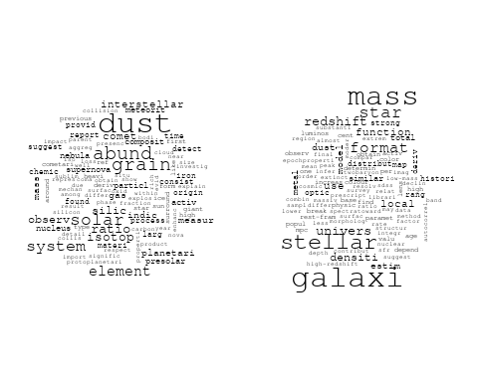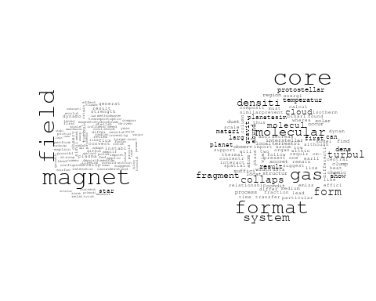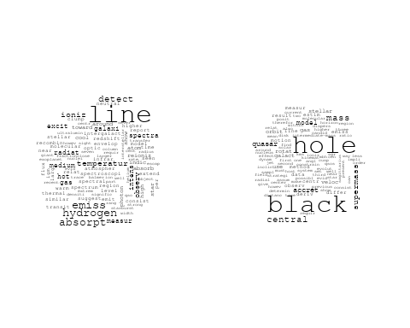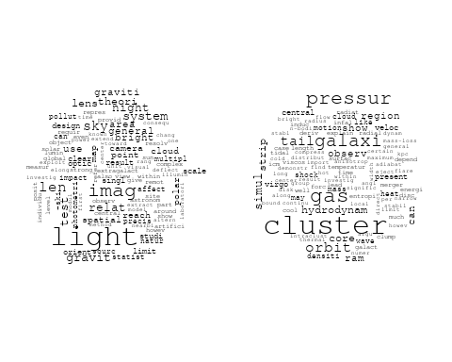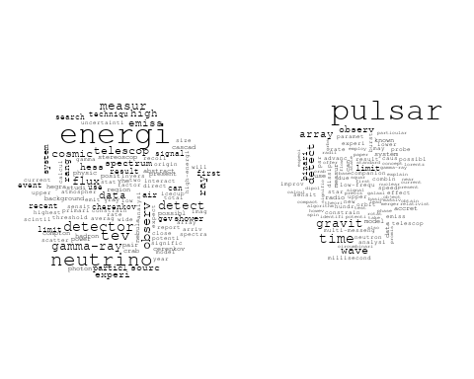

# Get the topic proportions for each document  
topic_proportions <- Research_topics$theta  
  
# Find the index of the topic with the highest proportion for each document  
# This will be the topic that each document is most likely to belong to  
max_topic_idx <- apply(topic_proportions, 1, which.max)  
  
# Add this as a new column to your data  
data_independent$topic <- max_topic_idx  
  
  
  
# Define the intervals  
intervals <- c('1824_1899', '1900_1964', '1965_1974', '1975_1984', '1985_1994', '1995_1999', '2000_2004', '2005_2009', '2010_2014', '2015_2019', '2020_2022')  
colors <- c('pink', 'blue', 'purple', 'yellow', 'green', 'pink', 'orange', 'violet', 'green', 'blue', 'pink')  
  
# Loop through the intervals and plot  
for(i in seq_along(intervals)){  
 # Filter data for when the pub_interval is equal to 1  
 data_filtered <- data_independent[data_independent[[paste0('pub_interval_', intervals[i])]] == 1,]  
   
 # Make the histogram  
   
 p <- ggplot(data_filtered, aes(x = topic)) +  
 geom_histogram(binwidth = 1, fill = colors[i], color = "black") +  
 xlab("Topic") +  
 ylab("Count") +  
 ggtitle(paste0("Topics from year ", gsub("_", " to ", intervals[i])))  
   
 print(p)  
}  
  
##Topic generation for Europe (in collaboration) publications  
  
data_collab <- data[data[["Europe"]] != 0,]  
  
# Save the original title data for future use  
data_collab$original_concatenated_title_abstract <- data_collab$concatenated_title_abstract  
  
#pre-processing the titles using textProcessor from the stm package  
processed_text <- textProcessor(data_collab$concatenated_title_abstract, metadata = data_collab)

## Building corpus...   
## Converting to Lower Case...   
## Removing punctuation...   
## Removing stopwords...   
## Removing numbers...   
## Stemming...   
## Creating Output...

# Further prepare the data by removing low-frequency terms  
out_text <- prepDocuments(processed_text$documents, processed_text$vocab, processed_text$meta)

## Removing 5015 of 15871 terms (5015 of 346655 tokens) due to frequency   
## Your corpus now has 4355 documents, 10856 terms and 341640 tokens.

docs_text <- out_text$documents  
vocab_text <- out_text$vocab  
meta_text <- out_text$meta  
  
  
#Prepare data  
plotRemoved(processed_text$documents, lower.thresh = seq(1, 200, by = 100))

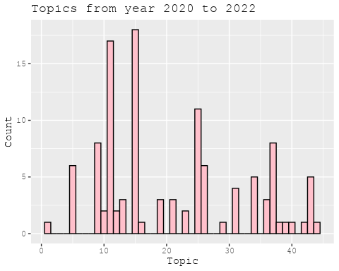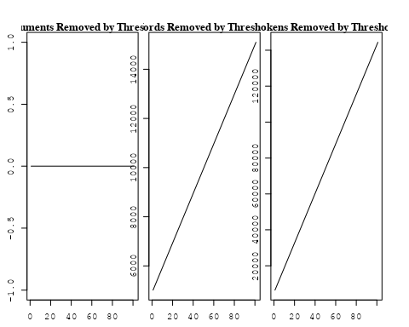

out_text <- prepDocuments(processed_text$documents, processed_text$vocab, processed_text$meta, lower.thresh = 8)

## Removing 12705 of 15871 terms (29661 of 346655 tokens) due to frequency   
## Your corpus now has 4355 documents, 3166 terms and 316994 tokens.

str(out_text$meta)

## 'data.frame': 4355 obs. of 39 variables:  
## $ concept_id : chr "https://openalex.org/C1276947" "https://openalex.org/C44870925" "https://openalex.org/C44870925" "https://openalex.org/C44870925" ...  
## $ work_id : chr "https://openalex.org/W1967633346" "https://openalex.org/W1996505939" "https://openalex.org/W1994827287" "https://openalex.org/W1548323710" ...  
## $ publication_year : int 2003 2014 2008 2002 1998 2008 2005 2005 2008 2008 ...  
## $ title : chr "Around-the-Clock Observations of the Q0957+561A,B Gravitationally Lensed Quasar. II. Results for the Second Observing Season" "A luminous, blue progenitor system for the type Iax supernova 2012Z" "On the Use of Blanketed Atmospheres as Boundary Conditions for Stellar Evolutionary Models" "Interpretation of the Core-Wing Anomaly of Balmer Line Profiles of Cool Ap Stars*" ...  
## $ paperabstract : chr "We report on an observing campaign in 2001 March to monitor the brightness of the later arriving Q0957+561B ima"| __truncated__ "Type Iax supernovae are stellar explosions that are spectroscopically similar to some type Ia supernovae at the"| __truncated__ "Stellar models have been computed for stars having [ Fe/H ] = 0.0 (assuming both the Grevesse & Sauval and Aspl"| __truncated__ "A number of cool magnetic chemically peculiar stars exhibit abnormal profiles of hydrogen Balmer lines. This an"| __truncated__ ...  
## $ country : chr "US RS" "DK US US DK" "CA SE" "SE SE" ...  
## $ year_concept : chr "2003+https://openalex.org/C1276947" "2014+https://openalex.org/C44870925" "2008+https://openalex.org/C44870925" "2002+https://openalex.org/C44870925" ...  
## $ concatenated_title_abstract : chr "Around-the-Clock Observations of the Q0957+561A,B Gravitationally Lensed Quasar. II. Results for the Second Obs"| __truncated__ "A luminous, blue progenitor system for the type Iax supernova 2012Z Type Iax supernovae are stellar explosions "| __truncated__ "On the Use of Blanketed Atmospheres as Boundary Conditions for Stellar Evolutionary Models Stellar models have "| __truncated__ "Interpretation of the Core-Wing Anomaly of Balmer Line Profiles of Cool Ap Stars* A number of cool magnetic che"| __truncated__ ...  
## $ US : num 50 50 0 0 0 50 0 50 0 0 ...  
## $ IN : num 0 0 0 0 0 0 0 0 0 0 ...  
## $ DE : num 0 0 0 0 0 0 0 0 0 0 ...  
## $ CH : num 0 0 0 0 0 0 0 0 0 0 ...  
## $ GB : num 0 0 0 0 0 0 0 0 0 0 ...  
## $ CN : num 0 0 0 0 0 0 0 0 0 0 ...  
## $ FR : num 0 0 0 0 0 0 0 0 0 0 ...  
## $ IT : num 0 0 0 0 0 0 0 0 0 0 ...  
## $ RU : num 0 0 0 0 0 0 0 0 0 0 ...  
## $ CA : num 0 0 50 0 0 0 0 0 0 0 ...  
## $ NL : num 0 0 0 0 0 0 0 0 0 0 ...  
## $ AU : num 0 0 0 0 0 0 0 0 0 0 ...  
## $ JP : num 0 0 0 0 0 0 0 0 0 0 ...  
## $ ES : num 0 0 0 0 0 0 0 0 0 0 ...  
## $ IL : num 0 0 0 0 0 0 0 0 0 0 ...  
## $ Americas : num 0 0 0 0 0 0 0 0 0 0 ...  
## $ Europe : num 50 50 50 100 100 50 100 50 100 100 ...  
## $ Africa : num 0 0 0 0 0 0 0 0 0 0 ...  
## $ AsiaAndOceania : num 0 0 0 0 0 0 0 0 0 0 ...  
## $ pub_interval_2020_2022 : int 0 0 0 0 0 0 0 0 0 0 ...  
## $ pub_interval_2015_2019 : int 0 0 0 0 0 0 0 0 0 0 ...  
## $ pub_interval_2010_2014 : int 0 1 0 0 0 0 0 0 0 0 ...  
## $ pub_interval_2005_2009 : int 0 0 1 0 0 1 1 1 1 1 ...  
## $ pub_interval_2000_2004 : int 1 0 0 1 0 0 0 0 0 0 ...  
## $ pub_interval_1995_1999 : int 0 0 0 0 1 0 0 0 0 0 ...  
## $ pub_interval_1985_1994 : int 0 0 0 0 0 0 0 0 0 0 ...  
## $ pub_interval_1975_1984 : int 0 0 0 0 0 0 0 0 0 0 ...  
## $ pub_interval_1965_1974 : int 0 0 0 0 0 0 0 0 0 0 ...  
## $ pub_interval_1900_1964 : int 0 0 0 0 0 0 0 0 0 0 ...  
## $ pub_interval_1824_1899 : int 0 0 0 0 0 0 0 0 0 0 ...  
## $ original_concatenated_title_abstract: chr "Around-the-Clock Observations of the Q0957+561A,B Gravitationally Lensed Quasar. II. Results for the Second Obs"| __truncated__ "A luminous, blue progenitor system for the type Iax supernova 2012Z Type Iax supernovae are stellar explosions "| __truncated__ "On the Use of Blanketed Atmospheres as Boundary Conditions for Stellar Evolutionary Models Stellar models have "| __truncated__ "Interpretation of the Core-Wing Anomaly of Balmer Line Profiles of Cool Ap Stars* A number of cool magnetic che"| __truncated__ ...

# Initialize an empty formula string  
prevalence_formula_str <- "~"  
  
# Define the publication intervals  
pub_intervals <- c("pub_interval_2020_2022", "pub_interval_2015_2019", "pub_interval_2010_2014",   
 "pub_interval_2005_2009", "pub_interval_2000_2004", "pub_interval_1995_1999",  
 "pub_interval_1985_1994", "pub_interval_1975_1984", "pub_interval_1965_1974",  
 "pub_interval_1900_1964", "pub_interval_1824_1899")  
  
# Add each publication interval to the formula string  
for (interval in pub_intervals) {  
 # add an if statement to handle the first addition (without '+')  
 if (prevalence_formula_str == "~") {  
 prevalence_formula_str <- paste(prevalence_formula_str, interval)  
 } else {  
 prevalence_formula_str <- paste(prevalence_formula_str, "+", interval)  
 }  
}  
  
  
# Convert the string to a formula  
prevalence_formula <- as.formula(prevalence_formula_str)  
print(prevalence_formula)

## ~pub_interval_2020_2022 + pub_interval_2015_2019 + pub_interval_2010_2014 +   
## pub_interval_2005_2009 + pub_interval_2000_2004 + pub_interval_1995_1999 +   
## pub_interval_1985_1994 + pub_interval_1975_1984 + pub_interval_1965_1974 +   
## pub_interval_1900_1964 + pub_interval_1824_1899

# Run STM model  
Research_topics <- stm(documents = out_text$documents,   
 vocab = out_text$vocab,   
 K = 44,   
 prevalence = prevalence_formula,   
 data = out_text$meta,   
 init.type = "Spectral",  
 max.em.its = 1000,  
 gamma.prior = 'L1')

## Beginning Spectral Initialization   
## Calculating the gram matrix...  
## Finding anchor words...  
## ............................................  
## Recovering initialization...  
## ...............................  
## Initialization complete.  
## .....................................................................................................  
## Completed E-Step (5 seconds).   
## Completed M-Step.   
## Completing Iteration 1 (approx. per word bound = -6.713)   
## .....................................................................................................  
## Completed E-Step (4 seconds).   
## Completed M-Step.   
## Completing Iteration 2 (approx. per word bound = -6.436, relative change = 4.117e-02)   
## .....................................................................................................  
## Completed E-Step (4 seconds).   
## Completed M-Step.   
## Completing Iteration 3 (approx. per word bound = -6.373, relative change = 9.852e-03)   
## .....................................................................................................  
## Completed E-Step (3 seconds).   
## Completed M-Step.   
## Completing Iteration 4 (approx. per word bound = -6.349, relative change = 3.666e-03)   
## .....................................................................................................  
## Completed E-Step (3 seconds).   
## Completed M-Step.   
## Completing Iteration 5 (approx. per word bound = -6.338, relative change = 1.811e-03)   
## Topic 1: star, wind, stellar, group, rotat   
## Topic 2: ngc, cluster, star, distanc, use   
## Topic 3: pulsar, puls, model, neutron, star   
## Topic 4: model, cosmolog, univers, paramet, energi   
## Topic 5: region, solar, evolut, wave, observ   
## Topic 6: burst, gamma-ray, grb, merger, grbs   
## Topic 7: dust, galaxi, format, observ, gas   
## Topic 8: sourc, radiat, belt, disk, object   
## Topic 9: planet, transit, star, mass, orbit   
## Topic 10: space, univers, observatori, astronomi, research   
## Topic 11: galaxi, radio, sampl, activ, luminos   
## Topic 12: cmes, cme, eject, event, mass   
## Topic 13: magnet, field, turbul, result, strength   
## Topic 14: variabl, cepheid, distanc, star, eclips   
## Topic 15: ray, cosmic, energi, particl, proton   
## Topic 16: binari, system, orbit, compon, mass   
## Topic 17: astrophys, astronom, physic, observ, studi   
## Topic 18: jet, accret, relativist, model, flow   
## Topic 19: star, supernova, system, solar, mass   
## Topic 20: star, period, pulsat, mode, frequenc   
## Topic 21: galaxi, survey, bar, imag, sampl   
## Topic 22: halo, model, galaxi, mass, simul   
## Topic 23: power, method, data, spectrum, use   
## Topic 24: review, observ, can, model, x-ray   
## Topic 25: x-ray, shell, emiss, supernova, kev   
## Topic 26: cloud, gas, molecular, format, core   
## Topic 27: hole, black, mass, star, binari   
## Topic 28: galaxi, emiss, line, abund, region   
## Topic 29: star, abund, element, metal, chemic   
## Topic 30: rotat, matter, dark, star, energi   
## Topic 31: burst, type, radio, optic, imag   
## Topic 32: solar, cycl, sun, model, variat   
## Topic 33: comet, observ, activ, distanc, water   
## Topic 34: data, observ, use, time, telescop   
## Topic 35: lens, light, gravit, observ, imag   
## Topic 36: asteroid, famili, object, orbit, observ   
## Topic 37: star, dwarf, stellar, age, metal   
## Topic 38: cluster, galaxi, region, luminos, distribut   
## Topic 39: emiss, x-ray, radio, observ, sourc   
## Topic 40: star, nebula, wind, featur, line   
## Topic 41: line, emiss, accret, observ, optic   
## Topic 42: flare, solar, observ, loop, coron   
## Topic 43: star, neutron, stellar, equat, model   
## Topic 44: region, temperatur, abund, relat, measur   
## .....................................................................................................  
## Completed E-Step (3 seconds).   
## Completed M-Step.   
## Completing Iteration 6 (approx. per word bound = -6.331, relative change = 1.111e-03)   
## .....................................................................................................  
## Completed E-Step (3 seconds).   
## Completed M-Step.   
## Completing Iteration 7 (approx. per word bound = -6.326, relative change = 7.210e-04)   
## .....................................................................................................  
## Completed E-Step (3 seconds).   
## Completed M-Step.   
## Completing Iteration 8 (approx. per word bound = -6.323, relative change = 5.059e-04)   
## .....................................................................................................  
## Completed E-Step (3 seconds).   
## Completed M-Step.   
## Completing Iteration 9 (approx. per word bound = -6.321, relative change = 4.019e-04)   
## .....................................................................................................  
## Completed E-Step (3 seconds).   
## Completed M-Step.   
## Completing Iteration 10 (approx. per word bound = -6.319, relative change = 3.272e-04)   
## Topic 1: star, wind, group, stellar, rotat   
## Topic 2: ngc, star, cluster, distanc, use   
## Topic 3: pulsar, puls, model, neutron, star   
## Topic 4: model, univers, cosmolog, paramet, energi   
## Topic 5: wave, solar, region, observ, coron   
## Topic 6: burst, gamma-ray, grb, grbs, observ   
## Topic 7: dust, galaxi, format, observ, star   
## Topic 8: sourc, disk, object, belt, class   
## Topic 9: planet, transit, star, mass, system   
## Topic 10: space, univers, observatori, mission, astronomi   
## Topic 11: galaxi, radio, sampl, agn, activ   
## Topic 12: cmes, cme, eject, mass, coron   
## Topic 13: magnet, field, turbul, result, effect   
## Topic 14: variabl, cepheid, distanc, star, eclips   
## Topic 15: ray, energi, cosmic, particl, acceler   
## Topic 16: binari, system, orbit, compon, mass   
## Topic 17: astrophys, physic, observ, astronom, studi   
## Topic 18: jet, accret, disk, relativist, flow   
## Topic 19: star, supernova, evolut, mass, system   
## Topic 20: star, pulsat, period, mode, frequenc   
## Topic 21: galaxi, survey, bar, imag, sampl   
## Topic 22: halo, model, galaxi, mass, simul   
## Topic 23: method, power, data, use, function   
## Topic 24: review, observ, can, model, studi   
## Topic 25: x-ray, emiss, shell, kev, temperatur   
## Topic 26: cloud, gas, molecular, core, format   
## Topic 27: hole, black, mass, star, binari   
## Topic 28: galaxi, emiss, line, abund, ioniz   
## Topic 29: star, abund, element, metal, chemic   
## Topic 30: rotat, matter, dark, star, differenti   
## Topic 31: imag, burst, radio, type, observ   
## Topic 32: solar, cycl, variat, sun, activ   
## Topic 33: comet, observ, activ, distanc, water   
## Topic 34: data, observ, use, time, measur   
## Topic 35: lens, gravit, light, event, microlens   
## Topic 36: asteroid, famili, object, orbit, observ   
## Topic 37: dwarf, star, stellar, age, metal   
## Topic 38: cluster, galaxi, region, field, luminos   
## Topic 39: x-ray, emiss, radio, observ, sourc   
## Topic 40: nebula, star, wind, featur, veloc   
## Topic 41: line, emiss, optic, spectra, broad   
## Topic 42: flare, solar, observ, electron, loop   
## Topic 43: star, stellar, neutron, model, mass   
## Topic 44: region, temperatur, abund, method, relat   
## .....................................................................................................  
## Completed E-Step (3 seconds).   
## Completed M-Step.   
## Completing Iteration 11 (approx. per word bound = -6.317, relative change = 2.792e-04)   
## .....................................................................................................  
## Completed E-Step (3 seconds).   
## Completed M-Step.   
## Completing Iteration 12 (approx. per word bound = -6.315, relative change = 2.415e-04)   
## .....................................................................................................  
## Completed E-Step (3 seconds).   
## Completed M-Step.   
## Completing Iteration 13 (approx. per word bound = -6.314, relative change = 1.947e-04)   
## .....................................................................................................  
## Completed E-Step (3 seconds).   
## Completed M-Step.   
## Completing Iteration 14 (approx. per word bound = -6.313, relative change = 1.940e-04)   
## .....................................................................................................  
## Completed E-Step (3 seconds).   
## Completed M-Step.   
## Completing Iteration 15 (approx. per word bound = -6.312, relative change = 1.814e-04)   
## Topic 1: star, wind, group, stellar, rotat   
## Topic 2: ngc, star, cluster, distanc, use   
## Topic 3: pulsar, puls, model, emiss, neutron   
## Topic 4: model, univers, cosmolog, paramet, energi   
## Topic 5: wave, solar, region, observ, coron   
## Topic 6: burst, gamma-ray, grb, grbs, observ   
## Topic 7: dust, galaxi, format, observ, star   
## Topic 8: sourc, disk, object, belt, class   
## Topic 9: planet, star, transit, mass, system   
## Topic 10: space, univers, observatori, mission, astronomi   
## Topic 11: galaxi, radio, agn, sampl, activ   
## Topic 12: cmes, cme, eject, coron, mass   
## Topic 13: magnet, field, turbul, result, effect   
## Topic 14: variabl, cepheid, distanc, star, eclips   
## Topic 15: energi, ray, particl, cosmic, acceler   
## Topic 16: binari, system, orbit, compon, mass   
## Topic 17: astrophys, physic, observ, astronom, studi   
## Topic 18: jet, accret, disk, flow, relativist   
## Topic 19: star, supernova, evolut, mass, massiv   
## Topic 20: star, pulsat, mode, period, frequenc   
## Topic 21: galaxi, survey, bar, imag, sampl   
## Topic 22: halo, galaxi, model, mass, simul   
## Topic 23: method, power, function, data, use   
## Topic 24: review, observ, physic, can, model   
## Topic 25: x-ray, emiss, shell, kev, shock   
## Topic 26: gas, cloud, molecular, core, format   
## Topic 27: hole, black, mass, star, binari   
## Topic 28: galaxi, emiss, line, ioniz, abund   
## Topic 29: star, abund, element, metal, chemic   
## Topic 30: rotat, matter, dark, star, differenti   
## Topic 31: imag, radio, burst, type, observ   
## Topic 32: solar, cycl, variat, sun, activ   
## Topic 33: comet, observ, distanc, water, activ   
## Topic 34: data, observ, use, measur, time   
## Topic 35: lens, gravit, light, event, imag   
## Topic 36: asteroid, famili, object, orbit, observ   
## Topic 37: dwarf, star, stellar, metal, age   
## Topic 38: cluster, galaxi, field, region, redshift   
## Topic 39: radio, x-ray, emiss, observ, sourc   
## Topic 40: nebula, star, wind, featur, model   
## Topic 41: line, emiss, optic, spectra, broad   
## Topic 42: flare, solar, event, electron, observ   
## Topic 43: star, stellar, model, neutron, mass   
## Topic 44: region, temperatur, abund, oxygen, determin   
## .....................................................................................................  
## Completed E-Step (3 seconds).   
## Completed M-Step.   
## Completing Iteration 16 (approx. per word bound = -6.311, relative change = 1.639e-04)   
## .....................................................................................................  
## Completed E-Step (3 seconds).   
## Completed M-Step.   
## Completing Iteration 17 (approx. per word bound = -6.310, relative change = 1.192e-04)   
## .....................................................................................................  
## Completed E-Step (3 seconds).   
## Completed M-Step.   
## Completing Iteration 18 (approx. per word bound = -6.309, relative change = 1.415e-04)   
## .....................................................................................................  
## Completed E-Step (3 seconds).   
## Completed M-Step.   
## Completing Iteration 19 (approx. per word bound = -6.308, relative change = 1.208e-04)   
## .....................................................................................................  
## Completed E-Step (3 seconds).   
## Completed M-Step.   
## Completing Iteration 20 (approx. per word bound = -6.308, relative change = 1.053e-04)   
## Topic 1: wind, star, group, stellar, rotat   
## Topic 2: ngc, star, cluster, distanc, use   
## Topic 3: pulsar, puls, model, emiss, neutron   
## Topic 4: model, cosmolog, univers, paramet, energi   
## Topic 5: wave, solar, observ, region, coron   
## Topic 6: burst, gamma-ray, grb, grbs, observ   
## Topic 7: dust, galaxi, format, star, observ   
## Topic 8: sourc, object, disk, belt, class   
## Topic 9: planet, star, transit, mass, system   
## Topic 10: space, univers, observatori, mission, astronomi   
## Topic 11: galaxi, radio, agn, sampl, activ   
## Topic 12: cme, cmes, eject, coron, mass   
## Topic 13: magnet, field, turbul, result, effect   
## Topic 14: variabl, cepheid, distanc, star, eclips   
## Topic 15: energi, particl, ray, cosmic, acceler   
## Topic 16: binari, system, orbit, mass, compon   
## Topic 17: astrophys, physic, observ, astronom, studi   
## Topic 18: jet, accret, disk, flow, model   
## Topic 19: star, supernova, evolut, massiv, mass   
## Topic 20: star, pulsat, mode, frequenc, period   
## Topic 21: galaxi, survey, bar, imag, sampl   
## Topic 22: halo, galaxi, model, mass, simul   
## Topic 23: method, power, function, use, data   
## Topic 24: review, observ, physic, understand, can   
## Topic 25: x-ray, emiss, kev, shell, luminos   
## Topic 26: gas, cloud, molecular, core, format   
## Topic 27: hole, black, mass, star, binari   
## Topic 28: galaxi, emiss, line, ioniz, lyα   
## Topic 29: star, abund, element, metal, chemic   
## Topic 30: rotat, matter, dark, star, differenti   
## Topic 31: imag, radio, burst, type, observ   
## Topic 32: solar, cycl, variat, activ, sun   
## Topic 33: comet, observ, distanc, water, dust   
## Topic 34: data, observ, use, measur, time   
## Topic 35: lens, gravit, event, light, imag   
## Topic 36: asteroid, famili, object, orbit, observ   
## Topic 37: dwarf, star, metal, stellar, white   
## Topic 38: cluster, galaxi, field, region, redshift   
## Topic 39: radio, emiss, x-ray, observ, sourc   
## Topic 40: nebula, star, featur, wind, model   
## Topic 41: line, emiss, optic, spectra, broad   
## Topic 42: flare, solar, event, energi, electron   
## Topic 43: star, model, stellar, neutron, mass   
## Topic 44: temperatur, region, abund, determin, use   
## .....................................................................................................  
## Completed E-Step (3 seconds).   
## Completed M-Step.   
## Completing Iteration 21 (approx. per word bound = -6.307, relative change = 1.070e-04)   
## .....................................................................................................  
## Completed E-Step (3 seconds).   
## Completed M-Step.   
## Completing Iteration 22 (approx. per word bound = -6.306, relative change = 1.008e-04)   
## .....................................................................................................  
## Completed E-Step (3 seconds).   
## Completed M-Step.   
## Completing Iteration 23 (approx. per word bound = -6.305, relative change = 1.353e-04)   
## .....................................................................................................  
## Completed E-Step (3 seconds).   
## Completed M-Step.   
## Completing Iteration 24 (approx. per word bound = -6.305, relative change = 1.001e-04)   
## .....................................................................................................  
## Completed E-Step (3 seconds).   
## Completed M-Step.   
## Completing Iteration 25 (approx. per word bound = -6.304, relative change = 8.093e-05)   
## Topic 1: wind, star, stellar, group, rotat   
## Topic 2: star, ngc, cluster, distanc, use   
## Topic 3: pulsar, puls, emiss, model, neutron   
## Topic 4: model, cosmolog, univers, energi, paramet   
## Topic 5: wave, solar, observ, region, coron   
## Topic 6: burst, gamma-ray, grb, grbs, observ   
## Topic 7: dust, galaxi, format, star, observ   
## Topic 8: sourc, object, disk, belt, solar   
## Topic 9: planet, transit, star, mass, system   
## Topic 10: space, univers, observatori, mission, astronomi   
## Topic 11: galaxi, radio, agn, sampl, activ   
## Topic 12: cme, cmes, coron, eject, mass   
## Topic 13: magnet, field, turbul, result, effect   
## Topic 14: variabl, cepheid, distanc, magellan, star   
## Topic 15: energi, particl, ray, cosmic, acceler   
## Topic 16: binari, system, orbit, mass, compon   
## Topic 17: astrophys, physic, observ, studi, astronom   
## Topic 18: jet, accret, disk, flow, model   
## Topic 19: star, supernova, evolut, massiv, mass   
## Topic 20: star, pulsat, mode, frequenc, oscil   
## Topic 21: galaxi, survey, bar, imag, sampl   
## Topic 22: halo, galaxi, model, mass, simul   
## Topic 23: method, power, function, use, model   
## Topic 24: review, observ, physic, understand, studi   
## Topic 25: x-ray, emiss, kev, shell, luminos   
## Topic 26: gas, cloud, molecular, core, format   
## Topic 27: hole, black, mass, star, binari   
## Topic 28: galaxi, emiss, line, ioniz, lyα   
## Topic 29: star, abund, element, metal, chemic   
## Topic 30: rotat, matter, dark, star, differenti   
## Topic 31: imag, radio, burst, type, telescop   
## Topic 32: solar, cycl, activ, variat, sun   
## Topic 33: comet, observ, distanc, water, dust   
## Topic 34: data, observ, use, measur, time   
## Topic 35: lens, gravit, event, light, imag   
## Topic 36: asteroid, famili, object, orbit, observ   
## Topic 37: dwarf, star, metal, white, stellar   
## Topic 38: cluster, galaxi, field, region, redshift   
## Topic 39: radio, emiss, x-ray, observ, sourc   
## Topic 40: nebula, star, featur, wind, model   
## Topic 41: line, emiss, optic, spectra, broad   
## Topic 42: flare, solar, event, energi, electron   
## Topic 43: star, model, stellar, equat, mass   
## Topic 44: temperatur, region, determin, abund, use   
## .....................................................................................................  
## Completed E-Step (3 seconds).   
## Completed M-Step.   
## Completing Iteration 26 (approx. per word bound = -6.304, relative change = 4.177e-05)   
## .....................................................................................................  
## Completed E-Step (3 seconds).   
## Completed M-Step.   
## Completing Iteration 27 (approx. per word bound = -6.303, relative change = 9.330e-05)   
## .....................................................................................................  
## Completed E-Step (3 seconds).   
## Completed M-Step.   
## Completing Iteration 28 (approx. per word bound = -6.303, relative change = 6.234e-05)   
## .....................................................................................................  
## Completed E-Step (3 seconds).   
## Completed M-Step.   
## Completing Iteration 29 (approx. per word bound = -6.303, relative change = 5.743e-05)   
## .....................................................................................................  
## Completed E-Step (3 seconds).   
## Completed M-Step.   
## Completing Iteration 30 (approx. per word bound = -6.302, relative change = 5.067e-05)   
## Topic 1: wind, star, stellar, group, rotat   
## Topic 2: star, ngc, cluster, distanc, use   
## Topic 3: pulsar, puls, emiss, model, neutron   
## Topic 4: model, cosmolog, univers, energi, dark   
## Topic 5: wave, solar, observ, region, coron   
## Topic 6: burst, gamma-ray, grb, grbs, observ   
## Topic 7: dust, galaxi, format, star, observ   
## Topic 8: sourc, object, disk, belt, solar   
## Topic 9: planet, transit, star, mass, system   
## Topic 10: space, univers, observatori, mission, astronomi   
## Topic 11: galaxi, radio, agn, activ, sampl   
## Topic 12: cme, cmes, coron, eject, mass   
## Topic 13: magnet, field, turbul, result, effect   
## Topic 14: variabl, cepheid, distanc, magellan, star   
## Topic 15: energi, particl, ray, cosmic, acceler   
## Topic 16: binari, system, orbit, mass, compon   
## Topic 17: astrophys, observ, physic, studi, astronom   
## Topic 18: jet, accret, disk, flow, model   
## Topic 19: star, supernova, evolut, massiv, mass   
## Topic 20: star, pulsat, mode, frequenc, oscil   
## Topic 21: galaxi, bar, survey, imag, spiral   
## Topic 22: halo, galaxi, model, mass, simul   
## Topic 23: method, function, power, model, use   
## Topic 24: review, observ, physic, understand, studi   
## Topic 25: x-ray, emiss, kev, shell, luminos   
## Topic 26: gas, cloud, molecular, core, format   
## Topic 27: hole, black, mass, binari, star   
## Topic 28: galaxi, emiss, line, ioniz, lyα   
## Topic 29: star, abund, element, metal, chemic   
## Topic 30: rotat, matter, dark, star, differenti   
## Topic 31: imag, radio, burst, type, telescop   
## Topic 32: solar, cycl, activ, variat, period   
## Topic 33: comet, observ, distanc, water, dust   
## Topic 34: data, observ, use, measur, time   
## Topic 35: lens, gravit, event, light, imag   
## Topic 36: asteroid, famili, object, orbit, observ   
## Topic 37: dwarf, star, metal, white, stellar   
## Topic 38: cluster, galaxi, field, region, redshift   
## Topic 39: radio, emiss, x-ray, observ, sourc   
## Topic 40: nebula, star, featur, observ, wind   
## Topic 41: line, emiss, optic, spectra, broad   
## Topic 42: flare, solar, event, energi, electron   
## Topic 43: model, star, stellar, equat, mass   
## Topic 44: temperatur, region, determin, abund, use   
## .....................................................................................................  
## Completed E-Step (3 seconds).   
## Completed M-Step.   
## Completing Iteration 31 (approx. per word bound = -6.302, relative change = 4.791e-05)   
## .....................................................................................................  
## Completed E-Step (3 seconds).   
## Completed M-Step.   
## Completing Iteration 32 (approx. per word bound = -6.302, relative change = 4.515e-05)   
## .....................................................................................................  
## Completed E-Step (3 seconds).   
## Completed M-Step.   
## Completing Iteration 33 (approx. per word bound = -6.301, relative change = 5.751e-05)   
## .....................................................................................................  
## Completed E-Step (3 seconds).   
## Completed M-Step.   
## Completing Iteration 34 (approx. per word bound = -6.301, relative change = 4.211e-05)   
## .....................................................................................................  
## Completed E-Step (3 seconds).   
## Completed M-Step.   
## Completing Iteration 35 (approx. per word bound = -6.301, relative change = 4.023e-05)   
## Topic 1: wind, star, stellar, group, rotat   
## Topic 2: star, ngc, cluster, distanc, use   
## Topic 3: pulsar, puls, emiss, model, neutron   
## Topic 4: model, cosmolog, univers, energi, dark   
## Topic 5: wave, solar, observ, region, coron   
## Topic 6: burst, gamma-ray, grb, grbs, observ   
## Topic 7: dust, galaxi, format, star, observ   
## Topic 8: sourc, object, disk, belt, solar   
## Topic 9: planet, transit, star, mass, system   
## Topic 10: space, univers, observatori, mission, astronomi   
## Topic 11: galaxi, radio, agn, activ, sampl   
## Topic 12: cme, cmes, coron, eject, mass   
## Topic 13: magnet, field, turbul, result, effect   
## Topic 14: variabl, cepheid, distanc, magellan, period   
## Topic 15: energi, particl, ray, acceler, cosmic   
## Topic 16: binari, system, orbit, mass, compon   
## Topic 17: astrophys, observ, studi, astronom, paper   
## Topic 18: jet, accret, disk, flow, disc   
## Topic 19: star, supernova, evolut, massiv, mass   
## Topic 20: star, pulsat, mode, frequenc, oscil   
## Topic 21: galaxi, bar, survey, imag, spiral   
## Topic 22: halo, galaxi, model, mass, simul   
## Topic 23: method, function, power, model, distribut   
## Topic 24: review, observ, physic, understand, studi   
## Topic 25: x-ray, emiss, kev, shell, luminos   
## Topic 26: gas, cloud, molecular, core, format   
## Topic 27: hole, black, mass, binari, star   
## Topic 28: galaxi, emiss, line, ioniz, lyα   
## Topic 29: star, abund, element, metal, chemic   
## Topic 30: rotat, matter, dark, star, differenti   
## Topic 31: imag, radio, burst, type, telescop   
## Topic 32: solar, cycl, activ, variat, period   
## Topic 33: comet, observ, distanc, water, dust   
## Topic 34: data, observ, use, measur, time   
## Topic 35: lens, gravit, event, light, imag   
## Topic 36: asteroid, famili, object, orbit, observ   
## Topic 37: dwarf, star, metal, white, stellar   
## Topic 38: cluster, galaxi, field, region, redshift   
## Topic 39: radio, emiss, x-ray, observ, sourc   
## Topic 40: nebula, star, featur, observ, wind   
## Topic 41: line, emiss, optic, spectra, broad   
## Topic 42: flare, solar, event, energi, electron   
## Topic 43: model, star, equat, stellar, solut   
## Topic 44: temperatur, region, determin, valu, use   
## .....................................................................................................  
## Completed E-Step (3 seconds).   
## Completed M-Step.   
## Completing Iteration 36 (approx. per word bound = -6.301, relative change = 4.052e-05)   
## .....................................................................................................  
## Completed E-Step (3 seconds).   
## Completed M-Step.   
## Completing Iteration 37 (approx. per word bound = -6.300, relative change = 4.642e-05)   
## .....................................................................................................  
## Completed E-Step (3 seconds).   
## Completed M-Step.   
## Completing Iteration 38 (approx. per word bound = -6.300, relative change = 3.763e-05)   
## .....................................................................................................  
## Completed E-Step (3 seconds).   
## Completed M-Step.   
## Completing Iteration 39 (approx. per word bound = -6.300, relative change = 3.556e-05)   
## .....................................................................................................  
## Completed E-Step (3 seconds).   
## Completed M-Step.   
## Completing Iteration 40 (approx. per word bound = -6.300, relative change = 3.747e-05)   
## Topic 1: wind, star, stellar, group, rotat   
## Topic 2: star, ngc, cluster, distanc, use   
## Topic 3: pulsar, puls, model, emiss, neutron   
## Topic 4: model, cosmolog, univers, dark, energi   
## Topic 5: solar, wave, observ, region, coron   
## Topic 6: burst, gamma-ray, grb, grbs, observ   
## Topic 7: dust, galaxi, format, star, observ   
## Topic 8: sourc, object, disk, solar, belt   
## Topic 9: planet, transit, star, mass, system   
## Topic 10: space, univers, observatori, mission, astronomi   
## Topic 11: galaxi, radio, agn, activ, luminos   
## Topic 12: cme, cmes, coron, eject, mass   
## Topic 13: magnet, field, turbul, result, effect   
## Topic 14: variabl, cepheid, distanc, period, magellan   
## Topic 15: energi, particl, ray, acceler, cosmic   
## Topic 16: binari, system, orbit, mass, compon   
## Topic 17: astrophys, observ, astronom, studi, one   
## Topic 18: jet, accret, disk, flow, disc   
## Topic 19: star, supernova, evolut, massiv, mass   
## Topic 20: star, pulsat, mode, frequenc, oscil   
## Topic 21: galaxi, bar, survey, spiral, imag   
## Topic 22: halo, galaxi, model, mass, simul   
## Topic 23: method, function, power, distribut, model   
## Topic 24: review, observ, physic, understand, studi   
## Topic 25: x-ray, emiss, kev, shell, observ   
## Topic 26: gas, cloud, molecular, core, format   
## Topic 27: hole, black, mass, binari, star   
## Topic 28: galaxi, emiss, line, ioniz, lyα   
## Topic 29: star, abund, element, metal, chemic   
## Topic 30: rotat, matter, dark, star, differenti   
## Topic 31: imag, radio, burst, type, telescop   
## Topic 32: solar, cycl, activ, variat, period   
## Topic 33: comet, observ, distanc, water, dust   
## Topic 34: data, observ, use, measur, telescop   
## Topic 35: lens, gravit, event, light, imag   
## Topic 36: asteroid, famili, object, orbit, observ   
## Topic 37: dwarf, star, metal, white, stellar   
## Topic 38: cluster, galaxi, field, region, redshift   
## Topic 39: radio, emiss, x-ray, observ, sourc   
## Topic 40: star, nebula, featur, observ, wind   
## Topic 41: line, emiss, optic, spectra, broad   
## Topic 42: flare, solar, event, energi, electron   
## Topic 43: model, star, equat, calcul, solut   
## Topic 44: temperatur, region, determin, valu, use   
## .....................................................................................................  
## Completed E-Step (3 seconds).   
## Completed M-Step.   
## Completing Iteration 41 (approx. per word bound = -6.299, relative change = 3.701e-05)   
## .....................................................................................................  
## Completed E-Step (3 seconds).   
## Completed M-Step.   
## Completing Iteration 42 (approx. per word bound = -6.299, relative change = 1.542e-05)   
## .....................................................................................................  
## Completed E-Step (3 seconds).   
## Completed M-Step.   
## Completing Iteration 43 (approx. per word bound = -6.299, relative change = 5.091e-05)   
## .....................................................................................................  
## Completed E-Step (3 seconds).   
## Completed M-Step.   
## Completing Iteration 44 (approx. per word bound = -6.299, relative change = 3.383e-05)   
## .....................................................................................................  
## Completed E-Step (3 seconds).   
## Completed M-Step.   
## Completing Iteration 45 (approx. per word bound = -6.299, relative change = 3.621e-05)   
## Topic 1: wind, star, stellar, group, rotat   
## Topic 2: star, ngc, cluster, distanc, use   
## Topic 3: pulsar, puls, model, emiss, neutron   
## Topic 4: model, cosmolog, univers, dark, energi   
## Topic 5: solar, wave, observ, region, coron   
## Topic 6: burst, gamma-ray, grb, grbs, observ   
## Topic 7: dust, galaxi, format, observ, star   
## Topic 8: sourc, object, disk, solar, belt   
## Topic 9: planet, transit, star, mass, system   
## Topic 10: univers, space, observatori, mission, astronomi   
## Topic 11: galaxi, radio, agn, activ, luminos   
## Topic 12: cme, cmes, coron, eject, mass   
## Topic 13: magnet, field, turbul, result, plasma   
## Topic 14: variabl, cepheid, distanc, period, star   
## Topic 15: energi, particl, ray, acceler, cosmic   
## Topic 16: binari, system, orbit, mass, compon   
## Topic 17: astrophys, astronom, observ, studi, one   
## Topic 18: jet, accret, disk, outflow, flow   
## Topic 19: star, supernova, evolut, massiv, mass   
## Topic 20: star, pulsat, mode, frequenc, oscil   
## Topic 21: galaxi, bar, survey, spiral, imag   
## Topic 22: halo, galaxi, model, mass, simul   
## Topic 23: function, method, power, distribut, model   
## Topic 24: observ, review, physic, understand, studi   
## Topic 25: x-ray, emiss, kev, observ, sourc   
## Topic 26: gas, cloud, molecular, core, format   
## Topic 27: hole, black, mass, binari, star   
## Topic 28: galaxi, emiss, line, ioniz, lyα   
## Topic 29: star, abund, element, metal, chemic   
## Topic 30: matter, rotat, dark, star, differenti   
## Topic 31: imag, radio, burst, telescop, type   
## Topic 32: solar, cycl, activ, period, variat   
## Topic 33: comet, observ, distanc, water, dust   
## Topic 34: data, observ, use, measur, telescop   
## Topic 35: lens, gravit, event, light, imag   
## Topic 36: asteroid, famili, object, orbit, observ   
## Topic 37: dwarf, star, white, metal, stellar   
## Topic 38: cluster, galaxi, field, region, redshift   
## Topic 39: radio, emiss, x-ray, observ, sourc   
## Topic 40: star, nebula, observ, wind, featur   
## Topic 41: line, emiss, optic, spectra, broad   
## Topic 42: flare, event, solar, energi, electron   
## Topic 43: model, star, equat, calcul, solut   
## Topic 44: temperatur, determin, valu, region, use   
## .....................................................................................................  
## Completed E-Step (3 seconds).   
## Completed M-Step.   
## Completing Iteration 46 (approx. per word bound = -6.298, relative change = 2.479e-05)   
## .....................................................................................................  
## Completed E-Step (3 seconds).   
## Completed M-Step.   
## Completing Iteration 47 (approx. per word bound = -6.298, relative change = 4.101e-05)   
## .....................................................................................................  
## Completed E-Step (3 seconds).   
## Completed M-Step.   
## Completing Iteration 48 (approx. per word bound = -6.298, relative change = 3.030e-05)   
## .....................................................................................................  
## Completed E-Step (3 seconds).   
## Completed M-Step.   
## Completing Iteration 49 (approx. per word bound = -6.298, relative change = 2.563e-05)   
## .....................................................................................................  
## Completed E-Step (3 seconds).   
## Completed M-Step.   
## Completing Iteration 50 (approx. per word bound = -6.298, relative change = 2.087e-05)   
## Topic 1: wind, star, stellar, group, rotat   
## Topic 2: star, ngc, cluster, distanc, age   
## Topic 3: pulsar, puls, model, emiss, neutron   
## Topic 4: model, cosmolog, univers, dark, energi   
## Topic 5: solar, wave, observ, region, coron   
## Topic 6: burst, gamma-ray, grb, grbs, observ   
## Topic 7: dust, galaxi, format, observ, star   
## Topic 8: sourc, object, disk, solar, belt   
## Topic 9: planet, transit, star, mass, system   
## Topic 10: univers, space, observatori, mission, astronomi   
## Topic 11: galaxi, radio, agn, activ, luminos   
## Topic 12: cme, cmes, coron, eject, mass   
## Topic 13: magnet, field, turbul, result, plasma   
## Topic 14: variabl, cepheid, distanc, period, star   
## Topic 15: energi, particl, ray, acceler, cosmic   
## Topic 16: binari, system, orbit, mass, compon   
## Topic 17: astrophys, astronom, observ, studi, one   
## Topic 18: jet, accret, disk, outflow, flow   
## Topic 19: star, supernova, evolut, massiv, mass   
## Topic 20: star, pulsat, mode, frequenc, oscil   
## Topic 21: galaxi, bar, survey, spiral, imag   
## Topic 22: halo, galaxi, model, mass, simul   
## Topic 23: function, method, power, distribut, model   
## Topic 24: observ, review, physic, studi, understand   
## Topic 25: x-ray, emiss, kev, sourc, observ   
## Topic 26: gas, cloud, molecular, core, format   
## Topic 27: hole, black, mass, binari, star   
## Topic 28: galaxi, emiss, line, ioniz, lyα   
## Topic 29: star, abund, element, metal, chemic   
## Topic 30: matter, rotat, dark, star, differenti   
## Topic 31: imag, radio, burst, telescop, type   
## Topic 32: solar, cycl, activ, period, variat   
## Topic 33: comet, observ, distanc, water, dust   
## Topic 34: data, observ, use, measur, telescop   
## Topic 35: lens, gravit, event, light, imag   
## Topic 36: asteroid, famili, object, orbit, observ   
## Topic 37: dwarf, star, white, metal, stellar   
## Topic 38: cluster, galaxi, field, region, redshift   
## Topic 39: radio, emiss, x-ray, observ, sourc   
## Topic 40: star, nebula, observ, wind, featur   
## Topic 41: line, emiss, optic, spectra, broad   
## Topic 42: flare, event, solar, energi, electron   
## Topic 43: model, calcul, equat, star, solut   
## Topic 44: temperatur, valu, determin, use, region   
## .....................................................................................................  
## Completed E-Step (3 seconds).   
## Completed M-Step.   
## Completing Iteration 51 (approx. per word bound = -6.298, relative change = 1.894e-05)   
## .....................................................................................................  
## Completed E-Step (3 seconds).   
## Completed M-Step.   
## Completing Iteration 52 (approx. per word bound = -6.297, relative change = 2.096e-05)   
## .....................................................................................................  
## Completed E-Step (3 seconds).   
## Completed M-Step.   
## Completing Iteration 53 (approx. per word bound = -6.297, relative change = 2.059e-05)   
## .....................................................................................................  
## Completed E-Step (3 seconds).   
## Completed M-Step.   
## Completing Iteration 54 (approx. per word bound = -6.297, relative change = 1.474e-05)   
## .....................................................................................................  
## Completed E-Step (3 seconds).   
## Completed M-Step.   
## Completing Iteration 55 (approx. per word bound = -6.297, relative change = 1.184e-05)   
## Topic 1: wind, star, stellar, group, rotat   
## Topic 2: star, ngc, cluster, distanc, age   
## Topic 3: pulsar, puls, model, emiss, neutron   
## Topic 4: model, cosmolog, univers, dark, energi   
## Topic 5: solar, wave, observ, region, coron   
## Topic 6: burst, gamma-ray, grb, grbs, observ   
## Topic 7: dust, galaxi, format, observ, star   
## Topic 8: sourc, object, solar, disk, belt   
## Topic 9: planet, transit, star, mass, system   
## Topic 10: univers, space, observatori, mission, astronomi   
## Topic 11: galaxi, radio, agn, activ, luminos   
## Topic 12: cme, cmes, coron, eject, mass   
## Topic 13: magnet, field, turbul, result, plasma   
## Topic 14: variabl, cepheid, distanc, period, star   
## Topic 15: energi, particl, ray, acceler, cosmic   
## Topic 16: binari, system, orbit, mass, compon   
## Topic 17: astrophys, astronom, observ, one, studi   
## Topic 18: jet, accret, disk, outflow, flow   
## Topic 19: star, supernova, evolut, massiv, mass   
## Topic 20: star, pulsat, mode, frequenc, oscil   
## Topic 21: galaxi, bar, survey, spiral, imag   
## Topic 22: galaxi, halo, model, mass, simul   
## Topic 23: function, power, distribut, method, model   
## Topic 24: observ, review, physic, studi, understand   
## Topic 25: x-ray, emiss, kev, sourc, observ   
## Topic 26: gas, cloud, molecular, core, format   
## Topic 27: hole, black, mass, binari, star   
## Topic 28: galaxi, emiss, line, ioniz, lyα   
## Topic 29: star, abund, element, metal, chemic   
## Topic 30: matter, rotat, dark, star, differenti   
## Topic 31: imag, radio, burst, telescop, type   
## Topic 32: solar, cycl, activ, period, variat   
## Topic 33: comet, observ, distanc, water, dust   
## Topic 34: data, observ, use, measur, telescop   
## Topic 35: lens, gravit, event, light, imag   
## Topic 36: asteroid, famili, object, orbit, observ   
## Topic 37: dwarf, star, white, metal, stellar   
## Topic 38: cluster, galaxi, field, region, redshift   
## Topic 39: radio, emiss, x-ray, observ, sourc   
## Topic 40: star, nebula, observ, wind, emiss   
## Topic 41: line, emiss, optic, spectra, broad   
## Topic 42: flare, event, solar, energi, electron   
## Topic 43: model, calcul, equat, solut, star   
## Topic 44: temperatur, valu, use, determin, deriv   
## .....................................................................................................  
## Completed E-Step (3 seconds).   
## Completed M-Step.   
## Completing Iteration 56 (approx. per word bound = -6.297, relative change = 1.209e-05)   
## .....................................................................................................  
## Completed E-Step (3 seconds).   
## Completed M-Step.   
## Completing Iteration 57 (approx. per word bound = -6.297, relative change = 1.321e-05)   
## .....................................................................................................  
## Completed E-Step (3 seconds).   
## Completed M-Step.   
## Completing Iteration 58 (approx. per word bound = -6.297, relative change = 1.289e-05)   
## .....................................................................................................  
## Completed E-Step (3 seconds).   
## Completed M-Step.   
## Completing Iteration 59 (approx. per word bound = -6.297, relative change = 1.465e-05)   
## .....................................................................................................  
## Completed E-Step (3 seconds).   
## Completed M-Step.   
## Completing Iteration 60 (approx. per word bound = -6.297, relative change = 1.583e-05)   
## Topic 1: wind, star, stellar, group, rotat   
## Topic 2: star, ngc, cluster, distanc, age   
## Topic 3: pulsar, puls, model, emiss, neutron   
## Topic 4: model, cosmolog, univers, dark, energi   
## Topic 5: solar, wave, observ, region, coron   
## Topic 6: burst, gamma-ray, grb, grbs, observ   
## Topic 7: dust, galaxi, grain, format, observ   
## Topic 8: sourc, object, solar, belt, disk   
## Topic 9: planet, transit, star, mass, system   
## Topic 10: univers, space, observatori, mission, astronomi   
## Topic 11: galaxi, radio, agn, activ, luminos   
## Topic 12: cme, cmes, coron, eject, mass   
## Topic 13: magnet, field, turbul, result, plasma   
## Topic 14: variabl, cepheid, distanc, period, star   
## Topic 15: energi, particl, ray, acceler, cosmic   
## Topic 16: binari, system, orbit, mass, compon   
## Topic 17: astrophys, astronom, observ, one, first   
## Topic 18: jet, accret, disk, outflow, flow   
## Topic 19: star, supernova, evolut, massiv, mass   
## Topic 20: star, pulsat, mode, frequenc, oscil   
## Topic 21: galaxi, bar, survey, spiral, imag   
## Topic 22: galaxi, halo, model, mass, simul   
## Topic 23: function, power, distribut, method, data   
## Topic 24: observ, review, physic, studi, discuss   
## Topic 25: x-ray, emiss, kev, sourc, observ   
## Topic 26: gas, cloud, molecular, core, format   
## Topic 27: hole, black, mass, binari, star   
## Topic 28: galaxi, emiss, line, ioniz, lyα   
## Topic 29: star, abund, element, metal, chemic   
## Topic 30: matter, rotat, dark, star, differenti   
## Topic 31: imag, radio, burst, telescop, type   
## Topic 32: solar, cycl, activ, period, variat   
## Topic 33: comet, observ, distanc, water, dust   
## Topic 34: data, observ, use, measur, telescop   
## Topic 35: lens, gravit, event, light, imag   
## Topic 36: asteroid, famili, object, orbit, observ   
## Topic 37: dwarf, star, white, metal, stellar   
## Topic 38: cluster, galaxi, field, region, redshift   
## Topic 39: radio, emiss, observ, x-ray, sourc   
## Topic 40: star, nebula, observ, wind, veloc   
## Topic 41: line, emiss, optic, spectra, broad   
## Topic 42: flare, event, solar, energi, electron   
## Topic 43: model, calcul, equat, solut, state   
## Topic 44: temperatur, valu, use, determin, deriv   
## .....................................................................................................  
## Completed E-Step (3 seconds).   
## Completed M-Step.   
## Completing Iteration 61 (approx. per word bound = -6.297, relative change = 1.401e-05)   
## .....................................................................................................  
## Completed E-Step (3 seconds).   
## Completed M-Step.   
## Completing Iteration 62 (approx. per word bound = -6.296, relative change = 1.464e-05)   
## .....................................................................................................  
## Completed E-Step (3 seconds).   
## Completed M-Step.   
## Completing Iteration 63 (approx. per word bound = -6.296, relative change = 1.713e-05)   
## .....................................................................................................  
## Completed E-Step (3 seconds).   
## Completed M-Step.   
## Model Converged

# Plot the STM model summary  
plot(Research_topics, type = "summary", xlim = c(0, 0.3))  
  
# Print the top 10 labels for each topic  
topic_labels <- labelTopics(Research_topics, n=10)  
print(topic_labels)

## Topic 1 Top Words:  
## Highest Prob: wind, star, stellar, group, rotat, model, format, effect, time, mass   
## FREX: wind, b-type, group, opac, slowli, feedback, regul, mixtur, gaseous, momentum   
## Lift: superior, regul, b-type, fossil, mirror, free-fal, imf, expel, lbol, wind   
## Score: wind, superior, b-type, group, star, protoclust, rotat, feedback, opac, stellar   
## Topic 2 Top Words:  
## Highest Prob: star, ngc, cluster, distanc, age, mag, use, giant, red, myr   
## FREX: ngc, myr, mag, redden, red, extinct, open, diagram, age, distanc   
## Lift: ubv, zam, cmds, color-magnitud, rgb, isochron, two-colour, redden, tip, smoother   
## Score: ngc, cluster, ubv, rgb, modulus, agb, star, myr, extinct, redden   
## Topic 3 Top Words:  
## Highest Prob: pulsar, puls, model, emiss, neutron, star, observ, radio, magnet, accret   
## FREX: pulsar, puls, millisecond, glitch, psr, crab, sax, gap, magnetar, neutron   
## Lift: glitch, interpuls, bolomet, energy-depend, millisecond, pulsar, sax, cap, psr, slab   
## Score: pulsar, puls, glitch, millisecond, neutron, psr, sax, crab, interpuls, magnet   
## Topic 4 Top Words:  
## Highest Prob: model, cosmolog, univers, dark, energi, paramet, data, matter, constraint, theori   
## FREX: cosmolog, string, graviti, scalar, λcdm, univers, spacetim, constant, constraint, expans   
## Lift: cdm, latest, λcdm, string, sitter, spacetim, scalar, phantom, snia, theorem   
## Score: cosmolog, latest, dark, string, univers, λcdm, scalar, matter, cosmic, cdm   
## Topic 5 Top Words:  
## Highest Prob: solar, wave, observ, region, coron, corona, atmospher, heat, magnet, plasma   
## FREX: corona, chromospher, photospher, reconnect, loop, euv, heat, wave, twist, coron   
## Lift: spicul, kink, multitud, twist, swedish, voyag, supratherm, quiet-sun, euv, cancel   
## Score: coron, corona, reconnect, loop, chromospher, wave, magnet, euv, plasma, solar   
## Topic 6 Top Words:  
## Highest Prob: burst, gamma-ray, grb, grbs, observ, afterglow, emiss, host, sne, optic   
## FREX: grb, grbs, afterglow, gamma-ray, burst, sne, swift, gamma, short, positron   
## Lift: afterglow, early-tim, grbs, park, grb, bats, faintest, prompt, long-dur, swift   
## Score: grb, burst, gamma-ray, grbs, afterglow, sne, park, swift, bats, host   
## Topic 7 Top Words:  
## Highest Prob: dust, galaxi, grain, observ, format, star, mass, interstellar, stellar, growth   
## FREX: dust, grain, growth, destruct, ism, gradient, interstellar, attenu, extinct, dust--ga   
## Lift: dust--ga, dust--met, attenu, destruct, dust, matur, grain, ism, des, dusti   
## Score: dust, dust--met, grain, dust--ga, growth, metal, ism, galaxi, interstellar, extinct   
## Topic 8 Top Words:  
## Highest Prob: sourc, object, solar, belt, disk, materi, form, class, system, composit   
## FREX: belt, chondrit, chondrul, sourc, planetesim, isotop, protoplanetari, composit, materi, meteorit   
## Lift: belt, carbonac, chondrul, ysos, chondrit, planetesim, primit, deepli, refractori, dichotomi   
## Score: belt, sourc, chondrit, chondrul, planetesim, isotop, meteorit, protoplanetari, kuiper, carbonac   
## Topic 9 Top Words:  
## Highest Prob: planet, transit, star, mass, system, planetari, orbit, exoplanet, radius, stellar   
## FREX: planet, exoplanet, transit, extrasolar, hat-pb, planetari, jupit, brown, habit, eccentr   
## Lift: hjd, hatnet, mjup, rjup, super-earth, earth-siz, hat-pb, planet, planet’, exoplanet   
## Score: planet, exoplanet, hat-pb, planetari, transit, extrasolar, orbit, jupit, hjd, star   
## Topic 10 Top Words:  
## Highest Prob: univers, space, observatori, mission, astronomi, will, scienc, research, detector, physic   
## FREX: institut, mission, depart, astronomi, scienc, usa, plan, china, european, technolog   
## Lift: china, esa, faculti, itali, franc, depart, usa, institut, academi, communic   
## Score: astronomi, esa, institut, univers, mission, scienc, china, usa, detector, research   
## Topic 11 Top Words:  
## Highest Prob: galaxi, radio, agn, activ, luminos, host, sampl, redshift, quasar, studi   
## FREX: agn, ellipt, galaxi, host, quasar, radio, redshift, luminos, protoclust, coma   
## Lift: frii, m-m, millimetr, dual, css, metrewav, protoclust, low-luminos, ellipt, oiii   
## Score: galaxi, radio, agn, quasar, redshift, coma, host, protoclust, frii, m-m   
## Topic 12 Top Words:  
## Highest Prob: cme, cmes, coron, eject, mass, solar, observ, wind, speed, erupt   
## FREX: cmes, cme, rope, eject, interplanetari, coron, icm, erupt, storm, heliospher   
## Lift: flux-rop, radio-quiet, cmes, geoeffect, ace, space-weath, geospac, rope, cme, storm   
## Score: cmes, cme, coron, rope, radio-quiet, eject, interplanetari, heliospher, icm, erupt   
## Topic 13 Top Words:  
## Highest Prob: magnet, field, turbul, result, plasma, instabl, effect, strength, structur, helic   
## FREX: turbul, magnet, helic, field, dynamo, magnetospher, instabl, shear, strength, mhd   
## Lift: zeeman, gauss, thread, dynamo, helic, stoke, turbul, amplif, reynold, spectropolarimet   
## Score: magnet, field, turbul, helic, dynamo, magnetospher, plasma, mhd, instabl, polar   
## Topic 14 Top Words:  
## Highest Prob: variabl, cepheid, distanc, period, star, magellan, cloud, eclips, galaxi, smc   
## FREX: cepheid, magellan, smc, variabl, deb, eclips, night, cataclysm, mira, cvs   
## Lift: anonym, baade-wesselink, cvs, deb, ftp, fullparti, michigan-dartmouth-mit, chart, period-luminos, period–luminos   
## Score: cepheid, deb, variabl, magellan, eclips, smc, anonym, cloud, night, period   
## Topic 15 Top Words:  
## Highest Prob: energi, particl, ray, acceler, cosmic, electron, radiat, neutrino, high, galact   
## FREX: ray, particl, tev, neutrino, gev, cosmic, acceler, proton, γray, electron   
## Lift: uhecr, aurora, ultra-high-energi, antarct, cerenkov, cherenkov, lepton, muon, air, ray   
## Score: ray, particl, acceler, aurora, cosmic, neutrino, tev, electron, gev, proton   
## Topic 16 Top Words:  
## Highest Prob: binari, system, orbit, mass, compon, period, companion, veloc, close, eclips   
## FREX: companion, binari, orbit, contact, system, primari, secondari, eclips, eccentr, tripl   
## Lift: bex-ray, cab, circumbinari, contact, single-lin, mmr, semidetach, sine-curv, double-lin, roch   
## Score: binari, orbit, eclips, system, companion, contact, period, eccentr, circumbinari, secondari   
## Topic 17 Top Words:  
## Highest Prob: astrophys, astronom, observ, one, first, studi, paper, research, system, theori   
## FREX: centuri, experiment, astronom, refer, interest, communiti, plate, idea, astrophys, strategi   
## Lift: belgrad, twentieth, scientist, centuri, communiti, sophist, famous, experiment, problemat, strategi   
## Score: belgrad, centuri, astronomi, astrophys, research, experiment, scientist, astronom, communiti, earth   
## Topic 18 Top Words:  
## Highest Prob: jet, accret, disk, outflow, flow, disc, model, relativist, polar, region   
## FREX: jet, outflow, collim, flow, blazar, accret, relativist, disc, disk, momentum   
## Lift: post-shock, advection-domin, parsec-scal, jet, equipartit, microquasar, collim, advect, self-compton, adaf   
## Score: jet, accret, outflow, relativist, post-shock, disk, disc, flow, blazar, collim   
## Topic 19 Top Words:  
## Highest Prob: star, supernova, evolut, massiv, mass, explos, neutron, progenitor, stellar, merger   
## FREX: supernova, progenitor, explos, r-process, envelop, ejecta, core-collaps, merger, captur, encount   
## Lift: electron-captur, enorm, neutrino-driven, ibc, pre-sn, r-process, neutron-rich, pre-explos, burn, core-collaps   
## Score: supernova, enorm, r-process, explos, progenitor, neutron, merger, star, ejecta, massiv   
## Topic 20 Top Words:  
## Highest Prob: star, pulsat, mode, frequenc, oscil, observ, period, amplitud, detect, modul   
## FREX: pulsat, mode, oscil, blazhko, kepler, sdb, frequenc, amplitud, modul, p-mode   
## Lift: blazhko, lsps, multisit, quintuplet, scuti, g-mode, lsp, multiplet, overton, roap   
## Score: pulsat, mode, oscil, blazhko, frequenc, kepler, star, lsp, modul, sdb   
## Topic 21 Top Words:  
## Highest Prob: galaxi, bar, survey, spiral, imag, sampl, use, bulg, data, nuclear   
## FREX: bar, spiral, bulg, nuclear, survey, early-typ, decomposit, morpholog, digit, classif   
## Lift: ohio, markarian, bulge--tot, neural, bar, dss, qsos, decomposit, isophot, h-band   
## Score: bar, galaxi, markarian, spiral, bulg, sdss, survey, redshift, decomposit, early-typ   
## Topic 22 Top Words:  
## Highest Prob: galaxi, halo, model, mass, simul, galact, format, veloc, observ, dynam   
## FREX: halo, simul, chaotic, spheric, virial, n-bodi, dispers, plane, profil, clump   
## Lift: subgalact, nfw, semi-analyt, press-schecht, triaxial, low-eccentr, phase-spac, chaotic, chao, n-bodi   
## Score: halo, galaxi, n-bodi, semi-analyt, simul, virial, dark, chaotic, nfw, profil   
## Topic 23 Top Words:  
## Highest Prob: function, power, distribut, method, data, model, fit, use, test, statist   
## FREX: wmap, function, power, nois, test, foreground, cmb, anisotropi, map, random   
## Lift: wilkinson, clean, non-gaussian, wmap, excurs, isotropi, cmb, varianc, multipol, likelihood   
## Score: wmap, cmb, clean, nois, anisotropi, power, foreground, microwav, function, map   
## Topic 24 Top Words:  
## Highest Prob: observ, physic, review, studi, discuss, understand, provid, model, process, can   
## FREX: review, understand, aspect, overview, physic, progress, question, advanc, snrs, futur   
## Lift: ionis, snrs, review, multi-wavelength, overview, chapter, outstand, aspect, answer, summaris   
## Score: review, ionis, snrs, overview, radio, understand, progress, astrophys, aspect, summar   
## Topic 25 Top Words:  
## Highest Prob: x-ray, emiss, sourc, kev, observ, hard, luminos, soft, shock, erg   
## FREX: kev, x-ray, chandra, hard, erg, soft, xmm-newton, luminos, cm-, shock   
## Lift: chandra, superbubbl, unabsorb, kev, xmm-newton, epic, x-ray-emit, asca, rosat, softer   
## Score: x-ray, superbubbl, kev, soft, chandra, emiss, hard, erg, xmm-newton, shock   
## Topic 26 Top Words:  
## Highest Prob: gas, cloud, molecular, core, format, disk, mass, densiti, region, star   
## FREX: molecular, cloud, gas, molecul, fragment, protostellar, protostar, collaps, core, column   
## Lift: choh, hco, molecular, protostellar, dissoci, chemistri, fragment, molecul, ammonia, protostar   
## Score: molecular, cloud, gas, hco, protostar, molecul, fragment, core, protostellar, collaps   
## Topic 27 Top Words:  
## Highest Prob: hole, black, mass, binari, star, gravit, rate, supermass, merger, wave   
## FREX: black, hole, supermass, smbh, merger, coalesc, merg, doubl, kick, gravit   
## Lift: kick, ligo, chirp, bhs, gws, supermass, smbh, black, hole, lisa   
## Score: black, hole, kick, supermass, merger, binari, smbh, gravit, ligo, neutron   
## Topic 28 Top Words:  
## Highest Prob: galaxi, emiss, line, ioniz, lyα, blue, abund, sbs, compact, region   
## FREX: sbs, lyα, ioniz, blue, neutral, bcgs, helium, ultraviolet, low-metal, escap   
## Lift: bcgs, izotov, sbs, bcds, thuan, angstrom, spectrophotometri, metal-defici, low-metal, lyα   
## Score: sbs, lyα, galaxi, bcgs, ioniz, emiss, abund, blue, low-metal, logoh   
## Topic 29 Top Words:  
## Highest Prob: star, abund, element, metal, chemic, model, stellar, spectra, atmospher, metal-poor   
## FREX: element, abund, carbon, metal-poor, chemic, lithium, comprehens, enrich, metal, s-process   
## Lift: lithium, lte, comprehens, microturbul, cube, s-process, neutron-captur, carbon, nitrogen, subgiant   
## Score: abund, comprehens, metal, element, lithium, metal-poor, chemic, star, carbon, s-process   
## Topic 30 Top Words:  
## Highest Prob: matter, rotat, dark, star, differenti, stellar, annihil, evolut, wimp, search   
## FREX: wimp, matter, annihil, dark, differenti, rotat, quark, axion, faster, tidal   
## Lift: relic, supersymmetr, chile, self-interact, wimp, axion, quark, annihil, violat, octupol   
## Score: matter, dark, rotat, wimp, quark, annihil, axion, chile, supersymmetr, differenti   
## Topic 31 Top Words:  
## Highest Prob: imag, radio, burst, telescop, type, observ, frequenc, optic, mhz, iii   
## FREX: mhz, minut, iii, spectrograph, drift, metric, fine, imag, resolut, disturb   
## Lift: fiber, khz, mhz, passband, scintil, fine-structur, fine, iri, minut, fuv   
## Score: burst, mhz, radio, fiber, imag, frequenc, drift, minut, scintil, spectrograph   
## Topic 32 Top Words:  
## Highest Prob: solar, cycl, activ, period, variat, sun, time, chang, sunspot, differ   
## FREX: cycl, sunspot, minimum, geomagnet, sun, solar, variat, gcr, chang, granul   
## Lift: limb-darken, gcr, sunspot, cycl, daili, granul, helioseismolog, regist, mid-, near-surfac   
## Score: cycl, solar, sunspot, geomagnet, gcr, period, sun, granul, limb-darken, heliospher   
## Topic 33 Top Words:  
## Highest Prob: comet, observ, distanc, water, dust, activ, coma, nucleus, detect, cometari   
## FREX: comet, water, cometari, meteoroid, coma, meteor, nucleus, trail, heliocentr, perihelion   
## Lift: afρ, bta, comet, water, meteoroid, meteor, trail, russia, cometari, vapor   
## Score: comet, coma, cometari, meteoroid, water, dust, afρ, meteor, perihelion, nucleus   
## Topic 34 Top Words:  
## Highest Prob: data, observ, use, measur, telescop, detect, time, obtain, present, techniqu   
## FREX: precis, techniqu, program, reduct, astrometr, improv, accuraci, campaign, data, photometr   
## Lift: speckl, wasp-, zenith, softwar, mas, packag, fold, figur, real-tim, refract   
## Score: wasp-, photometr, speckl, precis, photometri, telescop, astrometr, precess, data, filter   
## Topic 35 Top Words:  
## Highest Prob: lens, gravit, event, light, imag, microlens, per, len, observ, sourc   
## FREX: lens, microlens, len, gravit, cross, qso, coronagraph, event, ogl, delay   
## Lift: microlens, self-lens, len, lens, magnifi, zodiac, qso, magnif, multipli, ogl   
## Score: lens, microlens, len, gravit, zodiac, event, macho, coronagraph, ogl, qso   
## Topic 36 Top Words:  
## Highest Prob: asteroid, famili, object, orbit, observ, satellit, differ, find, rotat, survey   
## FREX: asteroid, famili, meteorit, bodi, satellit, minor, irregular, reson, occult, sdss   
## Lift: asteroid, main-belt, themi, famili, near-earth, trojan, neo, sider, semi-major, occult   
## Score: asteroid, famili, meteorit, main-belt, themi, orbit, neo, sdss, kbos, trojan   
## Topic 37 Top Words:  
## Highest Prob: dwarf, star, white, metal, stellar, age, sampl, galact, gradient, veloc   
## FREX: dwarf, white, gradient, thick, kinemat, milki, wds, gyr, kpc, age   
## Lift: thin-disc, rave, mcircl, wds, candl, fbs, fornax, dfbs, inth, text   
## Score: dwarf, white, metal, thin-disc, fbs, rave, feh, bulg, gradient, gaia   
## Topic 38 Top Words:  
## Highest Prob: cluster, galaxi, field, region, redshift, survey, globular, show, format, popul   
## FREX: cluster, globular, mpc, lae, intraclust, emitt, abel, bias, starburst, subaru   
## Lift: superclust, lae, intraclust, segreg, narrowband, abel, cluster, suprime-cam, ram, emitt   
## Score: cluster, superclust, lae, galaxi, globular, mpc, redshift, abel, intraclust, subaru   
## Topic 39 Top Words:  
## Highest Prob: radio, emiss, observ, x-ray, sourc, state, period, outburst, dwarf, time   
## FREX: maser, outburst, ghz, radio, state, rxte, cyg, cyclotron, array, rossi   
## Lift: depolar, tvlm, multifrequ, gyrosynchrotron, cyclotron, rxte, rossi, orb, pca, maser   
## Score: radio, tvlm, x-ray, maser, outburst, emiss, rxte, ghz, rossi, polar   
## Topic 40 Top Words:  
## Highest Prob: star, nebula, observ, wind, veloc, emiss, shell, featur, young, model   
## FREX: nebula, shell, agb, iso, featur, amorph, lobe, planetari, branch, obscur   
## Lift: proto-planetari, amorph, iso, nebula, carrier, herbig, vibrat, burster, sio, orion   
## Score: nebula, agb, proto-planetari, iso, shell, amorph, wind, planetari, dust, star   
## Topic 41 Top Words:  
## Highest Prob: line, emiss, optic, spectra, broad, profil, accret, agn, observ, quasar   
## FREX: broad, line, seyfert, tau, agn, quasar, narrow, blr, profil, width   
## Lift: blr, eigenvector, twenti, half-maximum, broad-lin, iip, brγ, fuor, double-peak, narrow-lin   
## Score: line, seyfert, agn, quasar, emiss, broad, blr, accret, twenti, profil   
## Topic 42 Top Words:  
## Highest Prob: flare, event, solar, energi, electron, flux, correl, peak, x-ray, releas   
## FREX: flare, sep, microwav, releas, erupt, impuls, superflar, event, goe, electr   
## Lift: rhessi, ribbon, sep, flare, sxr, impuls, superflar, active-region, goe, store   
## Score: flare, ribbon, sep, event, impuls, superflar, erupt, microwav, reconnect, loop   
## Topic 43 Top Words:  
## Highest Prob: model, calcul, equat, solut, state, effect, neutron, star, mass, code   
## FREX: equat, solut, code, interior, analyt, calcul, convect, numer, state, hydrodynam   
## Lift: deal, microphys, polytrop, interior, prescript, equat, superfluid, code, treatment, equilibria   
## Score: equat, deal, neutron, solut, interior, convect, code, analyt, state, core   
## Topic 44 Top Words:  
## Highest Prob: valu, temperatur, use, determin, deriv, measur, region, ratio, effect, relat   
## FREX: temperatur, valu, deriv, determin, correct, ratio, measur, factor, agreement, effect   
## Lift: high-metal, temperatur, valu, excel, librari, offset, correct, deriv, hii, determin   
## Score: temperatur, high-metal, abund, oxygen, valu, ratio, deriv, calibr, determin, method

# Match the processed documents with the original titles  
matched_titles <- out_text$meta$original_concatenated_title_abstract  
  
# Print top 5 documents for each topic  
top_docs <- findThoughts(Research_topics, texts = matched_titles, n = 5)$docs[[1]]  
print(top_docs)

## [1] "The effect of stellar winds on the formation of a protocluster We present smoothed particle hydrodynamics simulations of protoclusters including the effects of the stellar winds from massive stars. Using a particle-injection method, we investigate the effect of structure in close proximity to the wind sources and the short-time-scale influence of winds on protoclusters. We find that the structures such as discs and gaseous filaments have a strong collimating effect on winds. By a different technique of injecting momentum from point sources into our simulations, we compare the large-scale and long-term effects of isotropic and intrinsically collimated winds on protoclusters and find them to be similar, although the collimated winds take longer to exert a significant influence. We find that both types of wind are able to dramatically slow the global star formation process, but that the time-scale on which they can expel significant quantities of mass from the cluster is rather long (approaching 10 free-fall times). Clusters may then experience rapid star formation very early in their lifetimes, before switching to a mode where gas is gradually expelled, while star formation proceeds much more slowly over many free-fall times. This complicates any conclusions regarding slow star formation derived from measuring the star formation efficiency per free-fall time. We find that estimates of the efficacy of winds in dispersing clusters derived simply from the total wind momentum flux may not be very reliable. This is due to material being expelled from deep within stellar potential wells, often to velocities well in excess of the cluster escape velocity, and also to the loss of momentum flux through holes in the gas distribution. Winds have little effect on the accretion-driven stellar initial mass function (IMF) except at the very high mass end, where they serve to prevent some of the most massive objects accreting more material. Feedback does not result in the formation of further massive stars through the monolithic collapse of massive cores. We also find that the morphology of the gas, the rapid motions of the wind sources and the action of large-scale accretion flows prevent the formation of bubble-like structures. These effects may make it difficult to discern the influence of winds on very young clusters."   
## [2] "The effect of stellar winds on the formation of a protocluster We present smoothed particle hydrodynamics simulations of protoclusters including the effects of the stellar winds from massive stars. Using a particle-injection method, we investigate the effect of structure in close proximity to the wind sources and the short-time-scale influence of winds on protoclusters. We find that the structures such as discs and gaseous filaments have a strong collimating effect on winds. By a different technique of injecting momentum from point sources into our simulations, we compare the large-scale and long-term effects of isotropic and intrinsically collimated winds on protoclusters and find them to be similar, although the collimated winds take longer to exert a significant influence. We find that both types of wind are able to dramatically slow the global star formation process, but that the time-scale on which they can expel significant quantities of mass from the cluster is rather long (approaching 10 free-fall times). Clusters may then experience rapid star formation very early in their lifetimes, before switching to a mode where gas is gradually expelled, while star formation proceeds much more slowly over many free-fall times. This complicates any conclusions regarding slow star formation derived from measuring the star formation efficiency per free-fall time. We find that estimates of the efficacy of winds in dispersing clusters derived simply from the total wind momentum flux may not be very reliable. This is due to material being expelled from deep within stellar potential wells, often to velocities well in excess of the cluster escape velocity, and also to the loss of momentum flux through holes in the gas distribution. Winds have little effect on the accretion-driven stellar initial mass function (IMF) except at the very high mass end, where they serve to prevent some of the most massive objects accreting more material. Feedback does not result in the formation of further massive stars through the monolithic collapse of massive cores. We also find that the morphology of the gas, the rapid motions of the wind sources and the action of large-scale accretion flows prevent the formation of bubble-like structures. These effects may make it difficult to discern the influence of winds on very young clusters."   
## [3] "The effect of stellar winds on the formation of a protocluster We present smoothed particle hydrodynamics simulations of protoclusters including the effects of the stellar winds from massive stars. Using a particle-injection method, we investigate the effect of structure in close proximity to the wind sources and the short-time-scale influence of winds on protoclusters. We find that the structures such as discs and gaseous filaments have a strong collimating effect on winds. By a different technique of injecting momentum from point sources into our simulations, we compare the large-scale and long-term effects of isotropic and intrinsically collimated winds on protoclusters and find them to be similar, although the collimated winds take longer to exert a significant influence. We find that both types of wind are able to dramatically slow the global star formation process, but that the time-scale on which they can expel significant quantities of mass from the cluster is rather long (approaching 10 free-fall times). Clusters may then experience rapid star formation very early in their lifetimes, before switching to a mode where gas is gradually expelled, while star formation proceeds much more slowly over many free-fall times. This complicates any conclusions regarding slow star formation derived from measuring the star formation efficiency per free-fall time. We find that estimates of the efficacy of winds in dispersing clusters derived simply from the total wind momentum flux may not be very reliable. This is due to material being expelled from deep within stellar potential wells, often to velocities well in excess of the cluster escape velocity, and also to the loss of momentum flux through holes in the gas distribution. Winds have little effect on the accretion-driven stellar initial mass function (IMF) except at the very high mass end, where they serve to prevent some of the most massive objects accreting more material. Feedback does not result in the formation of further massive stars through the monolithic collapse of massive cores. We also find that the morphology of the gas, the rapid motions of the wind sources and the action of large-scale accretion flows prevent the formation of bubble-like structures. These effects may make it difficult to discern the influence of winds on very young clusters."   
## [4] "The effect of stellar winds on the formation of a protocluster We present smoothed particle hydrodynamics simulations of protoclusters including the effects of the stellar winds from massive stars. Using a particle-injection method, we investigate the effect of structure in close proximity to the wind sources and the short-time-scale influence of winds on protoclusters. We find that the structures such as discs and gaseous filaments have a strong collimating effect on winds. By a different technique of injecting momentum from point sources into our simulations, we compare the large-scale and long-term effects of isotropic and intrinsically collimated winds on protoclusters and find them to be similar, although the collimated winds take longer to exert a significant influence. We find that both types of wind are able to dramatically slow the global star formation process, but that the time-scale on which they can expel significant quantities of mass from the cluster is rather long (approaching 10 free-fall times). Clusters may then experience rapid star formation very early in their lifetimes, before switching to a mode where gas is gradually expelled, while star formation proceeds much more slowly over many free-fall times. This complicates any conclusions regarding slow star formation derived from measuring the star formation efficiency per free-fall time. We find that estimates of the efficacy of winds in dispersing clusters derived simply from the total wind momentum flux may not be very reliable. This is due to material being expelled from deep within stellar potential wells, often to velocities well in excess of the cluster escape velocity, and also to the loss of momentum flux through holes in the gas distribution. Winds have little effect on the accretion-driven stellar initial mass function (IMF) except at the very high mass end, where they serve to prevent some of the most massive objects accreting more material. Feedback does not result in the formation of further massive stars through the monolithic collapse of massive cores. We also find that the morphology of the gas, the rapid motions of the wind sources and the action of large-scale accretion flows prevent the formation of bubble-like structures. These effects may make it difficult to discern the influence of winds on very young clusters."   
## [5] "Stellar Rotation in Young Clusters: The First 4 Million Years To investigate what happens to angular momentum during the earliest observable phases of stellar evolution, we searched the literature for periods (P), projected rotational velocities (v sin i), and supporting data on K5–M2 stars (corresponding to masses 0.25–1 M⊙) from the Orion Nebula Cluster and environs, ρ Ophiuchi, TW Hydra, Taurus-Auriga, NGC 2264, Chamaeleon, Lupus, and η Chamaeleonis. We combine these measures of rotation with the stellar R (as determined from Lbol and Teff) to compare the data with two extreme cases: conservation of stellar angular velocity and conservation of stellar angular momentum. Analysis of the P data set suggests that the frequency distribution of periods among the youngest and oldest stars in the sample is indistinguishable, while the v sin i data set reveals a decrease in mean v sin i as a function of age. Both results suggest that a significant fraction of all pre–main-sequence (PMS) stars must evolve at nearly constant angular velocity during the first ~3–5 Myr after they begin their evolution down the convective tracks. Hence, the angular momenta of a significant fraction of pre–main-sequence (PMS) stars must be tightly regulated during the first few million years after they first become observable. This result seems surprising at first glance, because observations of young main-sequence stars reveal a population (30%–40%) of rapidly rotating stars that must begin to spin up at ages t 5 Myr. To determine whether these apparently contradictory results are reconcilable, we use simple models along with our data set to place limits on (1) the fraction of PMS stars that must be regulated, and (2) the complementary fraction that could spin up as a function of time but escape statistical detection given the broad distribution of stellar rotation rates. These models include (1) instantaneous release at the stellar birthline of a given fraction of stars, with the remaining fraction regulated for 10 Myr; (2) all stars regulated initially, with the released fraction varying linearly with time, and timescales for release of half the stars varying from 0.5 to 5 Myr (i.e., all released by 1 to 10 Myr); and (3) a hybrid model that invokes assumptions (1) and (2). In all cases, we find that a modest population (30%–40%) of PMS stars could be released within the first 1 Myr and still produce period distributions statistically consistent with the observed data. This population is large enough to account for the rapid rotators observed among young main-sequence stars of comparable mass. The limits placed by our models on the fraction of regulated and released stars as a function of time are also consistent with the lifetime of accretion disks as inferred from near-IR excesses, and hence with the hypothesis that disk locking accounts for rotation regulation during early PMS phases."

# Find and plot the key "thoughts" or documents for selected topics  
thoughts6 <- findThoughts(Research_topics, texts = matched_titles, n = 3, topics = 6)$docs[[1]]  
thoughts18 <- findThoughts(Research_topics, texts = matched_titles, n = 3, topics = 18)$docs[[1]]  
par(mfrow = c(1, 2), mar = c(0.5, 0.5, 1, 0.5))

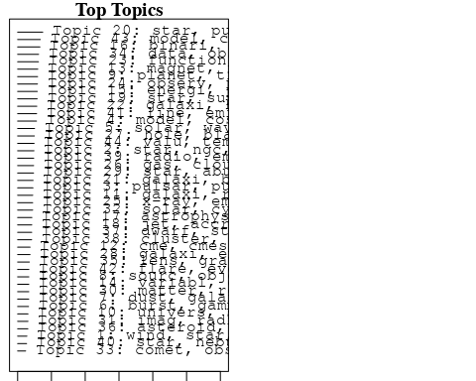

plotQuote(thoughts6, width = 30, main = "Topic 6")  
plotQuote(thoughts18, width = 30, main = "Topic 18")

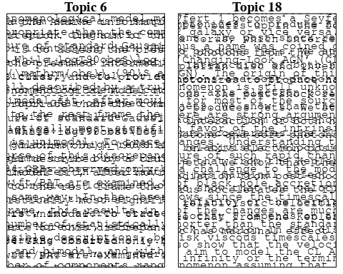

# Calculate and plot the correlation between topics  
mod.out.corr <- topicCorr(Research_topics)  
plot(mod.out.corr, cex = 1.5)  
  
  
# For each topic  
for (topic_num in 1:44) {  
 # Plot the word cloud  
 cloud(Research_topics, topic = topic_num, scale = c(2, 0.25))  
 Sys.sleep(2)  
}

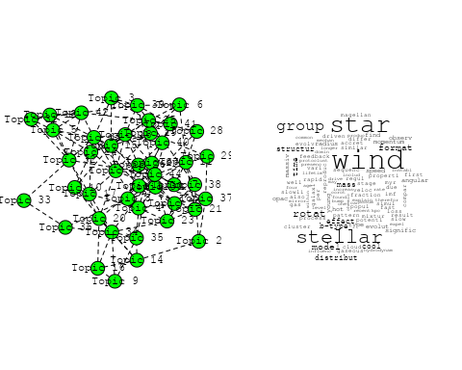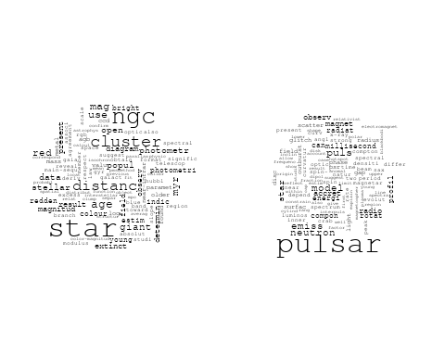

## Warning in wordcloud::wordcloud(words = vocab, freq = vec, max.words =  
## max.words, : model could not be fit on page. It will not be plotted.

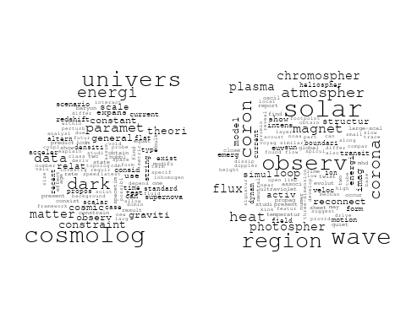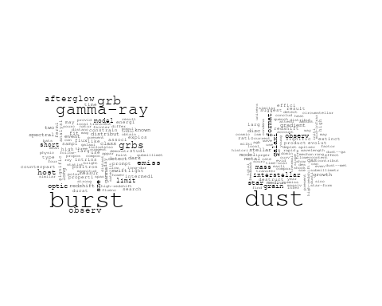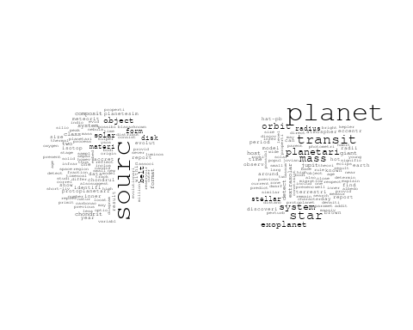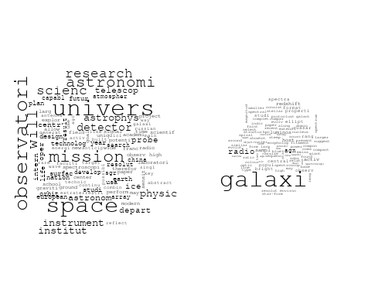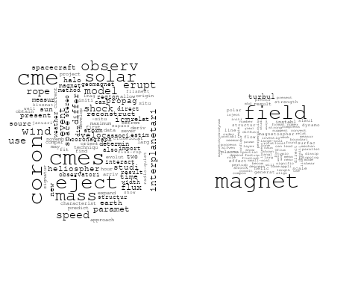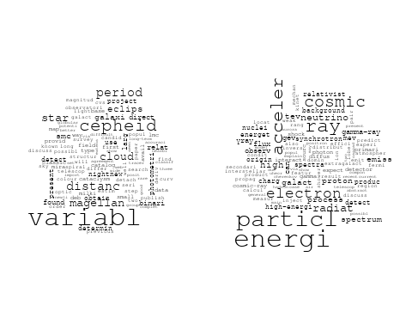

## Warning in wordcloud::wordcloud(words = vocab, freq = vec, max.words =  
## max.words, : astronomi could not be fit on page. It will not be plotted.

## Warning in wordcloud::wordcloud(words = vocab, freq = vec, max.words =  
## max.words, : experiment could not be fit on page. It will not be plotted.

## Warning in wordcloud::wordcloud(words = vocab, freq = vec, max.words =  
## max.words, : establish could not be fit on page. It will not be plotted.

## Warning in wordcloud::wordcloud(words = vocab, freq = vec, max.words =  
## max.words, : present could not be fit on page. It will not be plotted.

## Warning in wordcloud::wordcloud(words = vocab, freq = vec, max.words =  
## max.words, : earth could not be fit on page. It will not be plotted.

## Warning in wordcloud::wordcloud(words = vocab, freq = vec, max.words =  
## max.words, : paper could not be fit on page. It will not be plotted.

## Warning in wordcloud::wordcloud(words = vocab, freq = vec, max.words =  
## max.words, : observ could not be fit on page. It will not be plotted.

## Warning in wordcloud::wordcloud(words = vocab, freq = vec, max.words =  
## max.words, : process could not be fit on page. It will not be plotted.

## Warning in wordcloud::wordcloud(words = vocab, freq = vec, max.words =  
## max.words, : result could not be fit on page. It will not be plotted.

## Warning in wordcloud::wordcloud(words = vocab, freq = vec, max.words =  
## max.words, : discuss could not be fit on page. It will not be plotted.

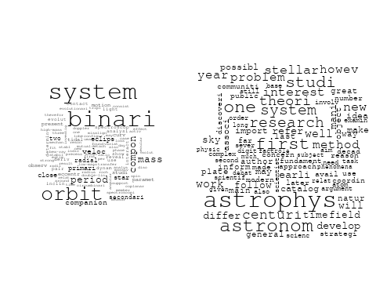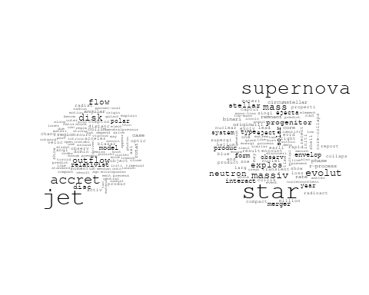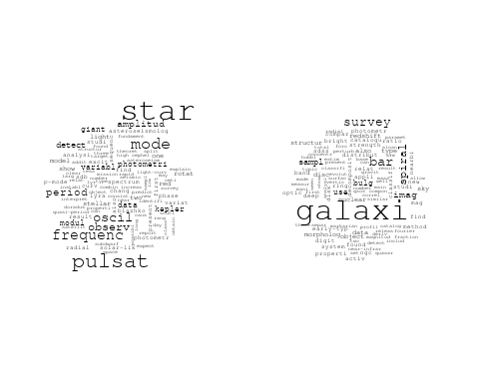

## Warning in wordcloud::wordcloud(words = vocab, freq = vec, max.words =  
## max.words, : distribut could not be fit on page. It will not be plotted.

## Warning in wordcloud::wordcloud(words = vocab, freq = vec, max.words =  
## max.words, : power could not be fit on page. It will not be plotted.

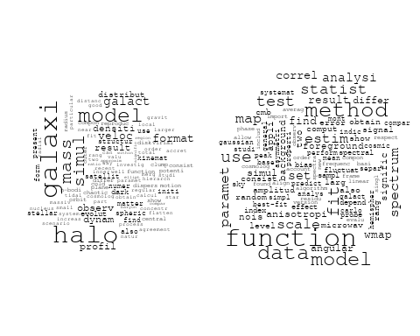

## Warning in wordcloud::wordcloud(words = vocab, freq = vec, max.words =  
## max.words, : review could not be fit on page. It will not be plotted.

## Warning in wordcloud::wordcloud(words = vocab, freq = vec, max.words =  
## max.words, : particular could not be fit on page. It will not be plotted.

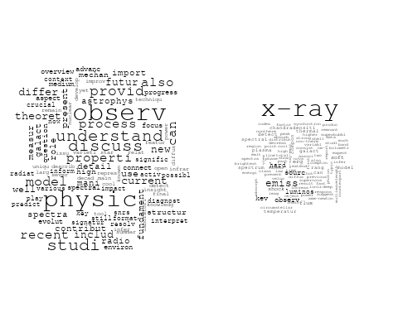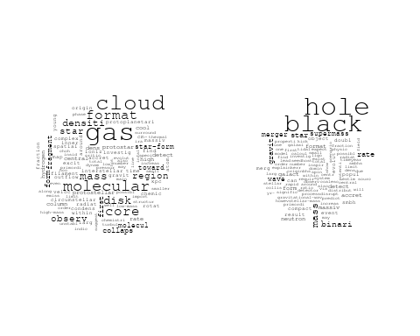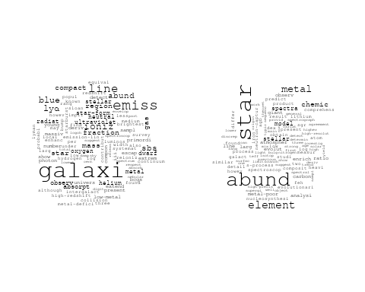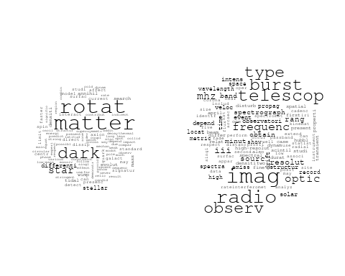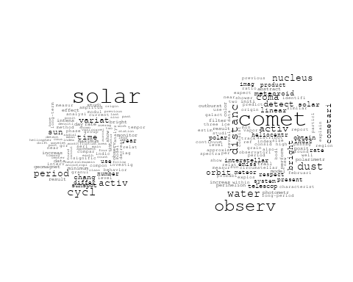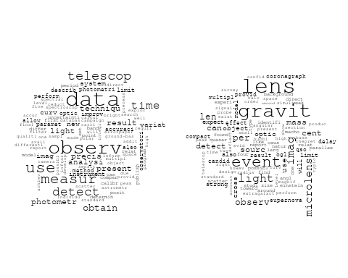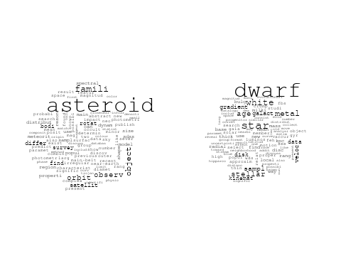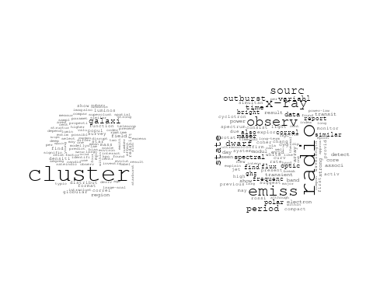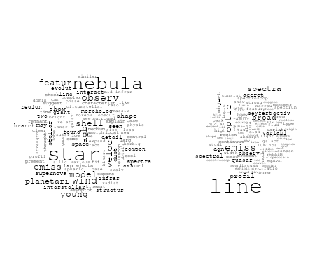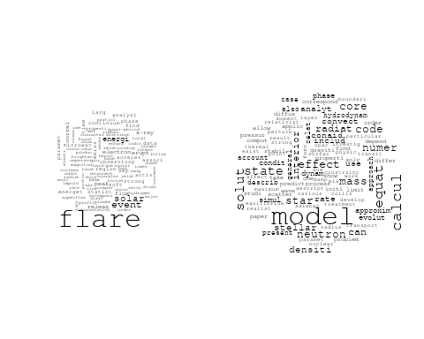

# Get the topic proportions for each document  
topic_proportions <- Research_topics$theta  
  
# Find the index of the topic with the highest proportion for each document  
# This will be the topic that each document is most likely to belong to  
max_topic_idx <- apply(topic_proportions, 1, which.max)  
  
# Add this as a new column to your data  
data_collab$topic <- max_topic_idx  
  
library(ggplot2)  
  
# Define the intervals  
intervals <- c('1824_1899', '1900_1964', '1965_1974', '1975_1984', '1985_1994', '1995_1999', '2000_2004', '2005_2009', '2010_2014', '2015_2019', '2020_2022')  
colors <- c('pink', 'blue', 'purple', 'yellow', 'green', 'pink', 'orange', 'violet', 'green', 'blue', 'pink')  
  
# Loop through the intervals and plot  
for(i in seq_along(intervals)){  
 # Filter data for when the pub_interval is equal to 1  
 data_filtered <- data_collab[data_collab[[paste0('pub_interval_', intervals[i])]] == 1,]  
   
 # Make the histogram  
   
 p <- ggplot(data_filtered, aes(x = topic)) +  
 geom_histogram(binwidth = 1, fill = colors[i], color = "black") +  
 xlab("Topic") +  
 ylab("Count") +  
 ggtitle(paste0("Topics from year ", gsub("_", " to ", intervals[i])))  
   
 print(p)  
}  
  
  
##Topic generation for Europe (independent) publications  
  
data_independent <- data[data[["Europe"]] == 100,]  
  
# Save the original title data for future use  
data_independent$original_concatenated_title_abstract <- data_independent$concatenated_title_abstract  
  
#pre-processing the titles using textProcessor from the stm package  
processed_text <- textProcessor(data_independent$concatenated_title_abstract, metadata = data_independent)

## Building corpus...   
## Converting to Lower Case...   
## Removing punctuation...   
## Removing stopwords...   
## Removing numbers...   
## Stemming...   
## Creating Output...

# Further prepare the data by removing low-frequency terms  
out_text <- prepDocuments(processed_text$documents, processed_text$vocab, processed_text$meta)

## Removing 3072 of 9361 terms (3072 of 127645 tokens) due to frequency   
## Your corpus now has 1638 documents, 6289 terms and 124573 tokens.

docs_text <- out_text$documents  
vocab_text <- out_text$vocab  
meta_text <- out_text$meta  
  
  
#Prepare data  
plotRemoved(processed_text$documents, lower.thresh = seq(1, 200, by = 100))

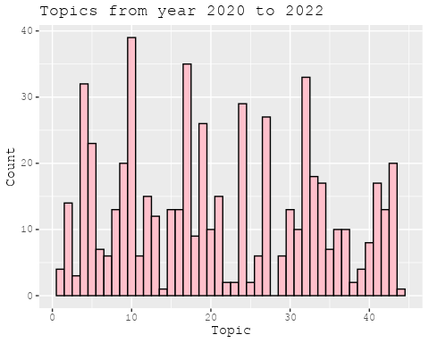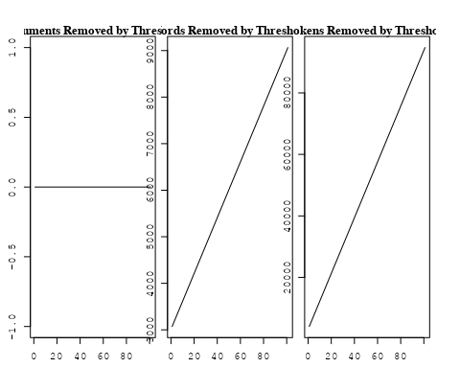

out_text <- prepDocuments(processed_text$documents, processed_text$vocab, processed_text$meta, lower.thresh = 8)

## Removing 7438 of 9361 terms (17336 of 127645 tokens) due to frequency   
## Your corpus now has 1638 documents, 1923 terms and 110309 tokens.

str(out_text$meta)

## 'data.frame': 1638 obs. of 39 variables:  
## $ concept_id : chr "https://openalex.org/C44870925" "https://openalex.org/C44870925" "https://openalex.org/C44870925" "https://openalex.org/C44870925" ...  
## $ work_id : chr "https://openalex.org/W1548323710" "https://openalex.org/W1993967893" "https://openalex.org/W2050900201" "https://openalex.org/W2077698413" ...  
## $ publication_year : int 2002 1998 2005 2008 2008 2004 2018 2022 2019 2021 ...  
## $ title : chr "Interpretation of the Core-Wing Anomaly of Balmer Line Profiles of Cool Ap Stars*" "The ISO-SWS 2.4-45.2 Micron Spectrum toward Orion IRc2" "Determination of the Coronal Density Stratification from the Observation of Harmonic Coronal Loop Oscillations" "CONFIRMATION OF THE ELECTRON CYCLOTRON MASER INSTABILITY AS THE DOMINANT SOURCE OF RADIO EMISSION FROM VERY LOW"| __truncated__ ...  
## $ paperabstract : chr "A number of cool magnetic chemically peculiar stars exhibit abnormal profiles of hydrogen Balmer lines. This an"| __truncated__ "The complete infrared spectrum from 2.4 to 45.2 μm toward the prototypical massive star-forming region Orion IR"| __truncated__ "The recent detection of multiple harmonic standing transverse oscillations in coronal loops by Verwichte et al."| __truncated__ "We report on radio observations of the M8.5 dwarf LSR J1835+3259 and the L3.5 dwarf 2MASS J00361617+1821104, wh"| __truncated__ ...  
## $ country : chr "SE SE" "BE" "BE BE BE BE BE BE" "IE IE IE IE" ...  
## $ year_concept : chr "2002+https://openalex.org/C44870925" "1998+https://openalex.org/C44870925" "2005+https://openalex.org/C44870925" "2008+https://openalex.org/C44870925" ...  
## $ concatenated_title_abstract : chr "Interpretation of the Core-Wing Anomaly of Balmer Line Profiles of Cool Ap Stars* A number of cool magnetic che"| __truncated__ "The ISO-SWS 2.4-45.2 Micron Spectrum toward Orion IRc2 The complete infrared spectrum from 2.4 to 45.2 μm towar"| __truncated__ "Determination of the Coronal Density Stratification from the Observation of Harmonic Coronal Loop Oscillations "| __truncated__ "CONFIRMATION OF THE ELECTRON CYCLOTRON MASER INSTABILITY AS THE DOMINANT SOURCE OF RADIO EMISSION FROM VERY LOW"| __truncated__ ...  
## $ US : num 0 0 0 0 0 0 0 0 0 0 ...  
## $ IN : num 0 0 0 0 0 0 0 0 0 0 ...  
## $ DE : num 0 0 0 0 0 0 0 0 0 0 ...  
## $ CH : num 0 0 0 0 0 0 0 0 0 0 ...  
## $ GB : num 0 0 0 0 0 0 0 0 0 0 ...  
## $ CN : num 0 0 0 0 0 0 0 0 0 0 ...  
## $ FR : num 0 0 0 0 0 0 0 0 0 0 ...  
## $ IT : num 0 0 0 0 0 0 0 0 0 0 ...  
## $ RU : num 0 0 0 0 0 0 0 0 0 0 ...  
## $ CA : num 0 0 0 0 0 0 0 0 0 0 ...  
## $ NL : num 0 0 0 0 0 0 0 0 0 0 ...  
## $ AU : num 0 0 0 0 0 0 0 0 0 0 ...  
## $ JP : num 0 0 0 0 0 0 0 0 0 0 ...  
## $ ES : num 0 0 0 0 0 0 0 0 0 0 ...  
## $ IL : num 0 0 0 0 0 0 0 0 0 0 ...  
## $ Americas : num 0 0 0 0 0 0 0 0 0 0 ...  
## $ Europe : num 100 100 100 100 100 100 100 100 100 100 ...  
## $ Africa : num 0 0 0 0 0 0 0 0 0 0 ...  
## $ AsiaAndOceania : num 0 0 0 0 0 0 0 0 0 0 ...  
## $ pub_interval_2020_2022 : int 0 0 0 0 0 0 0 1 0 1 ...  
## $ pub_interval_2015_2019 : int 0 0 0 0 0 0 1 0 1 0 ...  
## $ pub_interval_2010_2014 : int 0 0 0 0 0 0 0 0 0 0 ...  
## $ pub_interval_2005_2009 : int 0 0 1 1 1 0 0 0 0 0 ...  
## $ pub_interval_2000_2004 : int 1 0 0 0 0 1 0 0 0 0 ...  
## $ pub_interval_1995_1999 : int 0 1 0 0 0 0 0 0 0 0 ...  
## $ pub_interval_1985_1994 : int 0 0 0 0 0 0 0 0 0 0 ...  
## $ pub_interval_1975_1984 : int 0 0 0 0 0 0 0 0 0 0 ...  
## $ pub_interval_1965_1974 : int 0 0 0 0 0 0 0 0 0 0 ...  
## $ pub_interval_1900_1964 : int 0 0 0 0 0 0 0 0 0 0 ...  
## $ pub_interval_1824_1899 : int 0 0 0 0 0 0 0 0 0 0 ...  
## $ original_concatenated_title_abstract: chr "Interpretation of the Core-Wing Anomaly of Balmer Line Profiles of Cool Ap Stars* A number of cool magnetic che"| __truncated__ "The ISO-SWS 2.4-45.2 Micron Spectrum toward Orion IRc2 The complete infrared spectrum from 2.4 to 45.2 μm towar"| __truncated__ "Determination of the Coronal Density Stratification from the Observation of Harmonic Coronal Loop Oscillations "| __truncated__ "CONFIRMATION OF THE ELECTRON CYCLOTRON MASER INSTABILITY AS THE DOMINANT SOURCE OF RADIO EMISSION FROM VERY LOW"| __truncated__ ...

# Initialize an empty formula string  
prevalence_formula_str <- "~"  
  
# Define the publication intervals  
pub_intervals <- c("pub_interval_2020_2022", "pub_interval_2015_2019", "pub_interval_2010_2014",   
 "pub_interval_2005_2009", "pub_interval_2000_2004", "pub_interval_1995_1999",  
 "pub_interval_1985_1994", "pub_interval_1975_1984", "pub_interval_1965_1974",  
 "pub_interval_1900_1964", "pub_interval_1824_1899")  
  
# Add each publication interval to the formula string  
for (interval in pub_intervals) {  
 # add an if statement to handle the first addition (without '+')  
 if (prevalence_formula_str == "~") {  
 prevalence_formula_str <- paste(prevalence_formula_str, interval)  
 } else {  
 prevalence_formula_str <- paste(prevalence_formula_str, "+", interval)  
 }  
}  
  
  
# Convert the string to a formula  
prevalence_formula <- as.formula(prevalence_formula_str)  
print(prevalence_formula)

## ~pub_interval_2020_2022 + pub_interval_2015_2019 + pub_interval_2010_2014 +   
## pub_interval_2005_2009 + pub_interval_2000_2004 + pub_interval_1995_1999 +   
## pub_interval_1985_1994 + pub_interval_1975_1984 + pub_interval_1965_1974 +   
## pub_interval_1900_1964 + pub_interval_1824_1899

# Run STM model  
Research_topics <- stm(documents = out_text$documents,   
 vocab = out_text$vocab,   
 K = 44,   
 prevalence = prevalence_formula,   
 data = out_text$meta,   
 init.type = "Spectral",  
 max.em.its = 1000,  
 gamma.prior = 'L1')

## Beginning Spectral Initialization   
## Calculating the gram matrix...  
## Finding anchor words...  
## ............................................  
## Recovering initialization...  
## ...................  
## Initialization complete.  
## ......................................................................................................  
## Completed E-Step (1 seconds).   
## Completed M-Step.   
## Completing Iteration 1 (approx. per word bound = -6.414)   
## ......................................................................................................  
## Completed E-Step (1 seconds).   
## Completed M-Step.   
## Completing Iteration 2 (approx. per word bound = -6.143, relative change = 4.214e-02)   
## ......................................................................................................  
## Completed E-Step (1 seconds).   
## Completed M-Step.   
## Completing Iteration 3 (approx. per word bound = -6.065, relative change = 1.279e-02)   
## ......................................................................................................  
## Completed E-Step (1 seconds).   
## Completed M-Step.   
## Completing Iteration 4 (approx. per word bound = -6.032, relative change = 5.324e-03)   
## ......................................................................................................  
## Completed E-Step (1 seconds).   
## Completed M-Step.   
## Completing Iteration 5 (approx. per word bound = -6.016, relative change = 2.774e-03)   
## Topic 1: abund, star, stellar, element, determin   
## Topic 2: cluster, ngc, use, data, paramet   
## Topic 3: system, asteroid, star, inner, belt   
## Topic 4: magnet, solar, cosmic, field, ray   
## Topic 5: wave, gravit, neutron, star, mass   
## Topic 6: dust, gradient, galaxi, interstellar, observ   
## Topic 7: astronom, univers, astronomi, centuri, scienc   
## Topic 8: process, new, neutrino, recent, time   
## Topic 9: x-ray, accret, observ, model, pulsar   
## Topic 10: emiss, dwarf, radio, period, electron   
## Topic 11: wind, observ, high, model, spectral   
## Topic 12: evolut, instabl, studi, disk, map   
## Topic 13: particl, correct, author, acceler, observ   
## Topic 14: solar, paramet, veloc, coron, use   
## Topic 15: burst, gamma-ray, grb, distribut, grbs   
## Topic 16: pulsat, mode, star, galaxi, type   
## Topic 17: comet, observ, distanc, polar, bright   
## Topic 18: observ, transit, time, period, curv   
## Topic 19: spectra, radio, energi, acceler, shock   
## Topic 20: variabl, star, magellan, pulsat, cloud   
## Topic 21: cluster, star, age, globular, mass   
## Topic 22: orbit, system, model, motion, dynam   
## Topic 23: model, dark, matter, cosmolog, data   
## Topic 24: magnet, field, cosmic, ray, effect   
## Topic 25: physic, observ, model, review, star   
## Topic 26: binari, system, mass, compon, orbit   
## Topic 27: line, galaxi, emiss, broad, profil   
## Topic 28: hole, black, accret, model, jet   
## Topic 29: star, galact, metal, clump, red   
## Topic 30: solar, radio, observ, event, type   
## Topic 31: magnet, field, jet, scatter, pulsar   
## Topic 32: galaxi, group, veloc, halo, observ   
## Topic 33: model, function, use, code, calcul   
## Topic 34: x-ray, emiss, light, flux, sourc   
## Topic 35: galaxi, radio, sourc, optic, bar   
## Topic 36: star, stellar, evolut, mass, rotat   
## Topic 37: cloud, region, core, molecular, star   
## Topic 38: binari, interact, supernova, x-ray, associ   
## Topic 39: rotat, rate, solar, use, activ   
## Topic 40: frequenc, variat, variabl, period, star   
## Topic 41: galaxi, merger, host, binari, merg   
## Topic 42: planet, exoplanet, mass, orbit, star   
## Topic 43: flare, solar, magnet, flux, coron   
## Topic 44: neutron, star, line, rotat, flux   
## ......................................................................................................  
## Completed E-Step (1 seconds).   
## Completed M-Step.   
## Completing Iteration 6 (approx. per word bound = -6.006, relative change = 1.689e-03)   
## ......................................................................................................  
## Completed E-Step (1 seconds).   
## Completed M-Step.   
## Completing Iteration 7 (approx. per word bound = -5.998, relative change = 1.179e-03)   
## ......................................................................................................  
## Completed E-Step (1 seconds).   
## Completed M-Step.   
## Completing Iteration 8 (approx. per word bound = -5.993, relative change = 9.017e-04)   
## ......................................................................................................  
## Completed E-Step (1 seconds).   
## Completed M-Step.   
## Completing Iteration 9 (approx. per word bound = -5.989, relative change = 6.901e-04)   
## ......................................................................................................  
## Completed E-Step (1 seconds).   
## Completed M-Step.   
## Completing Iteration 10 (approx. per word bound = -5.986, relative change = 5.184e-04)   
## Topic 1: abund, star, stellar, element, determin   
## Topic 2: ngc, cluster, use, data, photometr   
## Topic 3: system, asteroid, star, belt, possibl   
## Topic 4: magnet, solar, heat, field, corona   
## Topic 5: wave, star, neutron, gravit, mass   
## Topic 6: dust, gradient, galaxi, interstellar, observ   
## Topic 7: astronom, univers, astronomi, centuri, research   
## Topic 8: process, neutrino, recent, new, also   
## Topic 9: x-ray, accret, model, energi, observ   
## Topic 10: emiss, dwarf, radio, period, electron   
## Topic 11: wind, observ, spectral, polar, high   
## Topic 12: evolut, instabl, studi, result, disk   
## Topic 13: particl, observ, author, detector, acceler   
## Topic 14: solar, paramet, wind, observ, use   
## Topic 15: burst, gamma-ray, grb, distribut, grbs   
## Topic 16: pulsat, bar, star, galaxi, spiral   
## Topic 17: comet, observ, distanc, polar, dust   
## Topic 18: observ, transit, time, period, curv   
## Topic 19: spectra, radio, energi, acceler, shock   
## Topic 20: star, pulsat, magellan, object, cloud   
## Topic 21: cluster, star, age, globular, stellar   
## Topic 22: orbit, system, model, motion, dynam   
## Topic 23: model, dark, matter, cosmolog, data   
## Topic 24: magnet, field, cosmic, ray, effect   
## Topic 25: physic, model, review, observ, nuclear   
## Topic 26: binari, system, mass, compon, orbit   
## Topic 27: line, emiss, galaxi, broad, profil   
## Topic 28: hole, black, accret, mass, model   
## Topic 29: star, galact, clump, metal, red   
## Topic 30: radio, solar, event, observ, type   
## Topic 31: magnet, field, jet, pulsar, scatter   
## Topic 32: galaxi, group, veloc, halo, format   
## Topic 33: model, function, use, method, simul   
## Topic 34: x-ray, emiss, light, flux, sourc   
## Topic 35: galaxi, radio, sourc, optic, agn   
## Topic 36: star, stellar, rotat, evolut, mass   
## Topic 37: cloud, region, core, molecular, gas   
## Topic 38: binari, x-ray, interact, supernova, star   
## Topic 39: rotat, solar, use, activ, rate   
## Topic 40: variabl, star, frequenc, variat, period   
## Topic 41: galaxi, merger, host, binari, merg   
## Topic 42: planet, exoplanet, orbit, star, mass   
## Topic 43: flare, solar, magnet, coron, flux   
## Topic 44: neutron, star, line, pulsar, rotat   
## ......................................................................................................  
## Completed E-Step (1 seconds).   
## Completed M-Step.   
## Completing Iteration 11 (approx. per word bound = -5.983, relative change = 3.923e-04)   
## ......................................................................................................  
## Completed E-Step (1 seconds).   
## Completed M-Step.   
## Completing Iteration 12 (approx. per word bound = -5.981, relative change = 3.800e-04)   
## ......................................................................................................  
## Completed E-Step (1 seconds).   
## Completed M-Step.   
## Completing Iteration 13 (approx. per word bound = -5.979, relative change = 3.164e-04)   
## ......................................................................................................  
## Completed E-Step (1 seconds).   
## Completed M-Step.   
## Completing Iteration 14 (approx. per word bound = -5.977, relative change = 3.443e-04)   
## ......................................................................................................  
## Completed E-Step (1 seconds).   
## Completed M-Step.   
## Completing Iteration 15 (approx. per word bound = -5.976, relative change = 2.776e-04)   
## Topic 1: abund, star, stellar, element, determin   
## Topic 2: ngc, cluster, use, data, photometr   
## Topic 3: asteroid, system, star, belt, possibl   
## Topic 4: magnet, solar, heat, field, corona   
## Topic 5: star, neutron, wave, gravit, mass   
## Topic 6: dust, gradient, galaxi, interstellar, observ   
## Topic 7: astronom, univers, astronomi, centuri, research   
## Topic 8: process, neutrino, recent, new, studi   
## Topic 9: x-ray, accret, model, observ, energi   
## Topic 10: emiss, dwarf, radio, period, electron   
## Topic 11: wind, observ, measur, polar, spectral   
## Topic 12: evolut, instabl, studi, result, growth   
## Topic 13: particl, observ, author, detector, energi   
## Topic 14: solar, paramet, wind, observ, eject   
## Topic 15: burst, gamma-ray, grb, distribut, grbs   
## Topic 16: bar, pulsat, galaxi, star, spiral   
## Topic 17: comet, observ, distanc, polar, dust   
## Topic 18: observ, time, transit, period, curv   
## Topic 19: spectra, energi, radio, acceler, shock   
## Topic 20: star, pulsat, magellan, object, survey   
## Topic 21: cluster, star, age, globular, stellar   
## Topic 22: orbit, system, model, motion, dynam   
## Topic 23: model, dark, matter, cosmolog, data   
## Topic 24: magnet, field, cosmic, ray, effect   
## Topic 25: physic, review, model, observ, star   
## Topic 26: binari, system, compon, mass, orbit   
## Topic 27: line, emiss, galaxi, broad, profil   
## Topic 28: hole, black, accret, mass, jet   
## Topic 29: star, galact, clump, metal, red   
## Topic 30: radio, event, solar, observ, type   
## Topic 31: magnet, field, jet, pulsar, scatter   
## Topic 32: galaxi, halo, group, veloc, format   
## Topic 33: model, use, function, method, simul   
## Topic 34: x-ray, emiss, light, flux, sourc   
## Topic 35: galaxi, radio, sourc, quasar, optic   
## Topic 36: star, stellar, rotat, evolut, mass   
## Topic 37: cloud, region, core, molecular, gas   
## Topic 38: binari, x-ray, interact, star, mass   
## Topic 39: solar, rotat, use, activ, valu   
## Topic 40: variabl, star, frequenc, variat, period   
## Topic 41: galaxi, merger, host, binari, merg   
## Topic 42: planet, exoplanet, orbit, star, transit   
## Topic 43: flare, solar, coron, magnet, flux   
## Topic 44: neutron, star, line, rotat, pulsar   
## ......................................................................................................  
## Completed E-Step (1 seconds).   
## Completed M-Step.   
## Completing Iteration 16 (approx. per word bound = -5.974, relative change = 2.702e-04)   
## ......................................................................................................  
## Completed E-Step (1 seconds).   
## Completed M-Step.   
## Completing Iteration 17 (approx. per word bound = -5.973, relative change = 2.270e-04)   
## ......................................................................................................  
## Completed E-Step (1 seconds).   
## Completed M-Step.   
## Completing Iteration 18 (approx. per word bound = -5.971, relative change = 2.167e-04)   
## ......................................................................................................  
## Completed E-Step (1 seconds).   
## Completed M-Step.   
## Completing Iteration 19 (approx. per word bound = -5.970, relative change = 2.150e-04)   
## ......................................................................................................  
## Completed E-Step (1 seconds).   
## Completed M-Step.   
## Completing Iteration 20 (approx. per word bound = -5.969, relative change = 2.015e-04)   
## Topic 1: abund, star, stellar, element, atmospher   
## Topic 2: ngc, cluster, use, data, photometr   
## Topic 3: asteroid, star, system, belt, possibl   
## Topic 4: magnet, solar, heat, turbul, corona   
## Topic 5: star, neutron, gravit, wave, mass   
## Topic 6: dust, gradient, galaxi, interstellar, observ   
## Topic 7: astronom, univers, astronomi, centuri, research   
## Topic 8: process, neutrino, recent, new, reson   
## Topic 9: x-ray, accret, model, observ, pulsar   
## Topic 10: emiss, dwarf, period, radio, electron   
## Topic 11: observ, wind, measur, polar, spectral   
## Topic 12: evolut, instabl, studi, result, growth   
## Topic 13: particl, observ, author, lyα, detector   
## Topic 14: solar, wind, paramet, observ, cmes   
## Topic 15: burst, gamma-ray, grb, distribut, grbs   
## Topic 16: bar, pulsat, galaxi, spiral, map   
## Topic 17: comet, observ, distanc, polar, bright   
## Topic 18: observ, time, transit, period, curv   
## Topic 19: energi, spectra, radio, acceler, high   
## Topic 20: star, pulsat, object, survey, magellan   
## Topic 21: cluster, star, age, stellar, globular   
## Topic 22: orbit, system, model, motion, dynam   
## Topic 23: model, dark, matter, cosmolog, data   
## Topic 24: magnet, field, cosmic, ray, effect   
## Topic 25: physic, review, model, observ, star   
## Topic 26: binari, system, compon, mass, orbit   
## Topic 27: line, emiss, galaxi, broad, profil   
## Topic 28: hole, black, accret, mass, jet   
## Topic 29: star, galact, clump, red, metal   
## Topic 30: radio, event, solar, observ, type   
## Topic 31: magnet, field, jet, relativist, pulsar   
## Topic 32: galaxi, halo, group, veloc, format   
## Topic 33: model, use, function, method, simul   
## Topic 34: x-ray, emiss, light, flux, sourc   
## Topic 35: galaxi, radio, quasar, sourc, optic   
## Topic 36: star, stellar, rotat, evolut, mass   
## Topic 37: cloud, region, core, molecular, gas   
## Topic 38: binari, x-ray, interact, star, mass   
## Topic 39: solar, rotat, use, activ, valu   
## Topic 40: variabl, star, frequenc, variat, period   
## Topic 41: galaxi, merger, host, binari, merg   
## Topic 42: planet, exoplanet, orbit, transit, star   
## Topic 43: flare, solar, coron, magnet, erupt   
## Topic 44: neutron, star, line, rotat, pulsar   
## ......................................................................................................  
## Completed E-Step (1 seconds).   
## Completed M-Step.   
## Completing Iteration 21 (approx. per word bound = -5.968, relative change = 1.992e-04)   
## ......................................................................................................  
## Completed E-Step (1 seconds).   
## Completed M-Step.   
## Completing Iteration 22 (approx. per word bound = -5.967, relative change = 1.456e-04)   
## ......................................................................................................  
## Completed E-Step (1 seconds).   
## Completed M-Step.   
## Completing Iteration 23 (approx. per word bound = -5.966, relative change = 1.941e-04)   
## ......................................................................................................  
## Completed E-Step (1 seconds).   
## Completed M-Step.   
## Completing Iteration 24 (approx. per word bound = -5.965, relative change = 1.454e-04)   
## ......................................................................................................  
## Completed E-Step (1 seconds).   
## Completed M-Step.   
## Completing Iteration 25 (approx. per word bound = -5.964, relative change = 1.216e-04)   
## Topic 1: abund, star, stellar, element, atmospher   
## Topic 2: ngc, cluster, use, data, photometr   
## Topic 3: asteroid, star, system, belt, possibl   
## Topic 4: magnet, solar, turbul, heat, corona   
## Topic 5: star, neutron, gravit, mass, wave   
## Topic 6: dust, gradient, galaxi, observ, interstellar   
## Topic 7: astronom, univers, astronomi, centuri, research   
## Topic 8: process, neutrino, recent, reson, new   
## Topic 9: x-ray, accret, model, observ, pulsar   
## Topic 10: emiss, dwarf, period, radio, electron   
## Topic 11: observ, wind, measur, polar, spectral   
## Topic 12: evolut, instabl, binari, studi, result   
## Topic 13: particl, observ, lyα, author, galaxi   
## Topic 14: solar, wind, observ, paramet, cmes   
## Topic 15: burst, gamma-ray, distribut, grb, grbs   
## Topic 16: bar, galaxi, pulsat, spiral, map   
## Topic 17: comet, observ, distanc, polar, bright   
## Topic 18: observ, time, transit, period, curv   
## Topic 19: energi, spectra, radio, acceler, high   
## Topic 20: star, pulsat, survey, object, magellan   
## Topic 21: cluster, star, age, galaxi, stellar   
## Topic 22: orbit, system, model, motion, dynam   
## Topic 23: model, dark, matter, cosmolog, data   
## Topic 24: field, magnet, cosmic, geomagnet, effect   
## Topic 25: physic, review, observ, model, star   
## Topic 26: binari, system, compon, mass, orbit   
## Topic 27: line, emiss, broad, profil, galaxi   
## Topic 28: hole, black, accret, mass, jet   
## Topic 29: star, galact, clump, red, giant   
## Topic 30: radio, event, solar, observ, type   
## Topic 31: magnet, field, jet, relativist, scatter   
## Topic 32: galaxi, halo, group, veloc, format   
## Topic 33: model, use, function, method, simul   
## Topic 34: x-ray, emiss, light, flux, sourc   
## Topic 35: galaxi, radio, quasar, sourc, agn   
## Topic 36: star, stellar, rotat, evolut, mass   
## Topic 37: cloud, region, core, molecular, gas   
## Topic 38: binari, x-ray, star, interact, mass   
## Topic 39: solar, rotat, use, activ, period   
## Topic 40: variabl, star, frequenc, variat, mode   
## Topic 41: galaxi, merger, host, binari, merg   
## Topic 42: planet, orbit, exoplanet, transit, star   
## Topic 43: flare, solar, coron, magnet, erupt   
## Topic 44: neutron, star, line, rotat, pulsar   
## ......................................................................................................  
## Completed E-Step (1 seconds).   
## Completed M-Step.   
## Completing Iteration 26 (approx. per word bound = -5.963, relative change = 1.045e-04)   
## ......................................................................................................  
## Completed E-Step (1 seconds).   
## Completed M-Step.   
## Completing Iteration 27 (approx. per word bound = -5.963, relative change = 1.015e-04)   
## ......................................................................................................  
## Completed E-Step (1 seconds).   
## Completed M-Step.   
## Completing Iteration 28 (approx. per word bound = -5.962, relative change = 1.004e-04)   
## ......................................................................................................  
## Completed E-Step (1 seconds).   
## Completed M-Step.   
## Completing Iteration 29 (approx. per word bound = -5.962, relative change = 9.160e-05)   
## ......................................................................................................  
## Completed E-Step (1 seconds).   
## Completed M-Step.   
## Completing Iteration 30 (approx. per word bound = -5.961, relative change = 8.863e-05)   
## Topic 1: abund, star, stellar, element, atmospher   
## Topic 2: ngc, cluster, use, data, photometr   
## Topic 3: asteroid, star, system, belt, possibl   
## Topic 4: magnet, solar, turbul, heat, wave   
## Topic 5: star, neutron, gravit, mass, wave   
## Topic 6: dust, gradient, galaxi, observ, interstellar   
## Topic 7: astronom, univers, astronomi, centuri, research   
## Topic 8: process, neutrino, recent, reson, origin   
## Topic 9: x-ray, accret, model, observ, pulsar   
## Topic 10: emiss, dwarf, period, radio, electron   
## Topic 11: observ, wind, measur, polar, spectral   
## Topic 12: evolut, instabl, binari, studi, result   
## Topic 13: particl, observ, galaxi, lyα, author   
## Topic 14: solar, wind, observ, paramet, cmes   
## Topic 15: burst, gamma-ray, distribut, grb, grbs   
## Topic 16: bar, galaxi, pulsat, spiral, map   
## Topic 17: comet, observ, distanc, polar, bright   
## Topic 18: observ, time, transit, period, curv   
## Topic 19: energi, spectra, radio, acceler, high   
## Topic 20: star, pulsat, object, survey, magellan   
## Topic 21: cluster, star, galaxi, age, stellar   
## Topic 22: orbit, system, model, motion, dynam   
## Topic 23: model, dark, matter, cosmolog, data   
## Topic 24: field, magnet, cosmic, geomagnet, effect   
## Topic 25: physic, review, star, observ, model   
## Topic 26: binari, system, compon, mass, orbit   
## Topic 27: line, emiss, broad, profil, galaxi   
## Topic 28: hole, black, accret, mass, jet   
## Topic 29: star, galact, clump, red, giant   
## Topic 30: radio, event, solar, observ, type   
## Topic 31: magnet, field, jet, scatter, relativist   
## Topic 32: galaxi, halo, group, veloc, format   
## Topic 33: model, use, function, method, simul   
## Topic 34: x-ray, emiss, light, flux, sourc   
## Topic 35: galaxi, radio, quasar, sourc, agn   
## Topic 36: star, stellar, rotat, evolut, mass   
## Topic 37: cloud, region, core, molecular, gas   
## Topic 38: binari, x-ray, star, interact, mass   
## Topic 39: solar, rotat, use, activ, period   
## Topic 40: variabl, star, frequenc, variat, mode   
## Topic 41: galaxi, merger, host, binari, merg   
## Topic 42: planet, orbit, exoplanet, transit, star   
## Topic 43: flare, solar, coron, magnet, erupt   
## Topic 44: neutron, star, line, pulsar, rotat   
## ......................................................................................................  
## Completed E-Step (1 seconds).   
## Completed M-Step.   
## Completing Iteration 31 (approx. per word bound = -5.961, relative change = 8.745e-05)   
## ......................................................................................................  
## Completed E-Step (1 seconds).   
## Completed M-Step.   
## Completing Iteration 32 (approx. per word bound = -5.960, relative change = 8.092e-05)   
## ......................................................................................................  
## Completed E-Step (1 seconds).   
## Completed M-Step.   
## Completing Iteration 33 (approx. per word bound = -5.960, relative change = 8.072e-05)   
## ......................................................................................................  
## Completed E-Step (1 seconds).   
## Completed M-Step.   
## Completing Iteration 34 (approx. per word bound = -5.959, relative change = 8.157e-05)   
## ......................................................................................................  
## Completed E-Step (1 seconds).   
## Completed M-Step.   
## Completing Iteration 35 (approx. per word bound = -5.959, relative change = 7.579e-05)   
## Topic 1: abund, star, stellar, element, atmospher   
## Topic 2: ngc, cluster, use, data, photometr   
## Topic 3: asteroid, system, star, belt, possibl   
## Topic 4: magnet, solar, turbul, heat, wave   
## Topic 5: star, gravit, neutron, mass, wave   
## Topic 6: dust, gradient, galaxi, observ, product   
## Topic 7: astronom, univers, astronomi, centuri, observ   
## Topic 8: process, neutrino, recent, reson, origin   
## Topic 9: x-ray, accret, model, observ, pulsar   
## Topic 10: emiss, dwarf, period, radio, electron   
## Topic 11: observ, wind, measur, spectral, polar   
## Topic 12: evolut, instabl, binari, studi, result   
## Topic 13: particl, galaxi, observ, lyα, author   
## Topic 14: solar, wind, observ, paramet, cmes   
## Topic 15: burst, gamma-ray, distribut, grb, grbs   
## Topic 16: bar, galaxi, pulsat, spiral, map   
## Topic 17: comet, observ, distanc, polar, bright   
## Topic 18: observ, time, transit, period, curv   
## Topic 19: energi, spectra, acceler, radio, shock   
## Topic 20: star, pulsat, survey, object, magellan   
## Topic 21: cluster, star, galaxi, age, stellar   
## Topic 22: orbit, system, model, motion, dynam   
## Topic 23: model, dark, matter, cosmolog, data   
## Topic 24: field, magnet, cosmic, geomagnet, effect   
## Topic 25: physic, review, star, observ, model   
## Topic 26: binari, system, compon, mass, orbit   
## Topic 27: line, emiss, broad, profil, galaxi   
## Topic 28: hole, black, accret, mass, jet   
## Topic 29: star, galact, red, clump, giant   
## Topic 30: radio, event, solar, observ, type   
## Topic 31: magnet, field, jet, scatter, relativist   
## Topic 32: galaxi, halo, group, veloc, format   
## Topic 33: model, use, function, method, simul   
## Topic 34: x-ray, emiss, light, flux, sourc   
## Topic 35: galaxi, radio, quasar, sourc, agn   
## Topic 36: star, stellar, rotat, evolut, mass   
## Topic 37: cloud, region, core, molecular, gas   
## Topic 38: x-ray, binari, star, interact, mass   
## Topic 39: solar, rotat, use, activ, period   
## Topic 40: variabl, star, frequenc, variat, mode   
## Topic 41: galaxi, merger, host, binari, merg   
## Topic 42: planet, orbit, exoplanet, transit, star   
## Topic 43: flare, solar, coron, magnet, erupt   
## Topic 44: neutron, star, line, pulsar, rotat   
## ......................................................................................................  
## Completed E-Step (1 seconds).   
## Completed M-Step.   
## Completing Iteration 36 (approx. per word bound = -5.958, relative change = 8.065e-05)   
## ......................................................................................................  
## Completed E-Step (1 seconds).   
## Completed M-Step.   
## Completing Iteration 37 (approx. per word bound = -5.958, relative change = 8.233e-05)   
## ......................................................................................................  
## Completed E-Step (1 seconds).   
## Completed M-Step.   
## Completing Iteration 38 (approx. per word bound = -5.957, relative change = 6.569e-05)   
## ......................................................................................................  
## Completed E-Step (1 seconds).   
## Completed M-Step.   
## Completing Iteration 39 (approx. per word bound = -5.957, relative change = 6.496e-05)   
## ......................................................................................................  
## Completed E-Step (1 seconds).   
## Completed M-Step.   
## Completing Iteration 40 (approx. per word bound = -5.957, relative change = 6.077e-05)   
## Topic 1: abund, star, stellar, element, atmospher   
## Topic 2: ngc, cluster, use, data, photometr   
## Topic 3: asteroid, system, star, belt, possibl   
## Topic 4: magnet, solar, turbul, heat, wave   
## Topic 5: star, gravit, neutron, mass, wave   
## Topic 6: dust, gradient, galaxi, observ, product   
## Topic 7: astronom, univers, astronomi, centuri, observ   
## Topic 8: process, neutrino, recent, reson, studi   
## Topic 9: x-ray, model, accret, observ, pulsar   
## Topic 10: emiss, dwarf, period, radio, electron   
## Topic 11: observ, wind, measur, spectral, polar   
## Topic 12: evolut, instabl, binari, studi, result   
## Topic 13: particl, galaxi, observ, lyα, author   
## Topic 14: solar, wind, observ, paramet, cmes   
## Topic 15: burst, gamma-ray, grb, distribut, grbs   
## Topic 16: bar, galaxi, spiral, pulsat, map   
## Topic 17: comet, observ, distanc, polar, dust   
## Topic 18: observ, time, transit, period, curv   
## Topic 19: energi, spectra, acceler, ray, shock   
## Topic 20: star, survey, pulsat, object, magellan   
## Topic 21: cluster, star, galaxi, age, stellar   
## Topic 22: orbit, system, model, motion, dynam   
## Topic 23: model, dark, matter, cosmolog, data   
## Topic 24: field, magnet, geomagnet, effect, atmospher   
## Topic 25: physic, review, star, observ, model   
## Topic 26: binari, system, compon, mass, orbit   
## Topic 27: line, emiss, broad, profil, galaxi   
## Topic 28: hole, black, accret, mass, jet   
## Topic 29: star, galact, red, clump, metal   
## Topic 30: radio, event, solar, type, observ   
## Topic 31: magnet, field, jet, scatter, relativist   
## Topic 32: galaxi, halo, group, veloc, format   
## Topic 33: model, use, function, method, calcul   
## Topic 34: x-ray, emiss, light, flux, sourc   
## Topic 35: galaxi, radio, quasar, sourc, agn   
## Topic 36: star, stellar, rotat, evolut, mass   
## Topic 37: cloud, region, core, molecular, gas   
## Topic 38: x-ray, binari, star, interact, mass   
## Topic 39: solar, rotat, activ, use, period   
## Topic 40: variabl, star, frequenc, variat, mode   
## Topic 41: galaxi, merger, host, binari, merg   
## Topic 42: planet, orbit, exoplanet, transit, star   
## Topic 43: flare, coron, solar, magnet, erupt   
## Topic 44: neutron, star, line, pulsar, rotat   
## ......................................................................................................  
## Completed E-Step (1 seconds).   
## Completed M-Step.   
## Completing Iteration 41 (approx. per word bound = -5.956, relative change = 5.543e-05)   
## ......................................................................................................  
## Completed E-Step (1 seconds).   
## Completed M-Step.   
## Completing Iteration 42 (approx. per word bound = -5.956, relative change = 4.677e-05)   
## ......................................................................................................  
## Completed E-Step (1 seconds).   
## Completed M-Step.   
## Completing Iteration 43 (approx. per word bound = -5.956, relative change = 5.098e-05)   
## ......................................................................................................  
## Completed E-Step (1 seconds).   
## Completed M-Step.   
## Completing Iteration 44 (approx. per word bound = -5.955, relative change = 5.193e-05)   
## ......................................................................................................  
## Completed E-Step (1 seconds).   
## Completed M-Step.   
## Completing Iteration 45 (approx. per word bound = -5.955, relative change = 4.884e-05)   
## Topic 1: abund, star, stellar, element, atmospher   
## Topic 2: ngc, cluster, use, data, star   
## Topic 3: asteroid, system, star, belt, possibl   
## Topic 4: magnet, solar, turbul, heat, wave   
## Topic 5: star, gravit, neutron, mass, wave   
## Topic 6: dust, gradient, galaxi, observ, product   
## Topic 7: astronom, univers, astronomi, centuri, observ   
## Topic 8: process, neutrino, recent, reson, studi   
## Topic 9: x-ray, model, accret, observ, pulsar   
## Topic 10: emiss, dwarf, period, radio, electron   
## Topic 11: observ, wind, measur, spectral, polar   
## Topic 12: evolut, instabl, binari, studi, result   
## Topic 13: particl, galaxi, observ, lyα, author   
## Topic 14: solar, wind, observ, paramet, cmes   
## Topic 15: burst, gamma-ray, grb, distribut, grbs   
## Topic 16: bar, galaxi, spiral, map, pulsat   
## Topic 17: comet, observ, distanc, polar, dust   
## Topic 18: observ, time, transit, period, curv   
## Topic 19: energi, spectra, ray, acceler, shock   
## Topic 20: star, survey, object, pulsat, magellan   
## Topic 21: cluster, star, galaxi, age, stellar   
## Topic 22: orbit, system, model, motion, dynam   
## Topic 23: model, dark, matter, cosmolog, data   
## Topic 24: field, magnet, geomagnet, effect, atmospher   
## Topic 25: physic, star, review, observ, model   
## Topic 26: binari, system, compon, mass, orbit   
## Topic 27: line, emiss, broad, profil, galaxi   
## Topic 28: hole, black, accret, mass, jet   
## Topic 29: star, galact, red, clump, metal   
## Topic 30: radio, event, solar, type, observ   
## Topic 31: magnet, field, jet, scatter, relativist   
## Topic 32: galaxi, halo, group, veloc, format   
## Topic 33: model, use, function, calcul, method   
## Topic 34: x-ray, emiss, light, flux, sourc   
## Topic 35: galaxi, radio, quasar, sourc, agn   
## Topic 36: star, stellar, rotat, evolut, mass   
## Topic 37: cloud, region, core, molecular, gas   
## Topic 38: x-ray, binari, star, interact, mass   
## Topic 39: solar, rotat, activ, use, period   
## Topic 40: star, variabl, frequenc, variat, period   
## Topic 41: galaxi, merger, host, binari, merg   
## Topic 42: planet, orbit, exoplanet, transit, star   
## Topic 43: flare, coron, solar, magnet, erupt   
## Topic 44: neutron, star, line, pulsar, rotat   
## ......................................................................................................  
## Completed E-Step (1 seconds).   
## Completed M-Step.   
## Completing Iteration 46 (approx. per word bound = -5.955, relative change = 4.987e-05)   
## ......................................................................................................  
## Completed E-Step (1 seconds).   
## Completed M-Step.   
## Completing Iteration 47 (approx. per word bound = -5.954, relative change = 4.918e-05)   
## ......................................................................................................  
## Completed E-Step (1 seconds).   
## Completed M-Step.   
## Completing Iteration 48 (approx. per word bound = -5.954, relative change = 5.306e-05)   
## ......................................................................................................  
## Completed E-Step (1 seconds).   
## Completed M-Step.   
## Completing Iteration 49 (approx. per word bound = -5.954, relative change = 5.233e-05)   
## ......................................................................................................  
## Completed E-Step (1 seconds).   
## Completed M-Step.   
## Completing Iteration 50 (approx. per word bound = -5.954, relative change = 5.109e-05)   
## Topic 1: abund, star, stellar, element, atmospher   
## Topic 2: ngc, cluster, use, data, star   
## Topic 3: asteroid, system, star, belt, possibl   
## Topic 4: magnet, solar, turbul, heat, wave   
## Topic 5: star, gravit, neutron, mass, wave   
## Topic 6: dust, galaxi, gradient, observ, product   
## Topic 7: astronom, univers, astronomi, centuri, observ   
## Topic 8: process, neutrino, recent, reson, studi   
## Topic 9: x-ray, model, accret, observ, pulsar   
## Topic 10: emiss, dwarf, period, radio, electron   
## Topic 11: observ, wind, measur, spectral, polar   
## Topic 12: evolut, instabl, binari, studi, result   
## Topic 13: particl, galaxi, observ, lyα, author   
## Topic 14: solar, wind, observ, paramet, cmes   
## Topic 15: burst, gamma-ray, grb, distribut, grbs   
## Topic 16: bar, galaxi, spiral, map, structur   
## Topic 17: comet, observ, distanc, polar, dust   
## Topic 18: observ, time, transit, period, curv   
## Topic 19: energi, ray, spectra, acceler, cosmic   
## Topic 20: star, survey, object, pulsat, magellan   
## Topic 21: cluster, star, galaxi, stellar, age   
## Topic 22: orbit, system, model, motion, dynam   
## Topic 23: model, dark, matter, cosmolog, data   
## Topic 24: field, magnet, geomagnet, effect, atmospher   
## Topic 25: physic, star, review, observ, model   
## Topic 26: binari, system, compon, mass, orbit   
## Topic 27: line, emiss, broad, profil, galaxi   
## Topic 28: hole, black, accret, mass, jet   
## Topic 29: star, galact, red, clump, metal   
## Topic 30: radio, event, solar, type, observ   
## Topic 31: magnet, field, jet, scatter, pulsar   
## Topic 32: galaxi, halo, group, veloc, format   
## Topic 33: model, use, function, calcul, method   
## Topic 34: x-ray, emiss, light, flux, sourc   
## Topic 35: galaxi, radio, quasar, sourc, agn   
## Topic 36: star, stellar, rotat, evolut, mass   
## Topic 37: cloud, region, core, molecular, gas   
## Topic 38: x-ray, binari, star, interact, mass   
## Topic 39: solar, rotat, activ, use, period   
## Topic 40: star, variabl, frequenc, period, variat   
## Topic 41: galaxi, merger, host, binari, merg   
## Topic 42: planet, orbit, exoplanet, transit, star   
## Topic 43: flare, coron, solar, magnet, erupt   
## Topic 44: neutron, star, line, pulsar, rotat   
## ......................................................................................................  
## Completed E-Step (1 seconds).   
## Completed M-Step.   
## Completing Iteration 51 (approx. per word bound = -5.953, relative change = 4.434e-05)   
## ......................................................................................................  
## Completed E-Step (1 seconds).   
## Completed M-Step.   
## Completing Iteration 52 (approx. per word bound = -5.953, relative change = 4.084e-05)   
## ......................................................................................................  
## Completed E-Step (1 seconds).   
## Completed M-Step.   
## Completing Iteration 53 (approx. per word bound = -5.953, relative change = 4.086e-05)   
## ......................................................................................................  
## Completed E-Step (1 seconds).   
## Completed M-Step.   
## Completing Iteration 54 (approx. per word bound = -5.953, relative change = 4.438e-05)   
## ......................................................................................................  
## Completed E-Step (1 seconds).   
## Completed M-Step.   
## Completing Iteration 55 (approx. per word bound = -5.952, relative change = 4.629e-05)   
## Topic 1: abund, star, stellar, element, atmospher   
## Topic 2: ngc, cluster, use, data, star   
## Topic 3: asteroid, system, star, belt, possibl   
## Topic 4: magnet, solar, turbul, heat, wave   
## Topic 5: star, gravit, neutron, mass, wave   
## Topic 6: dust, galaxi, gradient, observ, product   
## Topic 7: astronom, univers, astronomi, observ, centuri   
## Topic 8: process, neutrino, recent, reson, studi   
## Topic 9: x-ray, model, accret, observ, pulsar   
## Topic 10: emiss, dwarf, period, radio, electron   
## Topic 11: observ, wind, measur, spectral, polar   
## Topic 12: evolut, instabl, binari, studi, result   
## Topic 13: particl, galaxi, observ, lyα, author   
## Topic 14: solar, wind, observ, paramet, cmes   
## Topic 15: burst, gamma-ray, grb, distribut, grbs   
## Topic 16: bar, galaxi, spiral, map, structur   
## Topic 17: comet, observ, distanc, polar, dust   
## Topic 18: observ, time, transit, period, detect   
## Topic 19: energi, ray, spectra, acceler, cosmic   
## Topic 20: star, survey, object, pulsat, magellan   
## Topic 21: cluster, star, galaxi, stellar, age   
## Topic 22: orbit, system, model, motion, dynam   
## Topic 23: model, dark, matter, cosmolog, data   
## Topic 24: field, magnet, geomagnet, effect, observ   
## Topic 25: physic, star, review, observ, model   
## Topic 26: binari, system, compon, mass, orbit   
## Topic 27: line, emiss, broad, profil, galaxi   
## Topic 28: hole, black, accret, mass, jet   
## Topic 29: star, galact, red, clump, metal   
## Topic 30: radio, event, solar, type, observ   
## Topic 31: magnet, field, jet, scatter, pulsar   
## Topic 32: galaxi, halo, group, veloc, format   
## Topic 33: model, use, function, calcul, method   
## Topic 34: x-ray, emiss, light, flux, sourc   
## Topic 35: galaxi, radio, quasar, sourc, agn   
## Topic 36: star, stellar, rotat, evolut, mass   
## Topic 37: cloud, region, core, molecular, gas   
## Topic 38: x-ray, binari, star, interact, mass   
## Topic 39: solar, rotat, activ, use, period   
## Topic 40: star, variabl, frequenc, period, variat   
## Topic 41: galaxi, merger, host, binari, merg   
## Topic 42: planet, orbit, exoplanet, transit, star   
## Topic 43: flare, coron, solar, magnet, erupt   
## Topic 44: neutron, star, line, pulsar, rotat   
## ......................................................................................................  
## Completed E-Step (1 seconds).   
## Completed M-Step.   
## Completing Iteration 56 (approx. per word bound = -5.952, relative change = 4.323e-05)   
## ......................................................................................................  
## Completed E-Step (1 seconds).   
## Completed M-Step.   
## Completing Iteration 57 (approx. per word bound = -5.952, relative change = 3.999e-05)   
## ......................................................................................................  
## Completed E-Step (1 seconds).   
## Completed M-Step.   
## Completing Iteration 58 (approx. per word bound = -5.952, relative change = 3.574e-05)   
## ......................................................................................................  
## Completed E-Step (1 seconds).   
## Completed M-Step.   
## Completing Iteration 59 (approx. per word bound = -5.951, relative change = 3.454e-05)   
## ......................................................................................................  
## Completed E-Step (1 seconds).   
## Completed M-Step.   
## Completing Iteration 60 (approx. per word bound = -5.951, relative change = 3.323e-05)   
## Topic 1: abund, star, stellar, element, atmospher   
## Topic 2: ngc, cluster, use, data, star   
## Topic 3: asteroid, star, system, belt, possibl   
## Topic 4: magnet, solar, turbul, wave, heat   
## Topic 5: star, gravit, mass, neutron, wave   
## Topic 6: dust, galaxi, gradient, observ, product   
## Topic 7: astronom, univers, astronomi, observ, centuri   
## Topic 8: process, neutrino, recent, reson, studi   
## Topic 9: x-ray, model, accret, observ, pulsar   
## Topic 10: emiss, dwarf, period, radio, electron   
## Topic 11: observ, wind, spectral, measur, polar   
## Topic 12: evolut, instabl, binari, studi, result   
## Topic 13: particl, galaxi, observ, lyα, author   
## Topic 14: solar, wind, observ, paramet, cmes   
## Topic 15: burst, gamma-ray, grb, distribut, grbs   
## Topic 16: bar, galaxi, spiral, map, structur   
## Topic 17: comet, distanc, observ, polar, dust   
## Topic 18: observ, time, transit, period, detect   
## Topic 19: energi, ray, spectra, acceler, cosmic   
## Topic 20: star, survey, object, pulsat, magellan   
## Topic 21: cluster, star, galaxi, stellar, age   
## Topic 22: orbit, system, model, motion, dynam   
## Topic 23: model, dark, matter, cosmolog, data   
## Topic 24: field, magnet, geomagnet, effect, observ   
## Topic 25: physic, star, review, observ, model   
## Topic 26: binari, system, compon, mass, orbit   
## Topic 27: line, emiss, broad, profil, galaxi   
## Topic 28: hole, black, accret, mass, jet   
## Topic 29: star, galact, red, clump, metal   
## Topic 30: radio, event, solar, type, observ   
## Topic 31: magnet, field, jet, scatter, pulsar   
## Topic 32: galaxi, halo, group, veloc, format   
## Topic 33: model, use, function, calcul, method   
## Topic 34: x-ray, emiss, light, flux, sourc   
## Topic 35: galaxi, radio, quasar, sourc, agn   
## Topic 36: star, stellar, rotat, evolut, mass   
## Topic 37: cloud, region, core, molecular, gas   
## Topic 38: x-ray, binari, star, interact, mass   
## Topic 39: solar, rotat, activ, use, period   
## Topic 40: star, variabl, pulsat, period, frequenc   
## Topic 41: galaxi, merger, host, binari, star   
## Topic 42: planet, orbit, exoplanet, transit, star   
## Topic 43: flare, coron, solar, magnet, erupt   
## Topic 44: neutron, star, line, pulsar, rotat   
## ......................................................................................................  
## Completed E-Step (1 seconds).   
## Completed M-Step.   
## Completing Iteration 61 (approx. per word bound = -5.951, relative change = 2.872e-05)   
## ......................................................................................................  
## Completed E-Step (1 seconds).   
## Completed M-Step.   
## Completing Iteration 62 (approx. per word bound = -5.951, relative change = 2.714e-05)   
## ......................................................................................................  
## Completed E-Step (1 seconds).   
## Completed M-Step.   
## Completing Iteration 63 (approx. per word bound = -5.951, relative change = 2.524e-05)   
## ......................................................................................................  
## Completed E-Step (1 seconds).   
## Completed M-Step.   
## Completing Iteration 64 (approx. per word bound = -5.950, relative change = 2.613e-05)   
## ......................................................................................................  
## Completed E-Step (1 seconds).   
## Completed M-Step.   
## Completing Iteration 65 (approx. per word bound = -5.950, relative change = 2.855e-05)   
## Topic 1: abund, star, stellar, element, atmospher   
## Topic 2: ngc, cluster, use, data, star   
## Topic 3: asteroid, star, system, belt, possibl   
## Topic 4: magnet, solar, turbul, wave, heat   
## Topic 5: star, gravit, mass, neutron, wave   
## Topic 6: dust, galaxi, gradient, observ, product   
## Topic 7: astronom, univers, astronomi, observ, centuri   
## Topic 8: process, neutrino, recent, reson, studi   
## Topic 9: x-ray, model, accret, observ, pulsar   
## Topic 10: emiss, dwarf, period, radio, electron   
## Topic 11: observ, wind, spectral, measur, polar   
## Topic 12: evolut, instabl, binari, star, studi   
## Topic 13: particl, galaxi, observ, lyα, author   
## Topic 14: solar, wind, observ, paramet, cmes   
## Topic 15: burst, gamma-ray, grb, distribut, grbs   
## Topic 16: bar, galaxi, spiral, map, structur   
## Topic 17: comet, distanc, observ, polar, dust   
## Topic 18: observ, time, transit, period, detect   
## Topic 19: energi, ray, acceler, spectra, cosmic   
## Topic 20: star, survey, object, pulsat, magellan   
## Topic 21: cluster, star, galaxi, stellar, age   
## Topic 22: orbit, system, model, motion, dynam   
## Topic 23: model, dark, matter, cosmolog, data   
## Topic 24: field, magnet, geomagnet, effect, observ   
## Topic 25: physic, star, review, observ, model   
## Topic 26: binari, system, compon, mass, orbit   
## Topic 27: line, emiss, broad, profil, galaxi   
## Topic 28: hole, black, accret, mass, jet   
## Topic 29: star, galact, red, clump, metal   
## Topic 30: radio, event, solar, type, observ   
## Topic 31: magnet, field, jet, scatter, pulsar   
## Topic 32: galaxi, halo, group, veloc, format   
## Topic 33: model, use, function, calcul, method   
## Topic 34: x-ray, emiss, light, flux, sourc   
## Topic 35: galaxi, radio, quasar, sourc, agn   
## Topic 36: star, stellar, rotat, evolut, mass   
## Topic 37: cloud, region, core, molecular, gas   
## Topic 38: x-ray, binari, star, interact, mass   
## Topic 39: solar, activ, rotat, use, period   
## Topic 40: star, variabl, pulsat, period, frequenc   
## Topic 41: galaxi, merger, host, binari, star   
## Topic 42: planet, orbit, exoplanet, transit, star   
## Topic 43: flare, coron, solar, magnet, erupt   
## Topic 44: neutron, star, line, pulsar, rotat   
## ......................................................................................................  
## Completed E-Step (1 seconds).   
## Completed M-Step.   
## Completing Iteration 66 (approx. per word bound = -5.950, relative change = 2.921e-05)   
## ......................................................................................................  
## Completed E-Step (1 seconds).   
## Completed M-Step.   
## Completing Iteration 67 (approx. per word bound = -5.950, relative change = 2.388e-05)   
## ......................................................................................................  
## Completed E-Step (0 seconds).   
## Completed M-Step.   
## Completing Iteration 68 (approx. per word bound = -5.950, relative change = 2.186e-05)   
## ......................................................................................................  
## Completed E-Step (1 seconds).   
## Completed M-Step.   
## Completing Iteration 69 (approx. per word bound = -5.950, relative change = 2.220e-05)   
## ......................................................................................................  
## Completed E-Step (1 seconds).   
## Completed M-Step.   
## Completing Iteration 70 (approx. per word bound = -5.950, relative change = 2.085e-05)   
## Topic 1: abund, star, stellar, element, atmospher   
## Topic 2: ngc, cluster, use, data, star   
## Topic 3: asteroid, star, system, belt, possibl   
## Topic 4: magnet, solar, turbul, wave, heat   
## Topic 5: star, gravit, mass, neutron, wave   
## Topic 6: dust, galaxi, gradient, observ, product   
## Topic 7: astronom, univers, astronomi, observ, centuri   
## Topic 8: process, neutrino, recent, reson, studi   
## Topic 9: x-ray, model, accret, observ, pulsar   
## Topic 10: emiss, dwarf, period, radio, electron   
## Topic 11: observ, wind, spectral, measur, polar   
## Topic 12: evolut, instabl, binari, star, studi   
## Topic 13: particl, galaxi, observ, lyα, author   
## Topic 14: solar, wind, observ, paramet, cmes   
## Topic 15: burst, gamma-ray, grb, distribut, grbs   
## Topic 16: bar, galaxi, spiral, map, structur   
## Topic 17: comet, distanc, observ, polar, dust   
## Topic 18: observ, time, transit, period, detect   
## Topic 19: energi, ray, acceler, spectra, cosmic   
## Topic 20: star, survey, object, pulsat, magellan   
## Topic 21: cluster, star, galaxi, stellar, popul   
## Topic 22: orbit, system, model, motion, dynam   
## Topic 23: model, dark, matter, cosmolog, data   
## Topic 24: field, magnet, geomagnet, effect, observ   
## Topic 25: physic, star, review, observ, model   
## Topic 26: binari, system, compon, mass, orbit   
## Topic 27: line, emiss, broad, profil, galaxi   
## Topic 28: hole, black, accret, mass, jet   
## Topic 29: star, galact, red, clump, metal   
## Topic 30: radio, event, solar, type, observ   
## Topic 31: magnet, field, jet, scatter, pulsar   
## Topic 32: galaxi, halo, group, veloc, format   
## Topic 33: model, use, function, calcul, method   
## Topic 34: x-ray, emiss, light, sourc, flux   
## Topic 35: galaxi, radio, quasar, sourc, agn   
## Topic 36: star, stellar, rotat, evolut, mass   
## Topic 37: cloud, region, core, molecular, gas   
## Topic 38: x-ray, binari, star, interact, mass   
## Topic 39: solar, activ, rotat, use, period   
## Topic 40: star, variabl, pulsat, period, frequenc   
## Topic 41: galaxi, merger, host, binari, star   
## Topic 42: planet, orbit, exoplanet, transit, star   
## Topic 43: flare, coron, solar, magnet, erupt   
## Topic 44: neutron, star, line, pulsar, rotat   
## ......................................................................................................  
## Completed E-Step (0 seconds).   
## Completed M-Step.   
## Completing Iteration 71 (approx. per word bound = -5.949, relative change = 2.153e-05)   
## ......................................................................................................  
## Completed E-Step (0 seconds).   
## Completed M-Step.   
## Completing Iteration 72 (approx. per word bound = -5.949, relative change = 2.059e-05)   
## ......................................................................................................  
## Completed E-Step (0 seconds).   
## Completed M-Step.   
## Completing Iteration 73 (approx. per word bound = -5.949, relative change = 2.487e-05)   
## ......................................................................................................  
## Completed E-Step (0 seconds).   
## Completed M-Step.   
## Completing Iteration 74 (approx. per word bound = -5.949, relative change = 2.220e-05)   
## ......................................................................................................  
## Completed E-Step (0 seconds).   
## Completed M-Step.   
## Model Converged

# Plot the STM model summary  
plot(Research_topics, type = "summary", xlim = c(0, 0.3))  
  
# Print the top 10 labels for each topic  
topic_labels <- labelTopics(Research_topics, n=10)  
print(topic_labels)

## Topic 1 Top Words:  
## Highest Prob: abund, star, stellar, element, atmospher, determin, spectra, model, ratio, giant   
## FREX: abund, element, oxygen, mix, metal-poor, supergi, atmospher, log, chemic, comprehens   
## Lift: comprehens, lte, oxygen, abund, signal--nois, metal-poor, mix, spectrograph, high-precis, bang   
## Score: abund, comprehens, metal-poor, dex, supergi, high-precis, star, chemic, nucleosynthesi, element   
## Topic 2 Top Words:  
## Highest Prob: ngc, cluster, use, star, data, photometr, open, diagram, paramet, magnitud   
## FREX: ngc, diagram, colour, gaia, open, ccd, mag, photometr, cluster, ubv   
## Lift: two-colour, ubv, isochron, colour-magnitud, ngc, gaia, diagram, low-resolut, arcmin, ccd   
## Score: ngc, cluster, ubv, gaia, ccd, mag, colour, photometr, diagram, two-colour   
## Topic 3 Top Words:  
## Highest Prob: asteroid, star, system, belt, size, possibl, object, planet, small, region   
## FREX: asteroid, belt, bodi, size, enorm, inner, small, outer, agb, minor   
## Lift: enorm, belt, asteroid, focal, minor, bodi, agb, thought, perihelion, notabl   
## Score: asteroid, enorm, belt, planet, bodi, agb, ultracool, inner, size, perihelion   
## Topic 4 Top Words:  
## Highest Prob: magnet, solar, turbul, wave, heat, field, corona, effect, flux, chromospher   
## FREX: turbul, corona, heat, chromospher, loop, mhd, oscil, dissip, wave, dynamo   
## Lift: storm, acoust, magnetohydrodynam, turbul, loop, dynamo, chromospher, corona, dissip, heat   
## Score: magnet, storm, turbul, loop, corona, chromospher, coron, mhd, heat, wave   
## Topic 5 Top Words:  
## Highest Prob: star, gravit, mass, neutron, wave, graviti, can, state, equat, densiti   
## FREX: graviti, gravit, equat, quark, state, wave, primordi, modifi, hybrid, crust   
## Lift: quark, sound, schwarzschild, singular, crust, einstein, graviti, tensor, damp, explicit   
## Score: neutron, sound, gravit, quark, graviti, wave, equat, crust, primordi, matter   
## Topic 6 Top Words:  
## Highest Prob: dust, galaxi, gradient, observ, product, interstellar, ratio, growth, high, star   
## FREX: dust, gradient, destruct, product, dust--met, growth, interstellar, grain, sne, steeper   
## Lift: dust--met, destruct, dust, steeper, gradient, uniti, grain, net, sne, prevail   
## Score: dust, dust--met, gradient, destruct, grain, galaxi, growth, sne, interstellar, product   
## Topic 7 Top Words:  
## Highest Prob: astronom, univers, astronomi, observ, centuri, research, earth, one, system, scienc   
## FREX: astronomi, astronom, centuri, research, scienc, institut, univers, earth, refer, idea   
## Lift: institut, scientist, twentieth, astronomi, school, centuri, astronom, histor, celesti, educ   
## Score: institut, astronomi, astronom, centuri, earth, research, univers, radioact, cosmolog, school   
## Topic 8 Top Words:  
## Highest Prob: process, neutrino, recent, reson, studi, origin, can, observ, also, phenomenon   
## FREX: neutrino, articl, reson, process, phenomenon, deal, involv, atom, secular, reaction   
## Lift: deal, neutrino, failur, communiti, articl, absenc, compris, reaction, burn, fair   
## Score: deal, neutrino, reson, secular, atom, process, involv, phenomenon, articl, reaction   
## Topic 9 Top Words:  
## Highest Prob: x-ray, model, observ, accret, pulsar, energi, electron, spectral, time, radiat   
## FREX: compton, millisecond, mev, puls, tev, electron, outburst, pulsar, accret, photon   
## Lift: millisecond, rossi, mev, inflow, compton, cascad, blackbodi, puls, accretor, gev   
## Score: millisecond, pulsar, compton, x-ray, puls, accret, tev, neutron, electron, mev   
## Topic 10 Top Words:  
## Highest Prob: emiss, dwarf, period, radio, electron, maser, rotat, coher, observ, sourc   
## FREX: maser, coher, cyclotron, dwarf, ultracool, tvlm, electron, emiss, helic, period   
## Lift: gyrosynchrotron, tvlm, maser, cyclotron, ultracool, bolometr, coher, brown, broadband, inher   
## Score: tvlm, maser, ultracool, dwarf, cyclotron, radio, emiss, period, helic, coher   
## Topic 11 Top Words:  
## Highest Prob: observ, wind, spectral, measur, polar, telescop, pulsar, present, optic, psr   
## FREX: psr, polar, integr, wind, spectral, filter, resolut, telescop, camera, nebula   
## Lift: psr, rms, onboard, interferometri, camera, ambigu, free-fre, adapt, clue, alon   
## Score: psr, pulsar, polar, wind, binari, radio, spectral, camera, filter, rms   
## Topic 12 Top Words:  
## Highest Prob: evolut, instabl, binari, star, studi, result, growth, may, close, system   
## FREX: instabl, perturb, growth, evolut, non-linear, unstabl, scalar, asymptot, ioniz, influenc   
## Lift: scalar, instabl, perhap, non-linear, mild, viscos, know, tendenc, alway, asymptot   
## Score: scalar, instabl, binari, growth, evolut, perturb, unstabl, non-linear, n-bodi, shell   
## Topic 13 Top Words:  
## Highest Prob: particl, galaxi, observ, lyα, author, detector, origin, shower, cosmic, search   
## FREX: lyα, author, shower, detector, ice, life, air, particl, shell, signatur   
## Lift: author, lyα, air, ice, shower, life, multi-wavelength, lyman, answer, interfac   
## Score: author, lyα, shower, particl, life, ice, detector, air, shell, galaxi   
## Topic 14 Top Words:  
## Highest Prob: solar, wind, observ, cmes, paramet, eject, heliospher, coron, use, model   
## FREX: cmes, heliospher, icm, eject, rope, speed, spacecraft, -situ, earth, cme   
## Lift: -situ, rest, icm, coronagraph, heliospher, cmes, arriv, forecast, spacecraft, stereo   
## Score: cmes, icm, rest, heliospher, coron, cme, rope, -situ, solar, earth   
## Topic 15 Top Words:  
## Highest Prob: burst, gamma-ray, grb, distribut, grbs, observ, statist, fit, two, afterglow   
## FREX: grbs, grb, gamma-ray, afterglow, burst, bats, wmap, intermedi, fluctuat, classif   
## Lift: subclass, bats, wmap, grbs, swift, wilkinson, grb, afterglow, truli, gaussian   
## Score: burst, grb, grbs, gamma-ray, subclass, afterglow, bats, swift, wmap, fermi   
## Topic 16 Top Words:  
## Highest Prob: galaxi, bar, spiral, map, structur, cepheid, type, star, milki, disk   
## FREX: bar, spiral, cepheid, map, delta, milki, pattern, classic, strength, tracer   
## Lift: delta, bar, model-depend, arm, cepheid, spiral, face-, tracer, indirect, map   
## Score: bar, delta, cepheid, galaxi, spiral, milki, map, pulsat, arm, disc   
## Topic 17 Top Words:  
## Highest Prob: comet, distanc, observ, polar, dust, bright, nucleus, linear, activ, coma   
## FREX: comet, coma, cometari, nucleus, heliocentr, polar, outburst, linear, distanc, color   
## Lift: bta, coma, north, russia, comet, cometari, ras, polarimetr, sao, ref   
## Score: comet, coma, north, dust, cometari, polar, nucleus, heliocentr, outburst, distanc   
## Topic 18 Top Words:  
## Highest Prob: observ, time, transit, period, detect, curv, telescop, observatori, light, system   
## FREX: transit, curv, plate, observatori, moon, telescop, photometri, kitt, digit, precis   
## Lift: kitt, reduct, softwar, apertur, schmidt, plate, cadenc, octob, visual, program   
## Score: kitt, asteroid, transit, photometri, observatori, plate, curv, period, planet, photometr   
## Topic 19 Top Words:  
## Highest Prob: energi, ray, acceler, cosmic, shock, spectra, radio, high, particl, radiat   
## FREX: ray, shock, snrs, acceler, cosmic, remnant, energi, snr, fermi, tev   
## Lift: snr, snrs, cherenkov, bremsstrahlung, lepton, inject, recombin, ray, blazar, cosmic-ray   
## Score: snr, snrs, ray, acceler, cosmic, shock, radio, fermi, spectra, particl   
## Topic 20 Top Words:  
## Highest Prob: star, survey, object, pulsat, magellan, giant, cloud, b-type, studi, data   
## FREX: magellan, b-type, fbs, catalogu, opac, byurakan, survey, pulsat, mixtur, spb   
## Lift: binar, fbs, magellan, b-type, byurakan, updat, spb, cephei, opac, bump   
## Score: magellan, fbs, binar, pulsat, b-type, cepheid, spb, opac, catalogu, cloud   
## Topic 21 Top Words:  
## Highest Prob: cluster, star, galaxi, stellar, popul, format, age, region, globular, rate   
## FREX: cluster, globular, starburst, age, myr, popul, young, nearbi, sed, star-form   
## Lift: padova, starburst, waveband, globular, younger, cluster, mmt, myr, ago, eso   
## Score: cluster, globular, padova, age, myr, starburst, galaxi, extinct, star-form, young   
## Topic 22 Top Words:  
## Highest Prob: orbit, system, model, motion, dynam, galaxi, also, chaotic, galact, use   
## FREX: chaotic, motion, plane, stabil, orbit, eccentr, regular, circumbinari, satellit, stabl   
## Lift: tide, chaotic, lyapunov, coplanar, three-bodi, chao, circumbinari, outcom, expon, mutual   
## Score: chaotic, orbit, tide, circumbinari, eccentr, secular, system, motion, galaxi, companion   
## Topic 23 Top Words:  
## Highest Prob: model, dark, matter, cosmolog, data, univers, paramet, constraint, general, energi   
## FREX: dark, cosmolog, matter, lens, constraint, expans, flat, univers, baryon, λcdm   
## Lift: λcdm, cdm, baryon, dark, cosmolog, theorem, sphere, avoid, lens, metric   
## Score: cosmolog, dark, matter, cdm, lens, λcdm, univers, cluster, baryon, flat   
## Topic 24 Top Words:  
## Highest Prob: field, magnet, geomagnet, effect, observ, atmospher, time, measur, cosmic, increas   
## FREX: geomagnet, night, field, disturb, magnet, explos, sky, min, spectropolarimetr, atmospher   
## Lift: meter, spectropolarimetr, geomagnet, night, min, ionospher, disturb, decemb, pollut, ahead   
## Score: geomagnet, magnet, meter, night, field, disturb, spectropolarimetr, cosmic, explos, ray   
## Topic 25 Top Words:  
## Highest Prob: physic, star, review, observ, model, theoret, nuclear, discuss, stellar, data   
## FREX: review, nuclear, r-process, experiment, progress, theoret, physic, heavi, understand, insight   
## Lift: confront, effort, r-process, heavi, experiment, insight, progress, brief, broaden, fail   
## Score: r-process, confront, nuclear, review, experiment, nucleosynthesi, progress, supernova, atom, astrophys   
## Topic 26 Top Words:  
## Highest Prob: binari, system, compon, mass, orbit, eclips, paramet, period, secondari, star   
## FREX: binari, eclips, secondari, compon, contact, system, primari, orbit, detach, uma   
## Lift: contact, double-lin, cab, detach, eclips, uma, secondari, tripl, binari, roch   
## Score: binari, contact, eclips, orbit, system, detach, double-lin, secondari, compon, cab   
## Topic 27 Top Words:  
## Highest Prob: line, emiss, broad, profil, galaxi, spectra, activ, redshift, agn, use   
## FREX: broad, line, profil, blr, redshift, narrow, blue, agn, absorpt, emission-lin   
## Lift: blr, emission-lin, broad, double-peak, low-metal, line, broad-lin, narrow, sloan, mmt   
## Score: line, broad, emission-lin, blr, agn, emiss, profil, redshift, galaxi, low-metal   
## Topic 28 Top Words:  
## Highest Prob: hole, black, accret, mass, jet, model, optic, emiss, supermass, radio   
## FREX: hole, black, supermass, jet, spin, accret, photon, hard, flow, disrupt   
## Lift: cygnus, kerr, hole, black, apart, disrupt, lac, boost, supermass, seyfert   
## Score: black, hole, jet, cygnus, accret, supermass, smbh, agn, kerr, photon   
## Topic 29 Top Words:  
## Highest Prob: star, galact, red, clump, metal, extinct, dark, approxim, giant, distanc   
## FREX: clump, lmc, red, hipparco, extinct, centr, approxim, standard, metal, bulg   
## Lift: hipparco, lmc, parallax, smc, -band, window, clump, ogl, high-qual, centr   
## Score: hipparco, clump, lmc, extinct, red, metal, bulg, dark, smc, -band   
## Topic 30 Top Words:  
## Highest Prob: radio, event, solar, type, observ, burst, frequenc, wave, iii, mhz   
## FREX: event, mhz, iii, propag, type, frequenc, burst, cme, radio, intens   
## Lift: mhz, khz, euv, septemb, cut-, iii, minut, impuls, event, brighten   
## Score: mhz, burst, radio, cme, event, iii, frequenc, coron, solar, propag   
## Topic 31 Top Words:  
## Highest Prob: magnet, field, jet, scatter, pulsar, relativist, plasma, particl, rotat, acceler   
## FREX: jet, scatter, relativist, plasma, shear, flow, pulsar, angl, magnetospher, transvers   
## Lift: crab, lorentz, positron, transvers, electron-positron, backward, jet, shear, kinet, relativist   
## Score: jet, magnet, crab, pulsar, relativist, acceler, plasma, scatter, particl, field   
## Topic 32 Top Words:  
## Highest Prob: galaxi, halo, group, veloc, format, kinemat, star, observ, simul, galact   
## FREX: halo, group, kinemat, dispers, virial, bias, veloc, mpc, galaxi, deceler   
## Lift: acdm, deceler, void, virial, halo, mpc, bias, dispers, tangenti, ellipsoid   
## Score: galaxi, deceler, halo, group, virial, mpc, kinemat, bias, dispers, veloc   
## Topic 33 Top Words:  
## Highest Prob: model, use, function, calcul, method, obtain, simul, distribut, solut, numer   
## FREX: function, code, solut, numer, model, calcul, analyt, comput, equat, simul   
## Lift: grid, weight, code, formul, del, run, function, hydrodynam, diamet, version   
## Score: grid, code, function, solut, equat, analyt, numer, model, famili, simul   
## Topic 34 Top Words:  
## Highest Prob: x-ray, emiss, light, sourc, flux, optic, detect, densiti, power, background   
## FREX: x-ray, cm-, kev, soft, nontherm, erg, extragalact, column, background, xmm-newton   
## Lift: spite, xmm-newton, chandra, nontherm, south, erg, cm-, kev, column, soft   
## Score: x-ray, cm-, emiss, spite, soft, nontherm, erg, xmm-newton, kev, extragalact   
## Topic 35 Top Words:  
## Highest Prob: galaxi, radio, quasar, sourc, agn, optic, sampl, activ, studi, host   
## FREX: quasar, agn, radio, sdss, sampl, morpholog, optic, galaxi, sourc, host   
## Lift: axe, vlbi, quasar, sdss, undetect, early-typ, seyfert, interferometr, agn, morpholog   
## Score: quasar, radio, galaxi, agn, axe, sdss, sampl, host, ghz, vlbi   
## Topic 36 Top Words:  
## Highest Prob: star, stellar, rotat, evolut, mass, wind, massiv, rate, supernova, hot   
## FREX: interior, supergi, stellar, mass-loss, blue, hot, wind, loss, tess, rotat   
## Lift: tess, mass-loss, cygni, uncertain, interior, explod, supergi, sometim, low-frequ, brighter   
## Score: tess, star, supergi, rotat, interior, wind, stellar, mass-loss, massiv, blue   
## Topic 37 Top Words:  
## Highest Prob: cloud, region, core, molecular, gas, format, collaps, star, outflow, densiti   
## FREX: cloud, molecular, collaps, gas, outflow, core, star-form, ira, cool, hydrogen   
## Lift: ira, molecular, cloud, collaps, molecul, isotherm, jean, contract, water, outflow   
## Score: molecular, ira, cloud, outflow, core, collaps, gas, star-form, cm-, molecul   
## Topic 38 Top Words:  
## Highest Prob: x-ray, binari, star, interact, mass, system, associ, accret, disc, massiv   
## FREX: transfer, interact, nova, runaway, x-ray, disc, companion, associ, compact, circumstellar   
## Lift: runaway, symbiot, nova, recurr, stars’, act, transfer, controversi, neutron-star, lost   
## Score: runaway, binari, x-ray, disc, nova, accret, interact, massiv, companion, transfer   
## Topic 39 Top Words:  
## Highest Prob: solar, activ, rotat, use, period, cycl, valu, sun, sunspot, number   
## FREX: sunspot, cycl, differenti, sun, nois, activ, number, solar, doppler, minimum   
## Lift: sunspot, fals, wavelet, daili, nois, latitud, cyclic, cycl, differenti, alway   
## Score: sunspot, cycl, solar, fals, sun, rotat, period, nois, activ, latitud   
## Topic 40 Top Words:  
## Highest Prob: star, variabl, pulsat, period, frequenc, variat, mode, amplitud, observ, modul   
## FREX: mode, pulsat, modul, variabl, amplitud, blazhko, variat, frequenc, lyra, curv   
## Lift: blazhko, multicolour, preliminari, suspect, lyra, overton, season, modul, light-curv, week   
## Score: pulsat, blazhko, variabl, mode, modul, preliminari, frequenc, amplitud, lyra, period   
## Topic 41 Top Words:  
## Highest Prob: galaxi, merger, host, binari, star, merg, gravit, event, rate, mass   
## FREX: merger, merg, coalesc, ejecta, host, smbh, gravit, grb, event, doubl   
## Lift: coalesc, ejecta, merger, merg, gravitational-wav, interferomet, unveil, sink, long-dur, space-bas   
## Score: coalesc, merger, merg, ejecta, smbh, binari, host, grb, galaxi, burst   
## Topic 42 Top Words:  
## Highest Prob: planet, orbit, exoplanet, transit, star, planetari, mass, atmospher, jupit, system   
## FREX: exoplanet, planet, jupit, escap, migrat, planetari, transit, len, extrasolar, databas   
## Lift: add, jupit, escap, exoplanet, planet, habit, microlens, len, migrat, reservoir   
## Score: planet, exoplanet, add, jupit, extrasolar, microlens, migrat, orbit, planetari, transit   
## Topic 43 Top Words:  
## Highest Prob: flare, coron, solar, magnet, erupt, observ, field, find, flux, x-ray   
## FREX: flare, erupt, coron, reconnect, confin, goe, promin, quiet, cme, balmer   
## Lift: confin, noaa, flare, erupt, goe, reconnect, balmer, magnetogram, quiet, environment   
## Score: flare, coron, confin, erupt, reconnect, magnet, cme, rope, solar, magnetogram   
## Topic 44 Top Words:  
## Highest Prob: neutron, star, line, pulsar, rotat, magnet, dipol, flux, effect, anisotrop   
## FREX: neutron, dipol, superfluid, anisotrop, array, pulsar, reduc, oper, proton, fluid   
## Lift: superfluid, dipol, anisotrop, toroid, earth’, array, proport, neutron, uniform, fluid   
## Score: superfluid, neutron, pulsar, dipol, anisotrop, magnet, line, array, fluid, proton

# Match the processed documents with the original titles  
matched_titles <- out_text$meta$original_concatenated_title_abstract  
  
# Print top 5 documents for each topic  
top_docs <- findThoughts(Research_topics, texts = matched_titles, n = 5)$docs[[1]]  
print(top_docs)

## [1] "High-precision stellar abundances of the elements: methods and applications Efficient spectrographs at large telescopes have made it possible to obtain high-resolution spectra of stars with high signal-to-noise ratio and advances in model atmosphere analyses have enabled estimates of high-precision differential abundances of the elements from these spectra, i.e. with errors in the range 0.01–0.03 dex for F, G, and K stars. Methods to determine such high-precision abundances together with precise values of effective temperatures and surface gravities from equivalent widths of spectral lines or by spectrum synthesis techniques are outlined, and effects on abundance determinations from using a 3D non-LTE analysis instead of a classical 1D LTE analysis are considered. The determination of high-precision stellar abundances of the elements has led to the discovery of unexpected phenomena and relations with important bearings on the astrophysics of galaxies, stars, and planets, i.e. (i) Existence of discrete stellar populations within each of the main Galactic components (disk, halo, and bulge) providing new constraints on models for the formation of the Milky Way. (ii) Differences in the relation between abundances and elemental condensation temperature for the Sun and solar twins suggesting dust-cleansing effects in proto-planetary disks and/or engulfment of planets by stars; (iii) Differences in chemical composition between binary star components and between members of open or globular clusters showing that star- and cluster-formation processes are more complicated than previously thought; (iv) Tight relations between some abundance ratios and age for solar-like stars providing new constraints on nucleosynthesis and Galactic chemical evolution models as well as the composition of terrestrial exoplanets. We conclude that if stellar abundances with precisions of 0.01–0.03 dex can be achieved in studies of more distant stars and stars on the giant and supergiant branches, many more interesting future applications, of great relevance to stellar and galaxy evolution, are probable. Hence, in planning abundance surveys, it is important to carefully balance the need for large samples of stars against the spectral resolution and signal-to-noise ratio needed to obtain high-precision abundances. Furthermore, it is an advantage to work differentially on stars with similar atmospheric parameters, because then a simple 1D LTE analysis of stellar spectra may be sufficient. However, when determining high-precision absolute abundances or differential abundance between stars having more widely different parameters, e.g. metal-poor stars compared to the Sun or giants to dwarfs, then 3D non-LTE effects must be taken into account."   
## [2] "High-precision stellar abundances of the elements: methods and applications Efficient spectrographs at large telescopes have made it possible to obtain high-resolution spectra of stars with high signal-to-noise ratio and advances in model atmosphere analyses have enabled estimates of high-precision differential abundances of the elements from these spectra, i.e. with errors in the range 0.01–0.03 dex for F, G, and K stars. Methods to determine such high-precision abundances together with precise values of effective temperatures and surface gravities from equivalent widths of spectral lines or by spectrum synthesis techniques are outlined, and effects on abundance determinations from using a 3D non-LTE analysis instead of a classical 1D LTE analysis are considered. The determination of high-precision stellar abundances of the elements has led to the discovery of unexpected phenomena and relations with important bearings on the astrophysics of galaxies, stars, and planets, i.e. (i) Existence of discrete stellar populations within each of the main Galactic components (disk, halo, and bulge) providing new constraints on models for the formation of the Milky Way. (ii) Differences in the relation between abundances and elemental condensation temperature for the Sun and solar twins suggesting dust-cleansing effects in proto-planetary disks and/or engulfment of planets by stars; (iii) Differences in chemical composition between binary star components and between members of open or globular clusters showing that star- and cluster-formation processes are more complicated than previously thought; (iv) Tight relations between some abundance ratios and age for solar-like stars providing new constraints on nucleosynthesis and Galactic chemical evolution models as well as the composition of terrestrial exoplanets. We conclude that if stellar abundances with precisions of 0.01–0.03 dex can be achieved in studies of more distant stars and stars on the giant and supergiant branches, many more interesting future applications, of great relevance to stellar and galaxy evolution, are probable. Hence, in planning abundance surveys, it is important to carefully balance the need for large samples of stars against the spectral resolution and signal-to-noise ratio needed to obtain high-precision abundances. Furthermore, it is an advantage to work differentially on stars with similar atmospheric parameters, because then a simple 1D LTE analysis of stellar spectra may be sufficient. However, when determining high-precision absolute abundances or differential abundance between stars having more widely different parameters, e.g. metal-poor stars compared to the Sun or giants to dwarfs, then 3D non-LTE effects must be taken into account."   
## [3] "High-precision stellar abundances of the elements - methods and applications Efficient spectrographs at large telescopes have made it possible to obtain high-resolution spectra of stars with high signal-to-noise ratio and advances in model atmosphere analyses have enabled estimates of high-precision differential abundances of the elements from these spectra, i.e. with errors in the range 0.01–0.03 dex for F, G, and K stars. Methods to determine such high-precision abundances together with precise values of effective temperatures and surface gravities from equivalent widths of spectral lines or by spectrum synthesis techniques are outlined, and effects on abundance determinations from using a 3D non-LTE analysis instead of a classical 1D LTE analysis are considered. The determination of high-precision stellar abundances of the elements has led to the discovery of unexpected phenomena and relations with important bearings on the astrophysics of galaxies, stars, and planets, i.e. (i) Existence of discrete stellar populations within each of the main Galactic components (disk, halo, and bulge) providing new constraints on models for the formation of the Milky Way. (ii) Differences in the relation between abundances and elemental condensation temperature for the Sun and solar twins suggesting dust-cleansing effects in proto-planetary disks and/or engulfment of planets by stars; (iii) Differences in chemical composition between binary star components and between members of open or globular clusters showing that star- and cluster-formation processes are more complicated than previously thought; (iv) Tight relations between some abundance ratios and age for solar-like stars providing new constraints on nucleosynthesis and Galactic chemical evolution models as well as the composition of terrestrial exoplanets. We conclude that if stellar abundances with precisions of 0.01–0.03 dex can be achieved in studies of more distant stars and stars on the giant and supergiant branches, many more interesting future applications, of great relevance to stellar and galaxy evolution, are probable. Hence, in planning abundance surveys, it is important to carefully balance the need for large samples of stars against the spectral resolution and signal-to-noise ratio needed to obtain high-precision abundances. Furthermore, it is an advantage to work differentially on stars with similar atmospheric parameters, because then a simple 1D LTE analysis of stellar spectra may be sufficient. However, when determining high-precision absolute abundances or differential abundance between stars having more widely different parameters, e.g. metal-poor stars compared to the Sun or giants to dwarfs, then 3D non-LTE effects must be taken into account."  
## [4] "The fluorine abundance in a Galactic Bulge AGB star measured from CRIRES spectra We present measurements of the fluorine abundance in a Galactic bulge asymptotic giant branch (AGB) star. The measurements were performed using high-resolution K-band spectra obtained with the CRIRES spectrograph, which has been recently installed at ESO's VLT, together with state-of-the-art model atmospheres and synthetic spectra. This represents the first fluorine abundance measurement in a Galactic bulge star, and one of few measurements of this kind in a third dredge-up oxygen-rich AGB star. The F abundance is found to be close to the solar value scaled down to the metallicity of the star, and in agreement with disk giants that are comparable to the bulge giant studied here. The measurement is of astrophysical interest also because the star's mass can be estimated rather accurately ( -->1.4 M/M? 2.0). AGB nucleosynthesis models predict only a very mild enrichment of F in such low mass AGB stars. Thus, we suggest that the fluorine abundance found in the studied star is representative for the star's natal cloud, and that fluorine must have been produced at a similar level in the bulge and in the disk."   
## [5] "First Stellar Abundances in the Dwarf Irregular Galaxy IC 1613 Chemical abundances in three M supergiants in the Local Group dwarf irregular galaxy IC 1613 have been determined using high-resolution spectra obtained with the UVES spectrograph on the ESO 8.2 m Kueyen telescope. A detailed synthetic-spectrum analysis has been used to determine the atmospheric parameters and abundances of O, Na, Mg, Al, Si, Ca, Sc, Ti, Cr, Fe, Co, Ni, La, and Eu. We find the overall metallicity of the stars to be [Fe/H] = -0.67 ± 0.09 and the age 9-13 Myr, which is in excellent agreement with the present-day values in the age-metallicity relationship model of IC 1613 by Skillman et al. We have found that the three supergiants investigated have a mean [α/Fe] equal to about -0.1, which is lower than seen in Galactic stars at the same metallicity and is in agreement with the results obtained in other dwarf irregular galaxies. The oxygen abundances are in agreement with the upper values of the nebular oxygen determinations in IC 1613. The abundance ratios of s- and r-process elements to iron are enhanced relative to solar by about 0.3 dex. The abundance pattern of the elements studied is similar to that of the Small Magellanic Cloud, except for Co and Ni, which are underabundant in the SMC. The observed elemental abundances are generally in very good agreement with the recent chemical evolution model of Yuk and Lee."

# Find and plot the key "thoughts" or documents for selected topics  
thoughts6 <- findThoughts(Research_topics, texts = matched_titles, n = 3, topics = 6)$docs[[1]]  
thoughts18 <- findThoughts(Research_topics, texts = matched_titles, n = 3, topics = 18)$docs[[1]]  
par(mfrow = c(1, 2), mar = c(0.5, 0.5, 1, 0.5))

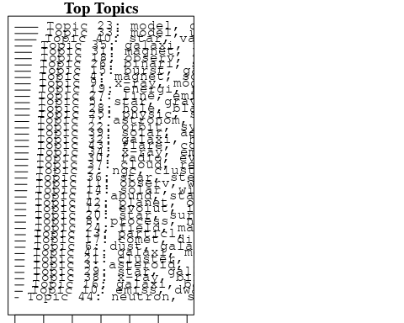

plotQuote(thoughts6, width = 30, main = "Topic 6")  
plotQuote(thoughts18, width = 30, main = "Topic 18")

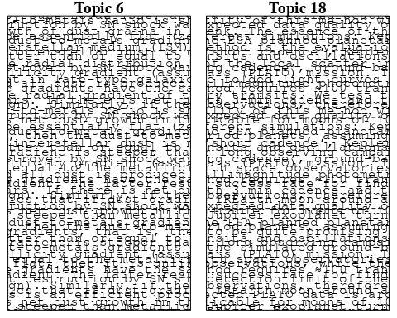

# Calculate and plot the correlation between topics  
mod.out.corr <- topicCorr(Research_topics)  
plot(mod.out.corr, cex = 1.5)  
  
  
# For each topic  
for (topic_num in 1:44) {  
 # Plot the word cloud  
 cloud(Research_topics, topic = topic_num, scale = c(2, 0.25))  
 Sys.sleep(2)  
}

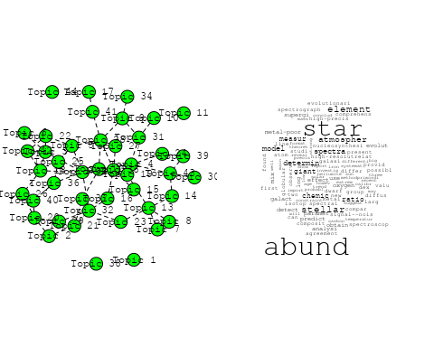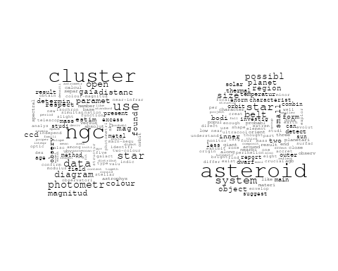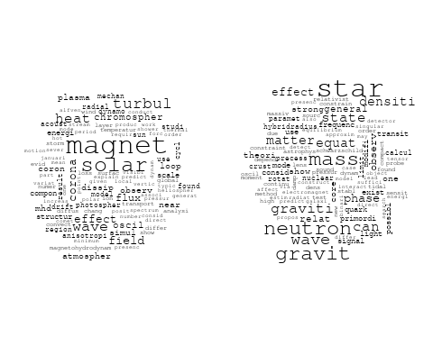

## Warning in wordcloud::wordcloud(words = vocab, freq = vec, max.words =  
## max.words, : univers could not be fit on page. It will not be plotted.

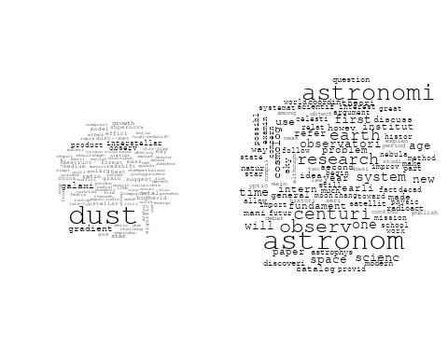

## Warning in wordcloud::wordcloud(words = vocab, freq = vec, max.words =  
## max.words, : x-ray could not be fit on page. It will not be plotted.

## Warning in wordcloud::wordcloud(words = vocab, freq = vec, max.words =  
## max.words, : pulsar could not be fit on page. It will not be plotted.

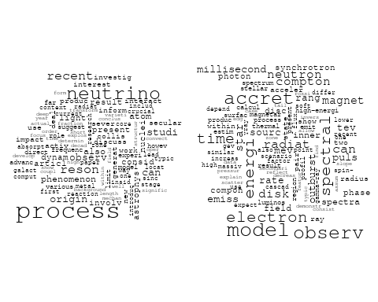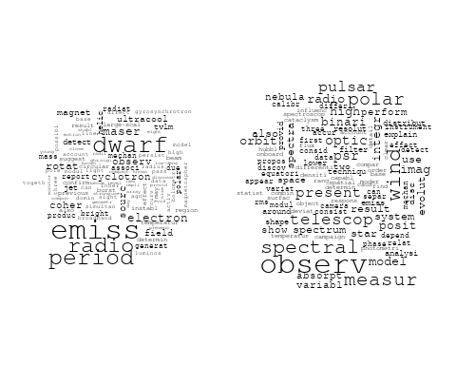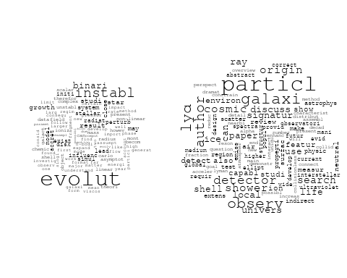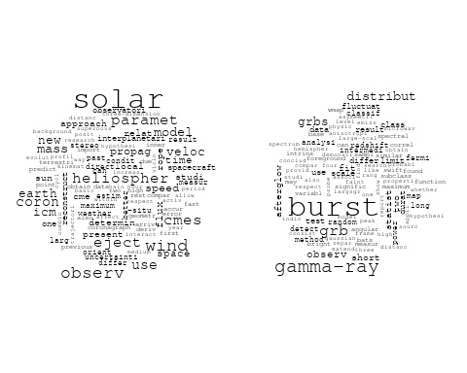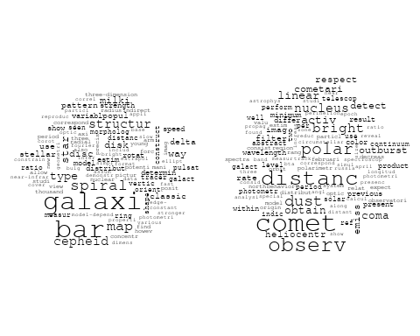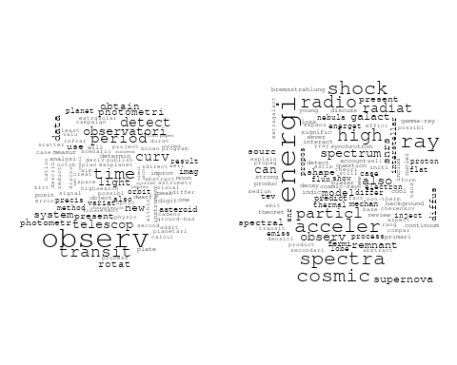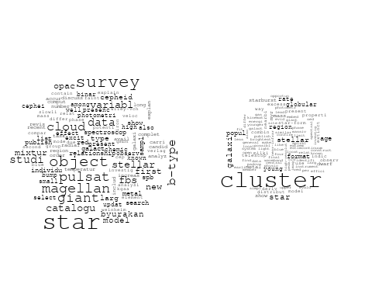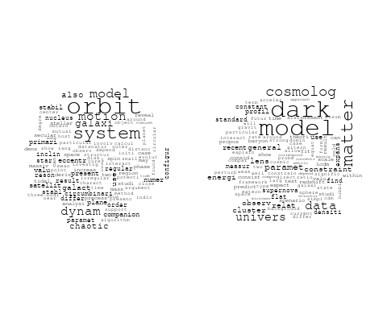

## Warning in wordcloud::wordcloud(words = vocab, freq = vec, max.words =  
## max.words, : astrophys could not be fit on page. It will not be plotted.

## Warning in wordcloud::wordcloud(words = vocab, freq = vec, max.words =  
## max.words, : star could not be fit on page. It will not be plotted.

## Warning in wordcloud::wordcloud(words = vocab, freq = vec, max.words =  
## max.words, : physic could not be fit on page. It will not be plotted.

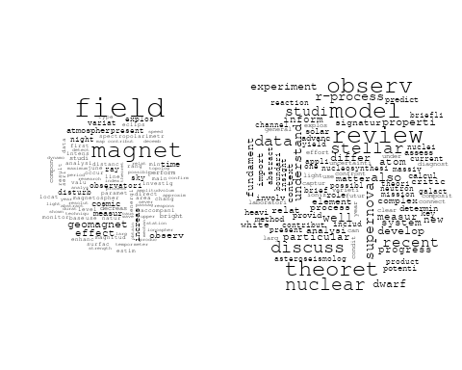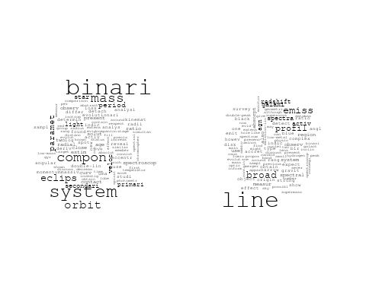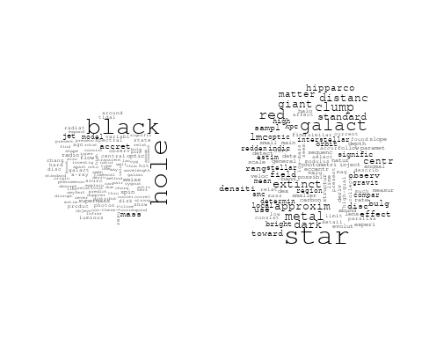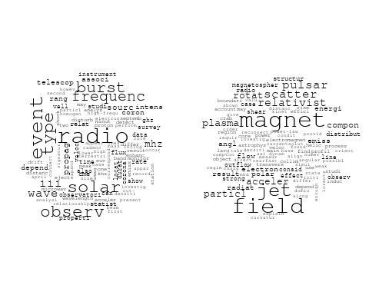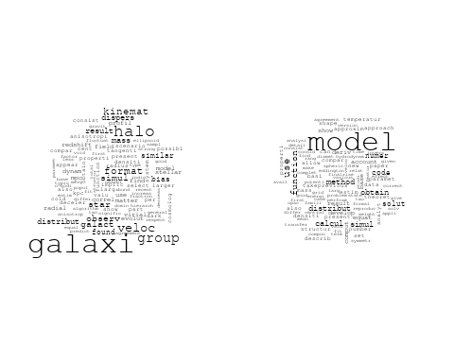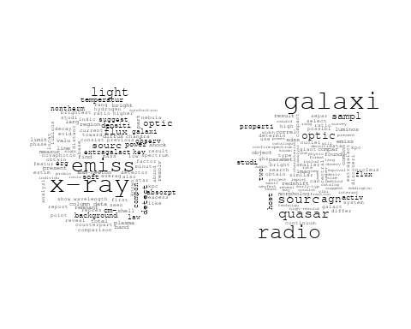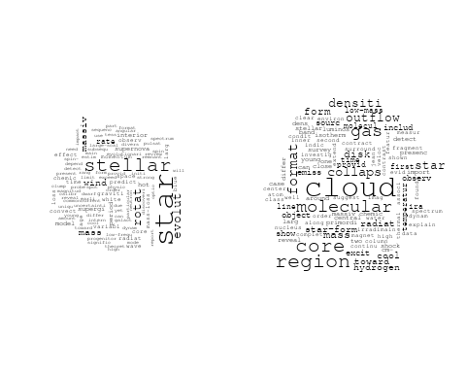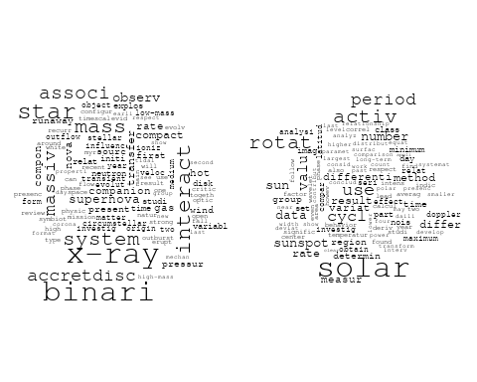

## Warning in wordcloud::wordcloud(words = vocab, freq = vec, max.words =  
## max.words, : merger could not be fit on page. It will not be plotted.

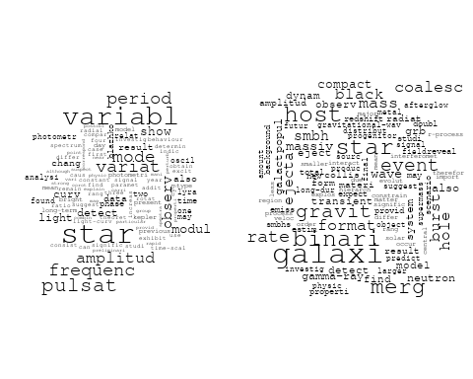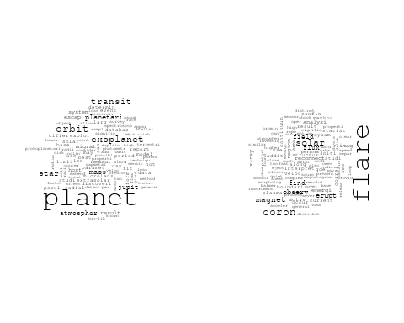

# Get the topic proportions for each document  
topic_proportions <- Research_topics$theta  
  
# Find the index of the topic with the highest proportion for each document  
# This will be the topic that each document is most likely to belong to  
max_topic_idx <- apply(topic_proportions, 1, which.max)  
  
# Add this as a new column to your data  
data_independent$topic <- max_topic_idx  
  
  
  
# Define the intervals  
intervals <- c('1824_1899', '1900_1964', '1965_1974', '1975_1984', '1985_1994', '1995_1999', '2000_2004', '2005_2009', '2010_2014', '2015_2019', '2020_2022')  
colors <- c('pink', 'blue', 'purple', 'yellow', 'green', 'pink', 'orange', 'violet', 'green', 'blue', 'pink')  
  
# Loop through the intervals and plot  
for(i in seq_along(intervals)){  
 # Filter data for when the pub_interval is equal to 1  
 data_filtered <- data_independent[data_independent[[paste0('pub_interval_', intervals[i])]] == 1,]  
   
 # Make the histogram  
   
 p <- ggplot(data_filtered, aes(x = topic)) +  
 geom_histogram(binwidth = 1, fill = colors[i], color = "black") +  
 xlab("Topic") +  
 ylab("Count") +  
 ggtitle(paste0("Topics from year ", gsub("_", " to ", intervals[i])))  
   
 print(p)  
}  
  
  
  
##Topic generation for IT (in collaboration) publications  
  
data_collab <- data[data[["IT"]] != 0,]  
  
# Save the original title data for future use  
data_collab$original_concatenated_title_abstract <- data_collab$concatenated_title_abstract  
  
#pre-processing the titles using textProcessor from the stm package  
processed_text <- textProcessor(data_collab$concatenated_title_abstract, metadata = data_collab)

## Building corpus...   
## Converting to Lower Case...   
## Removing punctuation...   
## Removing stopwords...   
## Removing numbers...   
## Stemming...   
## Creating Output...

# Further prepare the data by removing low-frequency terms  
out_text <- prepDocuments(processed_text$documents, processed_text$vocab, processed_text$meta)

## Removing 2735 of 11623 terms (2735 of 282817 tokens) due to frequency   
## Your corpus now has 3360 documents, 8888 terms and 280082 tokens.

docs_text <- out_text$documents  
vocab_text <- out_text$vocab  
meta_text <- out_text$meta  
  
  
#Prepare data  
plotRemoved(processed_text$documents, lower.thresh = seq(1, 200, by = 100))

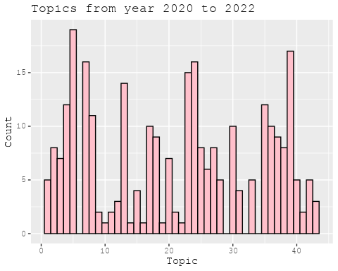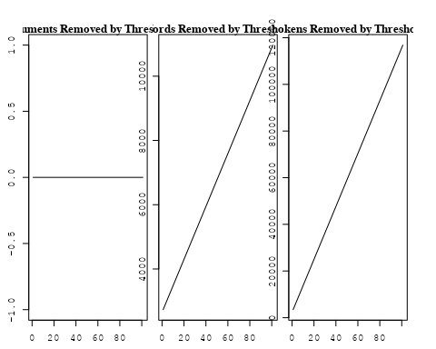

out_text <- prepDocuments(processed_text$documents, processed_text$vocab, processed_text$meta, lower.thresh = 8)

## Removing 8891 of 11623 terms (23275 of 282817 tokens) due to frequency   
## Your corpus now has 3360 documents, 2732 terms and 259542 tokens.

str(out_text$meta)

## 'data.frame': 3360 obs. of 39 variables:  
## $ concept_id : chr "https://openalex.org/C1276947" "https://openalex.org/C1276947" "https://openalex.org/C44870925" "https://openalex.org/C44870925" ...  
## $ work_id : chr "https://openalex.org/W2068317303" "https://openalex.org/W3127045467" "https://openalex.org/W2086348127" "https://openalex.org/W2130580407" ...  
## $ publication_year : int 2004 2021 2007 2011 1999 2001 1990 2009 2007 2011 ...  
## $ title : chr "Arp 299: A Second Merging System with Two Active Nuclei?" "A massive stellar bulge in a regularly rotating galaxy 1.2 billion years after the Big Bang" "Improving Stellar and Planetary Parameters of Transiting Planet Systems: The Case of TrES-2" "Creation of cosmic structure in the complex galaxy cluster merger Abell 2744" ...  
## $ paperabstract : chr "Recent BeppoSAX observations of Arp 299, a powerful far-IR merging starburst system composed of IC 694 and NGC "| __truncated__ "Early assembly of a galaxy disk and bulge Galaxy formation in the early Universe is thought to have been a chao"| __truncated__ "We report on a spectroscopic determination of the atmospheric parameters and chemical abundance of the parent s"| __truncated__ "We present a detailed strong lensing, weak lensing and X-ray analysis of Abell 2744 (z = 0:308), one of the mos"| __truncated__ ...  
## $ country : chr "IT IT IT IT" "GB GB IT GB GB IT" "IT US US US US IT" "US IT" ...  
## $ year_concept : chr "2004+https://openalex.org/C1276947" "2021+https://openalex.org/C1276947" "2007+https://openalex.org/C44870925" "2011+https://openalex.org/C44870925" ...  
## $ concatenated_title_abstract : chr "Arp 299: A Second Merging System with Two Active Nuclei? Recent BeppoSAX observations of Arp 299, a powerful fa"| __truncated__ "A massive stellar bulge in a regularly rotating galaxy 1.2 billion years after the Big Bang Early assembly of a"| __truncated__ "Improving Stellar and Planetary Parameters of Transiting Planet Systems: The Case of TrES-2 We report on a spec"| __truncated__ "Creation of cosmic structure in the complex galaxy cluster merger Abell 2744 We present a detailed strong lensi"| __truncated__ ...  
## $ US : num 0 0 66.7 50 0 ...  
## $ IN : num 0 0 0 0 0 0 0 0 0 0 ...  
## $ DE : num 0 0 0 0 0 ...  
## $ CH : num 0 0 0 0 0 0 0 50 0 0 ...  
## $ GB : num 0 66.7 0 0 0 ...  
## $ CN : num 0 0 0 0 0 0 0 0 0 0 ...  
## $ FR : num 0 0 0 0 0 0 0 0 0 0 ...  
## $ IT : num 100 33.3 33.3 50 100 ...  
## $ RU : num 0 0 0 0 0 0 0 0 0 0 ...  
## $ CA : num 0 0 0 0 0 0 0 0 0 0 ...  
## $ NL : num 0 0 0 0 0 0 0 0 0 0 ...  
## $ AU : num 0 0 0 0 0 0 0 0 0 0 ...  
## $ JP : num 0 0 0 0 0 0 0 0 0 0 ...  
## $ ES : num 0 0 0 0 0 0 0 0 0 0 ...  
## $ IL : num 0 0 0 0 0 0 0 0 0 0 ...  
## $ Americas : num 0 0 0 0 0 0 0 0 0 0 ...  
## $ Europe : num 0 0 0 0 0 ...  
## $ Africa : num 0 0 0 0 0 0 0 0 0 0 ...  
## $ AsiaAndOceania : num 0 0 0 0 0 0 0 0 0 0 ...  
## $ pub_interval_2020_2022 : int 0 1 0 0 0 0 0 0 0 0 ...  
## $ pub_interval_2015_2019 : int 0 0 0 0 0 0 0 0 0 0 ...  
## $ pub_interval_2010_2014 : int 0 0 0 1 0 0 0 0 0 1 ...  
## $ pub_interval_2005_2009 : int 0 0 1 0 0 0 0 1 1 0 ...  
## $ pub_interval_2000_2004 : int 1 0 0 0 0 1 0 0 0 0 ...  
## $ pub_interval_1995_1999 : int 0 0 0 0 1 0 0 0 0 0 ...  
## $ pub_interval_1985_1994 : int 0 0 0 0 0 0 1 0 0 0 ...  
## $ pub_interval_1975_1984 : int 0 0 0 0 0 0 0 0 0 0 ...  
## $ pub_interval_1965_1974 : int 0 0 0 0 0 0 0 0 0 0 ...  
## $ pub_interval_1900_1964 : int 0 0 0 0 0 0 0 0 0 0 ...  
## $ pub_interval_1824_1899 : int 0 0 0 0 0 0 0 0 0 0 ...  
## $ original_concatenated_title_abstract: chr "Arp 299: A Second Merging System with Two Active Nuclei? Recent BeppoSAX observations of Arp 299, a powerful fa"| __truncated__ "A massive stellar bulge in a regularly rotating galaxy 1.2 billion years after the Big Bang Early assembly of a"| __truncated__ "Improving Stellar and Planetary Parameters of Transiting Planet Systems: The Case of TrES-2 We report on a spec"| __truncated__ "Creation of cosmic structure in the complex galaxy cluster merger Abell 2744 We present a detailed strong lensi"| __truncated__ ...

# Initialize an empty formula string  
prevalence_formula_str <- "~"  
  
# Define the publication intervals  
pub_intervals <- c("pub_interval_2020_2022", "pub_interval_2015_2019", "pub_interval_2010_2014",   
 "pub_interval_2005_2009", "pub_interval_2000_2004", "pub_interval_1995_1999",  
 "pub_interval_1985_1994", "pub_interval_1975_1984", "pub_interval_1965_1974",  
 "pub_interval_1900_1964", "pub_interval_1824_1899")  
  
# Add each publication interval to the formula string  
for (interval in pub_intervals) {  
 # add an if statement to handle the first addition (without '+')  
 if (prevalence_formula_str == "~") {  
 prevalence_formula_str <- paste(prevalence_formula_str, interval)  
 } else {  
 prevalence_formula_str <- paste(prevalence_formula_str, "+", interval)  
 }  
}  
  
  
# Convert the string to a formula  
prevalence_formula <- as.formula(prevalence_formula_str)  
print(prevalence_formula)

## ~pub_interval_2020_2022 + pub_interval_2015_2019 + pub_interval_2010_2014 +   
## pub_interval_2005_2009 + pub_interval_2000_2004 + pub_interval_1995_1999 +   
## pub_interval_1985_1994 + pub_interval_1975_1984 + pub_interval_1965_1974 +   
## pub_interval_1900_1964 + pub_interval_1824_1899

# Run STM model  
Research_topics <- stm(documents = out_text$documents,   
 vocab = out_text$vocab,   
 K = 44,   
 prevalence = prevalence_formula,   
 data = out_text$meta,   
 init.type = "Spectral",  
 max.em.its = 1000,  
 gamma.prior = 'L1')

## Beginning Spectral Initialization   
## Calculating the gram matrix...  
## Finding anchor words...  
## ............................................  
## Recovering initialization...  
## ...........................  
## Initialization complete.  
## .....................................................................................................  
## Completed E-Step (3 seconds).   
## Completed M-Step.   
## Completing Iteration 1 (approx. per word bound = -6.572)   
## .....................................................................................................  
## Completed E-Step (3 seconds).   
## Completed M-Step.   
## Completing Iteration 2 (approx. per word bound = -6.299, relative change = 4.150e-02)   
## .....................................................................................................  
## Completed E-Step (3 seconds).   
## Completed M-Step.   
## Completing Iteration 3 (approx. per word bound = -6.235, relative change = 1.016e-02)   
## .....................................................................................................  
## Completed E-Step (2 seconds).   
## Completed M-Step.   
## Completing Iteration 4 (approx. per word bound = -6.210, relative change = 4.008e-03)   
## .....................................................................................................  
## Completed E-Step (2 seconds).   
## Completed M-Step.   
## Completing Iteration 5 (approx. per word bound = -6.197, relative change = 2.068e-03)   
## Topic 1: ray, burst, cosmic, gamma-ray, gamma   
## Topic 2: nova, outburst, day, phase, maximum   
## Topic 3: pulsar, millisecond, accret, period, system   
## Topic 4: spectra, grb, observ, light, featur   
## Topic 5: type, supernova, produc, telescop, space   
## Topic 6: observ, review, theoret, recent, discuss   
## Topic 7: polar, galaxi, ring, angl, photometr   
## Topic 8: star, planet, system, planetari, orbit   
## Topic 9: solar, observ, coron, corona, magnet   
## Topic 10: galaxi, luminos, dwarf, densiti, popul   
## Topic 11: x-ray, kev, observ, spectrum, emiss   
## Topic 12: dwarf, cool, white, gas, univers   
## Topic 13: metal, galaxi, star, host, x-ray   
## Topic 14: supernova, type, sne, rate, progenitor   
## Topic 15: agn, sourc, activ, sampl, x-ray   
## Topic 16: model, evolut, galaxi, format, chemic   
## Topic 17: line, quasar, broad, emiss, sourc   
## Topic 18: galaxi, gas, feedback, simul, wind   
## Topic 19: gravit, wave, detect, will, mission   
## Topic 20: star, neutron, gravit, mass, magnetar   
## Topic 21: cluster, galaxi, mass, x-ray, relat   
## Topic 22: observ, energi, emiss, x-ray, flux   
## Topic 23: cluster, ngc, abund, star, globular   
## Topic 24: redshift, use, survey, distribut, photometr   
## Topic 25: radio, sourc, jet, blazar, object   
## Topic 26: galaxi, ngc, stellar, observ, ellipt   
## Topic 27: microwav, power, background, cmb, cosmic   
## Topic 28: halo, dark, matter, galaxi, mass   
## Topic 29: star, mass, agb, metal, dust   
## Topic 30: distanc, star, cluster, use, data   
## Topic 31: mass, pulsar, observ, model, star   
## Topic 32: line, nebula, observ, mass, cloud   
## Topic 33: background, data, analysi, use, spectral   
## Topic 34: cluster, globular, star, popul, dynam   
## Topic 35: accret, rate, mass, luminos, disk   
## Topic 36: field, magnet, shock, acceler, particl   
## Topic 37: galaxi, mass, stellar, massiv, format   
## Topic 38: radio, sourc, cluster, emiss, two   
## Topic 39: x-ray, star, stellar, activ, observ   
## Topic 40: dark, matter, model, energi, neutrino   
## Topic 41: cluster, galaxi, mass, format, fraction   
## Topic 42: hole, black, binari, mass, merger   
## Topic 43: galact, space, univers, centr, milki   
## Topic 44: associ, supernova, burst, event, grb   
## .....................................................................................................  
## Completed E-Step (2 seconds).   
## Completed M-Step.   
## Completing Iteration 6 (approx. per word bound = -6.189, relative change = 1.256e-03)   
## .....................................................................................................  
## Completed E-Step (2 seconds).   
## Completed M-Step.   
## Completing Iteration 7 (approx. per word bound = -6.184, relative change = 9.004e-04)   
## .....................................................................................................  
## Completed E-Step (2 seconds).   
## Completed M-Step.   
## Completing Iteration 8 (approx. per word bound = -6.180, relative change = 6.663e-04)   
## .....................................................................................................  
## Completed E-Step (2 seconds).   
## Completed M-Step.   
## Completing Iteration 9 (approx. per word bound = -6.176, relative change = 5.422e-04)   
## .....................................................................................................  
## Completed E-Step (3 seconds).   
## Completed M-Step.   
## Completing Iteration 10 (approx. per word bound = -6.173, relative change = 4.814e-04)   
## Topic 1: ray, cosmic, gamma, gamma-ray, energi   
## Topic 2: nova, outburst, day, phase, observ   
## Topic 3: pulsar, millisecond, accret, period, system   
## Topic 4: burst, grb, spectra, light, afterglow   
## Topic 5: type, supernova, produc, telescop, progenitor   
## Topic 6: observ, review, theoret, recent, discuss   
## Topic 7: polar, galaxi, ring, angl, photometr   
## Topic 8: star, planet, system, planetari, orbit   
## Topic 9: solar, observ, coron, corona, magnet   
## Topic 10: galaxi, luminos, dwarf, densiti, popul   
## Topic 11: x-ray, kev, observ, spectrum, sourc   
## Topic 12: dwarf, cool, white, gas, mass   
## Topic 13: metal, galaxi, star, host, relat   
## Topic 14: supernova, type, sne, rate, progenitor   
## Topic 15: agn, sourc, activ, sampl, object   
## Topic 16: model, galaxi, evolut, format, star   
## Topic 17: line, quasar, broad, emiss, region   
## Topic 18: gas, simul, feedback, galaxi, wind   
## Topic 19: gravit, detect, will, mission, wave   
## Topic 20: star, neutron, gravit, magnetar, wave   
## Topic 21: cluster, galaxi, mass, x-ray, relat   
## Topic 22: observ, energi, emiss, x-ray, burst   
## Topic 23: cluster, star, abund, ngc, metal   
## Topic 24: redshift, use, survey, galaxi, estim   
## Topic 25: jet, radio, blazar, sourc, lac   
## Topic 26: galaxi, ngc, stellar, observ, ellipt   
## Topic 27: microwav, power, background, cosmic, cmb   
## Topic 28: halo, dark, matter, galaxi, mass   
## Topic 29: star, mass, dust, agb, metal   
## Topic 30: distanc, star, cluster, use, age   
## Topic 31: mass, observ, model, pulsar, star   
## Topic 32: line, nebula, cloud, mass, planetari   
## Topic 33: background, data, analysi, use, spectral   
## Topic 34: cluster, globular, star, popul, dynam   
## Topic 35: accret, rate, disk, mass, disc   
## Topic 36: field, magnet, shock, acceler, particl   
## Topic 37: galaxi, mass, stellar, format, massiv   
## Topic 38: radio, sourc, cluster, galaxi, emiss   
## Topic 39: star, x-ray, stellar, activ, observ   
## Topic 40: dark, matter, model, energi, cosmolog   
## Topic 41: cluster, galaxi, mass, fraction, group   
## Topic 42: hole, black, mass, binari, massiv   
## Topic 43: galact, univers, milki, way, space   
## Topic 44: burst, associ, supernova, grb, observ   
## .....................................................................................................  
## Completed E-Step (2 seconds).   
## Completed M-Step.   
## Completing Iteration 11 (approx. per word bound = -6.170, relative change = 4.437e-04)   
## .....................................................................................................  
## Completed E-Step (3 seconds).   
## Completed M-Step.   
## Completing Iteration 12 (approx. per word bound = -6.168, relative change = 3.973e-04)   
## .....................................................................................................  
## Completed E-Step (3 seconds).   
## Completed M-Step.   
## Completing Iteration 13 (approx. per word bound = -6.166, relative change = 3.436e-04)   
## .....................................................................................................  
## Completed E-Step (3 seconds).   
## Completed M-Step.   
## Completing Iteration 14 (approx. per word bound = -6.164, relative change = 3.162e-04)   
## .....................................................................................................  
## Completed E-Step (3 seconds).   
## Completed M-Step.   
## Completing Iteration 15 (approx. per word bound = -6.162, relative change = 2.804e-04)   
## Topic 1: ray, cosmic, gamma, energi, gamma-ray   
## Topic 2: nova, outburst, day, phase, observ   
## Topic 3: pulsar, millisecond, accret, system, period   
## Topic 4: burst, grb, grbs, afterglow, light   
## Topic 5: type, supernova, progenitor, produc, telescop   
## Topic 6: observ, review, theoret, discuss, process   
## Topic 7: polar, galaxi, ring, angl, observ   
## Topic 8: system, planet, star, planetari, orbit   
## Topic 9: solar, observ, coron, magnet, corona   
## Topic 10: galaxi, luminos, dwarf, densiti, popul   
## Topic 11: x-ray, kev, observ, spectrum, sourc   
## Topic 12: dwarf, cool, gas, white, star   
## Topic 13: galaxi, metal, star, host, relat   
## Topic 14: supernova, type, sne, rate, progenitor   
## Topic 15: agn, sourc, activ, sampl, object   
## Topic 16: model, galaxi, evolut, format, star   
## Topic 17: line, quasar, broad, emiss, region   
## Topic 18: simul, gas, feedback, galaxi, medium   
## Topic 19: gravit, detect, will, mission, wave   
## Topic 20: star, neutron, gravit, magnetar, wave   
## Topic 21: cluster, galaxi, mass, x-ray, relat   
## Topic 22: observ, energi, emiss, x-ray, flux   
## Topic 23: cluster, star, abund, ngc, metal   
## Topic 24: redshift, survey, use, galaxi, estim   
## Topic 25: jet, blazar, radio, sourc, lac   
## Topic 26: ngc, galaxi, stellar, observ, ellipt   
## Topic 27: microwav, power, background, cosmic, cmb   
## Topic 28: halo, dark, matter, galaxi, mass   
## Topic 29: star, mass, dust, agb, metal   
## Topic 30: distanc, star, cluster, use, age   
## Topic 31: mass, observ, model, pulsar, state   
## Topic 32: line, nebula, cloud, veloc, planetari   
## Topic 33: background, data, analysi, telescop, use   
## Topic 34: cluster, globular, star, popul, dynam   
## Topic 35: accret, rate, disc, disk, mass   
## Topic 36: field, magnet, shock, particl, acceler   
## Topic 37: galaxi, mass, stellar, format, massiv   
## Topic 38: radio, sourc, cluster, galaxi, emiss   
## Topic 39: star, x-ray, stellar, activ, observ   
## Topic 40: dark, matter, model, energi, cosmolog   
## Topic 41: cluster, galaxi, mass, group, fraction   
## Topic 42: hole, black, mass, binari, massiv   
## Topic 43: galact, milki, way, univers, centr   
## Topic 44: supernova, burst, associ, grb, observ   
## .....................................................................................................  
## Completed E-Step (3 seconds).   
## Completed M-Step.   
## Completing Iteration 16 (approx. per word bound = -6.161, relative change = 2.242e-04)   
## .....................................................................................................  
## Completed E-Step (3 seconds).   
## Completed M-Step.   
## Completing Iteration 17 (approx. per word bound = -6.160, relative change = 2.076e-04)   
## .....................................................................................................  
## Completed E-Step (3 seconds).   
## Completed M-Step.   
## Completing Iteration 18 (approx. per word bound = -6.158, relative change = 2.026e-04)   
## .....................................................................................................  
## Completed E-Step (3 seconds).   
## Completed M-Step.   
## Completing Iteration 19 (approx. per word bound = -6.157, relative change = 1.966e-04)   
## .....................................................................................................  
## Completed E-Step (3 seconds).   
## Completed M-Step.   
## Completing Iteration 20 (approx. per word bound = -6.156, relative change = 1.856e-04)   
## Topic 1: ray, cosmic, gamma, energi, diffus   
## Topic 2: nova, outburst, day, observ, phase   
## Topic 3: pulsar, millisecond, accret, system, period   
## Topic 4: burst, grb, grbs, gamma-ray, afterglow   
## Topic 5: type, supernova, progenitor, mass, rate   
## Topic 6: observ, review, theoret, process, discuss   
## Topic 7: polar, galaxi, ring, angl, observ   
## Topic 8: system, planet, star, planetari, orbit   
## Topic 9: solar, observ, coron, magnet, heat   
## Topic 10: galaxi, luminos, dwarf, densiti, star-form   
## Topic 11: x-ray, kev, observ, spectrum, sourc   
## Topic 12: dwarf, cool, gas, white, galaxi   
## Topic 13: galaxi, metal, star, host, relat   
## Topic 14: supernova, sne, type, rate, observ   
## Topic 15: agn, sourc, activ, sampl, object   
## Topic 16: model, galaxi, evolut, format, star   
## Topic 17: line, quasar, broad, emiss, optic   
## Topic 18: simul, gas, feedback, galaxi, medium   
## Topic 19: gravit, detect, will, mission, space   
## Topic 20: star, neutron, gravit, magnetar, wave   
## Topic 21: cluster, galaxi, mass, x-ray, relat   
## Topic 22: observ, energi, flux, emiss, x-ray   
## Topic 23: cluster, star, abund, ngc, metal   
## Topic 24: redshift, survey, galaxi, use, per   
## Topic 25: jet, blazar, radio, sourc, lac   
## Topic 26: ngc, galaxi, stellar, observ, ellipt   
## Topic 27: microwav, power, background, cosmic, cmb   
## Topic 28: halo, dark, matter, galaxi, mass   
## Topic 29: star, mass, dust, agb, abund   
## Topic 30: distanc, star, cluster, use, magnitud   
## Topic 31: mass, model, observ, equat, state   
## Topic 32: line, nebula, veloc, cloud, planetari   
## Topic 33: background, data, telescop, analysi, use   
## Topic 34: cluster, globular, star, popul, dynam   
## Topic 35: accret, disc, rate, disk, mass   
## Topic 36: field, magnet, shock, particl, acceler   
## Topic 37: galaxi, mass, stellar, format, massiv   
## Topic 38: radio, sourc, galaxi, cluster, emiss   
## Topic 39: star, x-ray, stellar, activ, observ   
## Topic 40: dark, matter, model, cosmolog, energi   
## Topic 41: cluster, galaxi, mass, group, fraction   
## Topic 42: hole, black, mass, binari, massiv   
## Topic 43: galact, way, milki, univers, centr   
## Topic 44: supernova, burst, event, associ, grb   
## .....................................................................................................  
## Completed E-Step (3 seconds).   
## Completed M-Step.   
## Completing Iteration 21 (approx. per word bound = -6.155, relative change = 1.594e-04)   
## .....................................................................................................  
## Completed E-Step (3 seconds).   
## Completed M-Step.   
## Completing Iteration 22 (approx. per word bound = -6.154, relative change = 1.602e-04)   
## .....................................................................................................  
## Completed E-Step (3 seconds).   
## Completed M-Step.   
## Completing Iteration 23 (approx. per word bound = -6.153, relative change = 1.501e-04)   
## .....................................................................................................  
## Completed E-Step (3 seconds).   
## Completed M-Step.   
## Completing Iteration 24 (approx. per word bound = -6.152, relative change = 1.391e-04)   
## .....................................................................................................  
## Completed E-Step (3 seconds).   
## Completed M-Step.   
## Completing Iteration 25 (approx. per word bound = -6.151, relative change = 1.261e-04)   
## Topic 1: ray, cosmic, gamma, energi, diffus   
## Topic 2: nova, outburst, day, observ, phase   
## Topic 3: pulsar, millisecond, accret, system, period   
## Topic 4: burst, grb, grbs, gamma-ray, afterglow   
## Topic 5: type, supernova, rate, progenitor, mass   
## Topic 6: observ, review, theoret, discuss, process   
## Topic 7: polar, galaxi, ring, angl, observ   
## Topic 8: system, planet, star, planetari, orbit   
## Topic 9: solar, observ, coron, magnet, event   
## Topic 10: galaxi, luminos, dwarf, densiti, observ   
## Topic 11: x-ray, observ, kev, spectrum, spectral   
## Topic 12: dwarf, gas, cool, white, galaxi   
## Topic 13: galaxi, metal, host, star, mass   
## Topic 14: supernova, type, sne, observ, mass   
## Topic 15: agn, sourc, activ, sampl, object   
## Topic 16: model, galaxi, evolut, format, star   
## Topic 17: line, quasar, broad, emiss, optic   
## Topic 18: simul, gas, feedback, galaxi, medium   
## Topic 19: detect, will, gravit, mission, space   
## Topic 20: star, neutron, gravit, magnetar, wave   
## Topic 21: cluster, galaxi, mass, x-ray, lens   
## Topic 22: observ, energi, flux, emiss, x-ray   
## Topic 23: cluster, star, abund, ngc, metal   
## Topic 24: redshift, survey, galaxi, use, per   
## Topic 25: blazar, jet, radio, lac, sourc   
## Topic 26: ngc, galaxi, stellar, observ, ellipt   
## Topic 27: power, microwav, background, cosmic, cmb   
## Topic 28: halo, dark, matter, galaxi, mass   
## Topic 29: star, mass, dust, abund, agb   
## Topic 30: distanc, star, cluster, use, mag   
## Topic 31: model, mass, equat, observ, state   
## Topic 32: line, veloc, nebula, cloud, core   
## Topic 33: background, data, telescop, analysi, use   
## Topic 34: cluster, globular, star, popul, dynam   
## Topic 35: accret, disc, rate, disk, mass   
## Topic 36: field, magnet, shock, particl, emiss   
## Topic 37: galaxi, mass, stellar, format, massiv   
## Topic 38: radio, sourc, galaxi, emiss, cluster   
## Topic 39: star, x-ray, stellar, activ, young   
## Topic 40: dark, matter, model, cosmolog, energi   
## Topic 41: cluster, galaxi, mass, group, fraction   
## Topic 42: black, hole, mass, binari, massiv   
## Topic 43: galact, way, milki, univers, centr   
## Topic 44: supernova, event, burst, associ, grb   
## .....................................................................................................  
## Completed E-Step (3 seconds).   
## Completed M-Step.   
## Completing Iteration 26 (approx. per word bound = -6.151, relative change = 9.704e-05)   
## .....................................................................................................  
## Completed E-Step (2 seconds).   
## Completed M-Step.   
## Completing Iteration 27 (approx. per word bound = -6.150, relative change = 1.350e-04)   
## .....................................................................................................  
## Completed E-Step (2 seconds).   
## Completed M-Step.   
## Completing Iteration 28 (approx. per word bound = -6.149, relative change = 1.198e-04)   
## .....................................................................................................  
## Completed E-Step (2 seconds).   
## Completed M-Step.   
## Completing Iteration 29 (approx. per word bound = -6.149, relative change = 1.151e-04)   
## .....................................................................................................  
## Completed E-Step (2 seconds).   
## Completed M-Step.   
## Completing Iteration 30 (approx. per word bound = -6.148, relative change = 9.978e-05)   
## Topic 1: ray, cosmic, gamma, energi, acceler   
## Topic 2: nova, outburst, day, observ, phase   
## Topic 3: pulsar, millisecond, accret, system, star   
## Topic 4: burst, grb, grbs, gamma-ray, afterglow   
## Topic 5: rate, supernova, type, progenitor, mass   
## Topic 6: observ, review, theoret, discuss, process   
## Topic 7: polar, galaxi, ring, angl, studi   
## Topic 8: system, planet, star, planetari, orbit   
## Topic 9: solar, observ, coron, magnet, event   
## Topic 10: galaxi, luminos, dwarf, densiti, observ   
## Topic 11: x-ray, observ, kev, spectrum, spectral   
## Topic 12: dwarf, gas, cool, galaxi, white   
## Topic 13: galaxi, metal, host, star, mass   
## Topic 14: supernova, type, sne, observ, spectra   
## Topic 15: agn, sourc, activ, sampl, object   
## Topic 16: model, galaxi, evolut, format, star   
## Topic 17: line, quasar, broad, emiss, optic   
## Topic 18: simul, gas, feedback, galaxi, medium   
## Topic 19: detect, will, mission, space, gravit   
## Topic 20: star, neutron, gravit, magnetar, wave   
## Topic 21: cluster, galaxi, mass, lens, x-ray   
## Topic 22: observ, energi, flux, x-ray, emiss   
## Topic 23: cluster, star, abund, ngc, metal   
## Topic 24: redshift, survey, per, galaxi, use   
## Topic 25: blazar, jet, radio, lac, object   
## Topic 26: ngc, galaxi, stellar, observ, ellipt   
## Topic 27: power, microwav, background, cosmic, cmb   
## Topic 28: halo, dark, matter, mass, galaxi   
## Topic 29: star, mass, dust, abund, agb   
## Topic 30: distanc, star, cluster, use, mag   
## Topic 31: model, mass, equat, observ, analyt   
## Topic 32: line, veloc, nebula, cloud, core   
## Topic 33: background, data, telescop, analysi, use   
## Topic 34: cluster, globular, star, popul, dynam   
## Topic 35: accret, disc, rate, disk, mass   
## Topic 36: field, magnet, shock, particl, emiss   
## Topic 37: galaxi, stellar, mass, massiv, format   
## Topic 38: radio, sourc, galaxi, emiss, cluster   
## Topic 39: star, x-ray, stellar, activ, young   
## Topic 40: dark, matter, model, cosmolog, energi   
## Topic 41: cluster, galaxi, mass, group, fraction   
## Topic 42: black, hole, mass, binari, massiv   
## Topic 43: galact, way, milki, univers, centr   
## Topic 44: supernova, burst, event, grbs, associ   
## .....................................................................................................  
## Completed E-Step (2 seconds).   
## Completed M-Step.   
## Completing Iteration 31 (approx. per word bound = -6.147, relative change = 9.762e-05)   
## .....................................................................................................  
## Completed E-Step (2 seconds).   
## Completed M-Step.   
## Completing Iteration 32 (approx. per word bound = -6.147, relative change = 8.465e-05)   
## .....................................................................................................  
## Completed E-Step (2 seconds).   
## Completed M-Step.   
## Completing Iteration 33 (approx. per word bound = -6.146, relative change = 7.797e-05)   
## .....................................................................................................  
## Completed E-Step (2 seconds).   
## Completed M-Step.   
## Completing Iteration 34 (approx. per word bound = -6.146, relative change = 7.056e-05)   
## .....................................................................................................  
## Completed E-Step (2 seconds).   
## Completed M-Step.   
## Completing Iteration 35 (approx. per word bound = -6.146, relative change = 5.172e-05)   
## Topic 1: ray, cosmic, energi, gamma, acceler   
## Topic 2: nova, outburst, day, observ, phase   
## Topic 3: pulsar, millisecond, accret, system, star   
## Topic 4: burst, grb, grbs, gamma-ray, afterglow   
## Topic 5: rate, supernova, type, progenitor, mass   
## Topic 6: observ, review, theoret, discuss, process   
## Topic 7: polar, galaxi, ring, angl, observ   
## Topic 8: system, planet, star, planetari, orbit   
## Topic 9: solar, observ, coron, magnet, event   
## Topic 10: galaxi, luminos, dwarf, densiti, observ   
## Topic 11: x-ray, observ, kev, spectrum, spectral   
## Topic 12: dwarf, gas, cool, galaxi, white   
## Topic 13: galaxi, metal, host, star, mass   
## Topic 14: supernova, type, sne, observ, spectra   
## Topic 15: agn, sourc, activ, sampl, object   
## Topic 16: model, galaxi, format, evolut, star   
## Topic 17: line, quasar, broad, optic, emiss   
## Topic 18: simul, gas, feedback, medium, galaxi   
## Topic 19: detect, will, mission, space, gravit   
## Topic 20: star, neutron, gravit, wave, magnetar   
## Topic 21: cluster, galaxi, mass, lens, x-ray   
## Topic 22: observ, energi, flux, x-ray, flare   
## Topic 23: cluster, star, abund, metal, ngc   
## Topic 24: redshift, survey, per, galaxi, use   
## Topic 25: blazar, jet, lac, energi, radio   
## Topic 26: ngc, galaxi, stellar, observ, ellipt   
## Topic 27: power, background, microwav, cosmic, cmb   
## Topic 28: halo, dark, matter, mass, galaxi   
## Topic 29: star, mass, dust, abund, metal   
## Topic 30: distanc, star, cluster, use, mag   
## Topic 31: model, equat, mass, analyt, state   
## Topic 32: line, nebula, veloc, cloud, core   
## Topic 33: background, data, analysi, telescop, use   
## Topic 34: cluster, globular, star, popul, dynam   
## Topic 35: accret, disc, rate, disk, mass   
## Topic 36: field, magnet, shock, emiss, particl   
## Topic 37: galaxi, stellar, mass, massiv, format   
## Topic 38: radio, sourc, galaxi, emiss, merger   
## Topic 39: star, x-ray, stellar, activ, young   
## Topic 40: dark, matter, model, cosmolog, energi   
## Topic 41: cluster, galaxi, mass, group, fraction   
## Topic 42: black, hole, binari, mass, merger   
## Topic 43: galact, way, milki, univers, centr   
## Topic 44: supernova, burst, event, grbs, grb   
## .....................................................................................................  
## Completed E-Step (2 seconds).   
## Completed M-Step.   
## Completing Iteration 36 (approx. per word bound = -6.145, relative change = 8.179e-05)   
## .....................................................................................................  
## Completed E-Step (2 seconds).   
## Completed M-Step.   
## Completing Iteration 37 (approx. per word bound = -6.145, relative change = 4.762e-05)   
## .....................................................................................................  
## Completed E-Step (2 seconds).   
## Completed M-Step.   
## Completing Iteration 38 (approx. per word bound = -6.144, relative change = 6.115e-05)   
## .....................................................................................................  
## Completed E-Step (2 seconds).   
## Completed M-Step.   
## Completing Iteration 39 (approx. per word bound = -6.144, relative change = 3.958e-05)   
## .....................................................................................................  
## Completed E-Step (2 seconds).   
## Completed M-Step.   
## Completing Iteration 40 (approx. per word bound = -6.144, relative change = 6.645e-05)   
## Topic 1: ray, cosmic, acceler, energi, gamma   
## Topic 2: nova, outburst, day, observ, phase   
## Topic 3: pulsar, millisecond, accret, system, star   
## Topic 4: burst, grb, grbs, gamma-ray, afterglow   
## Topic 5: rate, supernova, type, progenitor, mass   
## Topic 6: observ, review, discuss, theoret, process   
## Topic 7: polar, galaxi, ring, angl, studi   
## Topic 8: system, planet, star, planetari, orbit   
## Topic 9: solar, observ, coron, magnet, event   
## Topic 10: galaxi, luminos, densiti, dwarf, observ   
## Topic 11: x-ray, observ, kev, spectrum, spectral   
## Topic 12: dwarf, gas, galaxi, cool, white   
## Topic 13: galaxi, metal, host, star, mass   
## Topic 14: supernova, type, sne, observ, spectra   
## Topic 15: agn, sourc, activ, object, sampl   
## Topic 16: model, galaxi, format, evolut, star   
## Topic 17: line, quasar, broad, optic, emiss   
## Topic 18: simul, gas, feedback, medium, galaxi   
## Topic 19: detect, will, mission, space, astrophys   
## Topic 20: star, neutron, gravit, wave, magnetar   
## Topic 21: cluster, galaxi, mass, lens, x-ray   
## Topic 22: observ, energi, flux, x-ray, flare   
## Topic 23: cluster, star, metal, abund, ngc   
## Topic 24: redshift, survey, per, galaxi, use   
## Topic 25: blazar, jet, lac, energi, object   
## Topic 26: ngc, galaxi, stellar, observ, ellipt   
## Topic 27: power, background, microwav, cosmic, cmb   
## Topic 28: halo, dark, matter, mass, galaxi   
## Topic 29: star, mass, dust, abund, metal   
## Topic 30: distanc, star, cluster, use, mag   
## Topic 31: model, equat, mass, analyt, use   
## Topic 32: line, nebula, veloc, cloud, core   
## Topic 33: background, data, analysi, telescop, use   
## Topic 34: cluster, globular, star, popul, dynam   
## Topic 35: accret, disc, rate, disk, mass   
## Topic 36: field, magnet, shock, emiss, particl   
## Topic 37: galaxi, stellar, mass, massiv, early-typ   
## Topic 38: radio, sourc, galaxi, emiss, jet   
## Topic 39: star, x-ray, stellar, activ, young   
## Topic 40: dark, matter, model, cosmolog, energi   
## Topic 41: cluster, galaxi, mass, group, fraction   
## Topic 42: black, hole, mass, binari, massiv   
## Topic 43: galact, way, milki, univers, centr   
## Topic 44: burst, supernova, event, grb, grbs   
## .....................................................................................................  
## Completed E-Step (2 seconds).   
## Completed M-Step.   
## Completing Iteration 41 (approx. per word bound = -6.143, relative change = 5.439e-05)   
## .....................................................................................................  
## Completed E-Step (2 seconds).   
## Completed M-Step.   
## Completing Iteration 42 (approx. per word bound = -6.143, relative change = 5.325e-05)   
## .....................................................................................................  
## Completed E-Step (2 seconds).   
## Completed M-Step.   
## Completing Iteration 43 (approx. per word bound = -6.143, relative change = 2.806e-05)   
## .....................................................................................................  
## Completed E-Step (2 seconds).   
## Completed M-Step.   
## Completing Iteration 44 (approx. per word bound = -6.143, relative change = 7.452e-05)   
## .....................................................................................................  
## Completed E-Step (2 seconds).   
## Completed M-Step.   
## Completing Iteration 45 (approx. per word bound = -6.142, relative change = 4.751e-05)   
## Topic 1: ray, cosmic, acceler, energi, gamma   
## Topic 2: nova, outburst, day, observ, phase   
## Topic 3: pulsar, millisecond, accret, system, star   
## Topic 4: burst, grb, grbs, gamma-ray, afterglow   
## Topic 5: rate, supernova, type, progenitor, mass   
## Topic 6: observ, review, discuss, theoret, process   
## Topic 7: polar, galaxi, ring, angl, studi   
## Topic 8: system, planet, star, planetari, orbit   
## Topic 9: solar, observ, coron, magnet, event   
## Topic 10: galaxi, luminos, densiti, dwarf, observ   
## Topic 11: x-ray, observ, kev, spectrum, spectral   
## Topic 12: dwarf, gas, galaxi, cool, white   
## Topic 13: galaxi, metal, host, star, mass   
## Topic 14: type, supernova, sne, observ, spectra   
## Topic 15: agn, sourc, activ, object, galaxi   
## Topic 16: model, galaxi, format, evolut, star   
## Topic 17: line, quasar, broad, optic, emiss   
## Topic 18: simul, gas, feedback, medium, galaxi   
## Topic 19: detect, will, mission, space, astrophys   
## Topic 20: star, neutron, gravit, wave, magnetar   
## Topic 21: cluster, galaxi, mass, lens, x-ray   
## Topic 22: observ, energi, flux, x-ray, flare   
## Topic 23: cluster, star, metal, abund, ngc   
## Topic 24: redshift, survey, per, galaxi, use   
## Topic 25: blazar, jet, lac, energi, object   
## Topic 26: ngc, galaxi, stellar, observ, ellipt   
## Topic 27: power, background, microwav, cosmic, cmb   
## Topic 28: halo, dark, matter, mass, galaxi   
## Topic 29: star, mass, dust, abund, metal   
## Topic 30: distanc, star, cluster, use, mag   
## Topic 31: model, equat, mass, analyt, use   
## Topic 32: line, nebula, core, cloud, veloc   
## Topic 33: background, data, analysi, telescop, use   
## Topic 34: cluster, globular, star, popul, dynam   
## Topic 35: accret, disc, rate, disk, mass   
## Topic 36: field, magnet, shock, emiss, particl   
## Topic 37: galaxi, stellar, mass, early-typ, massiv   
## Topic 38: radio, sourc, galaxi, emiss, jet   
## Topic 39: star, x-ray, stellar, activ, young   
## Topic 40: dark, matter, model, cosmolog, energi   
## Topic 41: cluster, galaxi, group, mass, morpholog   
## Topic 42: black, hole, mass, binari, massiv   
## Topic 43: galact, way, milki, univers, centr   
## Topic 44: burst, supernova, event, grb, associ   
## .....................................................................................................  
## Completed E-Step (2 seconds).   
## Completed M-Step.   
## Completing Iteration 46 (approx. per word bound = -6.142, relative change = 3.642e-05)   
## .....................................................................................................  
## Completed E-Step (2 seconds).   
## Completed M-Step.   
## Completing Iteration 47 (approx. per word bound = -6.142, relative change = 3.886e-05)   
## .....................................................................................................  
## Completed E-Step (2 seconds).   
## Completed M-Step.   
## Completing Iteration 48 (approx. per word bound = -6.141, relative change = 4.185e-05)   
## .....................................................................................................  
## Completed E-Step (2 seconds).   
## Completed M-Step.   
## Completing Iteration 49 (approx. per word bound = -6.141, relative change = 4.411e-05)   
## .....................................................................................................  
## Completed E-Step (2 seconds).   
## Completed M-Step.   
## Completing Iteration 50 (approx. per word bound = -6.141, relative change = 4.302e-05)   
## Topic 1: ray, cosmic, acceler, energi, gamma   
## Topic 2: nova, outburst, day, observ, phase   
## Topic 3: pulsar, millisecond, accret, system, star   
## Topic 4: burst, grb, grbs, gamma-ray, afterglow   
## Topic 5: rate, supernova, type, progenitor, mass   
## Topic 6: observ, review, discuss, theoret, process   
## Topic 7: polar, galaxi, ring, angl, observ   
## Topic 8: system, planet, star, planetari, orbit   
## Topic 9: solar, observ, coron, magnet, heat   
## Topic 10: galaxi, luminos, densiti, observ, dwarf   
## Topic 11: x-ray, observ, kev, spectrum, spectral   
## Topic 12: dwarf, gas, galaxi, cool, star   
## Topic 13: galaxi, metal, host, star, mass   
## Topic 14: type, supernova, sne, observ, light   
## Topic 15: agn, sourc, activ, object, galaxi   
## Topic 16: model, galaxi, format, evolut, star   
## Topic 17: line, quasar, broad, optic, emiss   
## Topic 18: simul, gas, feedback, medium, galaxi   
## Topic 19: detect, will, mission, space, astrophys   
## Topic 20: star, neutron, gravit, wave, magnetar   
## Topic 21: cluster, galaxi, mass, x-ray, lens   
## Topic 22: observ, energi, flux, x-ray, flare   
## Topic 23: cluster, star, metal, abund, ngc   
## Topic 24: redshift, survey, per, galaxi, cent   
## Topic 25: blazar, jet, energi, lac, object   
## Topic 26: ngc, galaxi, stellar, observ, ellipt   
## Topic 27: power, background, microwav, cosmic, cmb   
## Topic 28: halo, dark, matter, mass, galaxi   
## Topic 29: star, mass, dust, abund, metal   
## Topic 30: distanc, star, cluster, use, mag   
## Topic 31: model, equat, mass, analyt, state   
## Topic 32: line, core, nebula, cloud, veloc   
## Topic 33: background, data, analysi, telescop, use   
## Topic 34: cluster, globular, star, popul, dynam   
## Topic 35: accret, disc, disk, rate, mass   
## Topic 36: field, magnet, shock, emiss, electron   
## Topic 37: galaxi, stellar, mass, early-typ, massiv   
## Topic 38: radio, sourc, galaxi, emiss, jet   
## Topic 39: star, x-ray, stellar, activ, young   
## Topic 40: dark, matter, model, cosmolog, energi   
## Topic 41: cluster, galaxi, group, mass, morpholog   
## Topic 42: black, hole, mass, binari, massiv   
## Topic 43: galact, way, milki, univers, centr   
## Topic 44: burst, supernova, event, grb, associ   
## .....................................................................................................  
## Completed E-Step (2 seconds).   
## Completed M-Step.   
## Completing Iteration 51 (approx. per word bound = -6.141, relative change = 1.382e-05)   
## .....................................................................................................  
## Completed E-Step (2 seconds).   
## Completed M-Step.   
## Completing Iteration 52 (approx. per word bound = -6.140, relative change = 6.410e-05)   
## .....................................................................................................  
## Completed E-Step (2 seconds).   
## Completed M-Step.   
## Completing Iteration 53 (approx. per word bound = -6.140, relative change = 4.362e-05)   
## .....................................................................................................  
## Completed E-Step (2 seconds).   
## Completed M-Step.   
## Completing Iteration 54 (approx. per word bound = -6.140, relative change = 4.175e-05)   
## .....................................................................................................  
## Completed E-Step (2 seconds).   
## Completed M-Step.   
## Completing Iteration 55 (approx. per word bound = -6.140, relative change = 3.938e-05)   
## Topic 1: ray, cosmic, acceler, energi, gamma   
## Topic 2: nova, outburst, day, observ, phase   
## Topic 3: pulsar, millisecond, accret, system, star   
## Topic 4: burst, grb, grbs, gamma-ray, afterglow   
## Topic 5: rate, supernova, type, progenitor, mass   
## Topic 6: observ, review, discuss, theoret, process   
## Topic 7: polar, galaxi, ring, angl, studi   
## Topic 8: system, planet, star, planetari, orbit   
## Topic 9: solar, observ, coron, magnet, heat   
## Topic 10: galaxi, luminos, densiti, observ, dwarf   
## Topic 11: x-ray, observ, kev, spectrum, spectral   
## Topic 12: dwarf, gas, galaxi, star, cool   
## Topic 13: galaxi, metal, host, star, mass   
## Topic 14: type, supernova, sne, light, observ   
## Topic 15: agn, sourc, activ, object, galaxi   
## Topic 16: model, galaxi, format, evolut, star   
## Topic 17: line, quasar, broad, optic, emiss   
## Topic 18: simul, gas, feedback, medium, galaxi   
## Topic 19: detect, will, mission, space, observ   
## Topic 20: star, neutron, gravit, wave, frequenc   
## Topic 21: cluster, galaxi, mass, x-ray, lens   
## Topic 22: observ, energi, x-ray, flux, flare   
## Topic 23: cluster, star, metal, abund, ngc   
## Topic 24: redshift, survey, per, galaxi, cent   
## Topic 25: blazar, jet, energi, lac, object   
## Topic 26: ngc, galaxi, stellar, observ, gas   
## Topic 27: power, background, microwav, cosmic, cmb   
## Topic 28: halo, dark, matter, mass, galaxi   
## Topic 29: star, mass, dust, abund, metal   
## Topic 30: distanc, star, cluster, use, mag   
## Topic 31: model, equat, mass, analyt, state   
## Topic 32: line, core, nebula, cloud, veloc   
## Topic 33: background, data, analysi, telescop, use   
## Topic 34: cluster, globular, star, popul, dynam   
## Topic 35: accret, disc, disk, rate, mass   
## Topic 36: field, magnet, shock, emiss, electron   
## Topic 37: galaxi, stellar, mass, early-typ, massiv   
## Topic 38: radio, sourc, emiss, galaxi, jet   
## Topic 39: star, x-ray, stellar, activ, young   
## Topic 40: dark, matter, model, cosmolog, energi   
## Topic 41: cluster, galaxi, group, mass, morpholog   
## Topic 42: black, hole, mass, binari, massiv   
## Topic 43: galact, way, milki, univers, centr   
## Topic 44: burst, supernova, event, grb, associ   
## .....................................................................................................  
## Completed E-Step (2 seconds).   
## Completed M-Step.   
## Completing Iteration 56 (approx. per word bound = -6.140, relative change = 1.775e-05)   
## .....................................................................................................  
## Completed E-Step (2 seconds).   
## Completed M-Step.   
## Completing Iteration 57 (approx. per word bound = -6.139, relative change = 3.939e-05)   
## .....................................................................................................  
## Completed E-Step (2 seconds).   
## Completed M-Step.   
## Completing Iteration 58 (approx. per word bound = -6.139, relative change = 2.922e-05)   
## .....................................................................................................  
## Completed E-Step (2 seconds).   
## Completed M-Step.   
## Completing Iteration 59 (approx. per word bound = -6.139, relative change = 2.561e-05)   
## .....................................................................................................  
## Completed E-Step (2 seconds).   
## Completed M-Step.   
## Completing Iteration 60 (approx. per word bound = -6.139, relative change = 2.728e-05)   
## Topic 1: ray, cosmic, acceler, energi, gamma   
## Topic 2: nova, outburst, day, observ, phase   
## Topic 3: pulsar, millisecond, accret, system, star   
## Topic 4: burst, grb, grbs, gamma-ray, afterglow   
## Topic 5: rate, supernova, type, progenitor, mass   
## Topic 6: observ, review, discuss, theoret, process   
## Topic 7: polar, galaxi, ring, angl, studi   
## Topic 8: system, planet, star, planetari, orbit   
## Topic 9: solar, observ, coron, magnet, heat   
## Topic 10: galaxi, luminos, densiti, observ, dwarf   
## Topic 11: x-ray, observ, kev, spectrum, spectral   
## Topic 12: dwarf, gas, galaxi, star, white   
## Topic 13: galaxi, metal, host, star, mass   
## Topic 14: type, supernova, sne, light, observ   
## Topic 15: agn, sourc, activ, galaxi, object   
## Topic 16: model, galaxi, format, evolut, star   
## Topic 17: line, quasar, broad, optic, emiss   
## Topic 18: simul, gas, feedback, medium, galaxi   
## Topic 19: detect, will, mission, space, observ   
## Topic 20: star, neutron, gravit, wave, frequenc   
## Topic 21: cluster, galaxi, mass, x-ray, lens   
## Topic 22: observ, energi, x-ray, flux, flare   
## Topic 23: cluster, star, metal, abund, ngc   
## Topic 24: redshift, survey, per, galaxi, cent   
## Topic 25: blazar, jet, energi, lac, object   
## Topic 26: ngc, galaxi, stellar, observ, gas   
## Topic 27: power, background, microwav, cosmic, cmb   
## Topic 28: halo, dark, matter, mass, galaxi   
## Topic 29: star, mass, dust, abund, metal   
## Topic 30: distanc, star, cluster, use, mag   
## Topic 31: model, equat, mass, analyt, state   
## Topic 32: line, core, cloud, nebula, veloc   
## Topic 33: background, data, analysi, use, telescop   
## Topic 34: cluster, globular, star, popul, dynam   
## Topic 35: accret, disc, disk, rate, mass   
## Topic 36: field, magnet, shock, emiss, electron   
## Topic 37: galaxi, stellar, mass, early-typ, massiv   
## Topic 38: radio, sourc, emiss, jet, galaxi   
## Topic 39: star, x-ray, stellar, activ, young   
## Topic 40: dark, matter, model, cosmolog, energi   
## Topic 41: cluster, galaxi, group, mass, morpholog   
## Topic 42: black, hole, mass, binari, massiv   
## Topic 43: galact, way, milki, univers, centr   
## Topic 44: burst, supernova, event, grb, associ   
## .....................................................................................................  
## Completed E-Step (2 seconds).   
## Completed M-Step.   
## Completing Iteration 61 (approx. per word bound = -6.139, relative change = 2.704e-05)   
## .....................................................................................................  
## Completed E-Step (2 seconds).   
## Completed M-Step.   
## Completing Iteration 62 (approx. per word bound = -6.139, relative change = 2.593e-05)   
## .....................................................................................................  
## Completed E-Step (2 seconds).   
## Completed M-Step.   
## Completing Iteration 63 (approx. per word bound = -6.138, relative change = 2.523e-05)   
## .....................................................................................................  
## Completed E-Step (2 seconds).   
## Completed M-Step.   
## Completing Iteration 64 (approx. per word bound = -6.138, relative change = 2.729e-05)   
## .....................................................................................................  
## Completed E-Step (2 seconds).   
## Completed M-Step.   
## Completing Iteration 65 (approx. per word bound = -6.138, relative change = 3.255e-05)   
## Topic 1: ray, cosmic, acceler, energi, gamma   
## Topic 2: nova, outburst, day, observ, phase   
## Topic 3: pulsar, millisecond, accret, system, star   
## Topic 4: burst, grb, grbs, gamma-ray, afterglow   
## Topic 5: rate, supernova, type, progenitor, mass   
## Topic 6: observ, review, discuss, theoret, process   
## Topic 7: polar, galaxi, ring, angl, studi   
## Topic 8: system, planet, star, planetari, orbit   
## Topic 9: solar, observ, coron, magnet, heat   
## Topic 10: galaxi, luminos, densiti, observ, dwarf   
## Topic 11: x-ray, observ, kev, spectrum, spectral   
## Topic 12: dwarf, gas, galaxi, star, white   
## Topic 13: galaxi, metal, host, star, mass   
## Topic 14: type, supernova, sne, light, observ   
## Topic 15: agn, sourc, activ, galaxi, object   
## Topic 16: model, galaxi, format, evolut, star   
## Topic 17: line, quasar, broad, optic, emiss   
## Topic 18: simul, gas, feedback, medium, cool   
## Topic 19: detect, will, mission, space, observ   
## Topic 20: star, neutron, gravit, wave, frequenc   
## Topic 21: cluster, galaxi, mass, x-ray, lens   
## Topic 22: observ, energi, x-ray, flux, flare   
## Topic 23: cluster, star, metal, abund, ngc   
## Topic 24: redshift, survey, per, galaxi, cent   
## Topic 25: blazar, jet, energi, lac, spectral   
## Topic 26: ngc, galaxi, stellar, observ, gas   
## Topic 27: power, background, microwav, cosmic, cmb   
## Topic 28: halo, dark, matter, mass, galaxi   
## Topic 29: star, dust, mass, abund, metal   
## Topic 30: distanc, star, cluster, use, mag   
## Topic 31: model, equat, mass, analyt, state   
## Topic 32: line, core, nebula, cloud, veloc   
## Topic 33: background, data, analysi, use, telescop   
## Topic 34: cluster, globular, star, popul, dynam   
## Topic 35: accret, disc, disk, rate, mass   
## Topic 36: field, magnet, shock, emiss, electron   
## Topic 37: galaxi, stellar, mass, early-typ, massiv   
## Topic 38: radio, sourc, jet, emiss, galaxi   
## Topic 39: star, x-ray, stellar, activ, observ   
## Topic 40: dark, matter, model, cosmolog, energi   
## Topic 41: cluster, galaxi, group, mass, morpholog   
## Topic 42: black, hole, mass, binari, merger   
## Topic 43: galact, way, milki, univers, centr   
## Topic 44: burst, supernova, event, grb, associ   
## .....................................................................................................  
## Completed E-Step (2 seconds).   
## Completed M-Step.   
## Completing Iteration 66 (approx. per word bound = -6.138, relative change = 3.518e-05)   
## .....................................................................................................  
## Completed E-Step (2 seconds).   
## Completed M-Step.   
## Completing Iteration 67 (approx. per word bound = -6.138, relative change = 3.068e-05)   
## .....................................................................................................  
## Completed E-Step (2 seconds).   
## Completed M-Step.   
## Completing Iteration 68 (approx. per word bound = -6.137, relative change = 2.118e-05)   
## .....................................................................................................  
## Completed E-Step (2 seconds).   
## Completed M-Step.   
## Completing Iteration 69 (approx. per word bound = -6.137, relative change = 2.082e-05)   
## .....................................................................................................  
## Completed E-Step (2 seconds).   
## Completed M-Step.   
## Completing Iteration 70 (approx. per word bound = -6.137, relative change = 1.934e-05)   
## Topic 1: ray, cosmic, acceler, energi, gamma   
## Topic 2: nova, outburst, day, observ, phase   
## Topic 3: pulsar, millisecond, accret, system, star   
## Topic 4: burst, grb, grbs, gamma-ray, afterglow   
## Topic 5: rate, supernova, type, progenitor, mass   
## Topic 6: observ, review, discuss, theoret, process   
## Topic 7: polar, galaxi, ring, angl, studi   
## Topic 8: planet, system, star, planetari, orbit   
## Topic 9: solar, observ, coron, magnet, heat   
## Topic 10: galaxi, luminos, observ, densiti, dwarf   
## Topic 11: x-ray, observ, kev, spectrum, spectral   
## Topic 12: dwarf, gas, galaxi, star, white   
## Topic 13: galaxi, metal, host, star, mass   
## Topic 14: type, supernova, sne, light, observ   
## Topic 15: agn, sourc, activ, galaxi, object   
## Topic 16: model, galaxi, format, evolut, star   
## Topic 17: line, quasar, broad, optic, emiss   
## Topic 18: simul, gas, feedback, medium, galaxi   
## Topic 19: detect, will, mission, space, observ   
## Topic 20: star, neutron, gravit, wave, frequenc   
## Topic 21: cluster, galaxi, mass, x-ray, lens   
## Topic 22: observ, energi, x-ray, flux, flare   
## Topic 23: cluster, star, abund, metal, ngc   
## Topic 24: redshift, survey, per, galaxi, cent   
## Topic 25: blazar, jet, energi, lac, spectral   
## Topic 26: ngc, galaxi, stellar, observ, gas   
## Topic 27: power, background, microwav, cosmic, cmb   
## Topic 28: halo, dark, mass, matter, galaxi   
## Topic 29: star, dust, mass, abund, metal   
## Topic 30: distanc, star, cluster, use, age   
## Topic 31: model, equat, mass, analyt, state   
## Topic 32: line, core, cloud, nebula, veloc   
## Topic 33: background, data, analysi, use, telescop   
## Topic 34: cluster, globular, star, popul, dynam   
## Topic 35: accret, disc, disk, rate, mass   
## Topic 36: field, magnet, shock, emiss, electron   
## Topic 37: galaxi, stellar, mass, massiv, etg   
## Topic 38: radio, sourc, jet, emiss, galaxi   
## Topic 39: star, x-ray, stellar, activ, observ   
## Topic 40: dark, matter, model, cosmolog, energi   
## Topic 41: cluster, galaxi, group, mass, morpholog   
## Topic 42: black, hole, mass, binari, merger   
## Topic 43: galact, way, milki, univers, centr   
## Topic 44: burst, supernova, event, grb, associ   
## .....................................................................................................  
## Completed E-Step (2 seconds).   
## Completed M-Step.   
## Completing Iteration 71 (approx. per word bound = -6.137, relative change = 2.223e-05)   
## .....................................................................................................  
## Completed E-Step (2 seconds).   
## Completed M-Step.   
## Completing Iteration 72 (approx. per word bound = -6.137, relative change = 2.104e-05)   
## .....................................................................................................  
## Completed E-Step (2 seconds).   
## Completed M-Step.   
## Completing Iteration 73 (approx. per word bound = -6.137, relative change = 2.125e-05)   
## .....................................................................................................  
## Completed E-Step (2 seconds).   
## Completed M-Step.   
## Completing Iteration 74 (approx. per word bound = -6.137, relative change = 2.709e-05)   
## .....................................................................................................  
## Completed E-Step (2 seconds).   
## Completed M-Step.   
## Completing Iteration 75 (approx. per word bound = -6.137, relative change = 2.411e-05)   
## Topic 1: ray, cosmic, acceler, energi, gamma   
## Topic 2: nova, outburst, day, observ, phase   
## Topic 3: pulsar, millisecond, accret, system, star   
## Topic 4: burst, grb, grbs, gamma-ray, afterglow   
## Topic 5: rate, supernova, type, progenitor, mass   
## Topic 6: observ, review, discuss, theoret, process   
## Topic 7: polar, galaxi, ring, angl, studi   
## Topic 8: planet, system, star, planetari, orbit   
## Topic 9: solar, observ, coron, magnet, heat   
## Topic 10: galaxi, luminos, observ, densiti, dwarf   
## Topic 11: x-ray, observ, kev, spectrum, spectral   
## Topic 12: dwarf, gas, galaxi, star, white   
## Topic 13: galaxi, metal, host, star, mass   
## Topic 14: supernova, type, sne, light, observ   
## Topic 15: agn, sourc, activ, galaxi, object   
## Topic 16: model, galaxi, format, evolut, star   
## Topic 17: line, quasar, broad, optic, emiss   
## Topic 18: simul, gas, feedback, medium, galaxi   
## Topic 19: detect, will, mission, space, observ   
## Topic 20: star, neutron, gravit, wave, frequenc   
## Topic 21: cluster, galaxi, mass, x-ray, lens   
## Topic 22: observ, energi, x-ray, flux, flare   
## Topic 23: star, cluster, abund, metal, ngc   
## Topic 24: redshift, survey, per, galaxi, cent   
## Topic 25: blazar, jet, energi, lac, spectral   
## Topic 26: ngc, galaxi, stellar, observ, gas   
## Topic 27: power, background, microwav, cosmic, cmb   
## Topic 28: halo, dark, mass, matter, galaxi   
## Topic 29: star, dust, mass, abund, metal   
## Topic 30: distanc, star, cluster, use, age   
## Topic 31: model, equat, mass, analyt, state   
## Topic 32: line, core, cloud, nebula, veloc   
## Topic 33: background, data, analysi, use, telescop   
## Topic 34: cluster, globular, star, popul, dynam   
## Topic 35: accret, disc, disk, rate, mass   
## Topic 36: field, magnet, shock, emiss, electron   
## Topic 37: galaxi, stellar, mass, etg, massiv   
## Topic 38: radio, sourc, jet, emiss, galaxi   
## Topic 39: star, x-ray, stellar, activ, observ   
## Topic 40: dark, matter, model, cosmolog, energi   
## Topic 41: cluster, galaxi, group, mass, morpholog   
## Topic 42: black, hole, mass, binari, merger   
## Topic 43: galact, way, milki, univers, centr   
## Topic 44: burst, supernova, event, grb, star   
## .....................................................................................................  
## Completed E-Step (2 seconds).   
## Completed M-Step.   
## Completing Iteration 76 (approx. per word bound = -6.136, relative change = 2.278e-05)   
## .....................................................................................................  
## Completed E-Step (2 seconds).   
## Completed M-Step.   
## Completing Iteration 77 (approx. per word bound = -6.136, relative change = 2.242e-05)   
## .....................................................................................................  
## Completed E-Step (2 seconds).   
## Completed M-Step.   
## Completing Iteration 78 (approx. per word bound = -6.136, relative change = 2.580e-05)   
## .....................................................................................................  
## Completed E-Step (2 seconds).   
## Completed M-Step.   
## Completing Iteration 79 (approx. per word bound = -6.136, relative change = 3.032e-05)   
## .....................................................................................................  
## Completed E-Step (2 seconds).   
## Completed M-Step.   
## Completing Iteration 80 (approx. per word bound = -6.136, relative change = 2.859e-05)   
## Topic 1: ray, cosmic, acceler, energi, gamma   
## Topic 2: nova, outburst, day, observ, phase   
## Topic 3: pulsar, millisecond, accret, system, star   
## Topic 4: burst, grb, grbs, gamma-ray, afterglow   
## Topic 5: rate, supernova, type, progenitor, mass   
## Topic 6: observ, review, discuss, theoret, process   
## Topic 7: polar, galaxi, ring, angl, studi   
## Topic 8: planet, system, star, planetari, orbit   
## Topic 9: solar, observ, coron, magnet, heat   
## Topic 10: galaxi, luminos, observ, densiti, dwarf   
## Topic 11: x-ray, observ, kev, spectrum, spectral   
## Topic 12: dwarf, gas, galaxi, star, white   
## Topic 13: galaxi, metal, host, star, mass   
## Topic 14: supernova, type, sne, light, observ   
## Topic 15: agn, sourc, activ, galaxi, object   
## Topic 16: model, galaxi, format, evolut, star   
## Topic 17: line, quasar, broad, optic, emiss   
## Topic 18: simul, gas, feedback, medium, galaxi   
## Topic 19: will, detect, mission, space, observ   
## Topic 20: star, neutron, gravit, wave, frequenc   
## Topic 21: cluster, galaxi, mass, x-ray, lens   
## Topic 22: observ, energi, x-ray, flux, flare   
## Topic 23: star, cluster, abund, metal, giant   
## Topic 24: redshift, survey, per, galaxi, cent   
## Topic 25: blazar, jet, energi, lac, spectral   
## Topic 26: ngc, galaxi, stellar, gas, observ   
## Topic 27: power, background, microwav, cosmic, cmb   
## Topic 28: halo, dark, mass, matter, galaxi   
## Topic 29: star, dust, mass, abund, metal   
## Topic 30: distanc, star, cluster, use, age   
## Topic 31: model, equat, mass, analyt, numer   
## Topic 32: line, core, cloud, nebula, veloc   
## Topic 33: background, data, analysi, use, telescop   
## Topic 34: cluster, globular, star, popul, dynam   
## Topic 35: accret, disc, disk, rate, mass   
## Topic 36: field, magnet, shock, emiss, electron   
## Topic 37: galaxi, stellar, mass, etg, format   
## Topic 38: radio, sourc, jet, emiss, galaxi   
## Topic 39: star, x-ray, stellar, activ, observ   
## Topic 40: dark, matter, model, cosmolog, energi   
## Topic 41: cluster, galaxi, group, mass, morpholog   
## Topic 42: black, hole, mass, binari, merger   
## Topic 43: galact, way, milki, univers, centr   
## Topic 44: burst, supernova, event, grb, star   
## .....................................................................................................  
## Completed E-Step (2 seconds).   
## Completed M-Step.   
## Completing Iteration 81 (approx. per word bound = -6.136, relative change = 2.549e-05)   
## .....................................................................................................  
## Completed E-Step (2 seconds).   
## Completed M-Step.   
## Completing Iteration 82 (approx. per word bound = -6.135, relative change = 2.068e-05)   
## .....................................................................................................  
## Completed E-Step (2 seconds).   
## Completed M-Step.   
## Completing Iteration 83 (approx. per word bound = -6.135, relative change = 1.706e-05)   
## .....................................................................................................  
## Completed E-Step (2 seconds).   
## Completed M-Step.   
## Completing Iteration 84 (approx. per word bound = -6.135, relative change = 1.609e-05)   
## .....................................................................................................  
## Completed E-Step (2 seconds).   
## Completed M-Step.   
## Completing Iteration 85 (approx. per word bound = -6.135, relative change = 1.486e-05)   
## Topic 1: ray, cosmic, acceler, energi, gamma   
## Topic 2: nova, outburst, day, observ, phase   
## Topic 3: pulsar, millisecond, accret, system, star   
## Topic 4: burst, grb, grbs, gamma-ray, afterglow   
## Topic 5: rate, supernova, type, progenitor, mass   
## Topic 6: observ, review, discuss, theoret, process   
## Topic 7: polar, galaxi, ring, angl, studi   
## Topic 8: planet, system, star, planetari, orbit   
## Topic 9: solar, observ, coron, magnet, event   
## Topic 10: galaxi, luminos, observ, densiti, dwarf   
## Topic 11: x-ray, observ, kev, spectrum, spectral   
## Topic 12: dwarf, gas, galaxi, star, white   
## Topic 13: galaxi, host, metal, star, mass   
## Topic 14: supernova, type, sne, light, observ   
## Topic 15: agn, sourc, activ, galaxi, object   
## Topic 16: model, galaxi, format, evolut, star   
## Topic 17: line, quasar, broad, optic, emiss   
## Topic 18: simul, gas, feedback, medium, galaxi   
## Topic 19: will, detect, mission, space, observ   
## Topic 20: star, neutron, gravit, wave, frequenc   
## Topic 21: cluster, galaxi, mass, x-ray, lens   
## Topic 22: observ, energi, x-ray, flux, flare   
## Topic 23: star, cluster, abund, metal, stellar   
## Topic 24: redshift, survey, per, galaxi, cent   
## Topic 25: blazar, jet, energi, lac, spectral   
## Topic 26: ngc, galaxi, stellar, gas, observ   
## Topic 27: power, background, microwav, cosmic, cmb   
## Topic 28: halo, mass, dark, matter, galaxi   
## Topic 29: star, dust, mass, abund, metal   
## Topic 30: distanc, star, cluster, use, age   
## Topic 31: model, equat, mass, analyt, numer   
## Topic 32: line, core, cloud, nebula, veloc   
## Topic 33: background, data, analysi, use, telescop   
## Topic 34: cluster, globular, star, popul, dynam   
## Topic 35: accret, disc, disk, rate, mass   
## Topic 36: field, magnet, shock, emiss, electron   
## Topic 37: galaxi, stellar, mass, etg, format   
## Topic 38: radio, sourc, jet, emiss, galaxi   
## Topic 39: star, x-ray, stellar, activ, observ   
## Topic 40: dark, matter, model, cosmolog, energi   
## Topic 41: cluster, galaxi, group, mass, morpholog   
## Topic 42: black, hole, mass, binari, merger   
## Topic 43: galact, way, milki, univers, centr   
## Topic 44: burst, supernova, event, grb, star   
## .....................................................................................................  
## Completed E-Step (2 seconds).   
## Completed M-Step.   
## Completing Iteration 86 (approx. per word bound = -6.135, relative change = 1.749e-05)   
## .....................................................................................................  
## Completed E-Step (2 seconds).   
## Completed M-Step.   
## Completing Iteration 87 (approx. per word bound = -6.135, relative change = 1.832e-05)   
## .....................................................................................................  
## Completed E-Step (2 seconds).   
## Completed M-Step.   
## Completing Iteration 88 (approx. per word bound = -6.135, relative change = 1.979e-05)   
## .....................................................................................................  
## Completed E-Step (2 seconds).   
## Completed M-Step.   
## Completing Iteration 89 (approx. per word bound = -6.135, relative change = 2.505e-05)   
## .....................................................................................................  
## Completed E-Step (2 seconds).   
## Completed M-Step.   
## Completing Iteration 90 (approx. per word bound = -6.135, relative change = 1.150e-05)   
## Topic 1: ray, cosmic, acceler, energi, gamma   
## Topic 2: nova, outburst, day, observ, phase   
## Topic 3: pulsar, millisecond, accret, system, star   
## Topic 4: burst, grb, grbs, gamma-ray, afterglow   
## Topic 5: rate, supernova, type, progenitor, sne   
## Topic 6: observ, review, discuss, theoret, process   
## Topic 7: polar, galaxi, ring, angl, studi   
## Topic 8: system, planet, star, planetari, orbit   
## Topic 9: solar, observ, coron, magnet, event   
## Topic 10: galaxi, luminos, observ, densiti, dwarf   
## Topic 11: x-ray, observ, kev, spectrum, spectral   
## Topic 12: dwarf, gas, galaxi, star, white   
## Topic 13: galaxi, host, metal, star, mass   
## Topic 14: type, supernova, sne, light, observ   
## Topic 15: agn, sourc, activ, galaxi, object   
## Topic 16: model, galaxi, format, evolut, star   
## Topic 17: line, quasar, broad, optic, emiss   
## Topic 18: simul, gas, feedback, medium, galaxi   
## Topic 19: will, detect, mission, space, observ   
## Topic 20: star, neutron, gravit, wave, frequenc   
## Topic 21: cluster, galaxi, mass, x-ray, lens   
## Topic 22: observ, energi, x-ray, flux, flare   
## Topic 23: star, cluster, abund, metal, stellar   
## Topic 24: redshift, survey, per, galaxi, cent   
## Topic 25: blazar, jet, energi, lac, spectral   
## Topic 26: ngc, galaxi, stellar, gas, observ   
## Topic 27: power, background, microwav, cosmic, cmb   
## Topic 28: halo, mass, dark, matter, galaxi   
## Topic 29: star, dust, mass, abund, metal   
## Topic 30: distanc, star, cluster, use, age   
## Topic 31: model, equat, mass, analyt, numer   
## Topic 32: core, line, cloud, nebula, veloc   
## Topic 33: background, data, analysi, use, telescop   
## Topic 34: cluster, globular, star, popul, dynam   
## Topic 35: accret, disc, disk, rate, mass   
## Topic 36: field, magnet, shock, emiss, electron   
## Topic 37: galaxi, stellar, mass, etg, early-typ   
## Topic 38: radio, sourc, jet, emiss, galaxi   
## Topic 39: star, x-ray, stellar, activ, observ   
## Topic 40: dark, matter, model, cosmolog, energi   
## Topic 41: cluster, galaxi, group, mass, morpholog   
## Topic 42: black, hole, mass, binari, massiv   
## Topic 43: galact, way, milki, univers, centr   
## Topic 44: burst, supernova, event, grb, star   
## .....................................................................................................  
## Completed E-Step (2 seconds).   
## Completed M-Step.   
## Completing Iteration 91 (approx. per word bound = -6.134, relative change = 1.276e-05)   
## .....................................................................................................  
## Completed E-Step (2 seconds).   
## Completed M-Step.   
## Completing Iteration 92 (approx. per word bound = -6.134, relative change = 1.481e-05)   
## .....................................................................................................  
## Completed E-Step (2 seconds).   
## Completed M-Step.   
## Completing Iteration 93 (approx. per word bound = -6.134, relative change = 1.796e-05)   
## .....................................................................................................  
## Completed E-Step (2 seconds).   
## Completed M-Step.   
## Completing Iteration 94 (approx. per word bound = -6.134, relative change = 1.533e-05)   
## .....................................................................................................  
## Completed E-Step (2 seconds).   
## Completed M-Step.   
## Completing Iteration 95 (approx. per word bound = -6.134, relative change = 1.520e-05)   
## Topic 1: ray, cosmic, acceler, energi, gamma   
## Topic 2: nova, outburst, day, observ, phase   
## Topic 3: pulsar, millisecond, accret, system, star   
## Topic 4: burst, grb, grbs, gamma-ray, afterglow   
## Topic 5: rate, supernova, type, progenitor, sne   
## Topic 6: observ, review, discuss, theoret, process   
## Topic 7: polar, galaxi, ring, angl, studi   
## Topic 8: system, planet, star, planetari, orbit   
## Topic 9: solar, observ, coron, magnet, event   
## Topic 10: galaxi, luminos, observ, densiti, dwarf   
## Topic 11: x-ray, observ, kev, spectrum, spectral   
## Topic 12: dwarf, gas, galaxi, star, white   
## Topic 13: galaxi, host, metal, star, mass   
## Topic 14: type, supernova, sne, light, observ   
## Topic 15: agn, sourc, activ, galaxi, object   
## Topic 16: model, galaxi, format, evolut, star   
## Topic 17: line, quasar, broad, optic, emiss   
## Topic 18: simul, gas, feedback, medium, galaxi   
## Topic 19: will, detect, mission, space, observ   
## Topic 20: star, neutron, gravit, wave, frequenc   
## Topic 21: cluster, galaxi, mass, x-ray, lens   
## Topic 22: observ, energi, x-ray, flux, flare   
## Topic 23: star, cluster, abund, metal, stellar   
## Topic 24: redshift, survey, per, galaxi, cent   
## Topic 25: blazar, jet, energi, lac, spectral   
## Topic 26: ngc, galaxi, stellar, gas, observ   
## Topic 27: power, background, microwav, cosmic, cmb   
## Topic 28: halo, mass, dark, matter, galaxi   
## Topic 29: star, dust, mass, abund, metal   
## Topic 30: distanc, star, cluster, use, age   
## Topic 31: model, equat, mass, analyt, numer   
## Topic 32: core, line, cloud, nebula, veloc   
## Topic 33: background, data, analysi, use, telescop   
## Topic 34: cluster, globular, star, popul, dynam   
## Topic 35: accret, disc, disk, rate, mass   
## Topic 36: field, magnet, shock, emiss, electron   
## Topic 37: galaxi, stellar, mass, etg, early-typ   
## Topic 38: radio, sourc, jet, emiss, galaxi   
## Topic 39: star, x-ray, stellar, activ, observ   
## Topic 40: dark, matter, model, cosmolog, energi   
## Topic 41: galaxi, cluster, group, mass, morpholog   
## Topic 42: black, hole, mass, binari, massiv   
## Topic 43: galact, way, milki, univers, centr   
## Topic 44: burst, supernova, event, grb, star   
## .....................................................................................................  
## Completed E-Step (2 seconds).   
## Completed M-Step.   
## Model Converged

# Plot the STM model summary  
plot(Research_topics, type = "summary", xlim = c(0, 0.3))  
  
# Print the top 10 labels for each topic  
topic_labels <- labelTopics(Research_topics, n=10)  
print(topic_labels)

## Topic 1 Top Words:  
## Highest Prob: ray, cosmic, acceler, energi, gamma, galact, diffus, particl, extragalact, observ   
## FREX: ray, gamma, acceler, cosmic, cosmic-ray, propag, extragalact, diffus, snr, proton   
## Lift: crs, ghirlanda, cosmic-ray, knee, eev, pamela, positron, pev, ray, ultra-high   
## Score: ray, gamma, acceler, cosmic, gamma-ray, cosmic-ray, extragalact, propag, γray, neutrino   
## Topic 2 Top Words:  
## Highest Prob: nova, outburst, day, observ, phase, bright, emiss, maximum, declin, oph   
## FREX: nova, outburst, oph, day, declin, cyg, lightcurv, month, maximum, recurr   
## Lift: con, nova, oph, cyg, lightcurv, began, monoton, recurr, preexist, outburst   
## Score: nova, outburst, con, oph, cyg, day, xrt, lightcurv, declin, month   
## Topic 3 Top Words:  
## Highest Prob: pulsar, millisecond, accret, system, star, binari, period, orbit, psr, companion   
## FREX: millisecond, pulsar, psr, puls, companion, spin, period, sax, spin-, xte   
## Lift: overflow, roch, millisecond, rotation-pow, san, spun, porb, pulsar, psr, xte   
## Score: pulsar, millisecond, psr, puls, orbit, companion, accret, neutron, spin-, roch   
## Topic 4 Top Words:  
## Highest Prob: burst, grb, grbs, gamma-ray, afterglow, correl, emiss, prompt, x-ray, light   
## FREX: afterglow, grbs, grb, burst, prompt, gamma-ray, swift, correl, curv, break   
## Lift: re-analysi, optimist, firebal, bats, afterglow, engin, prompt, grbs, grb, burst   
## Score: grb, grbs, afterglow, burst, gamma-ray, swift, prompt, curv, re-analysi, engin   
## Topic 5 Top Words:  
## Highest Prob: rate, supernova, type, progenitor, sne, mass, galaxi, limit, time, imag   
## FREX: progenitor, core-collaps, sne, type, rate, ii-p, supernova, hst, hubbl, ibc   
## Lift: pre-explos, osservatorio, ii-p, snia, magnetit, core-collaps, lock, ibc, progenitor, herschel   
## Score: sne, progenitor, supernova, ii-p, osservatorio, type, core-collaps, ibc, pre-explos, rate   
## Topic 6 Top Words:  
## Highest Prob: observ, review, discuss, theoret, process, evolut, recent, physic, properti, understand   
## FREX: review, understand, theoret, progress, aspect, experiment, question, focus, summar, key   
## Lift: pwne, special, experiment, progress, review, held, focuss, aspect, technic, effort   
## Score: review, progress, pwne, chemic, experiment, theoret, understand, focus, astrophys, perspect   
## Topic 7 Top Words:  
## Highest Prob: polar, galaxi, ring, angl, studi, observ, field, peculiar, simul, structur   
## FREX: ring, polar, angl, maser, mirror, -axi, peculiar, deflect, goal, alma   
## Lift: school, mirror, -axi, ring, degrad, maser, deflect, polar, jwst, orthogon   
## Score: polar, ring, maser, angl, school, -axi, alma, mirror, deflect, astronomi   
## Topic 8 Top Words:  
## Highest Prob: system, planet, star, planetari, orbit, binari, exoplanet, format, solar, observ   
## FREX: planet, exoplanet, bodi, planetesim, planetari, asteroid, system, extrasolar, composit, element   
## Lift: articl, hamburgeso, planet, rocki, extrasolar, planetesim, mantl, exoplanet, neutron-captur, sun-lik   
## Score: planet, exoplanet, planetari, planetesim, articl, asteroid, orbit, bodi, sun-lik, binari   
## Topic 9 Top Words:  
## Highest Prob: solar, observ, coron, magnet, event, heat, line, cme, eject, corona   
## FREX: cme, coron, loop, solar, cmes, coronagraph, sun, chromospher, cycl, corona   
## Lift: access, cmes, coronagraph, uvc, interplanetari, lasco, reconnect, soho, white-light, cme   
## Score: coron, cme, cmes, solar, access, loop, coronagraph, chromospher, corona, magnet   
## Topic 10 Top Words:  
## Highest Prob: galaxi, luminos, observ, densiti, dwarf, deep, popul, redshift, format, bright   
## FREX: color, deep, passiv, star-form, lsb, blue, strip, red, dwarf, surfac   
## Lift: field-north, kab, lsb, inher, faint-end, realiti, locus, des, field-south, schechter   
## Score: galaxi, lsb, passiv, dwarf, star-form, color, blue, luminos, redshift, field-south   
## Topic 11 Top Words:  
## Highest Prob: x-ray, observ, kev, spectrum, spectral, sourc, soft, variabl, emiss, model   
## FREX: compton, soft, kev, igr, hard, reflect, variabl, blackbodi, xmm-newton, xmm–newton   
## Lift: asca, reflector, xmm–newton, quasi-simultan, broadband, cut-, torus, compton, cyclotron, soft   
## Score: kev, x-ray, igr, soft, compton, xmm–newton, reflector, blackbodi, hard, outburst   
## Topic 12 Top Words:  
## Highest Prob: dwarf, gas, galaxi, star, white, cool, format, mass, massiv, form   
## FREX: white, dwarf, billion, cool, bulg, see, gas, brown, gobetti, year   
## Lift: gobetti, white, billion, brown, submillimet, switch, paradox, truncat, chaotic, disturb   
## Score: dwarf, gobetti, gas, white, bulg, cool, billion, galaxi, format, brown   
## Topic 13 Top Words:  
## Highest Prob: galaxi, host, metal, star, mass, relat, massiv, format, ulx, sfr   
## FREX: ulx, sfr, host, high-redshift, metal, bhs, pop, ultralumin, dot, ultra-lumin   
## Lift: ultra-lumin, ulx, super-eddington, pop, sfr, m-circl, dot, alpha, harbor, low-metal   
## Score: ulx, metal, sfr, ultra-lumin, bhs, galaxi, host, ultralumin, pop, ulirg   
## Topic 14 Top Words:  
## Highest Prob: type, supernova, sne, light, observ, spectra, curv, mass, ejecta, explos   
## FREX: sne, ejecta, hypernova, iip, explos, curv, late-tim, yr-, light, type   
## Lift: csm, stripped-envelop, iip, hypernova, caii, radioact, halpha, late-tim, nebular, circl   
## Score: sne, iip, hypernova, ejecta, supernova, csm, explos, stripped-envelop, progenitor, curv   
## Topic 15 Top Words:  
## Highest Prob: agn, sourc, activ, galaxi, object, x-ray, sampl, galact, optic, luminos   
## FREX: agn, ulirg, infrar, seyfert, obscur, nuclei, starburst, activ, absorb, ultralumin   
## Lift: superlumin, xmm―newton, unidentifi, micron, agn, ulirg, buri, liner, obscur, low-ion   
## Score: agn, ulirg, seyfert, superlumin, starburst, buri, obscur, activ, nuclei, ultralumin   
## Topic 16 Top Words:  
## Highest Prob: model, galaxi, format, evolut, star, observ, predict, stellar, function, mass   
## FREX: imf, reproduc, predict, starburst, evolut, sed, chemic, model, function, histori   
## Lift: thin, top-heavi, imf, grasil, sam, neighbourhood, salpet, dust-obscur, neighborhood, spectrophotometr   
## Score: thin, imf, galaxi, format, starburst, chemic, metal, sed, star, function   
## Topic 17 Top Words:  
## Highest Prob: line, quasar, broad, optic, emiss, region, sourc, ratio, high, compon   
## FREX: quasar, broad, line, blr, broad-lin, radio-quiet, width, qsos, radio-loud, eigenvector   
## Lift: eigenvector, fwhm, palma, reverber, blr, civ, quasar, notion, radio-quiet, broad   
## Score: quasar, line, broad, blr, radio-quiet, eigenvector, radio-loud, fwhm, broad-lin, qsos   
## Topic 18 Top Words:  
## Highest Prob: simul, gas, feedback, medium, galaxi, cool, hydrodynam, wind, observ, differ   
## FREX: feedback, hydrodynam, simul, medium, intergalact, conduct, igm, cool, wind, baryon   
## Lift: gadget-, multiphas, igm, lya, self-regul, entropi, feedback, forest, hydrodynam, protogalaxi   
## Score: feedback, simul, gas, hydrodynam, igm, agn, cool, enrich, medium, wind   
## Topic 19 Top Words:  
## Highest Prob: will, detect, mission, space, observ, astrophys, search, instrument, wave, detector   
## FREX: mission, ariel, multi-messeng, detector, next, instrument, will, gravitational-wav, scientif, search   
## Lift: antenna, multi-messeng, usepackageamsmath, theme, ariel, agenc, gravitational-wav, esa, usepackageamsfont, usepackageamssymb   
## Score: ariel, mission, multi-messeng, detector, wave, exoplanetari, scientif, theme, interferomet, will   
## Topic 20 Top Words:  
## Highest Prob: star, neutron, gravit, wave, frequenc, oscil, magnetar, popul, background, detect   
## FREX: neutron, oscil, magnetar, qpos, wave, quark, gravit, isol, frequenc, qpo   
## Lift: qpos, quark, strang, qpo, khz, quasi-period, neutron, endow, super, oscil   
## Score: neutron, strang, magnetar, quark, wave, star, qpos, gravit, oscil, qpo   
## Topic 21 Top Words:  
## Highest Prob: cluster, galaxi, mass, x-ray, lens, icm, relat, observ, temperatur, effect   
## FREX: icm, lens, cluster, intraclust, caustic, outskirt, temperatur, rich, virial, weak   
## Lift: lesson, icm, sunyaev-zeldovich, intra-clust, caustic, lens, stack, bend, intraclust, len   
## Score: cluster, lens, icm, intraclust, caustic, x-ray, galaxi, virial, mass, lesson   
## Topic 22 Top Words:  
## Highest Prob: observ, energi, x-ray, flux, flare, emiss, time, gamma-ray, sourc, kev   
## FREX: magic, flare, sgr, repeat, flux, swift, long-term, gev, crab, kev   
## Lift: stat, magic, stereoscop, vhe, markarian, phase-coher, crab, axp, hump, sgrs   
## Score: magic, flare, gamma-ray, sgr, swift, kev, tev, crab, stat, gev   
## Topic 23 Top Words:  
## Highest Prob: star, cluster, abund, metal, stellar, giant, ngc, age, branch, popul   
## FREX: branch, isochron, feh, abund, giant, dex, sequenc, metal-poor, age, evolutionari   
## Lift: isochron, subgiant, nirspec, sgb, overshoot, teff, eff, librari, terzan, intermediate-ag   
## Score: branch, metal, globular, cluster, ngc, abund, isochron, feh, metal-poor, giant   
## Topic 24 Top Words:  
## Highest Prob: redshift, survey, per, galaxi, cent, use, sampl, estim, distribut, luminos   
## FREX: cent, catalogu, count, survey, per, redshift, sdss, digit, photometr, reliabl   
## Lift: union, neural, world, train, cosmos, mid-infrar, mine, two-point, count, visual   
## Score: redshift, survey, photometr, cent, sdss, catalogu, union, digit, sloan, galaxi   
## Topic 25 Top Words:  
## Highest Prob: blazar, jet, energi, lac, spectral, object, distribut, emiss, fermi, model   
## FREX: blazar, lac, fermi, sed, lat, jet, tev, synchrotron, fsrqs, emit   
## Lift: fsrqs, fermilarg, y-ray, self-compton, γ‐ray, lat, lac, blazar, pks, fermi   
## Score: blazar, lac, jet, tev, fermi, lat, y-ray, sed, fsrqs, synchrotron   
## Topic 26 Top Words:  
## Highest Prob: ngc, galaxi, stellar, gas, observ, detect, ellipt, central, nuclear, present   
## FREX: ngc, nucleus, nuclear, ellipt, chandra, kinemat, spiral, camera, hst, central   
## Lift: line-strength, modal, ursa, spike, faintest, lmxbs, bidimension, decomposit, inact, fuel   
## Score: ngc, nucleus, galaxi, ellipt, line-strength, gas, spiral, lmxbs, chandra, nuclear   
## Topic 27 Top Words:  
## Highest Prob: power, background, microwav, cosmic, cmb, spectrum, primordi, anisotropi, non-gaussian, data   
## FREX: cmb, non-gaussian, microwav, anisotropi, primordi, wmap, cross-correl, power, fluctuat, gaussian   
## Lift: boomerang, fnl, bispectrum, flight, non-gaussian, cmb, wilkinson, wmap, -year, microwav   
## Score: cmb, microwav, non-gaussian, wmap, anisotropi, background, fnl, primordi, flight, boomerang   
## Topic 28 Top Words:  
## Highest Prob: halo, mass, dark, matter, galaxi, profil, densiti, model, distribut, satellit   
## FREX: halo, dark, matter, profil, n-bodi, radii, dsphs, satellit, subhalo, baryon   
## Lift: noncircular, subhalo, cuspi, dsphs, nfw, halo, galaxy-s, navarro-frenk-whit, n-bodi, contract   
## Score: halo, dark, noncircular, profil, matter, subhalo, virial, n-bodi, dsphs, mass   
## Topic 29 Top Words:  
## Highest Prob: star, dust, mass, abund, metal, agb, stellar, model, evolut, grain   
## FREX: agb, grain, asymptot, dust, nucleosynthesi, yield, envelop, mix, burn, lithium   
## Lift: super-agb, hydrostat, lithium, agb, grain, asymptot, amorph, nucleosynthesi, s-process, bottom   
## Score: agb, grain, dust, metal, branch, asymptot, abund, s-process, star, chemic   
## Topic 30 Top Words:  
## Highest Prob: distanc, star, cluster, use, age, magnitud, mag, relat, data, deriv   
## FREX: lyra, mag, distanc, parallax, absolut, clump, calibr, modulus, hipparco, pulsat   
## Lift: lyr, first-overton, moduli, parallax, zahb, zero-point, fundamental-mod, oosterhoff, period-luminos, trigonometr   
## Score: lyra, mag, hipparco, parallax, modulus, pulsat, clump, cluster, absolut, globular   
## Topic 31 Top Words:  
## Highest Prob: model, equat, mass, analyt, numer, use, state, system, effect, relativist   
## FREX: equat, analyt, glitch, numer, solut, precess, code, invers, state, stabil   
## Lift: glitch, drag, crust, trajectori, precess, equat, microphys, jump, analyt, stabil   
## Score: glitch, equat, pulsar, relativist, analyt, precess, state, numer, solut, code   
## Topic 32 Top Words:  
## Highest Prob: core, line, cloud, nebula, veloc, planetari, observ, telescop, found, lmc   
## FREX: pns, nebula, lmc, planetari, cloud, smc, spectrograph, pne, core, virgo   
## Lift: pne, pns, smc, trail, leo, lmc, cloudi, nebula, spectrograph, subclust   
## Score: pns, nebula, lmc, smc, planetari, pne, cloud, magellan, line, virgo   
## Topic 33 Top Words:  
## Highest Prob: background, data, analysi, use, telescop, spectral, imag, result, sky, measur   
## FREX: visibl, map, altitud, background, athena, applic, algorithm, sky, cherenkov, night   
## Lift: athena, pixel, altitud, epic, softwar, x-ray-emit, sodium, water, subtract, unexpect   
## Score: athena, background, altitud, cherenkov, map, pixel, sky, night, epic, hemispher   
## Topic 34 Top Words:  
## Highest Prob: cluster, globular, star, popul, dynam, observ, system, orbit, stellar, tidal   
## FREX: globular, tidal, blue, disrupt, helium, dynam, cluster, horizont, straggler, gcs   
## Lift: subsystem, bss, bsss, king, subpopul, disrupt, straggler, sagittarius, globular, hstwfpc   
## Score: globular, cluster, subsystem, bss, tidal, orbit, blue, straggler, bsss, disrupt   
## Topic 35 Top Words:  
## Highest Prob: accret, disc, disk, rate, mass, gas, flow, momentum, luminos, angular   
## FREX: disc, accret, momentum, flow, disk, instabl, angular, corona, pressur, inner   
## Lift: adaf, viscous, non-spher, fluoresc, fountain, bondi, consensus, inward, viscos, variant   
## Score: accret, disc, momentum, disk, adaf, flow, corona, angular, protostellar, gas   
## Topic 36 Top Words:  
## Highest Prob: field, magnet, shock, emiss, electron, particl, turbul, energi, acceler, strength   
## FREX: magnet, turbul, electron, shock, field, strength, magnetohydrodynam, synchrotron, particl, shell   
## Lift: reacceler, upstream, dynamo, turbul, magnetohydrodynam, mach, magnet, alfven, mhd, shock   
## Score: magnet, shock, turbul, electron, field, particl, acceler, synchrotron, magnetohydrodynam, upstream   
## Topic 37 Top Words:  
## Highest Prob: galaxi, stellar, mass, etg, early-typ, format, massiv, age, popul, star   
## FREX: etg, early-typ, gradient, assembl, age, colour, size, compact, gyr, variat   
## Lift: dri, etg, spider, monolith, waveband, sersic, inside-, early-typ, tilt, enlarg   
## Score: etg, early-typ, galaxi, dri, gradient, stellar, age, assembl, metal, spider   
## Topic 38 Top Words:  
## Highest Prob: radio, sourc, jet, emiss, galaxi, show, observ, structur, ghz, relativist   
## FREX: radio, ghz, radio-loud, jet, relic, unresolv, sourc, array, microquasar, vla   
## Lift: steep-spectrum, egret, vlba, fanaroff-riley, mji, radio, milliarcsecond, dichotomi, microquasar, parsec-scal   
## Score: radio, jet, ghz, sourc, radio-loud, relic, relativist, egret, vla, lobe   
## Topic 39 Top Words:  
## Highest Prob: star, x-ray, stellar, activ, observ, young, transient, abund, plasma, supergi   
## FREX: supergi, transient, young, orion, high-mass, plasma, fast, modul, monitor, chandra   
## Lift: coup, aci, lxlbol, ultradeep, tauri, pre-main-sequ, orion, grate, supergi, satur   
## Score: orion, lxlbol, supergi, x-ray, coron, tauri, transient, star, coup, igr   
## Topic 40 Top Words:  
## Highest Prob: dark, matter, model, cosmolog, energi, particl, neutrino, reioniz, paramet, graviti   
## FREX: reioniz, dark, graviti, neutrino, matter, cdm, cosmolog, annihil, quantum, constraint   
## Lift: axion-lik, steril, reioniz, annihil, cdm, quantum, self-interact, violat, scalar, antimatt   
## Score: dark, neutrino, steril, reioniz, cosmolog, matter, cdm, particl, quantum, annihil   
## Topic 41 Top Words:  
## Highest Prob: galaxi, cluster, group, mass, morpholog, fraction, redshift, infal, environ, sampl   
## FREX: group, infal, morpholog, dsc, fraction, cluster, environ, catalog, member, distant   
## Lift: clustercentr, dsc, galaxy-clust, morphology-dens, membership, group, bcg, wing, infal, mass-limit   
## Score: cluster, dsc, galaxi, group, infal, morpholog, redshift, mass, virial, wing   
## Topic 42 Top Words:  
## Highest Prob: black, hole, mass, binari, massiv, merger, supermass, accret, galaxi, time   
## FREX: black, hole, supermass, coalesc, smbhs, binari, mbh, bhs, merger, dual   
## Lift: loudest, smbh, dual, black, hole, supermass, coalesc, smbhs, pathway, mbh   
## Score: black, hole, binari, supermass, smbhs, dual, bhs, coalesc, merger, mbh   
## Topic 43 Top Words:  
## Highest Prob: galact, way, milki, univers, centr, itali, format, star, scienc, physic   
## FREX: itali, milki, institut, scienc, way, bologna, centr, warp, depart, astronomi   
## Lift: astronomia, dipartimento, fisica, garch, institut, istituto, inaf, bologna, nazional, itali   
## Score: itali, institut, milki, bologna, warp, fisica, scienc, garch, depart, astronomi   
## Topic 44 Top Words:  
## Highest Prob: burst, supernova, event, grb, star, associ, grbs, observ, gamma-ray, detect   
## FREX: grb, burst, grbs, explos, short, γray, associ, explod, link, event   
## Lift: long-dur, hitherto, explod, know, enigmat, ref, flash, death, arriv, long-last   
## Score: grb, grbs, burst, long-dur, supernova, gamma-ray, γray, explos, progenitor, explod

# Match the processed documents with the original titles  
matched_titles <- out_text$meta$original_concatenated_title_abstract  
  
# Print top 5 documents for each topic  
top_docs <- findThoughts(Research_topics, texts = matched_titles, n = 5)$docs[[1]]  
print(top_docs)

## [1] "Origin of Galactic Cosmic Rays Abstract The origin of the bulk of cosmic rays (CRs) observed at Earth is the topic of a century long investigation, paved with successes and failures. From the energetic point of view, supernova remnants (SNRs) remain the most plausible sources of CRs up to rigidity ∼ 10 6 – 10 7 GV . This confidence somehow resulted in the construction of a paradigm, the so-called SNR paradigm: CRs are accelerated through diffusive shock acceleration in SNRs and propagate diffusively in the Galaxy in an energy dependent way. Qualitative confirmation of the SNR acceleration scenario has recently been provided by gamma ray and X-ray observations. Diffusive propagation in the Galaxy is probed observationally through measurement of the secondary to primary nuclei flux ratios (such as B/C). There are however some weak points in the paradigm, which suggest that we are probably missing some physical ingredients in our models. The theory of diffusive shock acceleration at SNR shocks predicts spectra of accelerated particles which are systematically too hard compared with the ones inferred from gamma ray observations. Moreover, hard injection spectra indirectly imply a steep energy dependence of the diffusion coefficient in the Galaxy, which in turn leads to anisotropy larger than the observed one. Moreover recent measurements of the flux of nuclei suggest that the spectra have a break at rigidity ∼ 200 GV , which does not sit well with the common wisdom in acceleration and propagation. In this paper I will review these new developments and suggest some possible implications."  
## [2] "Origin of Galactic Cosmic Rays Abstract The origin of the bulk of cosmic rays (CRs) observed at Earth is the topic of a century long investigation, paved with successes and failures. From the energetic point of view, supernova remnants (SNRs) remain the most plausible sources of CRs up to rigidity ∼ 10 6 – 10 7 GV . This confidence somehow resulted in the construction of a paradigm, the so-called SNR paradigm: CRs are accelerated through diffusive shock acceleration in SNRs and propagate diffusively in the Galaxy in an energy dependent way. Qualitative confirmation of the SNR acceleration scenario has recently been provided by gamma ray and X-ray observations. Diffusive propagation in the Galaxy is probed observationally through measurement of the secondary to primary nuclei flux ratios (such as B/C). There are however some weak points in the paradigm, which suggest that we are probably missing some physical ingredients in our models. The theory of diffusive shock acceleration at SNR shocks predicts spectra of accelerated particles which are systematically too hard compared with the ones inferred from gamma ray observations. Moreover, hard injection spectra indirectly imply a steep energy dependence of the diffusion coefficient in the Galaxy, which in turn leads to anisotropy larger than the observed one. Moreover recent measurements of the flux of nuclei suggest that the spectra have a break at rigidity ∼ 200 GV , which does not sit well with the common wisdom in acceleration and propagation. In this paper I will review these new developments and suggest some possible implications."  
## [3] "Origin of Galactic Cosmic Rays Abstract The origin of the bulk of cosmic rays (CRs) observed at Earth is the topic of a century long investigation, paved with successes and failures. From the energetic point of view, supernova remnants (SNRs) remain the most plausible sources of CRs up to rigidity ∼ 10 6 – 10 7 GV . This confidence somehow resulted in the construction of a paradigm, the so-called SNR paradigm: CRs are accelerated through diffusive shock acceleration in SNRs and propagate diffusively in the Galaxy in an energy dependent way. Qualitative confirmation of the SNR acceleration scenario has recently been provided by gamma ray and X-ray observations. Diffusive propagation in the Galaxy is probed observationally through measurement of the secondary to primary nuclei flux ratios (such as B/C). There are however some weak points in the paradigm, which suggest that we are probably missing some physical ingredients in our models. The theory of diffusive shock acceleration at SNR shocks predicts spectra of accelerated particles which are systematically too hard compared with the ones inferred from gamma ray observations. Moreover, hard injection spectra indirectly imply a steep energy dependence of the diffusion coefficient in the Galaxy, which in turn leads to anisotropy larger than the observed one. Moreover recent measurements of the flux of nuclei suggest that the spectra have a break at rigidity ∼ 200 GV , which does not sit well with the common wisdom in acceleration and propagation. In this paper I will review these new developments and suggest some possible implications."  
## [4] "Origin of Galactic Cosmic Rays Abstract The origin of the bulk of cosmic rays (CRs) observed at Earth is the topic of a century long investigation, paved with successes and failures. From the energetic point of view, supernova remnants (SNRs) remain the most plausible sources of CRs up to rigidity ∼ 10 6 – 10 7 GV . This confidence somehow resulted in the construction of a paradigm, the so-called SNR paradigm: CRs are accelerated through diffusive shock acceleration in SNRs and propagate diffusively in the Galaxy in an energy dependent way. Qualitative confirmation of the SNR acceleration scenario has recently been provided by gamma ray and X-ray observations. Diffusive propagation in the Galaxy is probed observationally through measurement of the secondary to primary nuclei flux ratios (such as B/C). There are however some weak points in the paradigm, which suggest that we are probably missing some physical ingredients in our models. The theory of diffusive shock acceleration at SNR shocks predicts spectra of accelerated particles which are systematically too hard compared with the ones inferred from gamma ray observations. Moreover, hard injection spectra indirectly imply a steep energy dependence of the diffusion coefficient in the Galaxy, which in turn leads to anisotropy larger than the observed one. Moreover recent measurements of the flux of nuclei suggest that the spectra have a break at rigidity ∼ 200 GV , which does not sit well with the common wisdom in acceleration and propagation. In this paper I will review these new developments and suggest some possible implications."  
## [5] "Ultra-High-Energy Neutrino Scattering onto Relic Light Neutrinos in the Galactic Halo as a Possible Source of the Highest Energy Extragalactic Cosmic Rays The diffuse relic neutrinos with light mass are transparent to Ultrahigh energy (UHE) neutrinos at thousands EeV, born by photoproduction of pions by UHE protons on relic 2.73 K BBR radiation and originated in AGNs at cosmic distances. However these UHE $u$s may interact with those (mainly heaviest $u_{\\mu_r}$, $u_{au_r}$ and respective antineutrinos) clustered into HDM galactic halos. UHE photons or protons, secondaries of $uu_r$ scattering, might be the final observed signature of such high-energy chain reactions and may be responsible of the highest extragalactic cosmic-ray (CR) events. The chain-reactions conversion efficiency, ramifications and energetics are considered for the October 1991 CR event at 320 EeV observed by the Fly's Eye detector in Utah. These quantities seem compatible with the distance, direction and power (observed at MeV gamma energies) of the Seyfert galaxy MCG 8-11-11. The $uu_r$ interaction probability is favoured by at least three order of magnitude with respect to a direct $u$ scattering onto the Earth atmosphere. Therefore, it may better explain the extragalactic origin of the puzzling 320 EeV event, while offering indirect evidence of a hot dark galactic halo of light (i.e., $m_u\\sim$ tens eV) neutrinos, probably of tau flavour."

# Find and plot the key "thoughts" or documents for selected topics  
thoughts6 <- findThoughts(Research_topics, texts = matched_titles, n = 3, topics = 6)$docs[[1]]  
thoughts18 <- findThoughts(Research_topics, texts = matched_titles, n = 3, topics = 18)$docs[[1]]  
par(mfrow = c(1, 2), mar = c(0.5, 0.5, 1, 0.5))

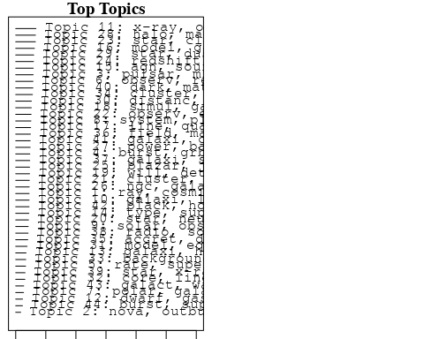

plotQuote(thoughts6, width = 30, main = "Topic 6")  
plotQuote(thoughts18, width = 30, main = "Topic 18")

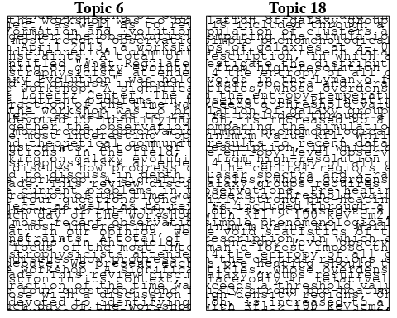

# Calculate and plot the correlation between topics  
mod.out.corr <- topicCorr(Research_topics)  
plot(mod.out.corr, cex = 1.5)  
  
  
# For each topic  
for (topic_num in 1:44) {  
 # Plot the word cloud  
 cloud(Research_topics, topic = topic_num, scale = c(2, 0.25))  
 Sys.sleep(2)  
}

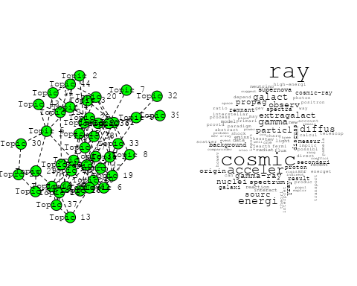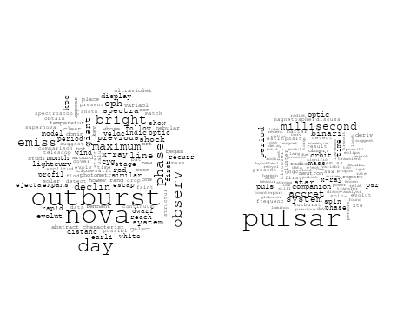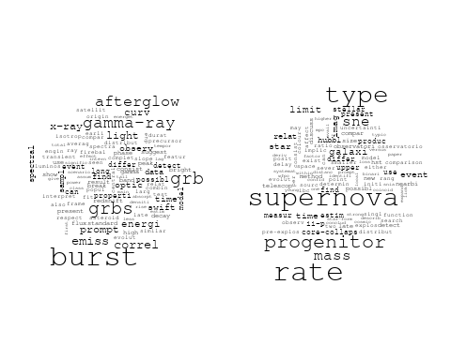

## Warning in wordcloud::wordcloud(words = vocab, freq = vec, max.words =  
## max.words, : review could not be fit on page. It will not be plotted.

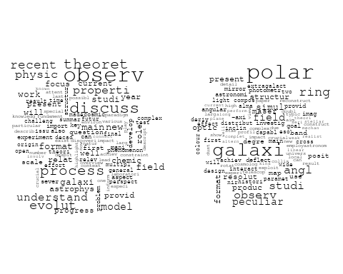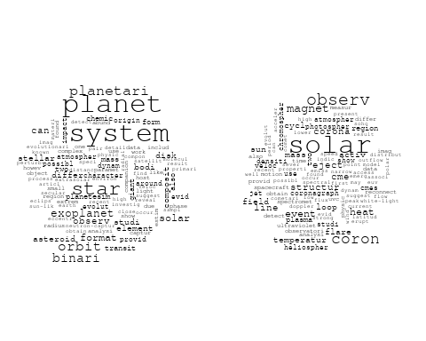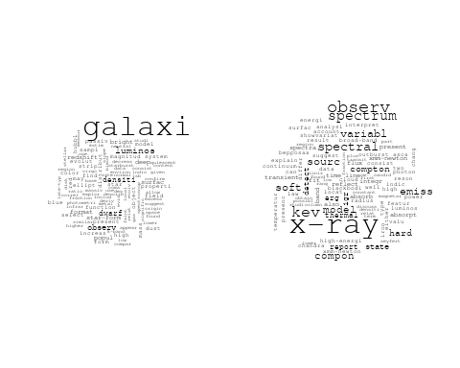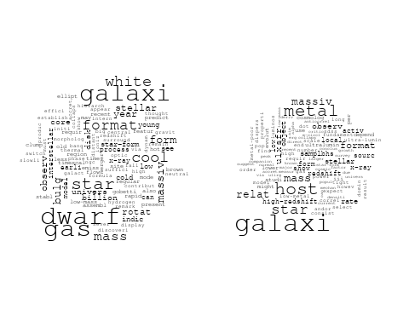

## Warning in wordcloud::wordcloud(words = vocab, freq = vec, max.words =  
## max.words, : luminos could not be fit on page. It will not be plotted.

## Warning in wordcloud::wordcloud(words = vocab, freq = vec, max.words =  
## max.words, : spectra could not be fit on page. It will not be plotted.

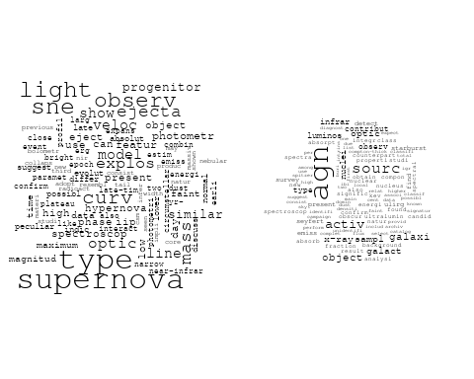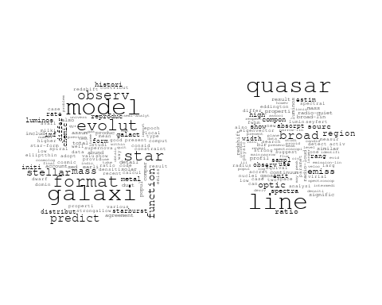

## Warning in wordcloud::wordcloud(words = vocab, freq = vec, max.words =  
## max.words, : detect could not be fit on page. It will not be plotted.

## Warning in wordcloud::wordcloud(words = vocab, freq = vec, max.words =  
## max.words, : detector could not be fit on page. It will not be plotted.

## Warning in wordcloud::wordcloud(words = vocab, freq = vec, max.words =  
## max.words, : gravitational-wav could not be fit on page. It will not be  
## plotted.

## Warning in wordcloud::wordcloud(words = vocab, freq = vec, max.words =  
## max.words, : ground-bas could not be fit on page. It will not be plotted.

## Warning in wordcloud::wordcloud(words = vocab, freq = vec, max.words =  
## max.words, : instrument could not be fit on page. It will not be plotted.

## Warning in wordcloud::wordcloud(words = vocab, freq = vec, max.words =  
## max.words, : wave could not be fit on page. It will not be plotted.

## Warning in wordcloud::wordcloud(words = vocab, freq = vec, max.words =  
## max.words, : will could not be fit on page. It will not be plotted.

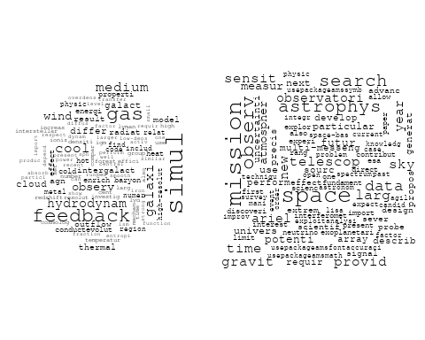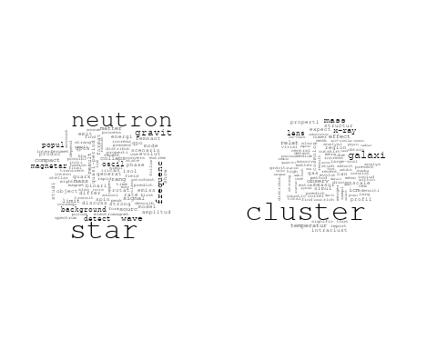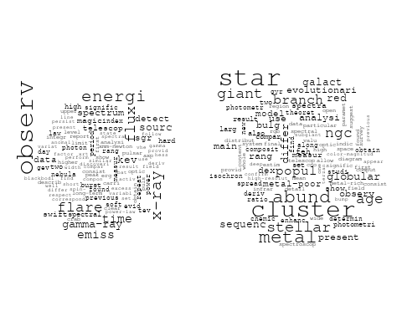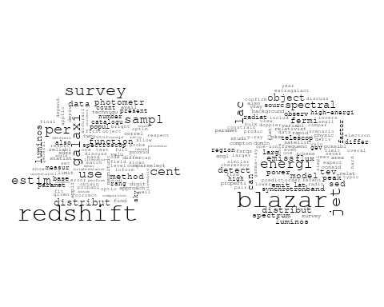

## Warning in wordcloud::wordcloud(words = vocab, freq = vec, max.words =  
## max.words, : cosmolog could not be fit on page. It will not be plotted.

## Warning in wordcloud::wordcloud(words = vocab, freq = vec, max.words =  
## max.words, : univers could not be fit on page. It will not be plotted.

## Warning in wordcloud::wordcloud(words = vocab, freq = vec, max.words =  
## max.words, : foreground could not be fit on page. It will not be plotted.

## Warning in wordcloud::wordcloud(words = vocab, freq = vec, max.words =  
## max.words, : anisotropi could not be fit on page. It will not be plotted.

## Warning in wordcloud::wordcloud(words = vocab, freq = vec, max.words =  
## max.words, : spectrum could not be fit on page. It will not be plotted.

## Warning in wordcloud::wordcloud(words = vocab, freq = vec, max.words =  
## max.words, : primordi could not be fit on page. It will not be plotted.

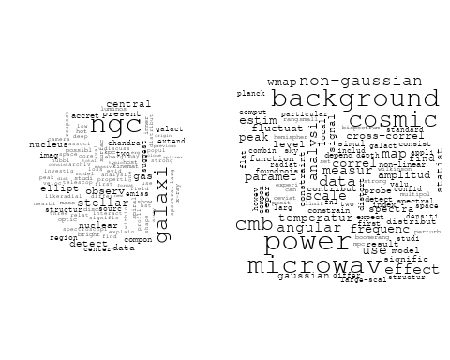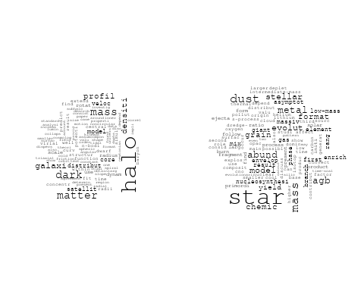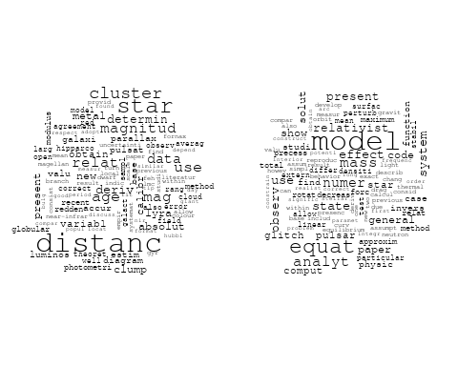

## Warning in wordcloud::wordcloud(words = vocab, freq = vec, max.words =  
## max.words, : line could not be fit on page. It will not be plotted.

## Warning in wordcloud::wordcloud(words = vocab, freq = vec, max.words =  
## max.words, : cloud could not be fit on page. It will not be plotted.

## Warning in wordcloud::wordcloud(words = vocab, freq = vec, max.words =  
## max.words, : data could not be fit on page. It will not be plotted.

## Warning in wordcloud::wordcloud(words = vocab, freq = vec, max.words =  
## max.words, : show could not be fit on page. It will not be plotted.

## Warning in wordcloud::wordcloud(words = vocab, freq = vec, max.words =  
## max.words, : present could not be fit on page. It will not be plotted.

## Warning in wordcloud::wordcloud(words = vocab, freq = vec, max.words =  
## max.words, : spectral could not be fit on page. It will not be plotted.

## Warning in wordcloud::wordcloud(words = vocab, freq = vec, max.words =  
## max.words, : visibl could not be fit on page. It will not be plotted.

## Warning in wordcloud::wordcloud(words = vocab, freq = vec, max.words =  
## max.words, : measur could not be fit on page. It will not be plotted.

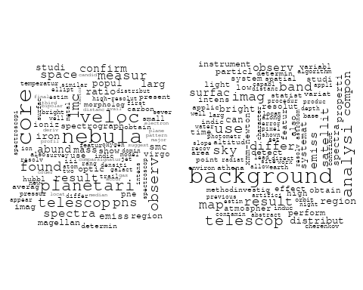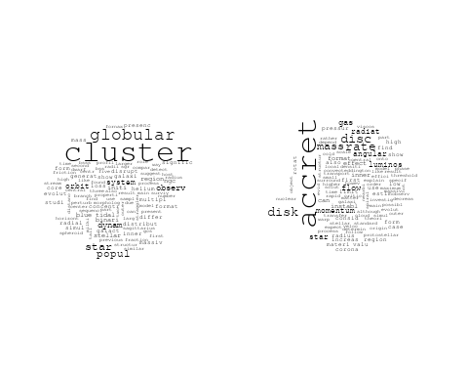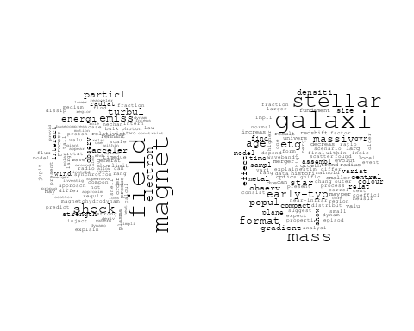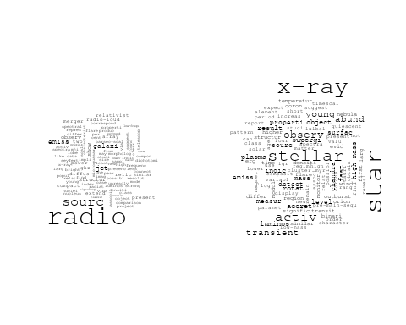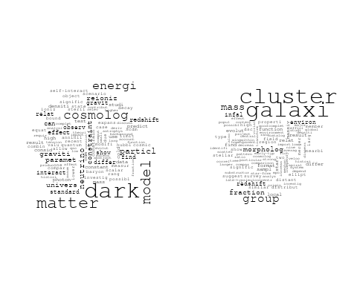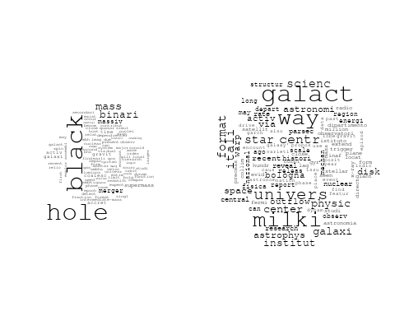

# Get the topic proportions for each document  
topic_proportions <- Research_topics$theta  
  
# Find the index of the topic with the highest proportion for each document  
# This will be the topic that each document is most likely to belong to  
max_topic_idx <- apply(topic_proportions, 1, which.max)  
  
# Add this as a new column to your data  
data_collab$topic <- max_topic_idx  
  
library(ggplot2)  
  
# Define the intervals  
intervals <- c('1824_1899', '1900_1964', '1965_1974', '1975_1984', '1985_1994', '1995_1999', '2000_2004', '2005_2009', '2010_2014', '2015_2019', '2020_2022')  
colors <- c('pink', 'blue', 'purple', 'yellow', 'green', 'pink', 'orange', 'violet', 'green', 'blue', 'pink')  
  
# Loop through the intervals and plot  
for(i in seq_along(intervals)){  
 # Filter data for when the pub_interval is equal to 1  
 data_filtered <- data_collab[data_collab[[paste0('pub_interval_', intervals[i])]] == 1,]  
   
 # Make the histogram  
   
 p <- ggplot(data_filtered, aes(x = topic)) +  
 geom_histogram(binwidth = 1, fill = colors[i], color = "black") +  
 xlab("Topic") +  
 ylab("Count") +  
 ggtitle(paste0("Topics from year ", gsub("_", " to ", intervals[i])))  
   
 print(p)  
}  
  
  
##Topic generation for IT (independent) publications  
  
data_independent <- data[data[["IT"]] == 100,]  
  
# Save the original title data for future use  
data_independent$original_concatenated_title_abstract <- data_independent$concatenated_title_abstract  
  
#pre-processing the titles using textProcessor from the stm package  
processed_text <- textProcessor(data_independent$concatenated_title_abstract, metadata = data_independent)

## Building corpus...   
## Converting to Lower Case...   
## Removing punctuation...   
## Removing stopwords...   
## Removing numbers...   
## Stemming...   
## Creating Output...

# Further prepare the data by removing low-frequency terms  
out_text <- prepDocuments(processed_text$documents, processed_text$vocab, processed_text$meta)

## Removing 1836 of 7455 terms (1836 of 126902 tokens) due to frequency   
## Your corpus now has 1504 documents, 5619 terms and 125066 tokens.

docs_text <- out_text$documents  
vocab_text <- out_text$vocab  
meta_text <- out_text$meta  
  
  
#Prepare data  
plotRemoved(processed_text$documents, lower.thresh = seq(1, 200, by = 100))

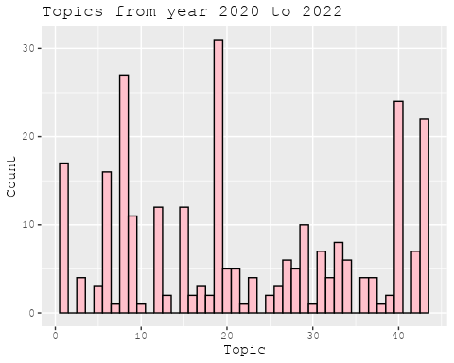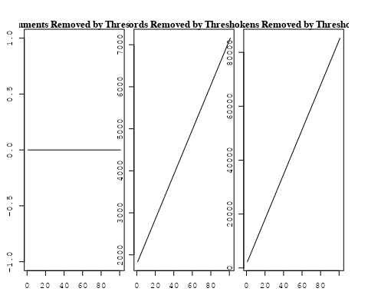

out_text <- prepDocuments(processed_text$documents, processed_text$vocab, processed_text$meta, lower.thresh = 8)

## Removing 5597 of 7455 terms (14537 of 126902 tokens) due to frequency   
## Your corpus now has 1504 documents, 1858 terms and 112365 tokens.

str(out_text$meta)

## 'data.frame': 1504 obs. of 39 variables:  
## $ concept_id : chr "https://openalex.org/C1276947" "https://openalex.org/C44870925" "https://openalex.org/C44870925" "https://openalex.org/C1276947" ...  
## $ work_id : chr "https://openalex.org/W2068317303" "https://openalex.org/W3106208106" "https://openalex.org/W3098398835" "https://openalex.org/W1998494018" ...  
## $ publication_year : int 2004 1999 2001 1990 2008 2008 2005 2004 2010 1996 ...  
## $ title : chr "Arp 299: A Second Merging System with Two Active Nuclei?" "The distribution of absorbing column densities among Seyfert 2 galaxies" "An efficient photoelectric X-ray Polarimeter for the study of Black Holes and Neutron Stars" "Clues on the Hot Star Content and the Ultraviolet Output of Elliptical Galaxies" ...  
## $ paperabstract : chr "Recent BeppoSAX observations of Arp 299, a powerful far-IR merging starburst system composed of IC 694 and NGC "| __truncated__ "We use hard X-ray data for an \"optimal\" sample of Seyfert 2 galaxies to derive the distribution of the gaseou"| __truncated__ "The study of astronomical objects using electromagnetic radiation involves four basic observational approaches:"| __truncated__ "Les galaxies elliptiques emettent un flux significatif de rayonnement aux longueurs d'onde au-dessous d'environ"| __truncated__ ...  
## $ country : chr "IT IT IT IT" "IT" "IT IT" "IT IT" ...  
## $ year_concept : chr "2004+https://openalex.org/C1276947" "1999+https://openalex.org/C44870925" "2001+https://openalex.org/C44870925" "1990+https://openalex.org/C1276947" ...  
## $ concatenated_title_abstract : chr "Arp 299: A Second Merging System with Two Active Nuclei? Recent BeppoSAX observations of Arp 299, a powerful fa"| __truncated__ "The distribution of absorbing column densities among Seyfert 2 galaxies We use hard X-ray data for an \"optimal"| __truncated__ "An efficient photoelectric X-ray Polarimeter for the study of Black Holes and Neutron Stars The study of astron"| __truncated__ "Clues on the Hot Star Content and the Ultraviolet Output of Elliptical Galaxies Les galaxies elliptiques emette"| __truncated__ ...  
## $ US : num 0 0 0 0 0 0 0 0 0 0 ...  
## $ IN : num 0 0 0 0 0 0 0 0 0 0 ...  
## $ DE : num 0 0 0 0 0 0 0 0 0 0 ...  
## $ CH : num 0 0 0 0 0 0 0 0 0 0 ...  
## $ GB : num 0 0 0 0 0 0 0 0 0 0 ...  
## $ CN : num 0 0 0 0 0 0 0 0 0 0 ...  
## $ FR : num 0 0 0 0 0 0 0 0 0 0 ...  
## $ IT : num 100 100 100 100 100 100 100 100 100 100 ...  
## $ RU : num 0 0 0 0 0 0 0 0 0 0 ...  
## $ CA : num 0 0 0 0 0 0 0 0 0 0 ...  
## $ NL : num 0 0 0 0 0 0 0 0 0 0 ...  
## $ AU : num 0 0 0 0 0 0 0 0 0 0 ...  
## $ JP : num 0 0 0 0 0 0 0 0 0 0 ...  
## $ ES : num 0 0 0 0 0 0 0 0 0 0 ...  
## $ IL : num 0 0 0 0 0 0 0 0 0 0 ...  
## $ Americas : num 0 0 0 0 0 0 0 0 0 0 ...  
## $ Europe : num 0 0 0 0 0 0 0 0 0 0 ...  
## $ Africa : num 0 0 0 0 0 0 0 0 0 0 ...  
## $ AsiaAndOceania : num 0 0 0 0 0 0 0 0 0 0 ...  
## $ pub_interval_2020_2022 : int 0 0 0 0 0 0 0 0 0 0 ...  
## $ pub_interval_2015_2019 : int 0 0 0 0 0 0 0 0 0 0 ...  
## $ pub_interval_2010_2014 : int 0 0 0 0 0 0 0 0 1 0 ...  
## $ pub_interval_2005_2009 : int 0 0 0 0 1 1 1 0 0 0 ...  
## $ pub_interval_2000_2004 : int 1 0 1 0 0 0 0 1 0 0 ...  
## $ pub_interval_1995_1999 : int 0 1 0 0 0 0 0 0 0 1 ...  
## $ pub_interval_1985_1994 : int 0 0 0 1 0 0 0 0 0 0 ...  
## $ pub_interval_1975_1984 : int 0 0 0 0 0 0 0 0 0 0 ...  
## $ pub_interval_1965_1974 : int 0 0 0 0 0 0 0 0 0 0 ...  
## $ pub_interval_1900_1964 : int 0 0 0 0 0 0 0 0 0 0 ...  
## $ pub_interval_1824_1899 : int 0 0 0 0 0 0 0 0 0 0 ...  
## $ original_concatenated_title_abstract: chr "Arp 299: A Second Merging System with Two Active Nuclei? Recent BeppoSAX observations of Arp 299, a powerful fa"| __truncated__ "The distribution of absorbing column densities among Seyfert 2 galaxies We use hard X-ray data for an \"optimal"| __truncated__ "An efficient photoelectric X-ray Polarimeter for the study of Black Holes and Neutron Stars The study of astron"| __truncated__ "Clues on the Hot Star Content and the Ultraviolet Output of Elliptical Galaxies Les galaxies elliptiques emette"| __truncated__ ...

# Initialize an empty formula string  
prevalence_formula_str <- "~"  
  
# Define the publication intervals  
pub_intervals <- c("pub_interval_2020_2022", "pub_interval_2015_2019", "pub_interval_2010_2014",   
 "pub_interval_2005_2009", "pub_interval_2000_2004", "pub_interval_1995_1999",  
 "pub_interval_1985_1994", "pub_interval_1975_1984", "pub_interval_1965_1974",  
 "pub_interval_1900_1964", "pub_interval_1824_1899")  
  
# Add each publication interval to the formula string  
for (interval in pub_intervals) {  
 # add an if statement to handle the first addition (without '+')  
 if (prevalence_formula_str == "~") {  
 prevalence_formula_str <- paste(prevalence_formula_str, interval)  
 } else {  
 prevalence_formula_str <- paste(prevalence_formula_str, "+", interval)  
 }  
}  
  
  
# Convert the string to a formula  
prevalence_formula <- as.formula(prevalence_formula_str)  
print(prevalence_formula)

## ~pub_interval_2020_2022 + pub_interval_2015_2019 + pub_interval_2010_2014 +   
## pub_interval_2005_2009 + pub_interval_2000_2004 + pub_interval_1995_1999 +   
## pub_interval_1985_1994 + pub_interval_1975_1984 + pub_interval_1965_1974 +   
## pub_interval_1900_1964 + pub_interval_1824_1899

# Run STM model  
Research_topics <- stm(documents = out_text$documents,   
 vocab = out_text$vocab,   
 K = 44,   
 prevalence = prevalence_formula,   
 data = out_text$meta,   
 init.type = "Spectral",  
 max.em.its = 1000,  
 gamma.prior = 'L1')

## Beginning Spectral Initialization   
## Calculating the gram matrix...  
## Finding anchor words...  
## ............................................  
## Recovering initialization...  
## ..................  
## Initialization complete.  
## ....................................................................................................  
## Completed E-Step (1 seconds).   
## Completed M-Step.   
## Completing Iteration 1 (approx. per word bound = -6.313)   
## ....................................................................................................  
## Completed E-Step (1 seconds).   
## Completed M-Step.   
## Completing Iteration 2 (approx. per word bound = -6.052, relative change = 4.134e-02)   
## ....................................................................................................  
## Completed E-Step (1 seconds).   
## Completed M-Step.   
## Completing Iteration 3 (approx. per word bound = -5.973, relative change = 1.318e-02)   
## ....................................................................................................  
## Completed E-Step (1 seconds).   
## Completed M-Step.   
## Completing Iteration 4 (approx. per word bound = -5.938, relative change = 5.792e-03)   
## ....................................................................................................  
## Completed E-Step (1 seconds).   
## Completed M-Step.   
## Completing Iteration 5 (approx. per word bound = -5.919, relative change = 3.213e-03)   
## Topic 1: space, telescop, type, supernova, observatori   
## Topic 2: spectra, light, line, constraint, veloc   
## Topic 3: univers, microwav, via, background, white   
## Topic 4: field, magnet, x-ray, see, magnetar   
## Topic 5: cluster, galaxi, properti, environ, group   
## Topic 6: solar, way, radio, present, merger   
## Topic 7: observ, pulsar, x-ray, model, glitch   
## Topic 8: agn, observ, contribut, galaxi, x-ray   
## Topic 9: data, survey, luminos, perform, new   
## Topic 10: star, abund, chemic, yield, element   
## Topic 11: kev, sourc, x-ray, observ, gamma-ray   
## Topic 12: observ, solar, flare, coron, activ   
## Topic 13: background, contribut, result, cosmic, xmm-newton   
## Topic 14: star, metal, observ, model, estim   
## Topic 15: hole, black, binari, merger, cluster   
## Topic 16: radio, object, sourc, emiss, detect   
## Topic 17: system, orbit, accret, star, evolut   
## Topic 18: galaxi, stellar, mass, etg, format   
## Topic 19: gravit, wave, star, popul, background   
## Topic 20: galaxi, dwarf, ngc, cluster, observ   
## Topic 21: star, mass, neutron, accret, phase   
## Topic 22: gas, simul, hot, cold, observ   
## Topic 23: mass, galaxi, black, hole, function   
## Topic 24: ray, observ, cosmic, acceler, origin   
## Topic 25: radiat, shock, emiss, particl, energi   
## Topic 26: dust, mass, metal, star, grain   
## Topic 27: data, analysi, use, estim, observ   
## Topic 28: burst, energi, gamma-ray, emiss, x-ray   
## Topic 29: pulsar, optic, star, psr, emiss   
## Topic 30: cluster, age, sequenc, ngc, stellar   
## Topic 31: dark, matter, model, energi, cosmolog   
## Topic 32: jet, sourc, radio, blazar, luminos   
## Topic 33: galaxi, redshift, mass, densiti, function   
## Topic 34: x-ray, metal, galaxi, star, relat   
## Topic 35: new, code, model, present, version   
## Topic 36: cluster, globular, star, format, popul   
## Topic 37: halo, dark, mass, matter, model   
## Topic 38: hole, black, observ, quasar, mass   
## Topic 39: accret, x-ray, time, observ, sourc   
## Topic 40: galaxi, format, star, model, agn   
## Topic 41: distanc, cluster, age, use, relat   
## Topic 42: grbs, burst, correl, grb, gamma-ray   
## Topic 43: model, simul, cosmolog, star, differ   
## Topic 44: nova, galact, maximum, declin, evolut   
## ....................................................................................................  
## Completed E-Step (1 seconds).   
## Completed M-Step.   
## Completing Iteration 6 (approx. per word bound = -5.906, relative change = 2.121e-03)   
## ....................................................................................................  
## Completed E-Step (1 seconds).   
## Completed M-Step.   
## Completing Iteration 7 (approx. per word bound = -5.898, relative change = 1.407e-03)   
## ....................................................................................................  
## Completed E-Step (1 seconds).   
## Completed M-Step.   
## Completing Iteration 8 (approx. per word bound = -5.892, relative change = 1.019e-03)   
## ....................................................................................................  
## Completed E-Step (1 seconds).   
## Completed M-Step.   
## Completing Iteration 9 (approx. per word bound = -5.888, relative change = 7.611e-04)   
## ....................................................................................................  
## Completed E-Step (1 seconds).   
## Completed M-Step.   
## Completing Iteration 10 (approx. per word bound = -5.884, relative change = 6.142e-04)   
## Topic 1: space, telescop, supernova, type, imag   
## Topic 2: spectra, line, light, veloc, power   
## Topic 3: univers, background, microwav, white, itali   
## Topic 4: field, magnet, x-ray, see, magnetar   
## Topic 5: cluster, galaxi, properti, environ, group   
## Topic 6: radio, merger, cluster, present, region   
## Topic 7: observ, pulsar, x-ray, star, model   
## Topic 8: agn, observ, contribut, infrar, galaxi   
## Topic 9: data, perform, luminos, survey, new   
## Topic 10: star, abund, chemic, element, yield   
## Topic 11: kev, sourc, x-ray, observ, gamma-ray   
## Topic 12: observ, solar, activ, coron, flare   
## Topic 13: background, result, xmm-newton, contribut, analysi   
## Topic 14: star, metal, model, observ, rang   
## Topic 15: hole, black, binari, pulsar, cluster   
## Topic 16: radio, sourc, object, limit, emiss   
## Topic 17: system, orbit, star, accret, evolut   
## Topic 18: galaxi, stellar, mass, etg, format   
## Topic 19: gravit, wave, star, popul, background   
## Topic 20: galaxi, dwarf, ngc, cluster, observ   
## Topic 21: star, mass, neutron, accret, evolut   
## Topic 22: gas, hot, simul, cold, cool   
## Topic 23: mass, galaxi, black, hole, accret   
## Topic 24: ray, cosmic, observ, acceler, will   
## Topic 25: shock, particl, radiat, emiss, electron   
## Topic 26: dust, mass, metal, grain, star   
## Topic 27: data, analysi, use, cmb, level   
## Topic 28: burst, energi, gamma-ray, x-ray, time   
## Topic 29: pulsar, optic, star, x-ray, emiss   
## Topic 30: cluster, age, sequenc, ngc, stellar   
## Topic 31: dark, matter, model, cosmolog, energi   
## Topic 32: sourc, jet, radio, blazar, luminos   
## Topic 33: galaxi, redshift, mass, function, densiti   
## Topic 34: x-ray, galaxi, metal, star, relat   
## Topic 35: new, model, code, present, comput   
## Topic 36: cluster, globular, star, format, popul   
## Topic 37: halo, dark, mass, matter, model   
## Topic 38: hole, black, observ, quasar, mass   
## Topic 39: accret, x-ray, sourc, observ, pulsar   
## Topic 40: galaxi, format, star, model, activ   
## Topic 41: distanc, cluster, age, relat, use   
## Topic 42: grbs, burst, correl, grb, gamma-ray   
## Topic 43: simul, model, star, cosmolog, format   
## Topic 44: nova, galact, declin, maximum, evolut   
## ....................................................................................................  
## Completed E-Step (1 seconds).   
## Completed M-Step.   
## Completing Iteration 11 (approx. per word bound = -5.881, relative change = 5.649e-04)   
## ....................................................................................................  
## Completed E-Step (1 seconds).   
## Completed M-Step.   
## Completing Iteration 12 (approx. per word bound = -5.878, relative change = 4.662e-04)   
## ....................................................................................................  
## Completed E-Step (1 seconds).   
## Completed M-Step.   
## Completing Iteration 13 (approx. per word bound = -5.876, relative change = 3.530e-04)   
## ....................................................................................................  
## Completed E-Step (1 seconds).   
## Completed M-Step.   
## Completing Iteration 14 (approx. per word bound = -5.874, relative change = 3.116e-04)   
## ....................................................................................................  
## Completed E-Step (1 seconds).   
## Completed M-Step.   
## Completing Iteration 15 (approx. per word bound = -5.872, relative change = 2.732e-04)   
## Topic 1: space, telescop, supernova, imag, hubbl   
## Topic 2: spectra, line, light, veloc, atmospher   
## Topic 3: univers, background, microwav, itali, white   
## Topic 4: field, magnet, x-ray, rotat, neutron   
## Topic 5: cluster, galaxi, properti, environ, icm   
## Topic 6: radio, merger, cluster, present, region   
## Topic 7: observ, pulsar, x-ray, star, model   
## Topic 8: agn, activ, contribut, observ, luminos   
## Topic 9: data, perform, survey, new, luminos   
## Topic 10: star, abund, chemic, element, metal   
## Topic 11: kev, sourc, x-ray, observ, gamma-ray   
## Topic 12: observ, solar, activ, coron, jet   
## Topic 13: background, result, xmm-newton, contribut, analysi   
## Topic 14: star, metal, model, observ, rang   
## Topic 15: hole, black, binari, pulsar, cluster   
## Topic 16: radio, sourc, object, emiss, limit   
## Topic 17: system, orbit, planet, star, evolut   
## Topic 18: galaxi, stellar, mass, etg, format   
## Topic 19: gravit, wave, star, popul, background   
## Topic 20: galaxi, dwarf, ngc, cluster, observ   
## Topic 21: star, mass, neutron, accret, evolut   
## Topic 22: gas, hot, simul, cold, observ   
## Topic 23: mass, galaxi, black, hole, accret   
## Topic 24: ray, cosmic, observ, acceler, will   
## Topic 25: particl, radiat, shock, emiss, electron   
## Topic 26: dust, mass, metal, grain, star   
## Topic 27: data, analysi, cmb, use, level   
## Topic 28: burst, energi, gamma-ray, x-ray, time   
## Topic 29: pulsar, optic, star, x-ray, psr   
## Topic 30: cluster, age, ngc, sequenc, main   
## Topic 31: dark, matter, model, energi, cosmolog   
## Topic 32: jet, sourc, radio, blazar, luminos   
## Topic 33: galaxi, redshift, mass, function, densiti   
## Topic 34: x-ray, galaxi, metal, star, relat   
## Topic 35: new, model, code, present, comput   
## Topic 36: cluster, globular, star, format, popul   
## Topic 37: halo, dark, mass, matter, profil   
## Topic 38: hole, black, observ, quasar, variabl   
## Topic 39: x-ray, accret, sourc, pulsar, observ   
## Topic 40: galaxi, format, star, model, evolut   
## Topic 41: distanc, cluster, age, relat, deriv   
## Topic 42: grbs, correl, burst, grb, gamma-ray   
## Topic 43: simul, model, star, cosmolog, format   
## Topic 44: nova, galact, star, declin, evolut   
## ....................................................................................................  
## Completed E-Step (1 seconds).   
## Completed M-Step.   
## Completing Iteration 16 (approx. per word bound = -5.871, relative change = 2.615e-04)   
## ....................................................................................................  
## Completed E-Step (1 seconds).   
## Completed M-Step.   
## Completing Iteration 17 (approx. per word bound = -5.869, relative change = 2.374e-04)   
## ....................................................................................................  
## Completed E-Step (1 seconds).   
## Completed M-Step.   
## Completing Iteration 18 (approx. per word bound = -5.868, relative change = 2.050e-04)   
## ....................................................................................................  
## Completed E-Step (1 seconds).   
## Completed M-Step.   
## Completing Iteration 19 (approx. per word bound = -5.867, relative change = 1.777e-04)   
## ....................................................................................................  
## Completed E-Step (1 seconds).   
## Completed M-Step.   
## Completing Iteration 20 (approx. per word bound = -5.866, relative change = 1.564e-04)   
## Topic 1: space, telescop, supernova, hubbl, imag   
## Topic 2: spectra, line, light, atmospher, observ   
## Topic 3: univers, background, microwav, itali, cosmic   
## Topic 4: field, magnet, x-ray, rotat, neutron   
## Topic 5: cluster, galaxi, properti, environ, icm   
## Topic 6: radio, merger, cluster, region, halo   
## Topic 7: observ, pulsar, x-ray, star, model   
## Topic 8: agn, activ, sampl, luminos, galaxi   
## Topic 9: data, perform, survey, new, satellit   
## Topic 10: star, abund, chemic, element, metal   
## Topic 11: kev, sourc, x-ray, observ, gamma-ray   
## Topic 12: observ, solar, activ, coron, jet   
## Topic 13: background, result, contribut, xmm-newton, analysi   
## Topic 14: star, metal, model, observ, pulsat   
## Topic 15: hole, black, binari, pulsar, cluster   
## Topic 16: radio, sourc, object, emiss, limit   
## Topic 17: system, orbit, planet, star, evolut   
## Topic 18: galaxi, stellar, mass, etg, format   
## Topic 19: gravit, wave, star, popul, background   
## Topic 20: galaxi, dwarf, ngc, cluster, structur   
## Topic 21: star, mass, neutron, accret, evolut   
## Topic 22: gas, hot, simul, cold, observ   
## Topic 23: mass, galaxi, black, hole, accret   
## Topic 24: ray, cosmic, observ, acceler, will   
## Topic 25: particl, radiat, shock, electron, emiss   
## Topic 26: dust, mass, grain, metal, star   
## Topic 27: data, analysi, cmb, use, measur   
## Topic 28: burst, energi, gamma-ray, x-ray, time   
## Topic 29: pulsar, optic, star, x-ray, psr   
## Topic 30: cluster, age, ngc, sequenc, main   
## Topic 31: dark, matter, model, energi, cosmolog   
## Topic 32: jet, sourc, radio, blazar, luminos   
## Topic 33: galaxi, redshift, mass, function, evolut   
## Topic 34: x-ray, galaxi, metal, relat, star   
## Topic 35: new, model, code, present, comput   
## Topic 36: cluster, globular, star, format, popul   
## Topic 37: halo, dark, mass, matter, profil   
## Topic 38: hole, black, observ, quasar, variabl   
## Topic 39: x-ray, accret, sourc, pulsar, observ   
## Topic 40: galaxi, format, star, model, evolut   
## Topic 41: distanc, cluster, age, relat, deriv   
## Topic 42: grbs, correl, burst, grb, gamma-ray   
## Topic 43: simul, model, star, cosmolog, format   
## Topic 44: nova, star, galact, declin, evolut   
## ....................................................................................................  
## Completed E-Step (1 seconds).   
## Completed M-Step.   
## Completing Iteration 21 (approx. per word bound = -5.865, relative change = 1.556e-04)   
## ....................................................................................................  
## Completed E-Step (1 seconds).   
## Completed M-Step.   
## Completing Iteration 22 (approx. per word bound = -5.865, relative change = 1.498e-04)   
## ....................................................................................................  
## Completed E-Step (1 seconds).   
## Completed M-Step.   
## Completing Iteration 23 (approx. per word bound = -5.864, relative change = 1.450e-04)   
## ....................................................................................................  
## Completed E-Step (1 seconds).   
## Completed M-Step.   
## Completing Iteration 24 (approx. per word bound = -5.863, relative change = 1.194e-04)   
## ....................................................................................................  
## Completed E-Step (1 seconds).   
## Completed M-Step.   
## Completing Iteration 25 (approx. per word bound = -5.862, relative change = 1.161e-04)   
## Topic 1: space, telescop, hubbl, supernova, imag   
## Topic 2: spectra, line, light, atmospher, observ   
## Topic 3: univers, background, microwav, itali, cosmic   
## Topic 4: field, magnet, x-ray, rotat, neutron   
## Topic 5: cluster, galaxi, properti, environ, icm   
## Topic 6: merger, radio, cluster, region, halo   
## Topic 7: observ, pulsar, x-ray, star, glitch   
## Topic 8: agn, activ, sampl, galaxi, luminos   
## Topic 9: data, perform, satellit, survey, new   
## Topic 10: star, abund, chemic, metal, element   
## Topic 11: kev, sourc, x-ray, observ, gamma-ray   
## Topic 12: observ, solar, activ, coron, jet   
## Topic 13: background, result, contribut, xmm-newton, analysi   
## Topic 14: star, metal, model, observ, pulsat   
## Topic 15: hole, black, binari, pulsar, cluster   
## Topic 16: radio, sourc, object, emiss, limit   
## Topic 17: system, orbit, planet, star, evolut   
## Topic 18: galaxi, stellar, mass, etg, format   
## Topic 19: gravit, wave, star, popul, background   
## Topic 20: galaxi, dwarf, ngc, cluster, structur   
## Topic 21: star, mass, neutron, accret, evolut   
## Topic 22: gas, hot, simul, cold, observ   
## Topic 23: mass, galaxi, black, hole, accret   
## Topic 24: ray, cosmic, observ, acceler, will   
## Topic 25: particl, radiat, shock, electron, emiss   
## Topic 26: dust, mass, grain, metal, star   
## Topic 27: data, analysi, cmb, use, measur   
## Topic 28: burst, gamma-ray, x-ray, energi, time   
## Topic 29: pulsar, optic, star, x-ray, psr   
## Topic 30: cluster, age, ngc, sequenc, present   
## Topic 31: dark, matter, model, energi, cosmolog   
## Topic 32: jet, sourc, blazar, radio, luminos   
## Topic 33: galaxi, redshift, mass, function, evolut   
## Topic 34: x-ray, galaxi, metal, relat, star   
## Topic 35: new, model, present, code, comput   
## Topic 36: cluster, globular, star, format, popul   
## Topic 37: halo, dark, mass, matter, profil   
## Topic 38: hole, black, observ, quasar, variabl   
## Topic 39: x-ray, accret, sourc, pulsar, observ   
## Topic 40: galaxi, format, star, model, evolut   
## Topic 41: distanc, cluster, age, relat, deriv   
## Topic 42: grbs, correl, burst, grb, gamma-ray   
## Topic 43: simul, model, star, cosmolog, format   
## Topic 44: nova, star, galact, declin, maximum   
## ....................................................................................................  
## Completed E-Step (1 seconds).   
## Completed M-Step.   
## Completing Iteration 26 (approx. per word bound = -5.862, relative change = 1.044e-04)   
## ....................................................................................................  
## Completed E-Step (1 seconds).   
## Completed M-Step.   
## Completing Iteration 27 (approx. per word bound = -5.861, relative change = 8.621e-05)   
## ....................................................................................................  
## Completed E-Step (1 seconds).   
## Completed M-Step.   
## Completing Iteration 28 (approx. per word bound = -5.861, relative change = 7.921e-05)   
## ....................................................................................................  
## Completed E-Step (1 seconds).   
## Completed M-Step.   
## Completing Iteration 29 (approx. per word bound = -5.860, relative change = 8.265e-05)   
## ....................................................................................................  
## Completed E-Step (1 seconds).   
## Completed M-Step.   
## Completing Iteration 30 (approx. per word bound = -5.860, relative change = 8.069e-05)   
## Topic 1: space, telescop, hubbl, imag, supernova   
## Topic 2: spectra, line, light, atmospher, observ   
## Topic 3: univers, background, microwav, cosmic, itali   
## Topic 4: field, magnet, x-ray, neutron, rotat   
## Topic 5: cluster, galaxi, properti, environ, icm   
## Topic 6: merger, radio, cluster, region, halo   
## Topic 7: observ, pulsar, star, x-ray, glitch   
## Topic 8: agn, activ, sampl, galaxi, luminos   
## Topic 9: data, satellit, perform, survey, test   
## Topic 10: star, abund, chemic, metal, element   
## Topic 11: kev, x-ray, sourc, observ, gamma-ray   
## Topic 12: observ, solar, activ, coron, jet   
## Topic 13: background, result, contribut, xmm-newton, analysi   
## Topic 14: star, metal, model, observ, stellar   
## Topic 15: hole, black, binari, pulsar, cluster   
## Topic 16: radio, sourc, object, emiss, limit   
## Topic 17: system, orbit, planet, star, evolut   
## Topic 18: galaxi, stellar, mass, etg, format   
## Topic 19: gravit, wave, star, popul, background   
## Topic 20: galaxi, dwarf, ngc, cluster, structur   
## Topic 21: star, mass, accret, neutron, evolut   
## Topic 22: gas, hot, simul, cold, observ   
## Topic 23: mass, galaxi, black, hole, accret   
## Topic 24: ray, cosmic, observ, acceler, will   
## Topic 25: shock, particl, radiat, electron, emiss   
## Topic 26: dust, mass, grain, metal, star   
## Topic 27: data, analysi, cmb, use, measur   
## Topic 28: burst, gamma-ray, x-ray, energi, time   
## Topic 29: pulsar, optic, star, x-ray, psr   
## Topic 30: cluster, age, ngc, sequenc, present   
## Topic 31: dark, matter, model, energi, cosmolog   
## Topic 32: jet, sourc, blazar, radio, line   
## Topic 33: galaxi, redshift, mass, function, evolut   
## Topic 34: x-ray, galaxi, metal, relat, star   
## Topic 35: new, model, present, code, comput   
## Topic 36: cluster, globular, star, format, popul   
## Topic 37: halo, dark, mass, profil, matter   
## Topic 38: hole, black, observ, quasar, variabl   
## Topic 39: x-ray, accret, sourc, pulsar, observ   
## Topic 40: galaxi, format, star, model, evolut   
## Topic 41: distanc, cluster, age, relat, deriv   
## Topic 42: grbs, correl, burst, grb, gamma-ray   
## Topic 43: simul, model, star, cosmolog, format   
## Topic 44: nova, star, galact, maximum, evolut   
## ....................................................................................................  
## Completed E-Step (1 seconds).   
## Completed M-Step.   
## Completing Iteration 31 (approx. per word bound = -5.859, relative change = 8.469e-05)   
## ....................................................................................................  
## Completed E-Step (1 seconds).   
## Completed M-Step.   
## Completing Iteration 32 (approx. per word bound = -5.859, relative change = 8.928e-05)   
## ....................................................................................................  
## Completed E-Step (1 seconds).   
## Completed M-Step.   
## Completing Iteration 33 (approx. per word bound = -5.858, relative change = 8.392e-05)   
## ....................................................................................................  
## Completed E-Step (1 seconds).   
## Completed M-Step.   
## Completing Iteration 34 (approx. per word bound = -5.858, relative change = 7.854e-05)   
## ....................................................................................................  
## Completed E-Step (1 seconds).   
## Completed M-Step.   
## Completing Iteration 35 (approx. per word bound = -5.857, relative change = 8.133e-05)   
## Topic 1: space, telescop, hubbl, imag, supernova   
## Topic 2: spectra, light, line, atmospher, observ   
## Topic 3: univers, background, microwav, cosmic, itali   
## Topic 4: field, magnet, x-ray, neutron, rotat   
## Topic 5: cluster, galaxi, properti, environ, icm   
## Topic 6: merger, radio, cluster, region, halo   
## Topic 7: observ, pulsar, star, x-ray, neutron   
## Topic 8: agn, activ, sampl, galaxi, luminos   
## Topic 9: data, satellit, perform, survey, test   
## Topic 10: star, abund, chemic, metal, element   
## Topic 11: kev, x-ray, sourc, observ, spectrum   
## Topic 12: observ, solar, activ, coron, jet   
## Topic 13: background, result, contribut, xmm-newton, analysi   
## Topic 14: star, metal, model, observ, stellar   
## Topic 15: hole, black, binari, pulsar, cluster   
## Topic 16: radio, sourc, object, emiss, limit   
## Topic 17: system, orbit, planet, star, evolut   
## Topic 18: galaxi, stellar, mass, etg, format   
## Topic 19: gravit, star, wave, popul, background   
## Topic 20: galaxi, dwarf, ngc, cluster, structur   
## Topic 21: star, mass, accret, evolut, phase   
## Topic 22: gas, hot, simul, cold, observ   
## Topic 23: mass, galaxi, black, hole, accret   
## Topic 24: ray, cosmic, observ, acceler, will   
## Topic 25: shock, particl, radiat, electron, emiss   
## Topic 26: dust, mass, grain, metal, star   
## Topic 27: data, analysi, cmb, use, measur   
## Topic 28: burst, gamma-ray, x-ray, energi, time   
## Topic 29: pulsar, optic, star, x-ray, psr   
## Topic 30: cluster, age, ngc, sequenc, present   
## Topic 31: dark, matter, model, energi, cosmolog   
## Topic 32: jet, blazar, sourc, radio, line   
## Topic 33: galaxi, redshift, mass, function, evolut   
## Topic 34: x-ray, galaxi, metal, relat, star   
## Topic 35: new, present, model, code, comput   
## Topic 36: cluster, globular, star, format, popul   
## Topic 37: halo, dark, profil, mass, matter   
## Topic 38: hole, black, observ, quasar, variabl   
## Topic 39: x-ray, accret, sourc, pulsar, observ   
## Topic 40: galaxi, format, star, model, evolut   
## Topic 41: distanc, cluster, age, relat, deriv   
## Topic 42: grbs, correl, burst, grb, use   
## Topic 43: simul, model, star, cosmolog, format   
## Topic 44: nova, star, galact, maximum, evolut   
## ....................................................................................................  
## Completed E-Step (1 seconds).   
## Completed M-Step.   
## Completing Iteration 36 (approx. per word bound = -5.857, relative change = 8.078e-05)   
## ....................................................................................................  
## Completed E-Step (1 seconds).   
## Completed M-Step.   
## Completing Iteration 37 (approx. per word bound = -5.856, relative change = 7.529e-05)   
## ....................................................................................................  
## Completed E-Step (1 seconds).   
## Completed M-Step.   
## Completing Iteration 38 (approx. per word bound = -5.856, relative change = 6.761e-05)   
## ....................................................................................................  
## Completed E-Step (1 seconds).   
## Completed M-Step.   
## Completing Iteration 39 (approx. per word bound = -5.856, relative change = 6.879e-05)   
## ....................................................................................................  
## Completed E-Step (1 seconds).   
## Completed M-Step.   
## Completing Iteration 40 (approx. per word bound = -5.855, relative change = 6.832e-05)   
## Topic 1: space, telescop, hubbl, imag, supernova   
## Topic 2: spectra, light, line, atmospher, observ   
## Topic 3: univers, background, microwav, cosmic, itali   
## Topic 4: field, magnet, x-ray, neutron, rotat   
## Topic 5: cluster, galaxi, properti, environ, icm   
## Topic 6: merger, radio, cluster, region, halo   
## Topic 7: observ, pulsar, star, x-ray, neutron   
## Topic 8: agn, activ, sampl, galaxi, luminos   
## Topic 9: satellit, data, perform, survey, qso   
## Topic 10: star, abund, chemic, metal, element   
## Topic 11: kev, x-ray, sourc, observ, spectrum   
## Topic 12: observ, solar, activ, coron, jet   
## Topic 13: background, result, contribut, xmm-newton, analysi   
## Topic 14: star, metal, model, stellar, observ   
## Topic 15: hole, black, binari, pulsar, cluster   
## Topic 16: radio, sourc, emiss, limit, object   
## Topic 17: system, orbit, planet, star, evolut   
## Topic 18: galaxi, stellar, mass, etg, format   
## Topic 19: gravit, star, wave, popul, background   
## Topic 20: galaxi, dwarf, ngc, cluster, structur   
## Topic 21: star, mass, accret, evolut, phase   
## Topic 22: gas, hot, simul, cold, observ   
## Topic 23: mass, galaxi, black, hole, accret   
## Topic 24: ray, cosmic, observ, acceler, will   
## Topic 25: shock, particl, radiat, electron, emiss   
## Topic 26: dust, mass, grain, metal, star   
## Topic 27: data, analysi, cmb, use, measur   
## Topic 28: burst, gamma-ray, x-ray, time, energi   
## Topic 29: pulsar, optic, star, x-ray, psr   
## Topic 30: cluster, age, ngc, sequenc, present   
## Topic 31: dark, matter, model, energi, cosmolog   
## Topic 32: jet, blazar, sourc, radio, line   
## Topic 33: galaxi, redshift, mass, function, distribut   
## Topic 34: x-ray, galaxi, metal, relat, star   
## Topic 35: new, present, model, code, comput   
## Topic 36: cluster, globular, star, format, popul   
## Topic 37: halo, dark, profil, mass, matter   
## Topic 38: hole, black, observ, quasar, variabl   
## Topic 39: x-ray, accret, sourc, pulsar, observ   
## Topic 40: galaxi, format, star, model, evolut   
## Topic 41: distanc, cluster, age, relat, deriv   
## Topic 42: grbs, correl, burst, grb, use   
## Topic 43: simul, model, star, cosmolog, format   
## Topic 44: nova, star, galact, maximum, evolut   
## ....................................................................................................  
## Completed E-Step (1 seconds).   
## Completed M-Step.   
## Completing Iteration 41 (approx. per word bound = -5.855, relative change = 6.560e-05)   
## ....................................................................................................  
## Completed E-Step (1 seconds).   
## Completed M-Step.   
## Completing Iteration 42 (approx. per word bound = -5.855, relative change = 4.394e-05)   
## ....................................................................................................  
## Completed E-Step (1 seconds).   
## Completed M-Step.   
## Completing Iteration 43 (approx. per word bound = -5.854, relative change = 8.787e-05)   
## ....................................................................................................  
## Completed E-Step (1 seconds).   
## Completed M-Step.   
## Completing Iteration 44 (approx. per word bound = -5.854, relative change = 5.645e-05)   
## ....................................................................................................  
## Completed E-Step (1 seconds).   
## Completed M-Step.   
## Completing Iteration 45 (approx. per word bound = -5.853, relative change = 6.218e-05)   
## Topic 1: space, telescop, hubbl, imag, supernova   
## Topic 2: spectra, light, line, atmospher, observ   
## Topic 3: univers, background, microwav, cosmic, itali   
## Topic 4: field, magnet, x-ray, neutron, rotat   
## Topic 5: cluster, galaxi, properti, environ, icm   
## Topic 6: merger, radio, cluster, region, halo   
## Topic 7: observ, pulsar, star, x-ray, neutron   
## Topic 8: agn, activ, sampl, galaxi, luminos   
## Topic 9: satellit, data, perform, survey, qso   
## Topic 10: star, abund, chemic, metal, element   
## Topic 11: kev, x-ray, sourc, observ, spectrum   
## Topic 12: observ, solar, activ, coron, jet   
## Topic 13: background, result, contribut, xmm-newton, analysi   
## Topic 14: star, metal, model, stellar, observ   
## Topic 15: hole, black, binari, pulsar, cluster   
## Topic 16: radio, sourc, emiss, limit, object   
## Topic 17: system, orbit, planet, star, evolut   
## Topic 18: galaxi, stellar, mass, etg, format   
## Topic 19: gravit, star, wave, popul, background   
## Topic 20: galaxi, dwarf, ngc, cluster, structur   
## Topic 21: star, mass, accret, evolut, phase   
## Topic 22: gas, hot, simul, observ, cold   
## Topic 23: mass, galaxi, black, hole, accret   
## Topic 24: ray, cosmic, observ, acceler, will   
## Topic 25: shock, particl, radiat, electron, emiss   
## Topic 26: dust, mass, grain, metal, star   
## Topic 27: data, analysi, cmb, use, measur   
## Topic 28: burst, gamma-ray, x-ray, time, energi   
## Topic 29: pulsar, optic, star, x-ray, psr   
## Topic 30: cluster, age, ngc, sequenc, present   
## Topic 31: dark, matter, model, energi, cosmolog   
## Topic 32: jet, blazar, sourc, radio, line   
## Topic 33: galaxi, redshift, mass, function, distribut   
## Topic 34: galaxi, x-ray, metal, relat, star   
## Topic 35: new, present, code, model, astrophys   
## Topic 36: cluster, globular, star, format, popul   
## Topic 37: halo, profil, dark, mass, matter   
## Topic 38: hole, black, observ, quasar, variabl   
## Topic 39: x-ray, accret, pulsar, sourc, observ   
## Topic 40: galaxi, format, star, model, evolut   
## Topic 41: distanc, cluster, age, relat, deriv   
## Topic 42: grbs, correl, burst, grb, use   
## Topic 43: simul, model, star, format, cosmolog   
## Topic 44: nova, star, galact, maximum, evolut   
## ....................................................................................................  
## Completed E-Step (1 seconds).   
## Completed M-Step.   
## Completing Iteration 46 (approx. per word bound = -5.853, relative change = 5.851e-05)   
## ....................................................................................................  
## Completed E-Step (1 seconds).   
## Completed M-Step.   
## Completing Iteration 47 (approx. per word bound = -5.853, relative change = 6.126e-05)   
## ....................................................................................................  
## Completed E-Step (0 seconds).   
## Completed M-Step.   
## Completing Iteration 48 (approx. per word bound = -5.852, relative change = 4.782e-05)   
## ....................................................................................................  
## Completed E-Step (1 seconds).   
## Completed M-Step.   
## Completing Iteration 49 (approx. per word bound = -5.852, relative change = 4.664e-05)   
## ....................................................................................................  
## Completed E-Step (0 seconds).   
## Completed M-Step.   
## Completing Iteration 50 (approx. per word bound = -5.852, relative change = 3.949e-05)   
## Topic 1: space, telescop, hubbl, imag, supernova   
## Topic 2: spectra, light, line, atmospher, observ   
## Topic 3: univers, background, microwav, cosmic, itali   
## Topic 4: field, magnet, x-ray, neutron, rotat   
## Topic 5: cluster, galaxi, properti, environ, icm   
## Topic 6: merger, radio, cluster, region, halo   
## Topic 7: observ, pulsar, star, x-ray, neutron   
## Topic 8: agn, activ, sampl, galaxi, luminos   
## Topic 9: satellit, data, perform, qso, survey   
## Topic 10: star, abund, chemic, metal, element   
## Topic 11: kev, x-ray, sourc, observ, spectrum   
## Topic 12: observ, solar, activ, coron, jet   
## Topic 13: background, result, xmm-newton, contribut, analysi   
## Topic 14: star, metal, model, stellar, observ   
## Topic 15: hole, black, binari, pulsar, cluster   
## Topic 16: radio, sourc, emiss, limit, object   
## Topic 17: system, orbit, planet, star, evolut   
## Topic 18: galaxi, stellar, mass, etg, format   
## Topic 19: gravit, star, wave, popul, background   
## Topic 20: galaxi, dwarf, ngc, cluster, detect   
## Topic 21: star, mass, evolut, accret, phase   
## Topic 22: gas, hot, simul, observ, cold   
## Topic 23: mass, galaxi, black, hole, accret   
## Topic 24: ray, cosmic, observ, acceler, diffus   
## Topic 25: shock, particl, electron, radiat, emiss   
## Topic 26: dust, mass, grain, metal, star   
## Topic 27: data, analysi, cmb, use, measur   
## Topic 28: burst, gamma-ray, x-ray, time, energi   
## Topic 29: pulsar, optic, star, x-ray, psr   
## Topic 30: cluster, age, ngc, sequenc, present   
## Topic 31: dark, matter, model, energi, cosmolog   
## Topic 32: jet, blazar, radio, sourc, line   
## Topic 33: galaxi, redshift, mass, function, distribut   
## Topic 34: galaxi, x-ray, metal, relat, star   
## Topic 35: new, present, code, astrophys, model   
## Topic 36: cluster, globular, star, format, popul   
## Topic 37: halo, profil, dark, mass, matter   
## Topic 38: hole, black, observ, quasar, variabl   
## Topic 39: x-ray, accret, pulsar, sourc, observ   
## Topic 40: galaxi, format, star, model, evolut   
## Topic 41: distanc, cluster, age, relat, deriv   
## Topic 42: grbs, correl, burst, grb, use   
## Topic 43: simul, model, star, format, cosmolog   
## Topic 44: nova, star, galact, maximum, evolut   
## ....................................................................................................  
## Completed E-Step (0 seconds).   
## Completed M-Step.   
## Completing Iteration 51 (approx. per word bound = -5.852, relative change = 3.868e-05)   
## ....................................................................................................  
## Completed E-Step (1 seconds).   
## Completed M-Step.   
## Completing Iteration 52 (approx. per word bound = -5.851, relative change = 2.300e-05)   
## ....................................................................................................  
## Completed E-Step (0 seconds).   
## Completed M-Step.   
## Completing Iteration 53 (approx. per word bound = -5.851, relative change = 3.264e-05)   
## ....................................................................................................  
## Completed E-Step (0 seconds).   
## Completed M-Step.   
## Completing Iteration 54 (approx. per word bound = -5.851, relative change = 3.524e-05)   
## ....................................................................................................  
## Completed E-Step (0 seconds).   
## Completed M-Step.   
## Completing Iteration 55 (approx. per word bound = -5.851, relative change = 3.423e-05)   
## Topic 1: space, telescop, hubbl, imag, supernova   
## Topic 2: spectra, light, line, atmospher, observ   
## Topic 3: univers, background, microwav, cosmic, itali   
## Topic 4: field, magnet, x-ray, neutron, rotat   
## Topic 5: cluster, galaxi, properti, environ, icm   
## Topic 6: merger, radio, cluster, halo, region   
## Topic 7: observ, pulsar, star, x-ray, neutron   
## Topic 8: agn, activ, sampl, galaxi, luminos   
## Topic 9: satellit, data, perform, qso, survey   
## Topic 10: star, abund, chemic, metal, element   
## Topic 11: x-ray, kev, sourc, observ, spectrum   
## Topic 12: observ, solar, activ, coron, jet   
## Topic 13: background, result, xmm-newton, contribut, analysi   
## Topic 14: star, metal, model, stellar, observ   
## Topic 15: hole, black, binari, pulsar, cluster   
## Topic 16: radio, sourc, emiss, limit, object   
## Topic 17: system, orbit, planet, star, evolut   
## Topic 18: galaxi, stellar, mass, etg, format   
## Topic 19: gravit, star, wave, popul, background   
## Topic 20: galaxi, dwarf, ngc, cluster, detect   
## Topic 21: star, mass, evolut, accret, phase   
## Topic 22: gas, hot, simul, observ, cold   
## Topic 23: mass, galaxi, black, hole, accret   
## Topic 24: ray, cosmic, observ, acceler, diffus   
## Topic 25: shock, particl, electron, radiat, emiss   
## Topic 26: dust, mass, grain, metal, star   
## Topic 27: data, analysi, cmb, use, measur   
## Topic 28: burst, gamma-ray, x-ray, time, grb   
## Topic 29: pulsar, optic, star, x-ray, psr   
## Topic 30: cluster, age, ngc, sequenc, present   
## Topic 31: dark, matter, model, energi, cosmolog   
## Topic 32: jet, blazar, radio, sourc, line   
## Topic 33: galaxi, redshift, mass, function, distribut   
## Topic 34: galaxi, x-ray, metal, relat, star   
## Topic 35: new, present, code, astrophys, comput   
## Topic 36: cluster, globular, star, format, popul   
## Topic 37: halo, profil, dark, mass, matter   
## Topic 38: hole, black, observ, quasar, variabl   
## Topic 39: x-ray, accret, pulsar, sourc, observ   
## Topic 40: galaxi, format, star, model, evolut   
## Topic 41: distanc, cluster, age, relat, deriv   
## Topic 42: grbs, correl, burst, grb, use   
## Topic 43: simul, model, star, format, cosmolog   
## Topic 44: nova, star, galact, maximum, evolut   
## ....................................................................................................  
## Completed E-Step (0 seconds).   
## Completed M-Step.   
## Completing Iteration 56 (approx. per word bound = -5.851, relative change = 3.042e-05)   
## ....................................................................................................  
## Completed E-Step (0 seconds).   
## Completed M-Step.   
## Completing Iteration 57 (approx. per word bound = -5.851, relative change = 2.908e-05)   
## ....................................................................................................  
## Completed E-Step (1 seconds).   
## Completed M-Step.   
## Completing Iteration 58 (approx. per word bound = -5.850, relative change = 2.968e-05)   
## ....................................................................................................  
## Completed E-Step (0 seconds).   
## Completed M-Step.   
## Completing Iteration 59 (approx. per word bound = -5.850, relative change = 3.206e-05)   
## ....................................................................................................  
## Completed E-Step (0 seconds).   
## Completed M-Step.   
## Completing Iteration 60 (approx. per word bound = -5.850, relative change = 2.957e-05)   
## Topic 1: space, telescop, hubbl, imag, supernova   
## Topic 2: spectra, light, line, atmospher, observ   
## Topic 3: univers, background, microwav, cosmic, itali   
## Topic 4: field, magnet, x-ray, neutron, rotat   
## Topic 5: cluster, galaxi, properti, environ, icm   
## Topic 6: merger, radio, cluster, halo, region   
## Topic 7: observ, pulsar, star, x-ray, neutron   
## Topic 8: agn, activ, sampl, galaxi, luminos   
## Topic 9: satellit, data, perform, qso, scenario   
## Topic 10: star, chemic, abund, metal, element   
## Topic 11: x-ray, kev, sourc, observ, spectrum   
## Topic 12: observ, solar, activ, coron, jet   
## Topic 13: background, result, xmm-newton, contribut, analysi   
## Topic 14: star, metal, model, stellar, observ   
## Topic 15: hole, black, binari, pulsar, cluster   
## Topic 16: radio, sourc, emiss, limit, object   
## Topic 17: system, orbit, planet, star, evolut   
## Topic 18: galaxi, stellar, mass, etg, format   
## Topic 19: gravit, star, wave, popul, background   
## Topic 20: galaxi, dwarf, ngc, cluster, detect   
## Topic 21: star, mass, evolut, accret, phase   
## Topic 22: gas, hot, simul, observ, cold   
## Topic 23: mass, galaxi, black, hole, accret   
## Topic 24: ray, cosmic, observ, acceler, diffus   
## Topic 25: shock, particl, electron, radiat, emiss   
## Topic 26: dust, mass, grain, metal, star   
## Topic 27: data, analysi, cmb, use, measur   
## Topic 28: burst, gamma-ray, x-ray, time, grb   
## Topic 29: pulsar, optic, star, x-ray, psr   
## Topic 30: cluster, age, ngc, sequenc, present   
## Topic 31: dark, matter, model, energi, cosmolog   
## Topic 32: jet, blazar, radio, sourc, line   
## Topic 33: galaxi, redshift, mass, function, distribut   
## Topic 34: galaxi, x-ray, metal, relat, star   
## Topic 35: new, present, code, astrophys, comput   
## Topic 36: cluster, globular, star, format, popul   
## Topic 37: halo, profil, dark, mass, matter   
## Topic 38: hole, black, observ, quasar, variabl   
## Topic 39: x-ray, accret, pulsar, sourc, observ   
## Topic 40: galaxi, format, star, model, evolut   
## Topic 41: distanc, cluster, age, relat, deriv   
## Topic 42: grbs, correl, burst, grb, use   
## Topic 43: simul, model, star, halo, format   
## Topic 44: nova, star, galact, maximum, evolut   
## ....................................................................................................  
## Completed E-Step (0 seconds).   
## Completed M-Step.   
## Completing Iteration 61 (approx. per word bound = -5.850, relative change = 3.191e-05)   
## ....................................................................................................  
## Completed E-Step (1 seconds).   
## Completed M-Step.   
## Completing Iteration 62 (approx. per word bound = -5.850, relative change = 3.090e-05)   
## ....................................................................................................  
## Completed E-Step (0 seconds).   
## Completed M-Step.   
## Completing Iteration 63 (approx. per word bound = -5.849, relative change = 2.646e-05)   
## ....................................................................................................  
## Completed E-Step (0 seconds).   
## Completed M-Step.   
## Completing Iteration 64 (approx. per word bound = -5.849, relative change = 2.322e-05)   
## ....................................................................................................  
## Completed E-Step (0 seconds).   
## Completed M-Step.   
## Completing Iteration 65 (approx. per word bound = -5.849, relative change = 2.492e-05)   
## Topic 1: space, telescop, hubbl, imag, supernova   
## Topic 2: spectra, light, line, atmospher, observ   
## Topic 3: univers, background, microwav, cosmic, itali   
## Topic 4: field, magnet, x-ray, neutron, rotat   
## Topic 5: cluster, galaxi, properti, environ, icm   
## Topic 6: merger, radio, cluster, halo, region   
## Topic 7: observ, pulsar, star, x-ray, neutron   
## Topic 8: agn, activ, sampl, galaxi, luminos   
## Topic 9: satellit, data, perform, scenario, qso   
## Topic 10: star, chemic, abund, metal, element   
## Topic 11: x-ray, kev, sourc, observ, spectrum   
## Topic 12: observ, solar, activ, coron, jet   
## Topic 13: background, result, xmm-newton, contribut, analysi   
## Topic 14: star, metal, model, stellar, observ   
## Topic 15: hole, black, binari, pulsar, cluster   
## Topic 16: radio, sourc, emiss, limit, object   
## Topic 17: system, orbit, planet, star, evolut   
## Topic 18: galaxi, stellar, mass, etg, format   
## Topic 19: gravit, star, wave, popul, background   
## Topic 20: galaxi, dwarf, ngc, cluster, detect   
## Topic 21: star, mass, evolut, accret, phase   
## Topic 22: gas, hot, simul, observ, cold   
## Topic 23: mass, galaxi, black, hole, accret   
## Topic 24: ray, cosmic, acceler, observ, diffus   
## Topic 25: shock, particl, electron, radiat, emiss   
## Topic 26: dust, mass, grain, metal, star   
## Topic 27: data, analysi, cmb, use, measur   
## Topic 28: burst, gamma-ray, x-ray, time, grb   
## Topic 29: pulsar, optic, star, x-ray, psr   
## Topic 30: cluster, age, ngc, sequenc, present   
## Topic 31: dark, matter, model, energi, cosmolog   
## Topic 32: jet, blazar, radio, sourc, line   
## Topic 33: galaxi, redshift, mass, function, distribut   
## Topic 34: galaxi, x-ray, metal, relat, star   
## Topic 35: new, present, code, astrophys, comput   
## Topic 36: cluster, globular, star, format, popul   
## Topic 37: halo, profil, dark, mass, matter   
## Topic 38: hole, black, observ, quasar, variabl   
## Topic 39: x-ray, accret, pulsar, sourc, observ   
## Topic 40: galaxi, format, star, model, evolut   
## Topic 41: distanc, cluster, age, relat, deriv   
## Topic 42: grbs, correl, burst, grb, use   
## Topic 43: simul, model, star, halo, format   
## Topic 44: nova, star, galact, maximum, evolut   
## ....................................................................................................  
## Completed E-Step (0 seconds).   
## Completed M-Step.   
## Completing Iteration 66 (approx. per word bound = -5.849, relative change = 2.208e-05)   
## ....................................................................................................  
## Completed E-Step (0 seconds).   
## Completed M-Step.   
## Completing Iteration 67 (approx. per word bound = -5.849, relative change = 1.987e-05)   
## ....................................................................................................  
## Completed E-Step (0 seconds).   
## Completed M-Step.   
## Completing Iteration 68 (approx. per word bound = -5.849, relative change = 2.126e-05)   
## ....................................................................................................  
## Completed E-Step (0 seconds).   
## Completed M-Step.   
## Completing Iteration 69 (approx. per word bound = -5.849, relative change = 2.202e-05)   
## ....................................................................................................  
## Completed E-Step (0 seconds).   
## Completed M-Step.   
## Completing Iteration 70 (approx. per word bound = -5.849, relative change = 2.552e-05)   
## Topic 1: space, telescop, hubbl, imag, supernova   
## Topic 2: spectra, light, line, atmospher, observ   
## Topic 3: univers, background, microwav, cosmic, itali   
## Topic 4: field, magnet, x-ray, neutron, rotat   
## Topic 5: cluster, galaxi, properti, environ, icm   
## Topic 6: merger, radio, cluster, halo, region   
## Topic 7: observ, pulsar, star, x-ray, neutron   
## Topic 8: agn, activ, sampl, galaxi, luminos   
## Topic 9: satellit, data, perform, scenario, qso   
## Topic 10: star, chemic, abund, metal, element   
## Topic 11: x-ray, kev, sourc, observ, spectrum   
## Topic 12: observ, solar, coron, activ, jet   
## Topic 13: background, result, xmm-newton, contribut, analysi   
## Topic 14: star, metal, model, stellar, observ   
## Topic 15: hole, black, binari, pulsar, cluster   
## Topic 16: radio, sourc, emiss, limit, object   
## Topic 17: system, orbit, planet, star, evolut   
## Topic 18: galaxi, stellar, mass, etg, format   
## Topic 19: gravit, star, wave, popul, background   
## Topic 20: galaxi, dwarf, ngc, cluster, detect   
## Topic 21: star, mass, accret, evolut, phase   
## Topic 22: gas, hot, simul, observ, cold   
## Topic 23: mass, galaxi, black, hole, accret   
## Topic 24: ray, cosmic, acceler, observ, diffus   
## Topic 25: shock, electron, particl, radiat, emiss   
## Topic 26: dust, mass, grain, metal, star   
## Topic 27: data, analysi, cmb, use, measur   
## Topic 28: burst, gamma-ray, x-ray, time, grb   
## Topic 29: pulsar, optic, star, x-ray, psr   
## Topic 30: cluster, age, ngc, sequenc, present   
## Topic 31: dark, matter, model, energi, cosmolog   
## Topic 32: jet, blazar, radio, sourc, line   
## Topic 33: galaxi, redshift, mass, function, distribut   
## Topic 34: galaxi, x-ray, metal, relat, star   
## Topic 35: new, present, code, astrophys, particular   
## Topic 36: cluster, globular, star, format, popul   
## Topic 37: halo, profil, dark, mass, matter   
## Topic 38: hole, black, observ, quasar, variabl   
## Topic 39: x-ray, accret, pulsar, sourc, observ   
## Topic 40: galaxi, format, star, model, evolut   
## Topic 41: distanc, cluster, age, relat, deriv   
## Topic 42: grbs, correl, burst, grb, gamma-ray   
## Topic 43: simul, model, star, halo, format   
## Topic 44: nova, star, galact, maximum, evolut   
## ....................................................................................................  
## Completed E-Step (0 seconds).   
## Completed M-Step.   
## Completing Iteration 71 (approx. per word bound = -5.848, relative change = 2.549e-05)   
## ....................................................................................................  
## Completed E-Step (0 seconds).   
## Completed M-Step.   
## Completing Iteration 72 (approx. per word bound = -5.848, relative change = 2.049e-05)   
## ....................................................................................................  
## Completed E-Step (0 seconds).   
## Completed M-Step.   
## Completing Iteration 73 (approx. per word bound = -5.848, relative change = 1.833e-05)   
## ....................................................................................................  
## Completed E-Step (0 seconds).   
## Completed M-Step.   
## Completing Iteration 74 (approx. per word bound = -5.848, relative change = 2.079e-05)   
## ....................................................................................................  
## Completed E-Step (0 seconds).   
## Completed M-Step.   
## Completing Iteration 75 (approx. per word bound = -5.848, relative change = 2.434e-05)   
## Topic 1: space, telescop, hubbl, imag, supernova   
## Topic 2: spectra, light, line, atmospher, observ   
## Topic 3: univers, background, microwav, cosmic, itali   
## Topic 4: field, magnet, x-ray, neutron, rotat   
## Topic 5: cluster, galaxi, properti, environ, icm   
## Topic 6: merger, radio, cluster, halo, region   
## Topic 7: observ, pulsar, star, x-ray, neutron   
## Topic 8: agn, activ, sampl, galaxi, luminos   
## Topic 9: satellit, data, scenario, qso, perform   
## Topic 10: star, chemic, abund, metal, element   
## Topic 11: x-ray, kev, sourc, observ, spectrum   
## Topic 12: observ, solar, coron, activ, jet   
## Topic 13: background, result, xmm-newton, contribut, analysi   
## Topic 14: star, metal, model, stellar, observ   
## Topic 15: hole, black, binari, pulsar, cluster   
## Topic 16: radio, sourc, emiss, limit, object   
## Topic 17: system, orbit, planet, star, evolut   
## Topic 18: galaxi, stellar, mass, etg, format   
## Topic 19: gravit, star, wave, popul, background   
## Topic 20: galaxi, dwarf, ngc, cluster, detect   
## Topic 21: star, mass, accret, evolut, phase   
## Topic 22: gas, hot, simul, observ, cold   
## Topic 23: mass, galaxi, black, hole, accret   
## Topic 24: ray, cosmic, acceler, observ, diffus   
## Topic 25: shock, electron, particl, radiat, emiss   
## Topic 26: dust, mass, grain, metal, star   
## Topic 27: data, analysi, cmb, use, measur   
## Topic 28: burst, gamma-ray, x-ray, time, grb   
## Topic 29: pulsar, optic, star, x-ray, psr   
## Topic 30: cluster, age, ngc, sequenc, present   
## Topic 31: dark, matter, model, energi, cosmolog   
## Topic 32: jet, blazar, radio, sourc, line   
## Topic 33: galaxi, redshift, mass, function, distribut   
## Topic 34: galaxi, x-ray, metal, relat, star   
## Topic 35: new, present, astrophys, code, particular   
## Topic 36: cluster, globular, star, format, popul   
## Topic 37: halo, profil, dark, mass, matter   
## Topic 38: hole, black, observ, quasar, variabl   
## Topic 39: x-ray, accret, pulsar, sourc, observ   
## Topic 40: galaxi, format, star, model, evolut   
## Topic 41: distanc, cluster, age, relat, deriv   
## Topic 42: grbs, correl, burst, grb, gamma-ray   
## Topic 43: simul, model, star, halo, format   
## Topic 44: nova, star, galact, maximum, evolut   
## ....................................................................................................  
## Completed E-Step (0 seconds).   
## Completed M-Step.   
## Completing Iteration 76 (approx. per word bound = -5.848, relative change = 2.544e-05)   
## ....................................................................................................  
## Completed E-Step (0 seconds).   
## Completed M-Step.   
## Completing Iteration 77 (approx. per word bound = -5.848, relative change = 2.032e-05)   
## ....................................................................................................  
## Completed E-Step (0 seconds).   
## Completed M-Step.   
## Completing Iteration 78 (approx. per word bound = -5.848, relative change = 1.883e-05)   
## ....................................................................................................  
## Completed E-Step (0 seconds).   
## Completed M-Step.   
## Completing Iteration 79 (approx. per word bound = -5.847, relative change = 1.823e-05)   
## ....................................................................................................  
## Completed E-Step (0 seconds).   
## Completed M-Step.   
## Completing Iteration 80 (approx. per word bound = -5.847, relative change = 1.715e-05)   
## Topic 1: space, telescop, hubbl, imag, supernova   
## Topic 2: spectra, light, line, atmospher, observ   
## Topic 3: univers, background, microwav, cosmic, itali   
## Topic 4: field, magnet, x-ray, neutron, rotat   
## Topic 5: cluster, galaxi, properti, environ, icm   
## Topic 6: merger, radio, cluster, halo, region   
## Topic 7: observ, pulsar, star, x-ray, neutron   
## Topic 8: agn, activ, sampl, galaxi, luminos   
## Topic 9: satellit, data, scenario, qso, test   
## Topic 10: star, chemic, abund, metal, element   
## Topic 11: x-ray, kev, sourc, observ, spectrum   
## Topic 12: observ, solar, coron, activ, jet   
## Topic 13: background, result, xmm-newton, contribut, analysi   
## Topic 14: star, metal, model, stellar, observ   
## Topic 15: hole, black, binari, pulsar, cluster   
## Topic 16: radio, sourc, emiss, limit, object   
## Topic 17: system, orbit, planet, star, evolut   
## Topic 18: galaxi, stellar, mass, etg, format   
## Topic 19: gravit, star, wave, popul, background   
## Topic 20: galaxi, dwarf, ngc, cluster, detect   
## Topic 21: star, mass, accret, evolut, phase   
## Topic 22: gas, hot, simul, observ, cold   
## Topic 23: mass, galaxi, black, hole, accret   
## Topic 24: ray, cosmic, acceler, observ, diffus   
## Topic 25: shock, electron, particl, radiat, emiss   
## Topic 26: dust, mass, grain, metal, star   
## Topic 27: data, analysi, cmb, use, measur   
## Topic 28: burst, gamma-ray, x-ray, time, grb   
## Topic 29: pulsar, optic, star, x-ray, psr   
## Topic 30: cluster, age, ngc, sequenc, present   
## Topic 31: dark, matter, model, energi, cosmolog   
## Topic 32: jet, blazar, radio, sourc, line   
## Topic 33: galaxi, redshift, mass, function, distribut   
## Topic 34: galaxi, x-ray, metal, relat, star   
## Topic 35: new, present, astrophys, code, particular   
## Topic 36: cluster, globular, star, format, popul   
## Topic 37: halo, profil, dark, mass, matter   
## Topic 38: hole, black, observ, quasar, variabl   
## Topic 39: x-ray, accret, pulsar, sourc, observ   
## Topic 40: galaxi, format, star, model, evolut   
## Topic 41: distanc, cluster, age, relat, deriv   
## Topic 42: grbs, correl, burst, grb, gamma-ray   
## Topic 43: simul, model, star, format, halo   
## Topic 44: nova, star, galact, maximum, evolut   
## ....................................................................................................  
## Completed E-Step (0 seconds).   
## Completed M-Step.   
## Completing Iteration 81 (approx. per word bound = -5.847, relative change = 1.714e-05)   
## ....................................................................................................  
## Completed E-Step (1 seconds).   
## Completed M-Step.   
## Completing Iteration 82 (approx. per word bound = -5.847, relative change = 1.746e-05)   
## ....................................................................................................  
## Completed E-Step (0 seconds).   
## Completed M-Step.   
## Completing Iteration 83 (approx. per word bound = -5.847, relative change = 1.680e-05)   
## ....................................................................................................  
## Completed E-Step (0 seconds).   
## Completed M-Step.   
## Completing Iteration 84 (approx. per word bound = -5.847, relative change = 1.664e-05)   
## ....................................................................................................  
## Completed E-Step (0 seconds).   
## Completed M-Step.   
## Completing Iteration 85 (approx. per word bound = -5.847, relative change = 1.590e-05)   
## Topic 1: space, telescop, hubbl, imag, supernova   
## Topic 2: spectra, light, line, atmospher, observ   
## Topic 3: univers, background, microwav, cosmic, itali   
## Topic 4: field, magnet, x-ray, neutron, rotat   
## Topic 5: cluster, galaxi, properti, environ, icm   
## Topic 6: merger, radio, cluster, halo, region   
## Topic 7: observ, pulsar, star, neutron, x-ray   
## Topic 8: agn, activ, sampl, galaxi, luminos   
## Topic 9: satellit, data, scenario, qso, test   
## Topic 10: star, chemic, abund, metal, element   
## Topic 11: x-ray, kev, sourc, observ, spectrum   
## Topic 12: observ, solar, coron, activ, jet   
## Topic 13: background, result, xmm-newton, contribut, analysi   
## Topic 14: star, metal, model, stellar, observ   
## Topic 15: hole, black, binari, pulsar, cluster   
## Topic 16: radio, sourc, emiss, limit, object   
## Topic 17: system, orbit, planet, star, evolut   
## Topic 18: galaxi, stellar, mass, etg, format   
## Topic 19: gravit, star, wave, popul, background   
## Topic 20: galaxi, dwarf, ngc, cluster, detect   
## Topic 21: star, mass, accret, evolut, phase   
## Topic 22: gas, hot, simul, observ, cold   
## Topic 23: mass, galaxi, black, hole, accret   
## Topic 24: ray, cosmic, acceler, observ, diffus   
## Topic 25: shock, electron, particl, radiat, emiss   
## Topic 26: dust, mass, grain, metal, star   
## Topic 27: data, analysi, cmb, use, measur   
## Topic 28: burst, gamma-ray, x-ray, time, grb   
## Topic 29: pulsar, optic, star, x-ray, millisecond   
## Topic 30: cluster, age, ngc, sequenc, present   
## Topic 31: dark, matter, model, energi, cosmolog   
## Topic 32: jet, blazar, radio, sourc, line   
## Topic 33: galaxi, redshift, mass, function, distribut   
## Topic 34: galaxi, x-ray, metal, relat, star   
## Topic 35: new, present, astrophys, code, particular   
## Topic 36: cluster, globular, star, format, popul   
## Topic 37: halo, profil, dark, mass, matter   
## Topic 38: hole, black, observ, quasar, variabl   
## Topic 39: x-ray, accret, pulsar, sourc, observ   
## Topic 40: galaxi, format, star, model, evolut   
## Topic 41: distanc, cluster, age, relat, deriv   
## Topic 42: grbs, correl, burst, grb, gamma-ray   
## Topic 43: simul, model, star, format, halo   
## Topic 44: nova, star, galact, maximum, evolut   
## ....................................................................................................  
## Completed E-Step (0 seconds).   
## Completed M-Step.   
## Model Converged

# Plot the STM model summary  
plot(Research_topics, type = "summary", xlim = c(0, 0.3))  
  
# Print the top 10 labels for each topic  
topic_labels <- labelTopics(Research_topics, n=10)  
print(topic_labels)

## Topic 1 Top Words:  
## Highest Prob: space, telescop, hubbl, imag, supernova, observ, measur, distanc, use, relat   
## FREX: hubbl, space, hst, telescop, camera, imag, nazional, ring, calibr, nebula   
## Lift: nazional, ring, camera, hst, cherenkov, geometri, templat, mas, collision, geometr   
## Score: nazional, hubbl, telescop, space, hst, camera, imag, ring, calibr, sky   
## Topic 2 Top Words:  
## Highest Prob: spectra, light, line, atmospher, observ, featur, detect, veloc, show, time   
## FREX: atmospher, spectra, spectroscopi, light, spot, low-resolut, featur, line, high-resolut, exoplanet   
## Lift: low-resolut, exoplanet, spot, sphere, atmospher, near-ir, plateau, insight, artifici, spectroscopi   
## Score: low-resolut, spectra, atmospher, exoplanet, pollut, spot, line, day, spectroscopi, light   
## Topic 3 Top Words:  
## Highest Prob: univers, background, microwav, cosmic, itali, anisotropi, space, cosmolog, bologna, peak   
## FREX: itali, microwav, univers, bologna, anisotropi, institut, white, scienc, astronomi, curvatur   
## Lift: itali, bologna, institut, candl, left, microwav, complementari, curvatur, bang, tini   
## Score: bologna, itali, univers, microwav, background, anisotropi, institut, cmb, astronomi, scienc   
## Topic 4 Top Words:  
## Highest Prob: field, magnet, x-ray, neutron, rotat, star, magnetar, period, binari, wind   
## FREX: magnet, magnetar, see, field, formula, fast, supergi, spin, wind, rotat   
## Lift: dipol, formula, toroid, supergi, week, magnetar, irrespect, see, magnet, fast   
## Score: magnet, formula, magnetar, neutron, supergi, spin, dipol, field, see, x-ray   
## Topic 5 Top Words:  
## Highest Prob: cluster, galaxi, properti, environ, icm, rate, type, morpholog, evolut, observ   
## FREX: icm, environ, cluster, intraclust, properti, morpholog, non-therm, large-scal, galaxi, substructur   
## Lift: destruct, icm, intraclust, non-therm, situ, substructur, rich, core-collaps, environ, large-scal   
## Score: cluster, galaxi, icm, destruct, intraclust, environ, morpholog, substructur, non-therm, early-typ   
## Topic 6 Top Words:  
## Highest Prob: merger, radio, cluster, halo, region, observ, rate, present, temperatur, shock   
## FREX: merger, perturb, turbul, milki, lens, ion, compress, inject, arc, exhibit   
## Lift: compress, arc, ongo, synergi, ion, pass, cone, present-day, front, merger   
## Score: compress, merger, radio, lens, arc, shock, synergi, turbul, cluster, halo   
## Topic 7 Top Words:  
## Highest Prob: observ, pulsar, star, neutron, x-ray, glitch, state, model, equat, magnetar   
## FREX: glitch, equat, state, magnetar, anomal, cyclotron, blackbodi, interior, agil, neutron   
## Lift: glitch, hamper, moment, cyclotron, interior, agil, record, otherwis, anomal, equat   
## Score: glitch, pulsar, magnetar, neutron, cyclotron, blackbodi, anomal, equat, state, x-ray   
## Topic 8 Top Words:  
## Highest Prob: agn, activ, sampl, galaxi, luminos, sourc, contribut, infrar, galact, observ   
## FREX: agn, infrar, seyfert, ulirg, activ, absorb, nuclei, contribut, obscur, sampl   
## Lift: alma, ulirg, obscur, agn, heavili, spitzer, seyfert, compton-thick, xmm, quantit   
## Score: agn, alma, ulirg, infrar, seyfert, absorb, obscur, redshift, activ, ultralumin   
## Topic 9 Top Words:  
## Highest Prob: satellit, data, scenario, test, qso, survey, perform, studi, need, approach   
## FREX: qso, satellit, threshold, design, gap, bodi, approach, need, advantag, captur   
## Lift: qso, gap, astronom, design, space-bas, advantag, practic, bodi, suppli, arcsec   
## Score: qso, captur, satellit, design, bodi, silic, advantag, gap, mission, threshold   
## Topic 10 Top Words:  
## Highest Prob: star, chemic, abund, metal, element, mass, stellar, ratio, model, agb   
## FREX: element, chemic, agb, abund, s-process, yield, opac, ratio, enrich, asymptot   
## Lift: hydrostat, s-process, opac, ofe, element, chemistri, agb, αfe, mass-loss, imf   
## Score: agb, chemic, abund, metal, element, s-process, hydrostat, nucleosynthesi, lithium, enrich   
## Topic 11 Top Words:  
## Highest Prob: x-ray, kev, sourc, observ, spectrum, gamma-ray, emiss, flux, hard, energi   
## FREX: kev, hard, integr, igr, blazar, cm-, soft, absorb, index, ibi   
## Lift: unidentifi, ibi, integralibi, cm-, hess, asca, emitt, follow-, cut-, kev   
## Score: kev, x-ray, igr, blazar, unidentifi, gamma-ray, swift, hard, ibi, absorb   
## Topic 12 Top Words:  
## Highest Prob: observ, solar, coron, activ, jet, mass, event, flare, eject, cme   
## FREX: coron, cme, cmes, sun, eject, cycl, plasma, flare, jet, heliospher   
## Lift: cme, soho, cmes, coron, sun, heliospher, loop, coronagraph, cycl, spectromet   
## Score: sun, coron, cme, cmes, jet, flare, eject, coronagraph, cycl, solar   
## Topic 13 Top Words:  
## Highest Prob: background, result, xmm-newton, contribut, analysi, x-ray, compon, differ, show, particl   
## FREX: athena, xmm-newton, background, epic, instrument, mission, along, stochast, induc, esa   
## Lift: athena, epic, esa, soon, nevertheless, modest, adequ, xmm, predomin, unexpect   
## Score: athena, background, epic, xmm-newton, mission, neutrino, stochast, magnetospher, esa, particl   
## Topic 14 Top Words:  
## Highest Prob: star, metal, model, stellar, observ, pulsat, rang, cluster, variabl, use   
## FREX: pulsat, bolometr, photometr, metal, empir, evolutionari, feh, isochron, lyr, red   
## Lift: lyr, teff, databas, grid, nonlinear, satisfactori, canon, bolometr, period-luminos, synthesi   
## Score: pulsat, metal, lyr, isochron, lyra, feh, star, bolometr, teff, cluster   
## Topic 15 Top Words:  
## Highest Prob: hole, black, binari, pulsar, cluster, star, merger, format, singl, orbit   
## FREX: binari, hole, black, encount, singl, coalesc, gcs, psr, intermediate-mass, array   
## Lift: coalesc, encount, gravitational-wav, tripl, ska, right, binari, squar, array, intermediate-mass   
## Score: black, hole, coalesc, binari, pulsar, psr, intermediate-mass, gcs, encount, millisecond   
## Topic 16 Top Words:  
## Highest Prob: radio, sourc, emiss, limit, object, detect, flux, tev, lat, band   
## FREX: lat, tev, radio, fermi, gev, upper, y-ray, limit, young, lac   
## Lift: y-ray, lat, mji, vla, gev, steeper, tev, gmbh, kgaa, verlag   
## Score: radio, lat, y-ray, tev, fermi, lac, magnet, ray, flux, gev   
## Topic 17 Top Words:  
## Highest Prob: system, orbit, planet, star, evolut, planetari, accret, solar, binari, mass   
## FREX: planet, planetari, orbit, system, secular, momentum, transfer, eccentr, perturb, companion   
## Lift: porb, secular, planet, eccentr, terrestri, planetari, irradi, lagrangian, transfer, momentum   
## Score: planet, orbit, planetari, porb, secular, eccentr, system, momentum, accret, solar   
## Topic 18 Top Words:  
## Highest Prob: galaxi, stellar, mass, etg, format, star, assembl, compact, densiti, observ   
## FREX: etg, assembl, early-typ, normal, compact, scheme, growth, furthermor, old, older   
## Lift: etg, assembl, older, remot, mgfe, pronounc, furthermor, enlarg, spite, simplifi   
## Score: assembl, etg, early-typ, galaxi, merger, mgfe, older, compact, stellar, old   
## Topic 19 Top Words:  
## Highest Prob: gravit, star, wave, popul, background, signal, generat, result, format, neutron   
## FREX: gravit, wave, signal, collaps, stochast, generat, amplitud, lisa, interferomet, lens   
## Lift: lisa, plan, interferomet, wave, gravit, stochast, inflationari, interferometr, back, small-scal   
## Score: gravit, wave, lisa, background, signal, neutron, lens, popul, stochast, interferomet   
## Topic 20 Top Words:  
## Highest Prob: galaxi, dwarf, ngc, cluster, detect, structur, two, stellar, popul, observ   
## FREX: dwarf, sgr, spheroid, cusp, ngc, sagittarius, tidal, center, dsph, structur   
## Lift: cusp, dsph, sagittarius, sgr, abridg, analog, spheroid, stream, dwarf, gradient   
## Score: cusp, dwarf, sagittarius, ngc, sgr, spheroid, dsph, globular, galaxi, cluster   
## Topic 21 Top Words:  
## Highest Prob: star, mass, accret, evolut, phase, neutron, first, limit, envelop, can   
## FREX: envelop, quark, burn, pollut, lithium, low-mass, hadron, phase, mix, collaps   
## Lift: quark, drastic, pollut, metal-fre, envelop, ignit, burn, zone, maintain, hadron   
## Score: quark, envelop, burn, star, pollut, neutron, lithium, accret, mass, hadron   
## Topic 22 Top Words:  
## Highest Prob: gas, hot, simul, observ, cold, temperatur, galaxi, cool, region, heat   
## FREX: hot, heat, gas, cold, hydrodynam, corona, cool, conduct, outflow, temperatur   
## Lift: entropi, travel, lag, feed, magnetohydrodynam, lyman, conduct, low-dens, box, filament   
## Score: gas, corona, heat, travel, cold, hot, simul, hydrodynam, cool, entropi   
## Topic 23 Top Words:  
## Highest Prob: mass, galaxi, black, hole, accret, function, group, activ, cluster, estim   
## FREX: bulg, virial, mbh, group, catalog, supermass, late-typ, mass, dispers, function   
## Lift: mbh, caustic, necessarili, tune, r-band, bulg, ineffici, lighter, supermass, virial   
## Score: mbh, agn, black, virial, hole, bulg, mass, group, catalog, accret   
## Topic 24 Top Words:  
## Highest Prob: ray, cosmic, acceler, observ, diffus, propag, supernova, origin, particl, will   
## FREX: ray, propag, diffus, acceler, cosmic, cosmic-ray, transport, atmospher, snr, gamma   
## Lift: bear, crs, snrs, centuri, cosmic-ray, rigid, snr, ray, transport, propag   
## Score: ray, acceler, cosmic, cosmic-ray, propag, crs, bear, snr, snrs, gamma   
## Topic 25 Top Words:  
## Highest Prob: shock, electron, particl, radiat, emiss, cloud, produc, acceler, energi, magnet   
## FREX: electron, shock, particl, altitud, cloud, radiat, dissip, shell, relativist, proton   
## Lift: altitud, time-depend, jupit, electron, slower, confin, damp, dissip, shock, x‐ray   
## Score: altitud, shock, particl, electron, cloud, acceler, magnet, radiat, nontherm, jupit   
## Topic 26 Top Words:  
## Highest Prob: dust, mass, grain, metal, star, format, progenitor, fragment, stellar, find   
## FREX: dust, grain, fragment, progenitor, ejecta, explos, condens, sne, silic, carbon   
## Lift: amorph, grain, dust, revers, molecul, fragment, condens, silic, progenitor, deplet   
## Score: dust, grain, metal, fragment, silic, revers, progenitor, amorph, sne, ejecta   
## Topic 27 Top Words:  
## Highest Prob: data, analysi, cmb, use, measur, level, sourc, estim, microwav, background   
## FREX: cmb, foreground, map, statist, microwav, level, non-gaussian, coma, confid, data   
## Lift: softwar, non-gaussian, cross-correl, coma, wmap, cmb, contamin, planck, foreground, latitud   
## Score: cmb, microwav, non-gaussian, softwar, foreground, cross-correl, coma, map, nois, wmap   
## Topic 28 Top Words:  
## Highest Prob: burst, gamma-ray, x-ray, time, grb, flare, energi, emiss, swift, observ   
## FREX: burst, swift, flare, prompt, afterglow, grb, gamma-ray, precursor, bat, long   
## Lift: precursor, afterglow, bat, prompt, octob, burst, flare, swift, quadrat, phase-coher   
## Score: burst, precursor, grb, swift, afterglow, flare, prompt, gamma-ray, bat, grbs   
## Topic 29 Top Words:  
## Highest Prob: pulsar, optic, star, x-ray, millisecond, psr, emiss, ngc, companion, radio   
## FREX: pulsar, psr, millisecond, optic, roch, companion, lobe, eclips, posit, counterpart   
## Lift: eclips, roch, overflow, lobe, vlt, nice, lose, psr, cap, reprocess   
## Score: pulsar, psr, millisecond, eclips, roch, lobe, companion, ngc, radio, optic   
## Topic 30 Top Words:  
## Highest Prob: cluster, age, ngc, sequenc, present, abund, main, differ, branch, use   
## FREX: sequenc, age, diagram, branch, rgb, bump, red, ngc, cno, isochron   
## Lift: high-precis, ccd, tip, triplet, bump, rgb, color-magnitud, turnoff, intermediate-ag, younger   
## Score: cluster, ngc, branch, globular, age, cno, isochron, turnoff, sequenc, high-precis   
## Topic 31 Top Words:  
## Highest Prob: dark, matter, model, energi, cosmolog, neutrino, univers, particl, interact, will   
## FREX: neutrino, dark, matter, antimatt, graviti, interact, experi, bound, positron, cosmolog   
## Lift: antimatt, model-independ, annihil, pamela, neutrino, positron, horizon, charg, bound, degeneraci   
## Score: dark, neutrino, model-independ, matter, antimatt, particl, cosmolog, acceler, positron, univers   
## Topic 32 Top Words:  
## Highest Prob: jet, blazar, radio, sourc, line, luminos, lac, power, emiss, object   
## FREX: blazar, jet, lac, broad, sed, quasar, line, fsrqs, radio-loud, radio   
## Lift: parsec-scal, fsrqs, radio-quiet, eigenvector, flat-spectrum, self-compton, broad, unresolv, radio-loud, jet   
## Score: jet, blazar, lac, radio, parsec-scal, quasar, fsrqs, sed, broad, radio-loud   
## Topic 33 Top Words:  
## Highest Prob: galaxi, redshift, mass, function, distribut, evolut, sampl, densiti, stellar, luminos   
## FREX: redshift, deep, function, infal, local, densiti, bimod, distribut, catalogu, sampl   
## Lift: mass-limit, median, passiv, field-south, bimod, infal, sfrs, semianalyt, gas-phas, b-band   
## Score: redshift, field-south, galaxi, mass-limit, deep, infal, bimod, densiti, mass, catalogu   
## Topic 34 Top Words:  
## Highest Prob: galaxi, x-ray, metal, relat, star, sfr, extrem, mass, observ, host   
## FREX: sfr, ulx, metal-poor, extrem, ultralumin, select, metal, host, bhs, scatter   
## Lift: engin, sfr, ulx, circumnuclear, arcsec, low-metal, self-similar, coverag, gmbh, kgaa   
## Score: sfr, ulx, metal, engin, metal-poor, x-ray, ultralumin, galaxi, ngc, bhs   
## Topic 35 Top Words:  
## Highest Prob: new, present, astrophys, code, particular, comput, main, physic, discuss, recent   
## FREX: code, astrophys, challeng, numer, complex, develop, del, new, interest, summar   
## Lift: del, strategi, vast, parallel, challeng, code, debat, summar, outstand, mhd   
## Score: del, code, astrophys, numer, relativist, new, summar, group, develop, review   
## Topic 36 Top Words:  
## Highest Prob: cluster, globular, star, format, popul, observ, generat, evolut, helium, dynam   
## FREX: helium, globular, blue, second, generat, multipl, horizont, straggler, cluster, super-agb   
## Lift: straggler, super-agb, helium, horizont, life, cen, destroy, dilut, multipl, blue   
## Score: globular, cluster, straggler, helium, super-agb, blue, branch, horizont, star, generat   
## Topic 37 Top Words:  
## Highest Prob: halo, profil, dark, mass, matter, densiti, model, galaxi, cluster, rotat   
## FREX: profil, halo, radii, tidal, dark, radius, virial, equilibrium, matter, concentr   
## Lift: triaxial, jean, friction, mond, king, circular, relax, equipartit, logarithm, n-bodi   
## Score: halo, dark, triaxial, profil, tidal, orbit, globular, cluster, virial, radius   
## Topic 38 Top Words:  
## Highest Prob: hole, black, observ, quasar, variabl, spectral, accret, mass, rate, state   
## FREX: quasar, hole, black, variabl, state, sdss, growth, hard, continuum, spectral   
## Lift: began, seed, sdss, quasi-period, high-frequ, quasar, emphasi, hole, black, state   
## Score: black, hole, quasar, began, variabl, spectral, accret, state, hard, sdss   
## Topic 39 Top Words:  
## Highest Prob: x-ray, accret, pulsar, sourc, observ, time, star, outburst, neutron, millisecond   
## FREX: outburst, puls, xte, sax, spin-, millisecond, pulsat, transient, torqu, xmm–newton   
## Lift: xte, torqu, sax, harmon, outburst, coher, spin-, puls, rxte, august   
## Score: pulsar, torqu, millisecond, outburst, sax, spin-, xte, pulsat, puls, neutron   
## Topic 40 Top Words:  
## Highest Prob: galaxi, format, star, model, evolut, spiral, rate, histori, observ, feedback   
## FREX: spiral, feedback, histori, ellipt, starburst, format, galaxi, early-typ, gyr, predict   
## Lift: output, spiral, sim, ism, starburst, irregular, damp, quench, salpet, feedback   
## Score: galaxi, output, spiral, format, feedback, starburst, histori, ellipt, metal, early-typ   
## Topic 41 Top Words:  
## Highest Prob: distanc, cluster, age, relat, deriv, star, use, mag, absolut, determin   
## FREX: lyra, absolut, distanc, mag, parallax, lmc, hipparco, age, accur, error   
## Lift: cepheid, k-band, zero-ag, hipparco, moduli, lmc, absolut, lyra, parallax, bar   
## Score: lyra, parallax, k-band, mag, globular, absolut, hipparco, distanc, age, modulus   
## Topic 42 Top Words:  
## Highest Prob: grbs, correl, burst, grb, gamma-ray, use, supernova, event, galaxi, energi   
## FREX: grbs, grb, correl, burst, gamma-ray, sne, event, yr-, supernova, frequent   
## Lift: frequent, grbs, collim, two-point, yr-, exposur, grb, fiduci, highest, correl   
## Score: grbs, grb, burst, frequent, gamma-ray, correl, sne, ray, magnetar, yr-   
## Topic 43 Top Words:  
## Highest Prob: simul, model, star, format, halo, cosmolog, mass, differ, redshift, galaxi   
## FREX: simul, reioniz, feedback, iii, hydrodynam, baryon, pop, cosmolog, cdm, semi-analyt   
## Lift: cdm, igm, pop, overdens, run, reioniz, semi-analyt, sph, lyα, notic   
## Score: cdm, pop, reioniz, simul, halo, feedback, baryon, redshift, hydrodynam, igm   
## Topic 44 Top Words:  
## Highest Prob: nova, star, galact, maximum, evolut, nucleosynthesi, declin, isotop, observ, intermediate-mass   
## FREX: nova, declin, isotop, nucleosynthesi, maximum, intermediate-mass, cno, yield, primari, element   
## Lift: nova, isotop, declin, recurr, nebular, nucleosynthesi, prescript, get, introduct, intermediate-mass   
## Score: nova, nucleosynthesi, intermediate-mass, isotop, cno, declin, maximum, recurr, day, yield

# Match the processed documents with the original titles  
matched_titles <- out_text$meta$original_concatenated_title_abstract  
  
# Print top 5 documents for each topic  
top_docs <- findThoughts(Research_topics, texts = matched_titles, n = 5)$docs[[1]]  
print(top_docs)

## [1] "The template type Ia supernova 1996X ABSTRA C T UBVRIJ photometry and optical spectra of the type Ia SN 1996X obtained at the European Southern Observatory (ESO) during a 1-yr-long observational campaign are presented, and supplemented by late-time Hubble Space Telescope (HST) photometry. Spectroscopically, SN 1996X appears to be a ‘normal’ SN Ia. The apparent magnitude at maximum was Ba 13:24 ^ 0:02; and the colour B 2 Va 0:00 ^ 0:03: The luminosity decline rate, DmBO15Ua1:31 ^ 0:08; is close to average for a SN Ia. The best estimate of the galactic extinction is ABa 0:30 ^ 0:05; and there is evidence that reddening within the parent galaxy is negligible. Detailed comparison of the light and colour curves of various ‘normal’ SNe Ia shows that the assumption that multicolour light curves can be described simply as a one-parameter family is not perfect. Together with problems in the calibration of the templates, this may explain the discrepancies in the distance modulus derived adopting different calibrations of the absolute magnitude versus light-curve shape relations. Indeed, we found that MB ranges from 219.08 to 219.48 and m ranges from 32.02 to 32.48 depending on the method used. Computations of model light-curve and synthetic spectra for both early and late times confirm that 1996X is a normal type Ia SN and that a satisfactory fit can be obtained using a W7 progenitor structure only if we adopt the short distance. A larger distance would imply too large a Ni mass for this fainter than average SN Ia."   
## [2] "The template type Ia supernova 1996X ABSTRA C T UBVRIJ photometry and optical spectra of the type Ia SN 1996X obtained at the European Southern Observatory (ESO) during a 1-yr-long observational campaign are presented, and supplemented by late-time Hubble Space Telescope (HST) photometry. Spectroscopically, SN 1996X appears to be a ‘normal’ SN Ia. The apparent magnitude at maximum was Ba 13:24 ^ 0:02; and the colour B 2 Va 0:00 ^ 0:03: The luminosity decline rate, DmBO15Ua1:31 ^ 0:08; is close to average for a SN Ia. The best estimate of the galactic extinction is ABa 0:30 ^ 0:05; and there is evidence that reddening within the parent galaxy is negligible. Detailed comparison of the light and colour curves of various ‘normal’ SNe Ia shows that the assumption that multicolour light curves can be described simply as a one-parameter family is not perfect. Together with problems in the calibration of the templates, this may explain the discrepancies in the distance modulus derived adopting different calibrations of the absolute magnitude versus light-curve shape relations. Indeed, we found that MB ranges from 219.08 to 219.48 and m ranges from 32.02 to 32.48 depending on the method used. Computations of model light-curve and synthetic spectra for both early and late times confirm that 1996X is a normal type Ia SN and that a satisfactory fit can be obtained using a W7 progenitor structure only if we adopt the short distance. A larger distance would imply too large a Ni mass for this fainter than average SN Ia."   
## [3] "The template type Ia supernova 1996X ABSTRA C T UBVRIJ photometry and optical spectra of the type Ia SN 1996X obtained at the European Southern Observatory (ESO) during a 1-yr-long observational campaign are presented, and supplemented by late-time Hubble Space Telescope (HST) photometry. Spectroscopically, SN 1996X appears to be a ‘normal’ SN Ia. The apparent magnitude at maximum was Ba 13:24 ^ 0:02; and the colour B 2 Va 0:00 ^ 0:03: The luminosity decline rate, DmBO15Ua1:31 ^ 0:08; is close to average for a SN Ia. The best estimate of the galactic extinction is ABa 0:30 ^ 0:05; and there is evidence that reddening within the parent galaxy is negligible. Detailed comparison of the light and colour curves of various ‘normal’ SNe Ia shows that the assumption that multicolour light curves can be described simply as a one-parameter family is not perfect. Together with problems in the calibration of the templates, this may explain the discrepancies in the distance modulus derived adopting different calibrations of the absolute magnitude versus light-curve shape relations. Indeed, we found that MB ranges from 219.08 to 219.48 and m ranges from 32.02 to 32.48 depending on the method used. Computations of model light-curve and synthetic spectra for both early and late times confirm that 1996X is a normal type Ia SN and that a satisfactory fit can be obtained using a W7 progenitor structure only if we adopt the short distance. A larger distance would imply too large a Ni mass for this fainter than average SN Ia."   
## [4] "The template type Ia supernova 1996X ABSTRA C T UBVRIJ photometry and optical spectra of the type Ia SN 1996X obtained at the European Southern Observatory (ESO) during a 1-yr-long observational campaign are presented, and supplemented by late-time Hubble Space Telescope (HST) photometry. Spectroscopically, SN 1996X appears to be a ‘normal’ SN Ia. The apparent magnitude at maximum was Ba 13:24 ^ 0:02; and the colour B 2 Va 0:00 ^ 0:03: The luminosity decline rate, DmBO15Ua1:31 ^ 0:08; is close to average for a SN Ia. The best estimate of the galactic extinction is ABa 0:30 ^ 0:05; and there is evidence that reddening within the parent galaxy is negligible. Detailed comparison of the light and colour curves of various ‘normal’ SNe Ia shows that the assumption that multicolour light curves can be described simply as a one-parameter family is not perfect. Together with problems in the calibration of the templates, this may explain the discrepancies in the distance modulus derived adopting different calibrations of the absolute magnitude versus light-curve shape relations. Indeed, we found that MB ranges from 219.08 to 219.48 and m ranges from 32.02 to 32.48 depending on the method used. Computations of model light-curve and synthetic spectra for both early and late times confirm that 1996X is a normal type Ia SN and that a satisfactory fit can be obtained using a W7 progenitor structure only if we adopt the short distance. A larger distance would imply too large a Ni mass for this fainter than average SN Ia."   
## [5] "Sky Brightness Evaluation at Concordia Station, Dome C, Antarctica, for Ground-Based Observations of the Solar Corona The evaluation of sky characteristics plays a fundamental role for many astrophysical experiments and ground-based observations. In solar physics, the main requirement for such observations is a very low sky brightness value, less than \\documentclass[12pt]{minimal} \\usepackage{amsmath} \\usepackage{wasysym} \\usepackage{amsfonts} \\usepackage{amssymb} \\usepackage{amsbsy} \\usepackage{mathrsfs} \\usepackage{upgreek} \\setlength{\\oddsidemargin}{-69pt} \\begin{document}$10^{-6}$\\end{document}10−6 of the solar disk brightness (\\documentclass[12pt]{minimal} \\usepackage{amsmath} \\usepackage{wasysym} \\usepackage{amsfonts} \\usepackage{amssymb} \\usepackage{amsbsy} \\usepackage{mathrsfs} \\usepackage{upgreek} \\setlength{\\oddsidemargin}{-69pt} \\begin{document}$\\mathrm{B}_{\\odot }$\\end{document}B⊙). Few places match such a requirement for ground-based, out-of-eclipse coronagraphic measurements. One of these places is, for instance, the Mauna Loa Observatory (\\documentclass[12pt]{minimal} \\usepackage{amsmath} \\usepackage{wasysym} \\usepackage{amsfonts} \\usepackage{amssymb} \\usepackage{amsbsy} \\usepackage{mathrsfs} \\usepackage{upgreek} \\setlength{\\oddsidemargin}{-69pt} \\begin{document}$\\approx 3400~\\mbox{m}$\\end{document}≈3400m a.s.l.). Another candidate coronagraphic site is the Dome C plateau in Antarctica. In this article, we show the first results of the sky brightness measurements at Dome C with the Extreme Solar Coronagraphy Antarctic Program Experiment (ESCAPE) at the Italian–French Concordia Station, on Dome C, Antarctica (\\documentclass[12pt]{minimal} \\usepackage{amsmath} \\usepackage{wasysym} \\usepackage{amsfonts} \\usepackage{amssymb} \\usepackage{amsbsy} \\usepackage{mathrsfs} \\usepackage{upgreek} \\setlength{\\oddsidemargin}{-69pt} \\begin{document}$\\approx 3300~\\mbox{m}$\\end{document}≈3300m a.s.l.) during the 34th and 35th summer Campaigns of the Italian Piano Nazionale Ricerche Antartiche (PNRA). The sky brightness measurements were carried out with the internally occulted Antarctic coronagraph AntarctiCor. In optimal atmospheric conditions the sky brightness of Dome C has reached values of the order of 1.0 – \\documentclass[12pt]{minimal} \\usepackage{amsmath} \\usepackage{wasysym} \\usepackage{amsfonts} \\usepackage{amssymb} \\usepackage{amsbsy} \\usepackage{mathrsfs} \\usepackage{upgreek} \\setlength{\\oddsidemargin}{-69pt} \\begin{document}$0.7 imes 10^{-6}~\\mathrm{B}_{\\odot }$\\end{document}0.7×10−6B⊙."

# Find and plot the key "thoughts" or documents for selected topics  
thoughts6 <- findThoughts(Research_topics, texts = matched_titles, n = 3, topics = 6)$docs[[1]]  
thoughts18 <- findThoughts(Research_topics, texts = matched_titles, n = 3, topics = 18)$docs[[1]]  
par(mfrow = c(1, 2), mar = c(0.5, 0.5, 1, 0.5))

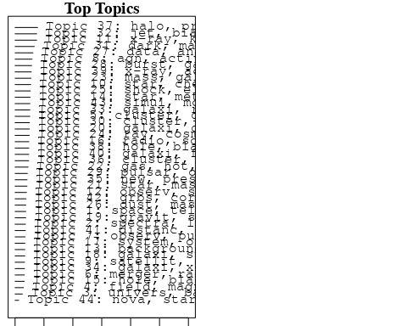

plotQuote(thoughts6, width = 30, main = "Topic 6")  
plotQuote(thoughts18, width = 30, main = "Topic 18")

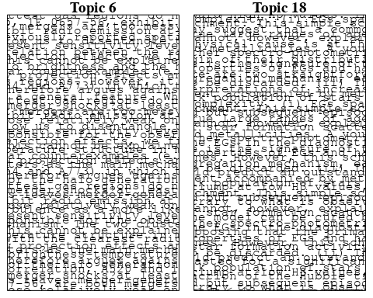

# Calculate and plot the correlation between topics  
mod.out.corr <- topicCorr(Research_topics)  
plot(mod.out.corr, cex = 1.5)  
  
  
# For each topic  
for (topic_num in 1:44) {  
 # Plot the word cloud  
 cloud(Research_topics, topic = topic_num, scale = c(2, 0.25))  
 Sys.sleep(2)  
}

## Warning in wordcloud::wordcloud(words = vocab, freq = vec, max.words =  
## max.words, : telescop could not be fit on page. It will not be plotted.

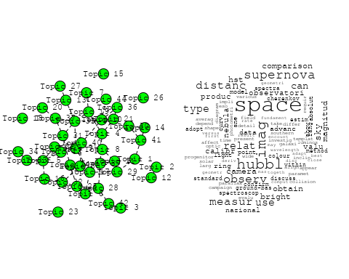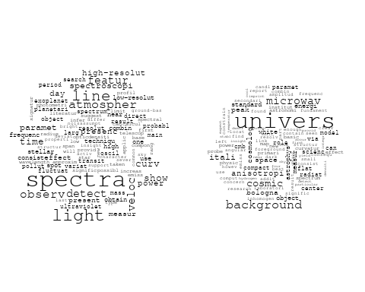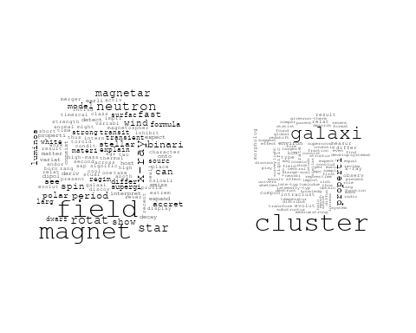

## Warning in wordcloud::wordcloud(words = vocab, freq = vec, max.words =  
## max.words, : pulsar could not be fit on page. It will not be plotted.

## Warning in wordcloud::wordcloud(words = vocab, freq = vec, max.words =  
## max.words, : star could not be fit on page. It will not be plotted.

## Warning in wordcloud::wordcloud(words = vocab, freq = vec, max.words =  
## max.words, : magnetar could not be fit on page. It will not be plotted.

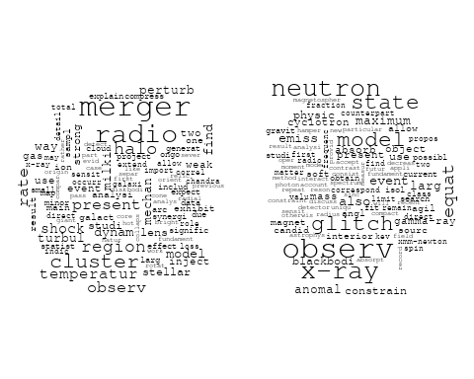

## Warning in wordcloud::wordcloud(words = vocab, freq = vec, max.words =  
## max.words, : resolut could not be fit on page. It will not be plotted.

## Warning in wordcloud::wordcloud(words = vocab, freq = vec, max.words =  
## max.words, : present could not be fit on page. It will not be plotted.

## Warning in wordcloud::wordcloud(words = vocab, freq = vec, max.words =  
## max.words, : satellit could not be fit on page. It will not be plotted.

## Warning in wordcloud::wordcloud(words = vocab, freq = vec, max.words =  
## max.words, : format could not be fit on page. It will not be plotted.

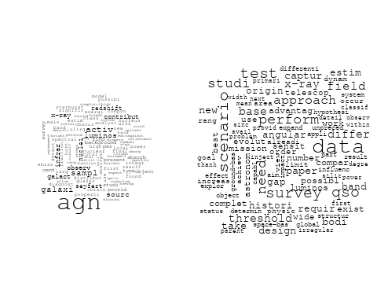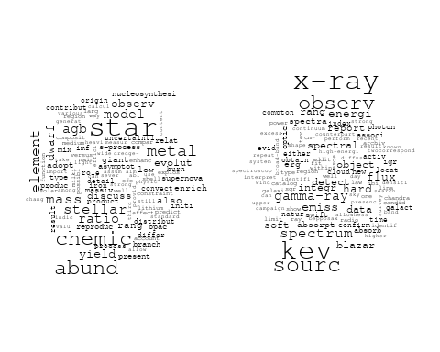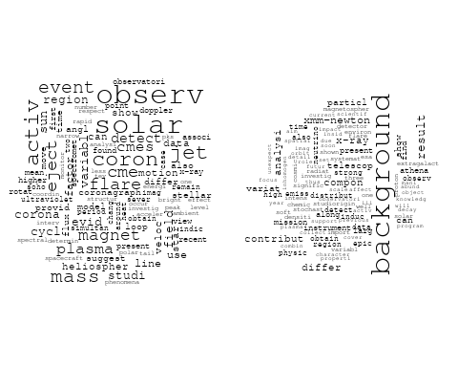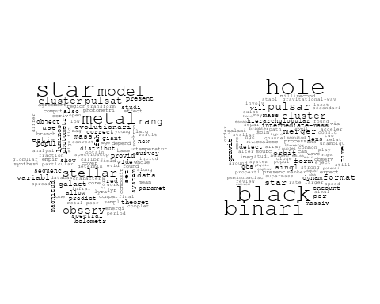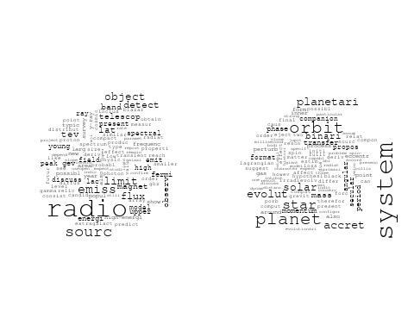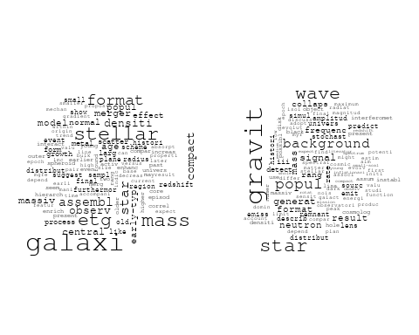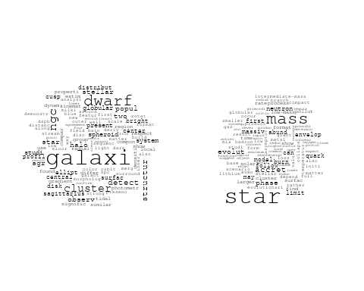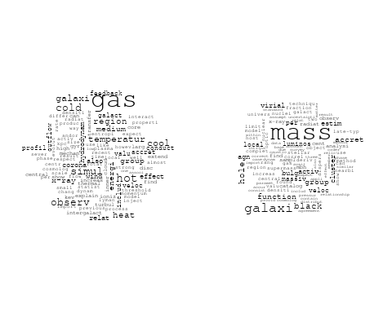

## Warning in wordcloud::wordcloud(words = vocab, freq = vec, max.words =  
## max.words, : electron could not be fit on page. It will not be plotted.

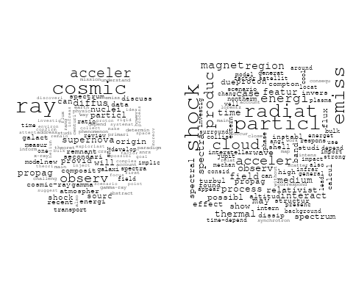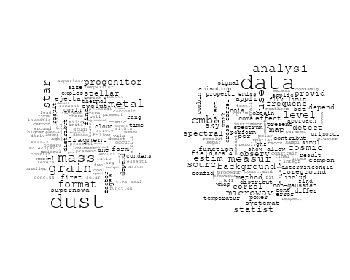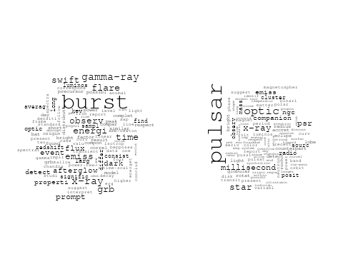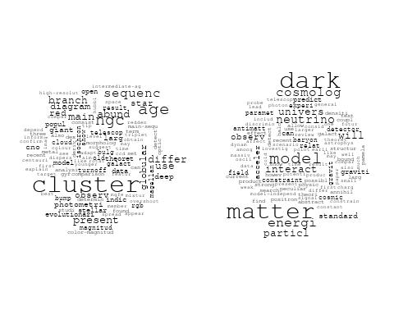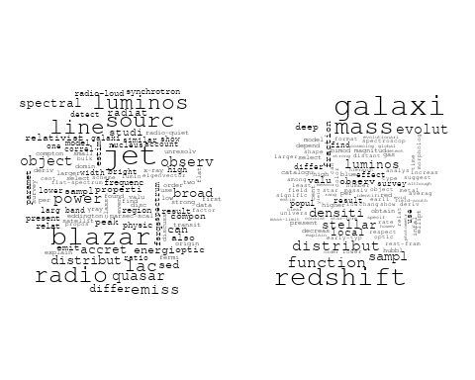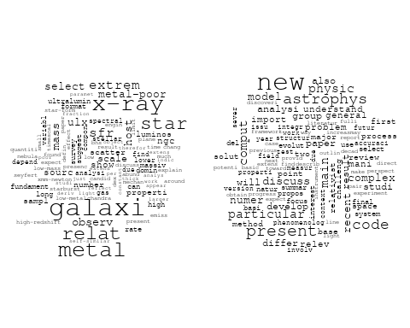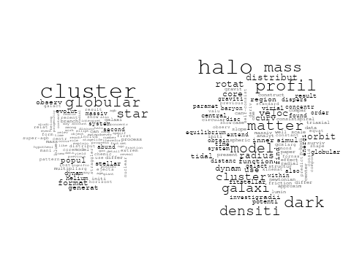

## Warning in wordcloud::wordcloud(words = vocab, freq = vec, max.words =  
## max.words, : pulsar could not be fit on page. It will not be plotted.

## Warning in wordcloud::wordcloud(words = vocab, freq = vec, max.words =  
## max.words, : outburst could not be fit on page. It will not be plotted.

## Warning in wordcloud::wordcloud(words = vocab, freq = vec, max.words =  
## max.words, : star could not be fit on page. It will not be plotted.

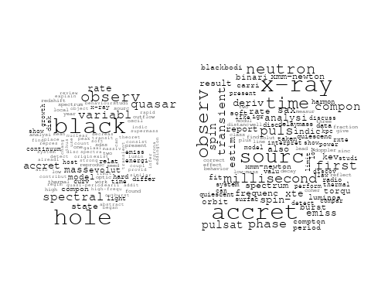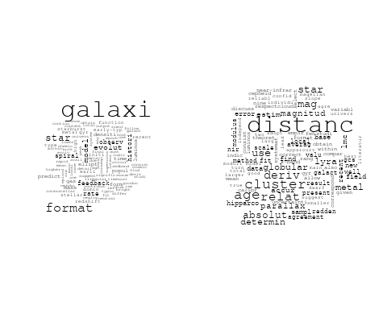

## Warning in wordcloud::wordcloud(words = vocab, freq = vec, max.words =  
## max.words, : model could not be fit on page. It will not be plotted.

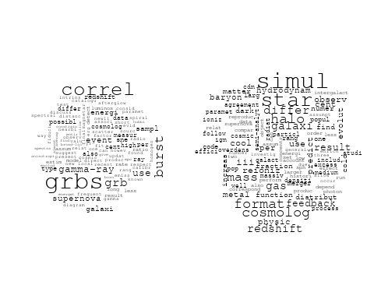

## Warning in wordcloud::wordcloud(words = vocab, freq = vec, max.words =  
## max.words, : star could not be fit on page. It will not be plotted.

# Get the topic proportions for each document  
topic_proportions <- Research_topics$theta  
  
# Find the index of the topic with the highest proportion for each document  
# This will be the topic that each document is most likely to belong to  
max_topic_idx <- apply(topic_proportions, 1, which.max)  
  
# Add this as a new column to your data  
data_independent$topic <- max_topic_idx  
  
  
  
# Define the intervals  
intervals <- c('1824_1899', '1900_1964', '1965_1974', '1975_1984', '1985_1994', '1995_1999', '2000_2004', '2005_2009', '2010_2014', '2015_2019', '2020_2022')  
colors <- c('pink', 'blue', 'purple', 'yellow', 'green', 'pink', 'orange', 'violet', 'green', 'blue', 'pink')  
  
# Loop through the intervals and plot  
for(i in seq_along(intervals)){  
 # Filter data for when the pub_interval is equal to 1  
 data_filtered <- data_independent[data_independent[[paste0('pub_interval_', intervals[i])]] == 1,]  
   
 # Make the histogram  
   
 p <- ggplot(data_filtered, aes(x = topic)) +  
 geom_histogram(binwidth = 1, fill = colors[i], color = "black") +  
 xlab("Topic") +  
 ylab("Count") +  
 ggtitle(paste0("Topics from year ", gsub("_", " to ", intervals[i])))  
   
 print(p)  
}  
  
  
##Topic generation for AU (in collaboration) publications  
  
data_collab <- data[data[["AU"]] != 0,]  
  
# Save the original title data for future use  
data_collab$original_concatenated_title_abstract <- data_collab$concatenated_title_abstract  
  
#pre-processing the titles using textProcessor from the stm package  
processed_text <- textProcessor(data_collab$concatenated_title_abstract, metadata = data_collab)

## Building corpus...   
## Converting to Lower Case...   
## Removing punctuation...   
## Removing stopwords...   
## Removing numbers...   
## Stemming...   
## Creating Output...

# Further prepare the data by removing low-frequency terms  
out_text <- prepDocuments(processed_text$documents, processed_text$vocab, processed_text$meta)

## Removing 2131 of 9442 terms (2131 of 215077 tokens) due to frequency   
## Your corpus now has 2590 documents, 7311 terms and 212946 tokens.

docs_text <- out_text$documents  
vocab_text <- out_text$vocab  
meta_text <- out_text$meta  
  
  
#Prepare data  
plotRemoved(processed_text$documents, lower.thresh = seq(1, 200, by = 100))

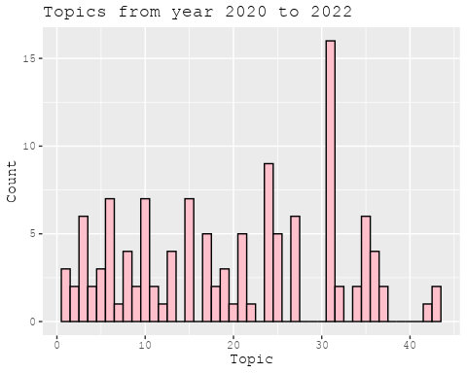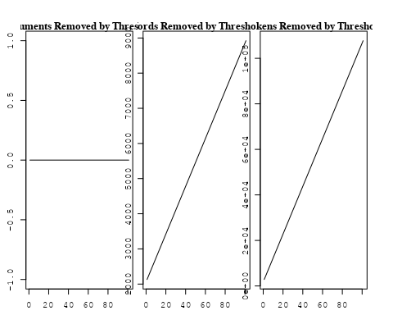

out_text <- prepDocuments(processed_text$documents, processed_text$vocab, processed_text$meta, lower.thresh = 8)

## Removing 7011 of 9442 terms (18830 of 215077 tokens) due to frequency   
## Your corpus now has 2590 documents, 2431 terms and 196247 tokens.

str(out_text$meta)

## 'data.frame': 2590 obs. of 39 variables:  
## $ concept_id : chr "https://openalex.org/C1276947" "https://openalex.org/C1276947" "https://openalex.org/C44870925" "https://openalex.org/C44870925" ...  
## $ work_id : chr "https://openalex.org/W3100822581" "https://openalex.org/W3140362863" "https://openalex.org/W2019918353" "https://openalex.org/W2089705336" ...  
## $ publication_year : int 2007 2021 1998 2001 2008 1999 2005 2001 1998 2014 ...  
## $ title : chr "Revealing Substructure in the Galactic Halo - The SEKBO RR Lyrae Survey" "Evidence for an intermediate-mass black hole from a gravitationally lensed gamma-ray burst" "The Nature of Bilateral Supernova Remnants" "NEW CLASS II METHANOL MASERS IN W3(OH)" ...  
## $ paperabstract : chr "We present a search for RR Lyrae variable stars from archival observations of the Southern Edgeworth-Kuiper Bel"| __truncated__ "If gamma-ray bursts are at cosmological distances, they must be gravitationally lensed occasionally [1, 2]. The"| __truncated__ "We present high-resolution radio images at 1.4 GHz of two Galactic supernova remnants (SNRs), G003.8–00.3 (form"| __truncated__ "We report interferometric observations of nine class II methanol maser candidate lines toward W3(OH). Narrow ma"| __truncated__ ...  
## $ country : chr "AU AU AU AU" "AU AU AU AU" "AU AU AU AU" "AU US AU US" ...  
## $ year_concept : chr "2007+https://openalex.org/C1276947" "2021+https://openalex.org/C1276947" "1998+https://openalex.org/C44870925" "2001+https://openalex.org/C44870925" ...  
## $ concatenated_title_abstract : chr "Revealing Substructure in the Galactic Halo - The SEKBO RR Lyrae Survey We present a search for RR Lyrae variab"| __truncated__ "Evidence for an intermediate-mass black hole from a gravitationally lensed gamma-ray burst If gamma-ray bursts "| __truncated__ "The Nature of Bilateral Supernova Remnants We present high-resolution radio images at 1.4 GHz of two Galactic s"| __truncated__ "NEW CLASS II METHANOL MASERS IN W3(OH) We report interferometric observations of nine class II methanol maser c"| __truncated__ ...  
## $ US : num 0 0 0 50 0 ...  
## $ IN : num 0 0 0 0 0 0 0 0 0 0 ...  
## $ DE : num 0 0 0 0 0 0 50 0 0 0 ...  
## $ CH : num 0 0 0 0 0 0 0 0 0 0 ...  
## $ GB : num 0 0 0 0 0 0 0 0 0 0 ...  
## $ CN : num 0 0 0 0 0 0 0 0 0 0 ...  
## $ FR : num 0 0 0 0 0 0 0 0 0 0 ...  
## $ IT : num 0 0 0 0 0 0 0 0 0 0 ...  
## $ RU : num 0 0 0 0 0 0 0 0 0 0 ...  
## $ CA : num 0 0 0 0 0 0 0 0 0 0 ...  
## $ NL : num 0 0 0 0 0 0 0 0 0 0 ...  
## $ AU : num 100 100 100 50 100 ...  
## $ JP : num 0 0 0 0 0 0 0 0 0 0 ...  
## $ ES : num 0 0 0 0 0 0 0 0 0 0 ...  
## $ IL : num 0 0 0 0 0 0 0 0 0 0 ...  
## $ Americas : num 0 0 0 0 0 0 0 0 0 0 ...  
## $ Europe : num 0 0 0 0 0 0 0 0 0 0 ...  
## $ Africa : num 0 0 0 0 0 0 0 0 0 0 ...  
## $ AsiaAndOceania : num 0 0 0 0 0 0 0 0 0 0 ...  
## $ pub_interval_2020_2022 : int 0 1 0 0 0 0 0 0 0 0 ...  
## $ pub_interval_2015_2019 : int 0 0 0 0 0 0 0 0 0 0 ...  
## $ pub_interval_2010_2014 : int 0 0 0 0 0 0 0 0 0 1 ...  
## $ pub_interval_2005_2009 : int 1 0 0 0 1 0 1 0 0 0 ...  
## $ pub_interval_2000_2004 : int 0 0 0 1 0 0 0 1 0 0 ...  
## $ pub_interval_1995_1999 : int 0 0 1 0 0 1 0 0 1 0 ...  
## $ pub_interval_1985_1994 : int 0 0 0 0 0 0 0 0 0 0 ...  
## $ pub_interval_1975_1984 : int 0 0 0 0 0 0 0 0 0 0 ...  
## $ pub_interval_1965_1974 : int 0 0 0 0 0 0 0 0 0 0 ...  
## $ pub_interval_1900_1964 : int 0 0 0 0 0 0 0 0 0 0 ...  
## $ pub_interval_1824_1899 : int 0 0 0 0 0 0 0 0 0 0 ...  
## $ original_concatenated_title_abstract: chr "Revealing Substructure in the Galactic Halo - The SEKBO RR Lyrae Survey We present a search for RR Lyrae variab"| __truncated__ "Evidence for an intermediate-mass black hole from a gravitationally lensed gamma-ray burst If gamma-ray bursts "| __truncated__ "The Nature of Bilateral Supernova Remnants We present high-resolution radio images at 1.4 GHz of two Galactic s"| __truncated__ "NEW CLASS II METHANOL MASERS IN W3(OH) We report interferometric observations of nine class II methanol maser c"| __truncated__ ...

# Initialize an empty formula string  
prevalence_formula_str <- "~"  
  
# Define the publication intervals  
pub_intervals <- c("pub_interval_2020_2022", "pub_interval_2015_2019", "pub_interval_2010_2014",   
 "pub_interval_2005_2009", "pub_interval_2000_2004", "pub_interval_1995_1999",  
 "pub_interval_1985_1994", "pub_interval_1975_1984", "pub_interval_1965_1974",  
 "pub_interval_1900_1964", "pub_interval_1824_1899")  
  
# Add each publication interval to the formula string  
for (interval in pub_intervals) {  
 # add an if statement to handle the first addition (without '+')  
 if (prevalence_formula_str == "~") {  
 prevalence_formula_str <- paste(prevalence_formula_str, interval)  
 } else {  
 prevalence_formula_str <- paste(prevalence_formula_str, "+", interval)  
 }  
}  
  
  
# Convert the string to a formula  
prevalence_formula <- as.formula(prevalence_formula_str)  
print(prevalence_formula)

## ~pub_interval_2020_2022 + pub_interval_2015_2019 + pub_interval_2010_2014 +   
## pub_interval_2005_2009 + pub_interval_2000_2004 + pub_interval_1995_1999 +   
## pub_interval_1985_1994 + pub_interval_1975_1984 + pub_interval_1965_1974 +   
## pub_interval_1900_1964 + pub_interval_1824_1899

# Run STM model  
Research_topics <- stm(documents = out_text$documents,   
 vocab = out_text$vocab,   
 K = 44,   
 prevalence = prevalence_formula,   
 data = out_text$meta,   
 init.type = "Spectral",  
 max.em.its = 1000,  
 gamma.prior = 'L1')

## Beginning Spectral Initialization   
## Calculating the gram matrix...  
## Finding anchor words...  
## ............................................  
## Recovering initialization...  
## ........................  
## Initialization complete.  
## .......................................................................................................  
## Completed E-Step (3 seconds).   
## Completed M-Step.   
## Completing Iteration 1 (approx. per word bound = -6.419)   
## .......................................................................................................  
## Completed E-Step (2 seconds).   
## Completed M-Step.   
## Completing Iteration 2 (approx. per word bound = -6.156, relative change = 4.094e-02)   
## .......................................................................................................  
## Completed E-Step (2 seconds).   
## Completed M-Step.   
## Completing Iteration 3 (approx. per word bound = -6.095, relative change = 9.954e-03)   
## .......................................................................................................  
## Completed E-Step (2 seconds).   
## Completed M-Step.   
## Completing Iteration 4 (approx. per word bound = -6.071, relative change = 3.924e-03)   
## .......................................................................................................  
## Completed E-Step (2 seconds).   
## Completed M-Step.   
## Completing Iteration 5 (approx. per word bound = -6.059, relative change = 1.993e-03)   
## Topic 1: star, galaxi, format, rate, form   
## Topic 2: radio, galaxi, burst, sourc, host   
## Topic 3: galact, plane, survey, catalogu, region   
## Topic 4: pulsar, time, observ, psr, radio   
## Topic 5: dark, halo, dwarf, matter, format   
## Topic 6: sourc, radio, survey, ghz, compact   
## Topic 7: survey, sky, data, per, will   
## Topic 8: distanc, hubbl, use, observ, space   
## Topic 9: remnant, emiss, radio, supernova, region   
## Topic 10: galaxi, cluster, gcs, globular, system   
## Topic 11: nebula, jet, wind, shock, pulsar   
## Topic 12: star, cluster, ngc, abund, globular   
## Topic 13: galaxi, redshift, survey, sampl, absorpt   
## Topic 14: radio, will, jet, astronomi, univers   
## Topic 15: halo, simul, model, dark, matter   
## Topic 16: maser, methanol, emiss, detect, sourc   
## Topic 17: quasar, microlens, region, reioniz, observ   
## Topic 18: binari, star, mass, system, dwarf   
## Topic 19: oscil, star, amplitud, sequenc, period   
## Topic 20: pulsar, model, observ, motion, distribut   
## Topic 21: line, model, densiti, use, region   
## Topic 22: x-ray, burst, observ, emiss, time   
## Topic 23: supernova, neutrino, produc, solar, sourc   
## Topic 24: gravit, wave, detect, background, observ   
## Topic 25: array, observ, data, use, frequenc   
## Topic 26: planet, orbit, veloc, star, system   
## Topic 27: magnet, field, star, rotat, observ   
## Topic 28: cluster, galaxi, gas, relic, region   
## Topic 29: distribut, flare, energi, solar, emiss   
## Topic 30: star, model, ratio, mass, supernova   
## Topic 31: galaxi, rotat, model, profil, bar   
## Topic 32: mass, star, stellar, cluster, model   
## Topic 33: polar, field, magnet, diffus, turbul   
## Topic 34: galaxi, group, mass, gas, luminos   
## Topic 35: stream, veloc, star, cloud, magellan   
## Topic 36: light, event, curv, periastron, observ   
## Topic 37: puls, pulsar, giant, emiss, profil   
## Topic 38: galaxi, dwarf, group, fornax, sampl   
## Topic 39: star, observ, imag, use, pulsat   
## Topic 40: galaxi, dust, emiss, radio, optic   
## Topic 41: disc, accret, can, use, extend   
## Topic 42: glitch, pulsar, neutron, time, star   
## Topic 43: hole, black, mass, accret, jet   
## Topic 44: object, sourc, percent, observ, various   
## .......................................................................................................  
## Completed E-Step (2 seconds).   
## Completed M-Step.   
## Completing Iteration 6 (approx. per word bound = -6.052, relative change = 1.184e-03)   
## .......................................................................................................  
## Completed E-Step (2 seconds).   
## Completed M-Step.   
## Completing Iteration 7 (approx. per word bound = -6.047, relative change = 7.859e-04)   
## .......................................................................................................  
## Completed E-Step (1 seconds).   
## Completed M-Step.   
## Completing Iteration 8 (approx. per word bound = -6.044, relative change = 5.378e-04)   
## .......................................................................................................  
## Completed E-Step (1 seconds).   
## Completed M-Step.   
## Completing Iteration 9 (approx. per word bound = -6.041, relative change = 4.235e-04)   
## .......................................................................................................  
## Completed E-Step (1 seconds).   
## Completed M-Step.   
## Completing Iteration 10 (approx. per word bound = -6.039, relative change = 3.597e-04)   
## Topic 1: star, galaxi, format, rate, form   
## Topic 2: radio, galaxi, sourc, burst, host   
## Topic 3: galact, survey, plane, catalogu, data   
## Topic 4: pulsar, time, observ, psr, radio   
## Topic 5: format, star, halo, dwarf, can   
## Topic 6: sourc, radio, survey, ghz, compact   
## Topic 7: survey, sky, galaxi, data, per   
## Topic 8: distanc, hubbl, use, space, measur   
## Topic 9: remnant, emiss, radio, supernova, region   
## Topic 10: galaxi, cluster, gcs, globular, system   
## Topic 11: jet, nebula, wind, shock, pulsar   
## Topic 12: star, cluster, abund, ngc, globular   
## Topic 13: galaxi, redshift, survey, sampl, absorpt   
## Topic 14: will, radio, review, astronomi, provid   
## Topic 15: halo, simul, dark, matter, model   
## Topic 16: maser, methanol, emiss, detect, sourc   
## Topic 17: quasar, reioniz, microlens, region, observ   
## Topic 18: binari, star, system, mass, dwarf   
## Topic 19: oscil, star, sequenc, amplitud, period   
## Topic 20: pulsar, model, observ, motion, distribut   
## Topic 21: line, model, use, region, densiti   
## Topic 22: x-ray, burst, observ, emiss, sourc   
## Topic 23: supernova, neutrino, produc, solar, cosmic   
## Topic 24: gravit, wave, detect, background, observ   
## Topic 25: array, observ, data, use, frequenc   
## Topic 26: planet, orbit, star, veloc, system   
## Topic 27: magnet, field, star, rotat, observ   
## Topic 28: cluster, galaxi, relic, region, field   
## Topic 29: flare, distribut, emiss, energi, solar   
## Topic 30: star, model, ratio, mass, supernova   
## Topic 31: galaxi, rotat, profil, model, mass   
## Topic 32: mass, star, stellar, cluster, model   
## Topic 33: polar, field, magnet, turbul, diffus   
## Topic 34: galaxi, group, mass, gas, luminos   
## Topic 35: stream, cloud, magellan, veloc, star   
## Topic 36: light, curv, event, observ, periastron   
## Topic 37: puls, pulsar, emiss, giant, profil   
## Topic 38: galaxi, dwarf, group, fornax, sampl   
## Topic 39: star, observ, imag, pulsat, use   
## Topic 40: galaxi, dust, emiss, radio, optic   
## Topic 41: disc, accret, can, differ, extend   
## Topic 42: glitch, pulsar, time, neutron, star   
## Topic 43: hole, black, mass, accret, jet   
## Topic 44: object, catalog, observ, various, result   
## .......................................................................................................  
## Completed E-Step (1 seconds).   
## Completed M-Step.   
## Completing Iteration 11 (approx. per word bound = -6.037, relative change = 3.254e-04)   
## .......................................................................................................  
## Completed E-Step (2 seconds).   
## Completed M-Step.   
## Completing Iteration 12 (approx. per word bound = -6.036, relative change = 2.845e-04)   
## .......................................................................................................  
## Completed E-Step (2 seconds).   
## Completed M-Step.   
## Completing Iteration 13 (approx. per word bound = -6.034, relative change = 2.340e-04)   
## .......................................................................................................  
## Completed E-Step (2 seconds).   
## Completed M-Step.   
## Completing Iteration 14 (approx. per word bound = -6.033, relative change = 2.162e-04)   
## .......................................................................................................  
## Completed E-Step (2 seconds).   
## Completed M-Step.   
## Completing Iteration 15 (approx. per word bound = -6.032, relative change = 2.159e-04)   
## Topic 1: star, galaxi, format, rate, gas   
## Topic 2: radio, galaxi, sourc, burst, host   
## Topic 3: galact, survey, plane, data, catalogu   
## Topic 4: pulsar, time, observ, psr, radio   
## Topic 5: star, format, can, form, dwarf   
## Topic 6: sourc, radio, survey, ghz, compact   
## Topic 7: survey, galaxi, per, sky, cent   
## Topic 8: distanc, hubbl, use, space, measur   
## Topic 9: remnant, radio, emiss, supernova, region   
## Topic 10: galaxi, cluster, gcs, globular, system   
## Topic 11: jet, nebula, wind, shock, pulsar   
## Topic 12: star, cluster, abund, ngc, metal   
## Topic 13: galaxi, redshift, sampl, survey, absorpt   
## Topic 14: will, radio, review, provid, astronomi   
## Topic 15: halo, dark, matter, simul, model   
## Topic 16: maser, methanol, emiss, detect, sourc   
## Topic 17: quasar, reioniz, microlens, observ, sourc   
## Topic 18: binari, star, system, mass, companion   
## Topic 19: oscil, star, amplitud, sequenc, period   
## Topic 20: pulsar, model, observ, motion, distribut   
## Topic 21: line, model, use, region, densiti   
## Topic 22: x-ray, burst, observ, emiss, sourc   
## Topic 23: supernova, neutrino, produc, cosmic, ray   
## Topic 24: gravit, wave, detect, background, observ   
## Topic 25: array, data, observ, use, frequenc   
## Topic 26: planet, orbit, star, veloc, eccentr   
## Topic 27: magnet, field, star, rotat, polar   
## Topic 28: cluster, galaxi, field, relic, find   
## Topic 29: emiss, flare, energi, distribut, solar   
## Topic 30: star, model, ratio, mass, supernova   
## Topic 31: galaxi, rotat, profil, model, kinemat   
## Topic 32: mass, star, stellar, model, cluster   
## Topic 33: polar, field, magnet, turbul, diffus   
## Topic 34: galaxi, mass, group, gas, luminos   
## Topic 35: stream, cloud, magellan, veloc, star   
## Topic 36: light, curv, event, observ, periastron   
## Topic 37: puls, pulsar, emiss, giant, profil   
## Topic 38: galaxi, dwarf, group, fornax, sampl   
## Topic 39: star, observ, imag, pulsat, use   
## Topic 40: galaxi, dust, ngc, emiss, optic   
## Topic 41: disc, accret, can, extend, use   
## Topic 42: glitch, pulsar, time, neutron, star   
## Topic 43: hole, black, mass, accret, jet   
## Topic 44: object, catalog, known, observ, present   
## .......................................................................................................  
## Completed E-Step (2 seconds).   
## Completed M-Step.   
## Completing Iteration 16 (approx. per word bound = -6.030, relative change = 1.904e-04)   
## .......................................................................................................  
## Completed E-Step (2 seconds).   
## Completed M-Step.   
## Completing Iteration 17 (approx. per word bound = -6.029, relative change = 1.691e-04)   
## .......................................................................................................  
## Completed E-Step (2 seconds).   
## Completed M-Step.   
## Completing Iteration 18 (approx. per word bound = -6.028, relative change = 1.468e-04)   
## .......................................................................................................  
## Completed E-Step (2 seconds).   
## Completed M-Step.   
## Completing Iteration 19 (approx. per word bound = -6.028, relative change = 1.351e-04)   
## .......................................................................................................  
## Completed E-Step (2 seconds).   
## Completed M-Step.   
## Completing Iteration 20 (approx. per word bound = -6.027, relative change = 1.270e-04)   
## Topic 1: galaxi, star, format, gas, rate   
## Topic 2: radio, galaxi, sourc, burst, host   
## Topic 3: galact, survey, plane, data, catalogu   
## Topic 4: pulsar, time, observ, psr, radio   
## Topic 5: star, format, can, form, stellar   
## Topic 6: sourc, radio, survey, ghz, compact   
## Topic 7: survey, galaxi, per, redshift, sky   
## Topic 8: distanc, hubbl, space, use, measur   
## Topic 9: remnant, emiss, radio, supernova, region   
## Topic 10: galaxi, cluster, gcs, globular, system   
## Topic 11: jet, nebula, wind, shock, pulsar   
## Topic 12: star, abund, cluster, ngc, metal   
## Topic 13: galaxi, redshift, sampl, absorpt, survey   
## Topic 14: will, radio, review, provid, survey   
## Topic 15: halo, dark, matter, simul, mass   
## Topic 16: maser, methanol, emiss, detect, sourc   
## Topic 17: quasar, reioniz, microlens, observ, sourc   
## Topic 18: binari, star, system, mass, companion   
## Topic 19: oscil, star, period, sequenc, amplitud   
## Topic 20: pulsar, model, observ, motion, distribut   
## Topic 21: line, model, use, region, densiti   
## Topic 22: x-ray, burst, observ, sourc, time   
## Topic 23: supernova, neutrino, produc, cosmic, ray   
## Topic 24: gravit, wave, detect, background, observ   
## Topic 25: array, data, observ, use, frequenc   
## Topic 26: planet, orbit, star, veloc, eccentr   
## Topic 27: magnet, field, star, rotat, polar   
## Topic 28: cluster, galaxi, relic, core, field   
## Topic 29: emiss, flare, energi, distribut, solar   
## Topic 30: star, model, ratio, mass, supernova   
## Topic 31: galaxi, rotat, profil, model, kinemat   
## Topic 32: mass, star, stellar, model, use   
## Topic 33: polar, field, magnet, turbul, diffus   
## Topic 34: galaxi, mass, gas, group, luminos   
## Topic 35: stream, cloud, magellan, star, veloc   
## Topic 36: light, event, curv, observ, periastron   
## Topic 37: puls, pulsar, emiss, giant, profil   
## Topic 38: galaxi, dwarf, group, fornax, sampl   
## Topic 39: star, observ, imag, pulsat, use   
## Topic 40: galaxi, dust, ngc, emiss, optic   
## Topic 41: disc, accret, can, use, extend   
## Topic 42: glitch, pulsar, time, neutron, star   
## Topic 43: hole, black, mass, accret, jet   
## Topic 44: object, catalog, present, known, observ   
## .......................................................................................................  
## Completed E-Step (2 seconds).   
## Completed M-Step.   
## Completing Iteration 21 (approx. per word bound = -6.026, relative change = 1.247e-04)   
## .......................................................................................................  
## Completed E-Step (2 seconds).   
## Completed M-Step.   
## Completing Iteration 22 (approx. per word bound = -6.025, relative change = 1.104e-04)   
## .......................................................................................................  
## Completed E-Step (2 seconds).   
## Completed M-Step.   
## Completing Iteration 23 (approx. per word bound = -6.025, relative change = 1.321e-04)   
## .......................................................................................................  
## Completed E-Step (2 seconds).   
## Completed M-Step.   
## Completing Iteration 24 (approx. per word bound = -6.024, relative change = 1.141e-04)   
## .......................................................................................................  
## Completed E-Step (2 seconds).   
## Completed M-Step.   
## Completing Iteration 25 (approx. per word bound = -6.023, relative change = 1.004e-04)   
## Topic 1: galaxi, star, format, gas, rate   
## Topic 2: radio, galaxi, sourc, burst, host   
## Topic 3: galact, survey, plane, data, region   
## Topic 4: pulsar, time, observ, radio, psr   
## Topic 5: star, format, can, form, stellar   
## Topic 6: sourc, radio, survey, ghz, compact   
## Topic 7: survey, galaxi, per, redshift, cent   
## Topic 8: distanc, hubbl, space, supernova, use   
## Topic 9: remnant, emiss, supernova, radio, region   
## Topic 10: galaxi, cluster, globular, gcs, system   
## Topic 11: jet, nebula, wind, shock, pulsar   
## Topic 12: star, abund, cluster, ngc, metal   
## Topic 13: galaxi, redshift, absorpt, sampl, survey   
## Topic 14: will, radio, review, survey, provid   
## Topic 15: halo, dark, matter, simul, mass   
## Topic 16: maser, methanol, emiss, detect, sourc   
## Topic 17: quasar, reioniz, microlens, sourc, observ   
## Topic 18: binari, star, system, mass, companion   
## Topic 19: oscil, star, variat, period, red   
## Topic 20: pulsar, model, observ, motion, distribut   
## Topic 21: line, model, use, region, emiss   
## Topic 22: x-ray, burst, observ, sourc, time   
## Topic 23: supernova, neutrino, cosmic, ray, produc   
## Topic 24: gravit, wave, detect, background, observ   
## Topic 25: array, data, use, observ, frequenc   
## Topic 26: planet, orbit, star, veloc, eccentr   
## Topic 27: magnet, field, star, rotat, polar   
## Topic 28: cluster, galaxi, core, relic, find   
## Topic 29: emiss, flare, energi, distribut, solar   
## Topic 30: star, model, ratio, mass, supernova   
## Topic 31: galaxi, rotat, profil, model, kinemat   
## Topic 32: mass, star, stellar, model, use   
## Topic 33: polar, field, magnet, turbul, diffus   
## Topic 34: galaxi, mass, gas, group, luminos   
## Topic 35: stream, cloud, magellan, veloc, star   
## Topic 36: light, event, curv, observ, periastron   
## Topic 37: puls, pulsar, emiss, giant, profil   
## Topic 38: galaxi, dwarf, group, fornax, sampl   
## Topic 39: star, observ, imag, pulsat, use   
## Topic 40: galaxi, dust, ngc, emiss, optic   
## Topic 41: disc, accret, can, use, extend   
## Topic 42: glitch, pulsar, time, neutron, star   
## Topic 43: hole, black, mass, accret, supermass   
## Topic 44: object, catalog, select, present, known   
## .......................................................................................................  
## Completed E-Step (2 seconds).   
## Completed M-Step.   
## Completing Iteration 26 (approx. per word bound = -6.023, relative change = 9.138e-05)   
## .......................................................................................................  
## Completed E-Step (2 seconds).   
## Completed M-Step.   
## Completing Iteration 27 (approx. per word bound = -6.022, relative change = 7.809e-05)   
## .......................................................................................................  
## Completed E-Step (2 seconds).   
## Completed M-Step.   
## Completing Iteration 28 (approx. per word bound = -6.022, relative change = 7.795e-05)   
## .......................................................................................................  
## Completed E-Step (2 seconds).   
## Completed M-Step.   
## Completing Iteration 29 (approx. per word bound = -6.022, relative change = 6.139e-05)   
## .......................................................................................................  
## Completed E-Step (2 seconds).   
## Completed M-Step.   
## Completing Iteration 30 (approx. per word bound = -6.021, relative change = 6.213e-05)   
## Topic 1: galaxi, format, star, gas, rate   
## Topic 2: radio, galaxi, sourc, burst, host   
## Topic 3: survey, galact, plane, data, region   
## Topic 4: pulsar, time, observ, radio, psr   
## Topic 5: star, format, can, form, stellar   
## Topic 6: sourc, radio, survey, ghz, compact   
## Topic 7: survey, galaxi, per, redshift, cent   
## Topic 8: distanc, hubbl, supernova, space, use   
## Topic 9: remnant, emiss, supernova, radio, region   
## Topic 10: galaxi, cluster, globular, gcs, system   
## Topic 11: jet, wind, nebula, shock, pulsar   
## Topic 12: star, abund, cluster, ngc, metal   
## Topic 13: galaxi, redshift, absorpt, sampl, survey   
## Topic 14: will, radio, review, survey, provid   
## Topic 15: halo, dark, matter, simul, mass   
## Topic 16: maser, methanol, emiss, detect, sourc   
## Topic 17: quasar, reioniz, microlens, sourc, observ   
## Topic 18: binari, star, system, mass, companion   
## Topic 19: star, oscil, variat, period, red   
## Topic 20: pulsar, model, observ, motion, distribut   
## Topic 21: line, model, use, region, emiss   
## Topic 22: x-ray, burst, observ, sourc, time   
## Topic 23: supernova, neutrino, ray, produc, cosmic   
## Topic 24: gravit, wave, detect, background, observ   
## Topic 25: array, data, use, frequenc, imag   
## Topic 26: planet, orbit, star, eccentr, veloc   
## Topic 27: magnet, field, star, rotat, polar   
## Topic 28: cluster, galaxi, core, relic, find   
## Topic 29: emiss, flare, solar, energi, distribut   
## Topic 30: star, model, ratio, supernova, mass   
## Topic 31: galaxi, rotat, profil, model, kinemat   
## Topic 32: mass, stellar, star, model, use   
## Topic 33: field, polar, magnet, turbul, diffus   
## Topic 34: galaxi, mass, gas, group, luminos   
## Topic 35: stream, cloud, magellan, veloc, star   
## Topic 36: light, curv, event, observ, periastron   
## Topic 37: puls, pulsar, emiss, giant, profil   
## Topic 38: galaxi, dwarf, group, fornax, sampl   
## Topic 39: star, observ, variabl, imag, pulsat   
## Topic 40: galaxi, dust, ngc, emiss, optic   
## Topic 41: disc, accret, can, use, differ   
## Topic 42: glitch, pulsar, time, neutron, star   
## Topic 43: hole, black, mass, accret, supermass   
## Topic 44: object, catalog, select, present, size   
## .......................................................................................................  
## Completed E-Step (2 seconds).   
## Completed M-Step.   
## Completing Iteration 31 (approx. per word bound = -6.021, relative change = 6.042e-05)   
## .......................................................................................................  
## Completed E-Step (2 seconds).   
## Completed M-Step.   
## Completing Iteration 32 (approx. per word bound = -6.020, relative change = 6.053e-05)   
## .......................................................................................................  
## Completed E-Step (2 seconds).   
## Completed M-Step.   
## Completing Iteration 33 (approx. per word bound = -6.020, relative change = 5.189e-05)   
## .......................................................................................................  
## Completed E-Step (2 seconds).   
## Completed M-Step.   
## Completing Iteration 34 (approx. per word bound = -6.020, relative change = 4.826e-05)   
## .......................................................................................................  
## Completed E-Step (2 seconds).   
## Completed M-Step.   
## Completing Iteration 35 (approx. per word bound = -6.019, relative change = 5.232e-05)   
## Topic 1: galaxi, format, star, gas, rate   
## Topic 2: radio, galaxi, sourc, burst, host   
## Topic 3: survey, galact, plane, data, region   
## Topic 4: pulsar, time, observ, radio, psr   
## Topic 5: star, can, format, form, stellar   
## Topic 6: sourc, radio, survey, ghz, compact   
## Topic 7: survey, galaxi, per, redshift, cent   
## Topic 8: distanc, hubbl, supernova, space, measur   
## Topic 9: remnant, emiss, supernova, radio, snr   
## Topic 10: galaxi, cluster, gcs, globular, system   
## Topic 11: jet, wind, nebula, shock, pulsar   
## Topic 12: star, abund, cluster, ngc, metal   
## Topic 13: galaxi, redshift, absorpt, sampl, survey   
## Topic 14: will, radio, review, survey, provid   
## Topic 15: halo, dark, matter, simul, mass   
## Topic 16: maser, methanol, emiss, detect, sourc   
## Topic 17: quasar, reioniz, microlens, sourc, observ   
## Topic 18: binari, star, system, mass, companion   
## Topic 19: star, oscil, variat, period, red   
## Topic 20: pulsar, model, observ, motion, distribut   
## Topic 21: line, model, use, region, emiss   
## Topic 22: x-ray, burst, observ, sourc, time   
## Topic 23: supernova, neutrino, ray, cosmic, produc   
## Topic 24: gravit, wave, detect, background, observ   
## Topic 25: array, data, use, frequenc, imag   
## Topic 26: planet, orbit, star, eccentr, veloc   
## Topic 27: magnet, field, star, rotat, polar   
## Topic 28: cluster, galaxi, core, relic, find   
## Topic 29: emiss, solar, flare, energi, distribut   
## Topic 30: star, model, ratio, supernova, element   
## Topic 31: galaxi, rotat, profil, model, kinemat   
## Topic 32: mass, stellar, star, model, use   
## Topic 33: field, polar, magnet, turbul, diffus   
## Topic 34: galaxi, mass, group, luminos, gas   
## Topic 35: stream, cloud, magellan, veloc, star   
## Topic 36: light, curv, event, observ, periastron   
## Topic 37: puls, pulsar, emiss, giant, profil   
## Topic 38: galaxi, dwarf, group, fornax, sampl   
## Topic 39: star, observ, variabl, imag, pulsat   
## Topic 40: galaxi, dust, ngc, emiss, gas   
## Topic 41: disc, accret, can, use, differ   
## Topic 42: glitch, pulsar, time, neutron, star   
## Topic 43: hole, black, mass, accret, supermass   
## Topic 44: object, catalog, optic, select, satellit   
## .......................................................................................................  
## Completed E-Step (2 seconds).   
## Completed M-Step.   
## Completing Iteration 36 (approx. per word bound = -6.019, relative change = 5.213e-05)   
## .......................................................................................................  
## Completed E-Step (2 seconds).   
## Completed M-Step.   
## Completing Iteration 37 (approx. per word bound = -6.019, relative change = 5.138e-05)   
## .......................................................................................................  
## Completed E-Step (2 seconds).   
## Completed M-Step.   
## Completing Iteration 38 (approx. per word bound = -6.019, relative change = 4.382e-05)   
## .......................................................................................................  
## Completed E-Step (2 seconds).   
## Completed M-Step.   
## Completing Iteration 39 (approx. per word bound = -6.018, relative change = 3.705e-05)   
## .......................................................................................................  
## Completed E-Step (2 seconds).   
## Completed M-Step.   
## Completing Iteration 40 (approx. per word bound = -6.018, relative change = 3.678e-05)   
## Topic 1: galaxi, format, star, gas, rate   
## Topic 2: radio, galaxi, sourc, burst, host   
## Topic 3: survey, galact, plane, data, region   
## Topic 4: pulsar, time, observ, radio, psr   
## Topic 5: star, can, format, form, stellar   
## Topic 6: sourc, radio, survey, ghz, compact   
## Topic 7: survey, galaxi, per, redshift, cent   
## Topic 8: distanc, hubbl, supernova, space, measur   
## Topic 9: remnant, emiss, supernova, radio, snr   
## Topic 10: galaxi, cluster, gcs, globular, system   
## Topic 11: jet, wind, nebula, shock, pulsar   
## Topic 12: star, abund, cluster, ngc, metal   
## Topic 13: galaxi, redshift, absorpt, sampl, survey   
## Topic 14: will, radio, review, survey, provid   
## Topic 15: halo, dark, matter, simul, mass   
## Topic 16: maser, methanol, emiss, detect, sourc   
## Topic 17: quasar, reioniz, microlens, sourc, observ   
## Topic 18: binari, star, system, mass, dwarf   
## Topic 19: star, oscil, variat, period, red   
## Topic 20: pulsar, model, observ, motion, distribut   
## Topic 21: line, use, model, region, emiss   
## Topic 22: x-ray, burst, observ, sourc, time   
## Topic 23: supernova, neutrino, ray, cosmic, energi   
## Topic 24: gravit, wave, detect, background, observ   
## Topic 25: array, data, use, frequenc, imag   
## Topic 26: planet, orbit, star, eccentr, veloc   
## Topic 27: magnet, field, star, rotat, polar   
## Topic 28: cluster, galaxi, core, relic, find   
## Topic 29: emiss, solar, flare, energi, distribut   
## Topic 30: star, model, ratio, supernova, element   
## Topic 31: galaxi, rotat, profil, model, kinemat   
## Topic 32: mass, stellar, star, model, use   
## Topic 33: field, polar, magnet, turbul, diffus   
## Topic 34: galaxi, mass, luminos, group, gas   
## Topic 35: stream, cloud, magellan, veloc, star   
## Topic 36: light, curv, event, observ, periastron   
## Topic 37: puls, pulsar, emiss, giant, profil   
## Topic 38: galaxi, dwarf, group, fornax, sampl   
## Topic 39: star, observ, variabl, imag, pulsat   
## Topic 40: galaxi, dust, ngc, emiss, gas   
## Topic 41: disc, accret, can, use, differ   
## Topic 42: glitch, pulsar, time, neutron, star   
## Topic 43: hole, black, mass, accret, supermass   
## Topic 44: object, optic, select, catalog, satellit   
## .......................................................................................................  
## Completed E-Step (2 seconds).   
## Completed M-Step.   
## Completing Iteration 41 (approx. per word bound = -6.018, relative change = 3.586e-05)   
## .......................................................................................................  
## Completed E-Step (2 seconds).   
## Completed M-Step.   
## Completing Iteration 42 (approx. per word bound = -6.018, relative change = 3.535e-05)   
## .......................................................................................................  
## Completed E-Step (2 seconds).   
## Completed M-Step.   
## Completing Iteration 43 (approx. per word bound = -6.018, relative change = 3.275e-05)   
## .......................................................................................................  
## Completed E-Step (2 seconds).   
## Completed M-Step.   
## Completing Iteration 44 (approx. per word bound = -6.017, relative change = 3.283e-05)   
## .......................................................................................................  
## Completed E-Step (2 seconds).   
## Completed M-Step.   
## Completing Iteration 45 (approx. per word bound = -6.017, relative change = 2.876e-05)   
## Topic 1: galaxi, format, star, gas, rate   
## Topic 2: radio, galaxi, sourc, burst, host   
## Topic 3: survey, galact, plane, data, region   
## Topic 4: pulsar, time, observ, radio, psr   
## Topic 5: star, can, format, form, stellar   
## Topic 6: sourc, radio, survey, ghz, compact   
## Topic 7: survey, galaxi, per, redshift, cent   
## Topic 8: distanc, hubbl, supernova, space, measur   
## Topic 9: remnant, supernova, emiss, radio, snr   
## Topic 10: galaxi, cluster, gcs, globular, system   
## Topic 11: jet, wind, nebula, shock, pulsar   
## Topic 12: star, abund, cluster, ngc, metal   
## Topic 13: galaxi, redshift, absorpt, sampl, survey   
## Topic 14: will, radio, review, survey, provid   
## Topic 15: halo, dark, matter, simul, mass   
## Topic 16: maser, methanol, emiss, detect, sourc   
## Topic 17: quasar, reioniz, microlens, sourc, observ   
## Topic 18: binari, star, system, mass, dwarf   
## Topic 19: variat, star, oscil, period, red   
## Topic 20: pulsar, model, observ, motion, distribut   
## Topic 21: line, use, region, model, emiss   
## Topic 22: x-ray, burst, observ, sourc, time   
## Topic 23: supernova, neutrino, ray, cosmic, energi   
## Topic 24: gravit, wave, detect, background, observ   
## Topic 25: array, data, use, frequenc, imag   
## Topic 26: planet, orbit, eccentr, star, veloc   
## Topic 27: magnet, field, star, rotat, polar   
## Topic 28: cluster, galaxi, core, relic, find   
## Topic 29: emiss, solar, flare, energi, distribut   
## Topic 30: star, model, ratio, element, supernova   
## Topic 31: galaxi, rotat, profil, model, kinemat   
## Topic 32: mass, stellar, star, model, use   
## Topic 33: field, magnet, polar, turbul, diffus   
## Topic 34: galaxi, mass, luminos, group, gas   
## Topic 35: stream, cloud, magellan, veloc, star   
## Topic 36: light, event, curv, periastron, observ   
## Topic 37: puls, pulsar, emiss, giant, profil   
## Topic 38: galaxi, dwarf, group, fornax, sampl   
## Topic 39: star, observ, variabl, imag, pulsat   
## Topic 40: galaxi, dust, ngc, emiss, gas   
## Topic 41: disc, accret, can, use, differ   
## Topic 42: glitch, pulsar, neutron, time, star   
## Topic 43: hole, black, mass, accret, supermass   
## Topic 44: object, optic, select, search, catalog   
## .......................................................................................................  
## Completed E-Step (2 seconds).   
## Completed M-Step.   
## Completing Iteration 46 (approx. per word bound = -6.017, relative change = 2.780e-05)   
## .......................................................................................................  
## Completed E-Step (2 seconds).   
## Completed M-Step.   
## Completing Iteration 47 (approx. per word bound = -6.017, relative change = 3.633e-05)   
## .......................................................................................................  
## Completed E-Step (2 seconds).   
## Completed M-Step.   
## Completing Iteration 48 (approx. per word bound = -6.017, relative change = 3.814e-05)   
## .......................................................................................................  
## Completed E-Step (2 seconds).   
## Completed M-Step.   
## Completing Iteration 49 (approx. per word bound = -6.016, relative change = 3.699e-05)   
## .......................................................................................................  
## Completed E-Step (1 seconds).   
## Completed M-Step.   
## Completing Iteration 50 (approx. per word bound = -6.016, relative change = 1.604e-05)   
## Topic 1: galaxi, format, star, gas, rate   
## Topic 2: radio, galaxi, sourc, burst, host   
## Topic 3: survey, galact, plane, data, region   
## Topic 4: pulsar, time, observ, radio, psr   
## Topic 5: star, format, can, form, stellar   
## Topic 6: sourc, radio, survey, ghz, compact   
## Topic 7: survey, galaxi, per, redshift, cent   
## Topic 8: distanc, hubbl, supernova, space, measur   
## Topic 9: remnant, supernova, emiss, radio, snr   
## Topic 10: galaxi, cluster, gcs, globular, system   
## Topic 11: jet, wind, nebula, shock, pulsar   
## Topic 12: star, abund, cluster, ngc, metal   
## Topic 13: galaxi, redshift, absorpt, sampl, -cm   
## Topic 14: will, radio, review, survey, provid   
## Topic 15: halo, dark, matter, simul, mass   
## Topic 16: maser, methanol, emiss, detect, sourc   
## Topic 17: quasar, reioniz, microlens, sourc, observ   
## Topic 18: binari, star, system, mass, dwarf   
## Topic 19: variat, star, oscil, period, red   
## Topic 20: pulsar, model, observ, motion, distribut   
## Topic 21: line, use, region, emiss, model   
## Topic 22: x-ray, burst, observ, sourc, time   
## Topic 23: neutrino, supernova, ray, cosmic, energi   
## Topic 24: gravit, wave, detect, background, observ   
## Topic 25: array, data, use, frequenc, imag   
## Topic 26: planet, orbit, eccentr, star, veloc   
## Topic 27: magnet, field, star, rotat, polar   
## Topic 28: cluster, galaxi, core, relic, find   
## Topic 29: emiss, solar, flare, energi, distribut   
## Topic 30: star, model, ratio, element, supernova   
## Topic 31: galaxi, rotat, profil, model, kinemat   
## Topic 32: mass, stellar, star, model, use   
## Topic 33: field, magnet, turbul, polar, diffus   
## Topic 34: galaxi, mass, luminos, group, gas   
## Topic 35: stream, cloud, magellan, veloc, star   
## Topic 36: light, event, curv, periastron, observ   
## Topic 37: puls, pulsar, emiss, giant, polar   
## Topic 38: galaxi, dwarf, group, fornax, sampl   
## Topic 39: star, observ, variabl, imag, pulsat   
## Topic 40: galaxi, dust, ngc, emiss, gas   
## Topic 41: disc, accret, can, use, differ   
## Topic 42: glitch, pulsar, neutron, time, star   
## Topic 43: hole, black, mass, accret, supermass   
## Topic 44: object, optic, select, candid, present   
## .......................................................................................................  
## Completed E-Step (2 seconds).   
## Completed M-Step.   
## Completing Iteration 51 (approx. per word bound = -6.016, relative change = 4.461e-05)   
## .......................................................................................................  
## Completed E-Step (1 seconds).   
## Completed M-Step.   
## Completing Iteration 52 (approx. per word bound = -6.016, relative change = 2.972e-05)   
## .......................................................................................................  
## Completed E-Step (1 seconds).   
## Completed M-Step.   
## Completing Iteration 53 (approx. per word bound = -6.016, relative change = 2.752e-05)   
## .......................................................................................................  
## Completed E-Step (1 seconds).   
## Completed M-Step.   
## Completing Iteration 54 (approx. per word bound = -6.015, relative change = 2.451e-05)   
## .......................................................................................................  
## Completed E-Step (1 seconds).   
## Completed M-Step.   
## Completing Iteration 55 (approx. per word bound = -6.015, relative change = 2.173e-05)   
## Topic 1: galaxi, format, star, gas, rate   
## Topic 2: radio, galaxi, sourc, burst, host   
## Topic 3: survey, galact, plane, data, region   
## Topic 4: pulsar, time, observ, radio, psr   
## Topic 5: star, format, can, form, stellar   
## Topic 6: sourc, radio, survey, ghz, compact   
## Topic 7: survey, galaxi, redshift, per, cent   
## Topic 8: distanc, hubbl, supernova, space, measur   
## Topic 9: remnant, supernova, emiss, radio, snr   
## Topic 10: galaxi, cluster, gcs, globular, system   
## Topic 11: jet, wind, nebula, shock, pulsar   
## Topic 12: star, abund, cluster, ngc, metal   
## Topic 13: galaxi, redshift, absorpt, sampl, -cm   
## Topic 14: will, radio, review, survey, provid   
## Topic 15: halo, dark, matter, simul, mass   
## Topic 16: maser, methanol, emiss, detect, sourc   
## Topic 17: quasar, reioniz, microlens, sourc, observ   
## Topic 18: binari, star, system, mass, dwarf   
## Topic 19: variat, star, oscil, period, sequenc   
## Topic 20: pulsar, model, observ, motion, distribut   
## Topic 21: line, use, region, emiss, model   
## Topic 22: x-ray, burst, observ, sourc, time   
## Topic 23: neutrino, supernova, ray, cosmic, energi   
## Topic 24: gravit, wave, detect, background, observ   
## Topic 25: array, data, use, imag, frequenc   
## Topic 26: planet, orbit, eccentr, star, veloc   
## Topic 27: magnet, field, star, rotat, polar   
## Topic 28: cluster, galaxi, core, relic, find   
## Topic 29: emiss, solar, flare, energi, distribut   
## Topic 30: star, model, ratio, element, supernova   
## Topic 31: galaxi, rotat, profil, model, kinemat   
## Topic 32: mass, stellar, star, model, use   
## Topic 33: field, magnet, turbul, diffus, scale   
## Topic 34: galaxi, mass, luminos, group, densiti   
## Topic 35: stream, cloud, magellan, veloc, star   
## Topic 36: light, event, curv, periastron, observ   
## Topic 37: puls, pulsar, emiss, polar, giant   
## Topic 38: galaxi, dwarf, group, fornax, sampl   
## Topic 39: star, observ, variabl, imag, pulsat   
## Topic 40: galaxi, ngc, dust, emiss, gas   
## Topic 41: disc, accret, can, use, differ   
## Topic 42: glitch, pulsar, neutron, time, star   
## Topic 43: hole, black, mass, accret, supermass   
## Topic 44: object, optic, candid, select, present   
## .......................................................................................................  
## Completed E-Step (1 seconds).   
## Completed M-Step.   
## Completing Iteration 56 (approx. per word bound = -6.015, relative change = 2.144e-05)   
## .......................................................................................................  
## Completed E-Step (1 seconds).   
## Completed M-Step.   
## Completing Iteration 57 (approx. per word bound = -6.015, relative change = 2.188e-05)   
## .......................................................................................................  
## Completed E-Step (1 seconds).   
## Completed M-Step.   
## Completing Iteration 58 (approx. per word bound = -6.015, relative change = 2.054e-05)   
## .......................................................................................................  
## Completed E-Step (1 seconds).   
## Completed M-Step.   
## Completing Iteration 59 (approx. per word bound = -6.015, relative change = 2.544e-05)   
## .......................................................................................................  
## Completed E-Step (1 seconds).   
## Completed M-Step.   
## Model Converged

# Plot the STM model summary  
plot(Research_topics, type = "summary", xlim = c(0, 0.3))  
  
# Print the top 10 labels for each topic  
topic_labels <- labelTopics(Research_topics, n=10)  
print(topic_labels)

## Topic 1 Top Words:  
## Highest Prob: galaxi, format, star, gas, rate, form, star-form, massiv, observ, disk   
## FREX: format, star-form, earli, form, gas, ring, rate, univers, disk, process   
## Lift: guid, collision, reservoir, build-, oldest, fuel, pathway, notion, galaxy—, quick   
## Score: galaxi, format, gas, star, guid, star-form, disk, molecular, redshift, ring   
## Topic 2 Top Words:  
## Highest Prob: radio, galaxi, sourc, burst, host, agn, observ, sampl, activ, emiss   
## FREX: agn, radio, fast, lobe, gpscss, host, radio-loud, baryon, gps, burst   
## Lift: johnston, gpscss, edge-brighten, low-pow, gps, radio-quiet, gigahertz, css, filamentari, radio-loud   
## Score: radio, agn, galaxi, burst, johnston, gpscss, gps, radio-loud, sourc, lobe   
## Topic 3 Top Words:  
## Highest Prob: survey, galact, plane, data, region, resolut, catalogu, southern, cover, imag   
## FREX: plane, arm, cover, galact, longitud, sgps, catalogu, southern, map, survey   
## Lift: sgps, copyright, quadrant, beam-, circ, longitud, royal, latitud, fourth, arm   
## Score: survey, sgps, galact, plane, catalogu, longitud, copyright, arm, multibeam, circ   
## Topic 4 Top Words:  
## Highest Prob: pulsar, time, observ, radio, psr, system, millisecond, park, period, measur   
## FREX: pulsar, park, millisecond, psr, time, multibeam, residu, receiv, precis, discov   
## Lift: solitari, redetect, multi-beam, interfac, frame, pulsar, drag, park, verif, multibeam   
## Score: pulsar, psr, millisecond, puls, park, solitari, radio, glitch, multibeam, period   
## Topic 5 Top Words:  
## Highest Prob: star, format, can, form, stellar, dwarf, cloud, tidal, halo, simul   
## FREX: tidal, merg, form, strip, interact, simul, clump, cloud, dissip, numer   
## Lift: putat, retain, collid, nucleat, ancient, convert, ultra-compact, dissip, tidal, strip   
## Score: tidal, halo, dwarf, gcs, merg, cloud, strip, putat, format, gas   
## Topic 6 Top Words:  
## Highest Prob: sourc, radio, survey, ghz, compact, telescop, flux, observ, sky, sampl   
## FREX: mji, ghz, sourc, molonglo, australia, vlbi, vla, sky, baselin, compact   
## Lift: atg, sumss, uss, molonglo, nvss, nrao, mji, faintest, vla, non-therm   
## Score: atg, radio, sourc, ghz, mji, molonglo, uss, survey, catalogu, vlbi   
## Topic 7 Top Words:  
## Highest Prob: survey, galaxi, redshift, per, cent, sky, measur, data, function, power   
## FREX: releas, digit, sloan, wigglez, acoust, sky, dfgs, bao, cent, per   
## Lift: fibr, wigglez, antarct, bao, gpc, skymapp, mpc−, distance–redshift, dfgs, quasi-stellar   
## Score: survey, redshift, dfgs, wigglez, bao, acoust, sky, antarct, galaxi, sloan   
## Topic 8 Top Words:  
## Highest Prob: distanc, hubbl, supernova, space, measur, use, telescop, mag, observ, constant   
## FREX: hubbl, space, cepheid, comet, distanc, constant, mag, hst, sne, supernova   
## Lift: comet, extinction-correct, hst, long-period, hubbl, sne, cepheid, wfpc, period-luminos, modulus   
## Score: comet, hubbl, cepheid, mag, supernova, hst, sne, distanc, calibr, period-luminos   
## Topic 9 Top Words:  
## Highest Prob: remnant, supernova, emiss, radio, snr, observ, region, compact, snrs, telescop   
## FREX: snr, remnant, snrs, shell, bilater, supernova, australia, continuum, atca, compact   
## Lift: bilater, snr, snrs, rcw, quasi-perpendicular, puppi, remnant, beamwidth, asca, tendenc   
## Score: bilater, snr, snrs, remnant, supernova, radio, shell, australia, emiss, continuum   
## Topic 10 Top Words:  
## Highest Prob: galaxi, cluster, globular, gcs, system, ngc, ellipt, metal, popul, milki   
## FREX: gcs, globular, subpopul, ellipt, metal-rich, colour, milki, old, metal, ngc   
## Lift: cani, subpopul, gcs, andromeda, galactocentr, situ, leo, spectrophotometr, inside-, globular   
## Score: gcs, globular, subpopul, cani, cluster, ngc, metal, ellipt, metal-rich, colour   
## Topic 11 Top Words:  
## Highest Prob: jet, wind, nebula, shock, pulsar, structur, radio, relativist, observ, compon   
## FREX: jet, knot, relativist, nebula, bow, shock, wind, pwn, wisp, chandra   
## Lift: wisp, knot, pwn, termin, bow, jet, collim, parsec-scal, deceler, relativist   
## Score: jet, wisp, pulsar, knot, shock, nebula, pwn, bow, relativist, wind   
## Topic 12 Top Words:  
## Highest Prob: star, abund, cluster, ngc, metal, globular, giant, metal-poor, chemic, element   
## FREX: abund, feh, metal-poor, globular, chemic, element, metal, ngc, cluster, dex   
## Lift: supersolar, star--star, lick, mdf, intermediate-ag, cfe, overabund, triplet, αelement, calcium   
## Score: abund, globular, ngc, cluster, metal-poor, star--star, feh, metal, chemic, element   
## Topic 13 Top Words:  
## Highest Prob: galaxi, redshift, absorpt, sampl, -cm, system, survey, line, detect, use   
## FREX: -cm, absorpt, damp, dlas, redshift, absorb, qso, qsos, dla, high-redshift   
## Lift: dlas, gmrt, zab, metrewav, dla, -cm, absorption-lin, qsos, heavili, damp   
## Score: redshift, absorpt, -cm, gmrt, dlas, galaxi, qso, quasar, dla, qsos   
## Topic 14 Top Words:  
## Highest Prob: will, radio, review, survey, provid, univers, astronomi, observ, new, cosmic   
## FREX: astronomi, ska, askap, review, will, australian, question, detector, astronom, insight   
## Lift: school, pathfind, askap, wife, topic, innov, answer, ska, next-gener, built   
## Score: ska, school, review, astronomi, askap, detector, radio, cosmic, ray, scienc   
## Topic 15 Top Words:  
## Highest Prob: halo, dark, matter, simul, mass, model, galaxi, distribut, satellit, cosmolog   
## FREX: dark, halo, matter, simul, tree, n-bodi, satellit, baryon, cdm, cosmolog   
## Lift: tree, subhalo, cdm, anti-correl, cut, bayesian, matter, dark, n-bodi, mirror   
## Score: tree, halo, dark, matter, simul, cdm, satellit, cosmolog, n-bodi, merger   
## Topic 16 Top Words:  
## Highest Prob: maser, methanol, emiss, detect, sourc, -ghz, associ, toward, region, observ   
## FREX: maser, methanol, -ghz, water, high-mass, toward, transit, site, clump, associ   
## Lift: hydroxyl, glimps, methanol, maser, ground-stat, water, -ghz, ammonia, ira, -mhz   
## Score: maser, methanol, -ghz, glimps, water, emiss, ammonia, high-mass, transit, hydroxyl   
## Topic 17 Top Words:  
## Highest Prob: quasar, reioniz, microlens, sourc, observ, lens, mass, region, size, lyα   
## FREX: reioniz, quasar, lyα, microlens, igm, lens, size, depth, intergalact, neutral   
## Lift: chile, broad-lin, microlen, forest, reioniz, linewidth, lyα, high-magnif, campana, igm   
## Score: quasar, microlens, reioniz, igm, lyα, lens, chile, intergalact, broad-lin, forest   
## Topic 18 Top Words:  
## Highest Prob: binari, star, system, mass, dwarf, companion, orbit, observ, stellar, brown   
## FREX: binari, brown, companion, pne, primari, white, planetari, system, close, orbit   
## Lift: brown, analogu, binari, engulf, destroy, dri, sun-lik, companion, jupiter-mass, belief   
## Score: brown, binari, pne, companion, sun-lik, dwarf, planet, orbit, white, planetari   
## Topic 19 Top Words:  
## Highest Prob: variat, star, oscil, period, sequenc, red, variabl, giant, amplitud, data   
## FREX: oscil, variat, sequenc, amplitud, campaign, pulsat, solar-lik, creation, red, ellipsoid   
## Lift: creation, solar-lik, semiregular, oscil, campaign, roch, laboratori, ellipsoid, ensembl, ambiti   
## Score: creation, oscil, pulsat, solar-lik, ellipsoid, variat, red, amplitud, sequenc, variabl   
## Topic 20 Top Words:  
## Highest Prob: pulsar, model, observ, motion, distribut, neutron, popul, use, data, veloc   
## FREX: null, motion, proper, birth, scintil, doubl, msps, parallax, spin, align   
## Lift: birthrat, null, kick, birth, subtract, scintil, parallax, msps, proper, mas   
## Score: pulsar, birthrat, null, msps, neutron, scintil, birth, vector, parallax, proper   
## Topic 21 Top Words:  
## Highest Prob: line, use, region, emiss, model, densiti, ioniz, absorpt, observ, temperatur   
## FREX: line, diagnost, ioniz, warm, temperatur, absorpt, ionis, pks, outflow, broad   
## Lift: lte, recombin, warm, ionis, diagnost, photoionis, nebular, m-circl, fine-structur, line   
## Score: line, lte, ioniz, absorpt, diagnost, warm, ionis, nebular, abund, pks   
## Topic 22 Top Words:  
## Highest Prob: x-ray, burst, observ, time, sourc, outburst, accret, emiss, may, flux   
## FREX: outburst, burst, x-ray, thermonuclear, rossi, kev, accretion-pow, transient, burn, radius-expans   
## Lift: radius-expans, rossi, sax, rxte, accretion-pow, recurr, thermonuclear, june, rosat, steadi   
## Score: x-ray, burst, rxte, outburst, thermonuclear, radius-expans, accretion-pow, rossi, millisecond, xte   
## Topic 23 Top Words:  
## Highest Prob: neutrino, supernova, ray, cosmic, energi, produc, origin, emiss, background, γray   
## FREX: neutrino, ray, γray, positron, radioact, earth, r-process, million, cosmic, tev   
## Lift: positron, cosmic-ray, radioact, neutrino, r-process, γray, penetr, tev, ray, pion   
## Score: positron, neutrino, ray, radioact, r-process, γray, meteorit, cosmic, tev, supernova   
## Topic 24 Top Words:  
## Highest Prob: gravit, wave, detect, background, observ, gravitational-wav, merger, burst, gamma-ray, rate   
## FREX: gravitational-wav, gravit, wave, background, coalesc, gamma-ray, ligo, detector, stochast, smbh   
## Lift: ligo, gravitational-wav, smbh, grbs, travers, electromagnet, coalesc, laser, spacetim, gravit   
## Score: wave, smbh, gravitational-wav, gravit, ligo, coalesc, detector, gamma-ray, merger, lens   
## Topic 25 Top Words:  
## Highest Prob: array, data, use, imag, frequenc, murchison, mhz, widefield, observ, mwa   
## FREX: murchison, widefield, mwa, low-frequ, array, mhz, -ski, polaris, gleam, interfer   
## Lift: mwa, reionis, widefield, field--view, murchison, radio-frequ, gleam, eor, ppta, pipelin   
## Score: murchison, mwa, widefield, radio-frequ, mhz, array, gleam, low-frequ, -ski, calibr   
## Topic 26 Top Words:  
## Highest Prob: planet, orbit, eccentr, star, veloc, system, companion, dispers, effect, light   
## FREX: planet, eccentr, orbit, short-period, companion, exoplanet, reson, ring, dispers, jupit   
## Lift: inflat, eccentr, planet, maxima, comment, short-period, reson, extrasolar, synchron, non-zero   
## Score: planet, eccentr, orbit, inflat, short-period, exoplanet, companion, sun-lik, extrasolar, jupit   
## Topic 27 Top Words:  
## Highest Prob: magnet, field, star, rotat, polar, observ, accret, period, white, use   
## FREX: magnet, spot, mountain, zeeman, field, tauri, white, faraday, differenti, confin   
## Lift: spectropolarimetri, spectropolarimetr, tauri, zeeman, mountain, spot, pre-main, dynamo, hydromagnet, cap   
## Score: magnet, mountain, polar, spectropolarimetri, zeeman, spot, field, white, rotat, faraday   
## Topic 28 Top Words:  
## Highest Prob: cluster, galaxi, core, relic, find, central, region, field, sampl, luminos   
## FREX: relic, cluster, intraclust, infal, cool, rich, caviti, abel, virgo, core   
## Lift: abel, x-ray-lumin, caviti, icm, outskirt, relic, intraclust, oppos, blank, regul   
## Score: cluster, abel, relic, galaxi, intraclust, infal, caviti, virgo, shock, x-ray   
## Topic 29 Top Words:  
## Highest Prob: emiss, solar, flare, energi, distribut, radio, x-ray, sourc, observ, state   
## FREX: flare, plasma, solar, coron, state, xte, hard, corona, energi, sunspot   
## Lift: flare, poisson, sunspot, coron, loop, spacecraft, corona, limb, harmon, hard   
## Score: flare, xte, poisson, coron, emiss, solar, x-ray, plasma, wave, sunspot   
## Topic 30 Top Words:  
## Highest Prob: star, model, ratio, element, supernova, abund, solar, mass, evolut, chemic   
## FREX: isotop, agb, nucleosynthesi, element, explos, mix, carbon, asymptot, convect, chemic   
## Lift: dredge-, hydrostat, carbon-rich, nitrogen, lithium, reaction, primit, isotop, nucleosynthesi, explos   
## Score: isotop, agb, nucleosynthesi, element, chemic, hydrostat, branch, abund, convect, grain   
## Topic 31 Top Words:  
## Highest Prob: galaxi, rotat, profil, model, kinemat, mass, bar, disk, spiral, veloc   
## FREX: bar, bulg, spiral, kinemat, profil, rotat, edge-, len, disk, ellipt   
## Lift: twist, edge-, contour, decomposit, bar, two-dimension, cuspi, deficit, inward, sersic   
## Score: bar, galaxi, bulg, kinemat, spiral, profil, edge-, twist, len, disk   
## Topic 32 Top Words:  
## Highest Prob: mass, stellar, star, model, use, format, determin, metal, find, method   
## FREX: imf, stellar, collis, redden, discrep, mass, indirect, temperatur, method, underestim   
## Lift: segreg, asteroseismolog, imf, protostar, half-mass, bolometr, overestim, densest, librari, indirect   
## Score: segreg, mass, imf, metal, stellar, redden, cepheid, asteroseismolog, star, indirect   
## Topic 33 Top Words:  
## Highest Prob: field, magnet, turbul, diffus, scale, hall, effect, cloud, polar, fluctuat   
## FREX: turbul, hall, grain, stoke, fluctuat, diffus, ambipolar, protostellar, vector, vertic   
## Lift: ambipolar, hall, thread, turbul, amplif, tabl, protostellar, midplan, cascad, ion   
## Score: hall, magnet, turbul, ambipolar, thread, stoke, grain, diffus, vector, vertic   
## Topic 34 Top Words:  
## Highest Prob: galaxi, luminos, mass, group, densiti, gas, function, find, local, similar   
## FREX: hipass, gama, luminos, group, blue, function, sfr, isol, assembl, environ   
## Lift: strangul, dip, hipass, lfs, gama, schechter, ram, environment, ram-pressur, millennium   
## Score: galaxi, hipass, gama, group, strangul, gas, sfr, luminos, blue, red   
## Topic 35 Top Words:  
## Highest Prob: stream, cloud, magellan, veloc, star, halo, galact, lmc, survey, group   
## FREX: stream, magellan, lyra, lmc, rave, substructur, cloud, overdens, smc, member   
## Lift: rave, helmi, stream, lyra, high-veloc, neighborhood, ukst, outlier, discrimin, prograd   
## Score: stream, rave, magellan, pne, lmc, lyra, halo, smc, cloud, helmi   
## Topic 36 Top Words:  
## Highest Prob: light, event, curv, periastron, observ, period, microlens, afterglow, grb, show   
## FREX: periastron, afterglow, curv, light, grb, event, microlens, passag, smc, ogl   
## Lift: brighten, periastron, passag, afterglow, ogl, caustic, brief, node, season, macho   
## Score: periastron, brighten, microlens, afterglow, curv, grb, event, light, passag, smc   
## Topic 37 Top Words:  
## Highest Prob: puls, pulsar, emiss, polar, giant, profil, psr, observ, radio, compon   
## FREX: puls, polar, psr, profil, giant, vela, phase, ghz, magnetospher, intens   
## Lift: micropuls, cylind, puls, magnetospher, orthogon, jitter, swing, window, nonlinear, single-puls   
## Score: puls, pulsar, psr, polar, micropuls, giant, vela, emiss, profil, millisecond   
## Topic 38 Top Words:  
## Highest Prob: galaxi, dwarf, group, fornax, sampl, bright, surfac, mag, magnitud, two   
## FREX: fornax, spheroid, b-band, group, near-infrar, mag, brightest, cen, early-typ, dwarf   
## Lift: dsph, b-band, j-band, h-band, regress, fornax, extratid, nir, r-band, k-band   
## Score: dsph, fornax, galaxi, dwarf, cen, spheroid, b-band, group, mag, nir   
## Topic 39 Top Words:  
## Highest Prob: star, observ, variabl, imag, pulsat, binari, use, compon, determin, new   
## FREX: eclips, interferometri, pulsat, ejecta, long-baselin, interferometr, flash, doradus, variabl, main-sequ   
## Lift: speckl, long-baselin, kepler, radial-veloc, suspect, nova, hipparco, doradus, defici, eclips   
## Score: long-baselin, pulsat, eclips, speckl, binari, interferometri, variabl, star, ejecta, exoplanet   
## Topic 40 Top Words:  
## Highest Prob: galaxi, ngc, dust, emiss, gas, starburst, optic, show, radio, region   
## FREX: starburst, dust, nucleus, ngc, seyfert, lane, agn, ioniz, infrar, control   
## Lift: lane, silic, nlr, seyfert, ridg, x-shape, starburst, narrow-lin, dust, mrc   
## Score: lane, ngc, dust, starburst, seyfert, agn, galaxi, nucleus, ioniz, gas   
## Topic 41 Top Words:  
## Highest Prob: disc, accret, can, use, differ, ratio, extend, result, numer, simul   
## FREX: disc, problem, numer, tilt, smooth, attenu, solut, regim, hemispher, equat   
## Lift: scalelength, tilt, disc, viscos, two-compon, attenu, treat, coeffici, inhibit, sph   
## Score: disc, tilt, warp, accret, numer, attenu, coeffici, hemispher, scalelength, solut   
## Topic 42 Top Words:  
## Highest Prob: glitch, pulsar, neutron, time, star, observ, nuclear, radio, fraction, previous   
## FREX: glitch, superfluid, recoveri, neutron, crust, delta, nuclear, relax, januari, vela   
## Lift: delta, superfluid, glitch, crust, post-glitch, recoveri, happen, januari, torqu, relax   
## Score: glitch, pulsar, delta, neutron, superfluid, crust, vela, recoveri, nuclear, post-glitch   
## Topic 43 Top Words:  
## Highest Prob: hole, black, mass, accret, supermass, galact, relat, outflow, activ, nuclei   
## FREX: hole, black, supermass, nuclei, outflow, accret, mbh, nuclear, photon, cygnus   
## Lift: super-eddington, hole, black, supermass, stellar-mass, mbh, stall, cygnus, trap, eddington   
## Score: black, hole, supermass, accret, super-eddington, quasar, mbh, outflow, jet, mass   
## Topic 44 Top Words:  
## Highest Prob: object, optic, candid, select, present, search, survey, catalog, satellit, dwarf   
## FREX: object, candid, select, catalog, optic, satellit, counterpart, search, discov, confirm   
## Lift: percent, catalog, object, candid, counterpart, criteria, select, void, optic, satellit   
## Score: percent, catalog, object, optic, candid, satellit, select, photometri, search, survey

# Match the processed documents with the original titles  
matched_titles <- out_text$meta$original_concatenated_title_abstract  
  
# Print top 5 documents for each topic  
top_docs <- findThoughts(Research_topics, texts = matched_titles, n = 5)$docs[[1]]  
print(top_docs)

## [1] "A giant galaxy in the young Universe with a massive ring In the local (redshift z  ≈ 0) Universe, collisional ring galaxies make up only ~0.01% of galaxies 1 and are formed by head-on galactic collisions that trigger radially propagating density waves 2 – 4 . These striking systems provide key snapshots for dissecting galactic disks and are studied extensively in the local Universe 5 – 9 . However, not much is known about distant ( z  > 0.1) collisional rings 10 – 14 . Here we present a detailed study of a ring galaxy at a look-back time of 10.8 Gyr ( z  = 2.19). Compared with our Milky Way, this galaxy has a similar stellar mass, but has a stellar half-light radius that is 1.5–2.2 times larger and is forming stars 50 times faster. The extended, diffuse stellar light outside the star-forming ring, combined with a radial velocity on the ring and an intruder galaxy nearby, provides evidence for this galaxy hosting a collisional ring. If the ring is secularly evolved 15 , 16 , the implied large bar in a giant disk would be inconsistent with the current understanding of the earliest formation of barred spirals 17 – 21 . Contrary to previous predictions 10 – 12 , this work suggests that massive collisional rings were as rare 11 Gyr ago as they are today. Our discovery offers a unique pathway for studying density waves in young galaxies, as well as constraining the cosmic evolution of spiral disks and galaxy groups. A ring galaxy is found at a look-back time of 10.8 Gyr. The diffuse stellar light outside the star-forming ring, the ring’s radial velocity and a nearby intruder galaxy indicate that this is a collisional ring galaxy."  
## [2] "A giant galaxy in the young Universe with a massive ring In the local (redshift z  ≈ 0) Universe, collisional ring galaxies make up only ~0.01% of galaxies 1 and are formed by head-on galactic collisions that trigger radially propagating density waves 2 – 4 . These striking systems provide key snapshots for dissecting galactic disks and are studied extensively in the local Universe 5 – 9 . However, not much is known about distant ( z  > 0.1) collisional rings 10 – 14 . Here we present a detailed study of a ring galaxy at a look-back time of 10.8 Gyr ( z  = 2.19). Compared with our Milky Way, this galaxy has a similar stellar mass, but has a stellar half-light radius that is 1.5–2.2 times larger and is forming stars 50 times faster. The extended, diffuse stellar light outside the star-forming ring, combined with a radial velocity on the ring and an intruder galaxy nearby, provides evidence for this galaxy hosting a collisional ring. If the ring is secularly evolved 15 , 16 , the implied large bar in a giant disk would be inconsistent with the current understanding of the earliest formation of barred spirals 17 – 21 . Contrary to previous predictions 10 – 12 , this work suggests that massive collisional rings were as rare 11 Gyr ago as they are today. Our discovery offers a unique pathway for studying density waves in young galaxies, as well as constraining the cosmic evolution of spiral disks and galaxy groups. A ring galaxy is found at a look-back time of 10.8 Gyr. The diffuse stellar light outside the star-forming ring, the ring’s radial velocity and a nearby intruder galaxy indicate that this is a collisional ring galaxy."  
## [3] "A giant galaxy in the young Universe with a massive ring In the local (redshift z  ≈ 0) Universe, collisional ring galaxies make up only ~0.01% of galaxies 1 and are formed by head-on galactic collisions that trigger radially propagating density waves 2 – 4 . These striking systems provide key snapshots for dissecting galactic disks and are studied extensively in the local Universe 5 – 9 . However, not much is known about distant ( z  > 0.1) collisional rings 10 – 14 . Here we present a detailed study of a ring galaxy at a look-back time of 10.8 Gyr ( z  = 2.19). Compared with our Milky Way, this galaxy has a similar stellar mass, but has a stellar half-light radius that is 1.5–2.2 times larger and is forming stars 50 times faster. The extended, diffuse stellar light outside the star-forming ring, combined with a radial velocity on the ring and an intruder galaxy nearby, provides evidence for this galaxy hosting a collisional ring. If the ring is secularly evolved 15 , 16 , the implied large bar in a giant disk would be inconsistent with the current understanding of the earliest formation of barred spirals 17 – 21 . Contrary to previous predictions 10 – 12 , this work suggests that massive collisional rings were as rare 11 Gyr ago as they are today. Our discovery offers a unique pathway for studying density waves in young galaxies, as well as constraining the cosmic evolution of spiral disks and galaxy groups. A ring galaxy is found at a look-back time of 10.8 Gyr. The diffuse stellar light outside the star-forming ring, the ring’s radial velocity and a nearby intruder galaxy indicate that this is a collisional ring galaxy."  
## [4] "A giant galaxy in the young Universe with a massive ring In the local (redshift z  ≈ 0) Universe, collisional ring galaxies make up only ~0.01% of galaxies 1 and are formed by head-on galactic collisions that trigger radially propagating density waves 2 – 4 . These striking systems provide key snapshots for dissecting galactic disks and are studied extensively in the local Universe 5 – 9 . However, not much is known about distant ( z  > 0.1) collisional rings 10 – 14 . Here we present a detailed study of a ring galaxy at a look-back time of 10.8 Gyr ( z  = 2.19). Compared with our Milky Way, this galaxy has a similar stellar mass, but has a stellar half-light radius that is 1.5–2.2 times larger and is forming stars 50 times faster. The extended, diffuse stellar light outside the star-forming ring, combined with a radial velocity on the ring and an intruder galaxy nearby, provides evidence for this galaxy hosting a collisional ring. If the ring is secularly evolved 15 , 16 , the implied large bar in a giant disk would be inconsistent with the current understanding of the earliest formation of barred spirals 17 – 21 . Contrary to previous predictions 10 – 12 , this work suggests that massive collisional rings were as rare 11 Gyr ago as they are today. Our discovery offers a unique pathway for studying density waves in young galaxies, as well as constraining the cosmic evolution of spiral disks and galaxy groups. A ring galaxy is found at a look-back time of 10.8 Gyr. The diffuse stellar light outside the star-forming ring, the ring’s radial velocity and a nearby intruder galaxy indicate that this is a collisional ring galaxy."  
## [5] "The New Galaxy: Signatures of its Formation ▪ Abstract The formation and evolution of galaxies is one of the great outstanding problems of astrophysics. Within the broad context of hierachical structure formation, we have only a crude picture of how galaxies like our own came into existence. A detailed physical picture where individual stellar populations can be associated with (tagged to) elements of the protocloud is far beyond our current understanding. Important clues have begun to emerge from both the Galaxy (near-field cosmology) and the high redshift universe (far-field cosmology). Here we focus on the fossil evidence provided by the Galaxy. Detailed studies of the Galaxy lie at the core of understanding the complex processes involved in baryon dissipation. This is a necessary first step toward achieving a successful theory of galaxy formation."

# Find and plot the key "thoughts" or documents for selected topics  
thoughts6 <- findThoughts(Research_topics, texts = matched_titles, n = 3, topics = 6)$docs[[1]]  
thoughts18 <- findThoughts(Research_topics, texts = matched_titles, n = 3, topics = 18)$docs[[1]]  
par(mfrow = c(1, 2), mar = c(0.5, 0.5, 1, 0.5))

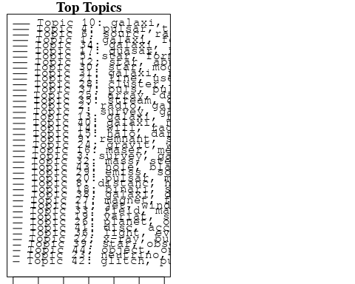

plotQuote(thoughts6, width = 30, main = "Topic 6")  
plotQuote(thoughts18, width = 30, main = "Topic 18")

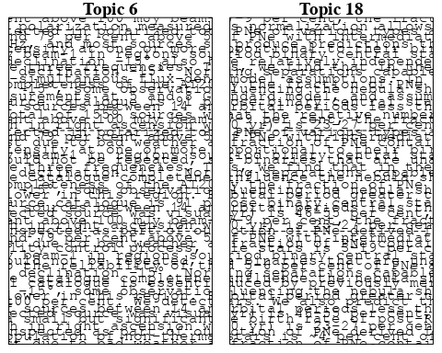

# Calculate and plot the correlation between topics  
mod.out.corr <- topicCorr(Research_topics)  
plot(mod.out.corr, cex = 1.5)  
  
  
# For each topic  
for (topic_num in 1:44) {  
 # Plot the word cloud  
 cloud(Research_topics, topic = topic_num, scale = c(2, 0.25))  
 Sys.sleep(2)  
}

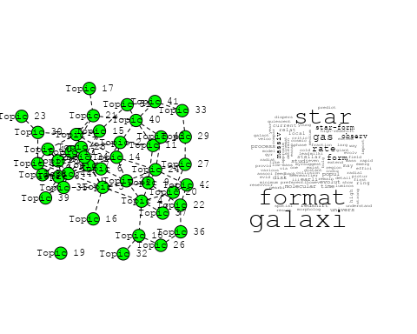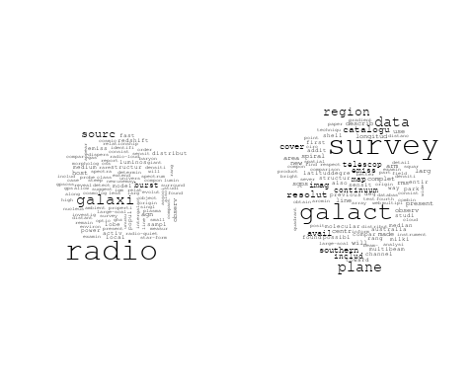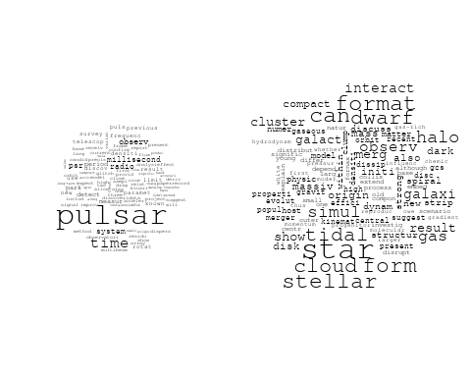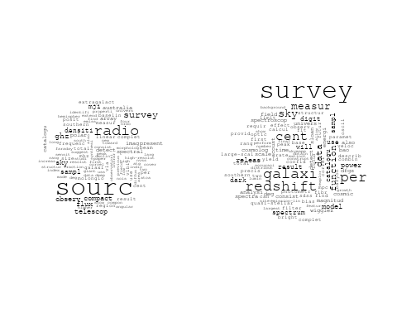

## Warning in wordcloud::wordcloud(words = vocab, freq = vec, max.words =  
## max.words, : supernova could not be fit on page. It will not be plotted.

## Warning in wordcloud::wordcloud(words = vocab, freq = vec, max.words =  
## max.words, : remnant could not be fit on page. It will not be plotted.

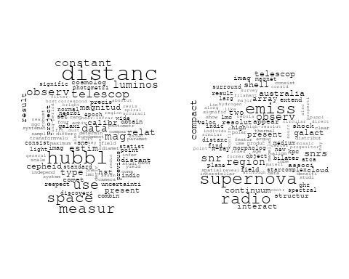

## Warning in wordcloud::wordcloud(words = vocab, freq = vec, max.words =  
## max.words, : globular could not be fit on page. It will not be plotted.

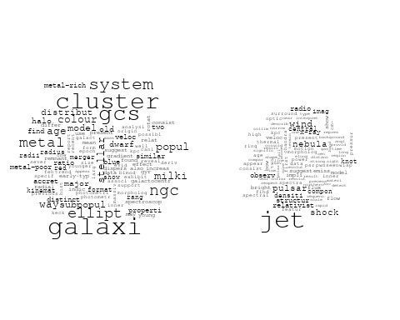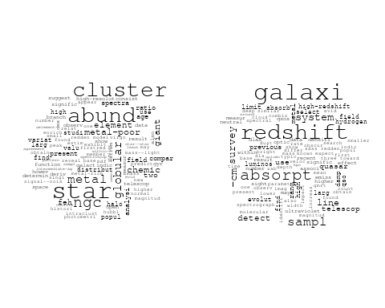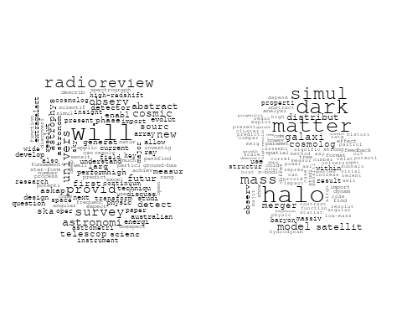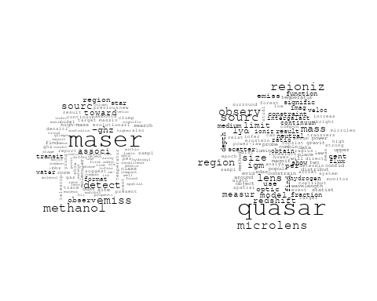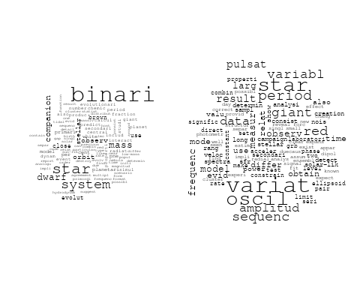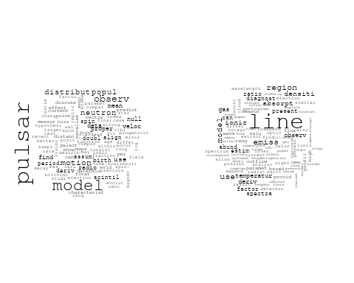

## Warning in wordcloud::wordcloud(words = vocab, freq = vec, max.words =  
## max.words, : background could not be fit on page. It will not be plotted.

## Warning in wordcloud::wordcloud(words = vocab, freq = vec, max.words =  
## max.words, : spectrum could not be fit on page. It will not be plotted.

## Warning in wordcloud::wordcloud(words = vocab, freq = vec, max.words =  
## max.words, : explain could not be fit on page. It will not be plotted.

## Warning in wordcloud::wordcloud(words = vocab, freq = vec, max.words =  
## max.words, : particl could not be fit on page. It will not be plotted.

## Warning in wordcloud::wordcloud(words = vocab, freq = vec, max.words =  
## max.words, : neutrino could not be fit on page. It will not be plotted.

## Warning in wordcloud::wordcloud(words = vocab, freq = vec, max.words =  
## max.words, : secondari could not be fit on page. It will not be plotted.

## Warning in wordcloud::wordcloud(words = vocab, freq = vec, max.words =  
## max.words, : detector could not be fit on page. It will not be plotted.

## Warning in wordcloud::wordcloud(words = vocab, freq = vec, max.words =  
## max.words, : cloud could not be fit on page. It will not be plotted.

## Warning in wordcloud::wordcloud(words = vocab, freq = vec, max.words =  
## max.words, : produc could not be fit on page. It will not be plotted.

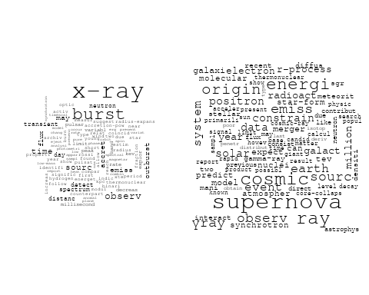

## Warning in wordcloud::wordcloud(words = vocab, freq = vec, max.words =  
## max.words, : murchison could not be fit on page. It will not be plotted.

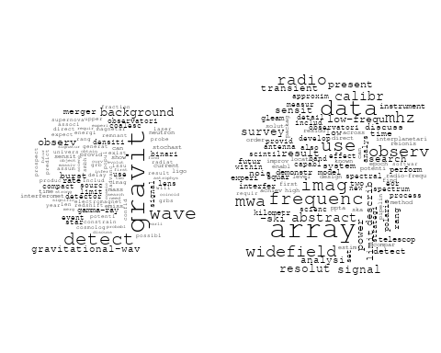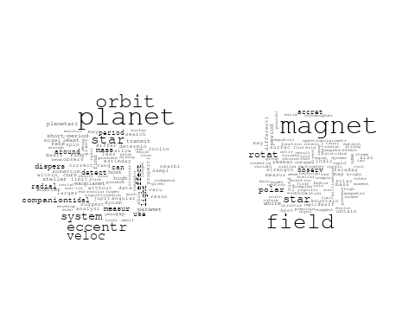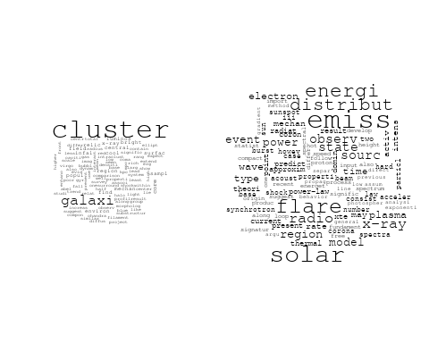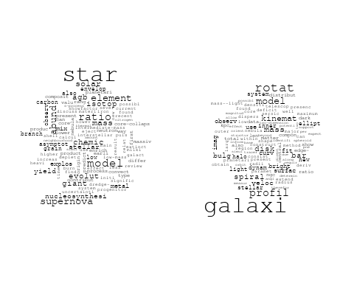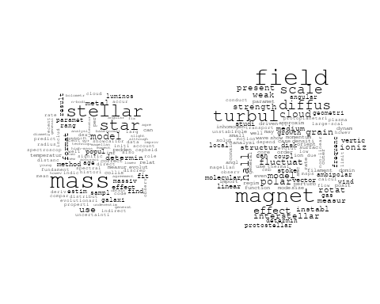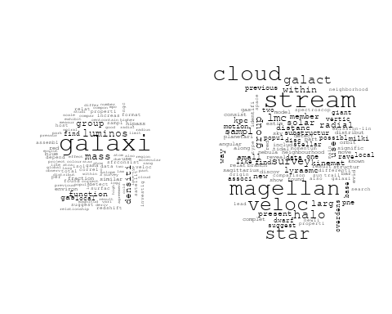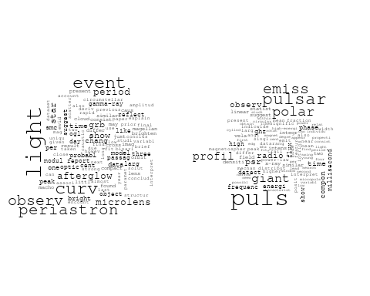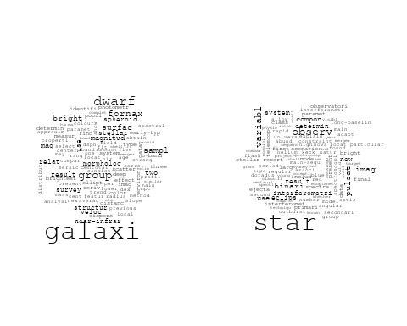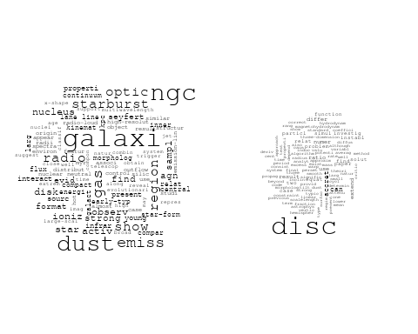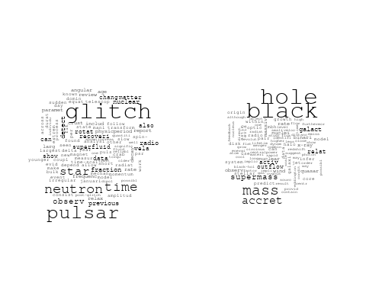

# Get the topic proportions for each document  
topic_proportions <- Research_topics$theta  
  
# Find the index of the topic with the highest proportion for each document  
# This will be the topic that each document is most likely to belong to  
max_topic_idx <- apply(topic_proportions, 1, which.max)  
  
# Add this as a new column to your data  
data_collab$topic <- max_topic_idx  
  
library(ggplot2)  
  
# Define the intervals  
intervals <- c('1824_1899', '1900_1964', '1965_1974', '1975_1984', '1985_1994', '1995_1999', '2000_2004', '2005_2009', '2010_2014', '2015_2019', '2020_2022')  
colors <- c('pink', 'blue', 'purple', 'yellow', 'green', 'pink', 'orange', 'violet', 'green', 'blue', 'pink')  
  
# Loop through the intervals and plot  
for(i in seq_along(intervals)){  
 # Filter data for when the pub_interval is equal to 1  
 data_filtered <- data_collab[data_collab[[paste0('pub_interval_', intervals[i])]] == 1,]  
   
 # Make the histogram  
   
 p <- ggplot(data_filtered, aes(x = topic)) +  
 geom_histogram(binwidth = 1, fill = colors[i], color = "black") +  
 xlab("Topic") +  
 ylab("Count") +  
 ggtitle(paste0("Topics from year ", gsub("_", " to ", intervals[i])))  
   
 print(p)  
}  
  
  
##Topic generation for AU (independent) publications  
  
data_independent <- data[data[["AU"]] == 100,]  
  
# Save the original title data for future use  
data_independent$original_concatenated_title_abstract <- data_independent$concatenated_title_abstract  
  
#pre-processing the titles using textProcessor from the stm package  
processed_text <- textProcessor(data_independent$concatenated_title_abstract, metadata = data_independent)

## Building corpus...   
## Converting to Lower Case...   
## Removing punctuation...   
## Removing stopwords...   
## Removing numbers...   
## Stemming...   
## Creating Output...

# Further prepare the data by removing low-frequency terms  
out_text <- prepDocuments(processed_text$documents, processed_text$vocab, processed_text$meta)

## Removing 1437 of 6057 terms (1437 of 85420 tokens) due to frequency   
## Your corpus now has 1028 documents, 4620 terms and 83983 tokens.

docs_text <- out_text$documents  
vocab_text <- out_text$vocab  
meta_text <- out_text$meta  
  
  
#Prepare data  
plotRemoved(processed_text$documents, lower.thresh = seq(1, 200, by = 100))

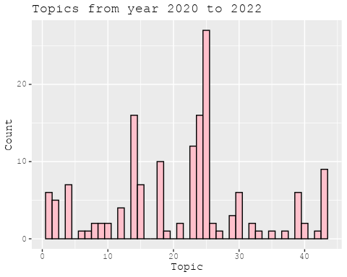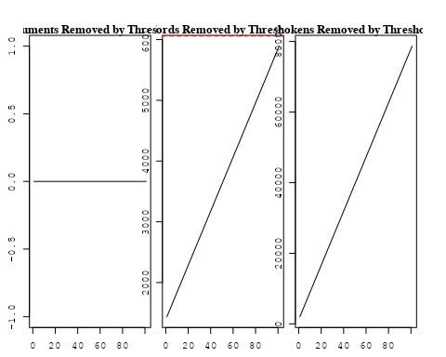

out_text <- prepDocuments(processed_text$documents, processed_text$vocab, processed_text$meta, lower.thresh = 8)

## Removing 4519 of 6057 terms (12103 of 85420 tokens) due to frequency   
## Your corpus now has 1028 documents, 1538 terms and 73317 tokens.

str(out_text$meta)

## 'data.frame': 1028 obs. of 39 variables:  
## $ concept_id : chr "https://openalex.org/C1276947" "https://openalex.org/C1276947" "https://openalex.org/C44870925" "https://openalex.org/C44870925" ...  
## $ work_id : chr "https://openalex.org/W3100822581" "https://openalex.org/W3140362863" "https://openalex.org/W2019918353" "https://openalex.org/W3104653637" ...  
## $ publication_year : int 2007 2021 1998 2008 2014 2014 2009 2004 2020 2010 ...  
## $ title : chr "Revealing Substructure in the Galactic Halo - The SEKBO RR Lyrae Survey" "Evidence for an intermediate-mass black hole from a gravitationally lensed gamma-ray burst" "The Nature of Bilateral Supernova Remnants" "The early-type galaxies NGC 1407 and NGC 1400 - II: star formation and chemical evolutionary history" ...  
## $ paperabstract : chr "We present a search for RR Lyrae variable stars from archival observations of the Southern Edgeworth-Kuiper Bel"| __truncated__ "If gamma-ray bursts are at cosmological distances, they must be gravitationally lensed occasionally [1, 2]. The"| __truncated__ "We present high-resolution radio images at 1.4 GHz of two Galactic supernova remnants (SNRs), G003.8–00.3 (form"| __truncated__ "We present a possible star formation and chemical evolutionary history for two early-type galaxies NGC 1407 and"| __truncated__ ...  
## $ country : chr "AU AU AU AU" "AU AU AU AU" "AU AU AU AU" "AU AU" ...  
## $ year_concept : chr "2007+https://openalex.org/C1276947" "2021+https://openalex.org/C1276947" "1998+https://openalex.org/C44870925" "2008+https://openalex.org/C44870925" ...  
## $ concatenated_title_abstract : chr "Revealing Substructure in the Galactic Halo - The SEKBO RR Lyrae Survey We present a search for RR Lyrae variab"| __truncated__ "Evidence for an intermediate-mass black hole from a gravitationally lensed gamma-ray burst If gamma-ray bursts "| __truncated__ "The Nature of Bilateral Supernova Remnants We present high-resolution radio images at 1.4 GHz of two Galactic s"| __truncated__ "The early-type galaxies NGC 1407 and NGC 1400 - II: star formation and chemical evolutionary history We present"| __truncated__ ...  
## $ US : num 0 0 0 0 0 0 0 0 0 0 ...  
## $ IN : num 0 0 0 0 0 0 0 0 0 0 ...  
## $ DE : num 0 0 0 0 0 0 0 0 0 0 ...  
## $ CH : num 0 0 0 0 0 0 0 0 0 0 ...  
## $ GB : num 0 0 0 0 0 0 0 0 0 0 ...  
## $ CN : num 0 0 0 0 0 0 0 0 0 0 ...  
## $ FR : num 0 0 0 0 0 0 0 0 0 0 ...  
## $ IT : num 0 0 0 0 0 0 0 0 0 0 ...  
## $ RU : num 0 0 0 0 0 0 0 0 0 0 ...  
## $ CA : num 0 0 0 0 0 0 0 0 0 0 ...  
## $ NL : num 0 0 0 0 0 0 0 0 0 0 ...  
## $ AU : num 100 100 100 100 100 100 100 100 100 100 ...  
## $ JP : num 0 0 0 0 0 0 0 0 0 0 ...  
## $ ES : num 0 0 0 0 0 0 0 0 0 0 ...  
## $ IL : num 0 0 0 0 0 0 0 0 0 0 ...  
## $ Americas : num 0 0 0 0 0 0 0 0 0 0 ...  
## $ Europe : num 0 0 0 0 0 0 0 0 0 0 ...  
## $ Africa : num 0 0 0 0 0 0 0 0 0 0 ...  
## $ AsiaAndOceania : num 0 0 0 0 0 0 0 0 0 0 ...  
## $ pub_interval_2020_2022 : int 0 1 0 0 0 0 0 0 1 0 ...  
## $ pub_interval_2015_2019 : int 0 0 0 0 0 0 0 0 0 0 ...  
## $ pub_interval_2010_2014 : int 0 0 0 0 1 1 0 0 0 1 ...  
## $ pub_interval_2005_2009 : int 1 0 0 1 0 0 1 0 0 0 ...  
## $ pub_interval_2000_2004 : int 0 0 0 0 0 0 0 1 0 0 ...  
## $ pub_interval_1995_1999 : int 0 0 1 0 0 0 0 0 0 0 ...  
## $ pub_interval_1985_1994 : int 0 0 0 0 0 0 0 0 0 0 ...  
## $ pub_interval_1975_1984 : int 0 0 0 0 0 0 0 0 0 0 ...  
## $ pub_interval_1965_1974 : int 0 0 0 0 0 0 0 0 0 0 ...  
## $ pub_interval_1900_1964 : int 0 0 0 0 0 0 0 0 0 0 ...  
## $ pub_interval_1824_1899 : int 0 0 0 0 0 0 0 0 0 0 ...  
## $ original_concatenated_title_abstract: chr "Revealing Substructure in the Galactic Halo - The SEKBO RR Lyrae Survey We present a search for RR Lyrae variab"| __truncated__ "Evidence for an intermediate-mass black hole from a gravitationally lensed gamma-ray burst If gamma-ray bursts "| __truncated__ "The Nature of Bilateral Supernova Remnants We present high-resolution radio images at 1.4 GHz of two Galactic s"| __truncated__ "The early-type galaxies NGC 1407 and NGC 1400 - II: star formation and chemical evolutionary history We present"| __truncated__ ...

# Initialize an empty formula string  
prevalence_formula_str <- "~"  
  
# Define the publication intervals  
pub_intervals <- c("pub_interval_2020_2022", "pub_interval_2015_2019", "pub_interval_2010_2014",   
 "pub_interval_2005_2009", "pub_interval_2000_2004", "pub_interval_1995_1999",  
 "pub_interval_1985_1994", "pub_interval_1975_1984", "pub_interval_1965_1974",  
 "pub_interval_1900_1964", "pub_interval_1824_1899")  
  
# Add each publication interval to the formula string  
for (interval in pub_intervals) {  
 # add an if statement to handle the first addition (without '+')  
 if (prevalence_formula_str == "~") {  
 prevalence_formula_str <- paste(prevalence_formula_str, interval)  
 } else {  
 prevalence_formula_str <- paste(prevalence_formula_str, "+", interval)  
 }  
}  
  
  
# Convert the string to a formula  
prevalence_formula <- as.formula(prevalence_formula_str)  
print(prevalence_formula)

## ~pub_interval_2020_2022 + pub_interval_2015_2019 + pub_interval_2010_2014 +   
## pub_interval_2005_2009 + pub_interval_2000_2004 + pub_interval_1995_1999 +   
## pub_interval_1985_1994 + pub_interval_1975_1984 + pub_interval_1965_1974 +   
## pub_interval_1900_1964 + pub_interval_1824_1899

# Run STM model  
Research_topics <- stm(documents = out_text$documents,   
 vocab = out_text$vocab,   
 K = 44,   
 prevalence = prevalence_formula,   
 data = out_text$meta,   
 init.type = "Spectral",  
 max.em.its = 1000,  
 gamma.prior = 'L1')

## Beginning Spectral Initialization   
## Calculating the gram matrix...  
## Finding anchor words...  
## ............................................  
## Recovering initialization...  
## ...............  
## Initialization complete.  
## ......................................................................................................  
## Completed E-Step (1 seconds).   
## Completed M-Step.   
## Completing Iteration 1 (approx. per word bound = -6.101)   
## ......................................................................................................  
## Completed E-Step (1 seconds).   
## Completed M-Step.   
## Completing Iteration 2 (approx. per word bound = -5.822, relative change = 4.577e-02)   
## ......................................................................................................  
## Completed E-Step (0 seconds).   
## Completed M-Step.   
## Completing Iteration 3 (approx. per word bound = -5.738, relative change = 1.437e-02)   
## ......................................................................................................  
## Completed E-Step (0 seconds).   
## Completed M-Step.   
## Completing Iteration 4 (approx. per word bound = -5.701, relative change = 6.471e-03)   
## ......................................................................................................  
## Completed E-Step (0 seconds).   
## Completed M-Step.   
## Completing Iteration 5 (approx. per word bound = -5.679, relative change = 3.764e-03)   
## Topic 1: sourc, catalogu, ghz, south, survey   
## Topic 2: galaxi, cluster, environ, host, satellit   
## Topic 3: galaxi, star, format, univers, critic   
## Topic 4: flare, distribut, energi, solar, region   
## Topic 5: halo, merger, dark, matter, simul   
## Topic 6: binari, star, observ, period, system   
## Topic 7: gravit, wave, neutron, star, detect   
## Topic 8: magnet, field, star, white, dwarf   
## Topic 9: remnant, supernova, galact, snrs, bilater   
## Topic 10: observ, telescop, field, will, optic   
## Topic 11: star, giant, branch, stellar, mix   
## Topic 12: system, metal, galaxi, redshift, damp   
## Topic 13: pulsar, model, magnet, rotat, field   
## Topic 14: maser, emiss, detect, transit, site   
## Topic 15: mass, stellar, relat, lmc, magellan   
## Topic 16: quasar, region, emiss, model, observ   
## Topic 17: cluster, globular, galaxi, metal, ngc   
## Topic 18: dwarf, mass, companion, star, stellar   
## Topic 19: data, calibr, new, databas, mwa   
## Topic 20: ngc, star, cluster, abund, redden   
## Topic 21: model, use, galaxi, line, starburst   
## Topic 22: radio, sourc, survey, galaxi, compact   
## Topic 23: galaxi, group, cloud, gas, mass   
## Topic 24: supernova, star, mass, yield, explos   
## Topic 25: veloc, galaxi, dispers, kinemat, rotat   
## Topic 26: maser, methanol, associ, sourc, -ghz   
## Topic 27: hole, black, mass, accret, binari   
## Topic 28: puls, profil, pulsar, compon, emiss   
## Topic 29: jet, radio, accret, disk, interact   
## Topic 30: mass, lens, gravit, len, matter   
## Topic 31: emiss, radio, x-ray, observ, synchrotron   
## Topic 32: galaxi, bar, disk, ring, spiral   
## Topic 33: pulsar, observ, null, time, survey   
## Topic 34: per, cent, catalogu, survey, releas   
## Topic 35: survey, radio, sourc, will, mhz   
## Topic 36: galaxi, optic, extinct, emiss, sky   
## Topic 37: spectra, variabl, optic, flux, pulsar   
## Topic 38: fornax, star, galaxi, shell, survey   
## Topic 39: array, murchison, frequenc, widefield, detect   
## Topic 40: simul, format, gas, cloud, can   
## Topic 41: pulsar, time, vela, glitch, motion   
## Topic 42: diffus, instabl, hall, disc, effect   
## Topic 43: survey, star, pne, lmc, previous   
## Topic 44: qso, redshift, object, survey, luminos   
## ......................................................................................................  
## Completed E-Step (0 seconds).   
## Completed M-Step.   
## Completing Iteration 6 (approx. per word bound = -5.666, relative change = 2.269e-03)   
## ......................................................................................................  
## Completed E-Step (0 seconds).   
## Completed M-Step.   
## Completing Iteration 7 (approx. per word bound = -5.658, relative change = 1.481e-03)   
## ......................................................................................................  
## Completed E-Step (0 seconds).   
## Completed M-Step.   
## Completing Iteration 8 (approx. per word bound = -5.652, relative change = 1.107e-03)   
## ......................................................................................................  
## Completed E-Step (0 seconds).   
## Completed M-Step.   
## Completing Iteration 9 (approx. per word bound = -5.646, relative change = 9.243e-04)   
## ......................................................................................................  
## Completed E-Step (0 seconds).   
## Completed M-Step.   
## Completing Iteration 10 (approx. per word bound = -5.643, relative change = 6.851e-04)   
## Topic 1: sourc, catalogu, ghz, survey, south   
## Topic 2: galaxi, cluster, environ, function, host   
## Topic 3: galaxi, star, format, univers, critic   
## Topic 4: flare, distribut, energi, solar, region   
## Topic 5: halo, merger, simul, dark, matter   
## Topic 6: binari, star, observ, system, light   
## Topic 7: gravit, wave, neutron, star, detect   
## Topic 8: magnet, field, star, white, dwarf   
## Topic 9: remnant, supernova, galact, snrs, radio   
## Topic 10: will, observ, telescop, field, optic   
## Topic 11: star, giant, branch, stellar, mix   
## Topic 12: galaxi, system, metal, redshift, abund   
## Topic 13: pulsar, model, magnet, rotat, polar   
## Topic 14: maser, emiss, detect, methanol, transit   
## Topic 15: mass, stellar, relat, lmc, magellan   
## Topic 16: quasar, region, emiss, observ, model   
## Topic 17: cluster, globular, galaxi, metal, ngc   
## Topic 18: dwarf, mass, companion, star, planet   
## Topic 19: data, calibr, new, mwa, use   
## Topic 20: ngc, star, cluster, abund, redden   
## Topic 21: model, use, galaxi, starburst, line   
## Topic 22: radio, sourc, survey, galaxi, compact   
## Topic 23: galaxi, cloud, group, gas, ngc   
## Topic 24: supernova, mass, star, explos, yield   
## Topic 25: veloc, galaxi, dispers, rotat, kinemat   
## Topic 26: maser, methanol, associ, sourc, -ghz   
## Topic 27: hole, black, mass, accret, binari   
## Topic 28: puls, profil, pulsar, compon, emiss   
## Topic 29: jet, radio, accret, disk, interact   
## Topic 30: lens, mass, gravit, len, matter   
## Topic 31: emiss, radio, observ, burst, synchrotron   
## Topic 32: galaxi, bar, ring, disk, spiral   
## Topic 33: pulsar, observ, null, time, survey   
## Topic 34: per, cent, survey, catalogu, releas   
## Topic 35: survey, radio, will, sourc, mhz   
## Topic 36: galaxi, extinct, emiss, line, optic   
## Topic 37: spectra, optic, may, flux, variabl   
## Topic 38: fornax, star, galaxi, dwarf, shell   
## Topic 39: array, murchison, frequenc, widefield, radio   
## Topic 40: format, gas, simul, can, cloud   
## Topic 41: pulsar, time, glitch, motion, vela   
## Topic 42: diffus, instabl, hall, disc, effect   
## Topic 43: survey, star, pne, magnitud, previous   
## Topic 44: qso, redshift, object, luminos, survey   
## ......................................................................................................  
## Completed E-Step (0 seconds).   
## Completed M-Step.   
## Completing Iteration 11 (approx. per word bound = -5.640, relative change = 5.165e-04)   
## ......................................................................................................  
## Completed E-Step (0 seconds).   
## Completed M-Step.   
## Completing Iteration 12 (approx. per word bound = -5.637, relative change = 5.428e-04)   
## ......................................................................................................  
## Completed E-Step (0 seconds).   
## Completed M-Step.   
## Completing Iteration 13 (approx. per word bound = -5.634, relative change = 4.529e-04)   
## ......................................................................................................  
## Completed E-Step (0 seconds).   
## Completed M-Step.   
## Completing Iteration 14 (approx. per word bound = -5.632, relative change = 4.117e-04)   
## ......................................................................................................  
## Completed E-Step (0 seconds).   
## Completed M-Step.   
## Completing Iteration 15 (approx. per word bound = -5.630, relative change = 3.740e-04)   
## Topic 1: sourc, catalogu, ghz, survey, flux   
## Topic 2: galaxi, cluster, environ, function, group   
## Topic 3: galaxi, star, format, critic, univers   
## Topic 4: flare, distribut, energi, solar, region   
## Topic 5: halo, simul, merger, dark, matter   
## Topic 6: binari, star, observ, system, light   
## Topic 7: gravit, wave, detect, star, neutron   
## Topic 8: magnet, field, star, white, dwarf   
## Topic 9: remnant, supernova, galact, radio, snrs   
## Topic 10: will, observ, telescop, field, first   
## Topic 11: star, giant, branch, stellar, mix   
## Topic 12: galaxi, metal, system, redshift, abund   
## Topic 13: pulsar, model, magnet, rotat, polar   
## Topic 14: maser, emiss, detect, methanol, transit   
## Topic 15: mass, stellar, relat, lmc, magellan   
## Topic 16: quasar, region, emiss, observ, model   
## Topic 17: cluster, globular, galaxi, metal, ngc   
## Topic 18: dwarf, mass, companion, planet, star   
## Topic 19: data, calibr, new, use, mwa   
## Topic 20: ngc, star, cluster, abund, redden   
## Topic 21: model, use, galaxi, starburst, optic   
## Topic 22: radio, sourc, survey, galaxi, compact   
## Topic 23: galaxi, cloud, gas, group, ngc   
## Topic 24: supernova, mass, star, explos, solar   
## Topic 25: veloc, galaxi, dispers, mass, rotat   
## Topic 26: maser, methanol, associ, sourc, -ghz   
## Topic 27: hole, black, mass, accret, binari   
## Topic 28: puls, profil, pulsar, emiss, compon   
## Topic 29: jet, radio, disk, accret, interact   
## Topic 30: lens, mass, gravit, len, sourc   
## Topic 31: emiss, radio, burst, observ, electron   
## Topic 32: galaxi, bar, ring, spiral, disk   
## Topic 33: pulsar, observ, null, time, survey   
## Topic 34: per, cent, survey, galaxi, catalogu   
## Topic 35: radio, survey, will, sourc, continuum   
## Topic 36: extinct, galaxi, emiss, line, use   
## Topic 37: spectra, optic, may, x-ray, flux   
## Topic 38: fornax, star, galaxi, dwarf, shell   
## Topic 39: array, frequenc, murchison, widefield, radio   
## Topic 40: format, gas, can, simul, cloud   
## Topic 41: pulsar, time, glitch, motion, vela   
## Topic 42: diffus, disc, hall, instabl, effect   
## Topic 43: survey, magnitud, star, pne, previous   
## Topic 44: object, qso, redshift, luminos, survey   
## ......................................................................................................  
## Completed E-Step (0 seconds).   
## Completed M-Step.   
## Completing Iteration 16 (approx. per word bound = -5.628, relative change = 3.059e-04)   
## ......................................................................................................  
## Completed E-Step (0 seconds).   
## Completed M-Step.   
## Completing Iteration 17 (approx. per word bound = -5.627, relative change = 2.481e-04)   
## ......................................................................................................  
## Completed E-Step (0 seconds).   
## Completed M-Step.   
## Completing Iteration 18 (approx. per word bound = -5.625, relative change = 2.263e-04)   
## ......................................................................................................  
## Completed E-Step (0 seconds).   
## Completed M-Step.   
## Completing Iteration 19 (approx. per word bound = -5.624, relative change = 1.993e-04)   
## ......................................................................................................  
## Completed E-Step (0 seconds).   
## Completed M-Step.   
## Completing Iteration 20 (approx. per word bound = -5.623, relative change = 1.833e-04)   
## Topic 1: sourc, catalogu, ghz, survey, sky   
## Topic 2: galaxi, cluster, group, environ, function   
## Topic 3: galaxi, star, format, critic, early-typ   
## Topic 4: flare, distribut, energi, solar, region   
## Topic 5: halo, simul, merger, dark, matter   
## Topic 6: binari, star, observ, system, periastron   
## Topic 7: gravit, wave, detect, star, neutron   
## Topic 8: magnet, field, star, white, dwarf   
## Topic 9: remnant, supernova, galact, radio, snrs   
## Topic 10: will, observ, telescop, provid, field   
## Topic 11: star, giant, stellar, branch, mix   
## Topic 12: galaxi, metal, system, redshift, abund   
## Topic 13: pulsar, model, magnet, rotat, polar   
## Topic 14: maser, emiss, methanol, detect, transit   
## Topic 15: mass, stellar, relat, lmc, magellan   
## Topic 16: quasar, region, observ, model, emiss   
## Topic 17: cluster, globular, galaxi, metal, ngc   
## Topic 18: dwarf, mass, companion, planet, star   
## Topic 19: data, calibr, new, model, use   
## Topic 20: ngc, star, cluster, abund, redden   
## Topic 21: model, use, galaxi, starburst, optic   
## Topic 22: radio, sourc, survey, galaxi, compact   
## Topic 23: galaxi, cloud, gas, ngc, magellan   
## Topic 24: supernova, mass, star, explos, solar   
## Topic 25: veloc, galaxi, dispers, mass, use   
## Topic 26: maser, methanol, associ, sourc, -ghz   
## Topic 27: hole, black, accret, mass, binari   
## Topic 28: puls, profil, pulsar, emiss, compon   
## Topic 29: jet, radio, disk, accret, interact   
## Topic 30: lens, mass, gravit, len, sourc   
## Topic 31: emiss, radio, burst, observ, electron   
## Topic 32: galaxi, bar, spiral, ring, disk   
## Topic 33: pulsar, observ, null, time, survey   
## Topic 34: per, survey, galaxi, cent, redshift   
## Topic 35: radio, survey, will, continuum, sourc   
## Topic 36: extinct, galaxi, emiss, line, use   
## Topic 37: spectra, optic, may, x-ray, flux   
## Topic 38: fornax, star, galaxi, dwarf, shell   
## Topic 39: array, frequenc, murchison, widefield, radio   
## Topic 40: format, gas, can, simul, galaxi   
## Topic 41: pulsar, time, glitch, motion, vela   
## Topic 42: diffus, disc, hall, effect, instabl   
## Topic 43: survey, magnitud, star, previous, pne   
## Topic 44: object, qso, redshift, survey, luminos   
## ......................................................................................................  
## Completed E-Step (0 seconds).   
## Completed M-Step.   
## Completing Iteration 21 (approx. per word bound = -5.622, relative change = 1.688e-04)   
## ......................................................................................................  
## Completed E-Step (0 seconds).   
## Completed M-Step.   
## Completing Iteration 22 (approx. per word bound = -5.621, relative change = 1.612e-04)   
## ......................................................................................................  
## Completed E-Step (0 seconds).   
## Completed M-Step.   
## Completing Iteration 23 (approx. per word bound = -5.620, relative change = 1.463e-04)   
## ......................................................................................................  
## Completed E-Step (0 seconds).   
## Completed M-Step.   
## Completing Iteration 24 (approx. per word bound = -5.620, relative change = 1.304e-04)   
## ......................................................................................................  
## Completed E-Step (0 seconds).   
## Completed M-Step.   
## Completing Iteration 25 (approx. per word bound = -5.619, relative change = 1.255e-04)   
## Topic 1: sourc, catalogu, survey, ghz, sky   
## Topic 2: galaxi, cluster, group, environ, function   
## Topic 3: galaxi, star, format, critic, dust   
## Topic 4: flare, distribut, energi, solar, region   
## Topic 5: halo, simul, merger, dark, matter   
## Topic 6: binari, star, observ, system, periastron   
## Topic 7: gravit, wave, detect, star, neutron   
## Topic 8: magnet, field, star, white, dwarf   
## Topic 9: remnant, supernova, galact, radio, snrs   
## Topic 10: will, observ, telescop, field, provid   
## Topic 11: star, giant, stellar, branch, mix   
## Topic 12: galaxi, metal, system, redshift, abund   
## Topic 13: pulsar, model, magnet, polar, rotat   
## Topic 14: maser, emiss, methanol, detect, transit   
## Topic 15: mass, stellar, relat, lmc, magellan   
## Topic 16: quasar, region, absorpt, observ, model   
## Topic 17: cluster, globular, galaxi, metal, ngc   
## Topic 18: dwarf, mass, companion, planet, star   
## Topic 19: data, calibr, new, model, use   
## Topic 20: ngc, star, cluster, abund, redden   
## Topic 21: model, use, galaxi, starburst, optic   
## Topic 22: radio, sourc, survey, galaxi, compact   
## Topic 23: galaxi, cloud, gas, ngc, magellan   
## Topic 24: supernova, mass, star, explos, solar   
## Topic 25: veloc, galaxi, dispers, mass, use   
## Topic 26: maser, methanol, associ, sourc, -ghz   
## Topic 27: hole, black, accret, mass, binari   
## Topic 28: puls, profil, pulsar, emiss, compon   
## Topic 29: jet, radio, disk, accret, interact   
## Topic 30: lens, mass, gravit, len, sourc   
## Topic 31: emiss, radio, observ, burst, electron   
## Topic 32: galaxi, bar, spiral, ring, disk   
## Topic 33: pulsar, observ, null, time, survey   
## Topic 34: per, survey, galaxi, cent, redshift   
## Topic 35: radio, survey, will, continuum, sourc   
## Topic 36: galaxi, extinct, emiss, line, use   
## Topic 37: optic, spectra, x-ray, may, flux   
## Topic 38: fornax, star, galaxi, dwarf, shell   
## Topic 39: array, frequenc, murchison, widefield, radio   
## Topic 40: format, gas, can, simul, cloud   
## Topic 41: pulsar, time, glitch, motion, vela   
## Topic 42: diffus, disc, hall, effect, magnet   
## Topic 43: survey, magnitud, star, previous, pne   
## Topic 44: object, qso, redshift, survey, luminos   
## ......................................................................................................  
## Completed E-Step (0 seconds).   
## Completed M-Step.   
## Completing Iteration 26 (approx. per word bound = -5.618, relative change = 1.151e-04)   
## ......................................................................................................  
## Completed E-Step (0 seconds).   
## Completed M-Step.   
## Completing Iteration 27 (approx. per word bound = -5.618, relative change = 1.204e-04)   
## ......................................................................................................  
## Completed E-Step (0 seconds).   
## Completed M-Step.   
## Completing Iteration 28 (approx. per word bound = -5.617, relative change = 1.097e-04)   
## ......................................................................................................  
## Completed E-Step (0 seconds).   
## Completed M-Step.   
## Completing Iteration 29 (approx. per word bound = -5.617, relative change = 9.913e-05)   
## ......................................................................................................  
## Completed E-Step (0 seconds).   
## Completed M-Step.   
## Completing Iteration 30 (approx. per word bound = -5.616, relative change = 9.430e-05)   
## Topic 1: sourc, catalogu, survey, ghz, sky   
## Topic 2: galaxi, cluster, group, environ, host   
## Topic 3: galaxi, star, format, critic, dust   
## Topic 4: flare, distribut, energi, solar, region   
## Topic 5: halo, simul, merger, dark, matter   
## Topic 6: binari, star, observ, system, periastron   
## Topic 7: gravit, wave, detect, star, neutron   
## Topic 8: magnet, field, star, white, dwarf   
## Topic 9: remnant, supernova, galact, radio, snrs   
## Topic 10: will, observ, telescop, field, provid   
## Topic 11: star, giant, stellar, branch, mix   
## Topic 12: galaxi, metal, system, redshift, abund   
## Topic 13: pulsar, model, magnet, polar, rotat   
## Topic 14: maser, emiss, methanol, detect, transit   
## Topic 15: mass, relat, stellar, lmc, magellan   
## Topic 16: quasar, region, absorpt, model, observ   
## Topic 17: cluster, globular, galaxi, metal, ngc   
## Topic 18: dwarf, mass, companion, planet, star   
## Topic 19: data, calibr, new, use, model   
## Topic 20: ngc, star, cluster, abund, redden   
## Topic 21: model, use, galaxi, starburst, optic   
## Topic 22: radio, sourc, survey, galaxi, compact   
## Topic 23: galaxi, cloud, gas, ngc, magellan   
## Topic 24: supernova, mass, star, explos, solar   
## Topic 25: veloc, galaxi, dispers, mass, use   
## Topic 26: maser, methanol, associ, sourc, -ghz   
## Topic 27: hole, black, accret, mass, binari   
## Topic 28: puls, profil, pulsar, emiss, compon   
## Topic 29: jet, radio, disk, accret, interact   
## Topic 30: lens, mass, gravit, len, sourc   
## Topic 31: emiss, radio, observ, burst, electron   
## Topic 32: galaxi, bar, spiral, ring, disk   
## Topic 33: pulsar, observ, null, time, survey   
## Topic 34: galaxi, survey, per, cent, redshift   
## Topic 35: radio, survey, will, continuum, burst   
## Topic 36: galaxi, emiss, line, extinct, use   
## Topic 37: optic, spectra, x-ray, may, flux   
## Topic 38: fornax, star, galaxi, dwarf, survey   
## Topic 39: array, murchison, frequenc, widefield, radio   
## Topic 40: format, gas, can, simul, galaxi   
## Topic 41: pulsar, time, glitch, motion, vela   
## Topic 42: diffus, disc, hall, effect, magnet   
## Topic 43: survey, magnitud, star, previous, pne   
## Topic 44: object, qso, redshift, survey, luminos   
## ......................................................................................................  
## Completed E-Step (0 seconds).   
## Completed M-Step.   
## Completing Iteration 31 (approx. per word bound = -5.615, relative change = 9.460e-05)   
## ......................................................................................................  
## Completed E-Step (0 seconds).   
## Completed M-Step.   
## Completing Iteration 32 (approx. per word bound = -5.615, relative change = 9.819e-05)   
## ......................................................................................................  
## Completed E-Step (0 seconds).   
## Completed M-Step.   
## Completing Iteration 33 (approx. per word bound = -5.614, relative change = 9.968e-05)   
## ......................................................................................................  
## Completed E-Step (0 seconds).   
## Completed M-Step.   
## Completing Iteration 34 (approx. per word bound = -5.614, relative change = 1.030e-04)   
## ......................................................................................................  
## Completed E-Step (0 seconds).   
## Completed M-Step.   
## Completing Iteration 35 (approx. per word bound = -5.613, relative change = 9.856e-05)   
## Topic 1: sourc, catalogu, survey, ghz, sky   
## Topic 2: galaxi, cluster, group, environ, find   
## Topic 3: galaxi, star, format, critic, dust   
## Topic 4: flare, distribut, energi, region, solar   
## Topic 5: halo, simul, merger, dark, matter   
## Topic 6: binari, star, observ, system, periastron   
## Topic 7: gravit, wave, detect, star, neutron   
## Topic 8: magnet, field, star, white, dwarf   
## Topic 9: remnant, supernova, galact, radio, snrs   
## Topic 10: will, observ, telescop, field, provid   
## Topic 11: star, giant, stellar, branch, mix   
## Topic 12: galaxi, metal, redshift, system, damp   
## Topic 13: pulsar, model, magnet, polar, rotat   
## Topic 14: maser, emiss, methanol, detect, transit   
## Topic 15: mass, relat, stellar, lmc, magellan   
## Topic 16: quasar, region, absorpt, model, observ   
## Topic 17: cluster, globular, galaxi, metal, ngc   
## Topic 18: mass, companion, dwarf, planet, star   
## Topic 19: data, calibr, new, use, model   
## Topic 20: ngc, star, cluster, abund, redden   
## Topic 21: model, use, galaxi, starburst, optic   
## Topic 22: radio, sourc, survey, galaxi, compact   
## Topic 23: galaxi, cloud, gas, ngc, magellan   
## Topic 24: supernova, mass, star, explos, solar   
## Topic 25: veloc, galaxi, dispers, mass, use   
## Topic 26: maser, methanol, associ, sourc, -ghz   
## Topic 27: hole, black, accret, mass, binari   
## Topic 28: puls, profil, pulsar, emiss, compon   
## Topic 29: jet, radio, disk, accret, interact   
## Topic 30: lens, mass, gravit, sourc, len   
## Topic 31: emiss, radio, observ, burst, electron   
## Topic 32: galaxi, bar, spiral, ring, disk   
## Topic 33: pulsar, observ, null, time, survey   
## Topic 34: galaxi, survey, per, cent, redshift   
## Topic 35: radio, survey, will, continuum, galaxi   
## Topic 36: galaxi, emiss, line, extinct, use   
## Topic 37: optic, spectra, x-ray, may, flux   
## Topic 38: fornax, star, dwarf, galaxi, survey   
## Topic 39: array, murchison, frequenc, widefield, radio   
## Topic 40: format, gas, can, simul, galaxi   
## Topic 41: pulsar, time, glitch, motion, vela   
## Topic 42: diffus, disc, hall, magnet, effect   
## Topic 43: survey, magnitud, star, previous, pne   
## Topic 44: object, qso, redshift, survey, luminos   
## ......................................................................................................  
## Completed E-Step (0 seconds).   
## Completed M-Step.   
## Completing Iteration 36 (approx. per word bound = -5.613, relative change = 9.252e-05)   
## ......................................................................................................  
## Completed E-Step (0 seconds).   
## Completed M-Step.   
## Completing Iteration 37 (approx. per word bound = -5.612, relative change = 9.730e-05)   
## ......................................................................................................  
## Completed E-Step (0 seconds).   
## Completed M-Step.   
## Completing Iteration 38 (approx. per word bound = -5.612, relative change = 9.800e-05)   
## ......................................................................................................  
## Completed E-Step (0 seconds).   
## Completed M-Step.   
## Completing Iteration 39 (approx. per word bound = -5.611, relative change = 1.027e-04)   
## ......................................................................................................  
## Completed E-Step (0 seconds).   
## Completed M-Step.   
## Completing Iteration 40 (approx. per word bound = -5.610, relative change = 1.032e-04)   
## Topic 1: sourc, catalogu, survey, ghz, sky   
## Topic 2: galaxi, cluster, group, environ, find   
## Topic 3: galaxi, star, format, critic, dust   
## Topic 4: flare, distribut, energi, region, solar   
## Topic 5: halo, simul, merger, dark, matter   
## Topic 6: binari, star, system, observ, periastron   
## Topic 7: gravit, wave, detect, star, neutron   
## Topic 8: magnet, field, star, white, dwarf   
## Topic 9: remnant, supernova, galact, radio, snrs   
## Topic 10: will, observ, telescop, field, provid   
## Topic 11: star, giant, stellar, branch, mix   
## Topic 12: galaxi, metal, redshift, system, damp   
## Topic 13: pulsar, model, magnet, polar, rotat   
## Topic 14: maser, emiss, methanol, detect, transit   
## Topic 15: mass, relat, stellar, lmc, magellan   
## Topic 16: quasar, region, absorpt, model, observ   
## Topic 17: cluster, globular, galaxi, metal, ngc   
## Topic 18: mass, companion, dwarf, planet, system   
## Topic 19: data, calibr, new, use, model   
## Topic 20: ngc, star, cluster, abund, redden   
## Topic 21: model, use, galaxi, starburst, optic   
## Topic 22: radio, sourc, survey, galaxi, compact   
## Topic 23: galaxi, cloud, gas, ngc, magellan   
## Topic 24: supernova, mass, star, explos, solar   
## Topic 25: veloc, galaxi, dispers, mass, use   
## Topic 26: maser, methanol, associ, sourc, -ghz   
## Topic 27: hole, black, accret, mass, binari   
## Topic 28: puls, profil, pulsar, emiss, compon   
## Topic 29: jet, radio, disk, accret, interact   
## Topic 30: lens, mass, gravit, sourc, len   
## Topic 31: emiss, radio, observ, burst, electron   
## Topic 32: galaxi, bar, spiral, ring, disk   
## Topic 33: pulsar, observ, null, time, survey   
## Topic 34: galaxi, survey, per, cent, redshift   
## Topic 35: radio, survey, will, continuum, galaxi   
## Topic 36: galaxi, line, emiss, extinct, use   
## Topic 37: optic, spectra, may, x-ray, flux   
## Topic 38: fornax, star, dwarf, galaxi, shell   
## Topic 39: array, murchison, frequenc, widefield, radio   
## Topic 40: format, gas, can, simul, galaxi   
## Topic 41: pulsar, time, glitch, motion, vela   
## Topic 42: diffus, disc, hall, magnet, effect   
## Topic 43: survey, magnitud, star, previous, pne   
## Topic 44: object, qso, redshift, survey, luminos   
## ......................................................................................................  
## Completed E-Step (0 seconds).   
## Completed M-Step.   
## Completing Iteration 41 (approx. per word bound = -5.610, relative change = 7.538e-05)   
## ......................................................................................................  
## Completed E-Step (0 seconds).   
## Completed M-Step.   
## Completing Iteration 42 (approx. per word bound = -5.610, relative change = 7.368e-05)   
## ......................................................................................................  
## Completed E-Step (0 seconds).   
## Completed M-Step.   
## Completing Iteration 43 (approx. per word bound = -5.609, relative change = 8.569e-05)   
## ......................................................................................................  
## Completed E-Step (0 seconds).   
## Completed M-Step.   
## Completing Iteration 44 (approx. per word bound = -5.609, relative change = 8.870e-05)   
## ......................................................................................................  
## Completed E-Step (0 seconds).   
## Completed M-Step.   
## Completing Iteration 45 (approx. per word bound = -5.608, relative change = 6.469e-05)   
## Topic 1: sourc, catalogu, survey, ghz, sky   
## Topic 2: galaxi, cluster, group, environ, find   
## Topic 3: galaxi, star, format, critic, dust   
## Topic 4: flare, distribut, energi, region, solar   
## Topic 5: halo, simul, merger, dark, matter   
## Topic 6: binari, star, system, observ, periastron   
## Topic 7: gravit, wave, detect, star, neutron   
## Topic 8: magnet, field, star, white, dwarf   
## Topic 9: remnant, supernova, galact, radio, snrs   
## Topic 10: will, observ, telescop, provid, field   
## Topic 11: star, giant, stellar, branch, mix   
## Topic 12: galaxi, metal, redshift, system, damp   
## Topic 13: pulsar, model, magnet, polar, emiss   
## Topic 14: maser, emiss, methanol, detect, transit   
## Topic 15: mass, relat, stellar, lmc, magellan   
## Topic 16: quasar, region, absorpt, model, observ   
## Topic 17: cluster, globular, galaxi, metal, ngc   
## Topic 18: mass, companion, dwarf, planet, system   
## Topic 19: data, calibr, new, use, model   
## Topic 20: ngc, star, cluster, abund, redden   
## Topic 21: model, use, galaxi, starburst, optic   
## Topic 22: radio, sourc, survey, galaxi, compact   
## Topic 23: galaxi, cloud, gas, ngc, magellan   
## Topic 24: supernova, mass, star, explos, solar   
## Topic 25: veloc, galaxi, dispers, mass, profil   
## Topic 26: maser, methanol, associ, sourc, -ghz   
## Topic 27: hole, black, accret, mass, binari   
## Topic 28: puls, profil, pulsar, emiss, compon   
## Topic 29: jet, radio, disk, accret, interact   
## Topic 30: lens, mass, gravit, len, sourc   
## Topic 31: emiss, radio, burst, observ, electron   
## Topic 32: galaxi, bar, ring, spiral, disk   
## Topic 33: pulsar, observ, null, time, survey   
## Topic 34: galaxi, survey, per, cent, redshift   
## Topic 35: radio, survey, will, continuum, galaxi   
## Topic 36: galaxi, line, emiss, extinct, use   
## Topic 37: optic, spectra, may, x-ray, flux   
## Topic 38: fornax, star, dwarf, galaxi, shell   
## Topic 39: array, murchison, frequenc, widefield, radio   
## Topic 40: format, gas, can, simul, galaxi   
## Topic 41: pulsar, time, glitch, motion, vela   
## Topic 42: diffus, disc, magnet, hall, effect   
## Topic 43: survey, magnitud, star, pne, previous   
## Topic 44: object, qso, redshift, survey, luminos   
## ......................................................................................................  
## Completed E-Step (0 seconds).   
## Completed M-Step.   
## Completing Iteration 46 (approx. per word bound = -5.608, relative change = 6.338e-05)   
## ......................................................................................................  
## Completed E-Step (0 seconds).   
## Completed M-Step.   
## Completing Iteration 47 (approx. per word bound = -5.608, relative change = 6.506e-05)   
## ......................................................................................................  
## Completed E-Step (0 seconds).   
## Completed M-Step.   
## Completing Iteration 48 (approx. per word bound = -5.607, relative change = 7.003e-05)   
## ......................................................................................................  
## Completed E-Step (0 seconds).   
## Completed M-Step.   
## Completing Iteration 49 (approx. per word bound = -5.607, relative change = 6.728e-05)   
## ......................................................................................................  
## Completed E-Step (0 seconds).   
## Completed M-Step.   
## Completing Iteration 50 (approx. per word bound = -5.606, relative change = 8.428e-05)   
## Topic 1: sourc, catalogu, survey, ghz, spectral   
## Topic 2: galaxi, cluster, group, environ, host   
## Topic 3: galaxi, star, format, critic, dust   
## Topic 4: flare, distribut, energi, region, solar   
## Topic 5: halo, simul, merger, dark, matter   
## Topic 6: binari, star, system, observ, periastron   
## Topic 7: gravit, wave, detect, star, neutron   
## Topic 8: magnet, field, star, white, dwarf   
## Topic 9: remnant, supernova, galact, radio, snrs   
## Topic 10: will, observ, telescop, provid, field   
## Topic 11: star, giant, stellar, branch, mix   
## Topic 12: galaxi, metal, redshift, system, damp   
## Topic 13: pulsar, model, magnet, polar, emiss   
## Topic 14: maser, emiss, methanol, detect, transit   
## Topic 15: mass, relat, stellar, lmc, magellan   
## Topic 16: quasar, region, absorpt, model, observ   
## Topic 17: cluster, globular, galaxi, metal, ngc   
## Topic 18: mass, companion, planet, dwarf, system   
## Topic 19: data, calibr, new, use, model   
## Topic 20: ngc, star, cluster, abund, redden   
## Topic 21: model, use, galaxi, starburst, optic   
## Topic 22: radio, sourc, survey, galaxi, compact   
## Topic 23: galaxi, cloud, gas, ngc, magellan   
## Topic 24: supernova, mass, star, explos, solar   
## Topic 25: veloc, galaxi, dispers, mass, use   
## Topic 26: maser, methanol, associ, sourc, -ghz   
## Topic 27: hole, black, accret, mass, binari   
## Topic 28: puls, profil, pulsar, emiss, compon   
## Topic 29: jet, radio, disk, accret, interact   
## Topic 30: lens, mass, gravit, sourc, len   
## Topic 31: emiss, radio, burst, observ, electron   
## Topic 32: galaxi, bar, ring, spiral, disk   
## Topic 33: pulsar, observ, null, time, survey   
## Topic 34: galaxi, survey, per, cent, redshift   
## Topic 35: radio, survey, will, continuum, emiss   
## Topic 36: galaxi, line, emiss, extinct, ioniz   
## Topic 37: optic, spectra, may, x-ray, flux   
## Topic 38: fornax, star, dwarf, galaxi, shell   
## Topic 39: array, murchison, frequenc, widefield, survey   
## Topic 40: format, gas, can, simul, galaxi   
## Topic 41: pulsar, time, glitch, motion, vela   
## Topic 42: diffus, disc, magnet, hall, effect   
## Topic 43: survey, star, magnitud, pne, previous   
## Topic 44: object, qso, redshift, survey, luminos   
## ......................................................................................................  
## Completed E-Step (0 seconds).   
## Completed M-Step.   
## Completing Iteration 51 (approx. per word bound = -5.606, relative change = 8.841e-05)   
## ......................................................................................................  
## Completed E-Step (0 seconds).   
## Completed M-Step.   
## Completing Iteration 52 (approx. per word bound = -5.605, relative change = 8.061e-05)   
## ......................................................................................................  
## Completed E-Step (0 seconds).   
## Completed M-Step.   
## Completing Iteration 53 (approx. per word bound = -5.605, relative change = 8.834e-05)   
## ......................................................................................................  
## Completed E-Step (0 seconds).   
## Completed M-Step.   
## Completing Iteration 54 (approx. per word bound = -5.605, relative change = 6.107e-05)   
## ......................................................................................................  
## Completed E-Step (0 seconds).   
## Completed M-Step.   
## Completing Iteration 55 (approx. per word bound = -5.604, relative change = 4.814e-05)   
## Topic 1: sourc, catalogu, ghz, survey, spectral   
## Topic 2: galaxi, cluster, group, environ, host   
## Topic 3: galaxi, star, format, critic, dust   
## Topic 4: flare, distribut, energi, region, solar   
## Topic 5: halo, simul, merger, dark, matter   
## Topic 6: binari, star, system, observ, periastron   
## Topic 7: gravit, wave, detect, star, neutron   
## Topic 8: magnet, field, star, white, dwarf   
## Topic 9: remnant, supernova, galact, radio, snrs   
## Topic 10: will, observ, telescop, provid, futur   
## Topic 11: star, giant, stellar, branch, mix   
## Topic 12: galaxi, metal, redshift, system, damp   
## Topic 13: pulsar, model, magnet, polar, emiss   
## Topic 14: maser, emiss, methanol, detect, transit   
## Topic 15: mass, relat, stellar, lmc, magellan   
## Topic 16: quasar, region, absorpt, model, observ   
## Topic 17: cluster, globular, galaxi, metal, ngc   
## Topic 18: mass, companion, planet, dwarf, system   
## Topic 19: data, calibr, new, use, model   
## Topic 20: ngc, star, cluster, abund, redden   
## Topic 21: model, use, galaxi, starburst, optic   
## Topic 22: radio, sourc, survey, galaxi, compact   
## Topic 23: galaxi, cloud, gas, ngc, magellan   
## Topic 24: supernova, mass, star, explos, solar   
## Topic 25: veloc, galaxi, dispers, mass, use   
## Topic 26: maser, methanol, associ, sourc, -ghz   
## Topic 27: hole, black, accret, mass, binari   
## Topic 28: puls, profil, compon, emiss, pulsar   
## Topic 29: jet, radio, disk, accret, interact   
## Topic 30: lens, mass, gravit, sourc, len   
## Topic 31: emiss, radio, burst, observ, electron   
## Topic 32: galaxi, bar, ring, spiral, disk   
## Topic 33: pulsar, observ, null, time, survey   
## Topic 34: galaxi, survey, per, cent, redshift   
## Topic 35: radio, survey, will, continuum, emiss   
## Topic 36: galaxi, line, emiss, extinct, ioniz   
## Topic 37: optic, spectra, may, x-ray, flux   
## Topic 38: fornax, star, dwarf, galaxi, shell   
## Topic 39: array, murchison, frequenc, widefield, survey   
## Topic 40: format, gas, can, simul, galaxi   
## Topic 41: pulsar, time, glitch, motion, vela   
## Topic 42: diffus, disc, magnet, hall, effect   
## Topic 43: survey, star, pne, magnitud, previous   
## Topic 44: object, qso, redshift, survey, luminos   
## ......................................................................................................  
## Completed E-Step (0 seconds).   
## Completed M-Step.   
## Completing Iteration 56 (approx. per word bound = -5.604, relative change = 4.309e-05)   
## ......................................................................................................  
## Completed E-Step (0 seconds).   
## Completed M-Step.   
## Completing Iteration 57 (approx. per word bound = -5.604, relative change = 4.539e-05)   
## ......................................................................................................  
## Completed E-Step (0 seconds).   
## Completed M-Step.   
## Completing Iteration 58 (approx. per word bound = -5.603, relative change = 4.738e-05)   
## ......................................................................................................  
## Completed E-Step (0 seconds).   
## Completed M-Step.   
## Completing Iteration 59 (approx. per word bound = -5.603, relative change = 4.108e-05)   
## ......................................................................................................  
## Completed E-Step (0 seconds).   
## Completed M-Step.   
## Completing Iteration 60 (approx. per word bound = -5.603, relative change = 2.940e-05)   
## Topic 1: sourc, catalogu, ghz, survey, radio   
## Topic 2: galaxi, cluster, group, environ, host   
## Topic 3: galaxi, star, format, critic, dust   
## Topic 4: flare, distribut, energi, region, solar   
## Topic 5: halo, simul, merger, dark, matter   
## Topic 6: binari, star, system, observ, periastron   
## Topic 7: gravit, wave, detect, star, neutron   
## Topic 8: magnet, field, star, white, dwarf   
## Topic 9: remnant, supernova, galact, radio, snrs   
## Topic 10: will, observ, telescop, provid, futur   
## Topic 11: star, giant, branch, stellar, mix   
## Topic 12: galaxi, metal, redshift, system, damp   
## Topic 13: pulsar, model, magnet, polar, emiss   
## Topic 14: maser, emiss, methanol, detect, transit   
## Topic 15: mass, relat, stellar, lmc, magellan   
## Topic 16: quasar, region, absorpt, model, observ   
## Topic 17: cluster, globular, galaxi, metal, ngc   
## Topic 18: mass, companion, planet, dwarf, system   
## Topic 19: data, calibr, new, use, model   
## Topic 20: ngc, star, cluster, abund, redden   
## Topic 21: model, use, galaxi, starburst, optic   
## Topic 22: radio, sourc, survey, galaxi, compact   
## Topic 23: galaxi, cloud, gas, ngc, magellan   
## Topic 24: supernova, mass, star, explos, solar   
## Topic 25: veloc, galaxi, dispers, mass, use   
## Topic 26: maser, methanol, associ, sourc, -ghz   
## Topic 27: hole, black, accret, mass, binari   
## Topic 28: puls, profil, compon, emiss, pulsar   
## Topic 29: jet, radio, disk, accret, interact   
## Topic 30: lens, mass, gravit, sourc, len   
## Topic 31: emiss, radio, burst, observ, electron   
## Topic 32: galaxi, bar, ring, spiral, disk   
## Topic 33: pulsar, observ, null, time, survey   
## Topic 34: galaxi, survey, per, cent, redshift   
## Topic 35: radio, survey, will, continuum, emiss   
## Topic 36: galaxi, line, emiss, extinct, ioniz   
## Topic 37: optic, spectra, may, x-ray, flux   
## Topic 38: fornax, star, dwarf, galaxi, shell   
## Topic 39: array, murchison, frequenc, widefield, survey   
## Topic 40: format, gas, can, simul, galaxi   
## Topic 41: pulsar, time, glitch, motion, vela   
## Topic 42: diffus, disc, magnet, hall, effect   
## Topic 43: survey, star, pne, magnitud, previous   
## Topic 44: object, qso, redshift, survey, luminos   
## ......................................................................................................  
## Completed E-Step (0 seconds).   
## Completed M-Step.   
## Completing Iteration 61 (approx. per word bound = -5.603, relative change = 2.480e-05)   
## ......................................................................................................  
## Completed E-Step (0 seconds).   
## Completed M-Step.   
## Completing Iteration 62 (approx. per word bound = -5.603, relative change = 2.363e-05)   
## ......................................................................................................  
## Completed E-Step (0 seconds).   
## Completed M-Step.   
## Completing Iteration 63 (approx. per word bound = -5.603, relative change = 2.556e-05)   
## ......................................................................................................  
## Completed E-Step (0 seconds).   
## Completed M-Step.   
## Completing Iteration 64 (approx. per word bound = -5.602, relative change = 3.377e-05)   
## ......................................................................................................  
## Completed E-Step (0 seconds).   
## Completed M-Step.   
## Completing Iteration 65 (approx. per word bound = -5.602, relative change = 4.099e-05)   
## Topic 1: sourc, catalogu, ghz, survey, radio   
## Topic 2: galaxi, cluster, group, environ, host   
## Topic 3: galaxi, star, format, critic, dust   
## Topic 4: flare, distribut, energi, region, solar   
## Topic 5: halo, simul, merger, dark, matter   
## Topic 6: binari, star, system, observ, periastron   
## Topic 7: gravit, wave, detect, star, neutron   
## Topic 8: magnet, field, star, white, dwarf   
## Topic 9: remnant, supernova, galact, radio, snrs   
## Topic 10: will, observ, telescop, provid, futur   
## Topic 11: star, giant, branch, stellar, mix   
## Topic 12: galaxi, metal, redshift, system, damp   
## Topic 13: pulsar, model, magnet, polar, emiss   
## Topic 14: maser, emiss, methanol, detect, transit   
## Topic 15: mass, relat, stellar, lmc, magellan   
## Topic 16: quasar, region, absorpt, model, observ   
## Topic 17: cluster, globular, galaxi, metal, ngc   
## Topic 18: mass, companion, planet, dwarf, system   
## Topic 19: data, calibr, new, use, model   
## Topic 20: ngc, star, cluster, abund, redden   
## Topic 21: model, use, galaxi, starburst, optic   
## Topic 22: radio, sourc, survey, galaxi, compact   
## Topic 23: galaxi, cloud, gas, ngc, magellan   
## Topic 24: supernova, mass, star, explos, solar   
## Topic 25: veloc, galaxi, dispers, mass, use   
## Topic 26: maser, methanol, associ, sourc, -ghz   
## Topic 27: hole, black, accret, mass, binari   
## Topic 28: puls, profil, compon, emiss, pulsar   
## Topic 29: jet, radio, disk, accret, interact   
## Topic 30: lens, mass, gravit, sourc, len   
## Topic 31: emiss, radio, burst, observ, electron   
## Topic 32: galaxi, bar, ring, spiral, disk   
## Topic 33: pulsar, observ, null, time, survey   
## Topic 34: galaxi, survey, per, cent, redshift   
## Topic 35: radio, survey, will, emiss, continuum   
## Topic 36: galaxi, line, emiss, extinct, ioniz   
## Topic 37: optic, spectra, may, x-ray, flux   
## Topic 38: fornax, star, dwarf, galaxi, shell   
## Topic 39: array, murchison, frequenc, widefield, survey   
## Topic 40: format, gas, can, galaxi, simul   
## Topic 41: pulsar, time, glitch, motion, vela   
## Topic 42: diffus, disc, magnet, hall, effect   
## Topic 43: survey, star, pne, magnitud, previous   
## Topic 44: object, qso, redshift, survey, luminos   
## ......................................................................................................  
## Completed E-Step (0 seconds).   
## Completed M-Step.   
## Completing Iteration 66 (approx. per word bound = -5.602, relative change = 3.830e-05)   
## ......................................................................................................  
## Completed E-Step (0 seconds).   
## Completed M-Step.   
## Completing Iteration 67 (approx. per word bound = -5.602, relative change = 3.115e-05)   
## ......................................................................................................  
## Completed E-Step (0 seconds).   
## Completed M-Step.   
## Completing Iteration 68 (approx. per word bound = -5.602, relative change = 2.512e-05)   
## ......................................................................................................  
## Completed E-Step (0 seconds).   
## Completed M-Step.   
## Completing Iteration 69 (approx. per word bound = -5.602, relative change = 2.936e-05)   
## ......................................................................................................  
## Completed E-Step (0 seconds).   
## Completed M-Step.   
## Completing Iteration 70 (approx. per word bound = -5.601, relative change = 3.746e-05)   
## Topic 1: sourc, catalogu, ghz, survey, radio   
## Topic 2: galaxi, cluster, group, environ, host   
## Topic 3: galaxi, star, format, critic, dust   
## Topic 4: flare, distribut, energi, region, solar   
## Topic 5: halo, simul, merger, dark, matter   
## Topic 6: binari, star, system, observ, periastron   
## Topic 7: gravit, wave, detect, star, neutron   
## Topic 8: magnet, field, star, white, dwarf   
## Topic 9: remnant, supernova, galact, radio, snrs   
## Topic 10: will, observ, telescop, futur, provid   
## Topic 11: star, giant, branch, stellar, mix   
## Topic 12: galaxi, metal, redshift, system, damp   
## Topic 13: pulsar, model, magnet, polar, emiss   
## Topic 14: maser, emiss, methanol, detect, transit   
## Topic 15: mass, relat, stellar, lmc, magellan   
## Topic 16: quasar, region, absorpt, model, observ   
## Topic 17: cluster, globular, galaxi, metal, ngc   
## Topic 18: mass, companion, planet, dwarf, system   
## Topic 19: data, calibr, new, use, model   
## Topic 20: ngc, star, cluster, abund, redden   
## Topic 21: model, use, galaxi, starburst, optic   
## Topic 22: radio, sourc, survey, galaxi, compact   
## Topic 23: galaxi, cloud, ngc, gas, magellan   
## Topic 24: supernova, mass, star, explos, solar   
## Topic 25: veloc, galaxi, dispers, mass, use   
## Topic 26: maser, methanol, associ, sourc, -ghz   
## Topic 27: hole, black, accret, mass, binari   
## Topic 28: puls, profil, compon, emiss, pulsar   
## Topic 29: jet, radio, disk, accret, interact   
## Topic 30: lens, mass, gravit, sourc, len   
## Topic 31: emiss, radio, burst, observ, electron   
## Topic 32: galaxi, bar, ring, spiral, disk   
## Topic 33: pulsar, observ, null, time, survey   
## Topic 34: galaxi, survey, per, cent, redshift   
## Topic 35: radio, survey, will, emiss, continuum   
## Topic 36: galaxi, line, emiss, extinct, ioniz   
## Topic 37: optic, spectra, may, x-ray, flux   
## Topic 38: fornax, star, dwarf, galaxi, shell   
## Topic 39: array, murchison, frequenc, widefield, survey   
## Topic 40: format, gas, can, galaxi, simul   
## Topic 41: pulsar, time, glitch, motion, vela   
## Topic 42: diffus, disc, magnet, hall, effect   
## Topic 43: survey, star, pne, previous, magnitud   
## Topic 44: object, qso, redshift, survey, luminos   
## ......................................................................................................  
## Completed E-Step (0 seconds).   
## Completed M-Step.   
## Completing Iteration 71 (approx. per word bound = -5.601, relative change = 3.660e-05)   
## ......................................................................................................  
## Completed E-Step (0 seconds).   
## Completed M-Step.   
## Completing Iteration 72 (approx. per word bound = -5.601, relative change = 3.454e-05)   
## ......................................................................................................  
## Completed E-Step (0 seconds).   
## Completed M-Step.   
## Completing Iteration 73 (approx. per word bound = -5.601, relative change = 3.561e-05)   
## ......................................................................................................  
## Completed E-Step (0 seconds).   
## Completed M-Step.   
## Completing Iteration 74 (approx. per word bound = -5.601, relative change = 3.387e-05)   
## ......................................................................................................  
## Completed E-Step (0 seconds).   
## Completed M-Step.   
## Completing Iteration 75 (approx. per word bound = -5.600, relative change = 3.373e-05)   
## Topic 1: sourc, catalogu, ghz, survey, radio   
## Topic 2: galaxi, cluster, group, environ, host   
## Topic 3: galaxi, star, format, critic, dust   
## Topic 4: flare, distribut, energi, region, solar   
## Topic 5: halo, simul, merger, dark, matter   
## Topic 6: binari, star, system, observ, periastron   
## Topic 7: gravit, wave, detect, star, neutron   
## Topic 8: magnet, field, star, white, dwarf   
## Topic 9: remnant, supernova, galact, radio, snrs   
## Topic 10: will, observ, telescop, futur, provid   
## Topic 11: star, giant, branch, stellar, mix   
## Topic 12: galaxi, metal, redshift, damp, system   
## Topic 13: pulsar, model, magnet, polar, emiss   
## Topic 14: maser, emiss, methanol, detect, transit   
## Topic 15: mass, relat, stellar, lmc, magellan   
## Topic 16: quasar, region, absorpt, model, observ   
## Topic 17: cluster, globular, galaxi, metal, ngc   
## Topic 18: mass, companion, planet, dwarf, system   
## Topic 19: data, calibr, new, use, model   
## Topic 20: ngc, star, cluster, abund, redden   
## Topic 21: model, use, galaxi, starburst, optic   
## Topic 22: radio, sourc, survey, galaxi, compact   
## Topic 23: galaxi, cloud, ngc, gas, magellan   
## Topic 24: supernova, mass, star, explos, solar   
## Topic 25: veloc, galaxi, dispers, mass, use   
## Topic 26: maser, methanol, associ, sourc, -ghz   
## Topic 27: hole, black, accret, mass, binari   
## Topic 28: puls, profil, compon, emiss, pulsar   
## Topic 29: jet, radio, disk, accret, interact   
## Topic 30: lens, mass, gravit, sourc, len   
## Topic 31: emiss, radio, burst, observ, electron   
## Topic 32: galaxi, bar, ring, spiral, disk   
## Topic 33: pulsar, observ, null, time, survey   
## Topic 34: galaxi, survey, per, cent, redshift   
## Topic 35: radio, survey, will, emiss, continuum   
## Topic 36: galaxi, line, emiss, extinct, ioniz   
## Topic 37: optic, spectra, may, x-ray, flux   
## Topic 38: fornax, star, dwarf, galaxi, shell   
## Topic 39: array, murchison, frequenc, widefield, survey   
## Topic 40: format, gas, can, galaxi, simul   
## Topic 41: pulsar, time, glitch, vela, motion   
## Topic 42: diffus, disc, magnet, hall, effect   
## Topic 43: survey, star, pne, previous, magnitud   
## Topic 44: object, qso, redshift, survey, luminos   
## ......................................................................................................  
## Completed E-Step (0 seconds).   
## Completed M-Step.   
## Completing Iteration 76 (approx. per word bound = -5.600, relative change = 3.803e-05)   
## ......................................................................................................  
## Completed E-Step (0 seconds).   
## Completed M-Step.   
## Completing Iteration 77 (approx. per word bound = -5.600, relative change = 4.673e-05)   
## ......................................................................................................  
## Completed E-Step (0 seconds).   
## Completed M-Step.   
## Completing Iteration 78 (approx. per word bound = -5.600, relative change = 4.860e-05)   
## ......................................................................................................  
## Completed E-Step (0 seconds).   
## Completed M-Step.   
## Completing Iteration 79 (approx. per word bound = -5.599, relative change = 2.920e-05)   
## ......................................................................................................  
## Completed E-Step (0 seconds).   
## Completed M-Step.   
## Completing Iteration 80 (approx. per word bound = -5.599, relative change = 2.021e-05)   
## Topic 1: sourc, catalogu, ghz, survey, radio   
## Topic 2: galaxi, cluster, group, environ, host   
## Topic 3: galaxi, star, format, critic, dust   
## Topic 4: flare, distribut, energi, region, solar   
## Topic 5: halo, simul, merger, dark, matter   
## Topic 6: binari, star, system, observ, periastron   
## Topic 7: gravit, wave, detect, star, neutron   
## Topic 8: magnet, field, star, white, dwarf   
## Topic 9: remnant, supernova, galact, radio, snrs   
## Topic 10: will, observ, futur, telescop, provid   
## Topic 11: star, giant, branch, stellar, mix   
## Topic 12: galaxi, metal, redshift, damp, system   
## Topic 13: pulsar, model, magnet, polar, emiss   
## Topic 14: maser, emiss, methanol, detect, transit   
## Topic 15: mass, relat, stellar, lmc, magellan   
## Topic 16: quasar, region, absorpt, model, observ   
## Topic 17: cluster, globular, galaxi, metal, ngc   
## Topic 18: mass, companion, planet, dwarf, system   
## Topic 19: data, calibr, new, use, model   
## Topic 20: ngc, star, cluster, abund, redden   
## Topic 21: model, use, galaxi, starburst, optic   
## Topic 22: radio, sourc, survey, galaxi, agn   
## Topic 23: galaxi, cloud, ngc, gas, magellan   
## Topic 24: supernova, mass, star, explos, solar   
## Topic 25: veloc, galaxi, dispers, mass, use   
## Topic 26: maser, methanol, associ, sourc, -ghz   
## Topic 27: hole, black, accret, mass, binari   
## Topic 28: puls, profil, compon, emiss, pulsar   
## Topic 29: jet, radio, disk, accret, interact   
## Topic 30: lens, mass, gravit, sourc, len   
## Topic 31: emiss, radio, burst, observ, electron   
## Topic 32: galaxi, bar, ring, spiral, disk   
## Topic 33: pulsar, observ, null, time, survey   
## Topic 34: galaxi, survey, per, cent, redshift   
## Topic 35: radio, survey, will, emiss, continuum   
## Topic 36: galaxi, line, emiss, extinct, ioniz   
## Topic 37: optic, spectra, may, x-ray, flux   
## Topic 38: fornax, star, dwarf, galaxi, shell   
## Topic 39: array, murchison, frequenc, widefield, survey   
## Topic 40: format, gas, can, galaxi, simul   
## Topic 41: pulsar, time, glitch, vela, motion   
## Topic 42: diffus, disc, magnet, hall, effect   
## Topic 43: survey, star, pne, previous, magnitud   
## Topic 44: object, redshift, qso, survey, luminos   
## ......................................................................................................  
## Completed E-Step (0 seconds).   
## Completed M-Step.   
## Completing Iteration 81 (approx. per word bound = -5.599, relative change = 1.935e-05)   
## ......................................................................................................  
## Completed E-Step (0 seconds).   
## Completed M-Step.   
## Completing Iteration 82 (approx. per word bound = -5.599, relative change = 1.924e-05)   
## ......................................................................................................  
## Completed E-Step (0 seconds).   
## Completed M-Step.   
## Completing Iteration 83 (approx. per word bound = -5.599, relative change = 1.891e-05)   
## ......................................................................................................  
## Completed E-Step (0 seconds).   
## Completed M-Step.   
## Completing Iteration 84 (approx. per word bound = -5.599, relative change = 1.975e-05)   
## ......................................................................................................  
## Completed E-Step (0 seconds).   
## Completed M-Step.   
## Completing Iteration 85 (approx. per word bound = -5.599, relative change = 1.884e-05)   
## Topic 1: sourc, catalogu, ghz, survey, radio   
## Topic 2: galaxi, cluster, group, environ, host   
## Topic 3: galaxi, star, format, critic, dust   
## Topic 4: flare, distribut, energi, region, solar   
## Topic 5: halo, simul, merger, dark, matter   
## Topic 6: binari, star, system, observ, periastron   
## Topic 7: gravit, wave, detect, star, neutron   
## Topic 8: magnet, field, star, white, dwarf   
## Topic 9: remnant, supernova, galact, radio, snrs   
## Topic 10: will, observ, futur, telescop, provid   
## Topic 11: star, giant, branch, stellar, mix   
## Topic 12: galaxi, metal, redshift, damp, system   
## Topic 13: pulsar, model, magnet, polar, emiss   
## Topic 14: maser, emiss, methanol, detect, transit   
## Topic 15: mass, relat, stellar, lmc, magellan   
## Topic 16: quasar, region, absorpt, model, observ   
## Topic 17: cluster, globular, galaxi, metal, ngc   
## Topic 18: mass, companion, planet, dwarf, system   
## Topic 19: data, calibr, new, use, model   
## Topic 20: ngc, star, cluster, abund, redden   
## Topic 21: model, use, galaxi, starburst, optic   
## Topic 22: radio, sourc, survey, galaxi, agn   
## Topic 23: galaxi, cloud, ngc, gas, magellan   
## Topic 24: supernova, mass, star, explos, solar   
## Topic 25: veloc, galaxi, dispers, mass, use   
## Topic 26: maser, methanol, associ, sourc, -ghz   
## Topic 27: hole, black, accret, mass, binari   
## Topic 28: puls, profil, compon, pulsar, emiss   
## Topic 29: jet, radio, disk, accret, interact   
## Topic 30: lens, mass, gravit, sourc, len   
## Topic 31: emiss, radio, burst, observ, electron   
## Topic 32: galaxi, bar, ring, spiral, disk   
## Topic 33: pulsar, observ, null, time, survey   
## Topic 34: galaxi, survey, per, cent, redshift   
## Topic 35: radio, survey, will, emiss, continuum   
## Topic 36: galaxi, line, emiss, extinct, ioniz   
## Topic 37: optic, spectra, may, x-ray, flux   
## Topic 38: fornax, star, dwarf, galaxi, shell   
## Topic 39: array, murchison, frequenc, widefield, survey   
## Topic 40: format, gas, can, galaxi, simul   
## Topic 41: pulsar, time, glitch, vela, motion   
## Topic 42: diffus, disc, magnet, hall, effect   
## Topic 43: survey, star, pne, previous, search   
## Topic 44: object, redshift, qso, survey, luminos   
## ......................................................................................................  
## Completed E-Step (0 seconds).   
## Completed M-Step.   
## Completing Iteration 86 (approx. per word bound = -5.599, relative change = 1.648e-05)   
## ......................................................................................................  
## Completed E-Step (0 seconds).   
## Completed M-Step.   
## Completing Iteration 87 (approx. per word bound = -5.599, relative change = 1.580e-05)   
## ......................................................................................................  
## Completed E-Step (0 seconds).   
## Completed M-Step.   
## Completing Iteration 88 (approx. per word bound = -5.599, relative change = 1.643e-05)   
## ......................................................................................................  
## Completed E-Step (0 seconds).   
## Completed M-Step.   
## Completing Iteration 89 (approx. per word bound = -5.598, relative change = 1.668e-05)   
## ......................................................................................................  
## Completed E-Step (0 seconds).   
## Completed M-Step.   
## Completing Iteration 90 (approx. per word bound = -5.598, relative change = 1.836e-05)   
## Topic 1: sourc, catalogu, ghz, survey, radio   
## Topic 2: galaxi, cluster, group, environ, host   
## Topic 3: galaxi, star, format, critic, dust   
## Topic 4: flare, distribut, energi, region, solar   
## Topic 5: halo, simul, merger, dark, matter   
## Topic 6: binari, star, system, observ, periastron   
## Topic 7: gravit, wave, detect, star, neutron   
## Topic 8: magnet, field, star, white, dwarf   
## Topic 9: remnant, supernova, galact, radio, snrs   
## Topic 10: will, observ, futur, telescop, provid   
## Topic 11: star, giant, branch, stellar, mix   
## Topic 12: galaxi, metal, redshift, damp, system   
## Topic 13: pulsar, model, magnet, polar, emiss   
## Topic 14: maser, emiss, methanol, detect, transit   
## Topic 15: mass, relat, stellar, lmc, magellan   
## Topic 16: quasar, region, absorpt, model, observ   
## Topic 17: cluster, globular, galaxi, metal, ngc   
## Topic 18: mass, companion, planet, dwarf, system   
## Topic 19: data, calibr, new, use, model   
## Topic 20: ngc, star, cluster, abund, redden   
## Topic 21: model, use, galaxi, starburst, optic   
## Topic 22: radio, sourc, survey, galaxi, agn   
## Topic 23: galaxi, cloud, ngc, gas, magellan   
## Topic 24: supernova, mass, star, explos, solar   
## Topic 25: veloc, galaxi, dispers, mass, use   
## Topic 26: maser, methanol, associ, sourc, -ghz   
## Topic 27: hole, black, accret, mass, binari   
## Topic 28: puls, profil, compon, pulsar, emiss   
## Topic 29: jet, radio, disk, accret, interact   
## Topic 30: lens, mass, gravit, sourc, black   
## Topic 31: emiss, radio, burst, observ, electron   
## Topic 32: galaxi, bar, ring, spiral, disk   
## Topic 33: pulsar, observ, null, time, survey   
## Topic 34: galaxi, survey, per, cent, redshift   
## Topic 35: radio, survey, will, emiss, continuum   
## Topic 36: galaxi, line, emiss, extinct, ioniz   
## Topic 37: optic, spectra, may, x-ray, flux   
## Topic 38: fornax, star, dwarf, galaxi, shell   
## Topic 39: array, murchison, frequenc, widefield, survey   
## Topic 40: format, gas, can, galaxi, simul   
## Topic 41: pulsar, time, glitch, vela, motion   
## Topic 42: diffus, disc, magnet, hall, effect   
## Topic 43: survey, star, pne, previous, search   
## Topic 44: object, redshift, qso, survey, luminos   
## ......................................................................................................  
## Completed E-Step (0 seconds).   
## Completed M-Step.   
## Completing Iteration 91 (approx. per word bound = -5.598, relative change = 1.908e-05)   
## ......................................................................................................  
## Completed E-Step (0 seconds).   
## Completed M-Step.   
## Completing Iteration 92 (approx. per word bound = -5.598, relative change = 1.955e-05)   
## ......................................................................................................  
## Completed E-Step (0 seconds).   
## Completed M-Step.   
## Completing Iteration 93 (approx. per word bound = -5.598, relative change = 1.649e-05)   
## ......................................................................................................  
## Completed E-Step (0 seconds).   
## Completed M-Step.   
## Completing Iteration 94 (approx. per word bound = -5.598, relative change = 1.297e-05)   
## ......................................................................................................  
## Completed E-Step (0 seconds).   
## Completed M-Step.   
## Completing Iteration 95 (approx. per word bound = -5.598, relative change = 1.204e-05)   
## Topic 1: sourc, catalogu, ghz, survey, radio   
## Topic 2: galaxi, cluster, group, environ, host   
## Topic 3: galaxi, star, format, critic, dust   
## Topic 4: flare, distribut, energi, region, solar   
## Topic 5: halo, simul, merger, dark, matter   
## Topic 6: binari, star, system, observ, periastron   
## Topic 7: gravit, wave, detect, star, neutron   
## Topic 8: magnet, field, star, white, dwarf   
## Topic 9: remnant, supernova, galact, radio, snrs   
## Topic 10: will, observ, futur, telescop, provid   
## Topic 11: star, giant, branch, stellar, mix   
## Topic 12: galaxi, metal, redshift, damp, system   
## Topic 13: pulsar, model, magnet, polar, emiss   
## Topic 14: maser, emiss, methanol, detect, transit   
## Topic 15: mass, relat, stellar, lmc, magellan   
## Topic 16: quasar, region, absorpt, model, observ   
## Topic 17: cluster, globular, galaxi, metal, ngc   
## Topic 18: mass, companion, planet, system, dwarf   
## Topic 19: data, calibr, new, use, model   
## Topic 20: ngc, star, cluster, abund, redden   
## Topic 21: model, use, galaxi, starburst, optic   
## Topic 22: radio, sourc, survey, galaxi, agn   
## Topic 23: galaxi, cloud, ngc, gas, magellan   
## Topic 24: supernova, mass, star, explos, solar   
## Topic 25: veloc, galaxi, dispers, mass, use   
## Topic 26: maser, methanol, associ, sourc, -ghz   
## Topic 27: hole, black, accret, mass, binari   
## Topic 28: puls, profil, compon, pulsar, emiss   
## Topic 29: jet, radio, disk, accret, interact   
## Topic 30: lens, mass, gravit, sourc, black   
## Topic 31: emiss, radio, burst, observ, electron   
## Topic 32: galaxi, bar, ring, spiral, disk   
## Topic 33: pulsar, observ, null, time, survey   
## Topic 34: galaxi, survey, per, cent, redshift   
## Topic 35: radio, survey, will, emiss, continuum   
## Topic 36: galaxi, line, emiss, extinct, ioniz   
## Topic 37: optic, spectra, may, x-ray, flux   
## Topic 38: fornax, star, dwarf, galaxi, shell   
## Topic 39: array, murchison, frequenc, widefield, survey   
## Topic 40: format, gas, can, galaxi, simul   
## Topic 41: pulsar, time, glitch, vela, motion   
## Topic 42: diffus, disc, magnet, hall, effect   
## Topic 43: survey, star, pne, previous, search   
## Topic 44: object, redshift, qso, survey, luminos   
## ......................................................................................................  
## Completed E-Step (0 seconds).   
## Completed M-Step.   
## Completing Iteration 96 (approx. per word bound = -5.598, relative change = 1.379e-05)   
## ......................................................................................................  
## Completed E-Step (0 seconds).   
## Completed M-Step.   
## Completing Iteration 97 (approx. per word bound = -5.598, relative change = 1.351e-05)   
## ......................................................................................................  
## Completed E-Step (0 seconds).   
## Completed M-Step.   
## Completing Iteration 98 (approx. per word bound = -5.598, relative change = 1.621e-05)   
## ......................................................................................................  
## Completed E-Step (0 seconds).   
## Completed M-Step.   
## Completing Iteration 99 (approx. per word bound = -5.598, relative change = 1.722e-05)   
## ......................................................................................................  
## Completed E-Step (0 seconds).   
## Completed M-Step.   
## Completing Iteration 100 (approx. per word bound = -5.597, relative change = 1.441e-05)   
## Topic 1: sourc, catalogu, survey, ghz, radio   
## Topic 2: galaxi, cluster, group, environ, host   
## Topic 3: galaxi, star, format, critic, dust   
## Topic 4: flare, distribut, energi, region, solar   
## Topic 5: halo, simul, merger, dark, matter   
## Topic 6: binari, star, system, observ, periastron   
## Topic 7: gravit, wave, detect, star, neutron   
## Topic 8: magnet, field, star, white, dwarf   
## Topic 9: remnant, supernova, galact, radio, snrs   
## Topic 10: will, observ, futur, telescop, provid   
## Topic 11: star, giant, branch, stellar, mix   
## Topic 12: galaxi, metal, redshift, damp, system   
## Topic 13: pulsar, model, magnet, polar, emiss   
## Topic 14: maser, emiss, methanol, detect, transit   
## Topic 15: mass, relat, stellar, lmc, magellan   
## Topic 16: quasar, region, absorpt, model, observ   
## Topic 17: cluster, globular, galaxi, metal, ngc   
## Topic 18: mass, companion, planet, system, dwarf   
## Topic 19: data, calibr, new, use, model   
## Topic 20: ngc, star, cluster, abund, redden   
## Topic 21: model, use, galaxi, starburst, optic   
## Topic 22: radio, sourc, survey, galaxi, agn   
## Topic 23: galaxi, cloud, ngc, gas, magellan   
## Topic 24: supernova, mass, star, explos, solar   
## Topic 25: veloc, galaxi, dispers, mass, use   
## Topic 26: maser, methanol, associ, sourc, -ghz   
## Topic 27: hole, black, accret, mass, binari   
## Topic 28: puls, profil, compon, pulsar, emiss   
## Topic 29: jet, radio, disk, accret, interact   
## Topic 30: lens, mass, gravit, sourc, black   
## Topic 31: emiss, radio, burst, observ, electron   
## Topic 32: galaxi, bar, ring, spiral, disk   
## Topic 33: pulsar, observ, null, time, survey   
## Topic 34: galaxi, survey, per, cent, redshift   
## Topic 35: radio, survey, will, emiss, continuum   
## Topic 36: galaxi, line, emiss, extinct, ioniz   
## Topic 37: optic, spectra, may, x-ray, flux   
## Topic 38: fornax, star, dwarf, galaxi, shell   
## Topic 39: array, frequenc, murchison, widefield, survey   
## Topic 40: format, gas, can, galaxi, simul   
## Topic 41: pulsar, time, glitch, vela, motion   
## Topic 42: diffus, disc, magnet, hall, effect   
## Topic 43: survey, star, pne, previous, search   
## Topic 44: object, redshift, qso, survey, luminos   
## ......................................................................................................  
## Completed E-Step (0 seconds).   
## Completed M-Step.   
## Completing Iteration 101 (approx. per word bound = -5.597, relative change = 1.891e-05)   
## ......................................................................................................  
## Completed E-Step (0 seconds).   
## Completed M-Step.   
## Completing Iteration 102 (approx. per word bound = -5.597, relative change = 1.913e-05)   
## ......................................................................................................  
## Completed E-Step (0 seconds).   
## Completed M-Step.   
## Completing Iteration 103 (approx. per word bound = -5.597, relative change = 1.513e-05)   
## ......................................................................................................  
## Completed E-Step (0 seconds).   
## Completed M-Step.   
## Completing Iteration 104 (approx. per word bound = -5.597, relative change = 1.399e-05)   
## ......................................................................................................  
## Completed E-Step (0 seconds).   
## Completed M-Step.   
## Completing Iteration 105 (approx. per word bound = -5.597, relative change = 1.297e-05)   
## Topic 1: sourc, catalogu, survey, ghz, radio   
## Topic 2: galaxi, cluster, group, environ, host   
## Topic 3: galaxi, star, format, critic, dust   
## Topic 4: flare, distribut, energi, region, solar   
## Topic 5: halo, simul, merger, dark, matter   
## Topic 6: binari, star, system, observ, periastron   
## Topic 7: gravit, wave, detect, star, neutron   
## Topic 8: magnet, field, star, white, dwarf   
## Topic 9: remnant, supernova, galact, radio, bilater   
## Topic 10: will, observ, futur, telescop, provid   
## Topic 11: star, giant, branch, stellar, mix   
## Topic 12: galaxi, metal, redshift, damp, system   
## Topic 13: pulsar, model, magnet, polar, emiss   
## Topic 14: maser, emiss, methanol, detect, transit   
## Topic 15: mass, relat, stellar, lmc, magellan   
## Topic 16: quasar, region, absorpt, model, observ   
## Topic 17: cluster, globular, galaxi, metal, ngc   
## Topic 18: mass, companion, planet, system, dwarf   
## Topic 19: data, calibr, new, use, model   
## Topic 20: ngc, star, cluster, abund, redden   
## Topic 21: model, use, galaxi, starburst, optic   
## Topic 22: radio, sourc, survey, galaxi, agn   
## Topic 23: galaxi, cloud, ngc, gas, magellan   
## Topic 24: supernova, mass, star, explos, solar   
## Topic 25: veloc, galaxi, dispers, mass, use   
## Topic 26: maser, methanol, associ, sourc, -ghz   
## Topic 27: hole, black, accret, mass, binari   
## Topic 28: puls, profil, compon, pulsar, emiss   
## Topic 29: jet, radio, disk, accret, interact   
## Topic 30: lens, mass, gravit, sourc, black   
## Topic 31: emiss, radio, burst, observ, electron   
## Topic 32: galaxi, bar, ring, spiral, disk   
## Topic 33: pulsar, observ, null, time, survey   
## Topic 34: galaxi, survey, per, cent, redshift   
## Topic 35: radio, survey, will, emiss, continuum   
## Topic 36: galaxi, line, emiss, extinct, ioniz   
## Topic 37: optic, spectra, may, x-ray, flux   
## Topic 38: fornax, star, dwarf, galaxi, shell   
## Topic 39: array, frequenc, murchison, widefield, survey   
## Topic 40: format, gas, can, galaxi, simul   
## Topic 41: pulsar, time, glitch, vela, motion   
## Topic 42: diffus, disc, magnet, hall, effect   
## Topic 43: star, survey, pne, previous, search   
## Topic 44: object, redshift, qso, survey, luminos   
## ......................................................................................................  
## Completed E-Step (0 seconds).   
## Completed M-Step.   
## Completing Iteration 106 (approx. per word bound = -5.597, relative change = 1.203e-05)   
## ......................................................................................................  
## Completed E-Step (0 seconds).   
## Completed M-Step.   
## Completing Iteration 107 (approx. per word bound = -5.597, relative change = 1.126e-05)   
## ......................................................................................................  
## Completed E-Step (0 seconds).   
## Completed M-Step.   
## Model Converged

# Plot the STM model summary  
plot(Research_topics, type = "summary", xlim = c(0, 0.3))  
  
# Print the top 10 labels for each topic  
topic_labels <- labelTopics(Research_topics, n=10)  
print(topic_labels)

## Topic 1 Top Words:  
## Highest Prob: sourc, catalogu, survey, ghz, radio, spectral, mhz, sky, polar, densiti   
## FREX: catalogu, ghz, mji, south, sourc, mhz, declin, index, spectral, faraday   
## Lift: definit, declin, faraday, south, multibeam, hemispher, catalogu, blind, polaris, nrao   
## Score: catalogu, ghz, mhz, sourc, mji, definit, polar, survey, declin, south   
## Topic 2 Top Words:  
## Highest Prob: galaxi, cluster, group, environ, host, found, satellit, find, popul, within   
## FREX: group, satellit, environ, cluster, host, colour, galaxi, infal, substructur, virial   
## Lift: abel, oppos, high-dens, satellit, -call, group, anisotropi, content, infal, pks   
## Score: cluster, galaxi, group, abel, environ, satellit, host, colour, substructur, infal   
## Topic 3 Top Words:  
## Highest Prob: galaxi, star, format, critic, dust, early-typ, observ, kinemat, univers, rate   
## FREX: critic, early-typ, format, quiescent, agn, kinemat, dust, gas-rich, control, feedback   
## Lift: critic, quiescent, minimum, unstabl, control, early-typ, feedback, varieti, non-detect, moreov   
## Score: critic, galaxi, early-typ, agn, dust, format, kinemat, quiescent, gas-rich, feedback   
## Topic 4 Top Words:  
## Highest Prob: flare, distribut, energi, region, solar, activ, sourc, time, emiss, rate   
## FREX: flare, energi, free, energet, activ, solar, power-law, input, law, speed   
## Lift: flare, free, experiment, energet, input, chromospher, refin, speed, life, exponenti   
## Score: flare, energi, solar, free, power-law, activ, input, solut, heat, energet   
## Topic 5 Top Words:  
## Highest Prob: halo, simul, merger, dark, matter, tree, use, mass, model, cut   
## FREX: tree, halo, cut, simul, merger, code, n-bodi, eject, dark, matter   
## Lift: tree, cut, mont, n-bodi, carlo, suppress, versus, eject, characteris, bayesian   
## Score: tree, halo, merger, cut, simul, dark, matter, n-bodi, merg, code   
## Topic 6 Top Words:  
## Highest Prob: binari, star, system, observ, periastron, light, period, orbit, curv, variabl   
## FREX: periastron, binari, eclips, curv, light, period, orbit, variabl, passag, reflect   
## Lift: periastron, eclips, passag, outburst, pass, curv, cross, twice, binari, just   
## Score: periastron, binari, eclips, passag, pulsar, orbit, period, light, psr, variabl   
## Topic 7 Top Words:  
## Highest Prob: gravit, wave, detect, star, neutron, pulsar, observ, accret, binari, magnet   
## FREX: wave, gravit, mountain, gravitational-wav, neutron, detector, ligo, signal, electromagnet, interferomet   
## Lift: quadrupol, spacetim, mountain, ligo, electromagnet, strain, moment, wave, relax, prospect   
## Score: wave, mountain, neutron, gravit, gravitational-wav, pulsar, detector, magnet, millisecond, binari   
## Topic 8 Top Words:  
## Highest Prob: magnet, field, star, white, dwarf, observ, model, distribut, msps, birth   
## FREX: white, magnet, birth, msps, field, spin, magnetar, hypothesi, progenitor, surfac   
## Lift: white, spectropolarimetr, birth, fossil, deduc, msps, magnet, spin-, conserv, radio-emit   
## Score: white, magnet, msps, birth, magnetar, neutron, pulsar, field, spin, deduc   
## Topic 9 Top Words:  
## Highest Prob: remnant, supernova, galact, radio, bilater, snrs, snr, appear, plane, field   
## FREX: bilater, remnant, snrs, snr, supernova, shock, former, plane, appear, australia   
## Lift: bilater, snrs, snr, former, stratif, apertur, indirect, remnant, parsec, axe   
## Score: bilater, snrs, snr, remnant, supernova, shock, radio, pulsar, australia, magnet   
## Topic 10 Top Words:  
## Highest Prob: will, observ, futur, telescop, provid, field, astronomi, optic, astronom, improv   
## FREX: next, astronomi, scientif, spectrograph, detector, improv, futur, astronom, perform, design   
## Lift: adapt, scientif, programm, wider, deliv, next, goal, hundr, unexpect, descript   
## Score: adapt, detector, scientif, next, astronomi, design, transient, astronom, scienc, pipelin   
## Topic 11 Top Words:  
## Highest Prob: star, giant, branch, stellar, mix, yield, element, low, nucleosynthesi, evolut   
## FREX: branch, mix, nucleosynthesi, asymptot, agb, giant, tip, element, metal-poor, yield   
## Lift: tip, asymptot, carbon, nucleosynthesi, branch, mix, mission, agb, outcom, govern   
## Score: branch, tip, nucleosynthesi, agb, giant, mix, intermediate-mass, asymptot, element, chemic   
## Topic 12 Top Words:  
## Highest Prob: galaxi, metal, redshift, damp, system, abund, dust, line, measur, onto   
## FREX: damp, onto, metal, deplet, deep, high-redshift, zab, dust, abund, absorpt   
## Lift: onto, zab, damp, deplet, most, drawn, broader, specul, routin, cross   
## Score: onto, damp, metal, abund, deplet, zab, redshift, dust, high-redshift, galaxi   
## Topic 13 Top Words:  
## Highest Prob: pulsar, model, magnet, polar, emiss, rotat, radio, field, stoke, measur   
## FREX: stoke, vector, tentat, polar, geometri, msps, magnetospher, corona, beam, visibl   
## Lift: magnetospher, tentat, stoke, cone, vector, corona, geometri, fill, anomali, height   
## Score: pulsar, magnet, stoke, tentat, msps, vector, polar, cone, magnetospher, psr   
## Topic 14 Top Words:  
## Highest Prob: maser, emiss, methanol, detect, transit, region, site, -ghz, observ, star   
## FREX: maser, transit, site, methanol, -mhz, -ghz, toward, target, search, detect   
## Lift: -mhz, molecul, orion, transit, site, maser, accompani, -ghz, split, methanol   
## Score: maser, methanol, -mhz, -ghz, transit, site, emiss, orion, toward, arm   
## Topic 15 Top Words:  
## Highest Prob: mass, relat, stellar, lmc, magellan, larg, use, cloud, determin, distanc   
## FREX: lmc, magellan, cepheid, relat, pulsat, dex, smc, oscil, discrep, distanc   
## Lift: cepheid, smc, main-sequ, dex, pulsat, lmc, oscil, discrep, alon, fix   
## Score: cepheid, lmc, magellan, smc, cloud, pulsat, dex, mass, discrep, convect   
## Topic 16 Top Words:  
## Highest Prob: quasar, region, absorpt, model, observ, emiss, use, result, variat, sampl   
## FREX: quasar, absorpt, wavelength, sdss, scatter, law, width, lumin, variat, microlens   
## Lift: chile, absorption-lin, sdss, quasar, absorb, word, keck, random, width, absorpt   
## Score: quasar, microlens, sdss, absorpt, lens, qso, chile, dipol, wavelength, synchrotron   
## Topic 17 Top Words:  
## Highest Prob: cluster, globular, galaxi, metal, ngc, system, gcs, popul, model, milki   
## FREX: globular, cluster, gcs, subpopul, colour, milki, metal, blue, metal-poor, way   
## Lift: subpopul, galactocentr, globular, bimod, feh, gcs, metal-rich, assign, colour, versus   
## Score: globular, cluster, subpopul, gcs, metal, ngc, colour, metal-rich, galaxi, halo   
## Topic 18 Top Words:  
## Highest Prob: mass, companion, planet, system, dwarf, stellar, star, ellipt, orbit, galaxi   
## FREX: companion, planet, eccentr, ellipt, dwarf, gcs, exoplanet, planetari, dri, possess   
## Lift: dri, planet, companion, jupit, migrat, unit, eccentr, inde, possess, exoplanet   
## Score: planet, companion, gcs, dwarf, dri, eccentr, ellipt, exoplanet, mass, planetari   
## Topic 19 Top Words:  
## Highest Prob: data, calibr, new, use, model, mwa, time, estim, access, system   
## FREX: access, calibr, packag, softwar, interfac, databas, mwa, catalog, develop, public   
## Lift: interfac, access, packag, user, softwar, databas, catalog, algorithm, pipelin, calibr   
## Score: access, interfac, mwa, calibr, databas, packag, softwar, pipelin, catalog, pulsar   
## Topic 20 Top Words:  
## Highest Prob: ngc, star, cluster, abund, redden, globular, format, high, can, new   
## FREX: ngc, redden, abund, agb, member, globular, cluster, element, chemic, disrupt   
## Lift: redden, agb, dilut, heavi, ordinari, ngc, build, member, gemini, high-dens   
## Score: redden, ngc, abund, cluster, globular, agb, gcs, chemic, element, metal   
## Topic 21 Top Words:  
## Highest Prob: model, use, galaxi, starburst, optic, abund, line, nebula, region, cool   
## FREX: starburst, cool, photoion, diagram, planetari, nebula, atmospher, inclus, diagnost, theoret   
## Lift: photoion, inclus, cool, starburst, isotop, warm, atmospher, big, diagram, treatment   
## Score: photoion, starburst, diagnost, abund, planetari, nebula, inclus, agn, metal-rich, cool   
## Topic 22 Top Words:  
## Highest Prob: radio, sourc, survey, galaxi, agn, compact, activ, observ, identifi, deep   
## FREX: agn, gpscss, radio, deep, activ, vlbi, ska, sourc, identifi, baselin   
## Lift: chandra, css, radio-loud, nvss, gpscss, vla, unbias, high-frequ, nrao, ska   
## Score: radio, gpscss, agn, sourc, chandra, survey, vlbi, ska, radio-loud, deep   
## Topic 23 Top Words:  
## Highest Prob: galaxi, cloud, ngc, gas, magellan, similar, stream, hipass, mass, interact   
## FREX: hipass, stream, magellan, cloud, atom, debri, ngc, gas, atca, interact   
## Lift: one-third, debri, atom, hipass, neighbour, stream, eso, fair, ram-pressur, intergalact   
## Score: ngc, hipass, cloud, magellan, interact, stream, gas, one-third, galaxi, tidal   
## Topic 24 Top Words:  
## Highest Prob: supernova, mass, star, explos, solar, model, burn, yield, abund, core-collaps   
## FREX: explos, burn, supernova, core-collaps, convect, yield, envelop, solar, phenomena, bulk   
## Lift: core-collaps, burn, explos, condens, convect, phenomena, quit, dilut, isotop, supernova   
## Score: core-collaps, burn, supernova, explos, convect, abund, shell, solar, phenomena, envelop   
## Topic 25 Top Words:  
## Highest Prob: veloc, galaxi, dispers, mass, use, model, rotat, kinemat, per, cent   
## FREX: dispers, veloc, slope, ellipt, correct, early-typ, kinemat, line--sight, near-infrar, bulg   
## Lift: line--sight, regress, k-band, dispers, slope, gamma, anisotrop, proxi, dot, flatten   
## Score: dispers, line--sight, veloc, galaxi, early-typ, bulg, ellipt, kinemat, spiral, merger   
## Topic 26 Top Words:  
## Highest Prob: maser, methanol, associ, sourc, -ghz, star, dust, class, clump, evolutionari   
## FREX: methanol, maser, -ghz, associ, glimps, high-mass, clump, class, evolutionari, dust   
## Lift: glimps, mid-infrar, high-mass, subgroup, methanol, micron, -ghz, maser, circumstellar, clump   
## Score: maser, methanol, -ghz, glimps, clump, dust, high-mass, associ, evolutionari, circumstellar   
## Topic 27 Top Words:  
## Highest Prob: hole, black, accret, mass, binari, supermass, star, doubl, rate, disc   
## FREX: hole, black, supermass, accret, doubl, binari, stall, nuclei, nuclear, pair   
## Lift: stall, hole, black, supermass, doubl, nuclei, radio-emit, refin, satisfi, accret   
## Score: black, hole, supermass, stall, accret, binari, doubl, jet, neutron, nuclei   
## Topic 28 Top Words:  
## Highest Prob: puls, profil, compon, pulsar, emiss, giant, observ, time, suggest, vela   
## FREX: puls, profil, compon, vela, giant, psr, singl, intens, millisecond, emit   
## Lift: orthogon, puls, chromospher, edg, nonlinear, profil, ordinari, normal, vela, emit   
## Score: puls, pulsar, psr, vela, orthogon, giant, profil, millisecond, emiss, polar   
## Topic 29 Top Words:  
## Highest Prob: jet, radio, disk, accret, interact, galaxi, nucleus, region, observ, veloc   
## FREX: jet, nucleus, bubbl, relativist, flow, interact, disk, seyfert, filament, ism   
## Lift: bubbl, collim, jet, seyfert, kinet, nucleus, filament, steep-spectrum, classic, flow   
## Score: jet, bubbl, nucleus, radio, interact, disk, relativist, accret, flow, seyfert   
## Topic 30 Top Words:  
## Highest Prob: lens, mass, gravit, sourc, black, len, hole, matter, compact, observ   
## FREX: lens, len, microlens, gravit, magnif, gamma-ray, black, matter, event, delay   
## Lift: magnif, lens, len, delay, microlens, einstein, claim, act, γray, arriv   
## Score: lens, microlens, len, magnif, black, hole, gamma-ray, gravit, burst, intermediate-mass   
## Topic 31 Top Words:  
## Highest Prob: emiss, radio, burst, observ, electron, result, associ, ray, cosmic, densiti   
## FREX: ray, electron, burst, synchrotron, gamma-ray, tev, coher, emiss, cosmic, prompt   
## Lift: tev, ray, instead, inject, prompt, driver, rad, favor, bremsstrahlung, persist   
## Score: tev, burst, emiss, gamma-ray, ray, synchrotron, electron, magnetar, mwa, murchison   
## Topic 32 Top Words:  
## Highest Prob: galaxi, bar, ring, spiral, disk, bulg, edge-, presenc, time, observ   
## FREX: bar, ring, spiral, edge-, bulg, disk, presenc, gyr, view, γray   
## Lift: ring, bar, edge-, look-back, two-dimension, spiral, bulg, γray, ime, disk   
## Score: ring, bar, spiral, edge-, bulg, disk, galaxi, γray, look-back, diagnost   
## Topic 33 Top Words:  
## Highest Prob: pulsar, observ, null, time, survey, puls, result, detect, radio, psr   
## FREX: null, pulsar, gravitational-wav, park, millisecond, psr, except, background, puls, term   
## Lift: null, verif, domain, single-puls, seven, postul, deliv, manifest, except, complic   
## Score: pulsar, null, gravitational-wav, millisecond, puls, psr, msps, park, survey, single-puls   
## Topic 34 Top Words:  
## Highest Prob: galaxi, survey, per, cent, redshift, data, catalogu, function, sky, optic   
## FREX: cent, per, releas, dfgs, version, catalogu, mag, southern, median, survey   
## Lift: version, releas, dfgs, legaci, autom, celesti, fainter, b-band, median, likelihood   
## Score: survey, dfgs, version, releas, galaxi, catalogu, cent, redshift, per, sky   
## Topic 35 Top Words:  
## Highest Prob: radio, survey, will, emiss, continuum, burst, sourc, observ, askap, studi   
## FREX: askap, molonglo, fast, mosaic, transform, astronomi, burst, continuum, will, pathfind   
## Lift: molonglo, mosaic, askap, pathfind, repeat, fast, web, discret, clean, flash   
## Score: molonglo, radio, askap, survey, burst, mosaic, astronomi, continuum, transform, fast   
## Topic 36 Top Words:  
## Highest Prob: galaxi, line, emiss, extinct, ioniz, diagnost, use, optic, model, review   
## FREX: extinct, diagnost, ioniz, coverag, review, rais, understand, littl, scatter, star-form   
## Lift: rais, extinct, coverag, diagnost, filter, benefit, summar, erg, hii, perspect   
## Score: extinct, diagnost, rais, ioniz, coverag, review, star-form, metal, line, sky   
## Topic 37 Top Words:  
## Highest Prob: optic, spectra, may, x-ray, flux, variabl, pulsar, knot, wind, emiss   
## FREX: knot, modul, arc, band, spectra, decreas, wind, cycl, seri, heat   
## Lift: knot, arc, modul, cycl, equatori, sinusoid, minut, crab, ccd, gemini   
## Score: knot, pulsar, variabl, x-ray, optic, wind, photometri, crab, scintil, spectra   
## Topic 38 Top Words:  
## Highest Prob: fornax, star, dwarf, galaxi, shell, survey, galact, arm, structur, lyra   
## FREX: fornax, lyra, arm, overdens, shell, spheroid, center, dwarf, trail, outer   
## Lift: lyra, overdens, fornax, arm, dimens, contamin, spheroid, shell, unseen, trail   
## Score: fornax, lyra, arm, shell, overdens, dwarf, spheroid, halo, trail, branch   
## Topic 39 Top Words:  
## Highest Prob: array, frequenc, murchison, widefield, survey, radio, mhz, imag, signal, abstract   
## FREX: murchison, widefield, array, low-frequ, frequenc, squar, signal, kilometr, instrument, scintil   
## Lift: status, murchison, widefield, interfer, kilometr, squar, era, scintil, residu, low-frequ   
## Score: murchison, array, widefield, mhz, frequenc, status, low-frequ, scintil, signal, mwa   
## Topic 40 Top Words:  
## Highest Prob: format, gas, can, galaxi, simul, star, cloud, form, stellar, disc   
## FREX: merg, gas, strip, simul, form, tidal, format, three-dimension, collis, pressur   
## Lift: three-dimension, hierarch, collid, older, owe, strip, ram-pressur, belt, merg, pictur   
## Score: three-dimension, strip, gas, cloud, tidal, merg, interact, disc, format, simul   
## Topic 41 Top Words:  
## Highest Prob: pulsar, time, glitch, vela, motion, deriv, distanc, parallax, rotat, measur   
## FREX: glitch, parallax, vela, motion, proper, acceler, vlbi, precis, brake, deriv   
## Lift: parallax, proper, glitch, superfluid, crust, crab, other, travel, motion, vela   
## Score: pulsar, glitch, proper, vela, parallax, vlbi, psr, brake, acceler, precis   
## Topic 42 Top Words:  
## Highest Prob: diffus, disc, magnet, hall, effect, field, instabl, turbul, ioniz, can   
## FREX: hall, turbul, instabl, diffus, regim, growth, grain, weak, role, protoplanetari   
## Lift: hall, pump, protoplanetari, coeffici, mhd, non-linear, vertic, perturb, exact, regim   
## Score: hall, diffus, magnet, pump, instabl, disc, turbul, grain, wave, ioniz   
## Topic 43 Top Words:  
## Highest Prob: star, survey, pne, previous, search, known, candid, lmc, use, discov   
## FREX: pne, candid, lmc, discov, emission-lin, search, exoplanet, known, spectroscop, planetari   
## Lift: pne, high-qual, uncov, exposur, transmiss, true, exoplanet, purpos, cross-correl, schmidt   
## Score: pne, lmc, exoplanet, mwa, emission-lin, shell, planetari, vela, survey, candid   
## Topic 44 Top Words:  
## Highest Prob: object, redshift, qso, survey, luminos, univers, quasi-stellar, gaia, evolut, sourc   
## FREX: qso, quasi-stellar, gaia, skymapp, object, unlik, redshift, luminos, highest, qsos   
## Lift: quasi-stellar, qso, skymapp, domain, gaia, atlas, highest, qsos, accept, anglo-australian   
## Score: quasi-stellar, qso, gaia, redshift, qsos, skymapp, atlas, survey, domain, luminos

# Match the processed documents with the original titles  
matched_titles <- out_text$meta$original_concatenated_title_abstract  
  
# Print top 5 documents for each topic  
top_docs <- findThoughts(Research_topics, texts = matched_titles, n = 5)$docs[[1]]  
print(top_docs)

## [1] "The Australia Telescope 20 GHz Survey: the source catalogue We present the full source catalogue from the Australia Telescope 20 GHz (AT20G) Survey. The AT20G is a blind radio survey carried out at 20 GHz with the Australia Telescope Compact Array (ATCA) from 2004 to 2008, and covers the whole sky south of declination 0°. The AT20G source catalogue presented here is an order of magnitude larger than any previous catalogue of high-frequency radio sources, and includes 5890 sources above a 20 GHz flux-density limit of 40 mJy. All AT20G sources have total intensity and polarization measured at 20 GHz, and most sources south of declination −15° also have near-simultaneous flux-density measurements at 5 and 8 GHz. A total of 1559 sources were detected in polarized total intensity at one or more of the three frequencies. \n \n \n \nThe completeness of the AT20G source catalogue is 91 per cent above 100 mJy beam−1 and 79 per cent above 50 mJy beam−1 in regions south of declination −15°. North of −15°, some observations of sources between 14 and 20 h in right ascension were lost due to bad weather and could not be repeated, so the catalogue completeness is lower in this region. Each detected source was visually inspected as part of our quality control process, and so the reliability of the final catalogue is essentially 100 per cent. \n \n \n \nWe detect a small but significant population of non-thermal sources that are either undetected or have only weak detections in low-frequency catalogues. We introduce the term Ultra-Inverted Spectrum to describe these radio sources, which have a spectral index α(5, 20) > +0.7 and which constitute roughly 1.2 per cent of the AT20G sample. \n \n \n \nThe 20 GHz flux densities measured for the strongest AT20G sources are in excellent agreement with the Wilkinson Microwave Anisotropy Probe (WMAP) 5-year source catalogue of Wright et al., and we find that the WMAP source catalogue is close to complete for sources stronger than 1.5 Jy at 23 GHz."  
## [2] "The Australia Telescope 20 GHz Survey: the source catalogue We present the full source catalogue from the Australia Telescope 20 GHz (AT20G) Survey. The AT20G is a blind radio survey carried out at 20 GHz with the Australia Telescope Compact Array (ATCA) from 2004 to 2008, and covers the whole sky south of declination 0°. The AT20G source catalogue presented here is an order of magnitude larger than any previous catalogue of high-frequency radio sources, and includes 5890 sources above a 20 GHz flux-density limit of 40 mJy. All AT20G sources have total intensity and polarization measured at 20 GHz, and most sources south of declination −15° also have near-simultaneous flux-density measurements at 5 and 8 GHz. A total of 1559 sources were detected in polarized total intensity at one or more of the three frequencies. \n \n \n \nThe completeness of the AT20G source catalogue is 91 per cent above 100 mJy beam−1 and 79 per cent above 50 mJy beam−1 in regions south of declination −15°. North of −15°, some observations of sources between 14 and 20 h in right ascension were lost due to bad weather and could not be repeated, so the catalogue completeness is lower in this region. Each detected source was visually inspected as part of our quality control process, and so the reliability of the final catalogue is essentially 100 per cent. \n \n \n \nWe detect a small but significant population of non-thermal sources that are either undetected or have only weak detections in low-frequency catalogues. We introduce the term Ultra-Inverted Spectrum to describe these radio sources, which have a spectral index α(5, 20) > +0.7 and which constitute roughly 1.2 per cent of the AT20G sample. \n \n \n \nThe 20 GHz flux densities measured for the strongest AT20G sources are in excellent agreement with the Wilkinson Microwave Anisotropy Probe (WMAP) 5-year source catalogue of Wright et al., and we find that the WMAP source catalogue is close to complete for sources stronger than 1.5 Jy at 23 GHz."  
## [3] "The Australia Telescope 20 GHz Survey: The Source Catalogue We present the full source catalogue from the Australia Telescope 20 GHz (AT20G) Survey. The AT20G is a blind radio survey carried out at 20 GHz with the Australia Telescope Compact Array (ATCA) from 2004 to 2008, and covers the whole sky south of declination 0°. The AT20G source catalogue presented here is an order of magnitude larger than any previous catalogue of high-frequency radio sources, and includes 5890 sources above a 20 GHz flux-density limit of 40 mJy. All AT20G sources have total intensity and polarization measured at 20 GHz, and most sources south of declination −15° also have near-simultaneous flux-density measurements at 5 and 8 GHz. A total of 1559 sources were detected in polarized total intensity at one or more of the three frequencies. \n \n \n \nThe completeness of the AT20G source catalogue is 91 per cent above 100 mJy beam−1 and 79 per cent above 50 mJy beam−1 in regions south of declination −15°. North of −15°, some observations of sources between 14 and 20 h in right ascension were lost due to bad weather and could not be repeated, so the catalogue completeness is lower in this region. Each detected source was visually inspected as part of our quality control process, and so the reliability of the final catalogue is essentially 100 per cent. \n \n \n \nWe detect a small but significant population of non-thermal sources that are either undetected or have only weak detections in low-frequency catalogues. We introduce the term Ultra-Inverted Spectrum to describe these radio sources, which have a spectral index α(5, 20) > +0.7 and which constitute roughly 1.2 per cent of the AT20G sample. \n \n \n \nThe 20 GHz flux densities measured for the strongest AT20G sources are in excellent agreement with the Wilkinson Microwave Anisotropy Probe (WMAP) 5-year source catalogue of Wright et al., and we find that the WMAP source catalogue is close to complete for sources stronger than 1.5 Jy at 23 GHz."  
## [4] "ATPMN: accurate positions and flux densities at 5 and 8 GHz for 8385 sources from the PMN survey We present a source catalogue of 9040 radio sources resulting from high-resolution observations of 8385 Parkes–MIT–NRAO (PMN) sources with the Australia Telescope Compact Array. The catalogue lists flux density and structural measurements at 4.8 and 8.6 GHz, derived from observations of all PMN sources in the declination range −87° < δ < −385 (exclusive of Galactic latitudes |b| < 2°) with flux density S4850≥ 70 mJy (50 mJy south of δ=−73°). We assess the quality of the data, which were gathered in 1992–1994, describe the population of catalogued sources and compare it to samples from complementary catalogues. In particular we find 127 radio sources with probable association with γ-ray sources observed by the orbiting Fermi Large Area Telescope."   
## [5] "A new search for distant radio galaxies in the Southern hemisphere – I. Sample definition and radio properties This paper introduces a new program to find high-redshift radio galaxies in the Southern hemisphere through ultrasteep spectrum (USS) selection. We define a sample of 234 USS radio sources with spectral indices α 843 408 ≤ -1.0 (S v oc v α ) and flux densities S 408 ≥ 200 mJy in a region of 0.35 sr, chosen by cross-correlating the revised 408 MHz Molonglo Reference Catalogue, the 843 MHz Sydney University Molonglo Sky Survey and the 1400 MHz NRAO VLA Sky Survey in the overlap region -40° < δ < -30°. We present Australia Telescope Compact Array (ATCA) high-resolution 1384 and 2368 MHz radio data for each source, which we use to analyse the morphological, spectral index and polarization properties of our sample. We find that 85 per cent of the sources have observed-frame spectral energy distributions that are straight over the frequency range 408-2368 MHz, and that, on average, sources with smaller angular sizes have slightly steeper spectral indices and lower fractional linear polarization. Fractional polarization is anticorrelated with flux density at both 1400 and 2368 MHz. We also use the ATCA data to determine observed-frame Faraday rotation measures for half of the sample."

# Find and plot the key "thoughts" or documents for selected topics  
thoughts6 <- findThoughts(Research_topics, texts = matched_titles, n = 3, topics = 6)$docs[[1]]  
thoughts18 <- findThoughts(Research_topics, texts = matched_titles, n = 3, topics = 18)$docs[[1]]  
par(mfrow = c(1, 2), mar = c(0.5, 0.5, 1, 0.5))

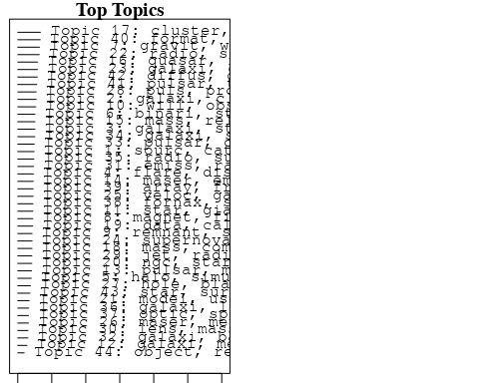

plotQuote(thoughts6, width = 30, main = "Topic 6")  
plotQuote(thoughts18, width = 30, main = "Topic 18")

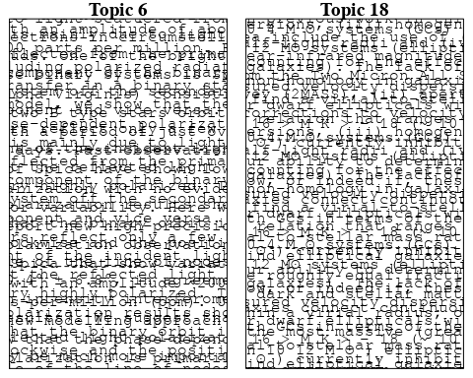

# Calculate and plot the correlation between topics  
mod.out.corr <- topicCorr(Research_topics)  
plot(mod.out.corr, cex = 1.5)  
  
  
# For each topic  
for (topic_num in 1:44) {  
 # Plot the word cloud  
 cloud(Research_topics, topic = topic_num, scale = c(2, 0.25))  
 Sys.sleep(2)  
}

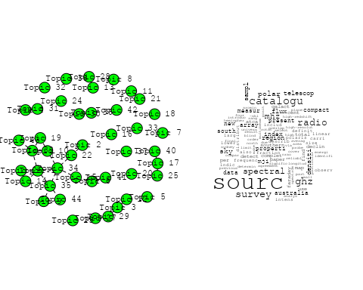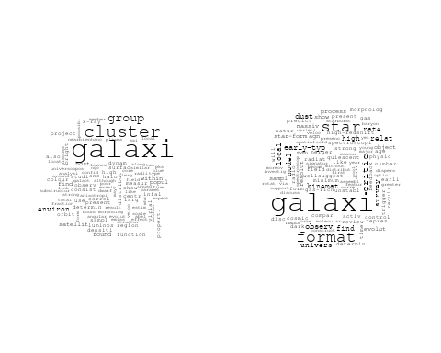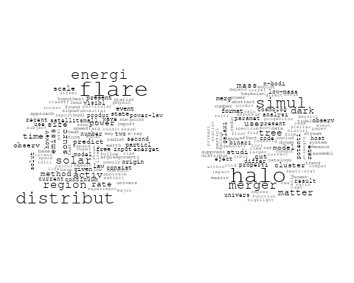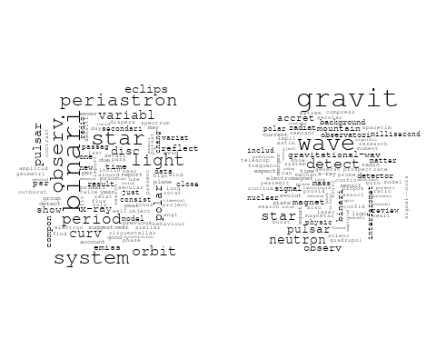

## Warning in wordcloud::wordcloud(words = vocab, freq = vec, max.words =  
## max.words, : supernova could not be fit on page. It will not be plotted.

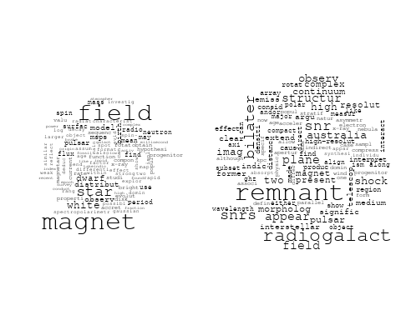

## Warning in wordcloud::wordcloud(words = vocab, freq = vec, max.words =  
## max.words, : telescop could not be fit on page. It will not be plotted.

## Warning in wordcloud::wordcloud(words = vocab, freq = vec, max.words =  
## max.words, : will could not be fit on page. It will not be plotted.

## Warning in wordcloud::wordcloud(words = vocab, freq = vec, max.words =  
## max.words, : astronomi could not be fit on page. It will not be plotted.

## Warning in wordcloud::wordcloud(words = vocab, freq = vec, max.words =  
## max.words, : first could not be fit on page. It will not be plotted.

## Warning in wordcloud::wordcloud(words = vocab, freq = vec, max.words =  
## max.words, : futur could not be fit on page. It will not be plotted.

## Warning in wordcloud::wordcloud(words = vocab, freq = vec, max.words =  
## max.words, : instrument could not be fit on page. It will not be plotted.

## Warning in wordcloud::wordcloud(words = vocab, freq = vec, max.words =  
## max.words, : scientif could not be fit on page. It will not be plotted.

## Warning in wordcloud::wordcloud(words = vocab, freq = vec, max.words =  
## max.words, : astrophys could not be fit on page. It will not be plotted.

## Warning in wordcloud::wordcloud(words = vocab, freq = vec, max.words =  
## max.words, : field could not be fit on page. It will not be plotted.

## Warning in wordcloud::wordcloud(words = vocab, freq = vec, max.words =  
## max.words, : wavelength could not be fit on page. It will not be plotted.

## Warning in wordcloud::wordcloud(words = vocab, freq = vec, max.words =  
## max.words, : potenti could not be fit on page. It will not be plotted.

## Warning in wordcloud::wordcloud(words = vocab, freq = vec, max.words =  
## max.words, : australian could not be fit on page. It will not be plotted.

## Warning in wordcloud::wordcloud(words = vocab, freq = vec, max.words =  
## max.words, : design could not be fit on page. It will not be plotted.

## Warning in wordcloud::wordcloud(words = vocab, freq = vec, max.words =  
## max.words, : unexpect could not be fit on page. It will not be plotted.

## Warning in wordcloud::wordcloud(words = vocab, freq = vec, max.words =  
## max.words, : oper could not be fit on page. It will not be plotted.

## Warning in wordcloud::wordcloud(words = vocab, freq = vec, max.words =  
## max.words, : describ could not be fit on page. It will not be plotted.

## Warning in wordcloud::wordcloud(words = vocab, freq = vec, max.words =  
## max.words, : next-gener could not be fit on page. It will not be plotted.

## Warning in wordcloud::wordcloud(words = vocab, freq = vec, max.words =  
## max.words, : next could not be fit on page. It will not be plotted.

## Warning in wordcloud::wordcloud(words = vocab, freq = vec, max.words =  
## max.words, : wide could not be fit on page. It will not be plotted.

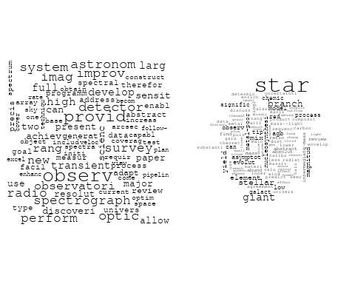

## Warning in wordcloud::wordcloud(words = vocab, freq = vec, max.words =  
## max.words, : galaxi could not be fit on page. It will not be plotted.

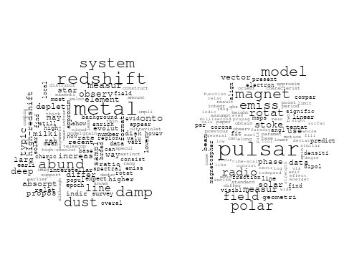

## Warning in wordcloud::wordcloud(words = vocab, freq = vec, max.words =  
## max.words, : mass could not be fit on page. It will not be plotted.

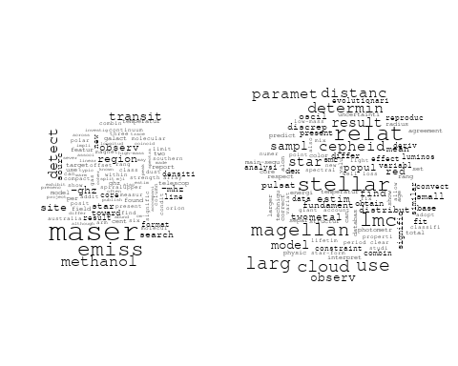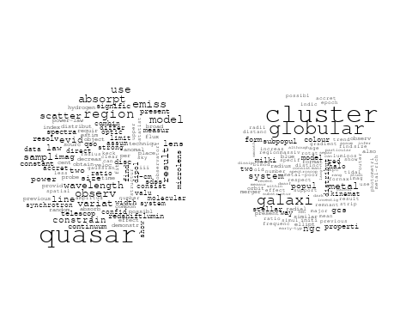

## Warning in wordcloud::wordcloud(words = vocab, freq = vec, max.words =  
## max.words, : companion could not be fit on page. It will not be plotted.

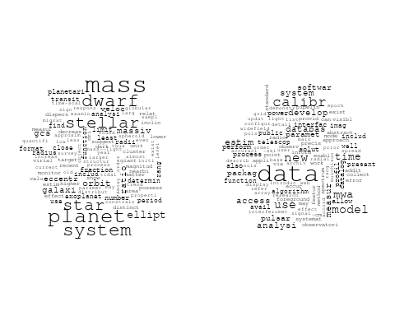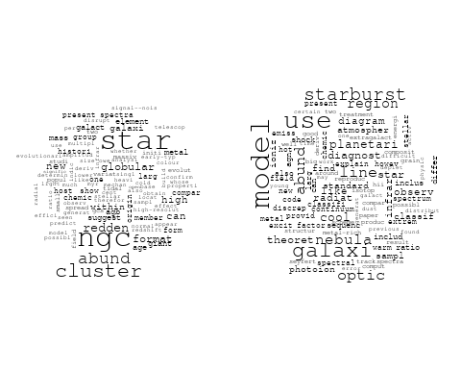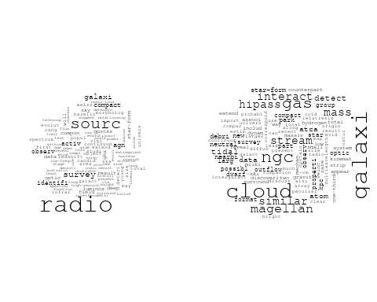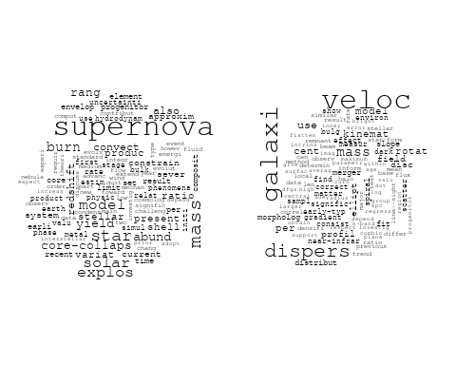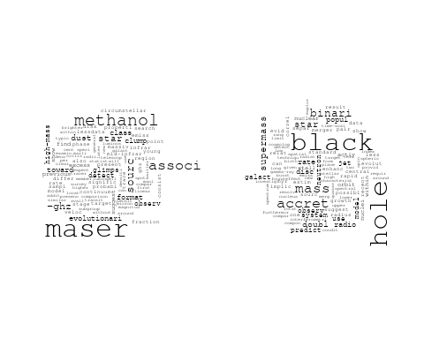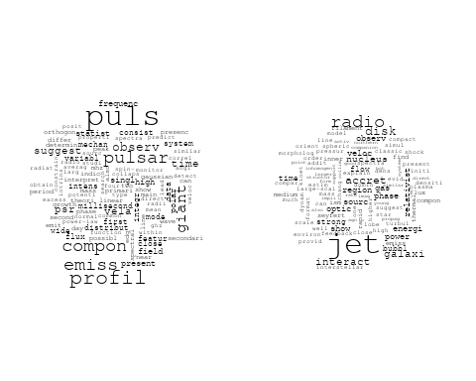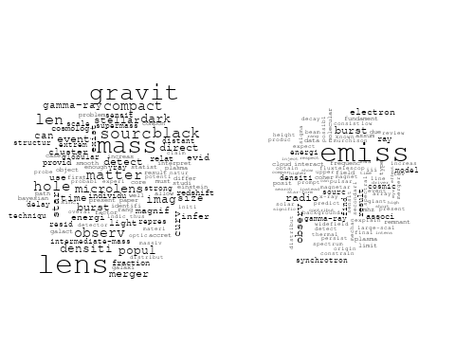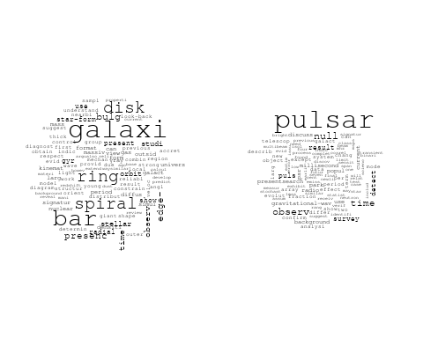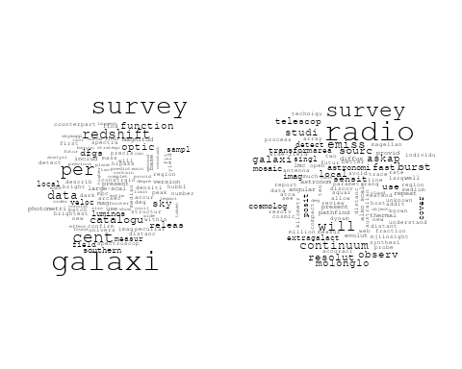

## Warning in wordcloud::wordcloud(words = vocab, freq = vec, max.words =  
## max.words, : ioniz could not be fit on page. It will not be plotted.

## Warning in wordcloud::wordcloud(words = vocab, freq = vec, max.words =  
## max.words, : bright could not be fit on page. It will not be plotted.

## Warning in wordcloud::wordcloud(words = vocab, freq = vec, max.words =  
## max.words, : luminos could not be fit on page. It will not be plotted.

## Warning in wordcloud::wordcloud(words = vocab, freq = vec, max.words =  
## max.words, : pressur could not be fit on page. It will not be plotted.

## Warning in wordcloud::wordcloud(words = vocab, freq = vec, max.words =  
## max.words, : physic could not be fit on page. It will not be plotted.

## Warning in wordcloud::wordcloud(words = vocab, freq = vec, max.words =  
## max.words, : metal could not be fit on page. It will not be plotted.

## Warning in wordcloud::wordcloud(words = vocab, freq = vec, max.words =  
## max.words, : calibr could not be fit on page. It will not be plotted.

## Warning in wordcloud::wordcloud(words = vocab, freq = vec, max.words =  
## max.words, : star could not be fit on page. It will not be plotted.

## Warning in wordcloud::wordcloud(words = vocab, freq = vec, max.words =  
## max.words, : amount could not be fit on page. It will not be plotted.

## Warning in wordcloud::wordcloud(words = vocab, freq = vec, max.words =  
## max.words, : typic could not be fit on page. It will not be plotted.

## Warning in wordcloud::wordcloud(words = vocab, freq = vec, max.words =  
## max.words, : conclud could not be fit on page. It will not be plotted.

## Warning in wordcloud::wordcloud(words = vocab, freq = vec, max.words =  
## max.words, : constant could not be fit on page. It will not be plotted.

## Warning in wordcloud::wordcloud(words = vocab, freq = vec, max.words =  
## max.words, : cosmolog could not be fit on page. It will not be plotted.

## Warning in wordcloud::wordcloud(words = vocab, freq = vec, max.words =  
## max.words, : differ could not be fit on page. It will not be plotted.

## Warning in wordcloud::wordcloud(words = vocab, freq = vec, max.words =  
## max.words, : transient could not be fit on page. It will not be plotted.

## Warning in wordcloud::wordcloud(words = vocab, freq = vec, max.words =  
## max.words, : increas could not be fit on page. It will not be plotted.

## Warning in wordcloud::wordcloud(words = vocab, freq = vec, max.words =  
## max.words, : band could not be fit on page. It will not be plotted.

## Warning in wordcloud::wordcloud(words = vocab, freq = vec, max.words =  
## max.words, : scintil could not be fit on page. It will not be plotted.

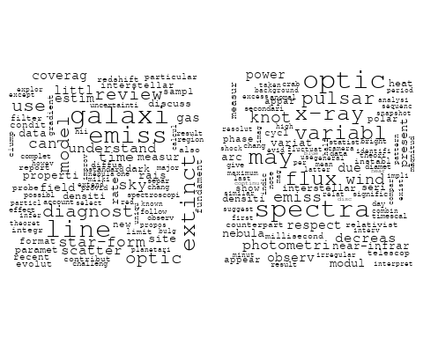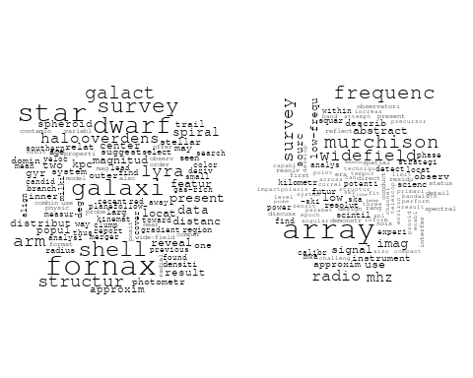

## Warning in wordcloud::wordcloud(words = vocab, freq = vec, max.words =  
## max.words, : format could not be fit on page. It will not be plotted.

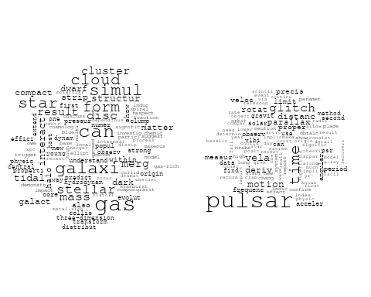

## Warning in wordcloud::wordcloud(words = vocab, freq = vec, max.words =  
## max.words, : diffus could not be fit on page. It will not be plotted.

## Warning in wordcloud::wordcloud(words = vocab, freq = vec, max.words =  
## max.words, : magnet could not be fit on page. It will not be plotted.

## Warning in wordcloud::wordcloud(words = vocab, freq = vec, max.words =  
## max.words, : star could not be fit on page. It will not be plotted.

## Warning in wordcloud::wordcloud(words = vocab, freq = vec, max.words =  
## max.words, : magnitud could not be fit on page. It will not be plotted.

## Warning in wordcloud::wordcloud(words = vocab, freq = vec, max.words =  
## max.words, : spectroscop could not be fit on page. It will not be plotted.

## Warning in wordcloud::wordcloud(words = vocab, freq = vec, max.words =  
## max.words, : nebula could not be fit on page. It will not be plotted.

## Warning in wordcloud::wordcloud(words = vocab, freq = vec, max.words =  
## max.words, : previous could not be fit on page. It will not be plotted.

## Warning in wordcloud::wordcloud(words = vocab, freq = vec, max.words =  
## max.words, : spectral could not be fit on page. It will not be plotted.

## Warning in wordcloud::wordcloud(words = vocab, freq = vec, max.words =  
## max.words, : magellan could not be fit on page. It will not be plotted.

## Warning in wordcloud::wordcloud(words = vocab, freq = vec, max.words =  
## max.words, : discov could not be fit on page. It will not be plotted.

## Warning in wordcloud::wordcloud(words = vocab, freq = vec, max.words =  
## max.words, : cloud could not be fit on page. It will not be plotted.

## Warning in wordcloud::wordcloud(words = vocab, freq = vec, max.words =  
## max.words, : select could not be fit on page. It will not be plotted.

## Warning in wordcloud::wordcloud(words = vocab, freq = vec, max.words =  
## max.words, : new could not be fit on page. It will not be plotted.

## Warning in wordcloud::wordcloud(words = vocab, freq = vec, max.words =  
## max.words, : emiss could not be fit on page. It will not be plotted.

## Warning in wordcloud::wordcloud(words = vocab, freq = vec, max.words =  
## max.words, : popul could not be fit on page. It will not be plotted.

## Warning in wordcloud::wordcloud(words = vocab, freq = vec, max.words =  
## max.words, : transmiss could not be fit on page. It will not be plotted.

## Warning in wordcloud::wordcloud(words = vocab, freq = vec, max.words =  
## max.words, : large-scal could not be fit on page. It will not be plotted.

## Warning in wordcloud::wordcloud(words = vocab, freq = vec, max.words =  
## max.words, : entir could not be fit on page. It will not be plotted.

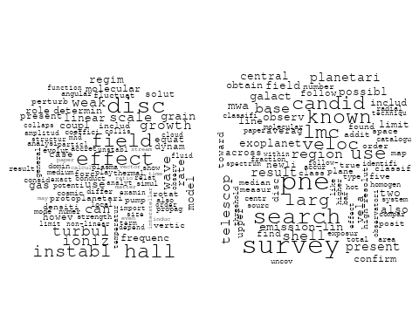

# Get the topic proportions for each document  
topic_proportions <- Research_topics$theta  
  
# Find the index of the topic with the highest proportion for each document  
# This will be the topic that each document is most likely to belong to  
max_topic_idx <- apply(topic_proportions, 1, which.max)  
  
# Add this as a new column to your data  
data_independent$topic <- max_topic_idx  
  
  
  
# Define the intervals  
intervals <- c('1824_1899', '1900_1964', '1965_1974', '1975_1984', '1985_1994', '1995_1999', '2000_2004', '2005_2009', '2010_2014', '2015_2019', '2020_2022')  
colors <- c('pink', 'blue', 'purple', 'yellow', 'green', 'pink', 'orange', 'violet', 'green', 'blue', 'pink')  
  
# Loop through the intervals and plot  
for(i in seq_along(intervals)){  
 # Filter data for when the pub_interval is equal to 1  
 data_filtered <- data_independent[data_independent[[paste0('pub_interval_', intervals[i])]] == 1,]  
   
 # Make the histogram  
   
 p <- ggplot(data_filtered, aes(x = topic)) +  
 geom_histogram(binwidth = 1, fill = colors[i], color = "black") +  
 xlab("Topic") +  
 ylab("Count") +  
 ggtitle(paste0("Topics from year ", gsub("_", " to ", intervals[i])))  
   
 print(p)  
}  
  
  
##Topic generation for CA (in collaboration) publications  
  
data_collab <- data[data[["CA"]] != 0,]  
  
# Save the original title data for future use  
data_collab$original_concatenated_title_abstract <- data_collab$concatenated_title_abstract  
  
#pre-processing the titles using textProcessor from the stm package  
processed_text <- textProcessor(data_collab$concatenated_title_abstract, metadata = data_collab)

## Building corpus...   
## Converting to Lower Case...   
## Removing punctuation...   
## Removing stopwords...   
## Removing numbers...   
## Stemming...   
## Creating Output...

# Further prepare the data by removing low-frequency terms  
out_text <- prepDocuments(processed_text$documents, processed_text$vocab, processed_text$meta)

## Removing 2430 of 10044 terms (2430 of 217233 tokens) due to frequency   
## Your corpus now has 2595 documents, 7614 terms and 214803 tokens.

docs_text <- out_text$documents  
vocab_text <- out_text$vocab  
meta_text <- out_text$meta  
  
  
#Prepare data  
plotRemoved(processed_text$documents, lower.thresh = seq(1, 200, by = 100))

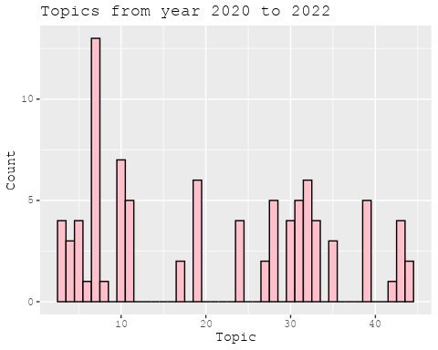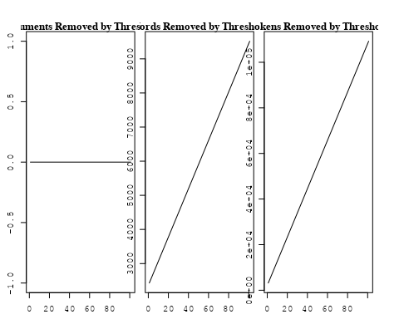

out_text <- prepDocuments(processed_text$documents, processed_text$vocab, processed_text$meta, lower.thresh = 8)

## Removing 7571 of 10044 terms (19270 of 217233 tokens) due to frequency   
## Your corpus now has 2595 documents, 2473 terms and 197963 tokens.

str(out_text$meta)

## 'data.frame': 2595 obs. of 39 variables:  
## $ concept_id : chr "https://openalex.org/C44870925" "https://openalex.org/C44870925" "https://openalex.org/C44870925" "https://openalex.org/C1276947" ...  
## $ work_id : chr "https://openalex.org/W1993164994" "https://openalex.org/W1994827287" "https://openalex.org/W3099799912" "https://openalex.org/W3099799912" ...  
## $ publication_year : int 1999 2008 1998 1998 2011 2001 2008 2001 2003 2001 ...  
## $ title : chr "Reconnection in a weakly stochastic field" "On the Use of Blanketed Atmospheres as Boundary Conditions for Stellar Evolutionary Models" "The Dependence of Cluster Galaxy Star Formation Rates on the Global Environment" "The Dependence of Cluster Galaxy Star Formation Rates on the Global Environment" ...  
## $ paperabstract : chr "We examine the effect of weak, small-scale magnetic field structure on the rate of reconnection in a strongly m"| __truncated__ "Stellar models have been computed for stars having [ Fe/H ] = 0.0 (assuming both the Grevesse & Sauval and Aspl"| __truncated__ "A comparison of star formation properties as a function of environment is made from the spectra of identically "| __truncated__ "A comparison of star formation properties as a function of environment is made from the spectra of identically "| __truncated__ ...  
## $ country : chr "US US CA US US CA" "CA SE" "US US CA US US CA" "US US CA US US CA" ...  
## $ year_concept : chr "1999+https://openalex.org/C44870925" "2008+https://openalex.org/C44870925" "1998+https://openalex.org/C44870925" "1998+https://openalex.org/C1276947" ...  
## $ concatenated_title_abstract : chr "Reconnection in a weakly stochastic field We examine the effect of weak, small-scale magnetic field structure o"| __truncated__ "On the Use of Blanketed Atmospheres as Boundary Conditions for Stellar Evolutionary Models Stellar models have "| __truncated__ "The Dependence of Cluster Galaxy Star Formation Rates on the Global Environment A comparison of star formation "| __truncated__ "The Dependence of Cluster Galaxy Star Formation Rates on the Global Environment A comparison of star formation "| __truncated__ ...  
## $ US : num 66.7 0 66.7 66.7 25 ...  
## $ IN : num 0 0 0 0 0 0 0 0 0 0 ...  
## $ DE : num 0 0 0 0 0 0 0 0 0 0 ...  
## $ CH : num 0 0 0 0 0 0 0 0 0 0 ...  
## $ GB : num 0 0 0 0 50 0 0 0 50 0 ...  
## $ CN : num 0 0 0 0 0 0 0 0 0 0 ...  
## $ FR : num 0 0 0 0 0 0 0 0 0 0 ...  
## $ IT : num 0 0 0 0 0 0 0 0 0 0 ...  
## $ RU : num 0 0 0 0 0 0 0 0 0 0 ...  
## $ CA : num 33.3 50 33.3 33.3 25 ...  
## $ NL : num 0 0 0 0 0 0 0 0 0 0 ...  
## $ AU : num 0 0 0 0 0 0 0 0 0 0 ...  
## $ JP : num 0 0 0 0 0 0 0 0 0 0 ...  
## $ ES : num 0 0 0 0 0 0 0 0 0 0 ...  
## $ IL : num 0 0 0 0 0 0 0 0 0 0 ...  
## $ Americas : num 0 0 0 0 0 0 0 0 0 0 ...  
## $ Europe : num 0 50 0 0 0 0 0 0 0 0 ...  
## $ Africa : num 0 0 0 0 0 0 0 0 0 0 ...  
## $ AsiaAndOceania : num 0 0 0 0 0 0 0 0 0 0 ...  
## $ pub_interval_2020_2022 : int 0 0 0 0 0 0 0 0 0 0 ...  
## $ pub_interval_2015_2019 : int 0 0 0 0 0 0 0 0 0 0 ...  
## $ pub_interval_2010_2014 : int 0 0 0 0 1 0 0 0 0 0 ...  
## $ pub_interval_2005_2009 : int 0 1 0 0 0 0 1 0 0 0 ...  
## $ pub_interval_2000_2004 : int 0 0 0 0 0 1 0 1 1 1 ...  
## $ pub_interval_1995_1999 : int 1 0 1 1 0 0 0 0 0 0 ...  
## $ pub_interval_1985_1994 : int 0 0 0 0 0 0 0 0 0 0 ...  
## $ pub_interval_1975_1984 : int 0 0 0 0 0 0 0 0 0 0 ...  
## $ pub_interval_1965_1974 : int 0 0 0 0 0 0 0 0 0 0 ...  
## $ pub_interval_1900_1964 : int 0 0 0 0 0 0 0 0 0 0 ...  
## $ pub_interval_1824_1899 : int 0 0 0 0 0 0 0 0 0 0 ...  
## $ original_concatenated_title_abstract: chr "Reconnection in a weakly stochastic field We examine the effect of weak, small-scale magnetic field structure o"| __truncated__ "On the Use of Blanketed Atmospheres as Boundary Conditions for Stellar Evolutionary Models Stellar models have "| __truncated__ "The Dependence of Cluster Galaxy Star Formation Rates on the Global Environment A comparison of star formation "| __truncated__ "The Dependence of Cluster Galaxy Star Formation Rates on the Global Environment A comparison of star formation "| __truncated__ ...

# Initialize an empty formula string  
prevalence_formula_str <- "~"  
  
# Define the publication intervals  
pub_intervals <- c("pub_interval_2020_2022", "pub_interval_2015_2019", "pub_interval_2010_2014",   
 "pub_interval_2005_2009", "pub_interval_2000_2004", "pub_interval_1995_1999",  
 "pub_interval_1985_1994", "pub_interval_1975_1984", "pub_interval_1965_1974",  
 "pub_interval_1900_1964", "pub_interval_1824_1899")  
  
# Add each publication interval to the formula string  
for (interval in pub_intervals) {  
 # add an if statement to handle the first addition (without '+')  
 if (prevalence_formula_str == "~") {  
 prevalence_formula_str <- paste(prevalence_formula_str, interval)  
 } else {  
 prevalence_formula_str <- paste(prevalence_formula_str, "+", interval)  
 }  
}  
  
  
# Convert the string to a formula  
prevalence_formula <- as.formula(prevalence_formula_str)  
print(prevalence_formula)

## ~pub_interval_2020_2022 + pub_interval_2015_2019 + pub_interval_2010_2014 +   
## pub_interval_2005_2009 + pub_interval_2000_2004 + pub_interval_1995_1999 +   
## pub_interval_1985_1994 + pub_interval_1975_1984 + pub_interval_1965_1974 +   
## pub_interval_1900_1964 + pub_interval_1824_1899

# Run STM model  
Research_topics <- stm(documents = out_text$documents,   
 vocab = out_text$vocab,   
 K = 44,   
 prevalence = prevalence_formula,   
 data = out_text$meta,   
 init.type = "Spectral",  
 max.em.its = 1000,  
 gamma.prior = 'L1')

## Beginning Spectral Initialization   
## Calculating the gram matrix...  
## Finding anchor words...  
## ............................................  
## Recovering initialization...  
## ........................  
## Initialization complete.  
## .......................................................................................................  
## Completed E-Step (3 seconds).   
## Completed M-Step.   
## Completing Iteration 1 (approx. per word bound = -6.523)   
## .......................................................................................................  
## Completed E-Step (2 seconds).   
## Completed M-Step.   
## Completing Iteration 2 (approx. per word bound = -6.245, relative change = 4.252e-02)   
## .......................................................................................................  
## Completed E-Step (2 seconds).   
## Completed M-Step.   
## Completing Iteration 3 (approx. per word bound = -6.172, relative change = 1.178e-02)   
## .......................................................................................................  
## Completed E-Step (2 seconds).   
## Completed M-Step.   
## Completing Iteration 4 (approx. per word bound = -6.145, relative change = 4.403e-03)   
## .......................................................................................................  
## Completed E-Step (2 seconds).   
## Completed M-Step.   
## Completing Iteration 5 (approx. per word bound = -6.131, relative change = 2.130e-03)   
## Topic 1: stream, survey, kinemat, similar, spectroscopi   
## Topic 2: galaxi, star, format, stellar, massiv   
## Topic 3: hole, black, accret, galact, jet   
## Topic 4: cosmolog, univers, physic, cosmic, observ   
## Topic 5: magnet, field, star, model, wind   
## Topic 6: light, curv, rotat, use, observ   
## Topic 7: disk, star, accret, mass, young   
## Topic 8: veloc, binari, system, radial, orbit   
## Topic 9: galaxi, gas, cloud, ngc, molecular   
## Topic 10: galaxi, spiral, dust, central, luminos   
## Topic 11: cluster, globular, color, ngc, metal   
## Topic 12: star, emiss, hot, line, activ   
## Topic 13: radio, sourc, burst, observ, galaxi   
## Topic 14: star, pulsat, period, observ, model   
## Topic 15: nebula, featur, planetari, infrar, star   
## Topic 16: wave, gravit, test, star, will   
## Topic 17: pulsar, emiss, plasma, magnet, field   
## Topic 18: disc, accret, instabl, rate, mass   
## Topic 19: planet, orbit, period, star, transit   
## Topic 20: dwarf, white, star, mass, cool   
## Topic 21: galaxi, format, star, pair, mass   
## Topic 22: model, abund, star, observ, solar   
## Topic 23: x-ray, pulsar, time, observ, flux   
## Topic 24: galaxi, cluster, format, stellar, halo   
## Topic 25: neutrino, energi, dark, limit, flux   
## Topic 26: gas, interstellar, line, grain, spectra   
## Topic 27: sourc, densiti, region, detect, line   
## Topic 28: distanc, cepheid, star, variabl, use   
## Topic 29: halo, mass, galaxi, dark, matter   
## Topic 30: binari, mass, system, cluster, star   
## Topic 31: radio, remnant, supernova, emiss, shock   
## Topic 32: model, simul, galaxi, paramet, observ   
## Topic 33: supernova, observ, valu, ratio, line   
## Topic 34: solar, observ, x-ray, flare, region   
## Topic 35: angular, blue, cluster, momentum, star   
## Topic 36: quasar, optic, lens, observ, redshift   
## Topic 37: survey, imag, data, telescop, use   
## Topic 38: x-ray, event, sourc, model, mass   
## Topic 39: polar, emiss, variabl, field, jet   
## Topic 40: galaxi, relat, mass, metal, sampl   
## Topic 41: cluster, galaxi, gcs, distribut, star   
## Topic 42: orbit, object, system, solar, famili   
## Topic 43: galaxi, redshift, survey, luminos, evolut   
## Topic 44: observ, properti, research, posit, current   
## .......................................................................................................  
## Completed E-Step (2 seconds).   
## Completed M-Step.   
## Completing Iteration 6 (approx. per word bound = -6.124, relative change = 1.240e-03)   
## .......................................................................................................  
## Completed E-Step (2 seconds).   
## Completed M-Step.   
## Completing Iteration 7 (approx. per word bound = -6.119, relative change = 7.823e-04)   
## .......................................................................................................  
## Completed E-Step (2 seconds).   
## Completed M-Step.   
## Completing Iteration 8 (approx. per word bound = -6.116, relative change = 5.407e-04)   
## .......................................................................................................  
## Completed E-Step (2 seconds).   
## Completed M-Step.   
## Completing Iteration 9 (approx. per word bound = -6.113, relative change = 4.160e-04)   
## .......................................................................................................  
## Completed E-Step (2 seconds).   
## Completed M-Step.   
## Completing Iteration 10 (approx. per word bound = -6.111, relative change = 3.347e-04)   
## Topic 1: stream, survey, kinemat, similar, detect   
## Topic 2: galaxi, star, format, stellar, gas   
## Topic 3: hole, black, accret, mass, galact   
## Topic 4: cosmolog, univers, cosmic, physic, paramet   
## Topic 5: field, magnet, star, wind, model   
## Topic 6: rotat, light, curv, use, measur   
## Topic 7: disk, star, accret, mass, young   
## Topic 8: veloc, binari, system, radial, orbit   
## Topic 9: galaxi, gas, cloud, ngc, molecular   
## Topic 10: galaxi, spiral, central, luminos, morpholog   
## Topic 11: cluster, star, ngc, globular, metal   
## Topic 12: star, emiss, hot, line, spectra   
## Topic 13: radio, sourc, burst, observ, galaxi   
## Topic 14: star, pulsat, period, model, observ   
## Topic 15: nebula, featur, planetari, infrar, star   
## Topic 16: wave, gravit, will, test, star   
## Topic 17: pulsar, emiss, plasma, radio, magnet   
## Topic 18: disc, accret, rate, instabl, gravit   
## Topic 19: planet, orbit, period, transit, star   
## Topic 20: dwarf, white, mass, star, age   
## Topic 21: galaxi, format, star, pair, mass   
## Topic 22: abund, model, star, observ, solar   
## Topic 23: x-ray, pulsar, time, observ, flux   
## Topic 24: galaxi, cluster, group, stellar, format   
## Topic 25: neutrino, energi, dark, limit, matter   
## Topic 26: gas, interstellar, grain, line, ioniz   
## Topic 27: sourc, densiti, region, detect, line   
## Topic 28: distanc, cepheid, star, variabl, lmc   
## Topic 29: halo, mass, dark, galaxi, matter   
## Topic 30: binari, mass, system, star, cluster   
## Topic 31: radio, remnant, supernova, emiss, shock   
## Topic 32: model, simul, galaxi, paramet, observ   
## Topic 33: supernova, observ, ratio, line, valu   
## Topic 34: solar, observ, flare, x-ray, region   
## Topic 35: angular, blue, momentum, cluster, dynam   
## Topic 36: quasar, optic, redshift, observ, present   
## Topic 37: survey, imag, data, telescop, use   
## Topic 38: x-ray, event, sourc, lens, model   
## Topic 39: polar, emiss, variabl, field, jet   
## Topic 40: galaxi, relat, mass, metal, sampl   
## Topic 41: cluster, galaxi, gcs, ngc, globular   
## Topic 42: orbit, object, system, solar, famili   
## Topic 43: galaxi, redshift, luminos, survey, evolut   
## Topic 44: observ, properti, posit, present, current   
## .......................................................................................................  
## Completed E-Step (2 seconds).   
## Completed M-Step.   
## Completing Iteration 11 (approx. per word bound = -6.110, relative change = 2.738e-04)   
## .......................................................................................................  
## Completed E-Step (2 seconds).   
## Completed M-Step.   
## Completing Iteration 12 (approx. per word bound = -6.108, relative change = 2.166e-04)   
## .......................................................................................................  
## Completed E-Step (2 seconds).   
## Completed M-Step.   
## Completing Iteration 13 (approx. per word bound = -6.107, relative change = 2.291e-04)   
## .......................................................................................................  
## Completed E-Step (2 seconds).   
## Completed M-Step.   
## Completing Iteration 14 (approx. per word bound = -6.105, relative change = 2.135e-04)   
## .......................................................................................................  
## Completed E-Step (2 seconds).   
## Completed M-Step.   
## Completing Iteration 15 (approx. per word bound = -6.104, relative change = 2.095e-04)   
## Topic 1: survey, stream, kinemat, similar, detect   
## Topic 2: galaxi, star, format, stellar, gas   
## Topic 3: hole, black, accret, mass, galact   
## Topic 4: cosmolog, cosmic, univers, spectrum, measur   
## Topic 5: magnet, field, star, wind, model   
## Topic 6: rotat, light, curv, use, method   
## Topic 7: disk, star, accret, mass, young   
## Topic 8: veloc, binari, radial, system, orbit   
## Topic 9: galaxi, cloud, gas, ngc, molecular   
## Topic 10: galaxi, spiral, luminos, central, morpholog   
## Topic 11: cluster, star, ngc, globular, color   
## Topic 12: star, emiss, line, spectra, hot   
## Topic 13: radio, sourc, burst, observ, galaxi   
## Topic 14: star, pulsat, period, variabl, amplitud   
## Topic 15: nebula, featur, planetari, infrar, emiss   
## Topic 16: gravit, wave, will, test, graviti   
## Topic 17: pulsar, emiss, radio, plasma, eclips   
## Topic 18: disc, accret, rate, instabl, mass   
## Topic 19: planet, orbit, transit, period, star   
## Topic 20: dwarf, white, mass, star, age   
## Topic 21: galaxi, format, star, pair, mass   
## Topic 22: abund, model, star, observ, element   
## Topic 23: x-ray, pulsar, time, observ, flux   
## Topic 24: galaxi, cluster, group, stellar, format   
## Topic 25: neutrino, energi, limit, dark, observ   
## Topic 26: gas, interstellar, grain, ioniz, model   
## Topic 27: sourc, region, densiti, line, molecular   
## Topic 28: distanc, cepheid, star, variabl, lmc   
## Topic 29: halo, mass, galaxi, dark, matter   
## Topic 30: binari, mass, system, star, cluster   
## Topic 31: radio, remnant, supernova, imag, shell   
## Topic 32: model, simul, galaxi, observ, profil   
## Topic 33: supernova, observ, ratio, star, smgs   
## Topic 34: solar, observ, flare, x-ray, region   
## Topic 35: angular, momentum, blue, cluster, dynam   
## Topic 36: quasar, optic, redshift, observ, survey   
## Topic 37: survey, data, imag, telescop, use   
## Topic 38: event, sourc, lens, x-ray, model   
## Topic 39: polar, emiss, field, variabl, jet   
## Topic 40: galaxi, relat, metal, mass, sampl   
## Topic 41: cluster, galaxi, gcs, globular, ngc   
## Topic 42: orbit, system, object, solar, famili   
## Topic 43: galaxi, redshift, luminos, survey, evolut   
## Topic 44: current, review, properti, evolut, discuss   
## .......................................................................................................  
## Completed E-Step (2 seconds).   
## Completed M-Step.   
## Completing Iteration 16 (approx. per word bound = -6.103, relative change = 1.838e-04)   
## .......................................................................................................  
## Completed E-Step (2 seconds).   
## Completed M-Step.   
## Completing Iteration 17 (approx. per word bound = -6.102, relative change = 1.702e-04)   
## .......................................................................................................  
## Completed E-Step (2 seconds).   
## Completed M-Step.   
## Completing Iteration 18 (approx. per word bound = -6.101, relative change = 1.577e-04)   
## .......................................................................................................  
## Completed E-Step (2 seconds).   
## Completed M-Step.   
## Completing Iteration 19 (approx. per word bound = -6.100, relative change = 1.381e-04)   
## .......................................................................................................  
## Completed E-Step (2 seconds).   
## Completed M-Step.   
## Completing Iteration 20 (approx. per word bound = -6.099, relative change = 1.543e-04)   
## Topic 1: survey, kinemat, stream, similar, detect   
## Topic 2: galaxi, star, format, stellar, gas   
## Topic 3: hole, black, accret, mass, galact   
## Topic 4: cosmolog, cosmic, univers, measur, spectrum   
## Topic 5: magnet, field, star, wind, line   
## Topic 6: rotat, light, curv, use, method   
## Topic 7: disk, star, accret, mass, young   
## Topic 8: veloc, binari, radial, system, orbit   
## Topic 9: cloud, galaxi, gas, molecular, ngc   
## Topic 10: galaxi, spiral, luminos, central, morpholog   
## Topic 11: cluster, star, ngc, globular, color   
## Topic 12: star, emiss, line, spectra, hot   
## Topic 13: radio, sourc, burst, observ, galaxi   
## Topic 14: star, pulsat, period, variabl, amplitud   
## Topic 15: nebula, featur, planetari, infrar, emiss   
## Topic 16: gravit, wave, will, test, graviti   
## Topic 17: pulsar, emiss, radio, plasma, eclips   
## Topic 18: disc, accret, rate, mass, instabl   
## Topic 19: planet, orbit, transit, period, star   
## Topic 20: dwarf, white, mass, star, age   
## Topic 21: galaxi, format, star, pair, mass   
## Topic 22: abund, model, star, observ, element   
## Topic 23: x-ray, pulsar, time, flux, observ   
## Topic 24: galaxi, group, cluster, stellar, colour   
## Topic 25: neutrino, energi, limit, dark, observ   
## Topic 26: gas, interstellar, grain, ioniz, model   
## Topic 27: sourc, region, line, molecular, densiti   
## Topic 28: distanc, cepheid, star, variabl, lmc   
## Topic 29: halo, mass, galaxi, dark, matter   
## Topic 30: binari, mass, star, system, cluster   
## Topic 31: radio, remnant, supernova, imag, shell   
## Topic 32: model, simul, galaxi, profil, observ   
## Topic 33: supernova, observ, smgs, star, ratio   
## Topic 34: solar, observ, flare, region, x-ray   
## Topic 35: angular, momentum, blue, cluster, dynam   
## Topic 36: quasar, optic, redshift, survey, observ   
## Topic 37: survey, data, imag, telescop, use   
## Topic 38: event, sourc, lens, x-ray, model   
## Topic 39: polar, emiss, field, jet, variabl   
## Topic 40: galaxi, relat, metal, mass, sampl   
## Topic 41: cluster, galaxi, gcs, globular, ngc   
## Topic 42: orbit, system, solar, object, famili   
## Topic 43: galaxi, redshift, luminos, survey, evolut   
## Topic 44: review, discuss, current, evolut, properti   
## .......................................................................................................  
## Completed E-Step (2 seconds).   
## Completed M-Step.   
## Completing Iteration 21 (approx. per word bound = -6.098, relative change = 1.427e-04)   
## .......................................................................................................  
## Completed E-Step (2 seconds).   
## Completed M-Step.   
## Completing Iteration 22 (approx. per word bound = -6.098, relative change = 1.391e-04)   
## .......................................................................................................  
## Completed E-Step (2 seconds).   
## Completed M-Step.   
## Completing Iteration 23 (approx. per word bound = -6.097, relative change = 1.312e-04)   
## .......................................................................................................  
## Completed E-Step (2 seconds).   
## Completed M-Step.   
## Completing Iteration 24 (approx. per word bound = -6.096, relative change = 1.197e-04)   
## .......................................................................................................  
## Completed E-Step (2 seconds).   
## Completed M-Step.   
## Completing Iteration 25 (approx. per word bound = -6.095, relative change = 1.089e-04)   
## Topic 1: survey, kinemat, stream, similar, detect   
## Topic 2: galaxi, star, format, stellar, gas   
## Topic 3: hole, black, accret, mass, galact   
## Topic 4: cosmolog, cosmic, measur, power, univers   
## Topic 5: magnet, field, star, wind, line   
## Topic 6: rotat, curv, light, use, method   
## Topic 7: disk, star, accret, mass, young   
## Topic 8: veloc, binari, radial, system, orbit   
## Topic 9: cloud, galaxi, gas, molecular, core   
## Topic 10: galaxi, spiral, luminos, central, morpholog   
## Topic 11: cluster, star, ngc, color, globular   
## Topic 12: star, emiss, spectra, line, hot   
## Topic 13: radio, sourc, burst, observ, galaxi   
## Topic 14: star, period, pulsat, variabl, amplitud   
## Topic 15: nebula, featur, planetari, infrar, emiss   
## Topic 16: gravit, wave, will, test, graviti   
## Topic 17: pulsar, emiss, radio, plasma, shock   
## Topic 18: disc, accret, mass, rate, instabl   
## Topic 19: planet, orbit, transit, period, star   
## Topic 20: dwarf, white, mass, star, age   
## Topic 21: galaxi, format, star, pair, mass   
## Topic 22: abund, model, star, observ, element   
## Topic 23: x-ray, pulsar, time, flux, observ   
## Topic 24: galaxi, group, cluster, stellar, colour   
## Topic 25: neutrino, energi, limit, dark, observ   
## Topic 26: gas, interstellar, grain, ioniz, densiti   
## Topic 27: sourc, region, line, molecular, densiti   
## Topic 28: distanc, cepheid, star, variabl, lmc   
## Topic 29: halo, mass, galaxi, dark, matter   
## Topic 30: binari, mass, star, system, companion   
## Topic 31: radio, remnant, supernova, imag, shell   
## Topic 32: model, simul, galaxi, profil, observ   
## Topic 33: supernova, observ, smgs, star, ratio   
## Topic 34: solar, observ, flare, region, x-ray   
## Topic 35: angular, momentum, blue, dynam, cluster   
## Topic 36: quasar, optic, redshift, survey, dust   
## Topic 37: survey, data, imag, telescop, use   
## Topic 38: event, lens, sourc, model, len   
## Topic 39: polar, emiss, field, jet, region   
## Topic 40: galaxi, relat, metal, mass, sampl   
## Topic 41: cluster, galaxi, gcs, globular, ngc   
## Topic 42: orbit, system, solar, object, famili   
## Topic 43: galaxi, redshift, luminos, survey, evolut   
## Topic 44: discuss, review, current, evolut, properti   
## .......................................................................................................  
## Completed E-Step (2 seconds).   
## Completed M-Step.   
## Completing Iteration 26 (approx. per word bound = -6.095, relative change = 1.041e-04)   
## .......................................................................................................  
## Completed E-Step (2 seconds).   
## Completed M-Step.   
## Completing Iteration 27 (approx. per word bound = -6.094, relative change = 1.021e-04)   
## .......................................................................................................  
## Completed E-Step (2 seconds).   
## Completed M-Step.   
## Completing Iteration 28 (approx. per word bound = -6.094, relative change = 7.825e-05)   
## .......................................................................................................  
## Completed E-Step (2 seconds).   
## Completed M-Step.   
## Completing Iteration 29 (approx. per word bound = -6.093, relative change = 1.134e-04)   
## .......................................................................................................  
## Completed E-Step (2 seconds).   
## Completed M-Step.   
## Completing Iteration 30 (approx. per word bound = -6.092, relative change = 8.239e-05)   
## Topic 1: survey, kinemat, stream, similar, detect   
## Topic 2: galaxi, star, format, stellar, gas   
## Topic 3: hole, black, accret, mass, jet   
## Topic 4: cosmolog, cosmic, power, spectrum, measur   
## Topic 5: magnet, field, star, wind, line   
## Topic 6: rotat, curv, use, light, method   
## Topic 7: disk, star, accret, mass, young   
## Topic 8: veloc, binari, radial, system, orbit   
## Topic 9: cloud, galaxi, gas, molecular, core   
## Topic 10: galaxi, spiral, luminos, central, morpholog   
## Topic 11: cluster, star, ngc, color, globular   
## Topic 12: star, spectra, emiss, line, hot   
## Topic 13: radio, sourc, burst, observ, galaxi   
## Topic 14: star, period, pulsat, variabl, amplitud   
## Topic 15: nebula, featur, planetari, infrar, emiss   
## Topic 16: gravit, wave, will, test, graviti   
## Topic 17: pulsar, emiss, radio, plasma, shock   
## Topic 18: disc, accret, mass, rate, instabl   
## Topic 19: planet, orbit, transit, period, star   
## Topic 20: dwarf, white, mass, star, age   
## Topic 21: galaxi, format, star, pair, mass   
## Topic 22: abund, model, star, observ, element   
## Topic 23: x-ray, pulsar, time, flux, observ   
## Topic 24: galaxi, group, cluster, stellar, colour   
## Topic 25: neutrino, energi, limit, dark, observ   
## Topic 26: gas, interstellar, grain, ioniz, radiat   
## Topic 27: sourc, region, line, molecular, densiti   
## Topic 28: distanc, cepheid, star, variabl, lmc   
## Topic 29: halo, mass, galaxi, dark, matter   
## Topic 30: binari, mass, star, system, companion   
## Topic 31: radio, remnant, supernova, imag, shell   
## Topic 32: model, simul, galaxi, profil, observ   
## Topic 33: supernova, observ, smgs, sne, star   
## Topic 34: solar, observ, flare, region, x-ray   
## Topic 35: angular, momentum, blue, dynam, cluster   
## Topic 36: quasar, optic, redshift, survey, dust   
## Topic 37: survey, data, imag, telescop, use   
## Topic 38: event, lens, sourc, model, len   
## Topic 39: polar, emiss, field, jet, region   
## Topic 40: galaxi, relat, metal, mass, sampl   
## Topic 41: cluster, galaxi, gcs, globular, ngc   
## Topic 42: orbit, system, solar, object, famili   
## Topic 43: galaxi, redshift, luminos, evolut, survey   
## Topic 44: discuss, review, current, evolut, observ   
## .......................................................................................................  
## Completed E-Step (2 seconds).   
## Completed M-Step.   
## Completing Iteration 31 (approx. per word bound = -6.092, relative change = 7.389e-05)   
## .......................................................................................................  
## Completed E-Step (2 seconds).   
## Completed M-Step.   
## Completing Iteration 32 (approx. per word bound = -6.092, relative change = 7.004e-05)   
## .......................................................................................................  
## Completed E-Step (2 seconds).   
## Completed M-Step.   
## Completing Iteration 33 (approx. per word bound = -6.091, relative change = 6.732e-05)   
## .......................................................................................................  
## Completed E-Step (2 seconds).   
## Completed M-Step.   
## Completing Iteration 34 (approx. per word bound = -6.091, relative change = 6.818e-05)   
## .......................................................................................................  
## Completed E-Step (2 seconds).   
## Completed M-Step.   
## Completing Iteration 35 (approx. per word bound = -6.090, relative change = 6.650e-05)   
## Topic 1: survey, kinemat, stream, similar, detect   
## Topic 2: galaxi, star, format, stellar, gas   
## Topic 3: hole, black, accret, mass, galact   
## Topic 4: cosmolog, cosmic, power, measur, spectrum   
## Topic 5: magnet, field, wind, star, line   
## Topic 6: rotat, curv, use, light, method   
## Topic 7: disk, star, accret, mass, young   
## Topic 8: veloc, binari, radial, system, orbit   
## Topic 9: cloud, galaxi, gas, molecular, core   
## Topic 10: galaxi, spiral, luminos, central, morpholog   
## Topic 11: cluster, star, ngc, color, globular   
## Topic 12: star, spectra, line, emiss, hot   
## Topic 13: radio, sourc, burst, observ, galaxi   
## Topic 14: star, period, variabl, pulsat, amplitud   
## Topic 15: nebula, featur, planetari, infrar, emiss   
## Topic 16: gravit, wave, will, test, graviti   
## Topic 17: pulsar, emiss, radio, plasma, shock   
## Topic 18: disc, accret, mass, rate, instabl   
## Topic 19: planet, orbit, transit, period, star   
## Topic 20: dwarf, white, mass, star, age   
## Topic 21: galaxi, format, star, pair, mass   
## Topic 22: abund, model, star, observ, element   
## Topic 23: x-ray, pulsar, time, flux, observ   
## Topic 24: galaxi, group, stellar, cluster, colour   
## Topic 25: neutrino, energi, limit, dark, observ   
## Topic 26: gas, interstellar, ioniz, grain, radiat   
## Topic 27: sourc, region, line, molecular, gas   
## Topic 28: distanc, cepheid, star, variabl, lmc   
## Topic 29: halo, mass, galaxi, dark, matter   
## Topic 30: binari, mass, star, system, companion   
## Topic 31: radio, remnant, supernova, imag, shell   
## Topic 32: model, simul, galaxi, profil, observ   
## Topic 33: supernova, observ, sne, smgs, star   
## Topic 34: solar, observ, flare, region, x-ray   
## Topic 35: angular, momentum, dynam, blue, cluster   
## Topic 36: quasar, optic, redshift, survey, dust   
## Topic 37: survey, data, imag, telescop, use   
## Topic 38: event, lens, sourc, model, len   
## Topic 39: polar, emiss, field, jet, region   
## Topic 40: galaxi, relat, metal, mass, sampl   
## Topic 41: cluster, galaxi, gcs, globular, ngc   
## Topic 42: orbit, system, solar, object, famili   
## Topic 43: galaxi, redshift, luminos, evolut, survey   
## Topic 44: discuss, observ, review, evolut, current   
## .......................................................................................................  
## Completed E-Step (2 seconds).   
## Completed M-Step.   
## Completing Iteration 36 (approx. per word bound = -6.090, relative change = 6.952e-05)   
## .......................................................................................................  
## Completed E-Step (2 seconds).   
## Completed M-Step.   
## Completing Iteration 37 (approx. per word bound = -6.090, relative change = 6.795e-05)   
## .......................................................................................................  
## Completed E-Step (2 seconds).   
## Completed M-Step.   
## Completing Iteration 38 (approx. per word bound = -6.089, relative change = 6.240e-05)   
## .......................................................................................................  
## Completed E-Step (2 seconds).   
## Completed M-Step.   
## Completing Iteration 39 (approx. per word bound = -6.089, relative change = 6.033e-05)   
## .......................................................................................................  
## Completed E-Step (2 seconds).   
## Completed M-Step.   
## Completing Iteration 40 (approx. per word bound = -6.088, relative change = 5.494e-05)   
## Topic 1: survey, kinemat, stream, similar, detect   
## Topic 2: galaxi, star, format, stellar, gas   
## Topic 3: hole, black, accret, mass, jet   
## Topic 4: cosmolog, cosmic, power, measur, spectrum   
## Topic 5: magnet, field, wind, star, line   
## Topic 6: rotat, curv, use, light, method   
## Topic 7: disk, star, accret, young, mass   
## Topic 8: veloc, binari, radial, system, orbit   
## Topic 9: cloud, galaxi, gas, molecular, core   
## Topic 10: galaxi, spiral, luminos, central, hubbl   
## Topic 11: cluster, star, ngc, color, globular   
## Topic 12: star, spectra, line, emiss, spectral   
## Topic 13: sourc, radio, burst, observ, galaxi   
## Topic 14: star, period, variabl, pulsat, amplitud   
## Topic 15: nebula, featur, planetari, infrar, emiss   
## Topic 16: gravit, wave, will, test, graviti   
## Topic 17: pulsar, emiss, radio, plasma, shock   
## Topic 18: disc, accret, mass, rate, instabl   
## Topic 19: planet, orbit, transit, star, period   
## Topic 20: dwarf, white, mass, star, age   
## Topic 21: galaxi, format, star, pair, mass   
## Topic 22: abund, model, star, observ, element   
## Topic 23: x-ray, pulsar, time, flux, observ   
## Topic 24: galaxi, group, stellar, cluster, colour   
## Topic 25: neutrino, energi, limit, dark, observ   
## Topic 26: gas, interstellar, ioniz, grain, radiat   
## Topic 27: sourc, region, line, molecular, gas   
## Topic 28: distanc, cepheid, star, variabl, lmc   
## Topic 29: halo, mass, galaxi, dark, matter   
## Topic 30: binari, mass, star, system, companion   
## Topic 31: radio, remnant, supernova, imag, shell   
## Topic 32: model, simul, galaxi, profil, observ   
## Topic 33: supernova, observ, sne, smgs, star   
## Topic 34: solar, observ, flare, region, x-ray   
## Topic 35: angular, momentum, dynam, blue, cluster   
## Topic 36: quasar, optic, redshift, survey, dust   
## Topic 37: survey, data, imag, telescop, use   
## Topic 38: lens, event, sourc, model, len   
## Topic 39: polar, emiss, field, jet, region   
## Topic 40: galaxi, relat, metal, mass, sampl   
## Topic 41: cluster, galaxi, gcs, globular, ngc   
## Topic 42: orbit, system, solar, object, famili   
## Topic 43: galaxi, redshift, luminos, evolut, survey   
## Topic 44: discuss, observ, evolut, review, current   
## .......................................................................................................  
## Completed E-Step (2 seconds).   
## Completed M-Step.   
## Completing Iteration 41 (approx. per word bound = -6.088, relative change = 5.856e-05)   
## .......................................................................................................  
## Completed E-Step (2 seconds).   
## Completed M-Step.   
## Completing Iteration 42 (approx. per word bound = -6.088, relative change = 5.176e-05)   
## .......................................................................................................  
## Completed E-Step (2 seconds).   
## Completed M-Step.   
## Completing Iteration 43 (approx. per word bound = -6.087, relative change = 4.874e-05)   
## .......................................................................................................  
## Completed E-Step (2 seconds).   
## Completed M-Step.   
## Completing Iteration 44 (approx. per word bound = -6.087, relative change = 4.699e-05)   
## .......................................................................................................  
## Completed E-Step (2 seconds).   
## Completed M-Step.   
## Completing Iteration 45 (approx. per word bound = -6.087, relative change = 4.548e-05)   
## Topic 1: kinemat, survey, stream, similar, detect   
## Topic 2: galaxi, star, format, stellar, gas   
## Topic 3: hole, black, accret, mass, galact   
## Topic 4: cosmolog, cosmic, power, measur, spectrum   
## Topic 5: magnet, field, wind, star, line   
## Topic 6: rotat, use, curv, light, method   
## Topic 7: disk, star, accret, young, mass   
## Topic 8: veloc, binari, radial, system, orbit   
## Topic 9: cloud, galaxi, gas, molecular, core   
## Topic 10: galaxi, spiral, luminos, central, morpholog   
## Topic 11: cluster, star, ngc, metal, color   
## Topic 12: star, spectra, line, emiss, spectral   
## Topic 13: sourc, radio, burst, observ, galaxi   
## Topic 14: star, period, variabl, pulsat, amplitud   
## Topic 15: nebula, featur, planetari, infrar, emiss   
## Topic 16: gravit, will, wave, test, graviti   
## Topic 17: pulsar, emiss, radio, plasma, shock   
## Topic 18: disc, accret, mass, rate, instabl   
## Topic 19: planet, orbit, transit, star, period   
## Topic 20: dwarf, white, mass, star, age   
## Topic 21: galaxi, format, star, pair, mass   
## Topic 22: abund, model, star, observ, element   
## Topic 23: x-ray, pulsar, time, flux, observ   
## Topic 24: galaxi, group, stellar, cluster, colour   
## Topic 25: neutrino, energi, limit, dark, observ   
## Topic 26: gas, interstellar, ioniz, grain, radiat   
## Topic 27: sourc, region, line, molecular, gas   
## Topic 28: distanc, cepheid, star, variabl, lmc   
## Topic 29: halo, mass, galaxi, dark, matter   
## Topic 30: binari, mass, star, system, companion   
## Topic 31: radio, remnant, supernova, imag, shell   
## Topic 32: model, simul, galaxi, profil, densiti   
## Topic 33: supernova, observ, sne, smgs, star   
## Topic 34: solar, observ, flare, region, x-ray   
## Topic 35: angular, momentum, dynam, blue, cluster   
## Topic 36: quasar, optic, redshift, survey, dust   
## Topic 37: survey, data, imag, telescop, use   
## Topic 38: lens, event, sourc, model, len   
## Topic 39: polar, emiss, field, jet, region   
## Topic 40: galaxi, relat, metal, mass, sampl   
## Topic 41: cluster, galaxi, gcs, globular, ngc   
## Topic 42: orbit, system, solar, object, famili   
## Topic 43: galaxi, redshift, luminos, evolut, survey   
## Topic 44: discuss, observ, review, evolut, year   
## .......................................................................................................  
## Completed E-Step (2 seconds).   
## Completed M-Step.   
## Completing Iteration 46 (approx. per word bound = -6.087, relative change = 4.417e-05)   
## .......................................................................................................  
## Completed E-Step (1 seconds).   
## Completed M-Step.   
## Completing Iteration 47 (approx. per word bound = -6.086, relative change = 4.388e-05)   
## .......................................................................................................  
## Completed E-Step (1 seconds).   
## Completed M-Step.   
## Completing Iteration 48 (approx. per word bound = -6.086, relative change = 4.634e-05)   
## .......................................................................................................  
## Completed E-Step (2 seconds).   
## Completed M-Step.   
## Completing Iteration 49 (approx. per word bound = -6.086, relative change = 4.185e-05)   
## .......................................................................................................  
## Completed E-Step (2 seconds).   
## Completed M-Step.   
## Completing Iteration 50 (approx. per word bound = -6.086, relative change = 3.934e-05)   
## Topic 1: kinemat, survey, stream, similar, detect   
## Topic 2: galaxi, star, format, stellar, gas   
## Topic 3: hole, black, accret, mass, jet   
## Topic 4: cosmolog, cosmic, power, measur, spectrum   
## Topic 5: magnet, field, wind, star, line   
## Topic 6: rotat, use, curv, light, method   
## Topic 7: disk, star, accret, young, mass   
## Topic 8: binari, veloc, radial, system, orbit   
## Topic 9: galaxi, cloud, gas, molecular, core   
## Topic 10: galaxi, spiral, luminos, central, morpholog   
## Topic 11: cluster, star, ngc, metal, globular   
## Topic 12: star, spectra, line, emiss, spectral   
## Topic 13: sourc, radio, burst, observ, galaxi   
## Topic 14: star, period, variabl, pulsat, amplitud   
## Topic 15: nebula, featur, planetari, infrar, emiss   
## Topic 16: gravit, will, wave, test, simul   
## Topic 17: pulsar, emiss, radio, plasma, shock   
## Topic 18: disc, accret, mass, rate, core   
## Topic 19: planet, orbit, transit, star, period   
## Topic 20: dwarf, white, mass, star, age   
## Topic 21: galaxi, format, star, pair, mass   
## Topic 22: abund, model, star, observ, element   
## Topic 23: x-ray, pulsar, time, flux, observ   
## Topic 24: galaxi, group, stellar, cluster, colour   
## Topic 25: neutrino, energi, limit, dark, observ   
## Topic 26: gas, ioniz, interstellar, radiat, grain   
## Topic 27: sourc, region, line, molecular, gas   
## Topic 28: distanc, cepheid, star, variabl, lmc   
## Topic 29: halo, mass, galaxi, dark, matter   
## Topic 30: binari, mass, star, system, companion   
## Topic 31: radio, remnant, supernova, imag, shell   
## Topic 32: model, simul, galaxi, profil, densiti   
## Topic 33: supernova, observ, sne, smgs, star   
## Topic 34: solar, observ, flare, region, x-ray   
## Topic 35: angular, momentum, dynam, blue, cluster   
## Topic 36: quasar, optic, redshift, survey, dust   
## Topic 37: survey, data, imag, telescop, use   
## Topic 38: lens, event, sourc, model, len   
## Topic 39: polar, emiss, field, jet, region   
## Topic 40: galaxi, relat, metal, mass, sampl   
## Topic 41: cluster, galaxi, gcs, globular, ngc   
## Topic 42: orbit, system, solar, object, famili   
## Topic 43: galaxi, redshift, luminos, evolut, survey   
## Topic 44: observ, discuss, year, review, evolut   
## .......................................................................................................  
## Completed E-Step (1 seconds).   
## Completed M-Step.   
## Completing Iteration 51 (approx. per word bound = -6.085, relative change = 3.583e-05)   
## .......................................................................................................  
## Completed E-Step (1 seconds).   
## Completed M-Step.   
## Completing Iteration 52 (approx. per word bound = -6.085, relative change = 3.664e-05)   
## .......................................................................................................  
## Completed E-Step (1 seconds).   
## Completed M-Step.   
## Completing Iteration 53 (approx. per word bound = -6.085, relative change = 3.864e-05)   
## .......................................................................................................  
## Completed E-Step (1 seconds).   
## Completed M-Step.   
## Completing Iteration 54 (approx. per word bound = -6.085, relative change = 3.808e-05)   
## .......................................................................................................  
## Completed E-Step (1 seconds).   
## Completed M-Step.   
## Completing Iteration 55 (approx. per word bound = -6.084, relative change = 3.185e-05)   
## Topic 1: kinemat, survey, stream, similar, detect   
## Topic 2: galaxi, star, format, stellar, gas   
## Topic 3: hole, black, accret, mass, galact   
## Topic 4: cosmolog, power, cosmic, measur, spectrum   
## Topic 5: magnet, field, wind, star, line   
## Topic 6: rotat, use, curv, light, method   
## Topic 7: disk, star, accret, young, mass   
## Topic 8: binari, veloc, radial, system, orbit   
## Topic 9: galaxi, cloud, gas, molecular, core   
## Topic 10: galaxi, spiral, luminos, central, morpholog   
## Topic 11: cluster, star, ngc, metal, globular   
## Topic 12: spectra, star, line, emiss, spectral   
## Topic 13: sourc, radio, burst, observ, galaxi   
## Topic 14: star, period, variabl, pulsat, frequenc   
## Topic 15: nebula, featur, planetari, infrar, emiss   
## Topic 16: gravit, will, wave, test, simul   
## Topic 17: pulsar, emiss, radio, plasma, shock   
## Topic 18: disc, accret, mass, rate, core   
## Topic 19: planet, orbit, transit, star, period   
## Topic 20: dwarf, white, mass, star, age   
## Topic 21: galaxi, format, star, pair, mass   
## Topic 22: abund, model, star, observ, element   
## Topic 23: x-ray, pulsar, time, flux, observ   
## Topic 24: galaxi, group, stellar, cluster, colour   
## Topic 25: neutrino, energi, limit, dark, observ   
## Topic 26: gas, ioniz, interstellar, radiat, grain   
## Topic 27: sourc, region, line, molecular, gas   
## Topic 28: distanc, cepheid, star, lmc, variabl   
## Topic 29: halo, mass, galaxi, dark, matter   
## Topic 30: binari, mass, star, system, companion   
## Topic 31: radio, remnant, supernova, imag, shell   
## Topic 32: model, simul, galaxi, profil, densiti   
## Topic 33: supernova, observ, sne, smgs, star   
## Topic 34: solar, observ, flare, region, x-ray   
## Topic 35: angular, momentum, dynam, blue, evolut   
## Topic 36: quasar, redshift, optic, survey, dust   
## Topic 37: survey, data, imag, telescop, use   
## Topic 38: lens, event, sourc, model, mass   
## Topic 39: polar, emiss, field, jet, region   
## Topic 40: galaxi, relat, metal, mass, sampl   
## Topic 41: cluster, galaxi, gcs, globular, ngc   
## Topic 42: orbit, system, solar, object, famili   
## Topic 43: galaxi, redshift, evolut, luminos, survey   
## Topic 44: observ, discuss, year, review, evolut   
## .......................................................................................................  
## Completed E-Step (1 seconds).   
## Completed M-Step.   
## Completing Iteration 56 (approx. per word bound = -6.084, relative change = 3.554e-05)   
## .......................................................................................................  
## Completed E-Step (1 seconds).   
## Completed M-Step.   
## Completing Iteration 57 (approx. per word bound = -6.084, relative change = 3.857e-05)   
## .......................................................................................................  
## Completed E-Step (1 seconds).   
## Completed M-Step.   
## Completing Iteration 58 (approx. per word bound = -6.084, relative change = 4.382e-05)   
## .......................................................................................................  
## Completed E-Step (1 seconds).   
## Completed M-Step.   
## Completing Iteration 59 (approx. per word bound = -6.083, relative change = 5.344e-05)   
## .......................................................................................................  
## Completed E-Step (1 seconds).   
## Completed M-Step.   
## Completing Iteration 60 (approx. per word bound = -6.083, relative change = 5.214e-05)   
## Topic 1: kinemat, survey, stream, similar, detect   
## Topic 2: galaxi, star, format, stellar, gas   
## Topic 3: hole, black, accret, mass, galact   
## Topic 4: cosmolog, power, cosmic, measur, spectrum   
## Topic 5: magnet, field, wind, star, line   
## Topic 6: rotat, use, curv, light, method   
## Topic 7: disk, star, accret, young, mass   
## Topic 8: binari, veloc, radial, system, orbit   
## Topic 9: galaxi, cloud, gas, molecular, core   
## Topic 10: galaxi, spiral, luminos, central, imag   
## Topic 11: star, cluster, ngc, metal, globular   
## Topic 12: spectra, star, line, emiss, spectral   
## Topic 13: sourc, radio, burst, observ, galaxi   
## Topic 14: star, period, variabl, pulsat, frequenc   
## Topic 15: nebula, featur, planetari, infrar, emiss   
## Topic 16: gravit, will, wave, test, simul   
## Topic 17: pulsar, emiss, radio, plasma, shock   
## Topic 18: disc, accret, mass, rate, core   
## Topic 19: planet, orbit, star, transit, period   
## Topic 20: dwarf, white, mass, star, age   
## Topic 21: galaxi, format, star, pair, mass   
## Topic 22: abund, model, star, observ, solar   
## Topic 23: x-ray, pulsar, time, flux, observ   
## Topic 24: galaxi, group, stellar, cluster, colour   
## Topic 25: neutrino, energi, dark, limit, observ   
## Topic 26: gas, ioniz, interstellar, radiat, grain   
## Topic 27: sourc, region, molecular, line, gas   
## Topic 28: distanc, cepheid, star, lmc, variabl   
## Topic 29: halo, mass, galaxi, dark, matter   
## Topic 30: binari, mass, star, system, companion   
## Topic 31: radio, remnant, supernova, imag, shell   
## Topic 32: model, simul, galaxi, profil, densiti   
## Topic 33: supernova, observ, sne, smgs, star   
## Topic 34: solar, observ, flare, region, x-ray   
## Topic 35: angular, momentum, dynam, blue, evolut   
## Topic 36: quasar, redshift, optic, survey, dust   
## Topic 37: survey, data, imag, telescop, use   
## Topic 38: lens, event, sourc, model, mass   
## Topic 39: polar, emiss, field, jet, region   
## Topic 40: galaxi, relat, metal, mass, sampl   
## Topic 41: cluster, galaxi, gcs, globular, ngc   
## Topic 42: orbit, system, solar, object, famili   
## Topic 43: galaxi, redshift, evolut, luminos, survey   
## Topic 44: observ, discuss, year, review, evolut   
## .......................................................................................................  
## Completed E-Step (1 seconds).   
## Completed M-Step.   
## Completing Iteration 61 (approx. per word bound = -6.083, relative change = 5.664e-05)   
## .......................................................................................................  
## Completed E-Step (1 seconds).   
## Completed M-Step.   
## Completing Iteration 62 (approx. per word bound = -6.082, relative change = 6.093e-05)   
## .......................................................................................................  
## Completed E-Step (1 seconds).   
## Completed M-Step.   
## Completing Iteration 63 (approx. per word bound = -6.082, relative change = 4.360e-05)   
## .......................................................................................................  
## Completed E-Step (1 seconds).   
## Completed M-Step.   
## Completing Iteration 64 (approx. per word bound = -6.082, relative change = 3.654e-05)   
## .......................................................................................................  
## Completed E-Step (1 seconds).   
## Completed M-Step.   
## Completing Iteration 65 (approx. per word bound = -6.082, relative change = 3.761e-05)   
## Topic 1: kinemat, survey, stream, similar, detect   
## Topic 2: galaxi, star, format, stellar, gas   
## Topic 3: hole, black, accret, mass, jet   
## Topic 4: power, cosmolog, cosmic, measur, scale   
## Topic 5: magnet, field, wind, star, line   
## Topic 6: rotat, use, curv, light, paramet   
## Topic 7: disk, star, accret, young, mass   
## Topic 8: binari, veloc, radial, system, orbit   
## Topic 9: galaxi, cloud, gas, core, observ   
## Topic 10: galaxi, spiral, luminos, central, imag   
## Topic 11: star, cluster, ngc, metal, globular   
## Topic 12: spectra, star, line, emiss, spectral   
## Topic 13: sourc, radio, burst, galaxi, observ   
## Topic 14: star, period, variabl, pulsat, frequenc   
## Topic 15: nebula, featur, planetari, infrar, emiss   
## Topic 16: gravit, will, wave, test, graviti   
## Topic 17: pulsar, emiss, radio, plasma, shock   
## Topic 18: disc, accret, mass, rate, core   
## Topic 19: planet, orbit, star, transit, period   
## Topic 20: dwarf, white, mass, star, age   
## Topic 21: galaxi, format, star, pair, mass   
## Topic 22: abund, model, star, observ, solar   
## Topic 23: x-ray, pulsar, time, flux, observ   
## Topic 24: galaxi, group, stellar, cluster, colour   
## Topic 25: neutrino, energi, dark, limit, observ   
## Topic 26: gas, ioniz, interstellar, radiat, grain   
## Topic 27: sourc, molecular, region, line, gas   
## Topic 28: distanc, cepheid, star, lmc, variabl   
## Topic 29: halo, mass, galaxi, dark, matter   
## Topic 30: binari, mass, star, system, companion   
## Topic 31: radio, remnant, supernova, imag, shell   
## Topic 32: model, galaxi, simul, profil, densiti   
## Topic 33: supernova, observ, sne, smgs, star   
## Topic 34: solar, observ, flare, region, x-ray   
## Topic 35: angular, momentum, dynam, blue, evolut   
## Topic 36: quasar, redshift, optic, survey, dust   
## Topic 37: survey, data, imag, telescop, use   
## Topic 38: lens, event, sourc, model, mass   
## Topic 39: polar, emiss, field, jet, region   
## Topic 40: galaxi, relat, metal, mass, sampl   
## Topic 41: cluster, galaxi, globular, gcs, ngc   
## Topic 42: orbit, system, solar, object, famili   
## Topic 43: galaxi, redshift, evolut, luminos, survey   
## Topic 44: observ, discuss, year, review, evolut   
## .......................................................................................................  
## Completed E-Step (1 seconds).   
## Completed M-Step.   
## Completing Iteration 66 (approx. per word bound = -6.081, relative change = 4.308e-05)   
## .......................................................................................................  
## Completed E-Step (1 seconds).   
## Completed M-Step.   
## Completing Iteration 67 (approx. per word bound = -6.081, relative change = 4.453e-05)   
## .......................................................................................................  
## Completed E-Step (1 seconds).   
## Completed M-Step.   
## Completing Iteration 68 (approx. per word bound = -6.081, relative change = 3.922e-05)   
## .......................................................................................................  
## Completed E-Step (1 seconds).   
## Completed M-Step.   
## Completing Iteration 69 (approx. per word bound = -6.081, relative change = 3.416e-05)   
## .......................................................................................................  
## Completed E-Step (1 seconds).   
## Completed M-Step.   
## Completing Iteration 70 (approx. per word bound = -6.080, relative change = 3.709e-05)   
## Topic 1: kinemat, survey, stream, similar, detect   
## Topic 2: galaxi, star, format, stellar, gas   
## Topic 3: hole, black, accret, mass, jet   
## Topic 4: power, cosmolog, cosmic, measur, scale   
## Topic 5: magnet, field, wind, star, line   
## Topic 6: rotat, use, curv, light, paramet   
## Topic 7: disk, star, accret, young, mass   
## Topic 8: binari, veloc, radial, system, orbit   
## Topic 9: galaxi, gas, cloud, energi, pressur   
## Topic 10: galaxi, spiral, luminos, central, imag   
## Topic 11: star, ngc, cluster, metal, globular   
## Topic 12: spectra, star, line, emiss, spectral   
## Topic 13: sourc, radio, burst, galaxi, observ   
## Topic 14: star, period, variabl, pulsat, frequenc   
## Topic 15: nebula, featur, planetari, infrar, emiss   
## Topic 16: gravit, will, wave, test, graviti   
## Topic 17: pulsar, emiss, radio, plasma, shock   
## Topic 18: disc, accret, mass, rate, core   
## Topic 19: planet, orbit, star, transit, period   
## Topic 20: dwarf, white, mass, star, age   
## Topic 21: galaxi, format, star, pair, mass   
## Topic 22: abund, model, star, observ, solar   
## Topic 23: x-ray, pulsar, time, flux, observ   
## Topic 24: galaxi, group, stellar, cluster, colour   
## Topic 25: neutrino, energi, dark, limit, observ   
## Topic 26: gas, ioniz, interstellar, radiat, densiti   
## Topic 27: molecular, region, sourc, line, gas   
## Topic 28: distanc, cepheid, star, lmc, variabl   
## Topic 29: halo, mass, galaxi, dark, matter   
## Topic 30: binari, mass, star, system, companion   
## Topic 31: radio, remnant, supernova, imag, shell   
## Topic 32: model, galaxi, simul, profil, densiti   
## Topic 33: supernova, observ, sne, smgs, star   
## Topic 34: solar, observ, flare, region, x-ray   
## Topic 35: angular, momentum, dynam, blue, evolut   
## Topic 36: quasar, redshift, optic, survey, observ   
## Topic 37: survey, data, imag, telescop, use   
## Topic 38: lens, event, sourc, mass, model   
## Topic 39: polar, emiss, field, jet, region   
## Topic 40: galaxi, relat, mass, metal, sampl   
## Topic 41: cluster, galaxi, globular, gcs, ngc   
## Topic 42: orbit, system, solar, object, famili   
## Topic 43: galaxi, redshift, evolut, luminos, survey   
## Topic 44: observ, discuss, year, review, time   
## .......................................................................................................  
## Completed E-Step (1 seconds).   
## Completed M-Step.   
## Completing Iteration 71 (approx. per word bound = -6.080, relative change = 3.946e-05)   
## .......................................................................................................  
## Completed E-Step (1 seconds).   
## Completed M-Step.   
## Completing Iteration 72 (approx. per word bound = -6.080, relative change = 4.077e-05)   
## .......................................................................................................  
## Completed E-Step (1 seconds).   
## Completed M-Step.   
## Completing Iteration 73 (approx. per word bound = -6.080, relative change = 3.507e-05)   
## .......................................................................................................  
## Completed E-Step (1 seconds).   
## Completed M-Step.   
## Completing Iteration 74 (approx. per word bound = -6.080, relative change = 3.208e-05)   
## .......................................................................................................  
## Completed E-Step (1 seconds).   
## Completed M-Step.   
## Completing Iteration 75 (approx. per word bound = -6.079, relative change = 2.790e-05)   
## Topic 1: kinemat, survey, stream, similar, veloc   
## Topic 2: galaxi, star, format, stellar, gas   
## Topic 3: hole, black, accret, mass, jet   
## Topic 4: power, cosmolog, cosmic, measur, scale   
## Topic 5: magnet, field, wind, star, line   
## Topic 6: rotat, use, curv, light, paramet   
## Topic 7: disk, star, accret, young, myr   
## Topic 8: binari, veloc, radial, system, orbit   
## Topic 9: galaxi, gas, cloud, energi, igm   
## Topic 10: galaxi, spiral, luminos, central, imag   
## Topic 11: star, ngc, cluster, metal, globular   
## Topic 12: spectra, star, line, emiss, spectral   
## Topic 13: sourc, radio, burst, galaxi, observ   
## Topic 14: star, period, variabl, pulsat, frequenc   
## Topic 15: nebula, featur, planetari, infrar, emiss   
## Topic 16: gravit, will, wave, test, graviti   
## Topic 17: pulsar, emiss, radio, plasma, shock   
## Topic 18: disc, accret, mass, core, rate   
## Topic 19: planet, orbit, star, transit, period   
## Topic 20: dwarf, white, mass, star, age   
## Topic 21: galaxi, format, star, pair, mass   
## Topic 22: abund, model, star, observ, solar   
## Topic 23: x-ray, pulsar, flux, time, observ   
## Topic 24: galaxi, group, stellar, cluster, colour   
## Topic 25: neutrino, energi, limit, dark, observ   
## Topic 26: gas, ioniz, interstellar, radiat, densiti   
## Topic 27: molecular, region, sourc, line, cloud   
## Topic 28: distanc, cepheid, star, lmc, type   
## Topic 29: halo, mass, galaxi, dark, matter   
## Topic 30: binari, mass, star, system, companion   
## Topic 31: radio, remnant, supernova, imag, shell   
## Topic 32: model, galaxi, profil, simul, densiti   
## Topic 33: supernova, observ, sne, smgs, star   
## Topic 34: solar, observ, flare, region, x-ray   
## Topic 35: angular, momentum, dynam, blue, evolut   
## Topic 36: quasar, redshift, optic, survey, observ   
## Topic 37: survey, data, imag, telescop, use   
## Topic 38: lens, event, sourc, mass, model   
## Topic 39: polar, emiss, field, jet, region   
## Topic 40: galaxi, relat, mass, metal, sampl   
## Topic 41: cluster, galaxi, globular, gcs, ngc   
## Topic 42: orbit, system, solar, object, famili   
## Topic 43: galaxi, redshift, evolut, luminos, survey   
## Topic 44: observ, discuss, year, review, time   
## .......................................................................................................  
## Completed E-Step (1 seconds).   
## Completed M-Step.   
## Completing Iteration 76 (approx. per word bound = -6.079, relative change = 2.170e-05)   
## .......................................................................................................  
## Completed E-Step (1 seconds).   
## Completed M-Step.   
## Completing Iteration 77 (approx. per word bound = -6.079, relative change = 2.065e-05)   
## .......................................................................................................  
## Completed E-Step (1 seconds).   
## Completed M-Step.   
## Completing Iteration 78 (approx. per word bound = -6.079, relative change = 2.195e-05)   
## .......................................................................................................  
## Completed E-Step (1 seconds).   
## Completed M-Step.   
## Completing Iteration 79 (approx. per word bound = -6.079, relative change = 2.323e-05)   
## .......................................................................................................  
## Completed E-Step (1 seconds).   
## Completed M-Step.   
## Completing Iteration 80 (approx. per word bound = -6.079, relative change = 2.451e-05)   
## Topic 1: kinemat, survey, stream, similar, veloc   
## Topic 2: galaxi, star, format, stellar, gas   
## Topic 3: hole, black, accret, mass, jet   
## Topic 4: power, cosmolog, cosmic, measur, scale   
## Topic 5: magnet, field, wind, star, line   
## Topic 6: rotat, use, curv, light, paramet   
## Topic 7: disk, star, accret, young, myr   
## Topic 8: binari, veloc, radial, system, orbit   
## Topic 9: galaxi, gas, cloud, energi, igm   
## Topic 10: galaxi, spiral, luminos, imag, central   
## Topic 11: star, ngc, cluster, metal, globular   
## Topic 12: spectra, star, line, emiss, spectral   
## Topic 13: sourc, radio, burst, galaxi, observ   
## Topic 14: star, period, variabl, pulsat, frequenc   
## Topic 15: nebula, featur, planetari, infrar, emiss   
## Topic 16: gravit, will, wave, test, graviti   
## Topic 17: pulsar, emiss, radio, plasma, shock   
## Topic 18: disc, accret, mass, core, rate   
## Topic 19: planet, orbit, star, transit, period   
## Topic 20: dwarf, white, mass, star, age   
## Topic 21: galaxi, format, star, pair, mass   
## Topic 22: abund, model, star, observ, solar   
## Topic 23: x-ray, pulsar, flux, time, observ   
## Topic 24: galaxi, group, stellar, cluster, colour   
## Topic 25: neutrino, energi, limit, dark, observ   
## Topic 26: gas, ioniz, radiat, interstellar, densiti   
## Topic 27: molecular, region, line, sourc, cloud   
## Topic 28: distanc, cepheid, star, lmc, type   
## Topic 29: halo, galaxi, mass, dark, matter   
## Topic 30: binari, mass, star, system, companion   
## Topic 31: radio, remnant, supernova, imag, shell   
## Topic 32: model, galaxi, profil, simul, densiti   
## Topic 33: supernova, observ, sne, smgs, star   
## Topic 34: solar, observ, flare, region, x-ray   
## Topic 35: angular, momentum, dynam, blue, evolut   
## Topic 36: quasar, redshift, optic, survey, observ   
## Topic 37: survey, data, imag, telescop, use   
## Topic 38: lens, event, sourc, mass, model   
## Topic 39: polar, emiss, field, jet, region   
## Topic 40: galaxi, relat, mass, metal, sampl   
## Topic 41: cluster, galaxi, globular, gcs, ngc   
## Topic 42: orbit, system, solar, object, famili   
## Topic 43: galaxi, redshift, evolut, luminos, survey   
## Topic 44: observ, discuss, year, review, univers   
## .......................................................................................................  
## Completed E-Step (2 seconds).   
## Completed M-Step.   
## Completing Iteration 81 (approx. per word bound = -6.079, relative change = 2.897e-05)   
## .......................................................................................................  
## Completed E-Step (1 seconds).   
## Completed M-Step.   
## Completing Iteration 82 (approx. per word bound = -6.078, relative change = 3.057e-05)   
## .......................................................................................................  
## Completed E-Step (1 seconds).   
## Completed M-Step.   
## Completing Iteration 83 (approx. per word bound = -6.078, relative change = 3.109e-05)   
## .......................................................................................................  
## Completed E-Step (1 seconds).   
## Completed M-Step.   
## Completing Iteration 84 (approx. per word bound = -6.078, relative change = 2.028e-05)   
## .......................................................................................................  
## Completed E-Step (1 seconds).   
## Completed M-Step.   
## Completing Iteration 85 (approx. per word bound = -6.078, relative change = 1.883e-05)   
## Topic 1: kinemat, survey, stream, veloc, similar   
## Topic 2: galaxi, star, format, stellar, gas   
## Topic 3: hole, black, accret, mass, jet   
## Topic 4: power, cosmolog, cosmic, measur, scale   
## Topic 5: magnet, field, wind, star, line   
## Topic 6: rotat, use, curv, light, paramet   
## Topic 7: disk, star, accret, myr, young   
## Topic 8: binari, veloc, radial, system, orbit   
## Topic 9: galaxi, gas, cloud, energi, igm   
## Topic 10: galaxi, spiral, luminos, imag, central   
## Topic 11: star, ngc, cluster, metal, globular   
## Topic 12: spectra, star, line, emiss, spectral   
## Topic 13: radio, sourc, burst, galaxi, observ   
## Topic 14: star, period, variabl, pulsat, frequenc   
## Topic 15: nebula, featur, planetari, infrar, emiss   
## Topic 16: gravit, will, wave, test, graviti   
## Topic 17: pulsar, emiss, radio, plasma, shock   
## Topic 18: disc, accret, mass, core, rate   
## Topic 19: planet, orbit, star, transit, period   
## Topic 20: dwarf, white, mass, star, age   
## Topic 21: galaxi, format, star, pair, mass   
## Topic 22: abund, model, star, observ, solar   
## Topic 23: x-ray, pulsar, flux, time, observ   
## Topic 24: galaxi, group, stellar, cluster, colour   
## Topic 25: neutrino, energi, limit, dark, observ   
## Topic 26: gas, ioniz, radiat, interstellar, densiti   
## Topic 27: molecular, region, line, sourc, cloud   
## Topic 28: distanc, cepheid, star, type, lmc   
## Topic 29: halo, galaxi, mass, dark, matter   
## Topic 30: binari, mass, star, system, companion   
## Topic 31: radio, remnant, supernova, imag, shell   
## Topic 32: model, galaxi, profil, simul, densiti   
## Topic 33: supernova, observ, sne, smgs, star   
## Topic 34: solar, observ, flare, region, x-ray   
## Topic 35: angular, momentum, dynam, blue, evolut   
## Topic 36: quasar, redshift, optic, survey, observ   
## Topic 37: survey, data, imag, telescop, use   
## Topic 38: lens, event, sourc, mass, model   
## Topic 39: polar, emiss, field, jet, region   
## Topic 40: galaxi, relat, mass, metal, sampl   
## Topic 41: cluster, galaxi, globular, gcs, ngc   
## Topic 42: orbit, system, solar, object, famili   
## Topic 43: galaxi, redshift, evolut, luminos, survey   
## Topic 44: observ, year, discuss, univers, review   
## .......................................................................................................  
## Completed E-Step (1 seconds).   
## Completed M-Step.   
## Completing Iteration 86 (approx. per word bound = -6.078, relative change = 1.719e-05)   
## .......................................................................................................  
## Completed E-Step (1 seconds).   
## Completed M-Step.   
## Completing Iteration 87 (approx. per word bound = -6.078, relative change = 1.654e-05)   
## .......................................................................................................  
## Completed E-Step (1 seconds).   
## Completed M-Step.   
## Completing Iteration 88 (approx. per word bound = -6.078, relative change = 1.742e-05)   
## .......................................................................................................  
## Completed E-Step (1 seconds).   
## Completed M-Step.   
## Completing Iteration 89 (approx. per word bound = -6.078, relative change = 2.080e-05)   
## .......................................................................................................  
## Completed E-Step (1 seconds).   
## Completed M-Step.   
## Completing Iteration 90 (approx. per word bound = -6.077, relative change = 2.507e-05)   
## Topic 1: kinemat, survey, stream, veloc, similar   
## Topic 2: galaxi, star, format, stellar, gas   
## Topic 3: hole, black, accret, mass, jet   
## Topic 4: power, cosmolog, cosmic, measur, scale   
## Topic 5: magnet, field, wind, star, line   
## Topic 6: rotat, use, curv, light, paramet   
## Topic 7: disk, star, accret, myr, mass   
## Topic 8: binari, veloc, radial, system, orbit   
## Topic 9: galaxi, gas, energi, cloud, igm   
## Topic 10: galaxi, spiral, luminos, imag, central   
## Topic 11: star, ngc, cluster, metal, globular   
## Topic 12: spectra, star, line, emiss, spectral   
## Topic 13: radio, sourc, burst, galaxi, observ   
## Topic 14: star, period, variabl, pulsat, frequenc   
## Topic 15: nebula, featur, planetari, infrar, emiss   
## Topic 16: gravit, will, test, wave, graviti   
## Topic 17: pulsar, emiss, radio, plasma, shock   
## Topic 18: disc, accret, mass, core, rate   
## Topic 19: planet, orbit, star, transit, period   
## Topic 20: dwarf, white, mass, star, age   
## Topic 21: galaxi, format, star, pair, mass   
## Topic 22: abund, model, star, observ, solar   
## Topic 23: x-ray, pulsar, flux, time, observ   
## Topic 24: galaxi, group, stellar, cluster, colour   
## Topic 25: neutrino, energi, limit, dark, observ   
## Topic 26: gas, ioniz, radiat, interstellar, densiti   
## Topic 27: molecular, region, line, cloud, sourc   
## Topic 28: distanc, star, cepheid, type, lmc   
## Topic 29: halo, galaxi, mass, dark, matter   
## Topic 30: binari, mass, star, system, companion   
## Topic 31: radio, remnant, supernova, imag, shell   
## Topic 32: model, galaxi, profil, simul, densiti   
## Topic 33: supernova, observ, sne, smgs, star   
## Topic 34: solar, observ, flare, region, x-ray   
## Topic 35: angular, momentum, dynam, blue, evolut   
## Topic 36: quasar, redshift, optic, survey, observ   
## Topic 37: survey, data, imag, telescop, use   
## Topic 38: lens, event, sourc, mass, model   
## Topic 39: polar, emiss, field, jet, region   
## Topic 40: galaxi, relat, mass, metal, sampl   
## Topic 41: cluster, galaxi, globular, gcs, ngc   
## Topic 42: orbit, system, solar, object, famili   
## Topic 43: galaxi, redshift, evolut, luminos, survey   
## Topic 44: observ, year, discuss, univers, review   
## .......................................................................................................  
## Completed E-Step (1 seconds).   
## Completed M-Step.   
## Completing Iteration 91 (approx. per word bound = -6.077, relative change = 2.632e-05)   
## .......................................................................................................  
## Completed E-Step (1 seconds).   
## Completed M-Step.   
## Completing Iteration 92 (approx. per word bound = -6.077, relative change = 2.544e-05)   
## .......................................................................................................  
## Completed E-Step (1 seconds).   
## Completed M-Step.   
## Completing Iteration 93 (approx. per word bound = -6.077, relative change = 2.872e-05)   
## .......................................................................................................  
## Completed E-Step (1 seconds).   
## Completed M-Step.   
## Completing Iteration 94 (approx. per word bound = -6.077, relative change = 2.571e-05)   
## .......................................................................................................  
## Completed E-Step (1 seconds).   
## Completed M-Step.   
## Completing Iteration 95 (approx. per word bound = -6.077, relative change = 2.050e-05)   
## Topic 1: kinemat, survey, stream, veloc, similar   
## Topic 2: galaxi, star, format, stellar, gas   
## Topic 3: hole, black, accret, mass, jet   
## Topic 4: power, cosmolog, measur, cosmic, scale   
## Topic 5: magnet, field, wind, star, line   
## Topic 6: rotat, use, light, curv, paramet   
## Topic 7: disk, star, accret, myr, mass   
## Topic 8: binari, veloc, radial, system, orbit   
## Topic 9: galaxi, gas, energi, cloud, igm   
## Topic 10: galaxi, spiral, luminos, imag, central   
## Topic 11: star, ngc, cluster, metal, globular   
## Topic 12: spectra, star, line, emiss, spectral   
## Topic 13: radio, sourc, burst, galaxi, observ   
## Topic 14: star, period, variabl, pulsat, frequenc   
## Topic 15: nebula, featur, planetari, infrar, emiss   
## Topic 16: gravit, will, test, wave, graviti   
## Topic 17: pulsar, emiss, radio, plasma, shock   
## Topic 18: disc, accret, mass, core, rate   
## Topic 19: planet, orbit, star, transit, period   
## Topic 20: dwarf, white, mass, star, age   
## Topic 21: galaxi, format, star, pair, mass   
## Topic 22: abund, model, star, observ, solar   
## Topic 23: x-ray, pulsar, flux, time, observ   
## Topic 24: galaxi, group, stellar, cluster, colour   
## Topic 25: neutrino, energi, limit, dark, observ   
## Topic 26: gas, ioniz, radiat, interstellar, densiti   
## Topic 27: molecular, region, line, cloud, sourc   
## Topic 28: distanc, star, cepheid, type, lmc   
## Topic 29: halo, mass, dark, galaxi, matter   
## Topic 30: binari, mass, star, system, companion   
## Topic 31: radio, remnant, supernova, imag, shell   
## Topic 32: model, galaxi, profil, simul, densiti   
## Topic 33: supernova, observ, sne, smgs, type   
## Topic 34: solar, observ, flare, region, x-ray   
## Topic 35: angular, momentum, dynam, blue, evolut   
## Topic 36: quasar, redshift, optic, survey, observ   
## Topic 37: survey, data, imag, telescop, use   
## Topic 38: lens, event, sourc, mass, model   
## Topic 39: polar, emiss, field, jet, region   
## Topic 40: galaxi, relat, mass, metal, sampl   
## Topic 41: cluster, galaxi, globular, gcs, ngc   
## Topic 42: orbit, system, solar, object, famili   
## Topic 43: galaxi, redshift, evolut, luminos, survey   
## Topic 44: observ, year, discuss, univers, review   
## .......................................................................................................  
## Completed E-Step (1 seconds).   
## Completed M-Step.   
## Completing Iteration 96 (approx. per word bound = -6.076, relative change = 1.674e-05)   
## .......................................................................................................  
## Completed E-Step (1 seconds).   
## Completed M-Step.   
## Completing Iteration 97 (approx. per word bound = -6.076, relative change = 2.213e-05)   
## .......................................................................................................  
## Completed E-Step (1 seconds).   
## Completed M-Step.   
## Completing Iteration 98 (approx. per word bound = -6.076, relative change = 2.464e-05)   
## .......................................................................................................  
## Completed E-Step (1 seconds).   
## Completed M-Step.   
## Completing Iteration 99 (approx. per word bound = -6.076, relative change = 1.951e-05)   
## .......................................................................................................  
## Completed E-Step (1 seconds).   
## Completed M-Step.   
## Completing Iteration 100 (approx. per word bound = -6.076, relative change = 1.729e-05)   
## Topic 1: kinemat, survey, stream, veloc, similar   
## Topic 2: galaxi, star, format, stellar, gas   
## Topic 3: hole, black, accret, mass, jet   
## Topic 4: power, measur, cosmolog, cosmic, scale   
## Topic 5: magnet, field, wind, star, line   
## Topic 6: rotat, use, light, curv, paramet   
## Topic 7: disk, star, accret, myr, mass   
## Topic 8: binari, veloc, radial, system, orbit   
## Topic 9: galaxi, gas, energi, cloud, igm   
## Topic 10: galaxi, spiral, luminos, imag, central   
## Topic 11: star, ngc, cluster, metal, globular   
## Topic 12: spectra, star, line, emiss, spectral   
## Topic 13: radio, sourc, burst, galaxi, observ   
## Topic 14: star, period, variabl, pulsat, frequenc   
## Topic 15: nebula, featur, planetari, infrar, emiss   
## Topic 16: gravit, will, test, wave, graviti   
## Topic 17: pulsar, emiss, radio, plasma, shock   
## Topic 18: disc, accret, mass, core, rate   
## Topic 19: planet, orbit, star, transit, period   
## Topic 20: dwarf, white, mass, star, age   
## Topic 21: galaxi, format, star, pair, mass   
## Topic 22: abund, model, star, observ, solar   
## Topic 23: x-ray, pulsar, flux, time, observ   
## Topic 24: galaxi, group, stellar, cluster, colour   
## Topic 25: neutrino, energi, limit, dark, observ   
## Topic 26: gas, ioniz, radiat, interstellar, densiti   
## Topic 27: molecular, region, line, cloud, gas   
## Topic 28: distanc, star, cepheid, type, lmc   
## Topic 29: halo, dark, mass, galaxi, matter   
## Topic 30: binari, mass, star, system, companion   
## Topic 31: radio, remnant, supernova, imag, shell   
## Topic 32: model, galaxi, profil, simul, densiti   
## Topic 33: supernova, observ, sne, smgs, type   
## Topic 34: solar, observ, flare, region, x-ray   
## Topic 35: angular, momentum, dynam, blue, evolut   
## Topic 36: quasar, redshift, optic, survey, observ   
## Topic 37: survey, data, imag, telescop, use   
## Topic 38: lens, event, sourc, mass, model   
## Topic 39: polar, emiss, field, jet, region   
## Topic 40: galaxi, relat, mass, metal, sampl   
## Topic 41: cluster, galaxi, globular, gcs, ngc   
## Topic 42: orbit, system, solar, object, famili   
## Topic 43: galaxi, redshift, evolut, luminos, survey   
## Topic 44: observ, year, univers, discuss, review   
## .......................................................................................................  
## Completed E-Step (1 seconds).   
## Completed M-Step.   
## Completing Iteration 101 (approx. per word bound = -6.076, relative change = 2.022e-05)   
## .......................................................................................................  
## Completed E-Step (1 seconds).   
## Completed M-Step.   
## Completing Iteration 102 (approx. per word bound = -6.076, relative change = 2.369e-05)   
## .......................................................................................................  
## Completed E-Step (1 seconds).   
## Completed M-Step.   
## Completing Iteration 103 (approx. per word bound = -6.076, relative change = 2.442e-05)   
## .......................................................................................................  
## Completed E-Step (1 seconds).   
## Completed M-Step.   
## Completing Iteration 104 (approx. per word bound = -6.075, relative change = 1.644e-05)   
## .......................................................................................................  
## Completed E-Step (1 seconds).   
## Completed M-Step.   
## Completing Iteration 105 (approx. per word bound = -6.075, relative change = 1.371e-05)   
## Topic 1: kinemat, survey, stream, veloc, satellit   
## Topic 2: galaxi, star, format, stellar, gas   
## Topic 3: hole, black, accret, mass, jet   
## Topic 4: power, measur, cosmolog, cosmic, scale   
## Topic 5: magnet, field, wind, star, line   
## Topic 6: use, rotat, light, curv, paramet   
## Topic 7: disk, star, accret, myr, mass   
## Topic 8: binari, veloc, radial, system, orbit   
## Topic 9: galaxi, gas, energi, cloud, igm   
## Topic 10: galaxi, spiral, luminos, imag, central   
## Topic 11: star, ngc, metal, cluster, globular   
## Topic 12: spectra, star, line, emiss, spectral   
## Topic 13: radio, sourc, burst, galaxi, observ   
## Topic 14: star, period, variabl, pulsat, frequenc   
## Topic 15: nebula, featur, planetari, infrar, emiss   
## Topic 16: gravit, will, test, wave, graviti   
## Topic 17: pulsar, emiss, radio, plasma, magnet   
## Topic 18: disc, accret, mass, core, rate   
## Topic 19: planet, orbit, star, transit, period   
## Topic 20: dwarf, white, mass, star, age   
## Topic 21: galaxi, format, star, pair, arm   
## Topic 22: abund, model, star, observ, solar   
## Topic 23: x-ray, pulsar, flux, time, observ   
## Topic 24: galaxi, group, stellar, cluster, colour   
## Topic 25: neutrino, energi, limit, dark, observ   
## Topic 26: gas, ioniz, radiat, interstellar, densiti   
## Topic 27: molecular, region, cloud, line, gas   
## Topic 28: distanc, star, cepheid, type, lmc   
## Topic 29: halo, dark, mass, galaxi, matter   
## Topic 30: binari, mass, star, system, companion   
## Topic 31: radio, remnant, supernova, imag, shell   
## Topic 32: model, galaxi, profil, simul, densiti   
## Topic 33: supernova, observ, sne, smgs, type   
## Topic 34: solar, observ, flare, region, x-ray   
## Topic 35: angular, momentum, dynam, blue, evolut   
## Topic 36: quasar, redshift, optic, survey, observ   
## Topic 37: survey, data, imag, telescop, use   
## Topic 38: lens, event, sourc, mass, model   
## Topic 39: polar, emiss, field, jet, region   
## Topic 40: galaxi, relat, mass, metal, sampl   
## Topic 41: cluster, galaxi, globular, gcs, ngc   
## Topic 42: orbit, system, solar, object, famili   
## Topic 43: galaxi, redshift, evolut, luminos, survey   
## Topic 44: observ, year, univers, discuss, review   
## .......................................................................................................  
## Completed E-Step (1 seconds).   
## Completed M-Step.   
## Completing Iteration 106 (approx. per word bound = -6.075, relative change = 1.209e-05)   
## .......................................................................................................  
## Completed E-Step (1 seconds).   
## Completed M-Step.   
## Completing Iteration 107 (approx. per word bound = -6.075, relative change = 1.103e-05)   
## .......................................................................................................  
## Completed E-Step (1 seconds).   
## Completed M-Step.   
## Completing Iteration 108 (approx. per word bound = -6.075, relative change = 1.128e-05)   
## .......................................................................................................  
## Completed E-Step (1 seconds).   
## Completed M-Step.   
## Completing Iteration 109 (approx. per word bound = -6.075, relative change = 1.300e-05)   
## .......................................................................................................  
## Completed E-Step (1 seconds).   
## Completed M-Step.   
## Completing Iteration 110 (approx. per word bound = -6.075, relative change = 1.580e-05)   
## Topic 1: kinemat, survey, stream, veloc, satellit   
## Topic 2: galaxi, star, format, stellar, gas   
## Topic 3: hole, black, accret, mass, jet   
## Topic 4: measur, power, cosmolog, cosmic, scale   
## Topic 5: magnet, field, wind, star, line   
## Topic 6: use, rotat, light, curv, paramet   
## Topic 7: disk, star, accret, myr, mass   
## Topic 8: binari, veloc, radial, system, orbit   
## Topic 9: galaxi, gas, energi, igm, cloud   
## Topic 10: galaxi, spiral, luminos, imag, central   
## Topic 11: star, ngc, metal, cluster, globular   
## Topic 12: spectra, star, line, emiss, spectral   
## Topic 13: radio, sourc, burst, observ, galaxi   
## Topic 14: star, period, variabl, pulsat, frequenc   
## Topic 15: nebula, featur, planetari, infrar, emiss   
## Topic 16: gravit, will, test, wave, graviti   
## Topic 17: pulsar, emiss, radio, plasma, magnet   
## Topic 18: disc, accret, mass, core, rate   
## Topic 19: planet, orbit, star, transit, period   
## Topic 20: dwarf, white, mass, star, age   
## Topic 21: galaxi, format, star, pair, arm   
## Topic 22: abund, model, star, observ, solar   
## Topic 23: x-ray, pulsar, flux, time, observ   
## Topic 24: galaxi, group, stellar, cluster, colour   
## Topic 25: neutrino, energi, limit, dark, observ   
## Topic 26: gas, ioniz, radiat, interstellar, densiti   
## Topic 27: molecular, region, cloud, line, gas   
## Topic 28: distanc, star, cepheid, type, lmc   
## Topic 29: halo, dark, mass, galaxi, matter   
## Topic 30: binari, mass, star, system, companion   
## Topic 31: radio, remnant, supernova, imag, shell   
## Topic 32: model, galaxi, profil, simul, mass   
## Topic 33: supernova, observ, sne, smgs, type   
## Topic 34: solar, observ, flare, region, x-ray   
## Topic 35: angular, momentum, dynam, blue, evolut   
## Topic 36: quasar, redshift, optic, survey, observ   
## Topic 37: survey, data, imag, telescop, use   
## Topic 38: lens, event, sourc, mass, model   
## Topic 39: polar, field, emiss, jet, region   
## Topic 40: galaxi, relat, mass, metal, sampl   
## Topic 41: cluster, galaxi, globular, gcs, ngc   
## Topic 42: orbit, system, solar, object, famili   
## Topic 43: galaxi, redshift, evolut, luminos, survey   
## Topic 44: observ, year, univers, discuss, review   
## .......................................................................................................  
## Completed E-Step (1 seconds).   
## Completed M-Step.   
## Completing Iteration 111 (approx. per word bound = -6.075, relative change = 1.504e-05)   
## .......................................................................................................  
## Completed E-Step (1 seconds).   
## Completed M-Step.   
## Completing Iteration 112 (approx. per word bound = -6.075, relative change = 1.176e-05)   
## .......................................................................................................  
## Completed E-Step (1 seconds).   
## Completed M-Step.   
## Completing Iteration 113 (approx. per word bound = -6.075, relative change = 1.091e-05)   
## .......................................................................................................  
## Completed E-Step (1 seconds).   
## Completed M-Step.   
## Completing Iteration 114 (approx. per word bound = -6.075, relative change = 1.110e-05)   
## .......................................................................................................  
## Completed E-Step (1 seconds).   
## Completed M-Step.   
## Model Converged

# Plot the STM model summary  
plot(Research_topics, type = "summary", xlim = c(0, 0.3))  
  
# Print the top 10 labels for each topic  
topic_labels <- labelTopics(Research_topics, n=10)  
print(topic_labels)

## Topic 1 Top Words:  
## Highest Prob: kinemat, survey, stream, satellit, veloc, similar, dispers, detect, associ, photometr   
## FREX: kinemat, stream, satellit, wigglez, nova, andromeda, dispers, survey, acoust, cent   
## Lift: las, multi-object, wigglez, stream, kinemat, subgroup, nova, andromeda, acoust, serendipit   
## Score: stream, kinemat, wigglez, survey, las, nova, satellit, acoust, oscil, andromeda   
## Topic 2 Top Words:  
## Highest Prob: galaxi, star, format, stellar, gas, feedback, simul, massiv, mass, model   
## FREX: feedback, format, ism, effici, massiv, collaps, billion, histori, gas, virial   
## Lift: consensus, kennicutt–schmidt, feedback, odd, gigayear, superwind, bang, analogu, big, ism   
## Score: feedback, galaxi, format, gas, wind, ism, simul, gas-rich, star, virial   
## Topic 3 Top Words:  
## Highest Prob: hole, black, accret, mass, jet, galact, agn, supermass, nuclei, spin   
## FREX: black, hole, supermass, nuclei, agn, disrupt, jet, accret, spin, outburst   
## Lift: articl, black, hole, supermass, exert, starlight, lag, broad-lin, nuclei, recoil   
## Score: black, hole, jet, supermass, agn, articl, accret, nuclei, flare, spin   
## Topic 4 Top Words:  
## Highest Prob: measur, power, cosmolog, cosmic, scale, spectrum, effect, reioniz, background, paramet   
## FREX: reioniz, cmb, cosmic, microwav, fluctuat, power, anisotropi, cosmolog, mpc, spectrum   
## Lift: chemistri, cmb, non-gaussian, sunyaev-zeldovich, microwav, wilkinson, planck, reioniz, anisotropi, recombin   
## Score: cmb, reioniz, cosmic, cosmolog, microwav, fluctuat, mpc, spectrum, shear, recombin   
## Topic 5 Top Words:  
## Highest Prob: magnet, field, wind, star, line, rotat, observ, model, outflow, stellar   
## FREX: magnet, wind, longitudin, field, stoke, strength, dipol, outflow, flow, espadon   
## Lift: espadon, spectropolarimet, spectropolarimetr, des, longitudin, forbidden, magnet, stoke, canada–france–hawaii, dipol   
## Score: magnet, wind, outflow, longitudin, stoke, field, espadon, rotat, spectropolarimetr, obliqu   
## Topic 6 Top Words:  
## Highest Prob: use, rotat, light, curv, paramet, method, determin, data, new, valu   
## FREX: curv, method, light, rotat, paramet, determin, techniqu, state, valu, correct   
## Lift: photoelectr, curv, turn-, fabry-perot, bin, passband, herschel, method, fourier, light   
## Score: rotat, photoelectr, curv, method, light, techniqu, photometr, state, bin, paramet   
## Topic 7 Top Words:  
## Highest Prob: disk, star, accret, myr, mass, young, radius, around, object, format   
## FREX: disk, myr, brown, photoevapor, accret, young, ori, warp, eject, chamaeleon   
## Lift: chamaeleon, disk, photoevapor, multiepoch, myr, ori, brown, warp, intrigu, sgr   
## Score: disk, accret, chamaeleon, photoevapor, myr, brown, ori, young, centrifug, warp   
## Topic 8 Top Words:  
## Highest Prob: binari, veloc, radial, system, orbit, star, period, close, compon, studi   
## FREX: contact, radial, binari, veloc, solut, peg, orbit, cyg, companion, eclips   
## Lift: contact, peg, sine-curv, cyg, double-lin, aur, oph, roch, detach, boo   
## Score: binari, orbit, contact, radial, veloc, eclips, cyg, peg, sine-curv, boo   
## Topic 9 Top Words:  
## Highest Prob: galaxi, gas, energi, igm, cloud, pressur, dust, observ, outflow, core   
## FREX: igm, intergalact, dsphs, pressur, ram, tail, fornax, ugc, buoyant, strip   
## Lift: dsphs, igm, ugc, ram, buoyant, sputter, intergalact, king, dusti, tail   
## Score: igm, ugc, dsphs, galaxi, ram, intergalact, gas, fornax, buoyant, outflow   
## Topic 10 Top Words:  
## Highest Prob: galaxi, spiral, luminos, imag, central, morpholog, hubbl, early-typ, ellipt, space   
## FREX: spiral, early-typ, morpholog, ellipt, slope, central, hubbl, luminos, bar, galaxi   
## Lift: atlas, b-band, surface-bright, artifici, intermediate-luminos, obey, sersic, hdf, early-typ, dichotomi   
## Score: galaxi, spiral, early-typ, atlas, ellipt, morpholog, central, hdf, hubbl, sersic   
## Topic 11 Top Words:  
## Highest Prob: star, ngc, metal, cluster, globular, halo, metal-poor, giant, color, red   
## FREX: metal-poor, metal-rich, red, mdf, color, ngc, feh, branch, globular, metal   
## Lift: metallicity-sensit, αfe, b-v, outer-halo, rgb, subgiant, horizontal-branch, subpopul, tip, closed-box   
## Score: metal-poor, ngc, metal-rich, mdf, globular, halo, rgb, metal, feh, branch   
## Topic 12 Top Words:  
## Highest Prob: spectra, star, line, emiss, spectral, show, observ, activ, absorpt, spectroscopi   
## FREX: spectra, mid-ir, pah, width, spectroscopi, spectral, line, absorpt, smgs, spitzer   
## Lift: centauri, mid-ir, pah, iue, absorption-lin, short-term, cyclic, balmer, slit, season   
## Score: mid-ir, smgs, spectra, emiss, pah, centauri, line, chromospher, agn, spectroscopi   
## Topic 13 Top Words:  
## Highest Prob: radio, sourc, burst, observ, galaxi, region, emiss, may, model, gamma-ray   
## FREX: grbs, frb, gamma-ray, radio, burst, repeat, precursor, sourc, grb, fast   
## Lift: frb, grb, viabl, grbs, μji, precursor, dozen, interfer, station, widespread   
## Score: radio, frb, grbs, sourc, burst, gamma-ray, precursor, jet, grb, viabl   
## Topic 14 Top Words:  
## Highest Prob: star, period, variabl, pulsat, frequenc, amplitud, oscil, show, model, day   
## FREX: pulsat, variabl, wolf-rayet, oscil, amplitud, subdwarf, modul, period, ceti, frequenc   
## Lift: laser, pulsat, wolf-rayet, ceti, asteroseismolog, microvari, subdwarf, nonradi, mmag, usepackageamsbsi   
## Score: pulsat, variabl, subdwarf, oscil, period, ceti, laser, wolf-rayet, amplitud, day   
## Topic 15 Top Words:  
## Highest Prob: nebula, featur, planetari, infrar, emiss, band, space, observ, model, star   
## FREX: nebula, ira, infrar, featur, planetari, proto-planetari, band, nebular, carbon, sed   
## Lift: proto-planetari, carbon-rich, nebular, ira, aromat, nebula, micron, torus, iso, radio-loud   
## Score: nebula, planetari, proto-planetari, ira, infrar, featur, nebular, agb, sed, dust   
## Topic 16 Top Words:  
## Highest Prob: gravit, will, test, wave, graviti, simul, can, general, code, field   
## FREX: graviti, mog, code, gravit, test, wave, modifi, issu, free, implement   
## Lift: ligo, mog, strong-field, bullet, bend, quantum, newtonian, technic, state---art, issu   
## Score: mog, gravit, pulsar, wave, graviti, ligo, code, issu, strong-field, test   
## Topic 17 Top Words:  
## Highest Prob: pulsar, emiss, radio, plasma, magnet, shock, field, energi, model, eclips   
## FREX: plasma, magnetospher, eclips, relativist, cascad, shock, magnetar, electron, compton, cosmic-ray   
## Lift: cyclotron, positron, cascad, compton, resist, cosmic-ray, hadron, transmit, crs, electr   
## Score: pulsar, plasma, magnetospher, eclips, magnet, cyclotron, relativist, magnetar, shock, cascad   
## Topic 18 Top Words:  
## Highest Prob: disc, accret, mass, core, rate, instabl, gravit, protostellar, turbul, simul   
## FREX: protostellar, disc, instabl, torqu, fragment, protostar, turbul, collaps, solid, unstabl   
## Lift: supercrit, tilt, viscos, protoplanetari, protostellar, solid, non-axisymmetr, torqu, dimensionless, fragment   
## Score: disc, protostellar, torqu, instabl, protostar, fragment, accret, protoplanetari, turbul, tilt   
## Topic 19 Top Words:  
## Highest Prob: planet, orbit, star, transit, period, planetari, system, jupit, exoplanet, mass   
## FREX: planet, exoplanet, jupit, transit, eccentr, migrat, extrasolar, planetari, wasp-b, orbit   
## Lift: periodogram, wasp-b, exoplanet, planet, close-, extrasolar, semimajor, jupit, habit, kepler   
## Score: planet, jupit, exoplanet, orbit, planetari, migrat, wasp-b, eccentr, periodogram, extrasolar   
## Topic 20 Top Words:  
## Highest Prob: dwarf, white, mass, star, age, cool, atmospher, observ, stellar, model   
## FREX: white, dwarf, cool, atmospher, age, sequenc, old, gyr, helium, hydrogen   
## Lift: coolest, jhk, trigonometr, white, wds, white-dwarf, bvri, oldest, dwarf, hydrogen-rich   
## Score: white, dwarf, age, trigonometr, cool, wds, atmospher, parallax, teff, helium   
## Topic 21 Top Words:  
## Highest Prob: galaxi, format, star, pair, arm, mass, spiral, rate, sampl, metal   
## FREX: arm, pair, sfr, nuclear, ring, seyfert, bar, enhanc, trend, separ   
## Lift: unbar, ring, sfrs, arm, arp, sfr, smallest, seyfert, narrowband, edge-   
## Score: sfr, galaxi, pair, arm, sfrs, unbar, spiral, arp, seyfert, nuclear   
## Topic 22 Top Words:  
## Highest Prob: abund, model, star, observ, solar, element, stellar, age, evolut, mass   
## FREX: abund, element, lithium, mix, overshoot, deplet, dredge-, convect, isochron, opac   
## Lift: opal, overshoot, s-process, nucleosynthesi, heavier, heavy-el, dredge-, lithium, zero-ag, bottom   
## Score: abund, dredge-, overshoot, lithium, isochron, convect, opal, element, nucleosynthesi, burn   
## Topic 23 Top Words:  
## Highest Prob: x-ray, pulsar, flux, time, observ, radio, neutron, burst, sourc, puls   
## FREX: x-ray, axp, anomal, pulsar, glitch, puls, kev, psr, neutron, outburst   
## Lift: axp, egret, rossi, glitch, sgrs, anomal, rxs, rosat, fluenc, swift   
## Score: pulsar, x-ray, glitch, axp, puls, neutron, psr, anomal, radio, rossi   
## Topic 24 Top Words:  
## Highest Prob: galaxi, group, stellar, cluster, colour, environ, popul, disc, virgo, format   
## FREX: colour, group, virgo, environ, environment, gas-poor, gradient, bulg, disc, median   
## Lift: bulge--tot, gas-poor, colour, virgo, mdfs, environment, decomposit, defici, bluer, group   
## Score: galaxi, colour, virgo, disc, gas-poor, group, bulg, bulge--tot, mdf, mdfs   
## Topic 25 Top Words:  
## Highest Prob: neutrino, energi, limit, dark, observ, neutron, matter, event, photon, background   
## FREX: neutrino, photon, mev, reaction, proton, ray, detector, energi, neutron, background   
## Lift: mev, neutrino, wimp, axion, proton, reject, shower, detector, reaction, crust   
## Score: neutrino, mev, neutron, reaction, proton, photon, dark, detector, energi, wimp   
## Topic 26 Top Words:  
## Highest Prob: gas, ioniz, radiat, interstellar, densiti, grain, temperatur, model, size, distribut   
## FREX: grain, interstellar, ion, ioniz, heat, atom, neutral, radiat, evapor, size   
## Lift: gas-phas, evapor, smc, superson, carbonac, ion, grain, fuse, photodissoci, denser   
## Score: grain, interstellar, gas, ioniz, gas-phas, evapor, smc, ion, radiat, heat   
## Topic 27 Top Words:  
## Highest Prob: molecular, region, cloud, line, gas, sourc, emiss, observ, ratio, detect   
## FREX: molecular, cloud, continuum, submillimet, region, map, hco, line, resolut, outflow   
## Lift: -cm, hco, coco, molecular, antenna, jame, jcmt, maxwel, maser, lyα   
## Score: molecular, cloud, gas, submillimet, hco, outflow, continuum, emiss, ngc, sourc   
## Topic 28 Top Words:  
## Highest Prob: distanc, star, cepheid, type, lmc, variabl, magellan, cloud, galact, photometri   
## FREX: cepheid, lmc, magellan, distanc, lyra, macho, calibr, mag, variabl, photometri   
## Lift: cepheid, johnson, kron-cousin, period-luminos, lmc, lyra, modulus, macho, magellan, crowd   
## Score: cepheid, lmc, macho, lyra, magellan, period-luminos, ngc, calibr, mag, variabl   
## Topic 29 Top Words:  
## Highest Prob: halo, dark, mass, galaxi, matter, kpc, radius, distribut, correl, veloc   
## FREX: halo, dark, subhalo, matter, substructur, shape, n-bodi, kpc, imf, potenti   
## Lift: subhalo, magnif, substructur, halo, contract, imf, zero-point, unabl, hernquist, adequ   
## Score: halo, dark, subhalo, matter, galaxi, magnif, imf, contract, mass, kpc   
## Topic 30 Top Words:  
## Highest Prob: binari, mass, star, system, companion, observ, pulsar, low-mass, lmxbs, properti   
## FREX: lmxbs, donor, millisecond, low-mass, binari, companion, brown, cha, multipl, evolutionari   
## Lift: lmxb, terzan, lmxbs, donor, half-mass, cha, recycl, substellar, widest, ultracompact   
## Score: binari, lmxbs, donor, pulsar, millisecond, lmxb, terzan, cha, gcs, brown   
## Topic 31 Top Words:  
## Highest Prob: radio, remnant, supernova, imag, shell, observ, emiss, nebula, distanc, shock   
## FREX: remnant, snr, shell, knot, expans, ejecta, radio, shock, crab, vla   
## Lift: eastern, pwn, snrs, hess, snr, crab, vlbi, west, southeast, knot   
## Score: snr, radio, knot, pulsar, remnant, nebula, shell, pwn, crab, supernova   
## Topic 32 Top Words:  
## Highest Prob: model, galaxi, profil, simul, densiti, mass, observ, matter, dark, predict   
## FREX: profil, cdm, mass--light, matter, nfw, bar, law, n-bodi, dark, predict   
## Lift: inflat, nfw, cdm, collisionless, contradict, cuspi, mass--light, frenk, navarro, cosmogoni   
## Score: dark, cdm, mass--light, galaxi, halo, nfw, profil, matter, simul, bar   
## Topic 33 Top Words:  
## Highest Prob: supernova, observ, sne, smgs, type, star, color, ratio, model, quark   
## FREX: sne, smgs, quark, water, supernova, light-curv, explos, snls, submillimetr, color   
## Lift: twelv, quark, water, snls, sne, ulirg, albedo, add, smgs, space-bas   
## Score: smgs, supernova, sne, quark, twelv, snls, water, submillimetr, explos, albedo   
## Topic 34 Top Words:  
## Highest Prob: solar, observ, flare, region, x-ray, flux, magnet, coron, activ, jet   
## FREX: coron, flare, euv, reconnect, chromospher, solar, cycl, soft, corona, sunspot   
## Lift: hinod, sunspot, yohkoh, coron, impuls, erupt, euv, reconnect, goe, interplanetari   
## Score: flare, coron, euv, reconnect, jet, chromospher, magnet, solar, hinod, corona   
## Topic 35 Top Words:  
## Highest Prob: angular, momentum, dynam, blue, evolut, merger, cluster, system, observ, straggler   
## FREX: momentum, angular, straggler, blue, collis, merger, dynam, merg, momenta, relax   
## Lift: straggler, momenta, coalesc, pericentr, momentum, outlier, get, angular, collis, friction   
## Score: straggler, momentum, blue, angular, merger, collis, binari, momenta, cluster, friction   
## Topic 36 Top Words:  
## Highest Prob: quasar, redshift, optic, survey, observ, dust, x-ray, absorb, absorpt, present   
## FREX: quasar, absorb, obscur, redden, string, absorpt, optic, redshift, sdss, emission-lin   
## Lift: quadrupl, qsos, quasar, obscur, undertaken, string, absorb, high-z, spacetim, lyman   
## Score: quasar, redshift, quadrupl, absorb, obscur, dust, redden, string, lens, pair   
## Topic 37 Top Words:  
## Highest Prob: survey, data, imag, telescop, use, galact, map, present, set, catalogu   
## FREX: catalogu, gemini, design, scuba, map, instrument, perform, blast, submillimetr, survey   
## Lift: scientif, balloon-born, common-us, user, blast, bolomet, gemini, autom, subtract, pipelin   
## Score: survey, scientif, catalogu, submillimetr, scuba, gemini, imag, blast, map, design   
## Topic 38 Top Words:  
## Highest Prob: lens, event, sourc, mass, model, len, microlens, weak, use, measur   
## FREX: lens, len, microlens, event, nois, foreground, weak, likelihood, macho, depth   
## Lift: characteris, len, lens, microlens, qso, color-color, low-level, likelihood, quadrat, mock   
## Score: lens, len, microlens, event, macho, sourc, characteris, ngc, agn, x-ray   
## Topic 39 Top Words:  
## Highest Prob: polar, field, emiss, jet, region, angl, direct, magnet, structur, toward   
## FREX: polar, faraday, orient, depolar, angl, align, jet, polarimetri, beam, toroid   
## Lift: polarimetri, cataclysm, rad, phase-depend, polar, depolar, faraday, horizon, orient, perseus   
## Score: polar, jet, depolar, cataclysm, emiss, faraday, toroid, magnet, polarimetri, orient   
## Topic 40 Top Words:  
## Highest Prob: galaxi, relat, mass, metal, sampl, correl, luminos, find, star, format   
## FREX: dex, relat, mass-metal, sdss, metal, sloan, correl, digit, tully-fish, slope   
## Lift: mass-metal, luminosity-metal, tighter, co-, -band, half-light, tully-fish, schmidt, dex, proxi   
## Score: mass-metal, galaxi, metal, dex, sdss, sloan, digit, tully-fish, bulg, co-   
## Topic 41 Top Words:  
## Highest Prob: cluster, galaxi, globular, gcs, ngc, system, star, format, distribut, young   
## FREX: cluster, gcs, globular, rich, intraclust, ngc, coma, young, member, milki   
## Lift: tabul, gaussian-lik, m-like, unimod, intraclust, rich, cluster, gcs, age-metal, coma   
## Score: cluster, gcs, globular, ngc, galaxi, intraclust, rich, metal-rich, m-like, coma   
## Topic 42 Top Words:  
## Highest Prob: orbit, system, solar, object, famili, asteroid, distribut, observ, belt, galact   
## FREX: asteroid, famili, oort, belt, kuiper, bodi, comet, orbit, meteorit, neptun   
## Lift: uranus, asteroid, kuiper, oort, neptun, famili, belt, meteorit, secular, eclipt   
## Score: orbit, oort, kuiper, asteroid, famili, belt, comet, solar, neptun, meteorit   
## Topic 43 Top Words:  
## Highest Prob: galaxi, redshift, evolut, luminos, survey, sampl, rate, field, pair, merger   
## FREX: redshift, pair, merger, select, cnoc, statist, evolut, luminos, rest-fram, lfs   
## Lift: ssrs, low-redshift, cnoc, abridg, lfs, passiv, intermediate-redshift, fade, encod, rest-fram   
## Score: redshift, galaxi, pair, merger, cnoc, ssrs, lfs, survey, evolut, select   
## Topic 44 Top Words:  
## Highest Prob: observ, year, univers, discuss, review, time, evolut, current, recent, understand   
## FREX: review, year, understand, past, univers, discuss, focus, research, mani, astronomi   
## Lift: unveil, review, research, centuri, highlight, past, reli, thank, astronomi, year   
## Score: review, univers, year, research, astronomi, unveil, understand, past, technolog, astrophys

# Match the processed documents with the original titles  
matched_titles <- out_text$meta$original_concatenated_title_abstract  
  
# Print top 5 documents for each topic  
top_docs <- findThoughts(Research_topics, texts = matched_titles, n = 5)$docs[[1]]  
print(top_docs)

## [1] "The kinematic footprints of five stellar streams in Andromeda's halo We present a spectroscopic analysis of five stellar streams ('A', 'B', 'Cr', 'Cp' and 'D') as well as the extended star cluster, EC4, which lies within Stream 'C', all discovered in the halo of M31 from our Canada-France-Hawaii Telescope/MegaCam survey. These spectroscopic results were initially serendipitous, making use of our existing observations from the DEep Imaging Multi-Object Spectrograph mounted on the Keck II telescope, and thereby emphasizing the ubiquity of tidal streams that account for similar to 70 per cent of the M31 halo stars in the targeted fields. Subsequent spectroscopy was then procured in Stream 'C' and Stream 'D' to trace the velocity gradient along the streams. Nine metal-rich ([Fe/H] similar to -0.7) stars at v(hel) = -349.5 km s(-1), sigma(v,corr) similar to 5.1 +/- 2.5 km s(-1) are proposed as a serendipitous detection of Stream 'Cr', with follow-up kinematic identification at a further point along the stream. Seven metal-poor ([Fe/H] similar to-1.3) stars confined to a narrow, 15 km s(-1) velocity bin centred at v(hel) = -285.6, sigma(v,corr) = 4.3(-1.4)(+1.7) km s(-1) represent a kinematic detection of Stream 'Cp', again with follow-up kinematic identification further along the stream. For the cluster EC4, candidate member stars with average [Fe/H] similar to-1.4, are found at v(hel) = -282 suggesting it could be related to Stream 'Cp'. No similarly obvious cold kinematic candidate is found for Stream 'D', although candidates are proposed in both of two spectroscopic pointings along the stream (both at similar to -400 km s(-1)). Spectroscopy near the edge of Stream 'B' suggests a likely kinematic detection at v(hel) similar to -330, sigma(v,corr) similar to 6.9 km s(-1), while a candidate kinematic detection of Stream 'A' is found (plausibly associated to M33 rather than M31) with v(hel) similar to -170, sigma(v,corr) = 12.5 km s(-1). The low dispersion of the streams in kinematics, physical thickness and metallicity makes it hard to reconcile with a scenario whereby these stream structures as an ensemble are related to the giant southern stream. We conclude that the M31 stellar halo is largely made up of multiple kinematically cold streams."   
## [2] "The kinematic footprints of five stellar streams in Andromeda's halo We present a spectroscopic analysis of five stellar streams ('A', 'B', 'Cr', 'Cp' and 'D') as well as the extended star cluster, EC4, which lies within Stream 'C', all discovered in the halo of M31 from our Canada-France-Hawaii Telescope/MegaCam survey. These spectroscopic results were initially serendipitous, making use of our existing observations from the DEep Imaging Multi-Object Spectrograph mounted on the Keck II telescope, and thereby emphasizing the ubiquity of tidal streams that account for similar to 70 per cent of the M31 halo stars in the targeted fields. Subsequent spectroscopy was then procured in Stream 'C' and Stream 'D' to trace the velocity gradient along the streams. Nine metal-rich ([Fe/H] similar to -0.7) stars at v(hel) = -349.5 km s(-1), sigma(v,corr) similar to 5.1 +/- 2.5 km s(-1) are proposed as a serendipitous detection of Stream 'Cr', with follow-up kinematic identification at a further point along the stream. Seven metal-poor ([Fe/H] similar to-1.3) stars confined to a narrow, 15 km s(-1) velocity bin centred at v(hel) = -285.6, sigma(v,corr) = 4.3(-1.4)(+1.7) km s(-1) represent a kinematic detection of Stream 'Cp', again with follow-up kinematic identification further along the stream. For the cluster EC4, candidate member stars with average [Fe/H] similar to-1.4, are found at v(hel) = -282 suggesting it could be related to Stream 'Cp'. No similarly obvious cold kinematic candidate is found for Stream 'D', although candidates are proposed in both of two spectroscopic pointings along the stream (both at similar to -400 km s(-1)). Spectroscopy near the edge of Stream 'B' suggests a likely kinematic detection at v(hel) similar to -330, sigma(v,corr) similar to 6.9 km s(-1), while a candidate kinematic detection of Stream 'A' is found (plausibly associated to M33 rather than M31) with v(hel) similar to -170, sigma(v,corr) = 12.5 km s(-1). The low dispersion of the streams in kinematics, physical thickness and metallicity makes it hard to reconcile with a scenario whereby these stream structures as an ensemble are related to the giant southern stream. We conclude that the M31 stellar halo is largely made up of multiple kinematically cold streams."   
## [3] "The kinematic footprints of five stellar streams in Andromeda's halo We present a spectroscopic analysis of five stellar streams ('A', 'B', 'Cr', 'Cp' and 'D') as well as the extended star cluster, EC4, which lies within Stream 'C', all discovered in the halo of M31 from our Canada-France-Hawaii Telescope/MegaCam survey. These spectroscopic results were initially serendipitous, making use of our existing observations from the DEep Imaging Multi-Object Spectrograph mounted on the Keck II telescope, and thereby emphasizing the ubiquity of tidal streams that account for similar to 70 per cent of the M31 halo stars in the targeted fields. Subsequent spectroscopy was then procured in Stream 'C' and Stream 'D' to trace the velocity gradient along the streams. Nine metal-rich ([Fe/H] similar to -0.7) stars at v(hel) = -349.5 km s(-1), sigma(v,corr) similar to 5.1 +/- 2.5 km s(-1) are proposed as a serendipitous detection of Stream 'Cr', with follow-up kinematic identification at a further point along the stream. Seven metal-poor ([Fe/H] similar to-1.3) stars confined to a narrow, 15 km s(-1) velocity bin centred at v(hel) = -285.6, sigma(v,corr) = 4.3(-1.4)(+1.7) km s(-1) represent a kinematic detection of Stream 'Cp', again with follow-up kinematic identification further along the stream. For the cluster EC4, candidate member stars with average [Fe/H] similar to-1.4, are found at v(hel) = -282 suggesting it could be related to Stream 'Cp'. No similarly obvious cold kinematic candidate is found for Stream 'D', although candidates are proposed in both of two spectroscopic pointings along the stream (both at similar to -400 km s(-1)). Spectroscopy near the edge of Stream 'B' suggests a likely kinematic detection at v(hel) similar to -330, sigma(v,corr) similar to 6.9 km s(-1), while a candidate kinematic detection of Stream 'A' is found (plausibly associated to M33 rather than M31) with v(hel) similar to -170, sigma(v,corr) = 12.5 km s(-1). The low dispersion of the streams in kinematics, physical thickness and metallicity makes it hard to reconcile with a scenario whereby these stream structures as an ensemble are related to the giant southern stream. We conclude that the M31 stellar halo is largely made up of multiple kinematically cold streams."   
## [4] "The kinematic footprints of five stellar streams in Andromeda's halo We present a spectroscopic analysis of five stellar streams ('A', 'B', 'Cr', 'Cp' and 'D') as well as the extended star cluster, EC4, which lies within Stream 'C', all discovered in the halo of M31 from our Canada-France-Hawaii Telescope/MegaCam survey. These spectroscopic results were initially serendipitous, making use of our existing observations from the DEep Imaging Multi-Object Spectrograph mounted on the Keck II telescope, and thereby emphasizing the ubiquity of tidal streams that account for similar to 70 per cent of the M31 halo stars in the targeted fields. Subsequent spectroscopy was then procured in Stream 'C' and Stream 'D' to trace the velocity gradient along the streams. Nine metal-rich ([Fe/H] similar to -0.7) stars at v(hel) = -349.5 km s(-1), sigma(v,corr) similar to 5.1 +/- 2.5 km s(-1) are proposed as a serendipitous detection of Stream 'Cr', with follow-up kinematic identification at a further point along the stream. Seven metal-poor ([Fe/H] similar to-1.3) stars confined to a narrow, 15 km s(-1) velocity bin centred at v(hel) = -285.6, sigma(v,corr) = 4.3(-1.4)(+1.7) km s(-1) represent a kinematic detection of Stream 'Cp', again with follow-up kinematic identification further along the stream. For the cluster EC4, candidate member stars with average [Fe/H] similar to-1.4, are found at v(hel) = -282 suggesting it could be related to Stream 'Cp'. No similarly obvious cold kinematic candidate is found for Stream 'D', although candidates are proposed in both of two spectroscopic pointings along the stream (both at similar to -400 km s(-1)). Spectroscopy near the edge of Stream 'B' suggests a likely kinematic detection at v(hel) similar to -330, sigma(v,corr) similar to 6.9 km s(-1), while a candidate kinematic detection of Stream 'A' is found (plausibly associated to M33 rather than M31) with v(hel) similar to -170, sigma(v,corr) = 12.5 km s(-1). The low dispersion of the streams in kinematics, physical thickness and metallicity makes it hard to reconcile with a scenario whereby these stream structures as an ensemble are related to the giant southern stream. We conclude that the M31 stellar halo is largely made up of multiple kinematically cold streams."   
## [5] "Cosmology with photometric redshift surveys We explore the utility of future photometric redshift imaging surveys for delineating the large-scale structure of the Universe, and assess the resulting constraints on the cosmological model. We perform the following two complementary types of analysis. \n(i) We quantify the statistical confidence and the accuracy with which such surveys will be able to detect and measure characteristic features in the clustering power spectrum such as the acoustic oscillations and the turnover, in a 'model-independent' fashion. We show for example that a 10 000-deg2 imaging survey with depth r= 22.5 and photometric redshift accuracy δz/(1 +z) = 0.03 will detect the acoustic oscillations with 99.9 per cent confidence, measuring the associated preferred cosmological scale with 2 per cent precision. Such a survey will also detect the turnover with 95 per cent confidence, determining the corresponding scale with 20 per cent accuracy. \n(ii) By assuming a Λ cold dark matter (ΛCDM) model power spectrum we calculate the confidence with which a non-zero baryon fraction can be deduced from such future galaxy surveys. We quantify 'wiggle detection' by calculating the number of standard deviations by which the baryon fraction is measured, after marginalizing over the shape parameter. This is typically a factor of 4 more significant (in terms of number of standard deviations) than the above 'model-independent' result. \nFor both analyses, we quantify the variation of the results with magnitude depth and photometric redshift precision, and discuss the prospects for obtaining the required performance with realistic future surveys. We conclude that the precision with which the clustering pattern may be inferred from future photometric redshift surveys will be competitive with contemporaneous spectroscopic redshift surveys, assuming that systematic effects can be controlled. We find that for equivalent wiggle detection power, a photometric redshift survey requires an area approximately 12[δz/(1 +z)]/0.03 times larger than a spectroscopic survey, for a given magnitude limit. We also note that an analysis of luminous red galaxies in the Sloan Digital Sky Survey may yield a marginal detection of acoustic oscillations in the imaging survey, in addition to that recently reported for the spectroscopic component."

# Find and plot the key "thoughts" or documents for selected topics  
thoughts6 <- findThoughts(Research_topics, texts = matched_titles, n = 3, topics = 6)$docs[[1]]  
thoughts18 <- findThoughts(Research_topics, texts = matched_titles, n = 3, topics = 18)$docs[[1]]  
par(mfrow = c(1, 2), mar = c(0.5, 0.5, 1, 0.5))

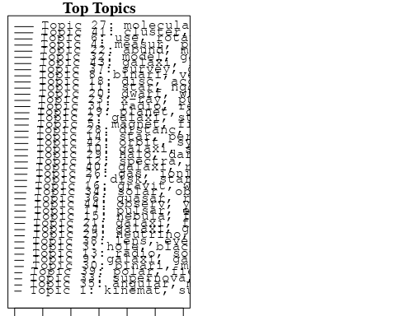

plotQuote(thoughts6, width = 30, main = "Topic 6")  
plotQuote(thoughts18, width = 30, main = "Topic 18")

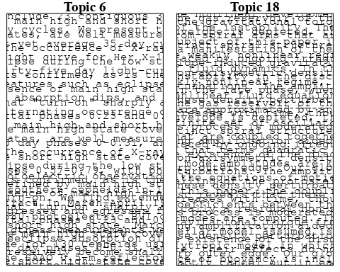

# Calculate and plot the correlation between topics  
mod.out.corr <- topicCorr(Research_topics)  
plot(mod.out.corr, cex = 1.5)  
  
  
# For each topic  
for (topic_num in 1:44) {  
 # Plot the word cloud  
 cloud(Research_topics, topic = topic_num, scale = c(2, 0.25))  
 Sys.sleep(2)  
}

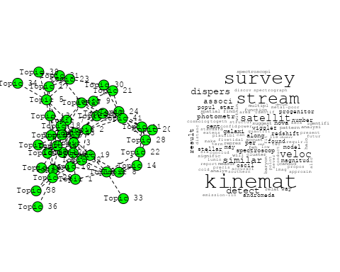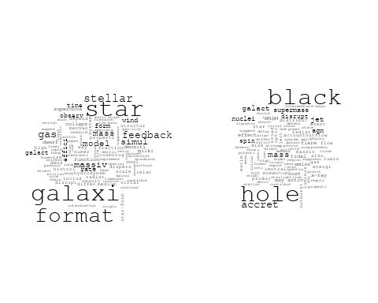

## Warning in wordcloud::wordcloud(words = vocab, freq = vec, max.words =  
## max.words, : cosmic could not be fit on page. It will not be plotted.

## Warning in wordcloud::wordcloud(words = vocab, freq = vec, max.words =  
## max.words, : cosmolog could not be fit on page. It will not be plotted.

## Warning in wordcloud::wordcloud(words = vocab, freq = vec, max.words =  
## max.words, : constraint could not be fit on page. It will not be plotted.

## Warning in wordcloud::wordcloud(words = vocab, freq = vec, max.words =  
## max.words, : consist could not be fit on page. It will not be plotted.

## Warning in wordcloud::wordcloud(words = vocab, freq = vec, max.words =  
## max.words, : fluctuat could not be fit on page. It will not be plotted.

## Warning in wordcloud::wordcloud(words = vocab, freq = vec, max.words =  
## max.words, : power could not be fit on page. It will not be plotted.

## Warning in wordcloud::wordcloud(words = vocab, freq = vec, max.words =  
## max.words, : background could not be fit on page. It will not be plotted.

## Warning in wordcloud::wordcloud(words = vocab, freq = vec, max.words =  
## max.words, : univers could not be fit on page. It will not be plotted.

## Warning in wordcloud::wordcloud(words = vocab, freq = vec, max.words =  
## max.words, : densiti could not be fit on page. It will not be plotted.

## Warning in wordcloud::wordcloud(words = vocab, freq = vec, max.words =  
## max.words, : distribut could not be fit on page. It will not be plotted.

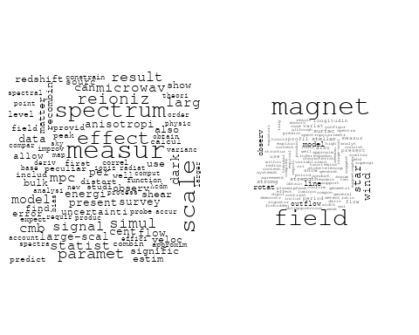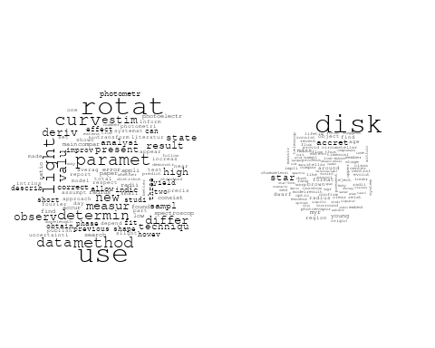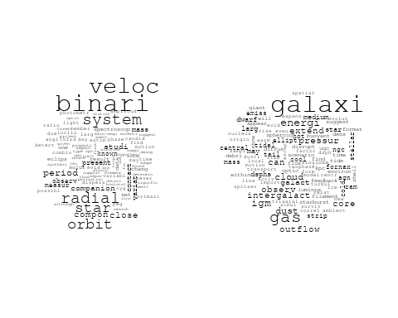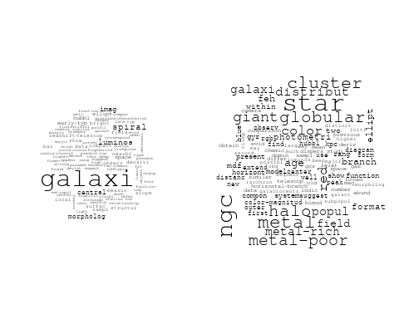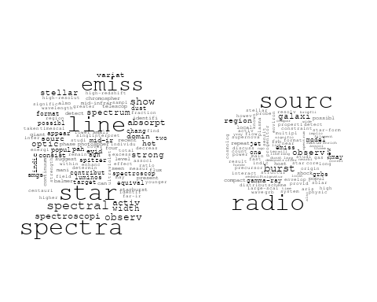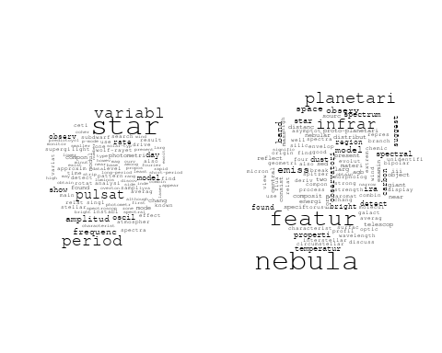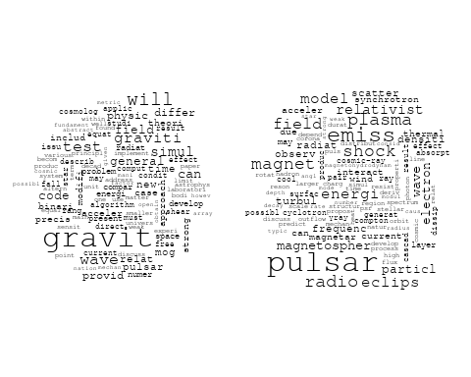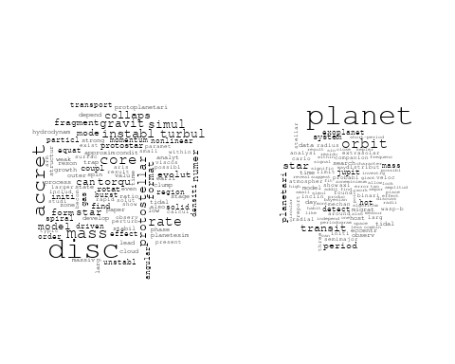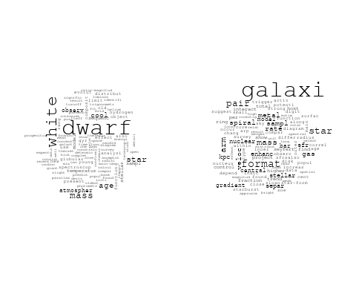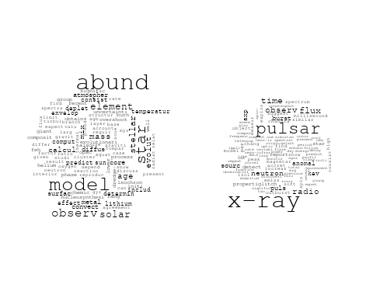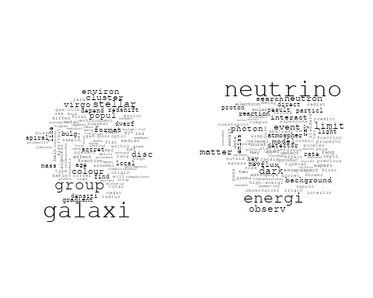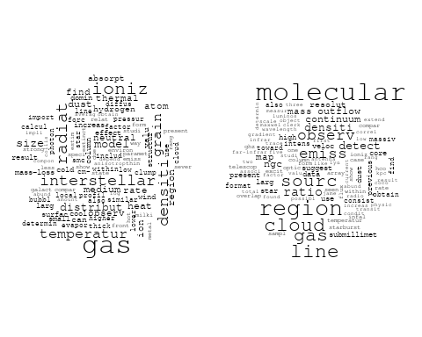

## Warning in wordcloud::wordcloud(words = vocab, freq = vec, max.words =  
## max.words, : photometri could not be fit on page. It will not be plotted.

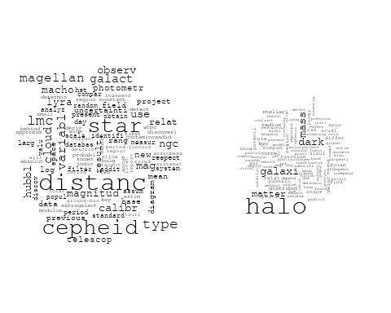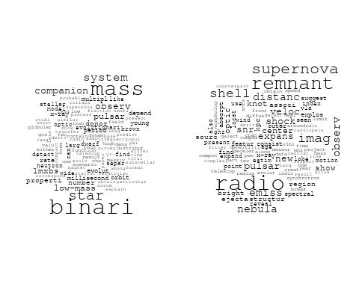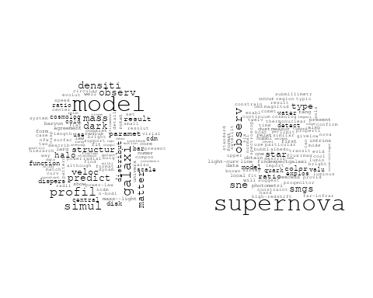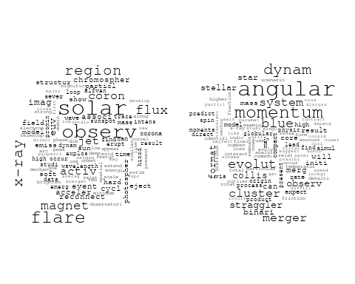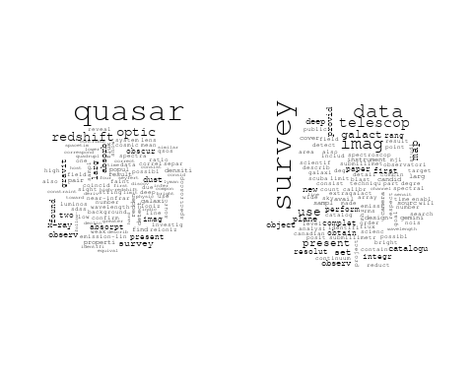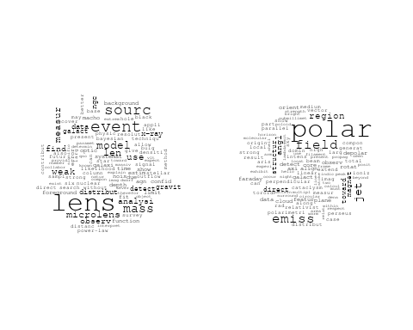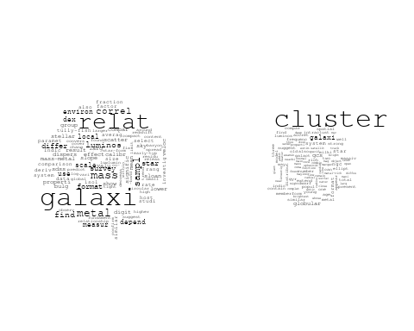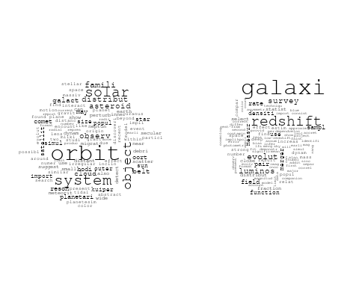

# Get the topic proportions for each document  
topic_proportions <- Research_topics$theta  
  
# Find the index of the topic with the highest proportion for each document  
# This will be the topic that each document is most likely to belong to  
max_topic_idx <- apply(topic_proportions, 1, which.max)  
  
# Add this as a new column to your data  
data_collab$topic <- max_topic_idx  
  
library(ggplot2)  
  
# Define the intervals  
intervals <- c('1824_1899', '1900_1964', '1965_1974', '1975_1984', '1985_1994', '1995_1999', '2000_2004', '2005_2009', '2010_2014', '2015_2019', '2020_2022')  
colors <- c('pink', 'blue', 'purple', 'yellow', 'green', 'pink', 'orange', 'violet', 'green', 'blue', 'pink')  
  
# Loop through the intervals and plot  
for(i in seq_along(intervals)){  
 # Filter data for when the pub_interval is equal to 1  
 data_filtered <- data_collab[data_collab[[paste0('pub_interval_', intervals[i])]] == 1,]  
   
 # Make the histogram  
   
 p <- ggplot(data_filtered, aes(x = topic)) +  
 geom_histogram(binwidth = 1, fill = colors[i], color = "black") +  
 xlab("Topic") +  
 ylab("Count") +  
 ggtitle(paste0("Topics from year ", gsub("_", " to ", intervals[i])))  
   
 print(p)  
}  
  
  
##Topic generation for CA (independent) publications  
  
data_independent <- data[data[["CA"]] == 100,]  
  
# Save the original title data for future use  
data_independent$original_concatenated_title_abstract <- data_independent$concatenated_title_abstract  
  
#pre-processing the titles using textProcessor from the stm package  
processed_text <- textProcessor(data_independent$concatenated_title_abstract, metadata = data_independent)

## Building corpus...   
## Converting to Lower Case...   
## Removing punctuation...   
## Removing stopwords...   
## Removing numbers...   
## Stemming...   
## Creating Output...

# Further prepare the data by removing low-frequency terms  
out_text <- prepDocuments(processed_text$documents, processed_text$vocab, processed_text$meta)

## Removing 1302 of 5664 terms (1302 of 71130 tokens) due to frequency   
## Your corpus now has 892 documents, 4362 terms and 69828 tokens.

docs_text <- out_text$documents  
vocab_text <- out_text$vocab  
meta_text <- out_text$meta  
  
  
#Prepare data  
plotRemoved(processed_text$documents, lower.thresh = seq(1, 200, by = 100))

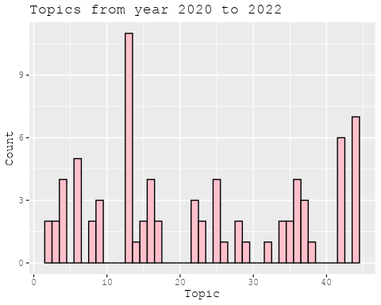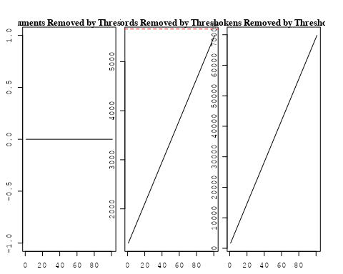

out_text <- prepDocuments(processed_text$documents, processed_text$vocab, processed_text$meta, lower.thresh = 8)

## Removing 4240 of 5664 terms (11131 of 71130 tokens) due to frequency   
## Your corpus now has 892 documents, 1424 terms and 59999 tokens.

str(out_text$meta)

## 'data.frame': 892 obs. of 39 variables:  
## $ concept_id : chr "https://openalex.org/C1276947" "https://openalex.org/C44870925" "https://openalex.org/C44870925" "https://openalex.org/C1276947" ...  
## $ work_id : chr "https://openalex.org/W1979518349" "https://openalex.org/W3098388870" "https://openalex.org/W2104067061" "https://openalex.org/W2951841130" ...  
## $ publication_year : int 2008 2000 2014 2012 2011 2005 2007 2011 2001 2022 ...  
## $ title : chr "Direct Imaging and Spectroscopy of a Planetary-Mass Candidate Companion to a Young Solar Analog" "The Star Formation History of the Starburst Region NGC 2363 and its Surroundings" "Kinematic classification of non-interacting spiral galaxies" "Herschel-PACS observations of [OI]63um towards submillimetre galaxies at z~1" ...  
## $ paperabstract : chr "We present Gemini near-infrared adaptive optics imaging and spectroscopy of a planetary-mass candidate companio"| __truncated__ "We present Hubble Space Telescope optical images and UV spectra, as well as ground-based near-infrared images o"| __truncated__ "Using neutral hydrogen (HI) rotation curves of 79 galaxies, culled from the literature, as well as measured fro"| __truncated__ "We present Herschel-PACS spectroscopy of the [O I]63 μm far-infrared cooling line from a sample of six unlensed"| __truncated__ ...  
## $ country : chr "CA CA" "CA CA CA CA" "CA CA CA" "CA" ...  
## $ year_concept : chr "2008+https://openalex.org/C1276947" "2000+https://openalex.org/C44870925" "2014+https://openalex.org/C44870925" "2012+https://openalex.org/C1276947" ...  
## $ concatenated_title_abstract : chr "Direct Imaging and Spectroscopy of a Planetary-Mass Candidate Companion to a Young Solar Analog We present Gemi"| __truncated__ "The Star Formation History of the Starburst Region NGC 2363 and its Surroundings We present Hubble Space Telesc"| __truncated__ "Kinematic classification of non-interacting spiral galaxies Using neutral hydrogen (HI) rotation curves of 79 g"| __truncated__ "Herschel-PACS observations of [OI]63um towards submillimetre galaxies at z~1 We present Herschel-PACS spectrosc"| __truncated__ ...  
## $ US : num 0 0 0 0 0 0 0 0 0 0 ...  
## $ IN : num 0 0 0 0 0 0 0 0 0 0 ...  
## $ DE : num 0 0 0 0 0 0 0 0 0 0 ...  
## $ CH : num 0 0 0 0 0 0 0 0 0 0 ...  
## $ GB : num 0 0 0 0 0 0 0 0 0 0 ...  
## $ CN : num 0 0 0 0 0 0 0 0 0 0 ...  
## $ FR : num 0 0 0 0 0 0 0 0 0 0 ...  
## $ IT : num 0 0 0 0 0 0 0 0 0 0 ...  
## $ RU : num 0 0 0 0 0 0 0 0 0 0 ...  
## $ CA : num 100 100 100 100 100 100 100 100 100 100 ...  
## $ NL : num 0 0 0 0 0 0 0 0 0 0 ...  
## $ AU : num 0 0 0 0 0 0 0 0 0 0 ...  
## $ JP : num 0 0 0 0 0 0 0 0 0 0 ...  
## $ ES : num 0 0 0 0 0 0 0 0 0 0 ...  
## $ IL : num 0 0 0 0 0 0 0 0 0 0 ...  
## $ Americas : num 0 0 0 0 0 0 0 0 0 0 ...  
## $ Europe : num 0 0 0 0 0 0 0 0 0 0 ...  
## $ Africa : num 0 0 0 0 0 0 0 0 0 0 ...  
## $ AsiaAndOceania : num 0 0 0 0 0 0 0 0 0 0 ...  
## $ pub_interval_2020_2022 : int 0 0 0 0 0 0 0 0 0 1 ...  
## $ pub_interval_2015_2019 : int 0 0 0 0 0 0 0 0 0 0 ...  
## $ pub_interval_2010_2014 : int 0 0 1 1 1 0 0 1 0 0 ...  
## $ pub_interval_2005_2009 : int 1 0 0 0 0 1 1 0 0 0 ...  
## $ pub_interval_2000_2004 : int 0 1 0 0 0 0 0 0 1 0 ...  
## $ pub_interval_1995_1999 : int 0 0 0 0 0 0 0 0 0 0 ...  
## $ pub_interval_1985_1994 : int 0 0 0 0 0 0 0 0 0 0 ...  
## $ pub_interval_1975_1984 : int 0 0 0 0 0 0 0 0 0 0 ...  
## $ pub_interval_1965_1974 : int 0 0 0 0 0 0 0 0 0 0 ...  
## $ pub_interval_1900_1964 : int 0 0 0 0 0 0 0 0 0 0 ...  
## $ pub_interval_1824_1899 : int 0 0 0 0 0 0 0 0 0 0 ...  
## $ original_concatenated_title_abstract: chr "Direct Imaging and Spectroscopy of a Planetary-Mass Candidate Companion to a Young Solar Analog We present Gemi"| __truncated__ "The Star Formation History of the Starburst Region NGC 2363 and its Surroundings We present Hubble Space Telesc"| __truncated__ "Kinematic classification of non-interacting spiral galaxies Using neutral hydrogen (HI) rotation curves of 79 g"| __truncated__ "Herschel-PACS observations of [OI]63um towards submillimetre galaxies at z~1 We present Herschel-PACS spectrosc"| __truncated__ ...

# Initialize an empty formula string  
prevalence_formula_str <- "~"  
  
# Define the publication intervals  
pub_intervals <- c("pub_interval_2020_2022", "pub_interval_2015_2019", "pub_interval_2010_2014",   
 "pub_interval_2005_2009", "pub_interval_2000_2004", "pub_interval_1995_1999",  
 "pub_interval_1985_1994", "pub_interval_1975_1984", "pub_interval_1965_1974",  
 "pub_interval_1900_1964", "pub_interval_1824_1899")  
  
# Add each publication interval to the formula string  
for (interval in pub_intervals) {  
 # add an if statement to handle the first addition (without '+')  
 if (prevalence_formula_str == "~") {  
 prevalence_formula_str <- paste(prevalence_formula_str, interval)  
 } else {  
 prevalence_formula_str <- paste(prevalence_formula_str, "+", interval)  
 }  
}  
  
  
# Convert the string to a formula  
prevalence_formula <- as.formula(prevalence_formula_str)  
print(prevalence_formula)

## ~pub_interval_2020_2022 + pub_interval_2015_2019 + pub_interval_2010_2014 +   
## pub_interval_2005_2009 + pub_interval_2000_2004 + pub_interval_1995_1999 +   
## pub_interval_1985_1994 + pub_interval_1975_1984 + pub_interval_1965_1974 +   
## pub_interval_1900_1964 + pub_interval_1824_1899

# Run STM model  
Research_topics <- stm(documents = out_text$documents,   
 vocab = out_text$vocab,   
 K = 44,   
 prevalence = prevalence_formula,   
 data = out_text$meta,   
 init.type = "Spectral",  
 max.em.its = 1000,  
 gamma.prior = 'L1')

## Beginning Spectral Initialization   
## Calculating the gram matrix...  
## Finding anchor words...  
## ............................................  
## Recovering initialization...  
## ..............  
## Initialization complete.  
## ...............................................................................................................  
## Completed E-Step (1 seconds).   
## Completed M-Step.   
## Completing Iteration 1 (approx. per word bound = -6.067)   
## ...............................................................................................................  
## Completed E-Step (0 seconds).   
## Completed M-Step.   
## Completing Iteration 2 (approx. per word bound = -5.803, relative change = 4.355e-02)   
## ...............................................................................................................  
## Completed E-Step (0 seconds).   
## Completed M-Step.   
## Completing Iteration 3 (approx. per word bound = -5.715, relative change = 1.523e-02)   
## ...............................................................................................................  
## Completed E-Step (0 seconds).   
## Completed M-Step.   
## Completing Iteration 4 (approx. per word bound = -5.674, relative change = 7.148e-03)   
## ...............................................................................................................  
## Completed E-Step (0 seconds).   
## Completed M-Step.   
## Completing Iteration 5 (approx. per word bound = -5.650, relative change = 4.162e-03)   
## Topic 1: hole, black, galaxi, found, system   
## Topic 2: magnet, star, field, model, abund   
## Topic 3: cluster, star, galaxi, system, format   
## Topic 4: disk, star, myr, accret, young   
## Topic 5: line, star, emiss, spectra, observ   
## Topic 6: nebula, planetari, star, model, featur   
## Topic 7: variabl, period, sourc, observ, photometr   
## Topic 8: data, flux, imag, map, use   
## Topic 9: energi, neutrino, limit, search, electron   
## Topic 10: color, relat, type, cepheid, use   
## Topic 11: burst, observ, jet, neutron, constraint   
## Topic 12: galaxi, pair, sampl, enhanc, format   
## Topic 13: object, solar, orbit, system, belt   
## Topic 14: binari, star, cluster, orbit, dwarf   
## Topic 15: quasar, reioniz, redshift, optic, ioniz   
## Topic 16: univers, observ, physic, astronomi, time   
## Topic 17: x-ray, flux, pulsar, time, puls   
## Topic 18: group, age, galaxi, local, cluster   
## Topic 19: radio, imag, optic, pulsar, expans   
## Topic 20: cluster, globular, galaxi, ngc, metal   
## Topic 21: planet, orbit, period, model, system   
## Topic 22: model, galaxi, dark, matter, mass   
## Topic 23: cloud, molecular, region, ratio, gas   
## Topic 24: galaxi, simul, format, model, halo   
## Topic 25: star, period, pulsat, variabl, cepheid   
## Topic 26: lens, sourc, observ, comet, densiti   
## Topic 27: mass, distribut, star, densiti, function   
## Topic 28: region, sourc, infal, outflow, mass   
## Topic 29: veloc, binari, radial, rotat, system   
## Topic 30: paramet, effect, find, use, calcul   
## Topic 31: galaxi, rate, relat, measur, use   
## Topic 32: mode, telescop, tidal, wave, frequenc   
## Topic 33: star, gas, atmospher, optic, ratio   
## Topic 34: dwarf, white, cool, mass, sequenc   
## Topic 35: ngc, star, halo, galaxi, metal   
## Topic 36: x-ray, observ, emiss, flare, hard   
## Topic 37: gas, disk, observ, interstellar, neutral   
## Topic 38: accret, disc, disk, mass, core   
## Topic 39: supernova, observ, mass, light, star   
## Topic 40: survey, sourc, data, galact, polar   
## Topic 41: pulsar, eclips, shock, wind, magnet   
## Topic 42: galaxi, redshift, luminos, sampl, evolut   
## Topic 43: galaxi, arm, dwarf, halo, model   
## Topic 44: disc, planet, zone, migrat, planetari   
## ...............................................................................................................  
## Completed E-Step (0 seconds).   
## Completed M-Step.   
## Completing Iteration 6 (approx. per word bound = -5.635, relative change = 2.633e-03)   
## ...............................................................................................................  
## Completed E-Step (0 seconds).   
## Completed M-Step.   
## Completing Iteration 7 (approx. per word bound = -5.626, relative change = 1.657e-03)   
## ...............................................................................................................  
## Completed E-Step (0 seconds).   
## Completed M-Step.   
## Completing Iteration 8 (approx. per word bound = -5.620, relative change = 1.112e-03)   
## ...............................................................................................................  
## Completed E-Step (0 seconds).   
## Completed M-Step.   
## Completing Iteration 9 (approx. per word bound = -5.615, relative change = 8.955e-04)   
## ...............................................................................................................  
## Completed E-Step (0 seconds).   
## Completed M-Step.   
## Completing Iteration 10 (approx. per word bound = -5.611, relative change = 7.359e-04)   
## Topic 1: hole, black, galaxi, found, system   
## Topic 2: magnet, star, field, model, abund   
## Topic 3: galaxi, cluster, star, stellar, format   
## Topic 4: disk, star, myr, accret, young   
## Topic 5: line, star, emiss, spectra, observ   
## Topic 6: nebula, planetari, star, model, evolut   
## Topic 7: variabl, star, period, companion, sourc   
## Topic 8: data, flux, imag, map, set   
## Topic 9: energi, neutrino, limit, search, electron   
## Topic 10: color, relat, type, cepheid, use   
## Topic 11: burst, neutron, star, observ, jet   
## Topic 12: galaxi, pair, sampl, format, enhanc   
## Topic 13: object, solar, system, orbit, belt   
## Topic 14: binari, star, cluster, giant, dwarf   
## Topic 15: quasar, reioniz, optic, redshift, halo   
## Topic 16: univers, observ, time, astronomi, hubbl   
## Topic 17: x-ray, flux, pulsar, time, puls   
## Topic 18: group, age, galaxi, local, cluster   
## Topic 19: radio, optic, imag, pulsar, expans   
## Topic 20: cluster, galaxi, globular, ngc, metal   
## Topic 21: planet, orbit, period, model, system   
## Topic 22: model, galaxi, dark, matter, mass   
## Topic 23: cloud, molecular, region, ratio, line   
## Topic 24: galaxi, simul, format, model, halo   
## Topic 25: star, period, pulsat, variabl, cepheid   
## Topic 26: lens, sourc, observ, comet, emiss   
## Topic 27: mass, distribut, densiti, star, function   
## Topic 28: region, sourc, infal, outflow, mass   
## Topic 29: veloc, binari, radial, rotat, system   
## Topic 30: paramet, use, effect, cosmolog, method   
## Topic 31: galaxi, measur, rate, relat, use   
## Topic 32: mode, telescop, tidal, wave, frequenc   
## Topic 33: gas, star, atmospher, ratio, optic   
## Topic 34: dwarf, white, star, cool, mass   
## Topic 35: ngc, star, halo, galaxi, metal   
## Topic 36: x-ray, observ, emiss, flux, flare   
## Topic 37: gas, disk, interstellar, shock, observ   
## Topic 38: accret, disc, disk, mass, core   
## Topic 39: supernova, observ, mass, light, type   
## Topic 40: survey, sourc, data, polar, galact   
## Topic 41: pulsar, eclips, wind, magnet, shock   
## Topic 42: galaxi, redshift, sampl, evolut, luminos   
## Topic 43: galaxi, arm, halo, dwarf, model   
## Topic 44: disc, planet, zone, migrat, planetari   
## ...............................................................................................................  
## Completed E-Step (1 seconds).   
## Completed M-Step.   
## Completing Iteration 11 (approx. per word bound = -5.607, relative change = 5.775e-04)   
## ...............................................................................................................  
## Completed E-Step (0 seconds).   
## Completed M-Step.   
## Completing Iteration 12 (approx. per word bound = -5.605, relative change = 4.590e-04)   
## ...............................................................................................................  
## Completed E-Step (0 seconds).   
## Completed M-Step.   
## Completing Iteration 13 (approx. per word bound = -5.602, relative change = 4.274e-04)   
## ...............................................................................................................  
## Completed E-Step (0 seconds).   
## Completed M-Step.   
## Completing Iteration 14 (approx. per word bound = -5.600, relative change = 3.899e-04)   
## ...............................................................................................................  
## Completed E-Step (0 seconds).   
## Completed M-Step.   
## Completing Iteration 15 (approx. per word bound = -5.598, relative change = 3.518e-04)   
## Topic 1: hole, black, galaxi, mass, quasar   
## Topic 2: magnet, star, field, model, abund   
## Topic 3: galaxi, cluster, star, stellar, system   
## Topic 4: disk, star, myr, accret, young   
## Topic 5: line, star, emiss, spectra, observ   
## Topic 6: nebula, planetari, star, model, evolut   
## Topic 7: variabl, star, companion, period, sourc   
## Topic 8: data, flux, imag, map, set   
## Topic 9: energi, neutrino, limit, search, electron   
## Topic 10: type, relat, color, cepheid, use   
## Topic 11: burst, neutron, star, observ, jet   
## Topic 12: galaxi, pair, sampl, format, enhanc   
## Topic 13: object, solar, system, orbit, belt   
## Topic 14: binari, star, cluster, hot, dwarf   
## Topic 15: quasar, reioniz, optic, ioniz, redshift   
## Topic 16: univers, observ, time, astronomi, hubbl   
## Topic 17: x-ray, flux, pulsar, time, puls   
## Topic 18: group, age, galaxi, local, cluster   
## Topic 19: radio, optic, imag, pulsar, expans   
## Topic 20: cluster, galaxi, globular, ngc, metal   
## Topic 21: planet, orbit, period, star, system   
## Topic 22: model, galaxi, dark, matter, mass   
## Topic 23: cloud, molecular, region, ratio, line   
## Topic 24: galaxi, simul, format, model, halo   
## Topic 25: star, period, pulsat, variabl, cepheid   
## Topic 26: lens, observ, sourc, comet, emiss   
## Topic 27: mass, densiti, distribut, structur, star   
## Topic 28: region, sourc, infal, outflow, mass   
## Topic 29: veloc, binari, radial, rotat, system   
## Topic 30: method, use, paramet, effect, cosmolog   
## Topic 31: galaxi, rate, measur, relat, pair   
## Topic 32: mode, reson, telescop, tidal, wave   
## Topic 33: gas, atmospher, star, ratio, optic   
## Topic 34: dwarf, white, star, mass, cool   
## Topic 35: ngc, star, halo, galaxi, metal   
## Topic 36: x-ray, observ, emiss, flux, flare   
## Topic 37: gas, disk, shock, interstellar, observ   
## Topic 38: accret, disc, disk, mass, core   
## Topic 39: supernova, observ, mass, light, type   
## Topic 40: survey, sourc, data, polar, galact   
## Topic 41: pulsar, eclips, wind, magnet, shock   
## Topic 42: galaxi, redshift, sampl, evolut, luminos   
## Topic 43: galaxi, arm, halo, dwarf, model   
## Topic 44: disc, planet, zone, migrat, planetari   
## ...............................................................................................................  
## Completed E-Step (0 seconds).   
## Completed M-Step.   
## Completing Iteration 16 (approx. per word bound = -5.596, relative change = 3.277e-04)   
## ...............................................................................................................  
## Completed E-Step (0 seconds).   
## Completed M-Step.   
## Completing Iteration 17 (approx. per word bound = -5.595, relative change = 2.611e-04)   
## ...............................................................................................................  
## Completed E-Step (0 seconds).   
## Completed M-Step.   
## Completing Iteration 18 (approx. per word bound = -5.594, relative change = 2.338e-04)   
## ...............................................................................................................  
## Completed E-Step (0 seconds).   
## Completed M-Step.   
## Completing Iteration 19 (approx. per word bound = -5.593, relative change = 1.921e-04)   
## ...............................................................................................................  
## Completed E-Step (0 seconds).   
## Completed M-Step.   
## Completing Iteration 20 (approx. per word bound = -5.591, relative change = 1.896e-04)   
## Topic 1: hole, black, galaxi, mass, quasar   
## Topic 2: magnet, star, field, model, abund   
## Topic 3: galaxi, cluster, star, system, stellar   
## Topic 4: disk, star, myr, accret, young   
## Topic 5: line, star, emiss, spectra, observ   
## Topic 6: nebula, planetari, star, model, evolut   
## Topic 7: variabl, star, companion, period, observ   
## Topic 8: data, flux, imag, map, object   
## Topic 9: energi, neutrino, limit, electron, search   
## Topic 10: type, color, relat, cepheid, use   
## Topic 11: burst, neutron, star, observ, jet   
## Topic 12: galaxi, pair, sampl, format, enhanc   
## Topic 13: object, solar, system, orbit, belt   
## Topic 14: binari, star, cluster, hot, dwarf   
## Topic 15: quasar, reioniz, optic, ioniz, redshift   
## Topic 16: univers, observ, time, astronomi, year   
## Topic 17: x-ray, flux, pulsar, time, puls   
## Topic 18: group, age, galaxi, local, distanc   
## Topic 19: radio, optic, imag, pulsar, expans   
## Topic 20: cluster, galaxi, globular, ngc, metal   
## Topic 21: planet, orbit, period, star, system   
## Topic 22: model, galaxi, dark, matter, mass   
## Topic 23: cloud, molecular, region, ratio, line   
## Topic 24: galaxi, format, simul, model, halo   
## Topic 25: star, period, pulsat, variabl, cepheid   
## Topic 26: lens, sourc, observ, comet, emiss   
## Topic 27: mass, densiti, distribut, structur, star   
## Topic 28: region, infal, sourc, outflow, mass   
## Topic 29: veloc, binari, radial, rotat, system   
## Topic 30: method, use, paramet, effect, cosmolog   
## Topic 31: galaxi, rate, measur, relat, pair   
## Topic 32: mode, reson, telescop, tidal, wave   
## Topic 33: gas, atmospher, star, ratio, emiss   
## Topic 34: dwarf, white, star, mass, model   
## Topic 35: ngc, star, halo, galaxi, metal   
## Topic 36: x-ray, observ, flux, emiss, flare   
## Topic 37: gas, disk, shock, interstellar, observ   
## Topic 38: accret, disc, disk, mass, core   
## Topic 39: supernova, observ, mass, light, type   
## Topic 40: survey, sourc, data, polar, galact   
## Topic 41: pulsar, eclips, wind, magnet, shock   
## Topic 42: galaxi, redshift, sampl, evolut, luminos   
## Topic 43: galaxi, arm, halo, dwarf, model   
## Topic 44: disc, planet, zone, migrat, planetari   
## ...............................................................................................................  
## Completed E-Step (0 seconds).   
## Completed M-Step.   
## Completing Iteration 21 (approx. per word bound = -5.590, relative change = 1.904e-04)   
## ...............................................................................................................  
## Completed E-Step (0 seconds).   
## Completed M-Step.   
## Completing Iteration 22 (approx. per word bound = -5.589, relative change = 2.051e-04)   
## ...............................................................................................................  
## Completed E-Step (0 seconds).   
## Completed M-Step.   
## Completing Iteration 23 (approx. per word bound = -5.588, relative change = 1.973e-04)   
## ...............................................................................................................  
## Completed E-Step (0 seconds).   
## Completed M-Step.   
## Completing Iteration 24 (approx. per word bound = -5.587, relative change = 1.731e-04)   
## ...............................................................................................................  
## Completed E-Step (0 seconds).   
## Completed M-Step.   
## Completing Iteration 25 (approx. per word bound = -5.586, relative change = 1.753e-04)   
## Topic 1: hole, black, mass, quasar, galaxi   
## Topic 2: magnet, star, field, model, abund   
## Topic 3: galaxi, cluster, star, system, stellar   
## Topic 4: star, disk, myr, accret, young   
## Topic 5: line, star, spectra, emiss, observ   
## Topic 6: nebula, planetari, star, model, evolut   
## Topic 7: variabl, star, companion, period, observ   
## Topic 8: data, flux, imag, map, object   
## Topic 9: energi, neutrino, limit, electron, search   
## Topic 10: type, color, relat, cepheid, use   
## Topic 11: burst, neutron, star, observ, jet   
## Topic 12: galaxi, pair, sampl, format, enhanc   
## Topic 13: object, solar, system, orbit, belt   
## Topic 14: binari, star, cluster, hot, dwarf   
## Topic 15: quasar, reioniz, optic, ioniz, redshift   
## Topic 16: univers, observ, time, year, astronomi   
## Topic 17: x-ray, flux, pulsar, time, puls   
## Topic 18: group, age, galaxi, local, distanc   
## Topic 19: radio, optic, imag, pulsar, expans   
## Topic 20: cluster, galaxi, globular, ngc, metal   
## Topic 21: planet, orbit, period, star, system   
## Topic 22: model, galaxi, dark, matter, mass   
## Topic 23: cloud, molecular, region, ratio, line   
## Topic 24: galaxi, format, simul, model, halo   
## Topic 25: star, period, pulsat, variabl, cluster   
## Topic 26: lens, observ, sourc, emiss, comet   
## Topic 27: mass, densiti, distribut, structur, star   
## Topic 28: region, infal, sourc, map, outflow   
## Topic 29: veloc, binari, rotat, radial, determin   
## Topic 30: method, use, paramet, effect, cosmolog   
## Topic 31: galaxi, rate, measur, relat, pair   
## Topic 32: mode, reson, telescop, tidal, oscil   
## Topic 33: gas, atmospher, star, ratio, emiss   
## Topic 34: dwarf, white, star, mass, model   
## Topic 35: ngc, star, halo, galaxi, metal   
## Topic 36: x-ray, observ, flux, emiss, flare   
## Topic 37: gas, disk, shock, interstellar, observ   
## Topic 38: accret, disc, disk, mass, core   
## Topic 39: supernova, observ, mass, light, nova   
## Topic 40: survey, sourc, data, polar, galact   
## Topic 41: pulsar, eclips, wind, magnet, shock   
## Topic 42: galaxi, redshift, sampl, evolut, luminos   
## Topic 43: galaxi, arm, halo, dwarf, model   
## Topic 44: disc, planet, zone, migrat, star   
## ...............................................................................................................  
## Completed E-Step (0 seconds).   
## Completed M-Step.   
## Completing Iteration 26 (approx. per word bound = -5.585, relative change = 1.623e-04)   
## ...............................................................................................................  
## Completed E-Step (0 seconds).   
## Completed M-Step.   
## Completing Iteration 27 (approx. per word bound = -5.584, relative change = 1.503e-04)   
## ...............................................................................................................  
## Completed E-Step (0 seconds).   
## Completed M-Step.   
## Completing Iteration 28 (approx. per word bound = -5.584, relative change = 1.380e-04)   
## ...............................................................................................................  
## Completed E-Step (0 seconds).   
## Completed M-Step.   
## Completing Iteration 29 (approx. per word bound = -5.583, relative change = 1.203e-04)   
## ...............................................................................................................  
## Completed E-Step (0 seconds).   
## Completed M-Step.   
## Completing Iteration 30 (approx. per word bound = -5.582, relative change = 1.019e-04)   
## Topic 1: hole, quasar, black, mass, galaxi   
## Topic 2: magnet, star, field, model, abund   
## Topic 3: galaxi, cluster, star, system, stellar   
## Topic 4: star, disk, myr, accret, young   
## Topic 5: line, star, spectra, observ, emiss   
## Topic 6: nebula, planetari, star, model, evolut   
## Topic 7: star, variabl, companion, period, observ   
## Topic 8: data, flux, imag, map, object   
## Topic 9: energi, neutrino, limit, electron, search   
## Topic 10: type, color, relat, cepheid, use   
## Topic 11: burst, neutron, star, observ, jet   
## Topic 12: galaxi, pair, sampl, format, enhanc   
## Topic 13: object, solar, orbit, system, belt   
## Topic 14: binari, star, cluster, hot, dwarf   
## Topic 15: quasar, reioniz, optic, ioniz, halo   
## Topic 16: univers, observ, time, year, astronomi   
## Topic 17: x-ray, flux, pulsar, time, puls   
## Topic 18: group, age, galaxi, local, distanc   
## Topic 19: radio, optic, imag, pulsar, expans   
## Topic 20: cluster, galaxi, globular, ngc, metal   
## Topic 21: planet, orbit, period, star, system   
## Topic 22: model, galaxi, dark, mass, matter   
## Topic 23: cloud, molecular, region, ratio, line   
## Topic 24: galaxi, format, simul, model, halo   
## Topic 25: star, period, pulsat, variabl, cluster   
## Topic 26: lens, observ, sourc, emiss, comet   
## Topic 27: mass, densiti, distribut, structur, simul   
## Topic 28: region, infal, sourc, map, outflow   
## Topic 29: veloc, binari, rotat, radial, determin   
## Topic 30: use, method, paramet, effect, cosmolog   
## Topic 31: galaxi, rate, measur, relat, pair   
## Topic 32: mode, reson, telescop, tidal, wave   
## Topic 33: gas, atmospher, star, ratio, emiss   
## Topic 34: dwarf, white, star, mass, cool   
## Topic 35: ngc, star, halo, galaxi, metal   
## Topic 36: x-ray, observ, flux, emiss, relat   
## Topic 37: gas, disk, shock, interstellar, observ   
## Topic 38: accret, disc, disk, mass, core   
## Topic 39: supernova, observ, mass, light, nova   
## Topic 40: survey, sourc, data, polar, galact   
## Topic 41: pulsar, eclips, wind, magnet, shock   
## Topic 42: galaxi, redshift, sampl, evolut, luminos   
## Topic 43: galaxi, arm, halo, dwarf, model   
## Topic 44: disc, planet, zone, migrat, star   
## ...............................................................................................................  
## Completed E-Step (0 seconds).   
## Completed M-Step.   
## Completing Iteration 31 (approx. per word bound = -5.582, relative change = 9.082e-05)   
## ...............................................................................................................  
## Completed E-Step (0 seconds).   
## Completed M-Step.   
## Completing Iteration 32 (approx. per word bound = -5.581, relative change = 9.049e-05)   
## ...............................................................................................................  
## Completed E-Step (0 seconds).   
## Completed M-Step.   
## Completing Iteration 33 (approx. per word bound = -5.581, relative change = 1.005e-04)   
## ...............................................................................................................  
## Completed E-Step (0 seconds).   
## Completed M-Step.   
## Completing Iteration 34 (approx. per word bound = -5.580, relative change = 1.085e-04)   
## ...............................................................................................................  
## Completed E-Step (0 seconds).   
## Completed M-Step.   
## Completing Iteration 35 (approx. per word bound = -5.580, relative change = 9.752e-05)   
## Topic 1: quasar, hole, mass, black, galaxi   
## Topic 2: magnet, star, field, model, abund   
## Topic 3: galaxi, cluster, star, system, stellar   
## Topic 4: star, disk, myr, accret, young   
## Topic 5: line, star, spectra, observ, emiss   
## Topic 6: nebula, planetari, star, model, evolut   
## Topic 7: variabl, star, companion, period, observ   
## Topic 8: data, flux, imag, map, object   
## Topic 9: energi, neutrino, limit, search, dark   
## Topic 10: type, color, relat, cepheid, use   
## Topic 11: burst, neutron, star, observ, jet   
## Topic 12: galaxi, pair, sampl, format, enhanc   
## Topic 13: object, orbit, solar, system, belt   
## Topic 14: binari, star, cluster, hot, dwarf   
## Topic 15: quasar, reioniz, optic, ioniz, halo   
## Topic 16: univers, observ, time, year, astronomi   
## Topic 17: x-ray, flux, pulsar, time, puls   
## Topic 18: group, age, galaxi, local, distanc   
## Topic 19: radio, optic, imag, pulsar, expans   
## Topic 20: cluster, galaxi, globular, ngc, metal   
## Topic 21: planet, orbit, period, star, system   
## Topic 22: model, galaxi, dark, mass, paramet   
## Topic 23: cloud, molecular, region, ratio, line   
## Topic 24: galaxi, format, simul, model, halo   
## Topic 25: star, period, pulsat, variabl, cepheid   
## Topic 26: lens, observ, sourc, emiss, comet   
## Topic 27: mass, densiti, distribut, structur, simul   
## Topic 28: region, infal, sourc, map, outflow   
## Topic 29: veloc, binari, rotat, radial, determin   
## Topic 30: use, method, paramet, effect, cosmolog   
## Topic 31: galaxi, rate, measur, relat, pair   
## Topic 32: mode, reson, telescop, tidal, wave   
## Topic 33: gas, atmospher, star, ratio, emiss   
## Topic 34: dwarf, white, star, mass, cool   
## Topic 35: ngc, star, halo, galaxi, metal   
## Topic 36: x-ray, observ, flux, emiss, relat   
## Topic 37: gas, disk, shock, interstellar, observ   
## Topic 38: accret, disc, disk, mass, core   
## Topic 39: supernova, observ, mass, light, nova   
## Topic 40: survey, sourc, data, polar, galact   
## Topic 41: pulsar, eclips, wind, magnet, shock   
## Topic 42: galaxi, redshift, sampl, evolut, luminos   
## Topic 43: galaxi, arm, halo, dwarf, model   
## Topic 44: disc, planet, zone, migrat, star   
## ...............................................................................................................  
## Completed E-Step (0 seconds).   
## Completed M-Step.   
## Completing Iteration 36 (approx. per word bound = -5.579, relative change = 7.479e-05)   
## ...............................................................................................................  
## Completed E-Step (0 seconds).   
## Completed M-Step.   
## Completing Iteration 37 (approx. per word bound = -5.579, relative change = 6.314e-05)   
## ...............................................................................................................  
## Completed E-Step (0 seconds).   
## Completed M-Step.   
## Completing Iteration 38 (approx. per word bound = -5.579, relative change = 6.009e-05)   
## ...............................................................................................................  
## Completed E-Step (0 seconds).   
## Completed M-Step.   
## Completing Iteration 39 (approx. per word bound = -5.578, relative change = 6.295e-05)   
## ...............................................................................................................  
## Completed E-Step (0 seconds).   
## Completed M-Step.   
## Completing Iteration 40 (approx. per word bound = -5.578, relative change = 6.967e-05)   
## Topic 1: quasar, mass, hole, galaxi, black   
## Topic 2: magnet, star, field, model, abund   
## Topic 3: galaxi, cluster, star, system, stellar   
## Topic 4: star, disk, myr, accret, young   
## Topic 5: line, star, spectra, observ, emiss   
## Topic 6: nebula, planetari, star, model, evolut   
## Topic 7: variabl, star, companion, period, observ   
## Topic 8: data, flux, imag, map, object   
## Topic 9: energi, neutrino, limit, search, dark   
## Topic 10: type, color, relat, cepheid, diagram   
## Topic 11: burst, neutron, star, observ, jet   
## Topic 12: galaxi, pair, sampl, format, enhanc   
## Topic 13: object, orbit, solar, system, belt   
## Topic 14: binari, star, cluster, hot, dwarf   
## Topic 15: quasar, reioniz, optic, ioniz, halo   
## Topic 16: univers, observ, time, year, astronomi   
## Topic 17: x-ray, flux, pulsar, time, puls   
## Topic 18: group, age, galaxi, distanc, local   
## Topic 19: radio, optic, imag, pulsar, expans   
## Topic 20: cluster, globular, galaxi, ngc, metal   
## Topic 21: planet, orbit, period, star, system   
## Topic 22: model, galaxi, dark, mass, paramet   
## Topic 23: cloud, molecular, region, ratio, line   
## Topic 24: galaxi, format, simul, model, halo   
## Topic 25: star, period, pulsat, variabl, cepheid   
## Topic 26: lens, sourc, observ, emiss, comet   
## Topic 27: mass, densiti, distribut, structur, simul   
## Topic 28: region, infal, sourc, map, outflow   
## Topic 29: veloc, binari, rotat, radial, determin   
## Topic 30: use, method, paramet, effect, cosmolog   
## Topic 31: galaxi, rate, measur, relat, pair   
## Topic 32: mode, reson, telescop, tidal, wave   
## Topic 33: gas, atmospher, ratio, star, emiss   
## Topic 34: dwarf, white, star, mass, cool   
## Topic 35: ngc, star, halo, galaxi, metal   
## Topic 36: x-ray, observ, flux, emiss, relat   
## Topic 37: gas, disk, shock, interstellar, observ   
## Topic 38: accret, disc, disk, mass, core   
## Topic 39: supernova, observ, mass, light, nova   
## Topic 40: survey, sourc, data, polar, galact   
## Topic 41: pulsar, eclips, wind, magnet, shock   
## Topic 42: galaxi, redshift, sampl, evolut, luminos   
## Topic 43: galaxi, arm, halo, dwarf, model   
## Topic 44: disc, planet, zone, migrat, star   
## ...............................................................................................................  
## Completed E-Step (0 seconds).   
## Completed M-Step.   
## Completing Iteration 41 (approx. per word bound = -5.578, relative change = 6.511e-05)   
## ...............................................................................................................  
## Completed E-Step (0 seconds).   
## Completed M-Step.   
## Completing Iteration 42 (approx. per word bound = -5.577, relative change = 5.330e-05)   
## ...............................................................................................................  
## Completed E-Step (0 seconds).   
## Completed M-Step.   
## Completing Iteration 43 (approx. per word bound = -5.577, relative change = 6.648e-05)   
## ...............................................................................................................  
## Completed E-Step (0 seconds).   
## Completed M-Step.   
## Completing Iteration 44 (approx. per word bound = -5.577, relative change = 6.361e-05)   
## ...............................................................................................................  
## Completed E-Step (0 seconds).   
## Completed M-Step.   
## Completing Iteration 45 (approx. per word bound = -5.576, relative change = 4.416e-05)   
## Topic 1: quasar, mass, hole, galaxi, black   
## Topic 2: magnet, star, field, model, abund   
## Topic 3: galaxi, cluster, star, system, stellar   
## Topic 4: star, disk, myr, accret, young   
## Topic 5: line, star, spectra, observ, emiss   
## Topic 6: nebula, planetari, star, model, evolut   
## Topic 7: variabl, star, companion, period, observ   
## Topic 8: data, flux, imag, map, object   
## Topic 9: energi, neutrino, limit, dark, search   
## Topic 10: type, color, relat, cepheid, diagram   
## Topic 11: burst, neutron, star, observ, jet   
## Topic 12: galaxi, pair, sampl, format, enhanc   
## Topic 13: object, orbit, system, solar, belt   
## Topic 14: binari, star, cluster, hot, dwarf   
## Topic 15: quasar, reioniz, optic, ioniz, halo   
## Topic 16: univers, observ, time, year, astronomi   
## Topic 17: x-ray, flux, pulsar, time, puls   
## Topic 18: group, age, galaxi, distanc, local   
## Topic 19: radio, optic, imag, pulsar, expans   
## Topic 20: cluster, globular, galaxi, ngc, metal   
## Topic 21: planet, orbit, period, star, system   
## Topic 22: model, galaxi, mass, dark, paramet   
## Topic 23: cloud, molecular, region, ratio, line   
## Topic 24: galaxi, format, simul, model, halo   
## Topic 25: star, period, pulsat, variabl, cepheid   
## Topic 26: lens, sourc, observ, emiss, comet   
## Topic 27: mass, densiti, distribut, structur, simul   
## Topic 28: region, infal, sourc, map, outflow   
## Topic 29: veloc, binari, rotat, radial, determin   
## Topic 30: use, method, paramet, effect, cosmolog   
## Topic 31: galaxi, rate, measur, relat, pair   
## Topic 32: mode, reson, telescop, tidal, wave   
## Topic 33: gas, atmospher, ratio, star, emiss   
## Topic 34: dwarf, white, star, mass, cool   
## Topic 35: ngc, star, halo, galaxi, metal   
## Topic 36: x-ray, observ, flux, relat, scale   
## Topic 37: gas, disk, shock, interstellar, observ   
## Topic 38: accret, disc, disk, mass, core   
## Topic 39: supernova, observ, mass, light, nova   
## Topic 40: survey, sourc, data, polar, galact   
## Topic 41: pulsar, eclips, wind, magnet, field   
## Topic 42: galaxi, redshift, evolut, sampl, luminos   
## Topic 43: galaxi, arm, halo, dwarf, model   
## Topic 44: disc, planet, zone, migrat, star   
## ...............................................................................................................  
## Completed E-Step (0 seconds).   
## Completed M-Step.   
## Completing Iteration 46 (approx. per word bound = -5.576, relative change = 4.441e-05)   
## ...............................................................................................................  
## Completed E-Step (0 seconds).   
## Completed M-Step.   
## Completing Iteration 47 (approx. per word bound = -5.576, relative change = 4.679e-05)   
## ...............................................................................................................  
## Completed E-Step (0 seconds).   
## Completed M-Step.   
## Completing Iteration 48 (approx. per word bound = -5.575, relative change = 4.606e-05)   
## ...............................................................................................................  
## Completed E-Step (0 seconds).   
## Completed M-Step.   
## Completing Iteration 49 (approx. per word bound = -5.575, relative change = 3.920e-05)   
## ...............................................................................................................  
## Completed E-Step (0 seconds).   
## Completed M-Step.   
## Completing Iteration 50 (approx. per word bound = -5.575, relative change = 4.485e-05)   
## Topic 1: quasar, mass, hole, galaxi, black   
## Topic 2: magnet, star, field, model, abund   
## Topic 3: galaxi, cluster, star, system, stellar   
## Topic 4: star, disk, myr, accret, young   
## Topic 5: line, star, spectra, observ, emiss   
## Topic 6: nebula, planetari, star, model, evolut   
## Topic 7: variabl, star, companion, period, observ   
## Topic 8: data, flux, imag, map, object   
## Topic 9: energi, neutrino, limit, dark, search   
## Topic 10: type, color, relat, cepheid, diagram   
## Topic 11: burst, neutron, star, observ, jet   
## Topic 12: galaxi, pair, sampl, format, enhanc   
## Topic 13: object, orbit, system, solar, belt   
## Topic 14: binari, star, cluster, hot, dwarf   
## Topic 15: quasar, reioniz, optic, ioniz, halo   
## Topic 16: univers, observ, time, year, astronomi   
## Topic 17: x-ray, flux, pulsar, time, puls   
## Topic 18: group, age, galaxi, distanc, local   
## Topic 19: radio, optic, imag, pulsar, expans   
## Topic 20: cluster, globular, galaxi, ngc, metal   
## Topic 21: planet, orbit, period, star, system   
## Topic 22: model, galaxi, mass, dark, paramet   
## Topic 23: cloud, molecular, region, ratio, line   
## Topic 24: galaxi, format, simul, model, halo   
## Topic 25: star, period, pulsat, variabl, cepheid   
## Topic 26: lens, sourc, observ, emiss, comet   
## Topic 27: mass, densiti, distribut, structur, simul   
## Topic 28: region, infal, sourc, map, outflow   
## Topic 29: veloc, binari, radial, rotat, determin   
## Topic 30: use, method, paramet, effect, cosmolog   
## Topic 31: galaxi, rate, measur, relat, pair   
## Topic 32: mode, reson, telescop, tidal, wave   
## Topic 33: gas, atmospher, ratio, star, emiss   
## Topic 34: dwarf, white, star, mass, cool   
## Topic 35: ngc, star, halo, galaxi, metal   
## Topic 36: x-ray, observ, flux, relat, scale   
## Topic 37: gas, disk, shock, interstellar, observ   
## Topic 38: accret, disc, disk, mass, core   
## Topic 39: supernova, observ, mass, light, nova   
## Topic 40: survey, sourc, data, polar, galact   
## Topic 41: pulsar, eclips, wind, magnet, field   
## Topic 42: galaxi, redshift, evolut, sampl, luminos   
## Topic 43: galaxi, arm, halo, model, dwarf   
## Topic 44: disc, planet, zone, migrat, star   
## ...............................................................................................................  
## Completed E-Step (0 seconds).   
## Completed M-Step.   
## Completing Iteration 51 (approx. per word bound = -5.575, relative change = 4.420e-05)   
## ...............................................................................................................  
## Completed E-Step (0 seconds).   
## Completed M-Step.   
## Completing Iteration 52 (approx. per word bound = -5.575, relative change = 3.853e-05)   
## ...............................................................................................................  
## Completed E-Step (0 seconds).   
## Completed M-Step.   
## Completing Iteration 53 (approx. per word bound = -5.574, relative change = 3.591e-05)   
## ...............................................................................................................  
## Completed E-Step (0 seconds).   
## Completed M-Step.   
## Completing Iteration 54 (approx. per word bound = -5.574, relative change = 3.717e-05)   
## ...............................................................................................................  
## Completed E-Step (0 seconds).   
## Completed M-Step.   
## Completing Iteration 55 (approx. per word bound = -5.574, relative change = 3.802e-05)   
## Topic 1: quasar, mass, hole, galaxi, black   
## Topic 2: magnet, star, field, model, abund   
## Topic 3: galaxi, cluster, star, system, stellar   
## Topic 4: star, disk, myr, accret, young   
## Topic 5: line, star, spectra, observ, emiss   
## Topic 6: nebula, planetari, star, model, evolut   
## Topic 7: variabl, star, companion, period, observ   
## Topic 8: data, flux, imag, map, object   
## Topic 9: energi, neutrino, limit, dark, search   
## Topic 10: type, color, relat, cepheid, diagram   
## Topic 11: burst, neutron, star, observ, jet   
## Topic 12: galaxi, pair, sampl, format, enhanc   
## Topic 13: object, orbit, system, solar, belt   
## Topic 14: binari, star, cluster, hot, dwarf   
## Topic 15: quasar, reioniz, optic, ioniz, halo   
## Topic 16: univers, observ, time, year, astronomi   
## Topic 17: x-ray, flux, pulsar, time, puls   
## Topic 18: group, age, galaxi, distanc, local   
## Topic 19: radio, optic, imag, pulsar, expans   
## Topic 20: cluster, galaxi, globular, ngc, metal   
## Topic 21: planet, orbit, period, star, system   
## Topic 22: model, galaxi, mass, dark, paramet   
## Topic 23: cloud, molecular, region, ratio, line   
## Topic 24: galaxi, format, simul, model, halo   
## Topic 25: star, period, pulsat, variabl, cepheid   
## Topic 26: lens, sourc, observ, emiss, comet   
## Topic 27: mass, densiti, distribut, structur, simul   
## Topic 28: region, infal, sourc, map, outflow   
## Topic 29: veloc, binari, radial, rotat, determin   
## Topic 30: use, method, paramet, effect, cosmolog   
## Topic 31: galaxi, rate, measur, relat, pair   
## Topic 32: mode, reson, telescop, tidal, wave   
## Topic 33: gas, atmospher, ratio, star, emiss   
## Topic 34: dwarf, white, star, mass, cool   
## Topic 35: ngc, star, halo, galaxi, metal   
## Topic 36: x-ray, observ, flux, relat, scale   
## Topic 37: gas, disk, shock, interstellar, observ   
## Topic 38: accret, disc, disk, mass, core   
## Topic 39: supernova, observ, mass, light, nova   
## Topic 40: survey, sourc, data, polar, galact   
## Topic 41: pulsar, eclips, wind, magnet, field   
## Topic 42: galaxi, redshift, evolut, sampl, luminos   
## Topic 43: galaxi, arm, halo, model, dwarf   
## Topic 44: disc, planet, zone, migrat, star   
## ...............................................................................................................  
## Completed E-Step (0 seconds).   
## Completed M-Step.   
## Completing Iteration 56 (approx. per word bound = -5.574, relative change = 3.935e-05)   
## ...............................................................................................................  
## Completed E-Step (0 seconds).   
## Completed M-Step.   
## Completing Iteration 57 (approx. per word bound = -5.574, relative change = 3.845e-05)   
## ...............................................................................................................  
## Completed E-Step (0 seconds).   
## Completed M-Step.   
## Completing Iteration 58 (approx. per word bound = -5.573, relative change = 3.666e-05)   
## ...............................................................................................................  
## Completed E-Step (0 seconds).   
## Completed M-Step.   
## Completing Iteration 59 (approx. per word bound = -5.573, relative change = 3.513e-05)   
## ...............................................................................................................  
## Completed E-Step (0 seconds).   
## Completed M-Step.   
## Completing Iteration 60 (approx. per word bound = -5.573, relative change = 3.366e-05)   
## Topic 1: quasar, mass, hole, galaxi, black   
## Topic 2: magnet, star, field, model, abund   
## Topic 3: galaxi, cluster, star, system, stellar   
## Topic 4: star, disk, myr, accret, young   
## Topic 5: line, star, spectra, observ, emiss   
## Topic 6: nebula, planetari, star, model, evolut   
## Topic 7: variabl, star, companion, period, observ   
## Topic 8: data, flux, imag, map, object   
## Topic 9: energi, neutrino, limit, dark, search   
## Topic 10: type, color, relat, cepheid, diagram   
## Topic 11: burst, neutron, star, observ, jet   
## Topic 12: galaxi, pair, sampl, format, enhanc   
## Topic 13: object, orbit, system, solar, belt   
## Topic 14: binari, star, cluster, hot, dwarf   
## Topic 15: quasar, reioniz, optic, ioniz, halo   
## Topic 16: univers, observ, time, year, astronomi   
## Topic 17: x-ray, flux, pulsar, time, puls   
## Topic 18: group, age, galaxi, distanc, local   
## Topic 19: radio, optic, imag, pulsar, expans   
## Topic 20: cluster, galaxi, ngc, globular, metal   
## Topic 21: planet, orbit, period, star, system   
## Topic 22: model, galaxi, mass, dark, paramet   
## Topic 23: cloud, molecular, region, ratio, line   
## Topic 24: galaxi, format, simul, model, halo   
## Topic 25: star, period, pulsat, variabl, cepheid   
## Topic 26: lens, sourc, observ, emiss, comet   
## Topic 27: mass, densiti, distribut, structur, state   
## Topic 28: region, infal, sourc, map, outflow   
## Topic 29: veloc, radial, rotat, binari, determin   
## Topic 30: use, method, paramet, effect, cosmolog   
## Topic 31: galaxi, rate, measur, relat, pair   
## Topic 32: mode, reson, telescop, tidal, wave   
## Topic 33: gas, atmospher, ratio, star, emiss   
## Topic 34: dwarf, white, star, mass, cool   
## Topic 35: ngc, star, halo, galaxi, metal   
## Topic 36: x-ray, observ, flux, relat, scale   
## Topic 37: gas, disk, shock, interstellar, observ   
## Topic 38: accret, disc, disk, mass, core   
## Topic 39: supernova, observ, mass, light, nova   
## Topic 40: survey, sourc, data, polar, galact   
## Topic 41: pulsar, eclips, wind, magnet, field   
## Topic 42: galaxi, redshift, evolut, sampl, luminos   
## Topic 43: galaxi, arm, halo, model, dwarf   
## Topic 44: disc, planet, zone, migrat, star   
## ...............................................................................................................  
## Completed E-Step (0 seconds).   
## Completed M-Step.   
## Completing Iteration 61 (approx. per word bound = -5.573, relative change = 3.286e-05)   
## ...............................................................................................................  
## Completed E-Step (0 seconds).   
## Completed M-Step.   
## Completing Iteration 62 (approx. per word bound = -5.573, relative change = 3.282e-05)   
## ...............................................................................................................  
## Completed E-Step (0 seconds).   
## Completed M-Step.   
## Completing Iteration 63 (approx. per word bound = -5.572, relative change = 3.615e-05)   
## ...............................................................................................................  
## Completed E-Step (0 seconds).   
## Completed M-Step.   
## Completing Iteration 64 (approx. per word bound = -5.572, relative change = 4.627e-05)   
## ...............................................................................................................  
## Completed E-Step (0 seconds).   
## Completed M-Step.   
## Completing Iteration 65 (approx. per word bound = -5.572, relative change = 5.747e-05)   
## Topic 1: quasar, mass, hole, galaxi, black   
## Topic 2: magnet, star, field, abund, model   
## Topic 3: galaxi, cluster, star, system, stellar   
## Topic 4: star, disk, myr, accret, young   
## Topic 5: line, star, spectra, observ, emiss   
## Topic 6: nebula, planetari, star, model, evolut   
## Topic 7: variabl, star, companion, period, observ   
## Topic 8: data, flux, imag, map, object   
## Topic 9: energi, neutrino, limit, dark, search   
## Topic 10: type, color, relat, cepheid, diagram   
## Topic 11: burst, neutron, star, observ, jet   
## Topic 12: galaxi, pair, sampl, format, enhanc   
## Topic 13: object, orbit, system, solar, belt   
## Topic 14: binari, star, cluster, hot, dwarf   
## Topic 15: quasar, reioniz, optic, ioniz, halo   
## Topic 16: univers, observ, time, year, astronomi   
## Topic 17: x-ray, flux, pulsar, time, puls   
## Topic 18: group, age, galaxi, distanc, local   
## Topic 19: radio, optic, imag, pulsar, expans   
## Topic 20: cluster, ngc, galaxi, globular, metal   
## Topic 21: planet, orbit, period, star, system   
## Topic 22: model, galaxi, mass, dark, paramet   
## Topic 23: cloud, molecular, region, ratio, line   
## Topic 24: galaxi, format, simul, model, halo   
## Topic 25: star, period, pulsat, variabl, cepheid   
## Topic 26: lens, sourc, observ, emiss, region   
## Topic 27: mass, densiti, distribut, structur, state   
## Topic 28: region, infal, sourc, map, outflow   
## Topic 29: veloc, radial, rotat, binari, determin   
## Topic 30: use, method, paramet, effect, cosmolog   
## Topic 31: galaxi, rate, measur, relat, pair   
## Topic 32: mode, reson, telescop, tidal, wave   
## Topic 33: gas, atmospher, ratio, star, emiss   
## Topic 34: dwarf, white, star, mass, cool   
## Topic 35: star, ngc, halo, metal, galaxi   
## Topic 36: x-ray, observ, flux, relat, scale   
## Topic 37: gas, disk, shock, interstellar, observ   
## Topic 38: accret, disc, disk, mass, core   
## Topic 39: supernova, observ, mass, light, nova   
## Topic 40: survey, sourc, data, polar, galact   
## Topic 41: pulsar, eclips, wind, magnet, field   
## Topic 42: galaxi, redshift, evolut, sampl, luminos   
## Topic 43: galaxi, arm, halo, model, dwarf   
## Topic 44: disc, planet, zone, migrat, star   
## ...............................................................................................................  
## Completed E-Step (0 seconds).   
## Completed M-Step.   
## Completing Iteration 66 (approx. per word bound = -5.571, relative change = 6.165e-05)   
## ...............................................................................................................  
## Completed E-Step (0 seconds).   
## Completed M-Step.   
## Completing Iteration 67 (approx. per word bound = -5.571, relative change = 5.635e-05)   
## ...............................................................................................................  
## Completed E-Step (0 seconds).   
## Completed M-Step.   
## Completing Iteration 68 (approx. per word bound = -5.571, relative change = 4.802e-05)   
## ...............................................................................................................  
## Completed E-Step (0 seconds).   
## Completed M-Step.   
## Completing Iteration 69 (approx. per word bound = -5.571, relative change = 3.546e-05)   
## ...............................................................................................................  
## Completed E-Step (0 seconds).   
## Completed M-Step.   
## Completing Iteration 70 (approx. per word bound = -5.570, relative change = 2.991e-05)   
## Topic 1: quasar, mass, hole, galaxi, black   
## Topic 2: magnet, star, field, abund, model   
## Topic 3: galaxi, cluster, star, system, stellar   
## Topic 4: star, disk, myr, accret, young   
## Topic 5: line, star, spectra, observ, emiss   
## Topic 6: nebula, planetari, star, model, evolut   
## Topic 7: variabl, star, companion, period, observ   
## Topic 8: data, flux, imag, map, object   
## Topic 9: energi, neutrino, limit, dark, search   
## Topic 10: type, color, relat, cepheid, diagram   
## Topic 11: burst, neutron, star, observ, jet   
## Topic 12: galaxi, pair, sampl, format, enhanc   
## Topic 13: object, orbit, system, solar, belt   
## Topic 14: binari, star, cluster, hot, dwarf   
## Topic 15: quasar, reioniz, optic, ioniz, halo   
## Topic 16: univers, observ, time, year, astronomi   
## Topic 17: x-ray, flux, pulsar, time, puls   
## Topic 18: group, age, galaxi, distanc, local   
## Topic 19: radio, optic, imag, pulsar, expans   
## Topic 20: cluster, ngc, galaxi, globular, metal   
## Topic 21: planet, orbit, period, star, system   
## Topic 22: model, galaxi, mass, dark, paramet   
## Topic 23: cloud, molecular, region, ratio, line   
## Topic 24: galaxi, format, simul, model, halo   
## Topic 25: star, period, pulsat, variabl, cepheid   
## Topic 26: lens, sourc, observ, emiss, region   
## Topic 27: mass, densiti, distribut, structur, state   
## Topic 28: region, infal, sourc, map, outflow   
## Topic 29: veloc, radial, rotat, binari, determin   
## Topic 30: use, method, paramet, lens, effect   
## Topic 31: galaxi, rate, measur, relat, pair   
## Topic 32: mode, reson, telescop, tidal, wave   
## Topic 33: gas, atmospher, star, ratio, emiss   
## Topic 34: dwarf, white, star, mass, cool   
## Topic 35: star, ngc, halo, metal, galaxi   
## Topic 36: x-ray, observ, flux, relat, scale   
## Topic 37: gas, disk, shock, interstellar, observ   
## Topic 38: accret, disc, disk, mass, core   
## Topic 39: supernova, observ, mass, light, nova   
## Topic 40: survey, sourc, data, polar, galact   
## Topic 41: pulsar, eclips, wind, magnet, field   
## Topic 42: galaxi, redshift, evolut, sampl, luminos   
## Topic 43: galaxi, arm, halo, model, dwarf   
## Topic 44: disc, planet, zone, migrat, star   
## ...............................................................................................................  
## Completed E-Step (0 seconds).   
## Completed M-Step.   
## Completing Iteration 71 (approx. per word bound = -5.570, relative change = 3.063e-05)   
## ...............................................................................................................  
## Completed E-Step (0 seconds).   
## Completed M-Step.   
## Completing Iteration 72 (approx. per word bound = -5.570, relative change = 3.062e-05)   
## ...............................................................................................................  
## Completed E-Step (0 seconds).   
## Completed M-Step.   
## Completing Iteration 73 (approx. per word bound = -5.570, relative change = 2.918e-05)   
## ...............................................................................................................  
## Completed E-Step (0 seconds).   
## Completed M-Step.   
## Completing Iteration 74 (approx. per word bound = -5.570, relative change = 2.450e-05)   
## ...............................................................................................................  
## Completed E-Step (0 seconds).   
## Completed M-Step.   
## Completing Iteration 75 (approx. per word bound = -5.570, relative change = 2.261e-05)   
## Topic 1: quasar, mass, hole, galaxi, black   
## Topic 2: magnet, star, field, abund, model   
## Topic 3: galaxi, cluster, star, system, stellar   
## Topic 4: star, disk, myr, accret, young   
## Topic 5: line, star, spectra, observ, emiss   
## Topic 6: nebula, planetari, star, model, evolut   
## Topic 7: variabl, star, companion, period, observ   
## Topic 8: data, flux, imag, map, object   
## Topic 9: energi, neutrino, limit, dark, search   
## Topic 10: type, color, relat, cepheid, diagram   
## Topic 11: burst, neutron, star, observ, jet   
## Topic 12: galaxi, pair, sampl, format, enhanc   
## Topic 13: object, orbit, system, solar, belt   
## Topic 14: binari, star, cluster, hot, dwarf   
## Topic 15: quasar, reioniz, optic, ioniz, halo   
## Topic 16: univers, observ, time, year, astronomi   
## Topic 17: x-ray, flux, pulsar, time, puls   
## Topic 18: group, age, galaxi, distanc, local   
## Topic 19: radio, optic, imag, pulsar, expans   
## Topic 20: cluster, ngc, galaxi, globular, metal   
## Topic 21: planet, orbit, period, star, system   
## Topic 22: model, galaxi, dark, mass, paramet   
## Topic 23: cloud, molecular, region, ratio, line   
## Topic 24: galaxi, format, simul, model, halo   
## Topic 25: star, period, pulsat, variabl, cepheid   
## Topic 26: lens, sourc, observ, emiss, region   
## Topic 27: mass, densiti, distribut, structur, state   
## Topic 28: region, infal, sourc, map, outflow   
## Topic 29: veloc, rotat, radial, binari, determin   
## Topic 30: use, method, lens, paramet, effect   
## Topic 31: galaxi, rate, measur, relat, pair   
## Topic 32: mode, reson, telescop, tidal, wave   
## Topic 33: gas, atmospher, star, ratio, emiss   
## Topic 34: dwarf, white, star, mass, cool   
## Topic 35: star, ngc, halo, metal, galaxi   
## Topic 36: x-ray, observ, flux, relat, scale   
## Topic 37: gas, disk, shock, interstellar, observ   
## Topic 38: accret, disc, disk, mass, core   
## Topic 39: supernova, observ, mass, light, nova   
## Topic 40: survey, sourc, data, polar, galact   
## Topic 41: pulsar, eclips, wind, magnet, field   
## Topic 42: galaxi, redshift, evolut, sampl, luminos   
## Topic 43: galaxi, arm, halo, model, dwarf   
## Topic 44: disc, planet, zone, migrat, star   
## ...............................................................................................................  
## Completed E-Step (0 seconds).   
## Completed M-Step.   
## Completing Iteration 76 (approx. per word bound = -5.570, relative change = 2.418e-05)   
## ...............................................................................................................  
## Completed E-Step (0 seconds).   
## Completed M-Step.   
## Completing Iteration 77 (approx. per word bound = -5.569, relative change = 2.948e-05)   
## ...............................................................................................................  
## Completed E-Step (0 seconds).   
## Completed M-Step.   
## Completing Iteration 78 (approx. per word bound = -5.569, relative change = 3.397e-05)   
## ...............................................................................................................  
## Completed E-Step (0 seconds).   
## Completed M-Step.   
## Completing Iteration 79 (approx. per word bound = -5.569, relative change = 3.342e-05)   
## ...............................................................................................................  
## Completed E-Step (0 seconds).   
## Completed M-Step.   
## Completing Iteration 80 (approx. per word bound = -5.569, relative change = 3.152e-05)   
## Topic 1: quasar, mass, hole, galaxi, black   
## Topic 2: magnet, star, field, abund, model   
## Topic 3: galaxi, cluster, star, system, stellar   
## Topic 4: star, disk, myr, accret, young   
## Topic 5: line, star, spectra, observ, emiss   
## Topic 6: nebula, planetari, star, model, evolut   
## Topic 7: variabl, star, companion, period, observ   
## Topic 8: data, flux, imag, map, object   
## Topic 9: energi, neutrino, limit, dark, search   
## Topic 10: type, color, relat, cepheid, diagram   
## Topic 11: burst, neutron, star, observ, jet   
## Topic 12: galaxi, pair, sampl, format, enhanc   
## Topic 13: object, system, orbit, solar, belt   
## Topic 14: binari, star, cluster, hot, dwarf   
## Topic 15: quasar, reioniz, optic, ioniz, halo   
## Topic 16: univers, observ, time, year, astronomi   
## Topic 17: x-ray, flux, pulsar, time, puls   
## Topic 18: group, age, galaxi, distanc, cluster   
## Topic 19: radio, optic, imag, pulsar, expans   
## Topic 20: cluster, ngc, galaxi, globular, metal   
## Topic 21: planet, orbit, period, star, system   
## Topic 22: model, galaxi, dark, mass, paramet   
## Topic 23: cloud, molecular, region, ratio, line   
## Topic 24: galaxi, format, simul, model, halo   
## Topic 25: star, period, pulsat, variabl, cepheid   
## Topic 26: lens, sourc, observ, emiss, region   
## Topic 27: mass, densiti, distribut, structur, initi   
## Topic 28: region, infal, sourc, map, outflow   
## Topic 29: veloc, rotat, radial, binari, determin   
## Topic 30: use, method, lens, paramet, effect   
## Topic 31: galaxi, rate, measur, relat, pair   
## Topic 32: mode, reson, telescop, tidal, wave   
## Topic 33: gas, atmospher, ratio, star, emiss   
## Topic 34: dwarf, white, star, mass, cool   
## Topic 35: star, ngc, halo, metal, galaxi   
## Topic 36: x-ray, observ, flux, relat, scale   
## Topic 37: gas, disk, shock, interstellar, observ   
## Topic 38: accret, disc, disk, mass, core   
## Topic 39: supernova, observ, mass, light, nova   
## Topic 40: survey, sourc, data, polar, galact   
## Topic 41: pulsar, eclips, wind, magnet, field   
## Topic 42: galaxi, redshift, evolut, sampl, luminos   
## Topic 43: galaxi, arm, halo, model, dwarf   
## Topic 44: disc, planet, zone, migrat, star   
## ...............................................................................................................  
## Completed E-Step (0 seconds).   
## Completed M-Step.   
## Completing Iteration 81 (approx. per word bound = -5.569, relative change = 2.832e-05)   
## ...............................................................................................................  
## Completed E-Step (0 seconds).   
## Completed M-Step.   
## Completing Iteration 82 (approx. per word bound = -5.569, relative change = 2.924e-05)   
## ...............................................................................................................  
## Completed E-Step (0 seconds).   
## Completed M-Step.   
## Completing Iteration 83 (approx. per word bound = -5.568, relative change = 3.324e-05)   
## ...............................................................................................................  
## Completed E-Step (0 seconds).   
## Completed M-Step.   
## Completing Iteration 84 (approx. per word bound = -5.568, relative change = 3.261e-05)   
## ...............................................................................................................  
## Completed E-Step (0 seconds).   
## Completed M-Step.   
## Completing Iteration 85 (approx. per word bound = -5.568, relative change = 3.609e-05)   
## Topic 1: quasar, mass, hole, galaxi, black   
## Topic 2: magnet, star, field, abund, model   
## Topic 3: galaxi, cluster, star, system, stellar   
## Topic 4: star, disk, myr, accret, young   
## Topic 5: line, star, spectra, observ, emiss   
## Topic 6: nebula, planetari, star, model, evolut   
## Topic 7: variabl, star, companion, period, observ   
## Topic 8: data, flux, imag, map, object   
## Topic 9: energi, neutrino, limit, dark, matter   
## Topic 10: type, color, relat, cepheid, diagram   
## Topic 11: burst, neutron, star, observ, jet   
## Topic 12: galaxi, pair, sampl, format, enhanc   
## Topic 13: object, system, orbit, solar, belt   
## Topic 14: binari, star, cluster, hot, dwarf   
## Topic 15: quasar, reioniz, optic, ioniz, halo   
## Topic 16: univers, observ, time, year, astronomi   
## Topic 17: x-ray, flux, pulsar, time, puls   
## Topic 18: group, age, galaxi, distanc, cluster   
## Topic 19: radio, optic, imag, pulsar, expans   
## Topic 20: cluster, ngc, galaxi, globular, metal   
## Topic 21: planet, orbit, period, star, system   
## Topic 22: model, galaxi, dark, mass, paramet   
## Topic 23: cloud, molecular, region, line, ratio   
## Topic 24: galaxi, format, simul, model, halo   
## Topic 25: star, period, pulsat, variabl, cepheid   
## Topic 26: lens, sourc, observ, emiss, region   
## Topic 27: mass, densiti, distribut, structur, initi   
## Topic 28: region, infal, sourc, outflow, map   
## Topic 29: veloc, rotat, radial, binari, determin   
## Topic 30: use, method, lens, paramet, effect   
## Topic 31: galaxi, rate, measur, relat, pair   
## Topic 32: mode, reson, telescop, tidal, wave   
## Topic 33: gas, atmospher, ratio, star, emiss   
## Topic 34: dwarf, white, star, mass, cool   
## Topic 35: star, ngc, halo, metal, galaxi   
## Topic 36: x-ray, observ, flux, relat, scale   
## Topic 37: gas, disk, shock, interstellar, observ   
## Topic 38: accret, disc, disk, mass, core   
## Topic 39: supernova, observ, mass, light, nova   
## Topic 40: survey, sourc, data, polar, galact   
## Topic 41: pulsar, eclips, wind, magnet, field   
## Topic 42: galaxi, redshift, evolut, sampl, luminos   
## Topic 43: galaxi, arm, halo, model, dwarf   
## Topic 44: disc, planet, zone, migrat, star   
## ...............................................................................................................  
## Completed E-Step (0 seconds).   
## Completed M-Step.   
## Completing Iteration 86 (approx. per word bound = -5.568, relative change = 2.583e-05)   
## ...............................................................................................................  
## Completed E-Step (0 seconds).   
## Completed M-Step.   
## Completing Iteration 87 (approx. per word bound = -5.568, relative change = 1.680e-05)   
## ...............................................................................................................  
## Completed E-Step (0 seconds).   
## Completed M-Step.   
## Completing Iteration 88 (approx. per word bound = -5.568, relative change = 1.717e-05)   
## ...............................................................................................................  
## Completed E-Step (0 seconds).   
## Completed M-Step.   
## Completing Iteration 89 (approx. per word bound = -5.568, relative change = 1.975e-05)   
## ...............................................................................................................  
## Completed E-Step (0 seconds).   
## Completed M-Step.   
## Completing Iteration 90 (approx. per word bound = -5.567, relative change = 2.375e-05)   
## Topic 1: quasar, mass, galaxi, hole, black   
## Topic 2: magnet, star, field, abund, model   
## Topic 3: galaxi, cluster, star, system, stellar   
## Topic 4: star, disk, myr, accret, young   
## Topic 5: line, star, spectra, observ, emiss   
## Topic 6: nebula, planetari, star, model, evolut   
## Topic 7: variabl, star, companion, period, observ   
## Topic 8: data, flux, imag, map, object   
## Topic 9: energi, neutrino, limit, dark, matter   
## Topic 10: type, color, relat, cepheid, diagram   
## Topic 11: burst, neutron, star, observ, jet   
## Topic 12: galaxi, pair, sampl, format, enhanc   
## Topic 13: object, system, orbit, solar, belt   
## Topic 14: binari, star, cluster, hot, dwarf   
## Topic 15: quasar, reioniz, optic, ioniz, halo   
## Topic 16: univers, observ, time, year, astronomi   
## Topic 17: x-ray, flux, pulsar, time, puls   
## Topic 18: group, age, galaxi, distanc, cluster   
## Topic 19: radio, optic, imag, pulsar, expans   
## Topic 20: cluster, ngc, galaxi, globular, metal   
## Topic 21: planet, orbit, period, star, system   
## Topic 22: model, galaxi, dark, mass, paramet   
## Topic 23: cloud, molecular, region, line, ratio   
## Topic 24: galaxi, format, simul, model, halo   
## Topic 25: star, period, pulsat, variabl, cepheid   
## Topic 26: lens, sourc, observ, emiss, region   
## Topic 27: mass, densiti, distribut, structur, initi   
## Topic 28: region, infal, sourc, outflow, map   
## Topic 29: veloc, rotat, radial, binari, determin   
## Topic 30: use, method, lens, paramet, effect   
## Topic 31: galaxi, rate, measur, relat, pair   
## Topic 32: mode, reson, telescop, tidal, wave   
## Topic 33: gas, atmospher, star, ratio, emiss   
## Topic 34: dwarf, white, star, mass, cool   
## Topic 35: star, ngc, halo, metal, galaxi   
## Topic 36: x-ray, observ, flux, relat, scale   
## Topic 37: gas, disk, shock, interstellar, observ   
## Topic 38: accret, disc, disk, mass, core   
## Topic 39: supernova, observ, mass, light, nova   
## Topic 40: survey, sourc, data, polar, galact   
## Topic 41: pulsar, eclips, wind, magnet, field   
## Topic 42: galaxi, redshift, evolut, sampl, luminos   
## Topic 43: galaxi, arm, halo, model, dwarf   
## Topic 44: disc, planet, zone, migrat, star   
## ...............................................................................................................  
## Completed E-Step (0 seconds).   
## Completed M-Step.   
## Completing Iteration 91 (approx. per word bound = -5.567, relative change = 3.040e-05)   
## ...............................................................................................................  
## Completed E-Step (0 seconds).   
## Completed M-Step.   
## Completing Iteration 92 (approx. per word bound = -5.567, relative change = 2.393e-05)   
## ...............................................................................................................  
## Completed E-Step (0 seconds).   
## Completed M-Step.   
## Completing Iteration 93 (approx. per word bound = -5.567, relative change = 2.084e-05)   
## ...............................................................................................................  
## Completed E-Step (0 seconds).   
## Completed M-Step.   
## Completing Iteration 94 (approx. per word bound = -5.567, relative change = 1.915e-05)   
## ...............................................................................................................  
## Completed E-Step (0 seconds).   
## Completed M-Step.   
## Completing Iteration 95 (approx. per word bound = -5.567, relative change = 1.643e-05)   
## Topic 1: quasar, mass, galaxi, hole, black   
## Topic 2: magnet, star, field, abund, model   
## Topic 3: galaxi, cluster, star, system, stellar   
## Topic 4: star, disk, myr, accret, young   
## Topic 5: line, star, spectra, observ, emiss   
## Topic 6: nebula, planetari, star, model, evolut   
## Topic 7: variabl, star, companion, period, observ   
## Topic 8: data, flux, imag, map, object   
## Topic 9: energi, neutrino, limit, dark, matter   
## Topic 10: type, color, relat, cepheid, diagram   
## Topic 11: burst, neutron, star, observ, jet   
## Topic 12: galaxi, pair, sampl, format, enhanc   
## Topic 13: object, system, orbit, solar, belt   
## Topic 14: binari, star, cluster, hot, dwarf   
## Topic 15: quasar, reioniz, optic, ioniz, halo   
## Topic 16: univers, observ, time, year, star   
## Topic 17: x-ray, flux, pulsar, time, puls   
## Topic 18: group, age, galaxi, distanc, cluster   
## Topic 19: radio, optic, imag, pulsar, expans   
## Topic 20: cluster, ngc, galaxi, globular, metal   
## Topic 21: planet, orbit, period, star, system   
## Topic 22: model, galaxi, dark, mass, paramet   
## Topic 23: cloud, molecular, region, line, ratio   
## Topic 24: galaxi, format, simul, model, observ   
## Topic 25: star, period, pulsat, variabl, cepheid   
## Topic 26: lens, sourc, observ, emiss, region   
## Topic 27: mass, densiti, distribut, structur, initi   
## Topic 28: region, infal, sourc, outflow, mass   
## Topic 29: veloc, rotat, radial, binari, determin   
## Topic 30: use, method, lens, paramet, effect   
## Topic 31: galaxi, rate, measur, relat, pair   
## Topic 32: mode, reson, telescop, tidal, wave   
## Topic 33: gas, atmospher, star, ratio, emiss   
## Topic 34: dwarf, white, star, mass, cool   
## Topic 35: star, ngc, halo, metal, galaxi   
## Topic 36: x-ray, observ, flux, relat, scale   
## Topic 37: gas, disk, shock, interstellar, observ   
## Topic 38: accret, disc, disk, mass, core   
## Topic 39: supernova, observ, mass, light, nova   
## Topic 40: survey, sourc, data, polar, galact   
## Topic 41: pulsar, eclips, wind, magnet, field   
## Topic 42: galaxi, redshift, evolut, sampl, luminos   
## Topic 43: galaxi, arm, halo, dwarf, model   
## Topic 44: disc, planet, zone, migrat, star   
## ...............................................................................................................  
## Completed E-Step (0 seconds).   
## Completed M-Step.   
## Completing Iteration 96 (approx. per word bound = -5.567, relative change = 1.616e-05)   
## ...............................................................................................................  
## Completed E-Step (0 seconds).   
## Completed M-Step.   
## Completing Iteration 97 (approx. per word bound = -5.567, relative change = 1.850e-05)   
## ...............................................................................................................  
## Completed E-Step (0 seconds).   
## Completed M-Step.   
## Completing Iteration 98 (approx. per word bound = -5.566, relative change = 2.099e-05)   
## ...............................................................................................................  
## Completed E-Step (0 seconds).   
## Completed M-Step.   
## Completing Iteration 99 (approx. per word bound = -5.566, relative change = 1.709e-05)   
## ...............................................................................................................  
## Completed E-Step (0 seconds).   
## Completed M-Step.   
## Completing Iteration 100 (approx. per word bound = -5.566, relative change = 1.491e-05)   
## Topic 1: quasar, mass, galaxi, hole, black   
## Topic 2: magnet, star, field, abund, model   
## Topic 3: galaxi, cluster, star, system, stellar   
## Topic 4: star, disk, myr, accret, young   
## Topic 5: line, star, spectra, observ, emiss   
## Topic 6: nebula, planetari, star, model, evolut   
## Topic 7: variabl, star, companion, period, observ   
## Topic 8: data, flux, imag, map, object   
## Topic 9: energi, neutrino, limit, dark, matter   
## Topic 10: type, color, relat, cepheid, diagram   
## Topic 11: burst, neutron, star, observ, jet   
## Topic 12: galaxi, pair, sampl, format, enhanc   
## Topic 13: object, system, orbit, solar, belt   
## Topic 14: binari, star, cluster, hot, dwarf   
## Topic 15: quasar, reioniz, optic, ioniz, halo   
## Topic 16: univers, observ, time, year, star   
## Topic 17: x-ray, flux, pulsar, time, puls   
## Topic 18: group, age, galaxi, distanc, cluster   
## Topic 19: radio, optic, imag, pulsar, expans   
## Topic 20: cluster, ngc, galaxi, globular, metal   
## Topic 21: planet, orbit, star, period, system   
## Topic 22: model, galaxi, dark, mass, paramet   
## Topic 23: cloud, molecular, region, line, ratio   
## Topic 24: galaxi, format, simul, model, observ   
## Topic 25: star, period, pulsat, variabl, cepheid   
## Topic 26: lens, sourc, observ, emiss, region   
## Topic 27: mass, densiti, distribut, initi, state   
## Topic 28: region, infal, sourc, outflow, mass   
## Topic 29: veloc, rotat, radial, binari, determin   
## Topic 30: use, method, lens, paramet, effect   
## Topic 31: galaxi, rate, measur, relat, pair   
## Topic 32: mode, reson, telescop, tidal, wave   
## Topic 33: gas, atmospher, star, ratio, emiss   
## Topic 34: dwarf, white, star, mass, cool   
## Topic 35: star, ngc, halo, metal, galaxi   
## Topic 36: x-ray, observ, flux, relat, scale   
## Topic 37: gas, disk, shock, interstellar, observ   
## Topic 38: accret, disc, disk, mass, core   
## Topic 39: supernova, observ, mass, light, nova   
## Topic 40: survey, sourc, data, polar, galact   
## Topic 41: pulsar, eclips, wind, magnet, field   
## Topic 42: galaxi, redshift, evolut, sampl, luminos   
## Topic 43: galaxi, arm, halo, dwarf, model   
## Topic 44: disc, planet, zone, migrat, star   
## ...............................................................................................................  
## Completed E-Step (0 seconds).   
## Completed M-Step.   
## Completing Iteration 101 (approx. per word bound = -5.566, relative change = 1.615e-05)   
## ...............................................................................................................  
## Completed E-Step (0 seconds).   
## Completed M-Step.   
## Completing Iteration 102 (approx. per word bound = -5.566, relative change = 1.566e-05)   
## ...............................................................................................................  
## Completed E-Step (0 seconds).   
## Completed M-Step.   
## Completing Iteration 103 (approx. per word bound = -5.566, relative change = 1.745e-05)   
## ...............................................................................................................  
## Completed E-Step (0 seconds).   
## Completed M-Step.   
## Completing Iteration 104 (approx. per word bound = -5.566, relative change = 2.164e-05)   
## ...............................................................................................................  
## Completed E-Step (0 seconds).   
## Completed M-Step.   
## Completing Iteration 105 (approx. per word bound = -5.566, relative change = 1.732e-05)   
## Topic 1: quasar, mass, galaxi, hole, black   
## Topic 2: magnet, star, field, abund, model   
## Topic 3: galaxi, cluster, star, system, stellar   
## Topic 4: star, disk, myr, accret, young   
## Topic 5: line, star, spectra, observ, emiss   
## Topic 6: nebula, planetari, star, model, evolut   
## Topic 7: variabl, star, companion, period, observ   
## Topic 8: data, flux, imag, map, object   
## Topic 9: energi, neutrino, limit, dark, matter   
## Topic 10: type, color, relat, cepheid, diagram   
## Topic 11: burst, neutron, star, observ, jet   
## Topic 12: galaxi, pair, sampl, format, enhanc   
## Topic 13: object, system, orbit, solar, belt   
## Topic 14: binari, star, cluster, hot, dwarf   
## Topic 15: quasar, reioniz, optic, ioniz, halo   
## Topic 16: univers, observ, time, year, star   
## Topic 17: x-ray, flux, pulsar, time, puls   
## Topic 18: group, age, galaxi, distanc, cluster   
## Topic 19: radio, optic, imag, pulsar, expans   
## Topic 20: cluster, ngc, galaxi, globular, metal   
## Topic 21: planet, orbit, star, period, system   
## Topic 22: model, galaxi, dark, mass, paramet   
## Topic 23: cloud, molecular, region, line, ratio   
## Topic 24: galaxi, format, simul, model, observ   
## Topic 25: star, period, pulsat, variabl, cepheid   
## Topic 26: lens, sourc, observ, emiss, region   
## Topic 27: mass, densiti, distribut, initi, state   
## Topic 28: region, infal, sourc, outflow, mass   
## Topic 29: veloc, rotat, radial, binari, determin   
## Topic 30: use, method, lens, paramet, effect   
## Topic 31: galaxi, rate, measur, relat, pair   
## Topic 32: mode, reson, telescop, tidal, wave   
## Topic 33: gas, atmospher, star, ratio, emiss   
## Topic 34: dwarf, white, star, mass, cool   
## Topic 35: star, ngc, halo, metal, galaxi   
## Topic 36: x-ray, observ, flux, relat, scale   
## Topic 37: gas, disk, shock, interstellar, observ   
## Topic 38: accret, disc, disk, mass, core   
## Topic 39: supernova, observ, mass, light, nova   
## Topic 40: survey, sourc, data, polar, galact   
## Topic 41: pulsar, eclips, wind, magnet, field   
## Topic 42: galaxi, redshift, evolut, sampl, luminos   
## Topic 43: galaxi, arm, halo, dwarf, model   
## Topic 44: disc, planet, zone, migrat, star   
## ...............................................................................................................  
## Completed E-Step (0 seconds).   
## Completed M-Step.   
## Completing Iteration 106 (approx. per word bound = -5.566, relative change = 1.611e-05)   
## ...............................................................................................................  
## Completed E-Step (0 seconds).   
## Completed M-Step.   
## Completing Iteration 107 (approx. per word bound = -5.566, relative change = 1.716e-05)   
## ...............................................................................................................  
## Completed E-Step (0 seconds).   
## Completed M-Step.   
## Completing Iteration 108 (approx. per word bound = -5.566, relative change = 1.604e-05)   
## ...............................................................................................................  
## Completed E-Step (0 seconds).   
## Completed M-Step.   
## Completing Iteration 109 (approx. per word bound = -5.565, relative change = 1.519e-05)   
## ...............................................................................................................  
## Completed E-Step (0 seconds).   
## Completed M-Step.   
## Completing Iteration 110 (approx. per word bound = -5.565, relative change = 1.588e-05)   
## Topic 1: quasar, mass, galaxi, hole, black   
## Topic 2: magnet, field, star, abund, model   
## Topic 3: galaxi, cluster, star, system, stellar   
## Topic 4: star, disk, myr, accret, young   
## Topic 5: line, star, spectra, observ, emiss   
## Topic 6: nebula, planetari, star, model, evolut   
## Topic 7: variabl, star, companion, period, observ   
## Topic 8: data, flux, imag, map, object   
## Topic 9: energi, neutrino, limit, dark, matter   
## Topic 10: type, color, relat, cepheid, diagram   
## Topic 11: burst, neutron, star, observ, jet   
## Topic 12: galaxi, pair, sampl, format, enhanc   
## Topic 13: object, system, orbit, solar, belt   
## Topic 14: binari, star, cluster, hot, dwarf   
## Topic 15: quasar, reioniz, optic, ioniz, halo   
## Topic 16: univers, time, observ, year, star   
## Topic 17: x-ray, flux, pulsar, time, puls   
## Topic 18: group, age, galaxi, distanc, cluster   
## Topic 19: radio, optic, imag, pulsar, expans   
## Topic 20: cluster, ngc, galaxi, globular, metal   
## Topic 21: planet, orbit, star, period, system   
## Topic 22: model, galaxi, dark, mass, paramet   
## Topic 23: cloud, molecular, region, line, ratio   
## Topic 24: galaxi, format, simul, model, observ   
## Topic 25: star, period, pulsat, variabl, cepheid   
## Topic 26: lens, sourc, observ, emiss, region   
## Topic 27: mass, densiti, distribut, initi, state   
## Topic 28: region, infal, sourc, outflow, mass   
## Topic 29: veloc, rotat, radial, binari, determin   
## Topic 30: use, method, lens, paramet, effect   
## Topic 31: galaxi, rate, measur, relat, pair   
## Topic 32: mode, reson, telescop, tidal, wave   
## Topic 33: gas, atmospher, star, ratio, emiss   
## Topic 34: dwarf, white, star, mass, cool   
## Topic 35: star, ngc, halo, metal, galaxi   
## Topic 36: x-ray, observ, flux, relat, scale   
## Topic 37: gas, disk, shock, observ, interstellar   
## Topic 38: accret, disc, disk, mass, core   
## Topic 39: supernova, observ, mass, light, nova   
## Topic 40: survey, sourc, data, polar, galact   
## Topic 41: pulsar, eclips, wind, magnet, field   
## Topic 42: galaxi, redshift, evolut, sampl, luminos   
## Topic 43: galaxi, arm, halo, dwarf, model   
## Topic 44: disc, planet, zone, migrat, star   
## ...............................................................................................................  
## Completed E-Step (0 seconds).   
## Completed M-Step.   
## Completing Iteration 111 (approx. per word bound = -5.565, relative change = 1.422e-05)   
## ...............................................................................................................  
## Completed E-Step (0 seconds).   
## Completed M-Step.   
## Completing Iteration 112 (approx. per word bound = -5.565, relative change = 1.539e-05)   
## ...............................................................................................................  
## Completed E-Step (0 seconds).   
## Completed M-Step.   
## Completing Iteration 113 (approx. per word bound = -5.565, relative change = 1.245e-05)   
## ...............................................................................................................  
## Completed E-Step (0 seconds).   
## Completed M-Step.   
## Completing Iteration 114 (approx. per word bound = -5.565, relative change = 1.698e-05)   
## ...............................................................................................................  
## Completed E-Step (0 seconds).   
## Completed M-Step.   
## Completing Iteration 115 (approx. per word bound = -5.565, relative change = 1.538e-05)   
## Topic 1: quasar, mass, galaxi, hole, black   
## Topic 2: magnet, field, star, abund, model   
## Topic 3: galaxi, cluster, star, system, stellar   
## Topic 4: star, disk, myr, accret, young   
## Topic 5: line, star, spectra, observ, emiss   
## Topic 6: nebula, planetari, star, model, evolut   
## Topic 7: variabl, star, companion, period, observ   
## Topic 8: data, flux, imag, map, object   
## Topic 9: energi, neutrino, limit, dark, matter   
## Topic 10: type, color, relat, cepheid, diagram   
## Topic 11: burst, neutron, star, observ, jet   
## Topic 12: galaxi, pair, sampl, format, enhanc   
## Topic 13: object, system, orbit, solar, belt   
## Topic 14: binari, star, cluster, hot, dwarf   
## Topic 15: quasar, reioniz, optic, ioniz, halo   
## Topic 16: univers, time, observ, year, star   
## Topic 17: x-ray, flux, pulsar, time, puls   
## Topic 18: group, age, galaxi, distanc, cluster   
## Topic 19: radio, optic, imag, pulsar, expans   
## Topic 20: cluster, ngc, galaxi, globular, metal   
## Topic 21: planet, orbit, star, period, system   
## Topic 22: model, galaxi, dark, mass, paramet   
## Topic 23: cloud, molecular, region, line, ratio   
## Topic 24: galaxi, format, simul, model, observ   
## Topic 25: star, period, pulsat, variabl, cepheid   
## Topic 26: lens, sourc, observ, emiss, region   
## Topic 27: mass, densiti, distribut, initi, state   
## Topic 28: region, infal, sourc, outflow, mass   
## Topic 29: veloc, rotat, radial, binari, determin   
## Topic 30: use, method, lens, paramet, effect   
## Topic 31: galaxi, rate, relat, measur, pair   
## Topic 32: mode, reson, telescop, tidal, wave   
## Topic 33: gas, atmospher, star, ratio, emiss   
## Topic 34: dwarf, white, star, mass, cool   
## Topic 35: star, ngc, halo, metal, galaxi   
## Topic 36: x-ray, observ, flux, scale, relat   
## Topic 37: gas, disk, shock, observ, interstellar   
## Topic 38: accret, disc, disk, mass, core   
## Topic 39: supernova, observ, mass, light, nova   
## Topic 40: survey, sourc, data, polar, galact   
## Topic 41: pulsar, eclips, wind, magnet, field   
## Topic 42: galaxi, redshift, evolut, sampl, luminos   
## Topic 43: galaxi, arm, halo, dwarf, model   
## Topic 44: disc, planet, zone, migrat, star   
## ...............................................................................................................  
## Completed E-Step (0 seconds).   
## Completed M-Step.   
## Completing Iteration 116 (approx. per word bound = -5.565, relative change = 1.130e-05)   
## ...............................................................................................................  
## Completed E-Step (0 seconds).   
## Completed M-Step.   
## Completing Iteration 117 (approx. per word bound = -5.565, relative change = 1.103e-05)   
## ...............................................................................................................  
## Completed E-Step (0 seconds).   
## Completed M-Step.   
## Completing Iteration 118 (approx. per word bound = -5.565, relative change = 1.050e-05)   
## ...............................................................................................................  
## Completed E-Step (0 seconds).   
## Completed M-Step.   
## Completing Iteration 119 (approx. per word bound = -5.565, relative change = 1.332e-05)   
## ...............................................................................................................  
## Completed E-Step (0 seconds).   
## Completed M-Step.   
## Completing Iteration 120 (approx. per word bound = -5.565, relative change = 1.430e-05)   
## Topic 1: quasar, mass, galaxi, hole, black   
## Topic 2: magnet, field, star, abund, model   
## Topic 3: galaxi, cluster, star, stellar, system   
## Topic 4: star, disk, myr, accret, young   
## Topic 5: line, star, spectra, observ, emiss   
## Topic 6: nebula, planetari, star, model, evolut   
## Topic 7: variabl, star, companion, period, observ   
## Topic 8: data, flux, imag, map, object   
## Topic 9: energi, neutrino, limit, dark, matter   
## Topic 10: type, color, relat, cepheid, diagram   
## Topic 11: burst, neutron, star, observ, jet   
## Topic 12: galaxi, pair, sampl, format, enhanc   
## Topic 13: object, system, orbit, solar, belt   
## Topic 14: binari, star, cluster, hot, dwarf   
## Topic 15: quasar, reioniz, optic, ioniz, halo   
## Topic 16: univers, time, observ, year, star   
## Topic 17: x-ray, flux, time, pulsar, puls   
## Topic 18: group, age, galaxi, distanc, cluster   
## Topic 19: radio, optic, imag, pulsar, expans   
## Topic 20: cluster, ngc, galaxi, globular, gcs   
## Topic 21: planet, orbit, star, period, system   
## Topic 22: model, galaxi, dark, mass, paramet   
## Topic 23: cloud, molecular, region, line, ratio   
## Topic 24: galaxi, format, simul, model, observ   
## Topic 25: star, period, pulsat, variabl, cepheid   
## Topic 26: lens, sourc, observ, emiss, region   
## Topic 27: mass, densiti, distribut, initi, model   
## Topic 28: region, infal, sourc, outflow, mass   
## Topic 29: veloc, rotat, radial, binari, determin   
## Topic 30: use, method, lens, paramet, effect   
## Topic 31: galaxi, rate, relat, measur, pair   
## Topic 32: mode, reson, telescop, tidal, wave   
## Topic 33: gas, atmospher, star, ratio, emiss   
## Topic 34: dwarf, white, star, mass, cool   
## Topic 35: star, ngc, halo, metal, galaxi   
## Topic 36: x-ray, observ, flux, relat, scale   
## Topic 37: gas, disk, shock, observ, interstellar   
## Topic 38: accret, disc, disk, mass, core   
## Topic 39: supernova, observ, mass, light, nova   
## Topic 40: survey, sourc, data, polar, galact   
## Topic 41: pulsar, eclips, wind, magnet, field   
## Topic 42: galaxi, redshift, evolut, sampl, luminos   
## Topic 43: galaxi, arm, halo, dwarf, model   
## Topic 44: disc, planet, zone, migrat, star   
## ...............................................................................................................  
## Completed E-Step (0 seconds).   
## Completed M-Step.   
## Model Converged

# Plot the STM model summary  
plot(Research_topics, type = "summary", xlim = c(0, 0.3))  
  
# Print the top 10 labels for each topic  
topic_labels <- labelTopics(Research_topics, n=10)  
print(topic_labels)

## Topic 1 Top Words:  
## Highest Prob: quasar, mass, galaxi, hole, black, found, halo, field, correl, system   
## FREX: hole, black, quasar, unit, warp, articl, agn, correl, seyfert, sdss   
## Lift: articl, black, hole, unit, seyfert, warp, undertaken, fair, agn, height   
## Score: quasar, black, hole, articl, agn, seyfert, halo, warp, sdss, galaxi   
## Topic 2 Top Words:  
## Highest Prob: magnet, field, star, abund, model, observ, calcul, convect, surfac, diffus   
## FREX: magnet, convect, calcul, vertic, abund, field, diffus, toroid, geometri, overshoot   
## Lift: geometri, vertic, poloid, toroid, convect, axisymmetr, intergalact, delta, overshoot, anomali   
## Score: magnet, abund, convect, geometri, isochron, field, overshoot, calcul, layer, toroid   
## Topic 3 Top Words:  
## Highest Prob: galaxi, cluster, star, stellar, system, massiv, format, mass, observ, histori   
## FREX: collis, histori, intermediate-mass, friction, massiv, cluster, mark, brightest, blue, high-veloc   
## Lift: mark, high-veloc, collis, proceed, friction, intermediate-mass, replac, primordi, histori, align   
## Score: cluster, galaxi, mark, collis, intermediate-mass, histori, burst, massiv, globular, friction   
## Topic 4 Top Words:  
## Highest Prob: star, disk, myr, accret, young, age, result, optic, stellar, region   
## FREX: myr, comprehens, young, disk, member, cha, multipl, adapt, low-mass, accret   
## Lift: comprehens, cha, myr, adapt, brown, rare, decemb, multipl, lifetim, emission-lin   
## Score: myr, comprehens, cha, disk, accret, young, brown, hydra, member, age   
## Topic 5 Top Words:  
## Highest Prob: line, star, spectra, observ, emiss, model, width, spectral, variat, show   
## FREX: line, width, spectra, equival, variat, photospher, spectral, photoevapor, spectrum, convect   
## Lift: weaker, equival, width, photoevapor, line, photospher, easili, tauri, cowork, spectra   
## Score: line, spectra, tauri, width, emiss, photoevapor, weaker, photospher, equival, spectrum   
## Topic 6 Top Words:  
## Highest Prob: nebula, planetari, star, model, evolut, featur, abund, mass, observ, central   
## FREX: nebula, planetari, plateau, featur, envelop, carbon, circumstellar, shell, repres, central   
## Lift: plateau, molecul, nitrogen, nebula, carbon, planetari, modern, circumstellar, ism, galactocentr   
## Score: nebula, planetari, plateau, envelop, carbon, shell, circumstellar, abund, nitrogen, featur   
## Topic 7 Top Words:  
## Highest Prob: variabl, star, companion, period, observ, binari, sourc, survey, orbit, flux   
## FREX: variabl, companion, suspect, contact, photometr, period, main-sequ, percent, carri, short-period   
## Lift: suspect, percent, incid, monitor, contact, main-sequ, variabl, iii, inconsist, carri   
## Score: suspect, variabl, contact, companion, percent, cepheid, binari, period, monitor, short-period   
## Topic 8 Top Words:  
## Highest Prob: data, flux, imag, map, object, set, use, camera, present, scuba   
## FREX: camera, scuba, scientif, emerg, public, array, version, submillimetr, inform, map   
## Lift: scientif, exploit, upon, public, ground, camera, version, scuba, scienc, emerg   
## Score: scuba, scientif, camera, submillimetr, map, public, catalogu, imag, flux, electron   
## Topic 9 Top Words:  
## Highest Prob: energi, neutrino, limit, dark, matter, search, flux, reaction, rang, model   
## FREX: neutrino, energi, reaction, photon, upper, electron, dark, visibl, equal, search   
## Lift: neutrino, reaction, photon, exposur, energi, visibl, cross, detector, concern, percent   
## Score: neutrino, reaction, energi, photon, dark, matter, electron, background, supernova, percent   
## Topic 10 Top Words:  
## Highest Prob: type, color, relat, cepheid, diagram, use, excess, dust, data, calibr   
## FREX: color, cepheid, diagram, type, excess, b-v, calibr, intrins, dust, bubbl   
## Lift: b-v, cepheid, color, arriv, excess, disappear, distinguish, latitud, diagram, complic   
## Score: cepheid, color, type, b-v, diagram, excess, bubbl, dust, calibr, supernova   
## Topic 11 Top Words:  
## Highest Prob: burst, neutron, star, observ, jet, gamma-ray, instabl, spin, fast, properti   
## FREX: neutron, burst, gamma-ray, spin, fast, jet, instabl, shear, envelop, unstabl   
## Lift: fast, gamma-ray, spin, neutron, prior, burst, shear, jet, durat, unstabl   
## Score: burst, neutron, fast, gamma-ray, jet, shear, spin, envelop, instabl, durat   
## Topic 12 Top Words:  
## Highest Prob: galaxi, pair, sampl, format, enhanc, metal, star, environ, fraction, sfr   
## FREX: pair, enhanc, sfr, environ, control, digit, sloan, separ, fraction, sampl   
## Lift: sfrs, sfr, control, pair, enhanc, environ, accompani, closest, strongest, digit   
## Score: pair, sfr, galaxi, control, digit, sloan, sfrs, enhanc, environ, colour   
## Topic 13 Top Words:  
## Highest Prob: object, system, orbit, solar, belt, comet, kuiper, planet, import, asteroid   
## FREX: belt, kuiper, comet, solar, object, asteroid, orbit, distant, discoveri, radii   
## Lift: kuiper, asteroid, belt, comet, diffract, encount, notabl, solar, plausibl, distant   
## Score: kuiper, belt, comet, orbit, asteroid, planet, solar, lens, object, cloud   
## Topic 14 Top Words:  
## Highest Prob: binari, star, cluster, hot, dwarf, white, globular, dredge-, giant, evolut   
## FREX: dredge-, hot, kick, burn, binari, asymptot, jupit, branch, white, asymmetr   
## Lift: kick, dredge-, interpuls, alter, asymptot, burn, hot, parent, asymmetr, white-dwarf   
## Score: dredge-, kick, binari, white, jupit, globular, branch, burn, dwarf, asymptot   
## Topic 15 Top Words:  
## Highest Prob: quasar, reioniz, optic, ioniz, halo, redshift, survey, present, observ, high   
## FREX: reioniz, quasar, ioniz, high-z, suppress, canada-fr, optic, depth, contribut, declin   
## Lift: high-z, reioniz, quasar, canada-fr, suppress, high-luminos, undertaken, filter, extrapol, ioniz   
## Score: quasar, reioniz, high-z, canada-fr, ioniz, redshift, halo, suppress, filter, depth   
## Topic 16 Top Words:  
## Highest Prob: univers, time, observ, year, star, astronomi, galaxi, hubbl, nebula, extragalact   
## FREX: univers, astronomi, year, centuri, extragalact, past, astronom, class, focus, hubbl   
## Lift: astronomi, centuri, date, decad, past, year, univers, astronom, effort, symmetr   
## Score: astronomi, univers, nebula, year, centuri, extragalact, decad, astronom, hubbl, late   
## Topic 17 Top Words:  
## Highest Prob: x-ray, flux, time, pulsar, puls, kev, observ, outburst, anomal, find   
## FREX: kev, outburst, x-ray, near-ir, anomal, chandra, puls, near-infrar, erg, flux   
## Lift: outburst, rossi, near-ir, kev, erg, anomal, chandra, axp, x-ray, near-infrar   
## Score: x-ray, pulsar, puls, outburst, kev, anomal, flux, rossi, near-infrar, near-ir   
## Topic 18 Top Words:  
## Highest Prob: group, age, galaxi, distanc, cluster, local, gyr, appear, associ, observ   
## FREX: group, gyr, age, mpc, local, move, distanc, member, myr, nearest   
## Lift: nearest, pre-main-sequ, gyr, modulus, group, mpc, mass--light, hydra, unless, deplet   
## Score: group, age, gyr, nearest, myr, local, mpc, hydra, isochron, gcs   
## Topic 19 Top Words:  
## Highest Prob: radio, optic, imag, pulsar, expans, featur, new, distanc, emiss, remnant   
## FREX: expans, radio, crab, remnant, vla, optic, seen, featur, imag, speed   
## Lift: crab, vla, youngest, sometim, expans, refin, promin, exterior, arcsec, radio   
## Score: radio, crab, pulsar, nebula, vla, expans, remnant, imag, optic, youngest   
## Topic 20 Top Words:  
## Highest Prob: cluster, ngc, galaxi, globular, gcs, metal, system, format, giant, distribut   
## FREX: gcs, cluster, ngc, globular, fornax, rich, red, metal-poor, coma, blue   
## Lift: fornax, turnov, gcs, rich, situ, coma, satisfactori, suppli, surpris, cluster   
## Score: cluster, gcs, ngc, globular, fornax, metal-poor, color, metal, galaxi, coma   
## Topic 21 Top Words:  
## Highest Prob: planet, orbit, star, period, system, model, migrat, data, host, analysi   
## FREX: planet, semimajor, migrat, bayesian, orbit, exoplanet, sin, host, eccentr, residu   
## Lift: bayesian, semimajor, sin, exoplanet, call, residu, planet, markov, habit, algorithm   
## Score: planet, bayesian, migrat, semimajor, orbit, habit, exoplanet, sin, residu, eccentr   
## Topic 22 Top Words:  
## Highest Prob: model, galaxi, dark, mass, paramet, matter, cluster, mog, veloc, distribut   
## FREX: mog, dark, matter, modifi, paramet, graviti, profil, acceler, fit, chain   
## Lift: mog, newtonian, baryon, permit, isotherm, chain, exponenti, modifi, alpha, specifi   
## Score: mog, newtonian, dark, matter, acceler, galaxi, bulg, halo, graviti, modifi   
## Topic 23 Top Words:  
## Highest Prob: cloud, molecular, region, line, ratio, gas, galaxi, within, emiss, galact   
## FREX: cloud, molecular, overlap, coco, destruct, integr, region, ratio, column, line   
## Lift: destruct, coco, overlap, cloud, input, destroy, cm-, molecular, column, ambient   
## Score: cloud, molecular, destruct, coco, overlap, gas, line, region, scuba, emiss   
## Topic 24 Top Words:  
## Highest Prob: galaxi, format, simul, model, observ, redshift, densiti, halo, evolut, cluster   
## FREX: band, bar, cusp, simul, feedback, univers, flat, format, redshift, earli   
## Lift: band, feedback, flat, cusp, subsequ, diverg, notic, cross-correl, bulk, centr   
## Score: band, galaxi, redshift, feedback, cusp, halo, univers, bar, simul, cosmolog   
## Topic 25 Top Words:  
## Highest Prob: star, period, pulsat, variabl, cepheid, cluster, observ, model, cycl, type   
## FREX: pulsat, period, cepheid, variabl, cycl, overton, day, random, approxim, excit   
## Lift: overton, pulsat, cycl, photoelectr, sens, behavior, period, eight, cepheid, variabl   
## Score: pulsat, cepheid, period, overton, variabl, cycl, day, tauri, type, globular   
## Topic 26 Top Words:  
## Highest Prob: lens, sourc, observ, emiss, region, pulsar, radio, aris, fluctuat, densiti   
## FREX: lens, resolv, plasma, fluctuat, aris, amplif, sourc, comet, situat, spectrum   
## Lift: amplif, situat, pass, offer, kilometr, isotrop, plasma, lens, resolv, inhomogen   
## Score: lens, plasma, amplif, pulsar, comet, sourc, fluctuat, emiss, radio, resolv   
## Topic 27 Top Words:  
## Highest Prob: mass, densiti, distribut, initi, model, state, structur, filament, core, power-law   
## FREX: power-law, filament, tail, solut, filamentari, equat, state, initi, fragment, phase-spac   
## Lift: tail, power-law, filamentari, phase-spac, filament, grid, ism, growth, solut, gaussian   
## Score: tail, filament, power-law, phase-spac, fragment, solut, filamentari, cloud, mass, densiti   
## Topic 28 Top Words:  
## Highest Prob: region, infal, sourc, outflow, mass, map, molecular, detect, toward, continuum   
## FREX: infal, outflow, toward, submillimet, continuum, map, region, seven, molecular, sourc   
## Lift: infal, submillimet, jame, maxwel, seven, clerk, extinct, continuum, toward, outflow   
## Score: infal, outflow, submillimet, molecular, map, sourc, jame, maxwel, clerk, continuum   
## Topic 29 Top Words:  
## Highest Prob: veloc, rotat, radial, binari, determin, mass, kinemat, studi, system, present   
## FREX: radial, kinemat, veloc, rotat, binari, contact, project, third, metal-poor, axi   
## Lift: goal, twist, contact, kinemat, galactocentr, homogen, third, radial, definit, deviat   
## Score: binari, metal-poor, metal-rich, radial, contact, rotat, kinemat, goal, veloc, nebula   
## Topic 30 Top Words:  
## Highest Prob: use, method, lens, paramet, effect, cosmolog, simul, can, measur, cosmic   
## FREX: method, recombin, cosmic, cosmolog, lens, background, techniqu, scheme, microwav, error   
## Lift: recombin, scheme, practic, microwav, varianc, suit, accuraci, impact, upcom, extract   
## Score: recombin, lens, cosmic, cosmolog, microwav, background, method, shear, spectrum, scheme   
## Topic 31 Top Words:  
## Highest Prob: galaxi, rate, relat, measur, pair, star, use, sampl, statist, survey   
## FREX: pair, digit, sloan, statist, merger, supergi, sky, rate, select, releas   
## Lift: gas-phas, well-defin, supergi, criteria, classif, fix, absolut, embed, undergon, isol   
## Score: pair, digit, sloan, galaxi, merger, supergi, gas-phas, group, sky, redshift   
## Topic 32 Top Words:  
## Highest Prob: mode, reson, telescop, tidal, wave, star, coupl, densiti, dissip, oscil   
## FREX: reson, mode, dissip, coupl, wave, tidal, oscil, nonlinear, jupit, perturb   
## Lift: serv, reson, propag, dissip, nonlinear, mode, fluid, qualiti, site, wave   
## Score: reson, mode, dissip, tidal, wave, serv, jupit, oscil, coupl, nonlinear   
## Topic 33 Top Words:  
## Highest Prob: gas, atmospher, star, ratio, emiss, molecular, may, puls, model, optic   
## FREX: atmospher, habit, puls, harbor, gas, tide, side, night, convers, molecular   
## Lift: harbor, hint, earth, night, revisit, side, habit, detector, atmospher, terrestri   
## Score: habit, atmospher, puls, harbor, planet, gas, molecular, tide, day, emiss   
## Topic 34 Top Words:  
## Highest Prob: dwarf, white, star, mass, cool, model, age, analysi, atmospher, temperatur   
## FREX: white, dwarf, cool, sequenc, teff, atmospher, composit, analysi, age, old   
## Lift: deeper, white, teff, parallax, dwarf, cool, appropri, white-dwarf, composit, sequenc   
## Score: white, dwarf, teff, cool, atmospher, parallax, age, sequenc, deeper, helium   
## Topic 35 Top Words:  
## Highest Prob: star, ngc, halo, metal, galaxi, compon, ellipt, giant, model, distribut   
## FREX: mdf, ellipt, ngc, feh, metal-poor, metal-rich, metal, halo, compon, distinct   
## Lift: mdf, outer-halo, fiduci, enrich, sharpli, belong, one-third, two-compon, wfpc, distinct   
## Score: mdf, ngc, halo, metal-poor, metal-rich, metal, outer-halo, ellipt, feh, leo   
## Topic 36 Top Words:  
## Highest Prob: x-ray, observ, flux, relat, scale, flare, emiss, hard, magnet, predict   
## FREX: flare, hard, x-ray, soft, transient, magnetar, scatter, ray, scale, invers   
## Lift: hard, soft, flare, transient, magnetar, invers, ray, small-scal, energet, brighten   
## Score: hard, x-ray, flare, soft, magnetar, transient, magnet, synchrotron, flux, high-energi   
## Topic 37 Top Words:  
## Highest Prob: gas, disk, shock, observ, interstellar, densiti, structur, wave, can, veloc   
## FREX: interstellar, shock, forc, grain, gas, ion, brake, wave, flow, neutral   
## Lift: ion, mhd, grain, brake, forc, stress, interstellar, fluid, keplerian, pictori   
## Score: ion, shock, gas, grain, brake, disk, wave, interstellar, forc, mhd   
## Topic 38 Top Words:  
## Highest Prob: accret, disc, disk, mass, core, magnet, rate, format, protostellar, protostar   
## FREX: protostar, disc, protostellar, accret, torqu, momentum, collaps, angular, disk, nuclear   
## Lift: centrifug, protostar, episod, momentum, torqu, protostellar, manifest, transport, nuclear, disc   
## Score: disc, protostar, protostellar, torqu, accret, centrifug, disk, burst, momentum, magnet   
## Topic 39 Top Words:  
## Highest Prob: supernova, observ, mass, light, nova, curv, star, use, standard, loss   
## FREX: nova, supernova, standard, explos, light, curv, loss, delay, primarili, lumin   
## Lift: nova, delay, high-energi, upcom, flash, section, primarili, explos, standard, supernova   
## Score: nova, supernova, explos, high-energi, loss, curv, delay, light, type, standard   
## Topic 40 Top Words:  
## Highest Prob: survey, sourc, data, polar, galact, imag, galaxi, observ, new, field   
## FREX: polar, mhz, survey, stoke, mji, complet, sourc, sky, count, submillimetr   
## Lift: stoke, mhz, mji, canadian, enabl, polar, north, target, gemini, rms   
## Score: mhz, stoke, mji, polar, survey, submillimetr, sourc, catalogu, scuba, canadian   
## Topic 41 Top Words:  
## Highest Prob: pulsar, eclips, wind, magnet, field, shock, supernova, emiss, relativist, star   
## FREX: eclips, pulsar, relativist, magnetospher, wind, snr, durat, shock, particl, angl   
## Lift: specul, snr, eclips, magnetospher, charg, magnetohydrodynam, pulsar, expand, relativist, modul   
## Score: pulsar, eclips, wind, magnetospher, magnet, shock, relativist, synchrotron, supernova, nebula   
## Topic 42 Top Words:  
## Highest Prob: galaxi, redshift, evolut, sampl, luminos, densiti, colour, field, correl, sourc   
## FREX: redshift, colour, virgo, len, deep, galaxi, photometr, correl, sampl, evolut   
## Lift: rest-fram, virgo, len, colour, contamin, coeffici, late-typ, descript, early-typ, care   
## Score: redshift, galaxi, colour, len, rest-fram, virgo, sampl, coeffici, photometr, deep   
## Topic 43 Top Words:  
## Highest Prob: galaxi, arm, halo, dwarf, model, tidal, radius, structur, stellar, spheroid   
## FREX: arm, spheroid, king, tidal, tide, lumin, spiral, satellit, strip, thin   
## Lift: adjac, king, monoton, spheroid, lose, disrupt, logarithm, arm, tide, threshold   
## Score: arm, spheroid, king, tidal, tide, halo, adjac, dwarf, galaxi, disrupt   
## Topic 44 Top Words:  
## Highest Prob: disc, planet, zone, migrat, star, planetari, irradi, mass, model, show   
## FREX: disc, zone, irradi, migrat, settl, protostellar, planet, instabl, planetari, heat   
## Lift: irradi, crucial, settl, zone, migrat, viscos, disc, criterion, extrasolar, analys   
## Score: disc, irradi, migrat, planet, zone, protostellar, settl, planetari, fragment, viscos

# Match the processed documents with the original titles  
matched_titles <- out_text$meta$original_concatenated_title_abstract  
  
# Print top 5 documents for each topic  
top_docs <- findThoughts(Research_topics, texts = matched_titles, n = 5)$docs[[1]]  
print(top_docs)

## [1] "The Stars and Stripes in Asia counter, except in the field of dialectics, between Marx and Malthus. Malthusia, if we may use this term geographically, has been in the hands of imperialists or nationalists and their embarrassments have provided a fertile soil for communist propaganda. To contain communism it is, therefore, imperative to dispose of the problem of food and population. The United Nations and its wealthier members have tackled this problem in a small way by technical assistance in its various forms and by the provision, on generous terms, of some capital resources. In words, the United Nations has been far more generous. It remains to be seen, however, whether more has been achieved than a restoration of morale and a postponement of the day of crisis by providing a breathing space in which Asian nationalism can struggle with the growth of population. The Economic Survey of Asia and the Far East, published by the United Nations, contains a thorough examination of the whole area from the standpoint of the agencies whose day to day work brings them face to face with this problem. On the stage of the Far East old actors have put on new masks and the spectators must become acquainted with the new dramatis personae. Have there, we must ask ourselves, been real changes or do the new masks barely conceal the old personalities? Canada's mask can perhaps be best described as an intense nationalism, which is dominantly political in character but which is being. given a more and more cvltural appearance. The other books mentioned in this article may be of some assistance in revealing the new cast although this has not been their primary purpose. Japan's effort to escape from over-population by industrialization and the acquisition of a market outside Japan, which would in turn provide raw materials and eventually food as well, ended in a disastrous war. As a result the United States inherited Japan's problem the victor became, by the law of his own being, a heres necessarius."  
## [2] "The Stars and Stripes in Asia counter, except in the field of dialectics, between Marx and Malthus. Malthusia, if we may use this term geographically, has been in the hands of imperialists or nationalists and their embarrassments have provided a fertile soil for communist propaganda. To contain communism it is, therefore, imperative to dispose of the problem of food and population. The United Nations and its wealthier members have tackled this problem in a small way by technical assistance in its various forms and by the provision, on generous terms, of some capital resources. In words, the United Nations has been far more generous. It remains to be seen, however, whether more has been achieved than a restoration of morale and a postponement of the day of crisis by providing a breathing space in which Asian nationalism can struggle with the growth of population. The Economic Survey of Asia and the Far East, published by the United Nations, contains a thorough examination of the whole area from the standpoint of the agencies whose day to day work brings them face to face with this problem. On the stage of the Far East old actors have put on new masks and the spectators must become acquainted with the new dramatis personae. Have there, we must ask ourselves, been real changes or do the new masks barely conceal the old personalities? Canada's mask can perhaps be best described as an intense nationalism, which is dominantly political in character but which is being. given a more and more cvltural appearance. The other books mentioned in this article may be of some assistance in revealing the new cast although this has not been their primary purpose. Japan's effort to escape from over-population by industrialization and the acquisition of a market outside Japan, which would in turn provide raw materials and eventually food as well, ended in a disastrous war. As a result the United States inherited Japan's problem the victor became, by the law of his own being, a heres necessarius."  
## [3] "The central engines of narrow-line seyfert 1 galaxies It has been suggested that narrow-line Seyfert 1 galaxies (NLS1s) are evolutionarily young objects, powered by accretion onto central black holes that are significantly lower in mass than those found in typical broad-line Seyfert galaxies. We explore this hypothesis through the analysis of high spatial resolution, near-IR imaging data. By employing the correlation between black hole mass and host galaxy bulge luminosity, we determine the mean black hole mass for our sample to be, in solar units, log(MBH) = 7.9. Using the correlation between the size of the broad-line region and the monochromatic continuum luminosity, we obtain black hole mass estimates under the assumption that the emission-line gas is in virial equilibrium. The mean black hole mass derived from this relation is log(MBH) = 6.4. We explore possible causes for this discrepancy in MBH estimates and the ramifications for our understanding of the role played by NLS1s in AGN evolution. Because numerical simulations constrain the start of the AGN duty cycle to a time shortly after a gravitational interaction, we examine the morphology and near-IR bulge colors of the NLS1 sample for evidence of recent encounters. The mean bulge color is found to be redder than that of both a matched sample of nonactive galaxies and published estimates for broad-line Seyfert galaxies. The source of the unusual bulge colors may be an excess of flux, peaking at 2.2 μm, that has been detected near the centers of some NLS1s. No evidence is found for light asymmetries or an extra stellar component that would indicate NLS1s are young objects. Finally, we postulate that there may be some interesting lines of circumstantial evidence suggesting that secular processes may be relevant in NLS1s."   
## [4] "The Central Engines of Narrow-Line Seyfert 1 Galaxies It has been suggested that narrow-line Seyfert 1 galaxies (NLS1s) are evolutionarily young objects, powered by accretion onto central black holes that are significantly lower in mass than those found in typical broad-line Seyfert galaxies. We explore this hypothesis through the analysis of high spatial resolution, near-IR imaging data. By employing the correlation between black hole mass and host galaxy bulge luminosity, we determine the mean black hole mass for our sample to be, in solar units, log(MBH) = 7.9. Using the correlation between the size of the broad-line region and the monochromatic continuum luminosity, we obtain black hole mass estimates under the assumption that the emission-line gas is in virial equilibrium. The mean black hole mass derived from this relation is log(MBH) = 6.4. We explore possible causes for this discrepancy in MBH estimates and the ramifications for our understanding of the role played by NLS1s in AGN evolution. Because numerical simulations constrain the start of the AGN duty cycle to a time shortly after a gravitational interaction, we examine the morphology and near-IR bulge colors of the NLS1 sample for evidence of recent encounters. The mean bulge color is found to be redder than that of both a matched sample of nonactive galaxies and published estimates for broad-line Seyfert galaxies. The source of the unusual bulge colors may be an excess of flux, peaking at 2.2 μm, that has been detected near the centers of some NLS1s. No evidence is found for light asymmetries or an extra stellar component that would indicate NLS1s are young objects. Finally, we postulate that there may be some interesting lines of circumstantial evidence suggesting that secular processes may be relevant in NLS1s."   
## [5] "Acceleration and Substructure Constraints in a Quasar Outflow We present observations of probable line-of-sight acceleration of a broad absorption trough of C IV in the quasar SDSS J024221.87+004912.6. We also discuss how the velocity overlap of two other outflowing systems in the same object constrains the properties of the outflows. The Si IV doublet in each system has one unblended transition and one transition that overlaps with absorption from the other system. The residual flux in the overlapping trough is well fit by the product of the residual fluxes in the unblended troughs. For these optically thick systems to yield such a result, at least one of them must consist of individual subunits, rather than being a single structure with velocity-dependent coverage of the source. If these subunits are identical, opaque, spherical clouds, we estimate the cloud radius to be r 3.9 × 1015 cm. If they are identical, opaque, linear filaments, we estimate their width to be w 6.5 × 1014 cm. These subunits are observed to cover the Mg II broad emission-line region of the quasar, at which distance from the black hole the above filament width is equal to the predicted scale height of the outer atmosphere of a thin accretion disk. Insofar as that scale height is a natural size scale for structures originating in an accretion disk, these observations are evidence that the accretion disk can be a source of quasar absorption systems. This paper is based on data from ESO program 075.B-0190(A)."

# Find and plot the key "thoughts" or documents for selected topics  
thoughts6 <- findThoughts(Research_topics, texts = matched_titles, n = 3, topics = 6)$docs[[1]]  
thoughts18 <- findThoughts(Research_topics, texts = matched_titles, n = 3, topics = 18)$docs[[1]]  
par(mfrow = c(1, 2), mar = c(0.5, 0.5, 1, 0.5))

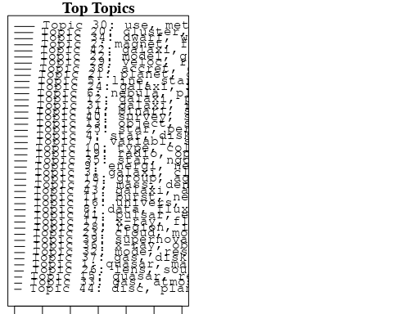

plotQuote(thoughts6, width = 30, main = "Topic 6")  
plotQuote(thoughts18, width = 30, main = "Topic 18")

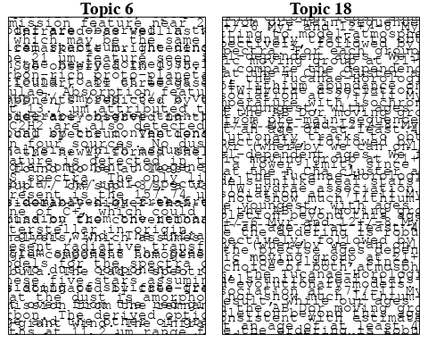

# Calculate and plot the correlation between topics  
mod.out.corr <- topicCorr(Research_topics)  
plot(mod.out.corr, cex = 1.5)  
  
  
# For each topic  
for (topic_num in 1:44) {  
 # Plot the word cloud  
 cloud(Research_topics, topic = topic_num, scale = c(2, 0.25))  
 Sys.sleep(2)  
}

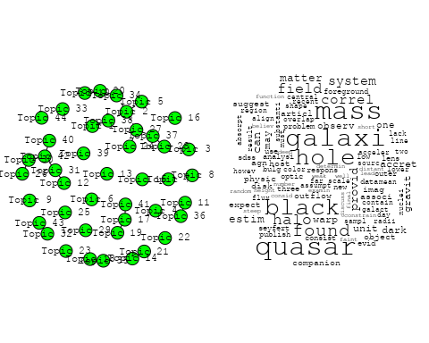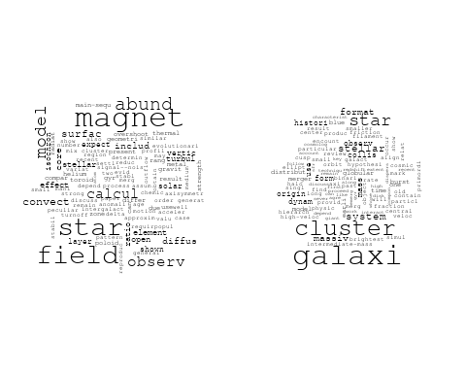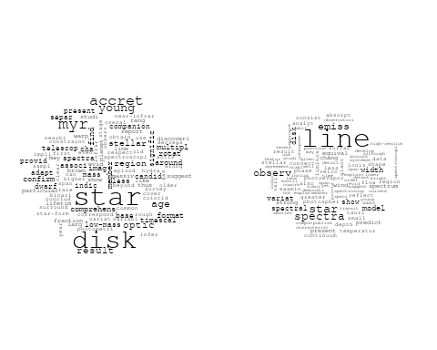

## Warning in wordcloud::wordcloud(words = vocab, freq = vec, max.words =  
## max.words, : star could not be fit on page. It will not be plotted.

## Warning in wordcloud::wordcloud(words = vocab, freq = vec, max.words =  
## max.words, : period could not be fit on page. It will not be plotted.

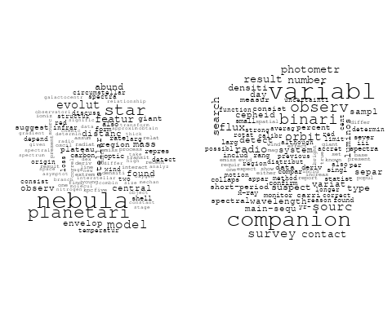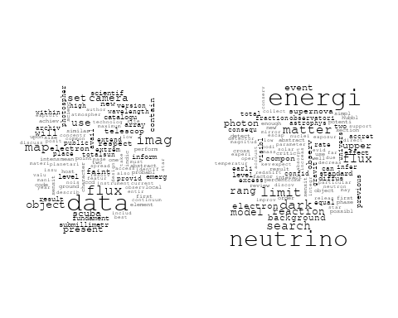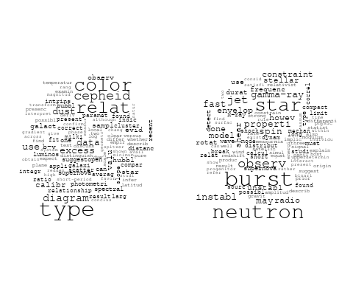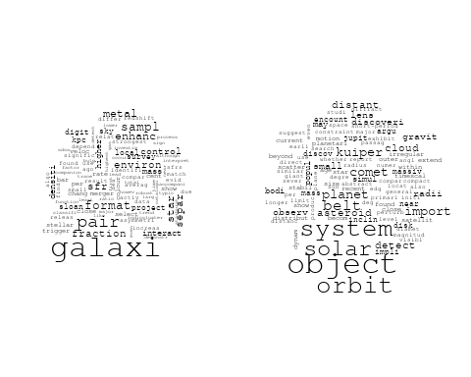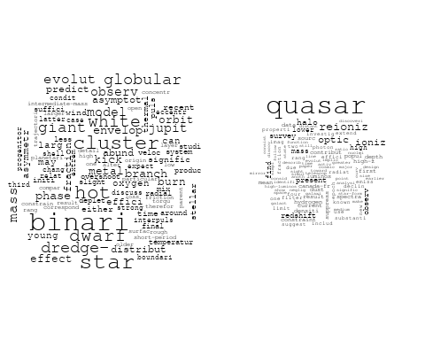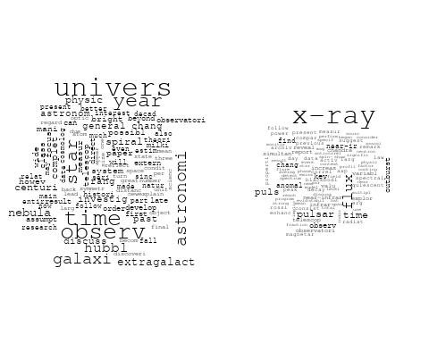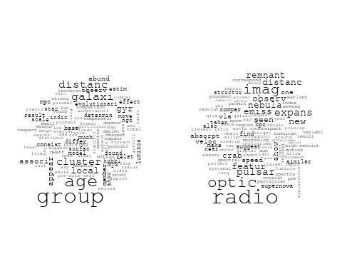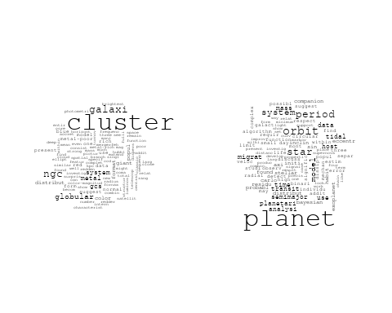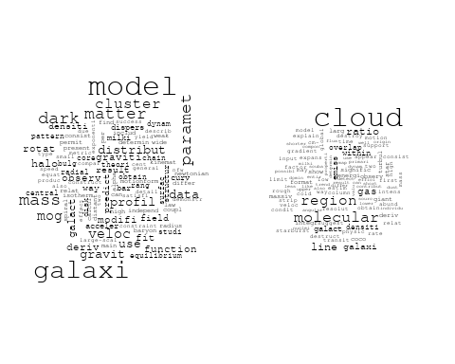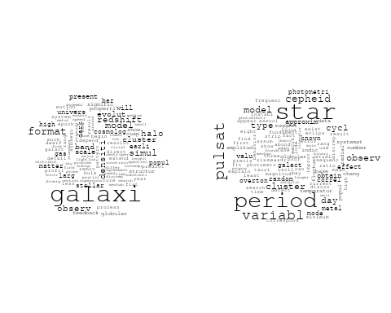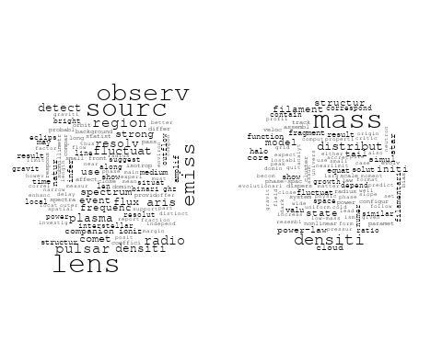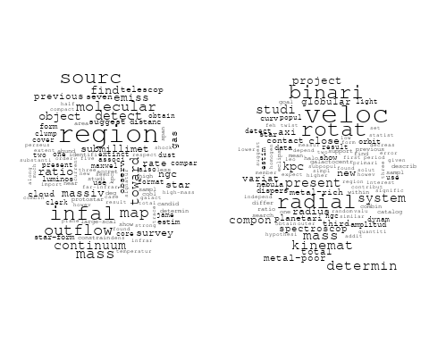

## Warning in wordcloud::wordcloud(words = vocab, freq = vec, max.words =  
## max.words, : paramet could not be fit on page. It will not be plotted.

## Warning in wordcloud::wordcloud(words = vocab, freq = vec, max.words =  
## max.words, : effect could not be fit on page. It will not be plotted.

## Warning in wordcloud::wordcloud(words = vocab, freq = vec, max.words =  
## max.words, : cosmic could not be fit on page. It will not be plotted.

## Warning in wordcloud::wordcloud(words = vocab, freq = vec, max.words =  
## max.words, : physic could not be fit on page. It will not be plotted.

## Warning in wordcloud::wordcloud(words = vocab, freq = vec, max.words =  
## max.words, : current could not be fit on page. It will not be plotted.

## Warning in wordcloud::wordcloud(words = vocab, freq = vec, max.words =  
## max.words, : describ could not be fit on page. It will not be plotted.

## Warning in wordcloud::wordcloud(words = vocab, freq = vec, max.words =  
## max.words, : statist could not be fit on page. It will not be plotted.

## Warning in wordcloud::wordcloud(words = vocab, freq = vec, max.words =  
## max.words, : calcul could not be fit on page. It will not be plotted.

## Warning in wordcloud::wordcloud(words = vocab, freq = vec, max.words =  
## max.words, : analysi could not be fit on page. It will not be plotted.

## Warning in wordcloud::wordcloud(words = vocab, freq = vec, max.words =  
## max.words, : comput could not be fit on page. It will not be plotted.

## Warning in wordcloud::wordcloud(words = vocab, freq = vec, max.words =  
## max.words, : limit could not be fit on page. It will not be plotted.

## Warning in wordcloud::wordcloud(words = vocab, freq = vec, max.words =  
## max.words, : investig could not be fit on page. It will not be plotted.

## Warning in wordcloud::wordcloud(words = vocab, freq = vec, max.words =  
## max.words, : survey could not be fit on page. It will not be plotted.

## Warning in wordcloud::wordcloud(words = vocab, freq = vec, max.words =  
## max.words, : requir could not be fit on page. It will not be plotted.

## Warning in wordcloud::wordcloud(words = vocab, freq = vec, max.words =  
## max.words, : varianc could not be fit on page. It will not be plotted.

## Warning in wordcloud::wordcloud(words = vocab, freq = vec, max.words =  
## max.words, : numer could not be fit on page. It will not be plotted.

## Warning in wordcloud::wordcloud(words = vocab, freq = vec, max.words =  
## max.words, : data could not be fit on page. It will not be plotted.

## Warning in wordcloud::wordcloud(words = vocab, freq = vec, max.words =  
## max.words, : also could not be fit on page. It will not be plotted.

## Warning in wordcloud::wordcloud(words = vocab, freq = vec, max.words =  
## max.words, : predict could not be fit on page. It will not be plotted.

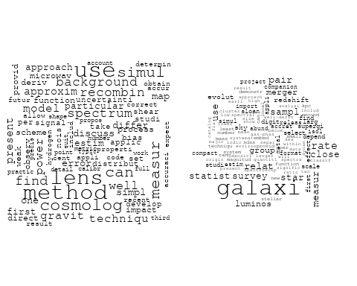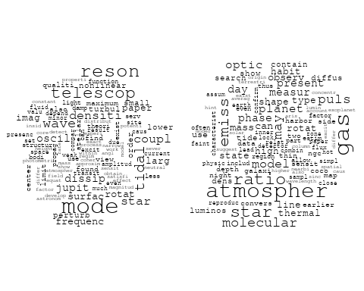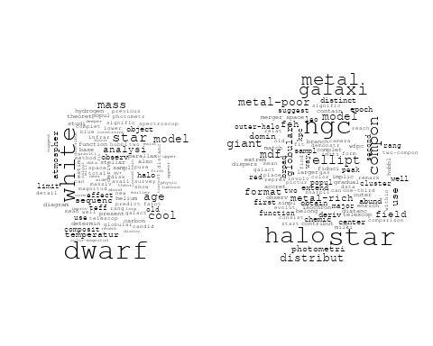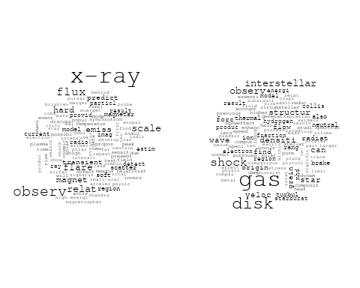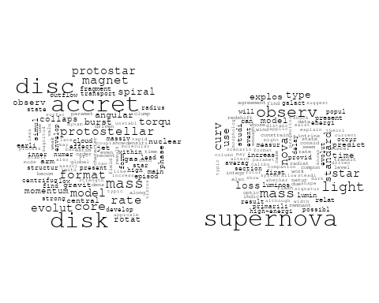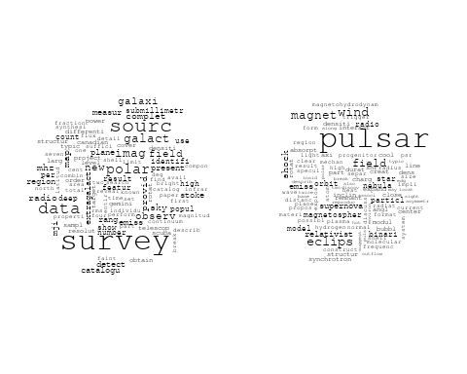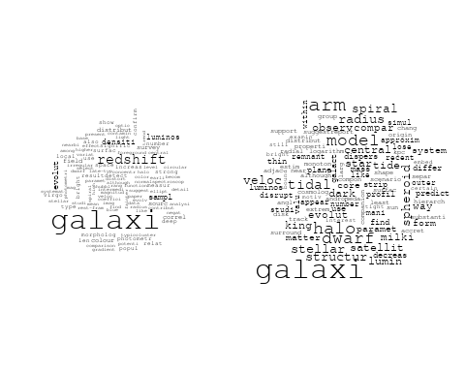

# Get the topic proportions for each document  
topic_proportions <- Research_topics$theta  
  
# Find the index of the topic with the highest proportion for each document  
# This will be the topic that each document is most likely to belong to  
max_topic_idx <- apply(topic_proportions, 1, which.max)  
  
# Add this as a new column to your data  
data_independent$topic <- max_topic_idx  
  
  
  
# Define the intervals  
intervals <- c('1824_1899', '1900_1964', '1965_1974', '1975_1984', '1985_1994', '1995_1999', '2000_2004', '2005_2009', '2010_2014', '2015_2019', '2020_2022')  
colors <- c('pink', 'blue', 'purple', 'yellow', 'green', 'pink', 'orange', 'violet', 'green', 'blue', 'pink')  
  
# Loop through the intervals and plot  
for(i in seq_along(intervals)){  
 # Filter data for when the pub_interval is equal to 1  
 data_filtered <- data_independent[data_independent[[paste0('pub_interval_', intervals[i])]] == 1,]  
   
 # Make the histogram  
   
 p <- ggplot(data_filtered, aes(x = topic)) +  
 geom_histogram(binwidth = 1, fill = colors[i], color = "black") +  
 xlab("Topic") +  
 ylab("Count") +  
 ggtitle(paste0("Topics from year ", gsub("_", " to ", intervals[i])))  
   
 print(p)  
}  
  
  
##Topic generation for JP (in collaboration) publications  
  
data_collab <- data[data[["JP"]] != 0,]  
  
# Save the original title data for future use  
data_collab$original_concatenated_title_abstract <- data_collab$concatenated_title_abstract  
  
#pre-processing the titles using textProcessor from the stm package  
processed_text <- textProcessor(data_collab$concatenated_title_abstract, metadata = data_collab)

## Building corpus...   
## Converting to Lower Case...   
## Removing punctuation...   
## Removing stopwords...   
## Removing numbers...   
## Stemming...   
## Creating Output...

# Further prepare the data by removing low-frequency terms  
out_text <- prepDocuments(processed_text$documents, processed_text$vocab, processed_text$meta)

## Removing 2300 of 8995 terms (2300 of 178949 tokens) due to frequency   
## Your corpus now has 2285 documents, 6695 terms and 176649 tokens.

docs_text <- out_text$documents  
vocab_text <- out_text$vocab  
meta_text <- out_text$meta  
  
  
#Prepare data  
plotRemoved(processed_text$documents, lower.thresh = seq(1, 200, by = 100))

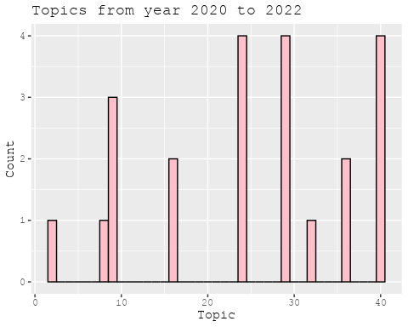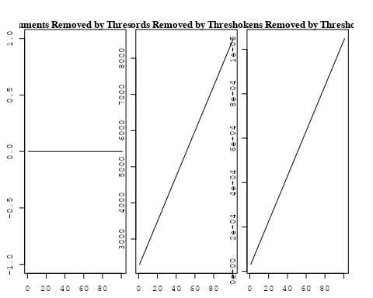

out_text <- prepDocuments(processed_text$documents, processed_text$vocab, processed_text$meta, lower.thresh = 8)

## Removing 6745 of 8995 terms (17145 of 178949 tokens) due to frequency   
## Your corpus now has 2285 documents, 2250 terms and 161804 tokens.

str(out_text$meta)

## 'data.frame': 2285 obs. of 39 variables:  
## $ concept_id : chr "https://openalex.org/C44870925" "https://openalex.org/C1276947" "https://openalex.org/C44870925" "https://openalex.org/C44870925" ...  
## $ work_id : chr "https://openalex.org/W3100494265" "https://openalex.org/W2153493790" "https://openalex.org/W2905780457" "https://openalex.org/W1993936459" ...  
## $ publication_year : int 2002 2011 2019 2006 1998 2009 1997 1998 2018 2016 ...  
## $ title : chr "Runaway Merging of Black Holes: Analytical Constraint on the Timescale" "Effects of the explosion asymmetry and viewing angle on the Type Ia supernova colour and luminosity calibration" "A warped disk around an infant protostar" "The escape fraction of ionizing photons from galaxies at z= 0–6" ...  
## $ paperabstract : chr "Following the discovery of a black hole (BH) with a mass of 103-106 M☉ in the starburst galaxy M82, we study th"| __truncated__ "Phenomenological relations exist between the peak luminosity and other observables of type Ia supernovae (SNe I"| __truncated__ "Recent exoplanet studies have revealed that the orbital planes of planets are not always aligned with one anoth"| __truncated__ "The escape fraction of ionizing photons from galaxies is a crucial quantity controlling the cosmic ionizing bac"| __truncated__ ...  
## $ country : chr "JP" "JP DE JP DE" "US JP JP US" "JP" ...  
## $ year_concept : chr "2002+https://openalex.org/C44870925" "2011+https://openalex.org/C1276947" "2019+https://openalex.org/C44870925" "2006+https://openalex.org/C44870925" ...  
## $ concatenated_title_abstract : chr "Runaway Merging of Black Holes: Analytical Constraint on the Timescale Following the discovery of a black hole "| __truncated__ "Effects of the explosion asymmetry and viewing angle on the Type Ia supernova colour and luminosity calibration"| __truncated__ "A warped disk around an infant protostar Recent exoplanet studies have revealed that the orbital planes of plan"| __truncated__ "The escape fraction of ionizing photons from galaxies at z= 0–6 The escape fraction of ionizing photons from ga"| __truncated__ ...  
## $ US : num 0 0 50 0 0 ...  
## $ IN : num 0 0 0 0 0 0 0 0 0 0 ...  
## $ DE : num 0 50 0 0 0 0 0 0 0 0 ...  
## $ CH : num 0 0 0 0 0 0 0 0 0 0 ...  
## $ GB : num 0 0 0 0 0 0 0 0 0 50 ...  
## $ CN : num 0 0 0 0 0 0 0 0 0 0 ...  
## $ FR : num 0 0 0 0 0 0 0 0 0 0 ...  
## $ IT : num 0 0 0 0 0 0 0 0 0 0 ...  
## $ RU : num 0 0 0 0 0 0 0 0 0 0 ...  
## $ CA : num 0 0 0 0 0 0 0 0 0 0 ...  
## $ NL : num 0 0 0 0 0 0 0 0 0 0 ...  
## $ AU : num 0 0 0 0 0 0 0 0 0 0 ...  
## $ JP : num 100 50 50 100 100 ...  
## $ ES : num 0 0 0 0 0 0 0 0 0 0 ...  
## $ IL : num 0 0 0 0 0 0 0 0 0 0 ...  
## $ Americas : num 0 0 0 0 0 0 0 0 0 0 ...  
## $ Europe : num 0 0 0 0 0 0 0 0 0 0 ...  
## $ Africa : num 0 0 0 0 0 0 0 0 0 0 ...  
## $ AsiaAndOceania : num 0 0 0 0 0 0 0 0 0 0 ...  
## $ pub_interval_2020_2022 : int 0 0 0 0 0 0 0 0 0 0 ...  
## $ pub_interval_2015_2019 : int 0 0 1 0 0 0 0 0 1 1 ...  
## $ pub_interval_2010_2014 : int 0 1 0 0 0 0 0 0 0 0 ...  
## $ pub_interval_2005_2009 : int 0 0 0 1 0 1 0 0 0 0 ...  
## $ pub_interval_2000_2004 : int 1 0 0 0 0 0 0 0 0 0 ...  
## $ pub_interval_1995_1999 : int 0 0 0 0 1 0 1 1 0 0 ...  
## $ pub_interval_1985_1994 : int 0 0 0 0 0 0 0 0 0 0 ...  
## $ pub_interval_1975_1984 : int 0 0 0 0 0 0 0 0 0 0 ...  
## $ pub_interval_1965_1974 : int 0 0 0 0 0 0 0 0 0 0 ...  
## $ pub_interval_1900_1964 : int 0 0 0 0 0 0 0 0 0 0 ...  
## $ pub_interval_1824_1899 : int 0 0 0 0 0 0 0 0 0 0 ...  
## $ original_concatenated_title_abstract: chr "Runaway Merging of Black Holes: Analytical Constraint on the Timescale Following the discovery of a black hole "| __truncated__ "Effects of the explosion asymmetry and viewing angle on the Type Ia supernova colour and luminosity calibration"| __truncated__ "A warped disk around an infant protostar Recent exoplanet studies have revealed that the orbital planes of plan"| __truncated__ "The escape fraction of ionizing photons from galaxies at z= 0–6 The escape fraction of ionizing photons from ga"| __truncated__ ...

# Initialize an empty formula string  
prevalence_formula_str <- "~"  
  
# Define the publication intervals  
pub_intervals <- c("pub_interval_2020_2022", "pub_interval_2015_2019", "pub_interval_2010_2014",   
 "pub_interval_2005_2009", "pub_interval_2000_2004", "pub_interval_1995_1999",  
 "pub_interval_1985_1994", "pub_interval_1975_1984", "pub_interval_1965_1974",  
 "pub_interval_1900_1964", "pub_interval_1824_1899")  
  
# Add each publication interval to the formula string  
for (interval in pub_intervals) {  
 # add an if statement to handle the first addition (without '+')  
 if (prevalence_formula_str == "~") {  
 prevalence_formula_str <- paste(prevalence_formula_str, interval)  
 } else {  
 prevalence_formula_str <- paste(prevalence_formula_str, "+", interval)  
 }  
}  
  
  
# Convert the string to a formula  
prevalence_formula <- as.formula(prevalence_formula_str)  
print(prevalence_formula)

## ~pub_interval_2020_2022 + pub_interval_2015_2019 + pub_interval_2010_2014 +   
## pub_interval_2005_2009 + pub_interval_2000_2004 + pub_interval_1995_1999 +   
## pub_interval_1985_1994 + pub_interval_1975_1984 + pub_interval_1965_1974 +   
## pub_interval_1900_1964 + pub_interval_1824_1899

# Run STM model  
Research_topics <- stm(documents = out_text$documents,   
 vocab = out_text$vocab,   
 K = 44,   
 prevalence = prevalence_formula,   
 data = out_text$meta,   
 init.type = "Spectral",  
 max.em.its = 1000,  
 gamma.prior = 'L1')

## Beginning Spectral Initialization   
## Calculating the gram matrix...  
## Finding anchor words...  
## ............................................  
## Recovering initialization...  
## ......................  
## Initialization complete.  
## .......................................................................................................  
## Completed E-Step (2 seconds).   
## Completed M-Step.   
## Completing Iteration 1 (approx. per word bound = -6.407)   
## .......................................................................................................  
## Completed E-Step (2 seconds).   
## Completed M-Step.   
## Completing Iteration 2 (approx. per word bound = -6.125, relative change = 4.407e-02)   
## .......................................................................................................  
## Completed E-Step (2 seconds).   
## Completed M-Step.   
## Completing Iteration 3 (approx. per word bound = -6.056, relative change = 1.124e-02)   
## .......................................................................................................  
## Completed E-Step (1 seconds).   
## Completed M-Step.   
## Completing Iteration 4 (approx. per word bound = -6.030, relative change = 4.231e-03)   
## .......................................................................................................  
## Completed E-Step (1 seconds).   
## Completed M-Step.   
## Completing Iteration 5 (approx. per word bound = -6.017, relative change = 2.138e-03)   
## Topic 1: dark, matter, cosmolog, model, halo   
## Topic 2: dwarf, radio, binari, star, companion   
## Topic 3: galaxi, format, gas, cluster, star   
## Topic 4: star, neutron, iii, binari, disc   
## Topic 5: univers, physic, astronomi, observ, first   
## Topic 6: x-ray, sourc, kev, emiss, observ   
## Topic 7: burst, supernova, neutrino, detect, explos   
## Topic 8: mass, wind, accret, dwarf, rate   
## Topic 9: maser, flow, coronagraph, two, time   
## Topic 10: lens, quasar, galaxi, imag, sdss   
## Topic 11: magnet, field, rotat, accret, jet   
## Topic 12: galaxi, emiss, region, gas, star-form   
## Topic 13: dust, grain, supernova, mass, shock   
## Topic 14: star, mode, frequenc, rotat, oscil   
## Topic 15: pulsar, observ, emiss, gamma-ray, spectrum   
## Topic 16: cluster, star, tidal, mass, massiv   
## Topic 17: relat, star, cluster, metal, period   
## Topic 18: planet, accret, mass, gas, giant   
## Topic 19: observ, data, use, galact, telescop   
## Topic 20: supernova, type, explos, sne, curv   
## Topic 21: cloud, star, format, core, molecular   
## Topic 22: galaxi, cluster, luminos, distribut, function   
## Topic 23: line, emiss, observ, region, veloc   
## Topic 24: galaxi, survey, redshift, deep, lyα   
## Topic 25: wave, gravit, event, observ, binari   
## Topic 26: flare, solar, energi, period, observ   
## Topic 27: function, local, effect, cosmolog, scale   
## Topic 28: remnant, supernova, deriv, abund, energi   
## Topic 29: galaxi, dust, continuum, ratio, model   
## Topic 30: hole, black, rotat, disk, collaps   
## Topic 31: disk, surfac, densiti, planetesim, protoplanetari   
## Topic 32: jet, disk, light, curv, grb   
## Topic 33: galaxi, matter, observ, background, dark   
## Topic 34: dust, star, grain, featur, format   
## Topic 35: star, abund, element, supernova, ratio   
## Topic 36: magnet, reconnect, flux, shock, observ   
## Topic 37: asteroid, magnitud, photometr, color, bodi   
## Topic 38: model, use, measur, observ, data   
## Topic 39: energi, ray, cosmic, neutrino, cosmic-ray   
## Topic 40: agn, disc, x-ray, accret, activ   
## Topic 41: star, stellar, object, popul, region   
## Topic 42: effect, halo, densiti, profil, dynam   
## Topic 43: electron, acceler, emiss, tev, shock   
## Topic 44: extinct, distanc, galact, law, toward   
## .......................................................................................................  
## Completed E-Step (1 seconds).   
## Completed M-Step.   
## Completing Iteration 6 (approx. per word bound = -6.010, relative change = 1.196e-03)   
## .......................................................................................................  
## Completed E-Step (1 seconds).   
## Completed M-Step.   
## Completing Iteration 7 (approx. per word bound = -6.005, relative change = 8.048e-04)   
## .......................................................................................................  
## Completed E-Step (1 seconds).   
## Completed M-Step.   
## Completing Iteration 8 (approx. per word bound = -6.002, relative change = 5.849e-04)   
## .......................................................................................................  
## Completed E-Step (1 seconds).   
## Completed M-Step.   
## Completing Iteration 9 (approx. per word bound = -5.999, relative change = 4.339e-04)   
## .......................................................................................................  
## Completed E-Step (1 seconds).   
## Completed M-Step.   
## Completing Iteration 10 (approx. per word bound = -5.997, relative change = 3.243e-04)   
## Topic 1: dark, matter, cosmolog, model, halo   
## Topic 2: binari, dwarf, radio, star, companion   
## Topic 3: galaxi, format, gas, cluster, star   
## Topic 4: star, neutron, disc, binari, iii   
## Topic 5: univers, physic, observ, first, astronomi   
## Topic 6: x-ray, sourc, kev, asca, emiss   
## Topic 7: burst, neutrino, supernova, detect, explos   
## Topic 8: mass, accret, dwarf, rate, wind   
## Topic 9: flow, maser, coronagraph, two, motion   
## Topic 10: lens, quasar, imag, sdss, len   
## Topic 11: magnet, field, rotat, jet, flow   
## Topic 12: region, galaxi, emiss, gas, ngc   
## Topic 13: dust, grain, mass, supernova, shock   
## Topic 14: star, mode, frequenc, rotat, oscil   
## Topic 15: pulsar, observ, emiss, gamma-ray, spectrum   
## Topic 16: cluster, star, tidal, model, mass   
## Topic 17: relat, star, cluster, metal, period   
## Topic 18: planet, accret, mass, gas, giant   
## Topic 19: observ, radio, data, use, measur   
## Topic 20: supernova, type, explos, sne, light   
## Topic 21: cloud, star, format, core, molecular   
## Topic 22: galaxi, cluster, luminos, distribut, function   
## Topic 23: line, emiss, observ, region, veloc   
## Topic 24: galaxi, survey, redshift, deep, cluster   
## Topic 25: wave, gravit, event, observ, microlens   
## Topic 26: flare, solar, energi, observ, period   
## Topic 27: function, cosmolog, effect, scale, cosmic   
## Topic 28: remnant, supernova, abund, deriv, interstellar   
## Topic 29: galaxi, dust, continuum, model, ratio   
## Topic 30: hole, black, rotat, accret, collaps   
## Topic 31: disk, surfac, densiti, protoplanetari, planetesim   
## Topic 32: jet, disk, light, curv, grb   
## Topic 33: galaxi, observ, matter, background, simul   
## Topic 34: star, dust, grain, featur, system   
## Topic 35: abund, star, element, supernova, ratio   
## Topic 36: reconnect, shock, flux, magnet, heat   
## Topic 37: asteroid, magnitud, photometr, bodi, color   
## Topic 38: model, use, observ, measur, data   
## Topic 39: ray, energi, cosmic, neutrino, proton   
## Topic 40: agn, activ, galaxi, seyfert, optic   
## Topic 41: star, object, stellar, sourc, popul   
## Topic 42: halo, effect, densiti, profil, dynam   
## Topic 43: electron, acceler, emiss, tev, shock   
## Topic 44: distanc, extinct, galact, law, determin   
## .......................................................................................................  
## Completed E-Step (1 seconds).   
## Completed M-Step.   
## Completing Iteration 11 (approx. per word bound = -5.996, relative change = 2.551e-04)   
## .......................................................................................................  
## Completed E-Step (1 seconds).   
## Completed M-Step.   
## Completing Iteration 12 (approx. per word bound = -5.994, relative change = 2.326e-04)   
## .......................................................................................................  
## Completed E-Step (1 seconds).   
## Completed M-Step.   
## Completing Iteration 13 (approx. per word bound = -5.993, relative change = 1.846e-04)   
## .......................................................................................................  
## Completed E-Step (1 seconds).   
## Completed M-Step.   
## Completing Iteration 14 (approx. per word bound = -5.992, relative change = 1.871e-04)   
## .......................................................................................................  
## Completed E-Step (1 seconds).   
## Completed M-Step.   
## Completing Iteration 15 (approx. per word bound = -5.991, relative change = 1.598e-04)   
## Topic 1: dark, matter, cosmolog, model, halo   
## Topic 2: radio, binari, star, dwarf, companion   
## Topic 3: galaxi, format, gas, cluster, star   
## Topic 4: star, disc, neutron, binari, state   
## Topic 5: univers, physic, year, observ, first   
## Topic 6: x-ray, sourc, kev, asca, emiss   
## Topic 7: burst, neutrino, supernova, detect, explos   
## Topic 8: mass, accret, dwarf, white, rate   
## Topic 9: flow, maser, coronagraph, two, motion   
## Topic 10: lens, quasar, imag, len, sdss   
## Topic 11: magnet, field, rotat, jet, outflow   
## Topic 12: region, galaxi, gas, emiss, ngc   
## Topic 13: dust, grain, mass, supernova, metal   
## Topic 14: star, mode, rotat, frequenc, oscil   
## Topic 15: pulsar, observ, emiss, spectrum, gamma-ray   
## Topic 16: cluster, star, tidal, model, mass   
## Topic 17: relat, star, cluster, period, metal   
## Topic 18: planet, accret, mass, gas, giant   
## Topic 19: observ, radio, measur, use, data   
## Topic 20: supernova, type, explos, sne, light   
## Topic 21: cloud, star, format, core, molecular   
## Topic 22: galaxi, cluster, distribut, luminos, function   
## Topic 23: line, emiss, observ, region, molecular   
## Topic 24: galaxi, survey, redshift, deep, cluster   
## Topic 25: wave, gravit, event, microlens, observ   
## Topic 26: flare, solar, energi, observ, period   
## Topic 27: function, cosmolog, effect, scale, cosmic   
## Topic 28: remnant, supernova, abund, deriv, interstellar   
## Topic 29: galaxi, dust, continuum, model, region   
## Topic 30: hole, black, rotat, accret, collaps   
## Topic 31: disk, accret, surfac, densiti, protoplanetari   
## Topic 32: jet, disk, light, curv, grb   
## Topic 33: galaxi, observ, simul, satellit, background   
## Topic 34: star, dust, grain, featur, system   
## Topic 35: star, abund, element, supernova, ratio   
## Topic 36: shock, reconnect, flux, magnet, heat   
## Topic 37: asteroid, magnitud, photometr, bodi, parent   
## Topic 38: model, use, observ, measur, data   
## Topic 39: ray, energi, cosmic, gamma-ray, proton   
## Topic 40: agn, galaxi, activ, emiss, seyfert   
## Topic 41: star, object, stellar, cluster, sourc   
## Topic 42: halo, densiti, effect, profil, dynam   
## Topic 43: electron, acceler, emiss, tev, shock   
## Topic 44: distanc, extinct, galact, law, determin   
## .......................................................................................................  
## Completed E-Step (1 seconds).   
## Completed M-Step.   
## Completing Iteration 16 (approx. per word bound = -5.990, relative change = 1.617e-04)   
## .......................................................................................................  
## Completed E-Step (1 seconds).   
## Completed M-Step.   
## Completing Iteration 17 (approx. per word bound = -5.989, relative change = 1.355e-04)   
## .......................................................................................................  
## Completed E-Step (1 seconds).   
## Completed M-Step.   
## Completing Iteration 18 (approx. per word bound = -5.989, relative change = 1.375e-04)   
## .......................................................................................................  
## Completed E-Step (1 seconds).   
## Completed M-Step.   
## Completing Iteration 19 (approx. per word bound = -5.988, relative change = 1.381e-04)   
## .......................................................................................................  
## Completed E-Step (1 seconds).   
## Completed M-Step.   
## Completing Iteration 20 (approx. per word bound = -5.987, relative change = 1.241e-04)   
## Topic 1: dark, matter, cosmolog, model, halo   
## Topic 2: radio, binari, star, companion, pulsar   
## Topic 3: galaxi, format, gas, cluster, star   
## Topic 4: star, disc, neutron, binari, state   
## Topic 5: univers, physic, year, observ, first   
## Topic 6: x-ray, sourc, kev, asca, observ   
## Topic 7: burst, neutrino, supernova, detect, explos   
## Topic 8: mass, dwarf, accret, white, rate   
## Topic 9: flow, maser, coronagraph, two, also   
## Topic 10: lens, quasar, imag, len, gravit   
## Topic 11: magnet, field, rotat, jet, outflow   
## Topic 12: region, galaxi, gas, emiss, ngc   
## Topic 13: dust, grain, mass, supernova, metal   
## Topic 14: star, mode, rotat, frequenc, oscil   
## Topic 15: pulsar, observ, emiss, spectrum, nebula   
## Topic 16: cluster, star, tidal, model, mass   
## Topic 17: relat, star, cluster, period, metal   
## Topic 18: planet, accret, mass, gas, giant   
## Topic 19: observ, radio, measur, use, solar   
## Topic 20: supernova, type, explos, sne, light   
## Topic 21: cloud, core, star, format, molecular   
## Topic 22: galaxi, cluster, distribut, luminos, function   
## Topic 23: line, emiss, observ, region, molecular   
## Topic 24: galaxi, survey, redshift, deep, cluster   
## Topic 25: wave, gravit, event, microlens, observ   
## Topic 26: flare, solar, energi, observ, time   
## Topic 27: function, cosmolog, effect, scale, cosmic   
## Topic 28: remnant, supernova, abund, interstellar, deriv   
## Topic 29: galaxi, dust, continuum, model, region   
## Topic 30: hole, black, rotat, accret, mass   
## Topic 31: disk, accret, surfac, inner, densiti   
## Topic 32: jet, disk, light, curv, model   
## Topic 33: galaxi, observ, simul, satellit, star   
## Topic 34: dust, star, grain, featur, system   
## Topic 35: star, abund, element, supernova, ratio   
## Topic 36: shock, reconnect, flux, wave, magnet   
## Topic 37: asteroid, magnitud, photometr, bodi, observ   
## Topic 38: model, use, observ, measur, data   
## Topic 39: ray, energi, cosmic, gamma-ray, proton   
## Topic 40: agn, galaxi, activ, emiss, luminos   
## Topic 41: star, object, stellar, cluster, young   
## Topic 42: halo, densiti, effect, profil, dynam   
## Topic 43: electron, acceler, emiss, tev, x-ray   
## Topic 44: distanc, galact, extinct, law, band   
## .......................................................................................................  
## Completed E-Step (1 seconds).   
## Completed M-Step.   
## Completing Iteration 21 (approx. per word bound = -5.986, relative change = 1.123e-04)   
## .......................................................................................................  
## Completed E-Step (1 seconds).   
## Completed M-Step.   
## Completing Iteration 22 (approx. per word bound = -5.986, relative change = 1.052e-04)   
## .......................................................................................................  
## Completed E-Step (1 seconds).   
## Completed M-Step.   
## Completing Iteration 23 (approx. per word bound = -5.985, relative change = 7.494e-05)   
## .......................................................................................................  
## Completed E-Step (1 seconds).   
## Completed M-Step.   
## Completing Iteration 24 (approx. per word bound = -5.985, relative change = 1.175e-04)   
## .......................................................................................................  
## Completed E-Step (1 seconds).   
## Completed M-Step.   
## Completing Iteration 25 (approx. per word bound = -5.984, relative change = 7.501e-05)   
## Topic 1: dark, matter, cosmolog, model, halo   
## Topic 2: radio, binari, star, companion, pulsar   
## Topic 3: galaxi, format, gas, cluster, star   
## Topic 4: star, disc, neutron, binari, state   
## Topic 5: univers, year, physic, observ, first   
## Topic 6: x-ray, sourc, kev, asca, observ   
## Topic 7: burst, neutrino, supernova, detect, explos   
## Topic 8: mass, dwarf, accret, white, rate   
## Topic 9: flow, maser, coronagraph, also, two   
## Topic 10: lens, quasar, imag, gravit, len   
## Topic 11: magnet, field, rotat, jet, outflow   
## Topic 12: region, galaxi, gas, emiss, ngc   
## Topic 13: dust, grain, mass, supernova, metal   
## Topic 14: star, mode, rotat, frequenc, instabl   
## Topic 15: pulsar, observ, emiss, spectrum, nebula   
## Topic 16: cluster, star, tidal, model, mass   
## Topic 17: relat, star, cluster, period, metal   
## Topic 18: planet, mass, accret, gas, giant   
## Topic 19: observ, radio, measur, use, solar   
## Topic 20: supernova, type, explos, sne, light   
## Topic 21: cloud, core, format, star, molecular   
## Topic 22: galaxi, cluster, distribut, luminos, function   
## Topic 23: line, emiss, observ, region, molecular   
## Topic 24: galaxi, survey, redshift, deep, cluster   
## Topic 25: wave, gravit, event, microlens, observ   
## Topic 26: flare, solar, observ, energi, time   
## Topic 27: function, cosmolog, effect, scale, cosmic   
## Topic 28: remnant, supernova, abund, iron, interstellar   
## Topic 29: galaxi, dust, continuum, model, region   
## Topic 30: hole, black, rotat, accret, supermass   
## Topic 31: disk, accret, inner, densiti, surfac   
## Topic 32: jet, disk, light, curv, model   
## Topic 33: galaxi, observ, simul, star, cosmic   
## Topic 34: dust, star, grain, featur, system   
## Topic 35: star, abund, element, supernova, ratio   
## Topic 36: shock, reconnect, flux, wave, magnet   
## Topic 37: asteroid, magnitud, photometr, bodi, observ   
## Topic 38: model, use, observ, measur, data   
## Topic 39: ray, energi, cosmic, gamma-ray, proton   
## Topic 40: agn, galaxi, activ, emiss, luminos   
## Topic 41: star, object, stellar, cluster, young   
## Topic 42: halo, densiti, effect, profil, dynam   
## Topic 43: electron, acceler, emiss, tev, x-ray   
## Topic 44: distanc, galact, band, extinct, variat   
## .......................................................................................................  
## Completed E-Step (1 seconds).   
## Completed M-Step.   
## Completing Iteration 26 (approx. per word bound = -5.984, relative change = 9.700e-05)   
## .......................................................................................................  
## Completed E-Step (1 seconds).   
## Completed M-Step.   
## Completing Iteration 27 (approx. per word bound = -5.983, relative change = 7.336e-05)   
## .......................................................................................................  
## Completed E-Step (1 seconds).   
## Completed M-Step.   
## Completing Iteration 28 (approx. per word bound = -5.983, relative change = 6.258e-05)   
## .......................................................................................................  
## Completed E-Step (1 seconds).   
## Completed M-Step.   
## Completing Iteration 29 (approx. per word bound = -5.982, relative change = 1.027e-04)   
## .......................................................................................................  
## Completed E-Step (1 seconds).   
## Completed M-Step.   
## Completing Iteration 30 (approx. per word bound = -5.982, relative change = 8.980e-05)   
## Topic 1: dark, matter, model, cosmolog, halo   
## Topic 2: radio, binari, star, companion, pulsar   
## Topic 3: galaxi, format, gas, star, cluster   
## Topic 4: star, disc, neutron, binari, state   
## Topic 5: univers, year, physic, observ, first   
## Topic 6: x-ray, sourc, kev, asca, observ   
## Topic 7: burst, neutrino, supernova, detect, explos   
## Topic 8: mass, dwarf, accret, white, rate   
## Topic 9: flow, maser, coronagraph, also, motion   
## Topic 10: lens, quasar, imag, gravit, len   
## Topic 11: magnet, field, rotat, jet, outflow   
## Topic 12: region, galaxi, gas, emiss, ngc   
## Topic 13: dust, grain, mass, supernova, format   
## Topic 14: star, mode, rotat, frequenc, instabl   
## Topic 15: pulsar, observ, emiss, spectrum, nebula   
## Topic 16: star, cluster, tidal, model, mass   
## Topic 17: relat, star, cluster, period, metal   
## Topic 18: planet, mass, accret, gas, giant   
## Topic 19: observ, measur, solar, radio, use   
## Topic 20: supernova, type, explos, sne, light   
## Topic 21: cloud, core, format, star, molecular   
## Topic 22: galaxi, cluster, distribut, luminos, mass   
## Topic 23: line, emiss, observ, region, molecular   
## Topic 24: galaxi, survey, redshift, deep, cluster   
## Topic 25: wave, gravit, event, microlens, observ   
## Topic 26: flare, solar, observ, energi, time   
## Topic 27: function, cosmolog, effect, scale, correl   
## Topic 28: remnant, supernova, abund, iron, interstellar   
## Topic 29: galaxi, dust, continuum, model, region   
## Topic 30: hole, black, rotat, accret, supermass   
## Topic 31: disk, accret, inner, densiti, surfac   
## Topic 32: jet, disk, light, curv, model   
## Topic 33: galaxi, observ, simul, star, cosmic   
## Topic 34: dust, star, grain, featur, system   
## Topic 35: star, abund, element, supernova, ratio   
## Topic 36: shock, reconnect, flux, wave, heat   
## Topic 37: asteroid, magnitud, photometr, bodi, observ   
## Topic 38: model, use, observ, measur, data   
## Topic 39: ray, energi, cosmic, gamma-ray, proton   
## Topic 40: agn, galaxi, activ, emiss, luminos   
## Topic 41: star, object, stellar, cluster, young   
## Topic 42: halo, densiti, effect, profil, dynam   
## Topic 43: electron, acceler, emiss, tev, synchrotron   
## Topic 44: distanc, variat, galact, band, extinct   
## .......................................................................................................  
## Completed E-Step (1 seconds).   
## Completed M-Step.   
## Completing Iteration 31 (approx. per word bound = -5.981, relative change = 7.750e-05)   
## .......................................................................................................  
## Completed E-Step (1 seconds).   
## Completed M-Step.   
## Completing Iteration 32 (approx. per word bound = -5.981, relative change = 7.051e-05)   
## .......................................................................................................  
## Completed E-Step (1 seconds).   
## Completed M-Step.   
## Completing Iteration 33 (approx. per word bound = -5.980, relative change = 6.687e-05)   
## .......................................................................................................  
## Completed E-Step (1 seconds).   
## Completed M-Step.   
## Completing Iteration 34 (approx. per word bound = -5.980, relative change = 5.640e-05)   
## .......................................................................................................  
## Completed E-Step (1 seconds).   
## Completed M-Step.   
## Completing Iteration 35 (approx. per word bound = -5.980, relative change = 5.400e-05)   
## Topic 1: dark, matter, model, cosmolog, halo   
## Topic 2: radio, binari, star, companion, pulsar   
## Topic 3: galaxi, format, gas, star, cluster   
## Topic 4: star, disc, neutron, binari, state   
## Topic 5: univers, physic, year, observ, first   
## Topic 6: x-ray, sourc, kev, asca, observ   
## Topic 7: burst, neutrino, supernova, detect, explos   
## Topic 8: mass, dwarf, white, accret, rate   
## Topic 9: flow, maser, coronagraph, also, motion   
## Topic 10: lens, quasar, gravit, imag, len   
## Topic 11: magnet, field, jet, rotat, outflow   
## Topic 12: region, galaxi, gas, emiss, ngc   
## Topic 13: dust, grain, mass, supernova, metal   
## Topic 14: star, mode, rotat, frequenc, instabl   
## Topic 15: pulsar, observ, emiss, nebula, spectrum   
## Topic 16: star, cluster, tidal, model, mass   
## Topic 17: relat, star, cluster, period, cepheid   
## Topic 18: planet, mass, accret, gas, giant   
## Topic 19: observ, solar, measur, use, radio   
## Topic 20: supernova, type, explos, sne, light   
## Topic 21: cloud, core, format, star, molecular   
## Topic 22: galaxi, cluster, distribut, luminos, mass   
## Topic 23: line, emiss, observ, molecular, region   
## Topic 24: galaxi, survey, redshift, deep, cluster   
## Topic 25: wave, gravit, event, microlens, observ   
## Topic 26: flare, solar, observ, energi, time   
## Topic 27: function, cosmolog, effect, scale, correl   
## Topic 28: remnant, supernova, abund, iron, interstellar   
## Topic 29: galaxi, dust, continuum, model, region   
## Topic 30: hole, black, rotat, accret, supermass   
## Topic 31: disk, accret, inner, densiti, protoplanetari   
## Topic 32: jet, disk, light, curv, model   
## Topic 33: galaxi, observ, simul, star, cosmic   
## Topic 34: dust, star, grain, featur, system   
## Topic 35: star, abund, element, supernova, ratio   
## Topic 36: shock, reconnect, flux, wave, heat   
## Topic 37: asteroid, magnitud, photometr, bodi, observ   
## Topic 38: model, use, observ, measur, data   
## Topic 39: ray, energi, cosmic, gamma-ray, detect   
## Topic 40: agn, galaxi, activ, emiss, luminos   
## Topic 41: star, object, stellar, cluster, young   
## Topic 42: halo, densiti, effect, dynam, profil   
## Topic 43: electron, acceler, emiss, tev, synchrotron   
## Topic 44: distanc, variat, galact, band, extinct   
## .......................................................................................................  
## Completed E-Step (1 seconds).   
## Completed M-Step.   
## Completing Iteration 36 (approx. per word bound = -5.979, relative change = 4.761e-05)   
## .......................................................................................................  
## Completed E-Step (1 seconds).   
## Completed M-Step.   
## Completing Iteration 37 (approx. per word bound = -5.979, relative change = 4.955e-05)   
## .......................................................................................................  
## Completed E-Step (1 seconds).   
## Completed M-Step.   
## Completing Iteration 38 (approx. per word bound = -5.979, relative change = 2.761e-05)   
## .......................................................................................................  
## Completed E-Step (1 seconds).   
## Completed M-Step.   
## Completing Iteration 39 (approx. per word bound = -5.979, relative change = 6.129e-05)   
## .......................................................................................................  
## Completed E-Step (1 seconds).   
## Completed M-Step.   
## Completing Iteration 40 (approx. per word bound = -5.978, relative change = 2.604e-05)   
## Topic 1: dark, matter, model, halo, cosmolog   
## Topic 2: radio, binari, star, companion, pulsar   
## Topic 3: galaxi, format, gas, star, cluster   
## Topic 4: star, disc, neutron, binari, state   
## Topic 5: univers, physic, observ, year, first   
## Topic 6: x-ray, sourc, kev, asca, observ   
## Topic 7: burst, neutrino, supernova, detect, explos   
## Topic 8: mass, dwarf, white, accret, rate   
## Topic 9: flow, maser, coronagraph, also, motion   
## Topic 10: lens, quasar, gravit, imag, len   
## Topic 11: magnet, field, jet, rotat, outflow   
## Topic 12: region, gas, galaxi, emiss, ngc   
## Topic 13: dust, grain, mass, supernova, growth   
## Topic 14: star, mode, rotat, frequenc, instabl   
## Topic 15: pulsar, observ, emiss, nebula, spectrum   
## Topic 16: star, cluster, tidal, model, mass   
## Topic 17: relat, star, cluster, period, cepheid   
## Topic 18: planet, mass, accret, gas, giant   
## Topic 19: observ, solar, measur, use, radio   
## Topic 20: supernova, type, explos, sne, light   
## Topic 21: cloud, core, star, format, molecular   
## Topic 22: galaxi, cluster, distribut, luminos, mass   
## Topic 23: line, emiss, observ, molecular, region   
## Topic 24: galaxi, survey, redshift, deep, cluster   
## Topic 25: wave, gravit, event, microlens, observ   
## Topic 26: flare, solar, observ, time, energi   
## Topic 27: function, cosmolog, effect, correl, scale   
## Topic 28: remnant, supernova, abund, iron, interstellar   
## Topic 29: galaxi, dust, continuum, model, region   
## Topic 30: hole, black, rotat, accret, supermass   
## Topic 31: disk, accret, inner, protoplanetari, densiti   
## Topic 32: jet, disk, light, curv, model   
## Topic 33: galaxi, observ, simul, cosmic, star   
## Topic 34: dust, star, grain, featur, system   
## Topic 35: star, abund, element, supernova, ratio   
## Topic 36: shock, reconnect, wave, flux, heat   
## Topic 37: asteroid, magnitud, photometr, bodi, observ   
## Topic 38: model, observ, use, measur, data   
## Topic 39: energi, ray, cosmic, gamma-ray, detect   
## Topic 40: agn, galaxi, activ, emiss, luminos   
## Topic 41: star, object, stellar, cluster, young   
## Topic 42: halo, densiti, effect, dynam, profil   
## Topic 43: electron, acceler, emiss, tev, synchrotron   
## Topic 44: distanc, variat, galact, band, relat   
## .......................................................................................................  
## Completed E-Step (1 seconds).   
## Completed M-Step.   
## Completing Iteration 41 (approx. per word bound = -5.978, relative change = 5.980e-05)   
## .......................................................................................................  
## Completed E-Step (1 seconds).   
## Completed M-Step.   
## Completing Iteration 42 (approx. per word bound = -5.978, relative change = 4.832e-05)   
## .......................................................................................................  
## Completed E-Step (1 seconds).   
## Completed M-Step.   
## Completing Iteration 43 (approx. per word bound = -5.977, relative change = 4.827e-05)   
## .......................................................................................................  
## Completed E-Step (1 seconds).   
## Completed M-Step.   
## Completing Iteration 44 (approx. per word bound = -5.977, relative change = 4.411e-05)   
## .......................................................................................................  
## Completed E-Step (1 seconds).   
## Completed M-Step.   
## Completing Iteration 45 (approx. per word bound = -5.977, relative change = 3.804e-05)   
## Topic 1: dark, matter, model, halo, cosmolog   
## Topic 2: radio, binari, star, companion, pulsar   
## Topic 3: galaxi, format, gas, star, cluster   
## Topic 4: star, disc, neutron, binari, state   
## Topic 5: univers, physic, observ, year, astronomi   
## Topic 6: x-ray, sourc, kev, asca, observ   
## Topic 7: burst, neutrino, supernova, detect, explos   
## Topic 8: mass, dwarf, white, accret, rate   
## Topic 9: flow, maser, coronagraph, also, motion   
## Topic 10: lens, quasar, gravit, imag, len   
## Topic 11: magnet, field, jet, rotat, outflow   
## Topic 12: region, gas, galaxi, emiss, ngc   
## Topic 13: dust, grain, mass, supernova, growth   
## Topic 14: star, mode, rotat, frequenc, instabl   
## Topic 15: pulsar, observ, emiss, nebula, spectrum   
## Topic 16: star, cluster, tidal, model, mass   
## Topic 17: relat, star, cluster, period, cepheid   
## Topic 18: planet, mass, accret, gas, giant   
## Topic 19: observ, solar, measur, use, radio   
## Topic 20: supernova, type, explos, sne, light   
## Topic 21: cloud, core, star, format, molecular   
## Topic 22: galaxi, cluster, distribut, luminos, mass   
## Topic 23: line, emiss, observ, molecular, region   
## Topic 24: galaxi, survey, redshift, deep, cluster   
## Topic 25: wave, gravit, event, microlens, observ   
## Topic 26: flare, solar, observ, time, energi   
## Topic 27: function, cosmolog, correl, effect, scale   
## Topic 28: remnant, supernova, abund, iron, interstellar   
## Topic 29: galaxi, dust, continuum, model, region   
## Topic 30: hole, black, rotat, accret, supermass   
## Topic 31: disk, accret, inner, protoplanetari, densiti   
## Topic 32: jet, disk, light, curv, model   
## Topic 33: galaxi, observ, simul, cosmic, star   
## Topic 34: dust, star, grain, featur, system   
## Topic 35: star, abund, element, supernova, ratio   
## Topic 36: shock, reconnect, wave, flux, heat   
## Topic 37: asteroid, magnitud, photometr, bodi, observ   
## Topic 38: model, observ, use, measur, data   
## Topic 39: energi, ray, cosmic, gamma-ray, detect   
## Topic 40: agn, galaxi, emiss, activ, seyfert   
## Topic 41: star, object, stellar, cluster, young   
## Topic 42: halo, densiti, effect, dynam, profil   
## Topic 43: electron, acceler, emiss, tev, x-ray   
## Topic 44: distanc, variat, galact, band, relat   
## .......................................................................................................  
## Completed E-Step (1 seconds).   
## Completed M-Step.   
## Completing Iteration 46 (approx. per word bound = -5.977, relative change = 3.474e-05)   
## .......................................................................................................  
## Completed E-Step (1 seconds).   
## Completed M-Step.   
## Completing Iteration 47 (approx. per word bound = -5.977, relative change = 4.235e-05)   
## .......................................................................................................  
## Completed E-Step (1 seconds).   
## Completed M-Step.   
## Completing Iteration 48 (approx. per word bound = -5.976, relative change = 3.973e-05)   
## .......................................................................................................  
## Completed E-Step (1 seconds).   
## Completed M-Step.   
## Completing Iteration 49 (approx. per word bound = -5.976, relative change = 3.252e-05)   
## .......................................................................................................  
## Completed E-Step (1 seconds).   
## Completed M-Step.   
## Completing Iteration 50 (approx. per word bound = -5.976, relative change = 3.105e-05)   
## Topic 1: dark, matter, model, halo, cosmolog   
## Topic 2: radio, binari, star, companion, pulsar   
## Topic 3: galaxi, format, star, gas, cluster   
## Topic 4: star, disc, neutron, binari, state   
## Topic 5: univers, physic, observ, year, astronomi   
## Topic 6: x-ray, sourc, kev, asca, observ   
## Topic 7: burst, neutrino, supernova, detect, explos   
## Topic 8: mass, dwarf, white, accret, rate   
## Topic 9: flow, maser, coronagraph, also, motion   
## Topic 10: lens, quasar, gravit, imag, len   
## Topic 11: magnet, field, jet, rotat, outflow   
## Topic 12: region, gas, galaxi, emiss, ngc   
## Topic 13: dust, grain, mass, supernova, growth   
## Topic 14: star, mode, rotat, frequenc, instabl   
## Topic 15: pulsar, observ, emiss, nebula, spectrum   
## Topic 16: star, cluster, model, tidal, mass   
## Topic 17: relat, star, cluster, period, cepheid   
## Topic 18: planet, mass, accret, gas, giant   
## Topic 19: observ, solar, measur, use, radio   
## Topic 20: supernova, type, explos, sne, light   
## Topic 21: cloud, core, star, format, molecular   
## Topic 22: galaxi, cluster, distribut, luminos, mass   
## Topic 23: line, emiss, observ, molecular, cloud   
## Topic 24: galaxi, survey, redshift, deep, cluster   
## Topic 25: wave, gravit, event, microlens, observ   
## Topic 26: flare, solar, observ, time, energi   
## Topic 27: function, cosmolog, correl, effect, scale   
## Topic 28: remnant, supernova, abund, iron, interstellar   
## Topic 29: galaxi, dust, continuum, model, region   
## Topic 30: hole, black, rotat, accret, supermass   
## Topic 31: disk, accret, protoplanetari, densiti, inner   
## Topic 32: jet, disk, light, curv, model   
## Topic 33: galaxi, observ, simul, cosmic, star   
## Topic 34: dust, star, featur, grain, system   
## Topic 35: star, abund, element, supernova, ratio   
## Topic 36: shock, reconnect, wave, flux, heat   
## Topic 37: asteroid, magnitud, photometr, bodi, observ   
## Topic 38: model, observ, use, measur, data   
## Topic 39: energi, ray, cosmic, gamma-ray, detect   
## Topic 40: agn, galaxi, emiss, activ, seyfert   
## Topic 41: star, object, stellar, cluster, young   
## Topic 42: halo, densiti, dynam, profil, effect   
## Topic 43: electron, acceler, emiss, tev, x-ray   
## Topic 44: distanc, variat, band, galact, relat   
## .......................................................................................................  
## Completed E-Step (1 seconds).   
## Completed M-Step.   
## Completing Iteration 51 (approx. per word bound = -5.976, relative change = 2.913e-05)   
## .......................................................................................................  
## Completed E-Step (1 seconds).   
## Completed M-Step.   
## Completing Iteration 52 (approx. per word bound = -5.976, relative change = 2.671e-05)   
## .......................................................................................................  
## Completed E-Step (1 seconds).   
## Completed M-Step.   
## Completing Iteration 53 (approx. per word bound = -5.975, relative change = 3.068e-05)   
## .......................................................................................................  
## Completed E-Step (1 seconds).   
## Completed M-Step.   
## Completing Iteration 54 (approx. per word bound = -5.975, relative change = 3.032e-05)   
## .......................................................................................................  
## Completed E-Step (1 seconds).   
## Completed M-Step.   
## Completing Iteration 55 (approx. per word bound = -5.975, relative change = 2.931e-05)   
## Topic 1: dark, matter, model, halo, cosmolog   
## Topic 2: radio, binari, star, companion, pulsar   
## Topic 3: galaxi, format, star, gas, cluster   
## Topic 4: star, disc, neutron, binari, state   
## Topic 5: univers, physic, observ, year, astronomi   
## Topic 6: x-ray, sourc, kev, observ, asca   
## Topic 7: burst, neutrino, supernova, detect, explos   
## Topic 8: mass, dwarf, white, accret, rate   
## Topic 9: flow, maser, coronagraph, also, two   
## Topic 10: lens, quasar, gravit, imag, len   
## Topic 11: magnet, field, jet, rotat, outflow   
## Topic 12: region, gas, galaxi, emiss, ngc   
## Topic 13: dust, grain, mass, supernova, growth   
## Topic 14: star, mode, rotat, frequenc, instabl   
## Topic 15: pulsar, observ, emiss, nebula, spectrum   
## Topic 16: star, cluster, model, tidal, mass   
## Topic 17: relat, star, cluster, period, cepheid   
## Topic 18: planet, mass, accret, gas, giant   
## Topic 19: observ, solar, measur, use, radio   
## Topic 20: supernova, type, explos, sne, light   
## Topic 21: cloud, core, star, format, molecular   
## Topic 22: galaxi, cluster, distribut, luminos, mass   
## Topic 23: line, emiss, observ, molecular, cloud   
## Topic 24: galaxi, survey, redshift, deep, cluster   
## Topic 25: wave, gravit, event, microlens, observ   
## Topic 26: flare, solar, observ, time, energi   
## Topic 27: function, cosmolog, correl, effect, scale   
## Topic 28: remnant, abund, supernova, iron, interstellar   
## Topic 29: galaxi, dust, continuum, model, region   
## Topic 30: hole, black, rotat, accret, supermass   
## Topic 31: disk, accret, protoplanetari, densiti, inner   
## Topic 32: jet, disk, light, curv, model   
## Topic 33: galaxi, observ, simul, cosmic, star   
## Topic 34: dust, star, featur, grain, system   
## Topic 35: star, abund, element, supernova, ratio   
## Topic 36: shock, wave, reconnect, flux, heat   
## Topic 37: asteroid, magnitud, photometr, bodi, observ   
## Topic 38: model, observ, use, measur, data   
## Topic 39: energi, ray, cosmic, gamma-ray, detect   
## Topic 40: agn, galaxi, emiss, activ, seyfert   
## Topic 41: star, object, stellar, cluster, young   
## Topic 42: halo, densiti, profil, dynam, effect   
## Topic 43: electron, acceler, emiss, tev, synchrotron   
## Topic 44: variat, distanc, band, galact, relat   
## .......................................................................................................  
## Completed E-Step (1 seconds).   
## Completed M-Step.   
## Completing Iteration 56 (approx. per word bound = -5.975, relative change = 2.637e-05)   
## .......................................................................................................  
## Completed E-Step (1 seconds).   
## Completed M-Step.   
## Completing Iteration 57 (approx. per word bound = -5.975, relative change = 2.486e-05)   
## .......................................................................................................  
## Completed E-Step (1 seconds).   
## Completed M-Step.   
## Completing Iteration 58 (approx. per word bound = -5.975, relative change = 2.602e-05)   
## .......................................................................................................  
## Completed E-Step (1 seconds).   
## Completed M-Step.   
## Completing Iteration 59 (approx. per word bound = -5.974, relative change = 3.128e-05)   
## .......................................................................................................  
## Completed E-Step (1 seconds).   
## Completed M-Step.   
## Completing Iteration 60 (approx. per word bound = -5.974, relative change = 3.175e-05)   
## Topic 1: dark, matter, model, halo, cosmolog   
## Topic 2: radio, binari, star, companion, pulsar   
## Topic 3: galaxi, format, star, cluster, gas   
## Topic 4: star, disc, neutron, binari, state   
## Topic 5: univers, observ, physic, year, astronomi   
## Topic 6: x-ray, sourc, kev, observ, asca   
## Topic 7: burst, neutrino, supernova, detect, explos   
## Topic 8: mass, dwarf, white, accret, wind   
## Topic 9: flow, maser, coronagraph, also, two   
## Topic 10: lens, quasar, gravit, imag, len   
## Topic 11: magnet, field, jet, rotat, outflow   
## Topic 12: region, gas, galaxi, emiss, ngc   
## Topic 13: dust, grain, mass, supernova, growth   
## Topic 14: star, mode, rotat, frequenc, instabl   
## Topic 15: pulsar, observ, emiss, nebula, spectrum   
## Topic 16: star, cluster, model, tidal, mass   
## Topic 17: relat, star, cluster, period, cepheid   
## Topic 18: planet, mass, accret, gas, giant   
## Topic 19: observ, solar, measur, use, radio   
## Topic 20: supernova, type, explos, sne, light   
## Topic 21: cloud, core, star, format, molecular   
## Topic 22: galaxi, cluster, distribut, luminos, mass   
## Topic 23: line, emiss, observ, molecular, cloud   
## Topic 24: galaxi, survey, redshift, deep, cluster   
## Topic 25: wave, gravit, event, microlens, observ   
## Topic 26: flare, solar, observ, time, energi   
## Topic 27: function, cosmolog, correl, effect, scale   
## Topic 28: remnant, abund, supernova, iron, interstellar   
## Topic 29: galaxi, dust, continuum, model, region   
## Topic 30: hole, black, rotat, accret, supermass   
## Topic 31: disk, accret, protoplanetari, densiti, inner   
## Topic 32: jet, disk, light, curv, model   
## Topic 33: galaxi, observ, simul, cosmic, star   
## Topic 34: dust, star, featur, grain, system   
## Topic 35: star, abund, element, supernova, ratio   
## Topic 36: shock, wave, reconnect, flux, heat   
## Topic 37: asteroid, magnitud, photometr, bodi, observ   
## Topic 38: model, observ, use, measur, data   
## Topic 39: energi, ray, cosmic, gamma-ray, detect   
## Topic 40: agn, galaxi, emiss, activ, seyfert   
## Topic 41: star, object, stellar, cluster, young   
## Topic 42: halo, densiti, profil, dynam, effect   
## Topic 43: electron, acceler, emiss, tev, synchrotron   
## Topic 44: variat, distanc, band, galact, relat   
## .......................................................................................................  
## Completed E-Step (1 seconds).   
## Completed M-Step.   
## Completing Iteration 61 (approx. per word bound = -5.974, relative change = 2.990e-05)   
## .......................................................................................................  
## Completed E-Step (1 seconds).   
## Completed M-Step.   
## Completing Iteration 62 (approx. per word bound = -5.974, relative change = 2.921e-05)   
## .......................................................................................................  
## Completed E-Step (1 seconds).   
## Completed M-Step.   
## Completing Iteration 63 (approx. per word bound = -5.974, relative change = 3.360e-05)   
## .......................................................................................................  
## Completed E-Step (1 seconds).   
## Completed M-Step.   
## Completing Iteration 64 (approx. per word bound = -5.973, relative change = 2.835e-05)   
## .......................................................................................................  
## Completed E-Step (1 seconds).   
## Completed M-Step.   
## Completing Iteration 65 (approx. per word bound = -5.973, relative change = 2.668e-05)   
## Topic 1: dark, matter, model, halo, cosmolog   
## Topic 2: radio, binari, companion, star, pulsar   
## Topic 3: galaxi, format, star, cluster, gas   
## Topic 4: star, disc, neutron, binari, state   
## Topic 5: univers, observ, physic, year, astronomi   
## Topic 6: x-ray, sourc, kev, observ, asca   
## Topic 7: burst, neutrino, supernova, detect, explos   
## Topic 8: mass, dwarf, white, accret, wind   
## Topic 9: flow, maser, coronagraph, also, two   
## Topic 10: lens, quasar, gravit, imag, len   
## Topic 11: magnet, field, jet, rotat, outflow   
## Topic 12: region, gas, galaxi, emiss, ngc   
## Topic 13: dust, grain, mass, supernova, growth   
## Topic 14: star, mode, rotat, frequenc, instabl   
## Topic 15: pulsar, observ, emiss, nebula, spectrum   
## Topic 16: star, cluster, model, tidal, mass   
## Topic 17: relat, star, cluster, period, cepheid   
## Topic 18: planet, mass, accret, gas, giant   
## Topic 19: observ, solar, measur, use, radio   
## Topic 20: supernova, type, explos, sne, light   
## Topic 21: cloud, core, star, format, molecular   
## Topic 22: galaxi, cluster, distribut, luminos, mass   
## Topic 23: line, emiss, observ, molecular, cloud   
## Topic 24: galaxi, survey, redshift, deep, cluster   
## Topic 25: wave, gravit, event, microlens, observ   
## Topic 26: flare, solar, observ, time, energi   
## Topic 27: function, cosmolog, correl, effect, scale   
## Topic 28: remnant, abund, supernova, iron, interstellar   
## Topic 29: galaxi, dust, continuum, model, lyman   
## Topic 30: hole, black, rotat, accret, supermass   
## Topic 31: disk, accret, protoplanetari, densiti, inner   
## Topic 32: jet, disk, light, curv, model   
## Topic 33: galaxi, observ, simul, cosmic, star   
## Topic 34: dust, star, featur, grain, system   
## Topic 35: star, abund, element, supernova, ratio   
## Topic 36: shock, wave, reconnect, flux, heat   
## Topic 37: asteroid, magnitud, photometr, bodi, observ   
## Topic 38: model, observ, use, measur, data   
## Topic 39: energi, ray, cosmic, gamma-ray, detect   
## Topic 40: agn, galaxi, emiss, activ, seyfert   
## Topic 41: star, object, stellar, cluster, young   
## Topic 42: halo, densiti, dynam, profil, simul   
## Topic 43: electron, acceler, emiss, tev, synchrotron   
## Topic 44: variat, distanc, relat, band, galact   
## .......................................................................................................  
## Completed E-Step (1 seconds).   
## Completed M-Step.   
## Completing Iteration 66 (approx. per word bound = -5.973, relative change = 2.324e-05)   
## .......................................................................................................  
## Completed E-Step (1 seconds).   
## Completed M-Step.   
## Completing Iteration 67 (approx. per word bound = -5.973, relative change = 1.964e-05)   
## .......................................................................................................  
## Completed E-Step (1 seconds).   
## Completed M-Step.   
## Completing Iteration 68 (approx. per word bound = -5.973, relative change = 1.861e-05)   
## .......................................................................................................  
## Completed E-Step (1 seconds).   
## Completed M-Step.   
## Completing Iteration 69 (approx. per word bound = -5.973, relative change = 2.040e-05)   
## .......................................................................................................  
## Completed E-Step (1 seconds).   
## Completed M-Step.   
## Completing Iteration 70 (approx. per word bound = -5.973, relative change = 2.591e-05)   
## Topic 1: dark, matter, model, halo, cosmolog   
## Topic 2: radio, binari, companion, star, pulsar   
## Topic 3: galaxi, format, star, cluster, gas   
## Topic 4: star, disc, neutron, binari, state   
## Topic 5: univers, observ, physic, year, astronomi   
## Topic 6: x-ray, sourc, kev, observ, asca   
## Topic 7: burst, neutrino, supernova, detect, explos   
## Topic 8: mass, dwarf, white, accret, wind   
## Topic 9: flow, maser, coronagraph, also, solut   
## Topic 10: lens, quasar, gravit, imag, len   
## Topic 11: magnet, field, jet, rotat, outflow   
## Topic 12: region, gas, galaxi, emiss, ngc   
## Topic 13: dust, grain, mass, supernova, growth   
## Topic 14: star, mode, rotat, frequenc, instabl   
## Topic 15: pulsar, observ, emiss, nebula, spectrum   
## Topic 16: star, cluster, model, tidal, mass   
## Topic 17: relat, star, cluster, period, cepheid   
## Topic 18: planet, mass, accret, gas, giant   
## Topic 19: observ, solar, measur, use, radio   
## Topic 20: supernova, type, explos, sne, light   
## Topic 21: cloud, core, star, format, molecular   
## Topic 22: galaxi, cluster, distribut, luminos, mass   
## Topic 23: line, emiss, observ, molecular, cloud   
## Topic 24: galaxi, survey, redshift, deep, cluster   
## Topic 25: wave, gravit, event, microlens, observ   
## Topic 26: flare, solar, observ, time, energi   
## Topic 27: function, cosmolog, correl, effect, scale   
## Topic 28: remnant, abund, supernova, iron, interstellar   
## Topic 29: galaxi, dust, continuum, lyman, region   
## Topic 30: hole, black, rotat, accret, supermass   
## Topic 31: disk, accret, protoplanetari, densiti, inner   
## Topic 32: jet, disk, light, curv, optic   
## Topic 33: galaxi, observ, simul, cosmic, star   
## Topic 34: dust, star, featur, grain, system   
## Topic 35: star, abund, element, supernova, ratio   
## Topic 36: shock, wave, reconnect, flux, heat   
## Topic 37: asteroid, magnitud, photometr, bodi, observ   
## Topic 38: model, observ, use, measur, data   
## Topic 39: energi, ray, cosmic, gamma-ray, detect   
## Topic 40: agn, galaxi, emiss, activ, seyfert   
## Topic 41: star, object, cluster, stellar, young   
## Topic 42: halo, densiti, dynam, profil, simul   
## Topic 43: electron, acceler, emiss, tev, synchrotron   
## Topic 44: variat, distanc, relat, band, region   
## .......................................................................................................  
## Completed E-Step (1 seconds).   
## Completed M-Step.   
## Completing Iteration 71 (approx. per word bound = -5.973, relative change = 2.997e-05)   
## .......................................................................................................  
## Completed E-Step (1 seconds).   
## Completed M-Step.   
## Completing Iteration 72 (approx. per word bound = -5.972, relative change = 2.189e-05)   
## .......................................................................................................  
## Completed E-Step (1 seconds).   
## Completed M-Step.   
## Completing Iteration 73 (approx. per word bound = -5.972, relative change = 2.199e-05)   
## .......................................................................................................  
## Completed E-Step (1 seconds).   
## Completed M-Step.   
## Completing Iteration 74 (approx. per word bound = -5.972, relative change = 2.056e-05)   
## .......................................................................................................  
## Completed E-Step (1 seconds).   
## Completed M-Step.   
## Completing Iteration 75 (approx. per word bound = -5.972, relative change = 1.713e-05)   
## Topic 1: dark, matter, model, halo, cosmolog   
## Topic 2: radio, binari, companion, pulsar, star   
## Topic 3: galaxi, format, star, cluster, gas   
## Topic 4: star, disc, neutron, binari, state   
## Topic 5: univers, observ, physic, year, astronomi   
## Topic 6: x-ray, sourc, kev, observ, asca   
## Topic 7: burst, neutrino, supernova, detect, explos   
## Topic 8: dwarf, mass, white, accret, wind   
## Topic 9: flow, maser, coronagraph, also, solut   
## Topic 10: lens, quasar, gravit, imag, len   
## Topic 11: magnet, field, jet, rotat, outflow   
## Topic 12: region, gas, galaxi, emiss, ngc   
## Topic 13: dust, grain, mass, supernova, growth   
## Topic 14: star, mode, rotat, frequenc, instabl   
## Topic 15: pulsar, observ, emiss, nebula, spectrum   
## Topic 16: star, cluster, model, tidal, mass   
## Topic 17: relat, star, cluster, period, variabl   
## Topic 18: planet, mass, accret, gas, giant   
## Topic 19: observ, solar, measur, use, radio   
## Topic 20: supernova, type, explos, sne, light   
## Topic 21: cloud, core, star, format, molecular   
## Topic 22: galaxi, cluster, distribut, luminos, mass   
## Topic 23: line, emiss, observ, molecular, cloud   
## Topic 24: galaxi, survey, redshift, deep, cluster   
## Topic 25: wave, gravit, event, microlens, observ   
## Topic 26: flare, solar, observ, time, energi   
## Topic 27: function, cosmolog, correl, effect, scale   
## Topic 28: remnant, abund, supernova, iron, interstellar   
## Topic 29: galaxi, dust, continuum, lyman, region   
## Topic 30: hole, black, rotat, accret, mass   
## Topic 31: disk, accret, densiti, protoplanetari, inner   
## Topic 32: jet, disk, light, curv, optic   
## Topic 33: galaxi, observ, simul, cosmic, star   
## Topic 34: dust, star, featur, grain, system   
## Topic 35: star, abund, element, supernova, ratio   
## Topic 36: shock, wave, reconnect, flux, heat   
## Topic 37: asteroid, magnitud, photometr, bodi, observ   
## Topic 38: model, observ, use, measur, data   
## Topic 39: energi, ray, cosmic, gamma-ray, detect   
## Topic 40: agn, galaxi, emiss, activ, seyfert   
## Topic 41: star, object, cluster, stellar, young   
## Topic 42: halo, densiti, dynam, profil, simul   
## Topic 43: electron, acceler, emiss, tev, synchrotron   
## Topic 44: variat, distanc, relat, region, band   
## .......................................................................................................  
## Completed E-Step (1 seconds).   
## Completed M-Step.   
## Completing Iteration 76 (approx. per word bound = -5.972, relative change = 2.003e-05)   
## .......................................................................................................  
## Completed E-Step (1 seconds).   
## Completed M-Step.   
## Completing Iteration 77 (approx. per word bound = -5.972, relative change = 1.867e-05)   
## .......................................................................................................  
## Completed E-Step (1 seconds).   
## Completed M-Step.   
## Completing Iteration 78 (approx. per word bound = -5.972, relative change = 1.757e-05)   
## .......................................................................................................  
## Completed E-Step (1 seconds).   
## Completed M-Step.   
## Completing Iteration 79 (approx. per word bound = -5.972, relative change = 1.695e-05)   
## .......................................................................................................  
## Completed E-Step (1 seconds).   
## Completed M-Step.   
## Completing Iteration 80 (approx. per word bound = -5.971, relative change = 1.855e-05)   
## Topic 1: dark, matter, model, halo, cosmolog   
## Topic 2: radio, binari, companion, pulsar, star   
## Topic 3: galaxi, format, star, cluster, gas   
## Topic 4: star, disc, neutron, binari, state   
## Topic 5: univers, observ, physic, year, astronomi   
## Topic 6: x-ray, sourc, kev, observ, asca   
## Topic 7: burst, neutrino, supernova, detect, explos   
## Topic 8: dwarf, mass, white, accret, wind   
## Topic 9: flow, maser, coronagraph, solut, also   
## Topic 10: lens, quasar, gravit, imag, len   
## Topic 11: magnet, field, jet, rotat, outflow   
## Topic 12: gas, region, galaxi, emiss, ngc   
## Topic 13: dust, grain, mass, supernova, growth   
## Topic 14: star, mode, rotat, frequenc, instabl   
## Topic 15: pulsar, observ, emiss, nebula, spectrum   
## Topic 16: star, cluster, model, tidal, mass   
## Topic 17: relat, star, cluster, period, variabl   
## Topic 18: planet, mass, accret, gas, giant   
## Topic 19: observ, solar, measur, use, radio   
## Topic 20: supernova, type, explos, sne, light   
## Topic 21: cloud, core, star, format, molecular   
## Topic 22: galaxi, cluster, distribut, luminos, mass   
## Topic 23: line, emiss, observ, molecular, cloud   
## Topic 24: galaxi, survey, redshift, deep, cluster   
## Topic 25: wave, gravit, event, microlens, observ   
## Topic 26: flare, solar, observ, time, energi   
## Topic 27: function, cosmolog, correl, effect, scale   
## Topic 28: remnant, abund, supernova, iron, interstellar   
## Topic 29: galaxi, dust, continuum, lyman, rate   
## Topic 30: hole, black, rotat, accret, mass   
## Topic 31: disk, accret, densiti, protoplanetari, inner   
## Topic 32: jet, disk, light, curv, optic   
## Topic 33: galaxi, observ, simul, cosmic, star   
## Topic 34: dust, star, featur, grain, system   
## Topic 35: star, abund, element, supernova, ratio   
## Topic 36: shock, wave, reconnect, flux, heat   
## Topic 37: asteroid, magnitud, photometr, bodi, observ   
## Topic 38: model, observ, use, measur, data   
## Topic 39: energi, ray, cosmic, gamma-ray, detect   
## Topic 40: agn, galaxi, emiss, activ, seyfert   
## Topic 41: star, object, cluster, stellar, young   
## Topic 42: halo, densiti, dynam, profil, simul   
## Topic 43: electron, acceler, emiss, tev, shock   
## Topic 44: variat, relat, distanc, region, band   
## .......................................................................................................  
## Completed E-Step (1 seconds).   
## Completed M-Step.   
## Completing Iteration 81 (approx. per word bound = -5.971, relative change = 1.714e-05)   
## .......................................................................................................  
## Completed E-Step (1 seconds).   
## Completed M-Step.   
## Completing Iteration 82 (approx. per word bound = -5.971, relative change = 1.554e-05)   
## .......................................................................................................  
## Completed E-Step (1 seconds).   
## Completed M-Step.   
## Completing Iteration 83 (approx. per word bound = -5.971, relative change = 1.255e-05)   
## .......................................................................................................  
## Completed E-Step (1 seconds).   
## Completed M-Step.   
## Completing Iteration 84 (approx. per word bound = -5.971, relative change = 1.271e-05)   
## .......................................................................................................  
## Completed E-Step (1 seconds).   
## Completed M-Step.   
## Completing Iteration 85 (approx. per word bound = -5.971, relative change = 1.491e-05)   
## Topic 1: dark, matter, model, halo, cosmolog   
## Topic 2: radio, binari, companion, pulsar, star   
## Topic 3: galaxi, format, star, cluster, gas   
## Topic 4: star, disc, neutron, binari, state   
## Topic 5: univers, observ, physic, year, astrophys   
## Topic 6: x-ray, sourc, kev, observ, asca   
## Topic 7: burst, neutrino, supernova, detect, explos   
## Topic 8: dwarf, mass, white, accret, wind   
## Topic 9: flow, maser, coronagraph, solut, also   
## Topic 10: lens, quasar, gravit, imag, len   
## Topic 11: magnet, field, jet, rotat, outflow   
## Topic 12: gas, region, galaxi, emiss, ngc   
## Topic 13: dust, grain, mass, supernova, growth   
## Topic 14: star, mode, rotat, frequenc, instabl   
## Topic 15: pulsar, observ, emiss, nebula, spectrum   
## Topic 16: star, cluster, model, tidal, mass   
## Topic 17: relat, star, cluster, period, variabl   
## Topic 18: planet, mass, accret, gas, giant   
## Topic 19: observ, solar, measur, use, radio   
## Topic 20: supernova, type, explos, sne, light   
## Topic 21: cloud, core, star, format, molecular   
## Topic 22: galaxi, cluster, distribut, luminos, mass   
## Topic 23: line, emiss, observ, molecular, cloud   
## Topic 24: galaxi, survey, redshift, deep, cluster   
## Topic 25: wave, gravit, event, microlens, observ   
## Topic 26: flare, solar, observ, time, energi   
## Topic 27: function, cosmolog, correl, scale, effect   
## Topic 28: remnant, abund, supernova, iron, interstellar   
## Topic 29: galaxi, dust, continuum, lyman, rate   
## Topic 30: hole, black, rotat, accret, mass   
## Topic 31: disk, accret, densiti, protoplanetari, inner   
## Topic 32: jet, disk, light, curv, optic   
## Topic 33: galaxi, observ, simul, star, cosmic   
## Topic 34: dust, star, featur, grain, system   
## Topic 35: star, abund, element, supernova, ratio   
## Topic 36: shock, wave, reconnect, flux, heat   
## Topic 37: asteroid, magnitud, photometr, bodi, observ   
## Topic 38: model, observ, use, measur, data   
## Topic 39: energi, ray, cosmic, gamma-ray, detect   
## Topic 40: agn, galaxi, emiss, activ, seyfert   
## Topic 41: star, object, cluster, stellar, young   
## Topic 42: halo, densiti, dynam, profil, simul   
## Topic 43: electron, acceler, emiss, tev, shock   
## Topic 44: relat, variat, distanc, region, band   
## .......................................................................................................  
## Completed E-Step (1 seconds).   
## Completed M-Step.   
## Completing Iteration 86 (approx. per word bound = -5.971, relative change = 1.446e-05)   
## .......................................................................................................  
## Completed E-Step (1 seconds).   
## Completed M-Step.   
## Completing Iteration 87 (approx. per word bound = -5.971, relative change = 1.550e-05)   
## .......................................................................................................  
## Completed E-Step (1 seconds).   
## Completed M-Step.   
## Completing Iteration 88 (approx. per word bound = -5.971, relative change = 1.578e-05)   
## .......................................................................................................  
## Completed E-Step (1 seconds).   
## Completed M-Step.   
## Completing Iteration 89 (approx. per word bound = -5.971, relative change = 1.442e-05)   
## .......................................................................................................  
## Completed E-Step (1 seconds).   
## Completed M-Step.   
## Completing Iteration 90 (approx. per word bound = -5.971, relative change = 1.982e-05)   
## Topic 1: dark, matter, model, halo, mass   
## Topic 2: radio, binari, companion, star, pulsar   
## Topic 3: galaxi, format, star, cluster, gas   
## Topic 4: star, disc, neutron, binari, state   
## Topic 5: univers, observ, physic, year, astrophys   
## Topic 6: x-ray, sourc, kev, observ, asca   
## Topic 7: burst, neutrino, supernova, detect, gamma-ray   
## Topic 8: dwarf, mass, white, accret, wind   
## Topic 9: flow, maser, coronagraph, solut, also   
## Topic 10: lens, quasar, gravit, imag, len   
## Topic 11: magnet, field, jet, rotat, outflow   
## Topic 12: gas, region, galaxi, emiss, ngc   
## Topic 13: dust, grain, mass, supernova, growth   
## Topic 14: star, mode, rotat, frequenc, instabl   
## Topic 15: pulsar, observ, emiss, nebula, spectrum   
## Topic 16: star, cluster, model, tidal, mass   
## Topic 17: relat, star, cluster, period, variabl   
## Topic 18: planet, mass, accret, gas, giant   
## Topic 19: observ, solar, measur, use, radio   
## Topic 20: supernova, type, explos, sne, light   
## Topic 21: cloud, core, format, star, molecular   
## Topic 22: galaxi, cluster, distribut, luminos, mass   
## Topic 23: line, emiss, observ, molecular, cloud   
## Topic 24: galaxi, survey, redshift, deep, cluster   
## Topic 25: wave, gravit, event, microlens, observ   
## Topic 26: flare, solar, observ, time, energi   
## Topic 27: function, cosmolog, correl, scale, effect   
## Topic 28: remnant, abund, supernova, iron, interstellar   
## Topic 29: galaxi, dust, continuum, lyman, rate   
## Topic 30: hole, black, rotat, accret, mass   
## Topic 31: disk, accret, densiti, protoplanetari, effect   
## Topic 32: jet, disk, light, curv, optic   
## Topic 33: galaxi, observ, simul, star, cosmic   
## Topic 34: dust, star, featur, grain, system   
## Topic 35: star, abund, element, supernova, ratio   
## Topic 36: shock, wave, reconnect, flux, heat   
## Topic 37: asteroid, magnitud, photometr, bodi, observ   
## Topic 38: model, observ, use, measur, data   
## Topic 39: energi, ray, cosmic, gamma-ray, detect   
## Topic 40: agn, galaxi, emiss, activ, seyfert   
## Topic 41: star, cluster, object, stellar, young   
## Topic 42: halo, densiti, dynam, profil, simul   
## Topic 43: electron, acceler, emiss, tev, shock   
## Topic 44: relat, variat, region, distanc, band   
## .......................................................................................................  
## Completed E-Step (1 seconds).   
## Completed M-Step.   
## Completing Iteration 91 (approx. per word bound = -5.970, relative change = 1.793e-05)   
## .......................................................................................................  
## Completed E-Step (1 seconds).   
## Completed M-Step.   
## Completing Iteration 92 (approx. per word bound = -5.970, relative change = 1.517e-05)   
## .......................................................................................................  
## Completed E-Step (1 seconds).   
## Completed M-Step.   
## Completing Iteration 93 (approx. per word bound = -5.970, relative change = 1.209e-05)   
## .......................................................................................................  
## Completed E-Step (1 seconds).   
## Completed M-Step.   
## Completing Iteration 94 (approx. per word bound = -5.970, relative change = 1.109e-05)   
## .......................................................................................................  
## Completed E-Step (1 seconds).   
## Completed M-Step.   
## Completing Iteration 95 (approx. per word bound = -5.970, relative change = 1.036e-05)   
## Topic 1: dark, matter, model, halo, mass   
## Topic 2: radio, binari, companion, star, pulsar   
## Topic 3: galaxi, format, star, cluster, gas   
## Topic 4: star, disc, neutron, binari, state   
## Topic 5: univers, observ, physic, year, astrophys   
## Topic 6: x-ray, sourc, kev, observ, asca   
## Topic 7: burst, neutrino, supernova, detect, gamma-ray   
## Topic 8: dwarf, mass, white, accret, wind   
## Topic 9: flow, maser, coronagraph, solut, also   
## Topic 10: lens, quasar, gravit, imag, len   
## Topic 11: magnet, field, jet, rotat, outflow   
## Topic 12: gas, region, galaxi, emiss, ngc   
## Topic 13: dust, grain, mass, supernova, growth   
## Topic 14: star, mode, rotat, frequenc, instabl   
## Topic 15: pulsar, observ, emiss, nebula, spectrum   
## Topic 16: star, cluster, model, tidal, mass   
## Topic 17: relat, star, cluster, period, variabl   
## Topic 18: planet, mass, accret, gas, giant   
## Topic 19: observ, solar, measur, use, radio   
## Topic 20: supernova, type, explos, sne, light   
## Topic 21: cloud, core, format, star, molecular   
## Topic 22: galaxi, cluster, distribut, luminos, mass   
## Topic 23: line, emiss, observ, molecular, cloud   
## Topic 24: galaxi, survey, redshift, deep, cluster   
## Topic 25: wave, gravit, event, microlens, observ   
## Topic 26: flare, solar, observ, time, energi   
## Topic 27: function, cosmolog, correl, scale, effect   
## Topic 28: remnant, abund, supernova, iron, interstellar   
## Topic 29: galaxi, dust, continuum, lyman, rate   
## Topic 30: hole, black, rotat, accret, mass   
## Topic 31: disk, accret, effect, densiti, protoplanetari   
## Topic 32: jet, light, disk, curv, optic   
## Topic 33: galaxi, observ, star, simul, cosmic   
## Topic 34: dust, star, featur, grain, system   
## Topic 35: star, abund, element, supernova, ratio   
## Topic 36: shock, wave, reconnect, flux, heat   
## Topic 37: asteroid, magnitud, photometr, bodi, observ   
## Topic 38: model, observ, use, measur, data   
## Topic 39: energi, ray, cosmic, gamma-ray, detect   
## Topic 40: agn, galaxi, emiss, activ, seyfert   
## Topic 41: star, cluster, object, stellar, young   
## Topic 42: halo, densiti, dynam, profil, simul   
## Topic 43: electron, acceler, emiss, tev, shock   
## Topic 44: relat, variat, region, distanc, band   
## .......................................................................................................  
## Completed E-Step (1 seconds).   
## Completed M-Step.   
## Completing Iteration 96 (approx. per word bound = -5.970, relative change = 1.115e-05)   
## .......................................................................................................  
## Completed E-Step (1 seconds).   
## Completed M-Step.   
## Completing Iteration 97 (approx. per word bound = -5.970, relative change = 1.211e-05)   
## .......................................................................................................  
## Completed E-Step (1 seconds).   
## Completed M-Step.   
## Completing Iteration 98 (approx. per word bound = -5.970, relative change = 1.474e-05)   
## .......................................................................................................  
## Completed E-Step (1 seconds).   
## Completed M-Step.   
## Completing Iteration 99 (approx. per word bound = -5.970, relative change = 1.501e-05)   
## .......................................................................................................  
## Completed E-Step (1 seconds).   
## Completed M-Step.   
## Completing Iteration 100 (approx. per word bound = -5.970, relative change = 1.503e-05)   
## Topic 1: dark, matter, model, halo, mass   
## Topic 2: radio, binari, companion, star, pulsar   
## Topic 3: galaxi, format, star, cluster, gas   
## Topic 4: star, disc, neutron, binari, state   
## Topic 5: univers, observ, physic, year, astrophys   
## Topic 6: x-ray, sourc, kev, observ, asca   
## Topic 7: burst, neutrino, supernova, detect, gamma-ray   
## Topic 8: dwarf, mass, white, accret, wind   
## Topic 9: flow, maser, coronagraph, solut, also   
## Topic 10: lens, quasar, gravit, imag, len   
## Topic 11: magnet, field, jet, rotat, outflow   
## Topic 12: gas, region, galaxi, emiss, ngc   
## Topic 13: dust, grain, mass, supernova, growth   
## Topic 14: star, mode, rotat, frequenc, instabl   
## Topic 15: pulsar, observ, emiss, nebula, spectrum   
## Topic 16: star, cluster, model, tidal, mass   
## Topic 17: relat, star, cluster, period, variabl   
## Topic 18: planet, mass, accret, gas, giant   
## Topic 19: observ, solar, measur, use, radio   
## Topic 20: supernova, type, explos, sne, light   
## Topic 21: cloud, core, format, star, molecular   
## Topic 22: galaxi, cluster, distribut, luminos, mass   
## Topic 23: line, emiss, observ, molecular, cloud   
## Topic 24: galaxi, survey, redshift, deep, cluster   
## Topic 25: wave, gravit, event, microlens, observ   
## Topic 26: flare, solar, observ, time, energi   
## Topic 27: function, cosmolog, correl, scale, effect   
## Topic 28: remnant, abund, supernova, iron, interstellar   
## Topic 29: galaxi, dust, continuum, lyman, rate   
## Topic 30: hole, black, rotat, accret, mass   
## Topic 31: disk, accret, effect, densiti, protoplanetari   
## Topic 32: jet, light, disk, curv, optic   
## Topic 33: galaxi, observ, star, cosmic, simul   
## Topic 34: dust, star, featur, grain, system   
## Topic 35: star, abund, element, supernova, ratio   
## Topic 36: shock, wave, reconnect, flux, heat   
## Topic 37: asteroid, magnitud, photometr, bodi, observ   
## Topic 38: model, observ, use, measur, data   
## Topic 39: energi, ray, cosmic, gamma-ray, detect   
## Topic 40: agn, galaxi, emiss, activ, seyfert   
## Topic 41: star, cluster, object, stellar, young   
## Topic 42: halo, densiti, dynam, profil, simul   
## Topic 43: electron, acceler, emiss, tev, shock   
## Topic 44: relat, variat, region, distanc, band   
## .......................................................................................................  
## Completed E-Step (1 seconds).   
## Completed M-Step.   
## Completing Iteration 101 (approx. per word bound = -5.970, relative change = 1.675e-05)   
## .......................................................................................................  
## Completed E-Step (1 seconds).   
## Completed M-Step.   
## Completing Iteration 102 (approx. per word bound = -5.970, relative change = 1.797e-05)   
## .......................................................................................................  
## Completed E-Step (1 seconds).   
## Completed M-Step.   
## Completing Iteration 103 (approx. per word bound = -5.969, relative change = 1.705e-05)   
## .......................................................................................................  
## Completed E-Step (1 seconds).   
## Completed M-Step.   
## Completing Iteration 104 (approx. per word bound = -5.969, relative change = 1.443e-05)   
## .......................................................................................................  
## Completed E-Step (1 seconds).   
## Completed M-Step.   
## Completing Iteration 105 (approx. per word bound = -5.969, relative change = 1.296e-05)   
## Topic 1: dark, matter, model, halo, mass   
## Topic 2: radio, binari, star, companion, pulsar   
## Topic 3: galaxi, format, star, cluster, gas   
## Topic 4: star, disc, neutron, binari, state   
## Topic 5: univers, physic, observ, year, astrophys   
## Topic 6: x-ray, sourc, kev, observ, asca   
## Topic 7: burst, neutrino, supernova, detect, gamma-ray   
## Topic 8: dwarf, mass, white, accret, wind   
## Topic 9: flow, maser, coronagraph, solut, also   
## Topic 10: lens, quasar, gravit, imag, len   
## Topic 11: magnet, field, jet, rotat, outflow   
## Topic 12: gas, region, galaxi, emiss, ngc   
## Topic 13: dust, grain, mass, supernova, growth   
## Topic 14: star, mode, rotat, frequenc, instabl   
## Topic 15: pulsar, observ, emiss, nebula, spectrum   
## Topic 16: star, cluster, model, tidal, mass   
## Topic 17: relat, star, cluster, period, variabl   
## Topic 18: planet, mass, gas, accret, giant   
## Topic 19: observ, solar, measur, use, radio   
## Topic 20: supernova, type, explos, sne, light   
## Topic 21: cloud, core, format, star, molecular   
## Topic 22: galaxi, cluster, distribut, luminos, mass   
## Topic 23: line, emiss, observ, molecular, cloud   
## Topic 24: galaxi, survey, redshift, deep, cluster   
## Topic 25: wave, gravit, event, microlens, observ   
## Topic 26: flare, solar, observ, time, energi   
## Topic 27: function, cosmolog, correl, scale, effect   
## Topic 28: remnant, abund, supernova, iron, interstellar   
## Topic 29: galaxi, dust, continuum, lyman, rate   
## Topic 30: hole, black, rotat, accret, mass   
## Topic 31: disk, accret, effect, densiti, inner   
## Topic 32: jet, light, disk, curv, optic   
## Topic 33: galaxi, observ, star, cosmic, simul   
## Topic 34: dust, star, featur, grain, system   
## Topic 35: star, abund, element, supernova, ratio   
## Topic 36: shock, wave, reconnect, flux, heat   
## Topic 37: asteroid, magnitud, photometr, bodi, observ   
## Topic 38: model, observ, use, measur, data   
## Topic 39: energi, ray, cosmic, gamma-ray, observ   
## Topic 40: agn, galaxi, emiss, activ, seyfert   
## Topic 41: star, cluster, object, stellar, young   
## Topic 42: halo, densiti, dynam, profil, simul   
## Topic 43: electron, acceler, emiss, tev, shock   
## Topic 44: relat, variat, region, band, distanc   
## .......................................................................................................  
## Completed E-Step (1 seconds).   
## Completed M-Step.   
## Completing Iteration 106 (approx. per word bound = -5.969, relative change = 1.242e-05)   
## .......................................................................................................  
## Completed E-Step (1 seconds).   
## Completed M-Step.   
## Completing Iteration 107 (approx. per word bound = -5.969, relative change = 1.235e-05)   
## .......................................................................................................  
## Completed E-Step (1 seconds).   
## Completed M-Step.   
## Completing Iteration 108 (approx. per word bound = -5.969, relative change = 2.582e-05)   
## .......................................................................................................  
## Completed E-Step (1 seconds).   
## Completed M-Step.   
## Model Converged

# Plot the STM model summary  
plot(Research_topics, type = "summary", xlim = c(0, 0.3))  
  
# Print the top 10 labels for each topic  
topic_labels <- labelTopics(Research_topics, n=10)  
print(topic_labels)

## Topic 1 Top Words:  
## Highest Prob: dark, matter, model, halo, mass, cosmolog, cluster, univers, particl, cold   
## FREX: dark, matter, axion, baryon, cold, cosmolog, inflat, halo, hierarch, scalar   
## Lift: scalar, supersymmetr, axion, λcdm, dark, minim, inflat, matter, relic, step   
## Score: dark, matter, axion, halo, cosmolog, baryon, inflat, scalar, cluster, particl   
## Topic 2 Top Words:  
## Highest Prob: radio, binari, star, companion, pulsar, emiss, observ, puls, x-ray, giant   
## FREX: radio, companion, puls, psr, crab, binari, primari, pulsar, coincid, old   
## Lift: psr, intermediate-ag, puls, regular, occasion, companion, crab, radio, birth, primari   
## Score: psr, pulsar, puls, companion, radio, binari, crab, primari, dwarf, x-ray   
## Topic 3 Top Words:  
## Highest Prob: galaxi, format, star, cluster, gas, dwarf, stellar, spiral, observ, form   
## FREX: merger, galaxi, spiral, ellipt, gas-rich, feedback, present-day, hot, format, pressur   
## Lift: gas-poor, gas-rich, primev, ram, high-spe, nucleat, present-day, suppos, vigor, n-bodysmooth   
## Score: galaxi, dwarf, cluster, merger, spiral, gas-rich, format, ram, bulg, feedback   
## Topic 4 Top Words:  
## Highest Prob: star, disc, neutron, binari, state, accret, observ, simul, merger, rate   
## FREX: disc, neutron, state, binari, merger, keplerian, truncat, coplanar, complex, articl   
## Lift: gravitational-wav, articl, coplanar, disc, truncat, keplerian, behaviour, simplic, neutron, imprint   
## Score: disc, neutron, binari, articl, coplanar, merger, state, gravitational-wav, star, eccentr   
## Topic 5 Top Words:  
## Highest Prob: univers, physic, observ, year, astrophys, astronomi, telescop, first, astronom, big   
## FREX: astronomi, astronom, big, institut, bang, scienc, mission, life, laboratori, million   
## Lift: institut, bang, technolog, era, life, astronomi, opportun, scienc, mission, plan   
## Score: institut, astronomi, univers, scienc, mission, big, bang, life, ccd, astronom   
## Topic 6 Top Words:  
## Highest Prob: x-ray, sourc, kev, observ, asca, emiss, galact, chandra, hard, detect   
## FREX: kev, x-ray, asca, chandra, hard, counterpart, sourc, brown, nir, erg   
## Lift: omc-, pca, kev, ginga, asca, rosat, aci, counter, x-ray, brown   
## Score: x-ray, kev, asca, chandra, omc-, brown, sourc, hard, nir, sgr   
## Topic 7 Top Words:  
## Highest Prob: burst, neutrino, supernova, detect, gamma-ray, explos, grb, observ, luminos, rate   
## FREX: neutrino, burst, proto-neutron, grb, core-collaps, grbs, super-kamiokand, gamma-ray, supernova, explos   
## Lift: super-kamiokand, proto-neutron, neutrino, collapse-driven, bounc, burst, decemb, entropi, bats, transpar   
## Score: neutrino, burst, grb, super-kamiokand, proto-neutron, grbs, gamma-ray, supernova, explos, core-collaps   
## Topic 8 Top Words:  
## Highest Prob: dwarf, mass, white, accret, wind, rate, model, nova, star, helium   
## FREX: nova, white, dwarf, outburst, helium, ignit, burn, wind, yr-, evolutionari   
## Lift: carbon-oxygen, mwd, nova, supersoft, wds, sco, ignit, chandrasekhar, cataclysm, blow   
## Score: nova, white, dwarf, companion, helium, outburst, accret, burn, wind, supersoft   
## Topic 9 Top Words:  
## Highest Prob: flow, maser, coronagraph, solut, also, two, motion, veloc, compon, imag   
## FREX: maser, coronagraph, flow, solut, design, tree, terrestri, motion, max, collim   
## Lift: maser, max, coronagraph, tree, baselin, flow, wit, min, astrometri, weight   
## Score: maser, coronagraph, flow, max, solut, design, tree, terrestri, planet, collim   
## Topic 10 Top Words:  
## Highest Prob: lens, quasar, gravit, imag, len, sdss, galaxi, redshift, separ, survey   
## FREX: quasar, lens, len, sdss, sloan, digit, approx, separ, sky, gravit   
## Lift: snapshot, len, quasar, magnif, lens, approx, sdss, sloan, digit, smbhs   
## Score: lens, quasar, len, sdss, sloan, digit, gravit, approx, imag, snapshot   
## Topic 11 Top Words:  
## Highest Prob: magnet, field, jet, rotat, outflow, turbul, simul, strength, strong, effect   
## FREX: magnet, shadow, field, toroid, turbul, mhd, strength, outflow, poloid, driven   
## Lift: collapsar, poloid, shadow, ohmic, helic, thread, twist, toroid, stress, mri   
## Score: magnet, field, shadow, jet, turbul, toroid, mhd, outflow, rotat, magnetohydrodynam   
## Topic 12 Top Words:  
## Highest Prob: gas, region, galaxi, emiss, ngc, star-form, molecular, type, spiral, filament   
## FREX: ngc, bar, emission-lin, disturb, arm, nuclear, filament, star-form, hcn, spiral   
## Lift: disturb, firebal, emission-lin, circumnuclear, bar, bluer, qsos, arm, hcn, toomr   
## Score: disturb, ngc, star-form, emission-lin, filament, bar, gas, molecular, circumnuclear, spiral   
## Topic 13 Top Words:  
## Highest Prob: dust, grain, mass, supernova, growth, format, speci, metal, size, ism   
## FREX: speci, grain, dust, growth, sed, ism, ejecta, size, destruct, revers   
## Lift: sputter, speci, photoelectr, headingg, destroy, grain, surviv, sed, revers, dust   
## Score: dust, grain, speci, sed, sputter, destruct, ejecta, ism, extinct, metal   
## Topic 14 Top Words:  
## Highest Prob: star, mode, rotat, frequenc, instabl, oscil, effect, pulsat, amplitud, coupl   
## FREX: mode, oscil, frequenc, coupl, pulsat, stabil, instabl, amplitud, unstabl, rotat   
## Lift: g-mode, mode, fourier, eclips, non-linear, crust, harmon, oscil, stand, coupl   
## Score: mode, pulsat, oscil, rotat, instabl, frequenc, g-mode, stabil, fourier, coupl   
## Topic 15 Top Words:  
## Highest Prob: pulsar, observ, emiss, nebula, spectrum, tev, gamma-ray, imag, telescop, data   
## FREX: pulsar, millisecond, tev, crab, tibet, nebula, compton, vela, gamma, γray   
## Lift: cerenkov, tibet, irac, millisecond, volt, hess, pulsar, march, egret, signi—c   
## Score: pulsar, tev, gamma-ray, nebula, tibet, crab, synchrotron, γray, millisecond, march   
## Topic 16 Top Words:  
## Highest Prob: star, cluster, model, tidal, mass, massiv, black, evolut, hole, galaxi   
## FREX: tidal, imbh, n-bodi, ulx, intermediate-mass, captur, gmcs, runaway, centr, globular   
## Lift: imbh, gmcs, point-lik, satisfactori, stellar-mass, intermediate-mass, canon, ulx, —eld, tidal   
## Score: imbh, tidal, cluster, ulx, n-bodi, black, gmcs, globular, hole, intermediate-mass   
## Topic 17 Top Words:  
## Highest Prob: relat, star, cluster, period, variabl, cepheid, metal, differ, type, lmc   
## FREX: cepheid, period-luminos, lmc, magellan, globular, modulus, relat, variabl, period, metal   
## Lift: ogle-iii, period-luminos, period–luminos, moduli, modulus, cepheid, smc, multi-epoch, lmc, magellan   
## Score: cepheid, period-luminos, lmc, modulus, globular, magellan, metal, period–luminos, ogle-iii, cluster   
## Topic 18 Top Words:  
## Highest Prob: planet, mass, gas, accret, giant, orbit, system, format, planetesim, planetari   
## FREX: planet, migrat, planetesim, protoplanet, impact, planetari, neptun, giant, orbit, eccentr   
## Lift: protoplanet, neptun, planet, saturn, migrat, exoplanet, moon, semimajor, extrasolar, habit   
## Score: planet, protoplanet, planetesim, migrat, neptun, orbit, eccentr, planetari, saturn, extrasolar   
## Topic 19 Top Words:  
## Highest Prob: observ, solar, measur, use, radio, data, telescop, sun, temperatur, deriv   
## FREX: sun, fir, interplanetari, ghz, reconstruct, beam, draw, heliospher, sis, coron   
## Lift: draw, interplanetari, two-temperatur, heliospher, bremsstrahlung, fir, sis, reconstruct, word, receiv   
## Score: draw, coron, sun, fir, ghz, radio, loop, solar, interplanetari, jet   
## Topic 20 Top Words:  
## Highest Prob: supernova, type, explos, sne, light, mass, curv, star, model, line   
## FREX: sne, explos, hypernova, csm, aspher, type, ejecta, day, progenitor, nebular   
## Lift: iso, h-rich, breakout, late-phas, aspher, csm, iin, -rich, ibc, hypernova   
## Score: sne, explos, supernova, csm, iso, hypernova, ejecta, progenitor, aspher, curv   
## Topic 21 Top Words:  
## Highest Prob: cloud, core, format, star, molecular, gas, fragment, densiti, collaps, mass   
## FREX: fragment, cloud, core, protostar, cm-, collaps, molecular, contract, protostellar, format   
## Lift: dissoci, photodissoci, opaqu, fragment, nest, superson, contract, protostar, protogalact, promot   
## Score: cloud, fragment, molecular, core, protostar, collaps, cm-, photodissoci, format, gas   
## Topic 22 Top Words:  
## Highest Prob: galaxi, cluster, distribut, luminos, mass, field, concentr, coma, profil, show   
## FREX: coma, virgo, concentr, intraclust, morpholog, cluster, classif, early-typ, segreg, orient   
## Lift: segreg, virgo, coma, late-typ, morphology-dens, early-typ, subsampl, half-light, stack, pronounc   
## Score: cluster, galaxi, coma, segreg, virgo, sdss, intraclust, early-typ, concentr, sloan   
## Topic 23 Top Words:  
## Highest Prob: line, emiss, observ, molecular, cloud, veloc, region, galact, center, gas   
## FREX: line, width, outflow, center, molecular, hco, column, veloc, continuum, cloud   
## Lift: radic, hco, vla, wing, column, line, sio, high-veloc, low-veloc, width   
## Score: line, molecular, cloud, radic, outflow, hco, emiss, continuum, width, center   
## Topic 24 Top Words:  
## Highest Prob: galaxi, survey, redshift, deep, cluster, field, imag, lyα, lae, subaru   
## FREX: lae, emitt, deep, cosmos, subaru, lyα, redshift, deg, survey, lab   
## Lift: contigu, narrow-band, prime-focus, subaruxmm-newton, sxds, lae, cosmos, overdens, akari, lbgs   
## Score: lae, lyα, cosmos, galaxi, survey, emitt, deep, redshift, lbgs, lab   
## Topic 25 Top Words:  
## Highest Prob: wave, gravit, event, microlens, observ, detect, blend, sourc, use, can   
## FREX: microlens, blend, wave, event, gravit, coalesc, interferomet, signal, experi, frequenc   
## Lift: laser, antenna, blend, microlens, gws, inflationari, coalesc, interferomet, stochast, wave   
## Score: wave, microlens, blend, gravit, event, antenna, coalesc, gws, interferomet, lens   
## Topic 26 Top Words:  
## Highest Prob: flare, solar, observ, time, energi, period, magnet, activ, coron, imag   
## FREX: flare, superflar, erupt, coron, solar, quiescent, tempor, solar-typ, soft, releas   
## Lift: magnetogram, superflar, flare, solar-typ, erupt, sunspot, sudden, earth’, euv, yohkoh   
## Score: flare, superflar, coron, solar, magnet, erupt, sgr, sunspot, solar-typ, magnetogram   
## Topic 27 Top Words:  
## Highest Prob: function, correl, cosmolog, scale, effect, paramet, anisotropi, densiti, background, cosmic   
## FREX: anisotropi, cmb, void, bias, function, microwav, fluctuat, cosmolog, correl, scale   
## Lift: void, mock, non-gaussian, cmb, anisotropi, sigma, bias, planck, two-point, nois   
## Score: void, cmb, cosmolog, bias, anisotropi, microwav, non-gaussian, background, function, fluctuat   
## Topic 28 Top Words:  
## Highest Prob: remnant, abund, supernova, iron, interstellar, result, deriv, model, explos, energi   
## FREX: iron, remnant, middle-ag, snrs, interstellar, crs, abund, snr, ism, pion   
## Lift: pion, middle-ag, equilibr, said, sedov, caviti, experiment, crs, subset, flux-limit   
## Score: snrs, remnant, middle-ag, pion, sedov, iron, abund, snr, lmc, ism   
## Topic 29 Top Words:  
## Highest Prob: galaxi, dust, continuum, lyman, rate, format, model, region, metal, sfr   
## FREX: lyman, sfr, continuum, heavi, dust--ga, destruct, dust, element, dust-obscur, rest-fram   
## Lift: dust--ga, instantan, lyman, dust-obscur, sfr, recycl, preexist, prepar, heavili, rest-fram   
## Score: dust, lyman, dust--ga, galaxi, continuum, sfr, dust-obscur, destruct, preexist, extinct   
## Topic 30 Top Words:  
## Highest Prob: hole, black, rotat, accret, mass, supermass, collaps, star, relativist, spin   
## FREX: hole, black, supermass, spin, rotat, collaps, relativist, infal, horizon, momentum   
## Lift: mass-shed, nonrot, supermass, hole, black, fuel, inevit, horizon, centrifug, qpos   
## Score: black, hole, supermass, rotat, collaps, spin, relativist, accret, disk, kerr   
## Topic 31 Top Words:  
## Highest Prob: disk, accret, effect, densiti, inner, protoplanetari, rate, surfac, gravit, region   
## FREX: disk, protoplanetari, encount, planetesim, aggreg, inner, perturb, viscous, part, outer   
## Lift: aggreg, midplan, encount, protoplanetari, disk, pericent, belt, viscos, viscous, facilit   
## Score: disk, planetesim, aggreg, protoplanetari, accret, encount, viscous, belt, perturb, midplan   
## Topic 32 Top Words:  
## Highest Prob: jet, light, disk, curv, optic, model, high, grb, accret, spectra   
## FREX: jet, grb, curv, afterglow, light, kerr, flash, standard, precess, superlumin   
## Lift: precess, -axi, advect, harder, super-eddington, lag, gro, multicolor, kerr, short-term   
## Score: jet, grb, disk, precess, afterglow, curv, gamma-ray, burst, ulx, black   
## Topic 33 Top Words:  
## Highest Prob: galaxi, observ, star, cosmic, simul, emiss, satellit, lyα, format, reioniz   
## FREX: reioniz, lyα, intergalact, satellit, fluctuat, bulg, background, feedback, cosmic, histori   
## Lift: lymanα, cobe, -cm, reioniz, subtract, intergalact, sporad, semi-analyt, protoclust, n-bodysmooth   
## Score: lyα, reioniz, galaxi, bulg, intergalact, cosmic, background, cobe, feedback, lymanα   
## Topic 34 Top Words:  
## Highest Prob: dust, star, featur, grain, system, gas, solar, ice, silic, detect   
## FREX: ice, silic, comet, crystallin, water, grain, mantl, featur, carbon, composit   
## Lift: olivin, alo, crystallin, mantl, comet, ice, cometari, silic, water, crystal   
## Score: grain, silic, dust, crystallin, ice, comet, alo, tauri, mantl, carbon   
## Topic 35 Top Words:  
## Highest Prob: star, abund, element, supernova, ratio, nucleosynthesi, model, r-process, chemic, metal   
## FREX: r-process, nucleosynthesi, element, abund, feh, metal-poor, chemic, reaction, pattern, ratio   
## Lift: emp, iron-peak, znfe, fallback, nucleosynthet, beryllium, r-process, neutron-rich, nucleosynthesi, metal-poor   
## Score: r-process, abund, nucleosynthesi, feh, element, metal-poor, emp, supernova, metal, explos   
## Topic 36 Top Words:  
## Highest Prob: shock, wave, reconnect, flux, heat, simul, plasma, magnet, observ, region   
## FREX: reconnect, heat, sheet, alfven, emerg, shock, creat, plasma, loop, mhd   
## Lift: tube, noaa, rope, reconnect, cmes, sheet, alfvén, horizont, cancel, alfven   
## Score: reconnect, wave, shock, alfven, magnet, plasma, loop, coron, mhd, cmes   
## Topic 37 Top Words:  
## Highest Prob: asteroid, magnitud, photometr, bodi, observ, parent, orbit, nebula, age, catalog   
## FREX: asteroid, parent, bodi, famili, photometr, chondrit, deplet, catalog, magnitud, exposur   
## Lift: famili, asteroid, chondrit, spacecraft, parent, electrostat, recov, meteorit, bodi, miner   
## Score: asteroid, famili, chondrit, bodi, photometr, parent, catalog, meteorit, eccentr, belt   
## Topic 38 Top Words:  
## Highest Prob: model, observ, use, measur, data, differ, two, spectral, predict, evolut   
## FREX: fit, carlo, mont, measur, model, method, spectral, waveform, simpl, uncertainti   
## Lift: waveform, qualiti, carlo, mont, meaning, ofe, monochromat, prototyp, plateau, aspect   
## Score: waveform, carlo, mont, measur, model, spectral, method, calibr, fit, spectrum   
## Topic 39 Top Words:  
## Highest Prob: energi, ray, cosmic, gamma-ray, observ, detect, gev, gamma, cosmic-ray, proton   
## FREX: ray, gev, cosmic-ray, proton, gamma, cosmic, air, gamma-ray, shower, array   
## Lift: icecub, muon, cta, gev, air, cherenkov, cosmic-ray, ray, shower, proton   
## Score: ray, gamma-ray, gev, cosmic-ray, proton, cosmic, gamma, grbs, shower, air   
## Topic 40 Top Words:  
## Highest Prob: agn, galaxi, emiss, activ, seyfert, nuclei, starburst, luminos, ulirg, ratio   
## FREX: agn, ulirg, seyfert, buri, pah, starburst, nuclei, liner, narrow-lin, nuclear   
## Lift: liner, buri, pah, polycycl, reprocess, narrow-lin, agn, ulirg, broad-lin, low-resolut   
## Score: agn, ulirg, seyfert, buri, pah, liner, starburst, mrk, narrow-lin, galaxi   
## Topic 41 Top Words:  
## Highest Prob: star, cluster, object, stellar, young, region, sourc, associ, cloud, popul   
## FREX: young, tau, object, near-infrar, tauri, stellar, embed, associ, ira, member   
## Lift: cepheus, tabl, yso, census, tip, tau, herbig-haro, constitu, young, k-band   
## Score: tau, young, cluster, tauri, near-infrar, star, tabl, cepheus, cloud, yso   
## Topic 42 Top Words:  
## Highest Prob: halo, densiti, dynam, profil, simul, effect, result, mass, find, distribut   
## FREX: friction, halo, profil, dynam, annihil, singular, approxim, densiti, n-bodi, corona   
## Lift: singular, frenk, navarro, friction, annihil, neglect, practic, suffer, strongest, quantum   
## Score: friction, halo, singular, n-bodi, dark, annihil, corona, dynam, profil, matter   
## Topic 43 Top Words:  
## Highest Prob: electron, acceler, emiss, tev, shock, synchrotron, x-ray, remnant, nontherm, thermal   
## FREX: electron, nontherm, synchrotron, acceler, tev, γray, snr, shell, thermal, compton   
## Lift: ssc, hadron, self-compton, nontherm, non-therm, rcw, electron, synchrotron, downstream, lepton   
## Score: tev, synchrotron, electron, snrs, acceler, γray, nontherm, snr, remnant, ssc   
## Topic 44 Top Words:  
## Highest Prob: relat, variat, region, band, distanc, galact, ratio, extinct, toward, determin   
## FREX: variat, band, distanc, extinct, toward, relat, law, intens, plane, inner   
## Lift: jhks, latitud, variat, across, distanc, necessarili, band, likelihood, tracer, board   
## Score: extinct, band, jhks, distanc, variat, galact, carrier, infrar, tracer, relat

# Match the processed documents with the original titles  
matched_titles <- out_text$meta$original_concatenated_title_abstract  
  
# Print top 5 documents for each topic  
top_docs <- findThoughts(Research_topics, texts = matched_titles, n = 5)$docs[[1]]  
print(top_docs)

## [1] "Dark energy cosmology: the equivalent description via different theoretical models and cosmography tests We review different dark energy cosmologies. In particular, we present the ΛCDM cosmology, Little Rip and Pseudo-Rip universes, the phantom and quintessence cosmologies with Type I, II, III and IV finite-time future singularities and non-singular dark energy universes. In the first part, we explain the ΛCDM model and well-established observational tests which constrain the current cosmic acceleration. After that, we investigate the dark fluid universe where a fluid has quite general equation of state (EoS) [including inhomogeneous or imperfect EoS]. All the above dark energy cosmologies for different fluids are explicitly realized, and their properties are also explored. It is shown that all the above dark energy universes may mimic the ΛCDM model currently, consistent with the recent observational data. Furthermore, special attention is paid to the equivalence of different dark energy models. We consider single and multiple scalar field theories, tachyon scalar theory and holographic dark energy as models for current acceleration with the features of quintessence/phantom cosmology, and demonstrate their equivalence to the corresponding fluid descriptions. In the second part, we study another equivalent class of dark energy models which includes F(R) gravity as well as F(R) Hořava-Lifshitz gravity and the teleparallel f(T) gravity. The cosmology of such models representing the ΛCDM-like universe or the accelerating expansion with the quintessence/phantom nature is described. Finally, we approach the problem of testing dark energy and alternative gravity models to general relativity by cosmography. We show that degeneration among parameters can be removed by accurate data analysis of large data samples and also present the examples."  
## [2] "Dark energy cosmology: the equivalent description via different theoretical models and cosmography tests We review different dark energy cosmologies. In particular, we present the ΛCDM cosmology, Little Rip and Pseudo-Rip universes, the phantom and quintessence cosmologies with Type I, II, III and IV finite-time future singularities and non-singular dark energy universes. In the first part, we explain the ΛCDM model and well-established observational tests which constrain the current cosmic acceleration. After that, we investigate the dark fluid universe where a fluid has quite general equation of state (EoS) [including inhomogeneous or imperfect EoS]. All the above dark energy cosmologies for different fluids are explicitly realized, and their properties are also explored. It is shown that all the above dark energy universes may mimic the ΛCDM model currently, consistent with the recent observational data. Furthermore, special attention is paid to the equivalence of different dark energy models. We consider single and multiple scalar field theories, tachyon scalar theory and holographic dark energy as models for current acceleration with the features of quintessence/phantom cosmology, and demonstrate their equivalence to the corresponding fluid descriptions. In the second part, we study another equivalent class of dark energy models which includes F(R) gravity as well as F(R) Hořava-Lifshitz gravity and the teleparallel f(T) gravity. The cosmology of such models representing the ΛCDM-like universe or the accelerating expansion with the quintessence/phantom nature is described. Finally, we approach the problem of testing dark energy and alternative gravity models to general relativity by cosmography. We show that degeneration among parameters can be removed by accurate data analysis of large data samples and also present the examples."  
## [3] "Demonstrating Discreteness and Collision Error in Cosmological N-Body Simulations of Dark Matter Gravitational Clustering Two-body scattering and other discreteness effects are unimportant in cosmological gravitational clustering in most scenarios since the dark matter has a small particle mass. The collective field should determine evolution; two-body scattering in simulations violates the Poisson-Vlasov equations. We test this result in PM, P3M, Tree, and NGPM codes, noting that a collisionless code will preserve the one-dimensional character of plane-wave collapse. We find collisionality vanishing as the softening parameter approaches the mean interparticle separation. Solutions for the problem are suggested, involving greater computer power, PM-based nested grid codes, and a more conservative approach to resolution claims."   
## [4] "Demonstrating Discreteness and Collision Error in Cosmological N-body Simulations of Dark Matter Gravitational Clustering Two-body scattering and other discreteness effects are unimportant in cosmological gravitational clustering in most scenarios since the dark matter has a small particle mass. The collective field should determine evolution; two-body scattering in simulations violates the Poisson-Vlasov equations. We test this result in PM, P3M, Tree, and NGPM codes, noting that a collisionless code will preserve the one-dimensional character of plane-wave collapse. We find collisionality vanishing as the softening parameter approaches the mean interparticle separation. Solutions for the problem are suggested, involving greater computer power, PM-based nested grid codes, and a more conservative approach to resolution claims."   
## [5] "Dark Matter in Axion Landscape Abstract If there are a plethora of axions in nature, they may have a complicated potential and create an axion landscape . We study a possibility that one of the axions is so light that it is cosmologically stable, explaining the observed dark matter density. In particular we focus on a case in which two (or more) shift-symmetry breaking terms conspire to make the axion sufficiently light at the potential minimum. In this case the axion has a flat-bottomed potential. In contrast to the case in which a single cosine term dominates the potential, the axion abundance as well as its isocurvature perturbations are significantly suppressed. This allows an axion with a rather large mass to serve as dark matter without fine-tuning of the initial misalignment, and further makes higher-scale inflation to be consistent with the scenario."

# Find and plot the key "thoughts" or documents for selected topics  
thoughts6 <- findThoughts(Research_topics, texts = matched_titles, n = 3, topics = 6)$docs[[1]]  
thoughts18 <- findThoughts(Research_topics, texts = matched_titles, n = 3, topics = 18)$docs[[1]]  
par(mfrow = c(1, 2), mar = c(0.5, 0.5, 1, 0.5))

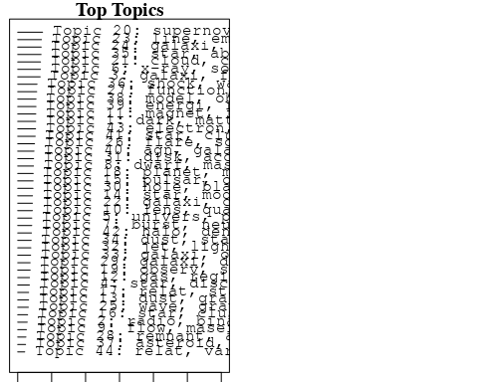

plotQuote(thoughts6, width = 30, main = "Topic 6")  
plotQuote(thoughts18, width = 30, main = "Topic 18")

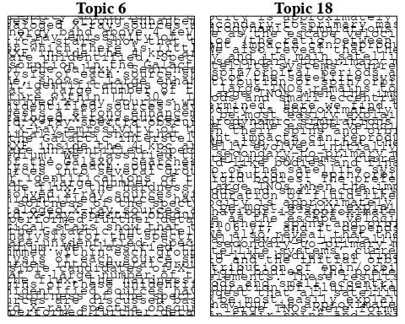

# Calculate and plot the correlation between topics  
mod.out.corr <- topicCorr(Research_topics)  
plot(mod.out.corr, cex = 1.5)  
  
  
# For each topic  
for (topic_num in 1:44) {  
 # Plot the word cloud  
 cloud(Research_topics, topic = topic_num, scale = c(2, 0.25))  
 Sys.sleep(2)  
}

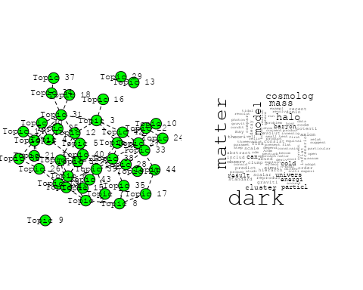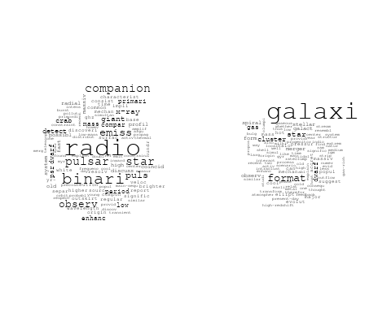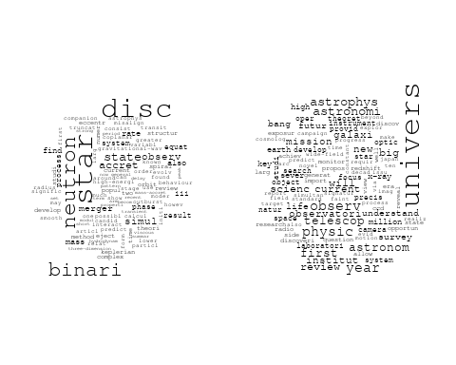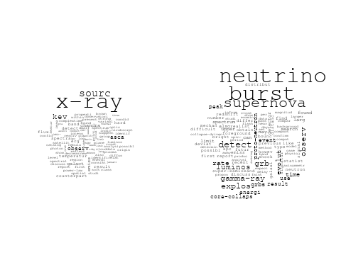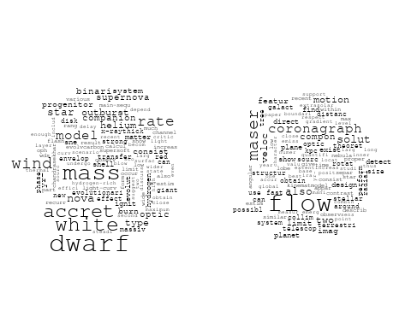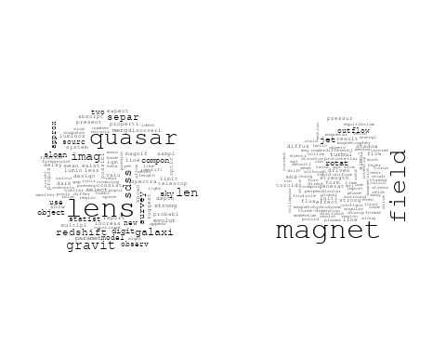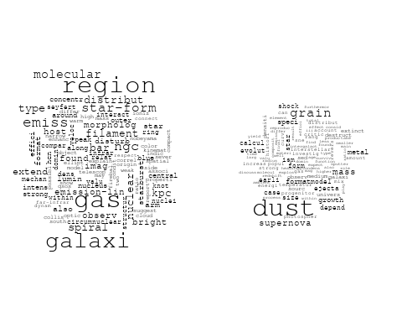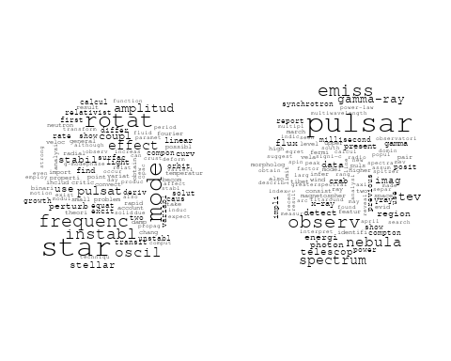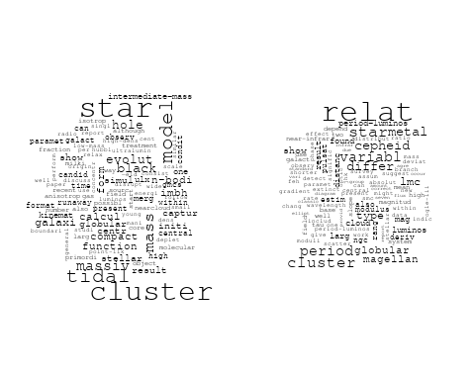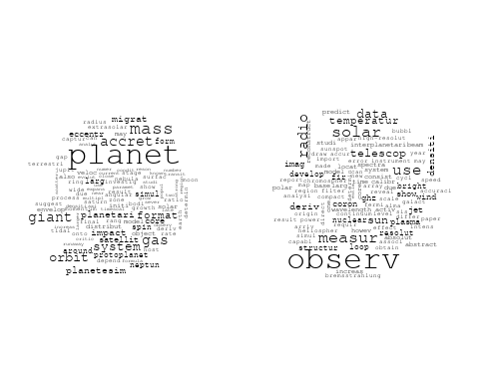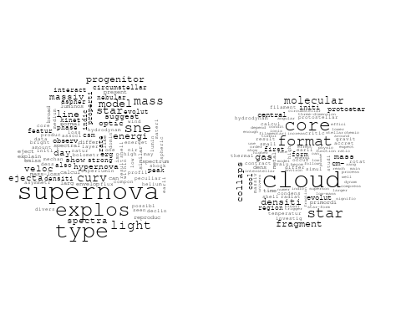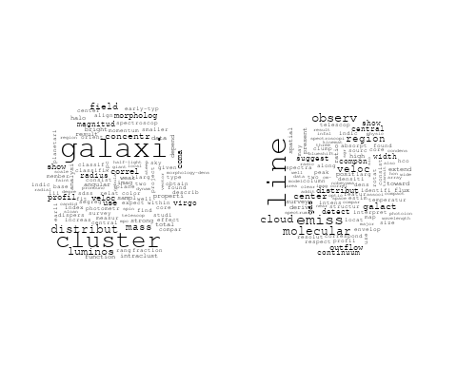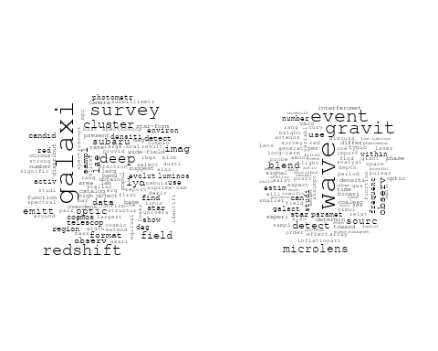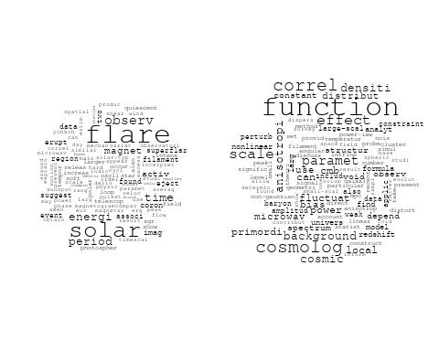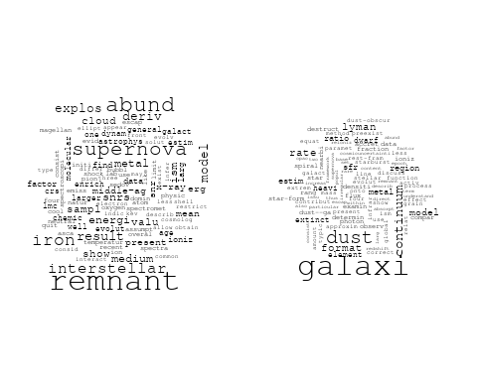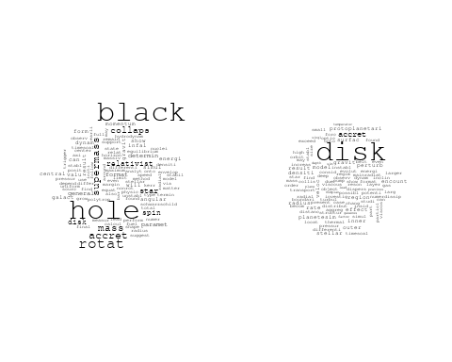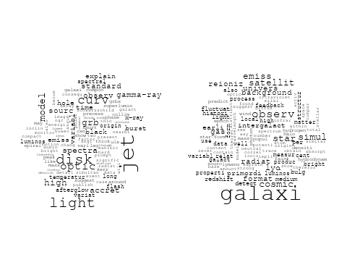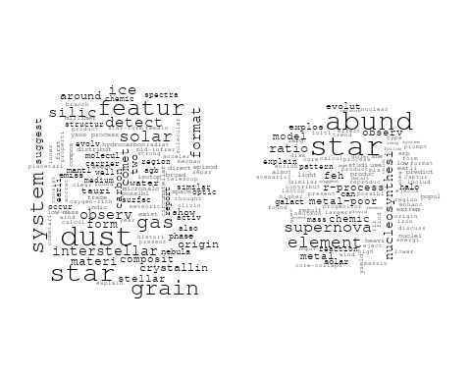

## Warning in wordcloud::wordcloud(words = vocab, freq = vec, max.words =  
## max.words, : reconnect could not be fit on page. It will not be plotted.

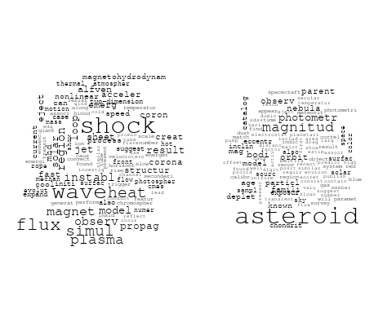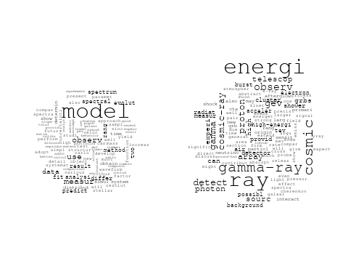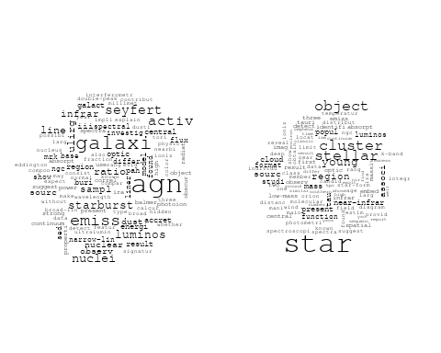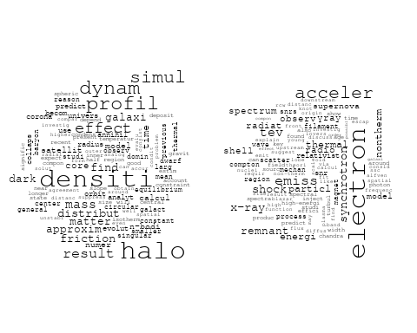

# Get the topic proportions for each document  
topic_proportions <- Research_topics$theta  
  
# Find the index of the topic with the highest proportion for each document  
# This will be the topic that each document is most likely to belong to  
max_topic_idx <- apply(topic_proportions, 1, which.max)  
  
# Add this as a new column to your data  
data_collab$topic <- max_topic_idx  
  
library(ggplot2)  
  
# Define the intervals  
intervals <- c('1824_1899', '1900_1964', '1965_1974', '1975_1984', '1985_1994', '1995_1999', '2000_2004', '2005_2009', '2010_2014', '2015_2019', '2020_2022')  
colors <- c('pink', 'blue', 'purple', 'yellow', 'green', 'pink', 'orange', 'violet', 'green', 'blue', 'pink')  
  
# Loop through the intervals and plot  
for(i in seq_along(intervals)){  
 # Filter data for when the pub_interval is equal to 1  
 data_filtered <- data_collab[data_collab[[paste0('pub_interval_', intervals[i])]] == 1,]  
   
 # Make the histogram  
   
 p <- ggplot(data_filtered, aes(x = topic)) +  
 geom_histogram(binwidth = 1, fill = colors[i], color = "black") +  
 xlab("Topic") +  
 ylab("Count") +  
 ggtitle(paste0("Topics from year ", gsub("_", " to ", intervals[i])))  
   
 print(p)  
}  
  
  
##Topic generation for JP (independent) publications  
  
data_independent <- data[data[["JP"]] == 100,]  
  
# Save the original title data for future use  
data_independent$original_concatenated_title_abstract <- data_independent$concatenated_title_abstract  
  
#pre-processing the titles using textProcessor from the stm package  
processed_text <- textProcessor(data_independent$concatenated_title_abstract, metadata = data_independent)

## Building corpus...   
## Converting to Lower Case...   
## Removing punctuation...   
## Removing stopwords...   
## Removing numbers...   
## Stemming...   
## Creating Output...

# Further prepare the data by removing low-frequency terms  
out_text <- prepDocuments(processed_text$documents, processed_text$vocab, processed_text$meta)

## Removing 1625 of 5817 terms (1625 of 77036 tokens) due to frequency   
## Your corpus now has 1029 documents, 4192 terms and 75411 tokens.

docs_text <- out_text$documents  
vocab_text <- out_text$vocab  
meta_text <- out_text$meta  
  
  
#Prepare data  
plotRemoved(processed_text$documents, lower.thresh = seq(1, 200, by = 100))

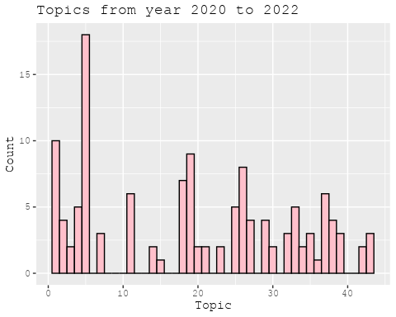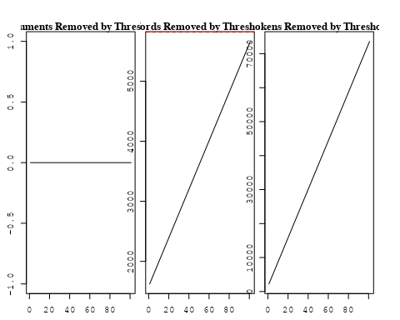

out_text <- prepDocuments(processed_text$documents, processed_text$vocab, processed_text$meta, lower.thresh = 8)

## Removing 4368 of 5817 terms (11036 of 77036 tokens) due to frequency   
## Your corpus now has 1029 documents, 1449 terms and 66000 tokens.

str(out_text$meta)

## 'data.frame': 1029 obs. of 39 variables:  
## $ concept_id : chr "https://openalex.org/C44870925" "https://openalex.org/C44870925" "https://openalex.org/C44870925" "https://openalex.org/C44870925" ...  
## $ work_id : chr "https://openalex.org/W3100494265" "https://openalex.org/W1993936459" "https://openalex.org/W3104374704" "https://openalex.org/W3098268841" ...  
## $ publication_year : int 2002 2006 1998 2009 1997 2019 2005 2004 2012 2003 ...  
## $ title : chr "Runaway Merging of Black Holes: Analytical Constraint on the Timescale" "The escape fraction of ionizing photons from galaxies at z= 0–6" "Low-Metallicity Inhibition of Type Ia Supernovae and Galactic and Cosmic Chemical Evolution" "A near-infrared survey of Miras and the distance to the Galactic Centre" ...  
## $ paperabstract : chr "Following the discovery of a black hole (BH) with a mass of 103-106 M☉ in the starburst galaxy M82, we study th"| __truncated__ "The escape fraction of ionizing photons from galaxies is a crucial quantity controlling the cosmic ionizing bac"| __truncated__ "We introduce a metallicity dependence of the Type Ia supernova (SN Ia) rate into the Galactic and cosmic chemic"| __truncated__ "We report the results of a near-infrared survey for long-period variables in a field of view of 20 arcmin by 30"| __truncated__ ...  
## $ country : chr "JP" "JP" "JP JP JP JP" "JP JP JP" ...  
## $ year_concept : chr "2002+https://openalex.org/C44870925" "2006+https://openalex.org/C44870925" "1998+https://openalex.org/C44870925" "2009+https://openalex.org/C44870925" ...  
## $ concatenated_title_abstract : chr "Runaway Merging of Black Holes: Analytical Constraint on the Timescale Following the discovery of a black hole "| __truncated__ "The escape fraction of ionizing photons from galaxies at z= 0–6 The escape fraction of ionizing photons from ga"| __truncated__ "Low-Metallicity Inhibition of Type Ia Supernovae and Galactic and Cosmic Chemical Evolution We introduce a meta"| __truncated__ "A near-infrared survey of Miras and the distance to the Galactic Centre We report the results of a near-infrare"| __truncated__ ...  
## $ US : num 0 0 0 0 0 0 0 0 0 0 ...  
## $ IN : num 0 0 0 0 0 0 0 0 0 0 ...  
## $ DE : num 0 0 0 0 0 0 0 0 0 0 ...  
## $ CH : num 0 0 0 0 0 0 0 0 0 0 ...  
## $ GB : num 0 0 0 0 0 0 0 0 0 0 ...  
## $ CN : num 0 0 0 0 0 0 0 0 0 0 ...  
## $ FR : num 0 0 0 0 0 0 0 0 0 0 ...  
## $ IT : num 0 0 0 0 0 0 0 0 0 0 ...  
## $ RU : num 0 0 0 0 0 0 0 0 0 0 ...  
## $ CA : num 0 0 0 0 0 0 0 0 0 0 ...  
## $ NL : num 0 0 0 0 0 0 0 0 0 0 ...  
## $ AU : num 0 0 0 0 0 0 0 0 0 0 ...  
## $ JP : num 100 100 100 100 100 100 100 100 100 100 ...  
## $ ES : num 0 0 0 0 0 0 0 0 0 0 ...  
## $ IL : num 0 0 0 0 0 0 0 0 0 0 ...  
## $ Americas : num 0 0 0 0 0 0 0 0 0 0 ...  
## $ Europe : num 0 0 0 0 0 0 0 0 0 0 ...  
## $ Africa : num 0 0 0 0 0 0 0 0 0 0 ...  
## $ AsiaAndOceania : num 0 0 0 0 0 0 0 0 0 0 ...  
## $ pub_interval_2020_2022 : int 0 0 0 0 0 0 0 0 0 0 ...  
## $ pub_interval_2015_2019 : int 0 0 0 0 0 1 0 0 0 0 ...  
## $ pub_interval_2010_2014 : int 0 0 0 0 0 0 0 0 1 0 ...  
## $ pub_interval_2005_2009 : int 0 1 0 1 0 0 1 0 0 0 ...  
## $ pub_interval_2000_2004 : int 1 0 0 0 0 0 0 1 0 1 ...  
## $ pub_interval_1995_1999 : int 0 0 1 0 1 0 0 0 0 0 ...  
## $ pub_interval_1985_1994 : int 0 0 0 0 0 0 0 0 0 0 ...  
## $ pub_interval_1975_1984 : int 0 0 0 0 0 0 0 0 0 0 ...  
## $ pub_interval_1965_1974 : int 0 0 0 0 0 0 0 0 0 0 ...  
## $ pub_interval_1900_1964 : int 0 0 0 0 0 0 0 0 0 0 ...  
## $ pub_interval_1824_1899 : int 0 0 0 0 0 0 0 0 0 0 ...  
## $ original_concatenated_title_abstract: chr "Runaway Merging of Black Holes: Analytical Constraint on the Timescale Following the discovery of a black hole "| __truncated__ "The escape fraction of ionizing photons from galaxies at z= 0–6 The escape fraction of ionizing photons from ga"| __truncated__ "Low-Metallicity Inhibition of Type Ia Supernovae and Galactic and Cosmic Chemical Evolution We introduce a meta"| __truncated__ "A near-infrared survey of Miras and the distance to the Galactic Centre We report the results of a near-infrare"| __truncated__ ...

# Initialize an empty formula string  
prevalence_formula_str <- "~"  
  
# Define the publication intervals  
pub_intervals <- c("pub_interval_2020_2022", "pub_interval_2015_2019", "pub_interval_2010_2014",   
 "pub_interval_2005_2009", "pub_interval_2000_2004", "pub_interval_1995_1999",  
 "pub_interval_1985_1994", "pub_interval_1975_1984", "pub_interval_1965_1974",  
 "pub_interval_1900_1964", "pub_interval_1824_1899")  
  
# Add each publication interval to the formula string  
for (interval in pub_intervals) {  
 # add an if statement to handle the first addition (without '+')  
 if (prevalence_formula_str == "~") {  
 prevalence_formula_str <- paste(prevalence_formula_str, interval)  
 } else {  
 prevalence_formula_str <- paste(prevalence_formula_str, "+", interval)  
 }  
}  
  
  
# Convert the string to a formula  
prevalence_formula <- as.formula(prevalence_formula_str)  
print(prevalence_formula)

## ~pub_interval_2020_2022 + pub_interval_2015_2019 + pub_interval_2010_2014 +   
## pub_interval_2005_2009 + pub_interval_2000_2004 + pub_interval_1995_1999 +   
## pub_interval_1985_1994 + pub_interval_1975_1984 + pub_interval_1965_1974 +   
## pub_interval_1900_1964 + pub_interval_1824_1899

# Run STM model  
Research_topics <- stm(documents = out_text$documents,   
 vocab = out_text$vocab,   
 K = 44,   
 prevalence = prevalence_formula,   
 data = out_text$meta,   
 init.type = "Spectral",  
 max.em.its = 1000,  
 gamma.prior = 'L1')

## Beginning Spectral Initialization   
## Calculating the gram matrix...  
## Finding anchor words...  
## ............................................  
## Recovering initialization...  
## ..............  
## Initialization complete.  
## ......................................................................................................  
## Completed E-Step (1 seconds).   
## Completed M-Step.   
## Completing Iteration 1 (approx. per word bound = -5.989)   
## ......................................................................................................  
## Completed E-Step (0 seconds).   
## Completed M-Step.   
## Completing Iteration 2 (approx. per word bound = -5.739, relative change = 4.186e-02)   
## ......................................................................................................  
## Completed E-Step (0 seconds).   
## Completed M-Step.   
## Completing Iteration 3 (approx. per word bound = -5.672, relative change = 1.170e-02)   
## ......................................................................................................  
## Completed E-Step (0 seconds).   
## Completed M-Step.   
## Completing Iteration 4 (approx. per word bound = -5.644, relative change = 4.894e-03)   
## ......................................................................................................  
## Completed E-Step (0 seconds).   
## Completed M-Step.   
## Completing Iteration 5 (approx. per word bound = -5.630, relative change = 2.444e-03)   
## Topic 1: galaxi, format, star, cluster, dwarf   
## Topic 2: nova, mass, outburst, model, dwarf   
## Topic 3: star, format, cloud, form, gas   
## Topic 4: black, hole, disk, spin, accret   
## Topic 5: disk, outflow, jet, veloc, wind   
## Topic 6: pulsar, gamma-ray, observ, tev, ray   
## Topic 7: asteroid, bodi, parent, age, surfac   
## Topic 8: dust, grain, mass, galaxi, metal   
## Topic 9: model, use, univers, observ, time   
## Topic 10: accret, rate, mass, star, disc   
## Topic 11: gas, molecular, cloud, shell, galact   
## Topic 12: cluster, star, format, relat, variabl   
## Topic 13: grb, burst, gamma-ray, grbs, model   
## Topic 14: region, galaxi, extinct, continuum, lyman   
## Topic 15: electron, tev, energi, acceler, γray   
## Topic 16: neutrino, supernova, burst, observ, explos   
## Topic 17: cloud, core, fragment, densiti, cm-   
## Topic 18: mode, rotat, star, instabl, oscil   
## Topic 19: flare, reconnect, observ, shock, x-ray   
## Topic 20: function, model, cosmolog, paramet, correl   
## Topic 21: lyα, galaxi, deep, high, lae   
## Topic 22: evolut, star, differ, approxim, collaps   
## Topic 23: satellit, orbit, impact, result, giant   
## Topic 24: supernova, remnant, gamma-ray, observ, telescop   
## Topic 25: featur, silic, grain, dust, detect   
## Topic 26: solar, observ, wind, period, activ   
## Topic 27: wave, gravit, binari, observ, turbul   
## Topic 28: effect, rotat, rate, veloc, disk   
## Topic 29: emiss, line, region, galaxi, ratio   
## Topic 30: line, measur, observ, detect, transit   
## Topic 31: lens, primordi, popul, light, curv   
## Topic 32: dark, halo, cluster, matter, mass   
## Topic 33: sne, supernova, can, observ, type   
## Topic 34: x-ray, sourc, kev, emiss, spectra   
## Topic 35: explos, abund, r-process, supernova, nucleosynthesi   
## Topic 36: time, wave, jet, polar, afterglow   
## Topic 37: observ, measur, model, distribut, resolut   
## Topic 38: eject, mass, coron, observ, associ   
## Topic 39: galaxi, spiral, metal, central, rotat   
## Topic 40: variabl, disk, galact, relat, bulg   
## Topic 41: magnet, field, simul, rotat, jet   
## Topic 42: quasar, imag, lens, len, galaxi   
## Topic 43: accret, disk, gas, planet, mass   
## Topic 44: star, product, exponenti, function, introduc   
## ......................................................................................................  
## Completed E-Step (0 seconds).   
## Completed M-Step.   
## Completing Iteration 6 (approx. per word bound = -5.622, relative change = 1.447e-03)   
## ......................................................................................................  
## Completed E-Step (0 seconds).   
## Completed M-Step.   
## Completing Iteration 7 (approx. per word bound = -5.616, relative change = 1.016e-03)   
## ......................................................................................................  
## Completed E-Step (0 seconds).   
## Completed M-Step.   
## Completing Iteration 8 (approx. per word bound = -5.612, relative change = 7.358e-04)   
## ......................................................................................................  
## Completed E-Step (0 seconds).   
## Completed M-Step.   
## Completing Iteration 9 (approx. per word bound = -5.609, relative change = 5.349e-04)   
## ......................................................................................................  
## Completed E-Step (0 seconds).   
## Completed M-Step.   
## Completing Iteration 10 (approx. per word bound = -5.607, relative change = 4.094e-04)   
## Topic 1: galaxi, format, star, cluster, dwarf   
## Topic 2: model, nova, mass, dwarf, outburst   
## Topic 3: star, format, form, cloud, gas   
## Topic 4: black, hole, disk, spin, accret   
## Topic 5: outflow, disk, jet, veloc, wind   
## Topic 6: pulsar, gamma-ray, observ, tev, ray   
## Topic 7: asteroid, bodi, parent, surfac, age   
## Topic 8: dust, grain, mass, galaxi, metal   
## Topic 9: model, use, observ, time, system   
## Topic 10: accret, disc, rate, mass, star   
## Topic 11: gas, molecular, cloud, shell, galact   
## Topic 12: cluster, star, format, activ, galaxi   
## Topic 13: grb, burst, gamma-ray, grbs, model   
## Topic 14: galaxi, region, extinct, continuum, lyman   
## Topic 15: electron, acceler, energi, tev, shock   
## Topic 16: neutrino, supernova, burst, observ, explos   
## Topic 17: cloud, core, fragment, densiti, cm-   
## Topic 18: mode, star, rotat, instabl, oscil   
## Topic 19: flare, reconnect, shock, x-ray, observ   
## Topic 20: function, model, cosmolog, paramet, correl   
## Topic 21: galaxi, lyα, deep, high, lae   
## Topic 22: evolut, star, differ, approxim, dynam   
## Topic 23: satellit, orbit, impact, result, giant   
## Topic 24: supernova, remnant, gamma-ray, observ, interact   
## Topic 25: featur, silic, grain, dust, star   
## Topic 26: solar, observ, wind, activ, period   
## Topic 27: wave, gravit, binari, observ, turbul   
## Topic 28: effect, rotat, veloc, disk, accret   
## Topic 29: emiss, line, region, galaxi, ratio   
## Topic 30: line, measur, detect, observ, determin   
## Topic 31: lens, primordi, curv, light, popul   
## Topic 32: dark, halo, cluster, matter, mass   
## Topic 33: sne, can, observ, supernova, survey   
## Topic 34: x-ray, sourc, kev, emiss, spectra   
## Topic 35: explos, abund, star, r-process, supernova   
## Topic 36: time, wave, polar, jet, radio   
## Topic 37: observ, measur, resolut, model, spectrum   
## Topic 38: eject, mass, coron, observ, associ   
## Topic 39: galaxi, spiral, metal, central, rotat   
## Topic 40: variabl, galact, disk, bulg, relat   
## Topic 41: magnet, field, jet, rotat, simul   
## Topic 42: quasar, lens, imag, len, galaxi   
## Topic 43: accret, disk, planet, gas, mass   
## Topic 44: star, product, exponenti, function, show   
## ......................................................................................................  
## Completed E-Step (0 seconds).   
## Completed M-Step.   
## Completing Iteration 11 (approx. per word bound = -5.605, relative change = 3.774e-04)   
## ......................................................................................................  
## Completed E-Step (0 seconds).   
## Completed M-Step.   
## Completing Iteration 12 (approx. per word bound = -5.603, relative change = 3.378e-04)   
## ......................................................................................................  
## Completed E-Step (0 seconds).   
## Completed M-Step.   
## Completing Iteration 13 (approx. per word bound = -5.601, relative change = 2.969e-04)   
## ......................................................................................................  
## Completed E-Step (0 seconds).   
## Completed M-Step.   
## Completing Iteration 14 (approx. per word bound = -5.600, relative change = 2.443e-04)   
## ......................................................................................................  
## Completed E-Step (0 seconds).   
## Completed M-Step.   
## Completing Iteration 15 (approx. per word bound = -5.599, relative change = 1.894e-04)   
## Topic 1: galaxi, format, star, cluster, dwarf   
## Topic 2: model, nova, mass, dwarf, outburst   
## Topic 3: star, format, form, cloud, gas   
## Topic 4: black, hole, disk, spin, mass   
## Topic 5: outflow, disk, jet, veloc, wind   
## Topic 6: pulsar, gamma-ray, observ, tev, ray   
## Topic 7: asteroid, bodi, parent, surfac, dust   
## Topic 8: dust, grain, mass, galaxi, metal   
## Topic 9: model, use, observ, time, system   
## Topic 10: accret, disc, mass, rate, star   
## Topic 11: gas, molecular, cloud, galact, shell   
## Topic 12: cluster, star, format, galaxi, activ   
## Topic 13: grb, burst, gamma-ray, grbs, model   
## Topic 14: galaxi, region, extinct, continuum, lyman   
## Topic 15: electron, acceler, energi, tev, shock   
## Topic 16: neutrino, supernova, burst, observ, explos   
## Topic 17: cloud, core, fragment, densiti, cm-   
## Topic 18: mode, star, rotat, instabl, oscil   
## Topic 19: flare, reconnect, shock, x-ray, observ   
## Topic 20: function, model, cosmolog, paramet, correl   
## Topic 21: galaxi, lyα, deep, emiss, redshift   
## Topic 22: evolut, star, differ, heat, dynam   
## Topic 23: satellit, orbit, impact, result, simul   
## Topic 24: supernova, remnant, gamma-ray, observ, interact   
## Topic 25: featur, silic, grain, dust, star   
## Topic 26: solar, observ, wind, activ, period   
## Topic 27: wave, gravit, binari, observ, turbul   
## Topic 28: effect, rotat, disk, veloc, accret   
## Topic 29: emiss, line, region, galaxi, ratio   
## Topic 30: line, measur, detect, observ, determin   
## Topic 31: lens, primordi, curv, popul, light   
## Topic 32: dark, halo, cluster, matter, mass   
## Topic 33: sne, can, observ, supernova, survey   
## Topic 34: x-ray, sourc, kev, emiss, spectra   
## Topic 35: explos, star, abund, supernova, r-process   
## Topic 36: time, wave, polar, jet, radio   
## Topic 37: observ, measur, spectrum, model, energi   
## Topic 38: eject, mass, observ, coron, associ   
## Topic 39: galaxi, spiral, metal, central, rotat   
## Topic 40: variabl, galact, disk, bulg, relat   
## Topic 41: magnet, field, jet, rotat, simul   
## Topic 42: quasar, lens, imag, len, galaxi   
## Topic 43: accret, disk, planet, gas, mass   
## Topic 44: star, product, exponenti, show, function   
## ......................................................................................................  
## Completed E-Step (0 seconds).   
## Completed M-Step.   
## Completing Iteration 16 (approx. per word bound = -5.598, relative change = 1.896e-04)   
## ......................................................................................................  
## Completed E-Step (0 seconds).   
## Completed M-Step.   
## Completing Iteration 17 (approx. per word bound = -5.597, relative change = 1.715e-04)   
## ......................................................................................................  
## Completed E-Step (0 seconds).   
## Completed M-Step.   
## Completing Iteration 18 (approx. per word bound = -5.596, relative change = 1.490e-04)   
## ......................................................................................................  
## Completed E-Step (0 seconds).   
## Completed M-Step.   
## Completing Iteration 19 (approx. per word bound = -5.595, relative change = 1.292e-04)   
## ......................................................................................................  
## Completed E-Step (0 seconds).   
## Completed M-Step.   
## Completing Iteration 20 (approx. per word bound = -5.594, relative change = 1.200e-04)   
## Topic 1: galaxi, format, star, cluster, dwarf   
## Topic 2: model, nova, dwarf, mass, outburst   
## Topic 3: star, format, form, cloud, gas   
## Topic 4: black, hole, disk, spin, mass   
## Topic 5: outflow, disk, jet, veloc, wind   
## Topic 6: pulsar, gamma-ray, tev, observ, ray   
## Topic 7: asteroid, bodi, parent, surfac, dust   
## Topic 8: dust, grain, mass, galaxi, metal   
## Topic 9: model, use, observ, time, predict   
## Topic 10: accret, disc, mass, rate, star   
## Topic 11: gas, molecular, cloud, galact, shell   
## Topic 12: cluster, star, format, galaxi, activ   
## Topic 13: grb, burst, gamma-ray, grbs, model   
## Topic 14: region, galaxi, extinct, continuum, lyman   
## Topic 15: electron, acceler, energi, tev, shock   
## Topic 16: neutrino, supernova, burst, observ, detect   
## Topic 17: cloud, core, fragment, densiti, cm-   
## Topic 18: mode, star, rotat, instabl, oscil   
## Topic 19: flare, reconnect, shock, x-ray, observ   
## Topic 20: function, model, cosmolog, paramet, correl   
## Topic 21: galaxi, lyα, redshift, deep, emiss   
## Topic 22: evolut, heat, star, differ, simul   
## Topic 23: satellit, orbit, impact, result, simul   
## Topic 24: supernova, remnant, gamma-ray, observ, interact   
## Topic 25: featur, silic, grain, dust, star   
## Topic 26: solar, observ, wind, period, activ   
## Topic 27: wave, gravit, binari, turbul, observ   
## Topic 28: effect, rotat, disk, accret, veloc   
## Topic 29: emiss, line, region, galaxi, ratio   
## Topic 30: line, measur, detect, observ, determin   
## Topic 31: lens, primordi, curv, popul, light   
## Topic 32: dark, cluster, halo, matter, mass   
## Topic 33: sne, can, observ, supernova, survey   
## Topic 34: x-ray, sourc, kev, emiss, spectra   
## Topic 35: star, explos, abund, supernova, r-process   
## Topic 36: time, polar, wave, jet, radio   
## Topic 37: observ, measur, energi, spectrum, model   
## Topic 38: eject, mass, observ, coron, associ   
## Topic 39: galaxi, spiral, metal, central, rotat   
## Topic 40: variabl, disk, galact, galaxi, bulg   
## Topic 41: magnet, field, jet, rotat, simul   
## Topic 42: quasar, lens, imag, len, galaxi   
## Topic 43: accret, planet, disk, gas, mass   
## Topic 44: star, product, exponenti, show, produc   
## ......................................................................................................  
## Completed E-Step (0 seconds).   
## Completed M-Step.   
## Completing Iteration 21 (approx. per word bound = -5.594, relative change = 1.236e-04)   
## ......................................................................................................  
## Completed E-Step (0 seconds).   
## Completed M-Step.   
## Completing Iteration 22 (approx. per word bound = -5.593, relative change = 1.136e-04)   
## ......................................................................................................  
## Completed E-Step (0 seconds).   
## Completed M-Step.   
## Completing Iteration 23 (approx. per word bound = -5.592, relative change = 9.824e-05)   
## ......................................................................................................  
## Completed E-Step (0 seconds).   
## Completed M-Step.   
## Completing Iteration 24 (approx. per word bound = -5.592, relative change = 9.196e-05)   
## ......................................................................................................  
## Completed E-Step (0 seconds).   
## Completed M-Step.   
## Completing Iteration 25 (approx. per word bound = -5.591, relative change = 8.930e-05)   
## Topic 1: galaxi, format, cluster, star, dwarf   
## Topic 2: model, nova, mass, dwarf, outburst   
## Topic 3: star, format, form, cloud, gas   
## Topic 4: black, hole, spin, disk, accret   
## Topic 5: outflow, disk, jet, veloc, wind   
## Topic 6: pulsar, tev, gamma-ray, observ, ray   
## Topic 7: asteroid, bodi, parent, surfac, dust   
## Topic 8: dust, grain, mass, galaxi, metal   
## Topic 9: model, use, observ, time, spectral   
## Topic 10: accret, disc, mass, rate, star   
## Topic 11: gas, molecular, cloud, galact, shell   
## Topic 12: cluster, star, format, galaxi, activ   
## Topic 13: grb, burst, gamma-ray, grbs, model   
## Topic 14: region, galaxi, extinct, continuum, lyman   
## Topic 15: electron, acceler, energi, tev, shock   
## Topic 16: neutrino, supernova, burst, observ, detect   
## Topic 17: cloud, core, fragment, densiti, cm-   
## Topic 18: mode, star, rotat, instabl, oscil   
## Topic 19: flare, reconnect, shock, x-ray, observ   
## Topic 20: function, model, cosmolog, paramet, correl   
## Topic 21: galaxi, lyα, redshift, emiss, deep   
## Topic 22: evolut, heat, star, simul, wave   
## Topic 23: satellit, orbit, impact, result, simul   
## Topic 24: supernova, remnant, gamma-ray, observ, interact   
## Topic 25: featur, silic, grain, dust, star   
## Topic 26: solar, observ, wind, period, activ   
## Topic 27: wave, gravit, binari, turbul, observ   
## Topic 28: effect, rotat, disk, veloc, accret   
## Topic 29: emiss, line, region, galaxi, ratio   
## Topic 30: line, detect, measur, observ, determin   
## Topic 31: lens, primordi, curv, popul, light   
## Topic 32: dark, cluster, halo, matter, mass   
## Topic 33: sne, can, observ, supernova, survey   
## Topic 34: x-ray, sourc, kev, emiss, spectra   
## Topic 35: star, explos, abund, supernova, r-process   
## Topic 36: time, polar, jet, radio, wave   
## Topic 37: observ, measur, energi, spectrum, model   
## Topic 38: eject, mass, observ, associ, coron   
## Topic 39: galaxi, spiral, metal, central, rotat   
## Topic 40: variabl, disk, galact, galaxi, bulg   
## Topic 41: magnet, field, jet, rotat, simul   
## Topic 42: quasar, lens, imag, len, galaxi   
## Topic 43: accret, planet, gas, disk, mass   
## Topic 44: produc, possibl, star, product, exponenti   
## ......................................................................................................  
## Completed E-Step (0 seconds).   
## Completed M-Step.   
## Completing Iteration 26 (approx. per word bound = -5.591, relative change = 9.729e-05)   
## ......................................................................................................  
## Completed E-Step (0 seconds).   
## Completed M-Step.   
## Completing Iteration 27 (approx. per word bound = -5.590, relative change = 9.427e-05)   
## ......................................................................................................  
## Completed E-Step (0 seconds).   
## Completed M-Step.   
## Completing Iteration 28 (approx. per word bound = -5.590, relative change = 8.939e-05)   
## ......................................................................................................  
## Completed E-Step (0 seconds).   
## Completed M-Step.   
## Completing Iteration 29 (approx. per word bound = -5.589, relative change = 8.645e-05)   
## ......................................................................................................  
## Completed E-Step (0 seconds).   
## Completed M-Step.   
## Completing Iteration 30 (approx. per word bound = -5.589, relative change = 8.609e-05)   
## Topic 1: galaxi, format, cluster, star, dwarf   
## Topic 2: model, nova, mass, dwarf, outburst   
## Topic 3: star, format, form, cloud, gas   
## Topic 4: black, hole, spin, disk, accret   
## Topic 5: outflow, disk, jet, veloc, wind   
## Topic 6: pulsar, tev, gamma-ray, observ, ray   
## Topic 7: asteroid, bodi, parent, surfac, dust   
## Topic 8: dust, grain, mass, galaxi, metal   
## Topic 9: model, use, observ, spectral, time   
## Topic 10: accret, disc, mass, rate, star   
## Topic 11: gas, cloud, molecular, shell, region   
## Topic 12: cluster, star, format, galaxi, activ   
## Topic 13: grb, burst, gamma-ray, grbs, model   
## Topic 14: region, galaxi, extinct, continuum, lyman   
## Topic 15: electron, acceler, energi, tev, shock   
## Topic 16: neutrino, supernova, burst, detect, observ   
## Topic 17: cloud, core, fragment, densiti, cm-   
## Topic 18: mode, star, rotat, instabl, oscil   
## Topic 19: flare, reconnect, shock, x-ray, observ   
## Topic 20: function, model, cosmolog, paramet, correl   
## Topic 21: galaxi, lyα, redshift, emiss, deep   
## Topic 22: evolut, heat, simul, wave, star   
## Topic 23: satellit, orbit, impact, result, simul   
## Topic 24: supernova, remnant, gamma-ray, observ, interact   
## Topic 25: featur, silic, grain, dust, star   
## Topic 26: solar, observ, wind, activ, period   
## Topic 27: wave, gravit, binari, turbul, observ   
## Topic 28: effect, disk, rotat, veloc, accret   
## Topic 29: emiss, line, region, galaxi, ratio   
## Topic 30: line, detect, measur, observ, determin   
## Topic 31: lens, primordi, curv, popul, light   
## Topic 32: dark, cluster, halo, matter, mass   
## Topic 33: sne, observ, can, supernova, survey   
## Topic 34: x-ray, sourc, kev, emiss, spectra   
## Topic 35: star, explos, abund, supernova, r-process   
## Topic 36: time, polar, radio, jet, wave   
## Topic 37: observ, measur, energi, spectrum, photon   
## Topic 38: eject, mass, associ, observ, coron   
## Topic 39: galaxi, spiral, metal, central, rotat   
## Topic 40: variabl, galact, disk, galaxi, bulg   
## Topic 41: magnet, field, jet, rotat, simul   
## Topic 42: quasar, lens, imag, len, galaxi   
## Topic 43: accret, planet, gas, disk, mass   
## Topic 44: possibl, produc, can, star, exponenti   
## ......................................................................................................  
## Completed E-Step (0 seconds).   
## Completed M-Step.   
## Completing Iteration 31 (approx. per word bound = -5.588, relative change = 8.572e-05)   
## ......................................................................................................  
## Completed E-Step (0 seconds).   
## Completed M-Step.   
## Completing Iteration 32 (approx. per word bound = -5.588, relative change = 8.122e-05)   
## ......................................................................................................  
## Completed E-Step (0 seconds).   
## Completed M-Step.   
## Completing Iteration 33 (approx. per word bound = -5.587, relative change = 8.821e-05)   
## ......................................................................................................  
## Completed E-Step (0 seconds).   
## Completed M-Step.   
## Completing Iteration 34 (approx. per word bound = -5.587, relative change = 7.495e-05)   
## ......................................................................................................  
## Completed E-Step (0 seconds).   
## Completed M-Step.   
## Completing Iteration 35 (approx. per word bound = -5.587, relative change = 6.623e-05)   
## Topic 1: galaxi, format, cluster, star, dwarf   
## Topic 2: model, nova, mass, dwarf, outburst   
## Topic 3: star, format, form, cloud, gas   
## Topic 4: black, hole, spin, disk, accret   
## Topic 5: outflow, disk, jet, veloc, wind   
## Topic 6: pulsar, tev, gamma-ray, observ, ray   
## Topic 7: asteroid, bodi, parent, surfac, dust   
## Topic 8: dust, grain, mass, galaxi, metal   
## Topic 9: model, use, observ, time, spectral   
## Topic 10: accret, disc, mass, rate, star   
## Topic 11: gas, cloud, molecular, region, shell   
## Topic 12: cluster, star, format, galaxi, activ   
## Topic 13: grb, burst, gamma-ray, grbs, model   
## Topic 14: region, galaxi, extinct, continuum, lyman   
## Topic 15: electron, acceler, energi, tev, shock   
## Topic 16: neutrino, supernova, detect, burst, observ   
## Topic 17: cloud, core, fragment, densiti, cm-   
## Topic 18: mode, star, rotat, instabl, oscil   
## Topic 19: flare, reconnect, shock, observ, x-ray   
## Topic 20: function, model, cosmolog, paramet, correl   
## Topic 21: galaxi, lyα, redshift, emiss, deep   
## Topic 22: evolut, heat, simul, shock, wave   
## Topic 23: satellit, orbit, impact, result, simul   
## Topic 24: supernova, remnant, gamma-ray, observ, interact   
## Topic 25: featur, silic, grain, dust, star   
## Topic 26: solar, observ, wind, activ, period   
## Topic 27: wave, gravit, binari, turbul, observ   
## Topic 28: effect, disk, rotat, veloc, accret   
## Topic 29: emiss, line, region, galaxi, ratio   
## Topic 30: line, detect, measur, observ, determin   
## Topic 31: lens, curv, primordi, popul, light   
## Topic 32: dark, cluster, halo, matter, mass   
## Topic 33: sne, observ, can, supernova, survey   
## Topic 34: x-ray, sourc, kev, emiss, spectra   
## Topic 35: star, explos, abund, supernova, r-process   
## Topic 36: time, polar, radio, jet, wave   
## Topic 37: observ, measur, energi, spectrum, photon   
## Topic 38: eject, mass, associ, observ, coron   
## Topic 39: galaxi, spiral, metal, central, rotat   
## Topic 40: variabl, galact, disk, galaxi, bulg   
## Topic 41: magnet, field, jet, rotat, simul   
## Topic 42: quasar, lens, imag, len, galaxi   
## Topic 43: planet, accret, gas, disk, mass   
## Topic 44: possibl, produc, can, energi, star   
## ......................................................................................................  
## Completed E-Step (0 seconds).   
## Completed M-Step.   
## Completing Iteration 36 (approx. per word bound = -5.586, relative change = 5.716e-05)   
## ......................................................................................................  
## Completed E-Step (0 seconds).   
## Completed M-Step.   
## Completing Iteration 37 (approx. per word bound = -5.586, relative change = 7.882e-05)   
## ......................................................................................................  
## Completed E-Step (0 seconds).   
## Completed M-Step.   
## Completing Iteration 38 (approx. per word bound = -5.586, relative change = 7.172e-05)   
## ......................................................................................................  
## Completed E-Step (0 seconds).   
## Completed M-Step.   
## Completing Iteration 39 (approx. per word bound = -5.585, relative change = 7.071e-05)   
## ......................................................................................................  
## Completed E-Step (0 seconds).   
## Completed M-Step.   
## Completing Iteration 40 (approx. per word bound = -5.585, relative change = 5.961e-05)   
## Topic 1: galaxi, format, cluster, star, dwarf   
## Topic 2: model, nova, mass, dwarf, outburst   
## Topic 3: star, format, form, cloud, gas   
## Topic 4: black, hole, spin, disk, accret   
## Topic 5: outflow, disk, jet, veloc, star   
## Topic 6: pulsar, tev, gamma-ray, observ, ray   
## Topic 7: asteroid, bodi, parent, surfac, dust   
## Topic 8: dust, grain, mass, galaxi, metal   
## Topic 9: model, use, observ, time, spectral   
## Topic 10: accret, disc, mass, rate, star   
## Topic 11: gas, cloud, molecular, region, shell   
## Topic 12: cluster, star, format, galaxi, activ   
## Topic 13: grb, burst, gamma-ray, grbs, model   
## Topic 14: region, galaxi, extinct, continuum, lyman   
## Topic 15: electron, acceler, energi, tev, shock   
## Topic 16: neutrino, supernova, detect, burst, observ   
## Topic 17: cloud, core, fragment, densiti, cm-   
## Topic 18: mode, star, rotat, instabl, oscil   
## Topic 19: flare, reconnect, shock, observ, jet   
## Topic 20: function, model, cosmolog, paramet, correl   
## Topic 21: galaxi, lyα, redshift, emiss, deep   
## Topic 22: evolut, heat, shock, simul, wave   
## Topic 23: satellit, orbit, impact, result, simul   
## Topic 24: supernova, remnant, gamma-ray, observ, interact   
## Topic 25: featur, silic, grain, dust, star   
## Topic 26: solar, observ, wind, activ, period   
## Topic 27: wave, gravit, binari, turbul, observ   
## Topic 28: effect, disk, rotat, veloc, accret   
## Topic 29: emiss, line, region, galaxi, ratio   
## Topic 30: line, detect, measur, observ, determin   
## Topic 31: lens, curv, primordi, popul, light   
## Topic 32: dark, cluster, halo, matter, mass   
## Topic 33: sne, observ, can, supernova, survey   
## Topic 34: x-ray, sourc, kev, emiss, spectra   
## Topic 35: star, explos, abund, supernova, r-process   
## Topic 36: time, polar, radio, jet, wave   
## Topic 37: observ, measur, energi, spectrum, photon   
## Topic 38: eject, mass, associ, observ, coron   
## Topic 39: galaxi, spiral, metal, central, rotat   
## Topic 40: variabl, galact, disk, galaxi, bulg   
## Topic 41: magnet, field, jet, rotat, simul   
## Topic 42: quasar, lens, imag, len, galaxi   
## Topic 43: planet, accret, gas, disk, mass   
## Topic 44: possibl, produc, energi, can, star   
## ......................................................................................................  
## Completed E-Step (0 seconds).   
## Completed M-Step.   
## Completing Iteration 41 (approx. per word bound = -5.585, relative change = 5.578e-05)   
## ......................................................................................................  
## Completed E-Step (0 seconds).   
## Completed M-Step.   
## Completing Iteration 42 (approx. per word bound = -5.584, relative change = 5.002e-05)   
## ......................................................................................................  
## Completed E-Step (0 seconds).   
## Completed M-Step.   
## Completing Iteration 43 (approx. per word bound = -5.584, relative change = 4.947e-05)   
## ......................................................................................................  
## Completed E-Step (0 seconds).   
## Completed M-Step.   
## Completing Iteration 44 (approx. per word bound = -5.584, relative change = 5.017e-05)   
## ......................................................................................................  
## Completed E-Step (0 seconds).   
## Completed M-Step.   
## Completing Iteration 45 (approx. per word bound = -5.583, relative change = 5.380e-05)   
## Topic 1: galaxi, format, cluster, star, dwarf   
## Topic 2: model, nova, dwarf, mass, outburst   
## Topic 3: star, format, form, cloud, gas   
## Topic 4: black, hole, spin, disk, mass   
## Topic 5: outflow, disk, jet, veloc, star   
## Topic 6: pulsar, tev, gamma-ray, observ, ray   
## Topic 7: asteroid, bodi, parent, surfac, dust   
## Topic 8: dust, grain, mass, galaxi, metal   
## Topic 9: model, use, observ, time, spectral   
## Topic 10: accret, disc, mass, rate, star   
## Topic 11: gas, cloud, molecular, region, shell   
## Topic 12: cluster, star, format, galaxi, activ   
## Topic 13: grb, gamma-ray, burst, grbs, model   
## Topic 14: region, galaxi, extinct, continuum, lyman   
## Topic 15: electron, acceler, energi, tev, shock   
## Topic 16: neutrino, supernova, detect, burst, observ   
## Topic 17: cloud, core, fragment, densiti, cm-   
## Topic 18: mode, star, rotat, instabl, oscil   
## Topic 19: flare, reconnect, shock, observ, jet   
## Topic 20: function, model, cosmolog, paramet, correl   
## Topic 21: galaxi, lyα, redshift, emiss, deep   
## Topic 22: evolut, heat, shock, simul, wave   
## Topic 23: satellit, orbit, impact, result, simul   
## Topic 24: supernova, remnant, gamma-ray, observ, interact   
## Topic 25: featur, silic, grain, dust, star   
## Topic 26: solar, observ, activ, wind, period   
## Topic 27: wave, gravit, binari, turbul, observ   
## Topic 28: effect, disk, rotat, veloc, accret   
## Topic 29: emiss, line, region, galaxi, ratio   
## Topic 30: line, detect, measur, observ, determin   
## Topic 31: lens, primordi, curv, popul, light   
## Topic 32: dark, cluster, halo, matter, mass   
## Topic 33: sne, observ, can, supernova, survey   
## Topic 34: x-ray, sourc, kev, emiss, spectra   
## Topic 35: star, explos, abund, supernova, r-process   
## Topic 36: time, polar, radio, jet, wave   
## Topic 37: observ, measur, energi, spectrum, photon   
## Topic 38: eject, mass, associ, observ, coron   
## Topic 39: galaxi, spiral, metal, central, rotat   
## Topic 40: variabl, galact, disk, galaxi, bulg   
## Topic 41: magnet, field, jet, rotat, simul   
## Topic 42: quasar, lens, imag, len, galaxi   
## Topic 43: planet, accret, gas, disk, mass   
## Topic 44: possibl, energi, produc, can, star   
## ......................................................................................................  
## Completed E-Step (0 seconds).   
## Completed M-Step.   
## Completing Iteration 46 (approx. per word bound = -5.583, relative change = 5.066e-05)   
## ......................................................................................................  
## Completed E-Step (0 seconds).   
## Completed M-Step.   
## Completing Iteration 47 (approx. per word bound = -5.583, relative change = 4.938e-05)   
## ......................................................................................................  
## Completed E-Step (0 seconds).   
## Completed M-Step.   
## Completing Iteration 48 (approx. per word bound = -5.583, relative change = 4.970e-05)   
## ......................................................................................................  
## Completed E-Step (0 seconds).   
## Completed M-Step.   
## Completing Iteration 49 (approx. per word bound = -5.582, relative change = 4.330e-05)   
## ......................................................................................................  
## Completed E-Step (0 seconds).   
## Completed M-Step.   
## Completing Iteration 50 (approx. per word bound = -5.582, relative change = 4.174e-05)   
## Topic 1: galaxi, format, cluster, star, dwarf   
## Topic 2: model, nova, dwarf, mass, outburst   
## Topic 3: star, format, form, cloud, gas   
## Topic 4: black, hole, spin, disk, mass   
## Topic 5: outflow, disk, jet, veloc, star   
## Topic 6: pulsar, tev, gamma-ray, observ, ray   
## Topic 7: asteroid, bodi, parent, surfac, dust   
## Topic 8: dust, grain, mass, galaxi, metal   
## Topic 9: model, use, observ, time, spectral   
## Topic 10: accret, disc, mass, rate, star   
## Topic 11: gas, cloud, molecular, region, shell   
## Topic 12: cluster, star, format, galaxi, activ   
## Topic 13: grb, gamma-ray, burst, grbs, model   
## Topic 14: region, galaxi, extinct, continuum, lyman   
## Topic 15: electron, acceler, tev, energi, shock   
## Topic 16: neutrino, supernova, burst, detect, observ   
## Topic 17: cloud, core, fragment, densiti, cm-   
## Topic 18: mode, star, rotat, oscil, instabl   
## Topic 19: flare, reconnect, shock, observ, jet   
## Topic 20: function, model, cosmolog, paramet, correl   
## Topic 21: galaxi, lyα, redshift, emiss, deep   
## Topic 22: evolut, heat, shock, wave, simul   
## Topic 23: satellit, orbit, impact, result, simul   
## Topic 24: supernova, remnant, gamma-ray, observ, interact   
## Topic 25: featur, silic, grain, dust, star   
## Topic 26: solar, observ, activ, wind, period   
## Topic 27: wave, gravit, binari, turbul, observ   
## Topic 28: effect, disk, rotat, veloc, accret   
## Topic 29: emiss, line, region, galaxi, ratio   
## Topic 30: line, detect, measur, observ, determin   
## Topic 31: lens, primordi, curv, popul, light   
## Topic 32: dark, cluster, halo, matter, mass   
## Topic 33: sne, observ, can, supernova, survey   
## Topic 34: x-ray, sourc, kev, emiss, spectra   
## Topic 35: star, explos, abund, supernova, r-process   
## Topic 36: time, radio, polar, jet, wave   
## Topic 37: observ, measur, energi, spectrum, photon   
## Topic 38: eject, mass, associ, observ, coron   
## Topic 39: galaxi, spiral, metal, central, rotat   
## Topic 40: variabl, galact, disk, galaxi, bulg   
## Topic 41: magnet, field, jet, rotat, simul   
## Topic 42: quasar, lens, imag, len, galaxi   
## Topic 43: planet, accret, gas, disk, mass   
## Topic 44: possibl, can, energi, produc, constraint   
## ......................................................................................................  
## Completed E-Step (0 seconds).   
## Completed M-Step.   
## Completing Iteration 51 (approx. per word bound = -5.582, relative change = 3.963e-05)   
## ......................................................................................................  
## Completed E-Step (0 seconds).   
## Completed M-Step.   
## Completing Iteration 52 (approx. per word bound = -5.582, relative change = 3.485e-05)   
## ......................................................................................................  
## Completed E-Step (0 seconds).   
## Completed M-Step.   
## Completing Iteration 53 (approx. per word bound = -5.581, relative change = 3.000e-05)   
## ......................................................................................................  
## Completed E-Step (0 seconds).   
## Completed M-Step.   
## Completing Iteration 54 (approx. per word bound = -5.581, relative change = 3.046e-05)   
## ......................................................................................................  
## Completed E-Step (0 seconds).   
## Completed M-Step.   
## Completing Iteration 55 (approx. per word bound = -5.581, relative change = 3.171e-05)   
## Topic 1: galaxi, format, cluster, star, dwarf   
## Topic 2: model, nova, dwarf, mass, outburst   
## Topic 3: star, format, form, cloud, gas   
## Topic 4: black, hole, spin, disk, mass   
## Topic 5: outflow, disk, jet, veloc, star   
## Topic 6: pulsar, tev, gamma-ray, observ, ray   
## Topic 7: asteroid, bodi, parent, surfac, dust   
## Topic 8: dust, grain, mass, galaxi, metal   
## Topic 9: model, use, observ, time, predict   
## Topic 10: accret, disc, mass, rate, star   
## Topic 11: gas, cloud, molecular, region, galact   
## Topic 12: cluster, star, format, galaxi, activ   
## Topic 13: grb, gamma-ray, burst, grbs, model   
## Topic 14: region, galaxi, extinct, continuum, lyman   
## Topic 15: electron, acceler, tev, energi, shock   
## Topic 16: neutrino, supernova, burst, detect, observ   
## Topic 17: cloud, core, fragment, densiti, cm-   
## Topic 18: mode, star, rotat, oscil, instabl   
## Topic 19: flare, reconnect, shock, observ, jet   
## Topic 20: function, model, cosmolog, paramet, correl   
## Topic 21: galaxi, lyα, redshift, emiss, deep   
## Topic 22: evolut, heat, wave, shock, simul   
## Topic 23: satellit, orbit, impact, result, simul   
## Topic 24: supernova, remnant, gamma-ray, observ, interact   
## Topic 25: featur, silic, grain, dust, star   
## Topic 26: solar, observ, activ, wind, period   
## Topic 27: wave, gravit, binari, turbul, observ   
## Topic 28: effect, disk, rotat, veloc, accret   
## Topic 29: emiss, line, region, galaxi, ratio   
## Topic 30: line, detect, measur, observ, determin   
## Topic 31: lens, primordi, curv, popul, light   
## Topic 32: dark, cluster, halo, matter, mass   
## Topic 33: sne, observ, can, supernova, survey   
## Topic 34: x-ray, sourc, kev, emiss, spectra   
## Topic 35: star, explos, abund, supernova, r-process   
## Topic 36: time, radio, polar, jet, wave   
## Topic 37: observ, measur, energi, spectrum, photon   
## Topic 38: eject, mass, associ, observ, coron   
## Topic 39: galaxi, spiral, metal, central, rotat   
## Topic 40: variabl, galact, disk, galaxi, bulg   
## Topic 41: magnet, field, jet, rotat, simul   
## Topic 42: quasar, lens, imag, len, galaxi   
## Topic 43: planet, accret, gas, disk, mass   
## Topic 44: can, possibl, energi, produc, constraint   
## ......................................................................................................  
## Completed E-Step (0 seconds).   
## Completed M-Step.   
## Completing Iteration 56 (approx. per word bound = -5.581, relative change = 3.350e-05)   
## ......................................................................................................  
## Completed E-Step (0 seconds).   
## Completed M-Step.   
## Completing Iteration 57 (approx. per word bound = -5.581, relative change = 3.481e-05)   
## ......................................................................................................  
## Completed E-Step (0 seconds).   
## Completed M-Step.   
## Completing Iteration 58 (approx. per word bound = -5.581, relative change = 3.314e-05)   
## ......................................................................................................  
## Completed E-Step (0 seconds).   
## Completed M-Step.   
## Completing Iteration 59 (approx. per word bound = -5.580, relative change = 3.561e-05)   
## ......................................................................................................  
## Completed E-Step (0 seconds).   
## Completed M-Step.   
## Completing Iteration 60 (approx. per word bound = -5.580, relative change = 3.706e-05)   
## Topic 1: galaxi, format, cluster, star, dwarf   
## Topic 2: model, nova, dwarf, mass, outburst   
## Topic 3: star, format, form, cloud, gas   
## Topic 4: black, hole, spin, disk, mass   
## Topic 5: outflow, disk, jet, veloc, star   
## Topic 6: pulsar, tev, gamma-ray, observ, ray   
## Topic 7: asteroid, bodi, parent, surfac, accret   
## Topic 8: dust, grain, mass, galaxi, metal   
## Topic 9: model, use, observ, time, predict   
## Topic 10: accret, disc, mass, rate, star   
## Topic 11: gas, cloud, molecular, region, galact   
## Topic 12: cluster, star, format, galaxi, activ   
## Topic 13: grb, gamma-ray, burst, grbs, observ   
## Topic 14: region, galaxi, extinct, continuum, lyman   
## Topic 15: electron, acceler, tev, energi, shock   
## Topic 16: neutrino, supernova, detect, observ, burst   
## Topic 17: cloud, core, fragment, densiti, cm-   
## Topic 18: mode, star, rotat, oscil, instabl   
## Topic 19: flare, reconnect, shock, observ, jet   
## Topic 20: function, model, cosmolog, paramet, correl   
## Topic 21: galaxi, lyα, redshift, emiss, deep   
## Topic 22: evolut, heat, wave, shock, simul   
## Topic 23: satellit, orbit, impact, result, simul   
## Topic 24: supernova, remnant, gamma-ray, observ, interact   
## Topic 25: featur, silic, grain, dust, star   
## Topic 26: solar, observ, activ, wind, period   
## Topic 27: wave, gravit, binari, turbul, observ   
## Topic 28: effect, disk, rotat, veloc, accret   
## Topic 29: emiss, line, region, galaxi, ratio   
## Topic 30: line, detect, measur, observ, determin   
## Topic 31: lens, primordi, curv, popul, light   
## Topic 32: dark, cluster, halo, matter, mass   
## Topic 33: sne, observ, can, supernova, type   
## Topic 34: x-ray, sourc, kev, emiss, spectra   
## Topic 35: star, explos, abund, supernova, r-process   
## Topic 36: time, radio, polar, jet, front   
## Topic 37: observ, measur, energi, spectrum, photon   
## Topic 38: eject, mass, associ, observ, coron   
## Topic 39: galaxi, spiral, metal, central, rotat   
## Topic 40: variabl, galact, disk, galaxi, bulg   
## Topic 41: magnet, field, jet, rotat, simul   
## Topic 42: quasar, lens, imag, len, galaxi   
## Topic 43: planet, gas, accret, disk, mass   
## Topic 44: can, energi, possibl, produc, constraint   
## ......................................................................................................  
## Completed E-Step (0 seconds).   
## Completed M-Step.   
## Completing Iteration 61 (approx. per word bound = -5.580, relative change = 4.235e-05)   
## ......................................................................................................  
## Completed E-Step (0 seconds).   
## Completed M-Step.   
## Completing Iteration 62 (approx. per word bound = -5.580, relative change = 4.251e-05)   
## ......................................................................................................  
## Completed E-Step (0 seconds).   
## Completed M-Step.   
## Completing Iteration 63 (approx. per word bound = -5.579, relative change = 3.405e-05)   
## ......................................................................................................  
## Completed E-Step (0 seconds).   
## Completed M-Step.   
## Completing Iteration 64 (approx. per word bound = -5.579, relative change = 3.178e-05)   
## ......................................................................................................  
## Completed E-Step (0 seconds).   
## Completed M-Step.   
## Completing Iteration 65 (approx. per word bound = -5.579, relative change = 3.494e-05)   
## Topic 1: galaxi, format, cluster, star, dwarf   
## Topic 2: model, nova, dwarf, outburst, mass   
## Topic 3: star, format, form, cloud, gas   
## Topic 4: black, hole, spin, disk, mass   
## Topic 5: outflow, disk, jet, veloc, star   
## Topic 6: pulsar, tev, gamma-ray, observ, ray   
## Topic 7: asteroid, bodi, parent, surfac, accret   
## Topic 8: dust, grain, mass, galaxi, metal   
## Topic 9: model, use, observ, time, predict   
## Topic 10: accret, disc, mass, rate, star   
## Topic 11: gas, cloud, molecular, region, galact   
## Topic 12: cluster, star, format, galaxi, activ   
## Topic 13: grb, gamma-ray, burst, grbs, observ   
## Topic 14: region, galaxi, extinct, continuum, lyman   
## Topic 15: electron, acceler, tev, energi, shock   
## Topic 16: neutrino, supernova, detect, observ, burst   
## Topic 17: cloud, core, fragment, densiti, cm-   
## Topic 18: mode, star, rotat, oscil, instabl   
## Topic 19: flare, reconnect, shock, observ, jet   
## Topic 20: function, model, cosmolog, paramet, correl   
## Topic 21: galaxi, lyα, redshift, emiss, deep   
## Topic 22: evolut, heat, wave, shock, simul   
## Topic 23: satellit, orbit, impact, result, simul   
## Topic 24: supernova, remnant, gamma-ray, observ, interact   
## Topic 25: featur, silic, grain, dust, star   
## Topic 26: solar, observ, activ, wind, period   
## Topic 27: wave, gravit, binari, turbul, observ   
## Topic 28: effect, disk, rotat, veloc, accret   
## Topic 29: emiss, line, region, galaxi, ratio   
## Topic 30: line, detect, measur, observ, determin   
## Topic 31: lens, primordi, curv, popul, light   
## Topic 32: dark, cluster, halo, matter, mass   
## Topic 33: sne, observ, can, supernova, dust   
## Topic 34: x-ray, sourc, kev, emiss, spectra   
## Topic 35: star, explos, abund, supernova, r-process   
## Topic 36: time, radio, polar, jet, front   
## Topic 37: observ, measur, energi, spectrum, photon   
## Topic 38: eject, mass, associ, observ, coron   
## Topic 39: galaxi, spiral, metal, central, star   
## Topic 40: variabl, galact, disk, galaxi, bulg   
## Topic 41: magnet, field, jet, rotat, simul   
## Topic 42: quasar, imag, lens, len, galaxi   
## Topic 43: planet, gas, accret, disk, mass   
## Topic 44: can, energi, possibl, produc, constraint   
## ......................................................................................................  
## Completed E-Step (0 seconds).   
## Completed M-Step.   
## Completing Iteration 66 (approx. per word bound = -5.579, relative change = 3.313e-05)   
## ......................................................................................................  
## Completed E-Step (0 seconds).   
## Completed M-Step.   
## Completing Iteration 67 (approx. per word bound = -5.579, relative change = 3.022e-05)   
## ......................................................................................................  
## Completed E-Step (0 seconds).   
## Completed M-Step.   
## Completing Iteration 68 (approx. per word bound = -5.579, relative change = 3.305e-05)   
## ......................................................................................................  
## Completed E-Step (0 seconds).   
## Completed M-Step.   
## Completing Iteration 69 (approx. per word bound = -5.578, relative change = 3.263e-05)   
## ......................................................................................................  
## Completed E-Step (0 seconds).   
## Completed M-Step.   
## Completing Iteration 70 (approx. per word bound = -5.578, relative change = 2.883e-05)   
## Topic 1: galaxi, format, cluster, star, dwarf   
## Topic 2: nova, model, dwarf, outburst, mass   
## Topic 3: star, format, form, cloud, gas   
## Topic 4: black, hole, spin, disk, mass   
## Topic 5: outflow, jet, disk, veloc, star   
## Topic 6: pulsar, tev, gamma-ray, observ, ray   
## Topic 7: asteroid, bodi, parent, surfac, accret   
## Topic 8: dust, grain, mass, galaxi, metal   
## Topic 9: model, use, observ, time, spectral   
## Topic 10: accret, disc, mass, rate, star   
## Topic 11: gas, cloud, molecular, region, galact   
## Topic 12: cluster, star, format, galaxi, activ   
## Topic 13: grb, gamma-ray, burst, grbs, observ   
## Topic 14: region, galaxi, extinct, continuum, lyman   
## Topic 15: electron, acceler, tev, energi, shock   
## Topic 16: neutrino, supernova, detect, observ, event   
## Topic 17: cloud, core, fragment, densiti, cm-   
## Topic 18: mode, star, rotat, oscil, instabl   
## Topic 19: flare, reconnect, shock, observ, jet   
## Topic 20: function, model, cosmolog, paramet, correl   
## Topic 21: galaxi, lyα, redshift, emiss, deep   
## Topic 22: evolut, heat, wave, shock, simul   
## Topic 23: satellit, orbit, impact, result, simul   
## Topic 24: supernova, remnant, gamma-ray, observ, interact   
## Topic 25: featur, silic, grain, dust, star   
## Topic 26: solar, observ, activ, wind, period   
## Topic 27: wave, gravit, binari, turbul, observ   
## Topic 28: effect, disk, rotat, veloc, accret   
## Topic 29: emiss, line, region, galaxi, ratio   
## Topic 30: line, detect, measur, observ, determin   
## Topic 31: lens, primordi, curv, popul, light   
## Topic 32: dark, cluster, halo, matter, mass   
## Topic 33: sne, observ, can, supernova, dust   
## Topic 34: x-ray, sourc, kev, emiss, spectra   
## Topic 35: star, explos, abund, supernova, r-process   
## Topic 36: time, radio, polar, jet, front   
## Topic 37: observ, measur, energi, spectrum, photon   
## Topic 38: eject, associ, mass, observ, coron   
## Topic 39: galaxi, spiral, metal, central, star   
## Topic 40: variabl, galact, disk, galaxi, bulg   
## Topic 41: magnet, field, jet, rotat, simul   
## Topic 42: quasar, imag, lens, len, galaxi   
## Topic 43: planet, gas, accret, disk, mass   
## Topic 44: can, energi, possibl, produc, constraint   
## ......................................................................................................  
## Completed E-Step (0 seconds).   
## Completed M-Step.   
## Completing Iteration 71 (approx. per word bound = -5.578, relative change = 2.620e-05)   
## ......................................................................................................  
## Completed E-Step (0 seconds).   
## Completed M-Step.   
## Completing Iteration 72 (approx. per word bound = -5.578, relative change = 2.573e-05)   
## ......................................................................................................  
## Completed E-Step (0 seconds).   
## Completed M-Step.   
## Completing Iteration 73 (approx. per word bound = -5.578, relative change = 2.506e-05)   
## ......................................................................................................  
## Completed E-Step (0 seconds).   
## Completed M-Step.   
## Completing Iteration 74 (approx. per word bound = -5.578, relative change = 2.528e-05)   
## ......................................................................................................  
## Completed E-Step (0 seconds).   
## Completed M-Step.   
## Completing Iteration 75 (approx. per word bound = -5.578, relative change = 2.982e-05)   
## Topic 1: galaxi, format, cluster, star, dwarf   
## Topic 2: nova, model, dwarf, outburst, mass   
## Topic 3: star, format, form, cloud, gas   
## Topic 4: black, hole, spin, disk, mass   
## Topic 5: outflow, jet, veloc, disk, star   
## Topic 6: pulsar, tev, gamma-ray, observ, ray   
## Topic 7: asteroid, bodi, parent, surfac, accret   
## Topic 8: dust, grain, mass, galaxi, metal   
## Topic 9: model, use, observ, time, spectral   
## Topic 10: accret, disc, mass, rate, star   
## Topic 11: gas, cloud, molecular, region, galact   
## Topic 12: cluster, star, format, galaxi, activ   
## Topic 13: grb, gamma-ray, burst, grbs, observ   
## Topic 14: region, galaxi, extinct, continuum, lyman   
## Topic 15: electron, acceler, tev, energi, shock   
## Topic 16: neutrino, supernova, detect, event, observ   
## Topic 17: cloud, core, fragment, densiti, cm-   
## Topic 18: mode, star, rotat, oscil, instabl   
## Topic 19: flare, reconnect, shock, observ, jet   
## Topic 20: function, model, cosmolog, paramet, correl   
## Topic 21: galaxi, lyα, redshift, emiss, deep   
## Topic 22: evolut, heat, wave, shock, simul   
## Topic 23: satellit, orbit, impact, result, simul   
## Topic 24: supernova, remnant, gamma-ray, observ, interact   
## Topic 25: featur, silic, grain, dust, star   
## Topic 26: solar, observ, activ, wind, period   
## Topic 27: wave, gravit, binari, turbul, observ   
## Topic 28: effect, disk, rotat, accret, veloc   
## Topic 29: emiss, line, region, galaxi, ratio   
## Topic 30: line, detect, measur, observ, determin   
## Topic 31: lens, primordi, curv, popul, light   
## Topic 32: dark, cluster, halo, matter, mass   
## Topic 33: sne, observ, can, supernova, dust   
## Topic 34: x-ray, sourc, kev, emiss, spectra   
## Topic 35: star, explos, abund, supernova, r-process   
## Topic 36: time, radio, polar, jet, front   
## Topic 37: observ, measur, energi, spectrum, photon   
## Topic 38: eject, associ, mass, observ, coron   
## Topic 39: galaxi, spiral, metal, star, central   
## Topic 40: galact, variabl, disk, galaxi, bulg   
## Topic 41: magnet, field, jet, rotat, simul   
## Topic 42: quasar, imag, lens, len, galaxi   
## Topic 43: planet, gas, accret, disk, mass   
## Topic 44: can, energi, possibl, produc, constraint   
## ......................................................................................................  
## Completed E-Step (0 seconds).   
## Completed M-Step.   
## Completing Iteration 76 (approx. per word bound = -5.577, relative change = 3.691e-05)   
## ......................................................................................................  
## Completed E-Step (0 seconds).   
## Completed M-Step.   
## Completing Iteration 77 (approx. per word bound = -5.577, relative change = 2.937e-05)   
## ......................................................................................................  
## Completed E-Step (0 seconds).   
## Completed M-Step.   
## Completing Iteration 78 (approx. per word bound = -5.577, relative change = 3.303e-05)   
## ......................................................................................................  
## Completed E-Step (0 seconds).   
## Completed M-Step.   
## Completing Iteration 79 (approx. per word bound = -5.577, relative change = 3.041e-05)   
## ......................................................................................................  
## Completed E-Step (0 seconds).   
## Completed M-Step.   
## Completing Iteration 80 (approx. per word bound = -5.577, relative change = 2.877e-05)   
## Topic 1: galaxi, format, cluster, star, dwarf   
## Topic 2: nova, model, dwarf, outburst, mass   
## Topic 3: star, format, form, cloud, gas   
## Topic 4: black, hole, spin, disk, mass   
## Topic 5: outflow, jet, veloc, disk, star   
## Topic 6: pulsar, tev, gamma-ray, observ, ray   
## Topic 7: asteroid, bodi, parent, surfac, accret   
## Topic 8: dust, grain, mass, galaxi, metal   
## Topic 9: model, use, observ, time, spectral   
## Topic 10: accret, disc, mass, rate, star   
## Topic 11: gas, cloud, molecular, region, galact   
## Topic 12: cluster, star, format, galaxi, activ   
## Topic 13: grb, gamma-ray, burst, grbs, observ   
## Topic 14: region, galaxi, extinct, continuum, lyman   
## Topic 15: electron, acceler, tev, energi, shock   
## Topic 16: neutrino, supernova, detect, event, observ   
## Topic 17: cloud, core, fragment, densiti, cm-   
## Topic 18: mode, star, rotat, oscil, instabl   
## Topic 19: flare, reconnect, shock, observ, jet   
## Topic 20: function, model, cosmolog, paramet, correl   
## Topic 21: galaxi, lyα, redshift, emiss, deep   
## Topic 22: evolut, heat, wave, shock, simul   
## Topic 23: satellit, orbit, impact, result, simul   
## Topic 24: supernova, remnant, gamma-ray, observ, interact   
## Topic 25: featur, silic, grain, dust, star   
## Topic 26: solar, observ, activ, wind, period   
## Topic 27: wave, gravit, binari, turbul, observ   
## Topic 28: effect, disk, rotat, accret, veloc   
## Topic 29: emiss, line, region, galaxi, ratio   
## Topic 30: line, detect, measur, observ, determin   
## Topic 31: lens, primordi, curv, popul, light   
## Topic 32: dark, cluster, halo, matter, mass   
## Topic 33: sne, observ, can, supernova, dust   
## Topic 34: x-ray, sourc, kev, emiss, spectra   
## Topic 35: star, explos, abund, supernova, r-process   
## Topic 36: time, radio, polar, jet, front   
## Topic 37: observ, measur, energi, spectrum, photon   
## Topic 38: eject, associ, observ, mass, coron   
## Topic 39: galaxi, spiral, metal, star, rotat   
## Topic 40: galact, variabl, disk, galaxi, bulg   
## Topic 41: magnet, field, jet, rotat, simul   
## Topic 42: quasar, imag, lens, len, galaxi   
## Topic 43: planet, gas, accret, disk, mass   
## Topic 44: can, energi, possibl, produc, model   
## ......................................................................................................  
## Completed E-Step (0 seconds).   
## Completed M-Step.   
## Completing Iteration 81 (approx. per word bound = -5.576, relative change = 2.165e-05)   
## ......................................................................................................  
## Completed E-Step (0 seconds).   
## Completed M-Step.   
## Completing Iteration 82 (approx. per word bound = -5.576, relative change = 1.689e-05)   
## ......................................................................................................  
## Completed E-Step (0 seconds).   
## Completed M-Step.   
## Completing Iteration 83 (approx. per word bound = -5.576, relative change = 1.612e-05)   
## ......................................................................................................  
## Completed E-Step (0 seconds).   
## Completed M-Step.   
## Completing Iteration 84 (approx. per word bound = -5.576, relative change = 1.588e-05)   
## ......................................................................................................  
## Completed E-Step (0 seconds).   
## Completed M-Step.   
## Completing Iteration 85 (approx. per word bound = -5.576, relative change = 1.619e-05)   
## Topic 1: galaxi, format, cluster, star, dwarf   
## Topic 2: nova, model, dwarf, outburst, mass   
## Topic 3: star, format, form, cloud, gas   
## Topic 4: black, hole, spin, disk, mass   
## Topic 5: outflow, jet, veloc, disk, star   
## Topic 6: pulsar, tev, gamma-ray, observ, ray   
## Topic 7: asteroid, bodi, parent, surfac, accret   
## Topic 8: dust, grain, mass, galaxi, metal   
## Topic 9: model, use, observ, time, spectral   
## Topic 10: accret, disc, mass, rate, star   
## Topic 11: gas, cloud, molecular, region, galact   
## Topic 12: cluster, star, format, galaxi, activ   
## Topic 13: grb, gamma-ray, burst, grbs, observ   
## Topic 14: region, galaxi, extinct, continuum, lyman   
## Topic 15: electron, acceler, tev, energi, shock   
## Topic 16: neutrino, supernova, detect, event, observ   
## Topic 17: cloud, core, fragment, densiti, cm-   
## Topic 18: mode, star, rotat, oscil, instabl   
## Topic 19: flare, reconnect, shock, observ, jet   
## Topic 20: function, model, cosmolog, paramet, correl   
## Topic 21: galaxi, lyα, redshift, emiss, deep   
## Topic 22: evolut, wave, heat, shock, simul   
## Topic 23: satellit, orbit, impact, result, simul   
## Topic 24: supernova, remnant, gamma-ray, observ, interact   
## Topic 25: featur, silic, grain, dust, star   
## Topic 26: solar, observ, activ, wind, period   
## Topic 27: wave, gravit, binari, turbul, observ   
## Topic 28: effect, disk, rotat, accret, veloc   
## Topic 29: emiss, line, region, galaxi, ratio   
## Topic 30: line, detect, measur, observ, determin   
## Topic 31: lens, primordi, curv, popul, light   
## Topic 32: dark, cluster, halo, matter, mass   
## Topic 33: sne, observ, can, supernova, dust   
## Topic 34: x-ray, sourc, kev, emiss, spectra   
## Topic 35: star, explos, abund, supernova, r-process   
## Topic 36: time, radio, polar, jet, front   
## Topic 37: observ, measur, energi, spectrum, photon   
## Topic 38: eject, observ, associ, mass, coron   
## Topic 39: galaxi, spiral, metal, star, rotat   
## Topic 40: galact, variabl, disk, galaxi, bulg   
## Topic 41: magnet, field, jet, rotat, simul   
## Topic 42: quasar, imag, lens, len, galaxi   
## Topic 43: planet, gas, accret, disk, mass   
## Topic 44: can, energi, possibl, model, produc   
## ......................................................................................................  
## Completed E-Step (0 seconds).   
## Completed M-Step.   
## Completing Iteration 86 (approx. per word bound = -5.576, relative change = 1.779e-05)   
## ......................................................................................................  
## Completed E-Step (0 seconds).   
## Completed M-Step.   
## Completing Iteration 87 (approx. per word bound = -5.576, relative change = 1.916e-05)   
## ......................................................................................................  
## Completed E-Step (0 seconds).   
## Completed M-Step.   
## Completing Iteration 88 (approx. per word bound = -5.576, relative change = 1.763e-05)   
## ......................................................................................................  
## Completed E-Step (0 seconds).   
## Completed M-Step.   
## Completing Iteration 89 (approx. per word bound = -5.576, relative change = 2.191e-05)   
## ......................................................................................................  
## Completed E-Step (0 seconds).   
## Completed M-Step.   
## Completing Iteration 90 (approx. per word bound = -5.576, relative change = 1.551e-05)   
## Topic 1: galaxi, format, cluster, star, dwarf   
## Topic 2: nova, model, dwarf, outburst, mass   
## Topic 3: star, format, form, cloud, gas   
## Topic 4: black, hole, spin, disk, mass   
## Topic 5: outflow, jet, veloc, disk, star   
## Topic 6: pulsar, tev, gamma-ray, observ, ray   
## Topic 7: asteroid, bodi, parent, surfac, accret   
## Topic 8: dust, grain, mass, galaxi, metal   
## Topic 9: model, use, observ, time, spectral   
## Topic 10: accret, disc, mass, rate, star   
## Topic 11: gas, cloud, molecular, galact, region   
## Topic 12: cluster, star, format, galaxi, activ   
## Topic 13: grb, gamma-ray, burst, grbs, observ   
## Topic 14: region, galaxi, extinct, continuum, lyman   
## Topic 15: electron, acceler, tev, energi, shock   
## Topic 16: neutrino, supernova, detect, event, observ   
## Topic 17: cloud, core, fragment, densiti, cm-   
## Topic 18: mode, star, rotat, oscil, instabl   
## Topic 19: flare, reconnect, shock, observ, jet   
## Topic 20: function, model, cosmolog, paramet, correl   
## Topic 21: galaxi, lyα, redshift, emiss, deep   
## Topic 22: evolut, wave, heat, shock, simul   
## Topic 23: satellit, orbit, impact, result, simul   
## Topic 24: supernova, remnant, gamma-ray, observ, interact   
## Topic 25: featur, silic, grain, dust, star   
## Topic 26: solar, observ, activ, wind, period   
## Topic 27: wave, gravit, binari, turbul, observ   
## Topic 28: effect, disk, rotat, accret, veloc   
## Topic 29: emiss, line, region, galaxi, ratio   
## Topic 30: line, detect, measur, observ, determin   
## Topic 31: lens, primordi, curv, popul, light   
## Topic 32: dark, cluster, halo, matter, mass   
## Topic 33: sne, observ, can, supernova, dust   
## Topic 34: x-ray, sourc, kev, emiss, spectra   
## Topic 35: star, explos, abund, supernova, r-process   
## Topic 36: time, radio, polar, jet, front   
## Topic 37: observ, measur, energi, spectrum, photon   
## Topic 38: eject, observ, associ, mass, coron   
## Topic 39: galaxi, spiral, metal, star, rotat   
## Topic 40: galact, variabl, disk, galaxi, bulg   
## Topic 41: magnet, field, jet, rotat, simul   
## Topic 42: quasar, lens, imag, len, galaxi   
## Topic 43: planet, gas, accret, disk, mass   
## Topic 44: can, energi, possibl, model, produc   
## ......................................................................................................  
## Completed E-Step (0 seconds).   
## Completed M-Step.   
## Completing Iteration 91 (approx. per word bound = -5.576, relative change = 1.185e-05)   
## ......................................................................................................  
## Completed E-Step (0 seconds).   
## Completed M-Step.   
## Completing Iteration 92 (approx. per word bound = -5.575, relative change = 1.511e-05)   
## ......................................................................................................  
## Completed E-Step (0 seconds).   
## Completed M-Step.   
## Completing Iteration 93 (approx. per word bound = -5.575, relative change = 1.919e-05)   
## ......................................................................................................  
## Completed E-Step (0 seconds).   
## Completed M-Step.   
## Completing Iteration 94 (approx. per word bound = -5.575, relative change = 1.276e-05)   
## ......................................................................................................  
## Completed E-Step (0 seconds).   
## Completed M-Step.   
## Completing Iteration 95 (approx. per word bound = -5.575, relative change = 1.297e-05)   
## Topic 1: galaxi, format, cluster, star, dwarf   
## Topic 2: nova, model, dwarf, outburst, mass   
## Topic 3: star, format, form, gas, cloud   
## Topic 4: black, hole, spin, disk, mass   
## Topic 5: outflow, jet, veloc, disk, star   
## Topic 6: pulsar, tev, gamma-ray, observ, ray   
## Topic 7: asteroid, bodi, parent, surfac, accret   
## Topic 8: dust, grain, mass, galaxi, metal   
## Topic 9: model, use, observ, time, spectral   
## Topic 10: accret, disc, mass, rate, star   
## Topic 11: cloud, molecular, gas, galact, region   
## Topic 12: cluster, star, format, galaxi, activ   
## Topic 13: grb, gamma-ray, burst, grbs, observ   
## Topic 14: region, galaxi, extinct, continuum, lyman   
## Topic 15: electron, acceler, tev, energi, shock   
## Topic 16: neutrino, supernova, event, detect, observ   
## Topic 17: cloud, core, fragment, densiti, cm-   
## Topic 18: mode, star, rotat, oscil, instabl   
## Topic 19: flare, reconnect, shock, observ, jet   
## Topic 20: function, model, cosmolog, paramet, correl   
## Topic 21: galaxi, lyα, redshift, emiss, deep   
## Topic 22: evolut, wave, heat, shock, simul   
## Topic 23: satellit, orbit, impact, result, simul   
## Topic 24: supernova, remnant, gamma-ray, observ, interact   
## Topic 25: featur, silic, grain, dust, star   
## Topic 26: solar, observ, activ, wind, period   
## Topic 27: wave, gravit, binari, turbul, observ   
## Topic 28: effect, disk, rotat, accret, veloc   
## Topic 29: emiss, line, region, galaxi, ratio   
## Topic 30: line, detect, measur, observ, determin   
## Topic 31: lens, primordi, curv, popul, light   
## Topic 32: dark, cluster, halo, matter, mass   
## Topic 33: sne, observ, can, supernova, dust   
## Topic 34: x-ray, sourc, kev, emiss, spectra   
## Topic 35: star, explos, abund, supernova, r-process   
## Topic 36: time, radio, polar, jet, front   
## Topic 37: observ, measur, energi, spectrum, photon   
## Topic 38: eject, filament, observ, coron, mass   
## Topic 39: galaxi, spiral, metal, star, rotat   
## Topic 40: galact, variabl, disk, galaxi, bulg   
## Topic 41: magnet, field, jet, rotat, simul   
## Topic 42: quasar, lens, imag, len, galaxi   
## Topic 43: planet, gas, accret, disk, mass   
## Topic 44: can, energi, model, possibl, produc   
## ......................................................................................................  
## Completed E-Step (0 seconds).   
## Completed M-Step.   
## Completing Iteration 96 (approx. per word bound = -5.575, relative change = 1.143e-05)   
## ......................................................................................................  
## Completed E-Step (0 seconds).   
## Completed M-Step.   
## Completing Iteration 97 (approx. per word bound = -5.575, relative change = 1.054e-05)   
## ......................................................................................................  
## Completed E-Step (0 seconds).   
## Completed M-Step.   
## Model Converged

# Plot the STM model summary  
plot(Research_topics, type = "summary", xlim = c(0, 0.3))  
  
# Print the top 10 labels for each topic  
topic_labels <- labelTopics(Research_topics, n=10)  
print(topic_labels)

## Topic 1 Top Words:  
## Highest Prob: galaxi, format, cluster, star, dwarf, observ, effect, mechan, rate, disk   
## FREX: gas-rich, pressur, galaxi, dwarf, intraclust, merger, extern, encount, tidal, cluster   
## Lift: gas-rich, feedback, intraclust, ongo, transform, link, accumul, creation, plan, environment   
## Score: galaxi, gas-rich, dwarf, cluster, merger, tidal, format, pressur, encount, environment   
## Topic 2 Top Words:  
## Highest Prob: nova, model, dwarf, outburst, mass, star, white, optic, light, curv   
## FREX: nova, outburst, helium, white, aspher, dwarf, companion, thick, light-curv, yr-   
## Lift: nova, aspher, outburst, light-curv, recurr, classic, helium, emphas, companion, yr-   
## Score: nova, outburst, dwarf, white, helium, companion, aspher, light-curv, recurr, curv   
## Topic 3 Top Words:  
## Highest Prob: star, format, form, gas, cloud, molecular, two, object, year, one   
## FREX: million, form, compress, year, format, class, molecular, gas, cool, photodissoci   
## Lift: photodissoci, million, compress, episod, thousand, pictur, lie, unknown, class, clue   
## Score: photodissoci, cloud, molecular, star, gas, format, million, compress, episod, form   
## Topic 4 Top Words:  
## Highest Prob: black, hole, spin, disk, mass, accret, sourc, supermass, galaxi, galact   
## FREX: black, spin, hole, supermass, centr, compact, intermediate-mass, merg, axi, accept   
## Lift: spin, black, hole, supermass, accept, intermediate-mass, schwarzschild, horizon, ultralumin, centr   
## Score: black, hole, spin, supermass, centr, intermediate-mass, disk, accret, sgr, rotat   
## Topic 5 Top Words:  
## Highest Prob: outflow, jet, veloc, disk, star, wind, emiss, tau, two, spatial   
## FREX: outflow, tau, bipolar, jet, spatial, wind, veloc, high-veloc, flow, open   
## Lift: launch, outflow, tau, bipolar, blueshift, high-veloc, low-veloc, adapt, eddington, sum   
## Score: tau, outflow, jet, launch, wind, disk, high-veloc, veloc, low-veloc, bipolar   
## Topic 6 Top Words:  
## Highest Prob: pulsar, tev, gamma-ray, observ, ray, gamma, emiss, region, energi, flux   
## FREX: pulsar, gamma, tev, ray, vela, gamma-ray, shower, puls, array, search   
## Lift: puls, shower, pulsar, vela, februari, offset, januari, south, modul, gamma   
## Score: pulsar, tev, puls, vela, gamma-ray, ray, gamma, shower, south, januari   
## Topic 7 Top Words:  
## Highest Prob: asteroid, bodi, parent, surfac, accret, dust, particl, age, impact, composit   
## FREX: parent, bodi, asteroid, meteorit, chondrit, isotop, composit, age, exposur, impact   
## Lift: parent, meteorit, chondrit, isotop, bodi, asteroid, exposur, blackbodi, return, terrestri   
## Score: parent, bodi, asteroid, chondrit, meteorit, isotop, dust, flash, impact, exposur   
## Topic 8 Top Words:  
## Highest Prob: dust, grain, mass, galaxi, metal, supernova, format, destruct, growth, model   
## FREX: dust, destruct, grain, growth, condens, ism, speci, ejecta, element, heavi   
## Lift: instantan, preexist, recycl, destruct, oxid, condens, surviv, prepar, speci, dust   
## Score: dust, grain, destruct, element, metal, preexist, ism, speci, dust--ga, growth   
## Topic 9 Top Words:  
## Highest Prob: model, use, observ, time, spectral, predict, system, spectrum, can, resolut   
## FREX: spectral, resolut, predict, develop, calibr, energet, requir, nagoya, method, fit   
## Lift: nagoya, input, best, somewhat, plot, synthet, calibr, reproduct, advantag, step   
## Score: nagoya, spectral, calibr, resolut, spectrum, develop, best, input, synthet, model   
## Topic 10 Top Words:  
## Highest Prob: accret, disc, mass, rate, star, binari, model, dwarf, white, supernova   
## FREX: disc, burn, supersoft, white, companion, evolutionari, hydrogen, binari, hydrogen-rich, accret   
## Lift: burn, disc, supersoft, keplerian, hydrogen-rich, mass-accret, undergo, main-sequ, truncat, behaviour   
## Score: disc, burn, accret, white, binari, supersoft, dwarf, companion, evolutionari, hydrogen-rich   
## Topic 11 Top Words:  
## Highest Prob: cloud, molecular, gas, galact, region, shell, observ, center, line, emiss   
## FREX: shell, molecular, center, intens, map, gas, cloud, arm, warm, concentr   
## Lift: arc, arm, southern, warm, western, shell, northern, minor, -ski, molecular   
## Score: molecular, cloud, shell, arc, gas, center, galact, arm, map, sio   
## Topic 12 Top Words:  
## Highest Prob: cluster, star, format, galaxi, activ, relat, variabl, red, high, period   
## FREX: cluster, globular, red, lmc, dusti, environ, emitt, colour, embed, wide-field   
## Lift: jhk, arcmin, member, globular, filter, lmc, outskirt, colour, wide-field, cluster   
## Score: cluster, emitt, globular, jhk, lmc, tau, colour, variabl, wide-field, star   
## Topic 13 Top Words:  
## Highest Prob: grb, gamma-ray, burst, grbs, observ, detect, model, energi, rate, emiss   
## FREX: grb, grbs, burst, gamma-ray, afterglow, flash, prompt, look, peak, durat   
## Lift: look, grb, grbs, bats, cherenkov, flash, isotrop, ground-bas, afterglow, burst   
## Score: grb, grbs, gamma-ray, burst, afterglow, look, prompt, flash, cherenkov, cosmolog   
## Topic 14 Top Words:  
## Highest Prob: region, galaxi, extinct, continuum, lyman, star-form, estim, fraction, ratio, distribut   
## FREX: continuum, lyman, extinct, star-form, starburst, ioniz, fraction, infrar, region, estim   
## Lift: lyman, far-infrar, continuum, neglig, extinct, starburst, appreci, necessarili, hotter, tendenc   
## Score: lyman, extinct, continuum, star-form, starburst, galaxi, ioniz, dust--ga, sfr, infrar   
## Topic 15 Top Words:  
## Highest Prob: electron, acceler, tev, energi, shock, γray, remnant, nontherm, radiat, thermal   
## FREX: electron, γray, nontherm, acceler, snr, tev, upstream, snrs, synchrotron, remnant   
## Lift: yrs, nontherm, upstream, γray, snr, unidentifi, downstream, electron, older, histor   
## Score: tev, electron, snrs, nontherm, γray, snr, acceler, yrs, synchrotron, remnant   
## Topic 16 Top Words:  
## Highest Prob: neutrino, supernova, event, detect, observ, burst, explos, detector, energi, high   
## FREX: neutrino, detector, core-collaps, event, icecub, cosmic-ray, burst, might, high-energi, explos   
## Lift: icecub, neutrino, detector, compris, window, advanc, swift, enabl, mev, accompani   
## Score: neutrino, icecub, detector, burst, core-collaps, supernova, explos, cosmic-ray, event, mev   
## Topic 17 Top Words:  
## Highest Prob: cloud, core, fragment, densiti, cm-, metal, format, collaps, initi, evolut   
## FREX: fragment, core, cloud, cm-, protostar, contract, collaps, initi, metal, protostellar   
## Lift: nest, fragment, contract, protostar, protostellar, promot, born, cm-, grid, core   
## Score: fragment, cloud, core, protostar, cm-, contract, nest, collaps, metal, rotat   
## Topic 18 Top Words:  
## Highest Prob: mode, star, rotat, oscil, instabl, effect, stabil, find, flow, coupl   
## FREX: mode, oscil, stabil, coupl, convect, non-linear, instabl, flow, rotat, unstabl   
## Lift: non-linear, mode, oscil, convect, stabil, nonaxisymmetr, unstabl, coupl, low-frequ, viscous   
## Score: mode, rotat, oscil, non-linear, stabil, instabl, convect, flow, coupl, friction   
## Topic 19 Top Words:  
## Highest Prob: flare, reconnect, shock, observ, jet, model, magnet, loop, x-ray, region   
## FREX: flare, reconnect, loop, sheet, fast, creat, releas, shock, resist, hard   
## Lift: yohkoh, impuls, reconnect, flare, sheet, loop, fast, chromospher, creat, bubbl   
## Score: flare, reconnect, loop, yohkoh, magnet, jet, resist, sheet, shock, creat   
## Topic 20 Top Words:  
## Highest Prob: function, model, cosmolog, paramet, correl, luminos, constant, densiti, relat, scale   
## FREX: cosmolog, function, bias, hubbl, constant, correl, distort, local, paramet, construct   
## Lift: distort, bias, hubbl, cosmolog, gaussian, explicit, high-z, catalog, margin, function   
## Score: cosmolog, distort, bias, function, correl, hubbl, nonlinear, n-bodi, luminos, baryon   
## Topic 21 Top Words:  
## Highest Prob: galaxi, lyα, redshift, emiss, deep, univers, lae, high, star, format   
## FREX: lyα, lae, deep, emitt, reioniz, intergalact, lymanα, subaru, redshift, spectroscop   
## Lift: lymanα, lae, lyα, reioniz, narrowband, emitt, bang, intergalact, rest-fram, ref   
## Score: lyα, lae, emitt, galaxi, redshift, lymanα, reioniz, deep, intergalact, subaru   
## Topic 22 Top Words:  
## Highest Prob: evolut, wave, heat, shock, simul, star, nonlinear, approxim, collaps, dynam   
## FREX: heat, nonlinear, proto-neutron, approxim, collaps, graviti, propag, hydrodynam, instabl, self-similar   
## Lift: graviti, proto-neutron, self-similar, heat, bounc, nonlinear, quick, scheme, sphere, superson   
## Score: graviti, proto-neutron, nonlinear, wave, heat, collaps, instabl, self-similar, bounc, propag   
## Topic 23 Top Words:  
## Highest Prob: satellit, orbit, impact, result, simul, giant, larg, deplet, eccentr, form   
## FREX: satellit, orbit, deplet, impact, saturn, eccentr, circular, inclin, ring, asteroid   
## Lift: saturn, moon, migrat, deplet, circular, inclin, satellit, impact, eccentr, orbit   
## Score: saturn, bodi, orbit, asteroid, satellit, deplet, eccentr, impact, ring, migrat   
## Topic 24 Top Words:  
## Highest Prob: supernova, remnant, gamma-ray, observ, interact, snrs, cloud, molecular, escap, telescop   
## FREX: remnant, snrs, escap, hess, interact, expans, supernova, gamma-ray, pion, rim   
## Lift: hess, pion, foreground, famous, inde, rim, remnant, escap, away, expans   
## Score: hess, remnant, snrs, supernova, gamma-ray, escap, molecular, rim, cloud, pion   
## Topic 25 Top Words:  
## Highest Prob: featur, silic, grain, dust, star, observ, detect, crystallin, emiss, around   
## FREX: silic, featur, crystallin, water, grain, comet, carbon, tauri, broad, mid-infrar   
## Lift: crystallin, silic, comet, water, olivin, featur, ice, parallel, mid-infrar, tauri   
## Score: crystallin, silic, grain, dust, featur, comet, water, tauri, carbon, olivin   
## Topic 26 Top Words:  
## Highest Prob: solar, observ, activ, wind, period, cycl, densiti, system, sun, origin   
## FREX: cycl, solar, sun, content, plasma, solar-typ, period, wind, activ, coron   
## Lift: cycl, content, sun, solar-typ, scienc, sudden, record, relationship, solar, corona   
## Score: cycl, solar, sun, coron, wind, solar-typ, content, period, plasma, activ   
## Topic 27 Top Words:  
## Highest Prob: wave, gravit, binari, turbul, observ, radio, frequenc, merger, detect, number   
## FREX: wave, turbul, binari, gravit, merger, frequenc, radio, alfven, interferomet, amplitud   
## Lift: interferomet, plan, turbul, wave, merger, oper, binari, deform, status, gravit   
## Score: wave, binari, interferomet, gravit, turbul, merger, radio, alfven, frequenc, pulsar   
## Topic 28 Top Words:  
## Highest Prob: disk, effect, rotat, accret, veloc, gravit, energi, rate, relativist, neutrino   
## FREX: annihil, ignit, radial, effect, relativist, regim, infal, deposit, disk, angular   
## Lift: ignit, annihil, come, rigid, deposit, outcom, infal, ideal, regim, semianalyt   
## Score: ignit, disk, rotat, neutrino, annihil, relativist, accret, infal, gravit, radial   
## Topic 29 Top Words:  
## Highest Prob: emiss, line, region, galaxi, ratio, seyfert, observ, agn, gas, hcn   
## FREX: seyfert, agn, hcn, narrow-lin, balmer, sed, hidden, line, ngc, photoion   
## Lift: hidden, narrow-lin, seyfert, balmer, hcn, broad-lin, agn, sed, millimet, compil   
## Score: seyfert, hidden, hcn, balmer, narrow-lin, agn, emiss, photoion, sed, line   
## Topic 30 Top Words:  
## Highest Prob: line, measur, detect, observ, determin, abund, medium, spectra, spectroscopi, respect   
## FREX: spectroscopi, column, laboratori, atom, measur, line, spectromet, medium, ism, astronom   
## Lift: laboratori, ghz, atom, track, column, spectromet, spectroscopi, classif, phenomenon, astronom   
## Score: laboratori, spectroscopi, line, cosmic-ray, spectromet, measur, medium, ism, abund, column   
## Topic 31 Top Words:  
## Highest Prob: lens, primordi, curv, popul, light, star, iii, microwav, background, effect   
## FREX: primordi, lens, microwav, cmb, inflat, iii, fluctuat, delay, background, imprint   
## Lift: cmb, imprint, inflat, microwav, nois, foreground, usual, lens, delay, novel   
## Score: lens, imprint, cmb, grb, inflat, microwav, iii, primordi, grbs, fluctuat   
## Topic 32 Top Words:  
## Highest Prob: dark, cluster, halo, matter, mass, galaxi, densiti, profil, univers, model   
## FREX: dark, halo, matter, cluster, profil, cold, friction, univers, particl, baryon   
## Lift: frenk, navarro, dark, halo, hierarch, matter, point-spread, baryon, corot, profil   
## Score: dark, halo, cluster, matter, friction, frenk, galaxi, navarro, abund, univers   
## Topic 33 Top Words:  
## Highest Prob: sne, observ, can, supernova, dust, type, nir, survey, curv, redshift   
## FREX: sne, nir, mag, intergalact, survey, upcom, iron, low-metal, progenitor, superlumin   
## Lift: nir, sne, low-metal, frame, upcom, superlumin, deg, time-scal, mag, bound   
## Score: sne, nir, mag, dust, extinct, low-metal, upcom, redshift, survey, colour   
## Topic 34 Top Words:  
## Highest Prob: x-ray, sourc, kev, emiss, spectra, line, observ, asca, stellar, luminos   
## FREX: x-ray, kev, asca, sourc, erg, spectra, hard, fluoresc, rosat, sgr   
## Lift: fluoresc, rosat, ginga, kev, asca, x-ray, bolometr, extragalact, erg, hard   
## Score: x-ray, kev, fluoresc, asca, spectra, sgr, chandra, emiss, sourc, hard   
## Topic 35 Top Words:  
## Highest Prob: star, explos, abund, supernova, r-process, nucleosynthesi, element, model, ratio, metal-poor   
## FREX: r-process, nucleosynthesi, explos, metal-poor, abund, element, pattern, yield, nuclei, reaction   
## Lift: network, neutron-rich, r-process, nucleosynthesi, metal-poor, neutrino-driven, hypernova, mix, altern, pattern   
## Score: r-process, explos, nucleosynthesi, network, metal-poor, element, abund, feh, prompt, supernova   
## Topic 36 Top Words:  
## Highest Prob: time, radio, polar, jet, front, afterglow, light, imag, wave, amplif   
## FREX: polar, front, amplif, microlens, afterglow, radio, monitor, collim, jet, alfven   
## Lift: amplif, microlens, polar, front, proper, engin, collim, monitor, maxim, afterglow   
## Score: amplif, afterglow, microlens, front, polar, jet, radio, collim, alfven, wave   
## Topic 37 Top Words:  
## Highest Prob: observ, measur, energi, spectrum, photon, model, kev, tev, electron, telescop   
## FREX: mev, synchrotron, reconstruct, compton, kev, march, camera, band, photon, measur   
## Lift: multiband, hst, reconstruct, march, mev, blazar, april, multiwavelength, track, k-band   
## Score: march, tev, multiband, synchrotron, mev, kev, compton, multiwavelength, gev, camera   
## Topic 38 Top Words:  
## Highest Prob: eject, filament, observ, coron, mass, associ, imag, solar, region, case   
## FREX: eject, filament, coron, associ, emerg, case, plasma, slow, soft, loop   
## Lift: eject, coron, filament, emerg, jetlik, ghz, solar-typ, slow, tempor, associ   
## Score: eject, coron, filament, reconnect, loop, imag, plasma, emerg, soft, solar-typ   
## Topic 39 Top Words:  
## Highest Prob: galaxi, spiral, metal, star, rotat, central, show, disk, feh, bar   
## FREX: spiral, bar, feh, fundament, ellipt, metal, gradient, morpholog, central, sampl   
## Lift: fundament, claim, debri, bar, ellipt, elong, early-typ, feh, spiral, morpholog   
## Score: fundament, feh, spiral, galaxi, bar, ellipt, rotat, metal, sfr, early-typ   
## Topic 40 Top Words:  
## Highest Prob: galact, variabl, disk, galaxi, bulg, relat, evolut, star, mass, clump   
## FREX: bulg, variabl, clump, clumpi, galact, circumstellar, near-infrar, low-luminos, total, extinct   
## Lift: bulg, clumpi, low-luminos, manner, ingredi, clump, circumstellar, variabl, asymmetri, redden   
## Score: bulg, variabl, disk, extinct, clumpi, galact, low-luminos, clump, galaxi, circumstellar   
## Topic 41 Top Words:  
## Highest Prob: magnet, field, jet, rotat, simul, disk, flux, mhd, toroid, magnetohydrodynam   
## FREX: magnet, field, toroid, mhd, poloid, magnetohydrodynam, torus, strength, jet, thread   
## Lift: thread, poloid, twist, toroid, torus, magnet, magnetorot, mhd, field, magnetohydrodynam   
## Score: magnet, field, poloid, toroid, jet, mhd, rotat, magnetohydrodynam, thread, torus   
## Topic 42 Top Words:  
## Highest Prob: quasar, lens, imag, len, galaxi, model, gravit, use, sampl, separ   
## FREX: quasar, len, lens, separ, imag, sampl, statist, digit, sloan, analyz   
## Lift: digit, sloan, len, quasar, einstein, rare, research, lens, small-scal, separ   
## Score: len, quasar, lens, digit, imag, sloan, gravit, separ, galaxi, sampl   
## Topic 43 Top Words:  
## Highest Prob: planet, gas, accret, disk, mass, planetesim, giant, core, format, system   
## FREX: planet, planetesim, planetari, protoplanetari, envelop, gas, onto, giant, extrasolar, accret   
## Lift: planetesim, planet, extrasolar, semimajor, protoplanetari, planetari, divers, insight, jupit, onset   
## Score: planetesim, planet, accret, disk, gas, planetari, protoplanetari, extrasolar, giant, envelop   
## Topic 44 Top Words:  
## Highest Prob: can, energi, model, possibl, produc, massiv, mass, constraint, radiat, reaction   
## FREX: reaction, exponenti, abstract, possibl, produc, induc, constraint, standard, potenti, starburst   
## Lift: exponenti, path, induc, reaction, abstract, product, potenti, exampl, whether, heavier   
## Score: exponenti, reaction, starburst, abstract, induc, energi, potenti, product, constraint, via

# Match the processed documents with the original titles  
matched_titles <- out_text$meta$original_concatenated_title_abstract  
  
# Print top 5 documents for each topic  
top_docs <- findThoughts(Research_topics, texts = matched_titles, n = 5)$docs[[1]]  
print(top_docs)

## [1] "Quantitative Estimates of Environmental Effects on the Star Formation Rate of Disk Galaxies in Clusters of Galaxies A simple model is constructed to evaluate the change of star formation rate of a disk galaxy due to environmental effects in clusters of galaxies. Three effects are investigated: (1) tidal force from the potential well of the cluster, (2) increase of external pressure when the galaxy plows into the intracluster medium, and (3) high-speed encounters between galaxies. General analysis indicates that the star formation rate increases significantly when the pressure of molecular clouds rises above ~3 × 105 cm-3 K in ~108 yr. This is because the pressure rise makes the destruction time of the majority of molecular clouds in the galaxy less than 108 yr. The tidal force from the potential well of the cluster accelerates molecular clouds in a disk galaxy infalling toward the cluster center. Thus, the kinetic pressure rises above ~3 × 105 cm-3 K. Before the galaxy reaches the cluster center, the star formation rate reaches a maximum. The peak is 3-4 times larger than the initial value. If this is the main mechanism of the Butcher-Oemler effect, blue galaxies are expected to be located within ~300 kpc from the center of the cluster. However this prediction is inconsistent with the recent observations. The increase of external pressure when the galaxy plows into the intracluster medium does not change star formation rate of a disk galaxy significantly. Thus, the increase of external pressure may not be the main mechanism of the Butcher-Oemler effect. The velocity perturbation induced by a single high-speed encounter between galaxies is too small to affect star formation rate of a disk galaxy, while successive high-speed encounters (galaxy harassment) trigger star formation activity because of the accumulation of gas in the galaxy center. Therefore, the galaxy harassment remains a candidate for a mechanism of the Butcher-Oemler effect."  
## [2] "Quantitative Estimates of Environmental Effects on the Star Formation Rate of Disk Galaxies in Clusters of Galaxies A simple model is constructed to evaluate the change of star formation rate of a disk galaxy due to environmental effects in clusters of galaxies. Three effects are investigated: (1) tidal force from the potential well of the cluster, (2) increase of external pressure when the galaxy plows into the intracluster medium, and (3) high-speed encounters between galaxies. General analysis indicates that the star formation rate increases significantly when the pressure of molecular clouds rises above ~3 × 105 cm-3 K in ~108 yr. This is because the pressure rise makes the destruction time of the majority of molecular clouds in the galaxy less than 108 yr. The tidal force from the potential well of the cluster accelerates molecular clouds in a disk galaxy infalling toward the cluster center. Thus, the kinetic pressure rises above ~3 × 105 cm-3 K. Before the galaxy reaches the cluster center, the star formation rate reaches a maximum. The peak is 3-4 times larger than the initial value. If this is the main mechanism of the Butcher-Oemler effect, blue galaxies are expected to be located within ~300 kpc from the center of the cluster. However this prediction is inconsistent with the recent observations. The increase of external pressure when the galaxy plows into the intracluster medium does not change star formation rate of a disk galaxy significantly. Thus, the increase of external pressure may not be the main mechanism of the Butcher-Oemler effect. The velocity perturbation induced by a single high-speed encounter between galaxies is too small to affect star formation rate of a disk galaxy, while successive high-speed encounters (galaxy harassment) trigger star formation activity because of the accumulation of gas in the galaxy center. Therefore, the galaxy harassment remains a candidate for a mechanism of the Butcher-Oemler effect."  
## [3] "Quantitative Estimates of Environmental Effects on the Star Formation Rate of Disk Galaxies in Clusters of Galaxies A simple model is constructed to evaluate the change of star formation rate of a disk galaxy due to environmental effects in clusters of galaxies. Three effects are investigated: (1) tidal force from the potential well of the cluster, (2) increase of external pressure when the galaxy plows into the intracluster medium, and (3) high-speed encounters between galaxies. General analysis indicates that the star formation rate increases significantly when the pressure of molecular clouds rises above ~3 × 105 cm-3 K in ~108 yr. This is because the pressure rise makes the destruction time of the majority of molecular clouds in the galaxy less than 108 yr. The tidal force from the potential well of the cluster accelerates molecular clouds in a disk galaxy infalling toward the cluster center. Thus, the kinetic pressure rises above ~3 × 105 cm-3 K. Before the galaxy reaches the cluster center, the star formation rate reaches a maximum. The peak is 3-4 times larger than the initial value. If this is the main mechanism of the Butcher-Oemler effect, blue galaxies are expected to be located within ~300 kpc from the center of the cluster. However this prediction is inconsistent with the recent observations. The increase of external pressure when the galaxy plows into the intracluster medium does not change star formation rate of a disk galaxy significantly. Thus, the increase of external pressure may not be the main mechanism of the Butcher-Oemler effect. The velocity perturbation induced by a single high-speed encounter between galaxies is too small to affect star formation rate of a disk galaxy, while successive high-speed encounters (galaxy harassment) trigger star formation activity because of the accumulation of gas in the galaxy center. Therefore, the galaxy harassment remains a candidate for a mechanism of the Butcher-Oemler effect."  
## [4] "Quantitative Estimates of Environmental Effects on the Star Formation Rate of Disk Galaxies in Clusters of Galaxies A simple model is constructed to evaluate the change of star formation rate of a disk galaxy due to environmental effects in clusters of galaxies. Three effects are investigated: (1) tidal force from the potential well of the cluster, (2) increase of external pressure when the galaxy plows into the intracluster medium, and (3) high-speed encounters between galaxies. General analysis indicates that the star formation rate increases significantly when the pressure of molecular clouds rises above ~3 × 105 cm-3 K in ~108 yr. This is because the pressure rise makes the destruction time of the majority of molecular clouds in the galaxy less than 108 yr. The tidal force from the potential well of the cluster accelerates molecular clouds in a disk galaxy infalling toward the cluster center. Thus, the kinetic pressure rises above ~3 × 105 cm-3 K. Before the galaxy reaches the cluster center, the star formation rate reaches a maximum. The peak is 3-4 times larger than the initial value. If this is the main mechanism of the Butcher-Oemler effect, blue galaxies are expected to be located within ~300 kpc from the center of the cluster. However this prediction is inconsistent with the recent observations. The increase of external pressure when the galaxy plows into the intracluster medium does not change star formation rate of a disk galaxy significantly. Thus, the increase of external pressure may not be the main mechanism of the Butcher-Oemler effect. The velocity perturbation induced by a single high-speed encounter between galaxies is too small to affect star formation rate of a disk galaxy, while successive high-speed encounters (galaxy harassment) trigger star formation activity because of the accumulation of gas in the galaxy center. Therefore, the galaxy harassment remains a candidate for a mechanism of the Butcher-Oemler effect."  
## [5] "Unequal-Mass Galaxy Mergers and the Creation of Cluster S0 Galaxies It is a long-standing and remarkable problem as to when and how red S0 galaxies were formed in clusters of galaxies. We here propose that the major mechanism for the S0 creation is galaxy merging between two spirals with unequal mass. Our numerical simulations demonstrate that galaxy merging exhausts a large amount of the interstellar medium of two gas-rich spirals, owing to the moderately enhanced star formation, and subsequently transforms the two into one gas-poor S0 galaxy with a structure and kinematics strikingly similar to the observed ones. This secondary S0 formation with enhanced star formation explains the smaller fraction of the S0 population recently observed in some distant clusters of galaxies. Unequal-mass galaxy mergers thus provide an evolutionary link between a larger number of blue spirals observed in intermediate-redshift clusters and the red S0's prevalent in the present-day ones."

# Find and plot the key "thoughts" or documents for selected topics  
thoughts6 <- findThoughts(Research_topics, texts = matched_titles, n = 3, topics = 6)$docs[[1]]  
thoughts18 <- findThoughts(Research_topics, texts = matched_titles, n = 3, topics = 18)$docs[[1]]  
par(mfrow = c(1, 2), mar = c(0.5, 0.5, 1, 0.5))

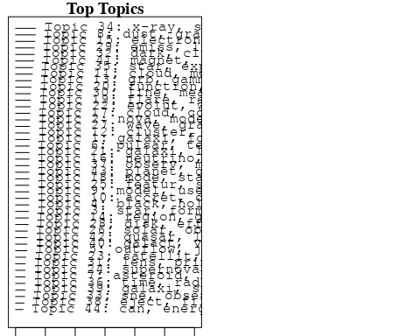

plotQuote(thoughts6, width = 30, main = "Topic 6")  
plotQuote(thoughts18, width = 30, main = "Topic 18")

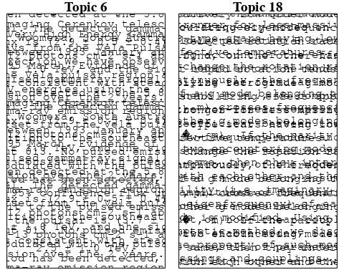

# Calculate and plot the correlation between topics  
mod.out.corr <- topicCorr(Research_topics)  
plot(mod.out.corr, cex = 1.5)  
  
  
# For each topic  
for (topic_num in 1:44) {  
 # Plot the word cloud  
 cloud(Research_topics, topic = topic_num, scale = c(2, 0.25))  
 Sys.sleep(2)  
}

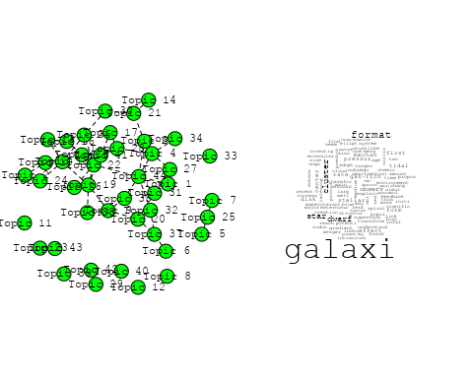

## Warning in wordcloud::wordcloud(words = vocab, freq = vec, max.words =  
## max.words, : mass could not be fit on page. It will not be plotted.

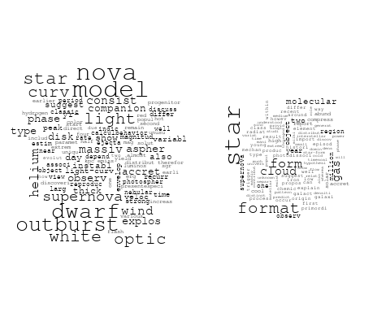

## Warning in wordcloud::wordcloud(words = vocab, freq = vec, max.words =  
## max.words, : outflow could not be fit on page. It will not be plotted.

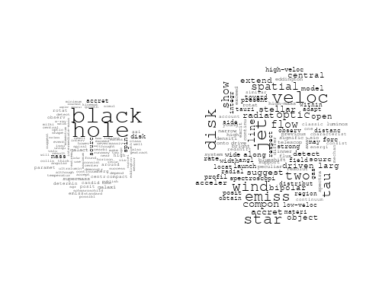

## Warning in wordcloud::wordcloud(words = vocab, freq = vec, max.words =  
## max.words, : pulsar could not be fit on page. It will not be plotted.

## Warning in wordcloud::wordcloud(words = vocab, freq = vec, max.words =  
## max.words, : particl could not be fit on page. It will not be plotted.

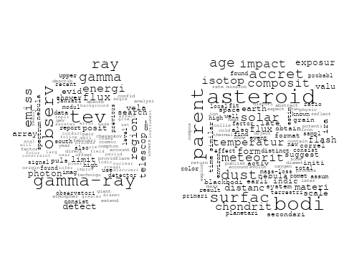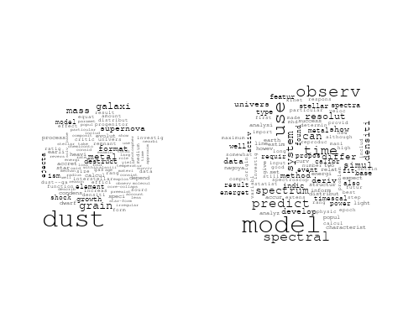

## Warning in wordcloud::wordcloud(words = vocab, freq = vec, max.words =  
## max.words, : cloud could not be fit on page. It will not be plotted.

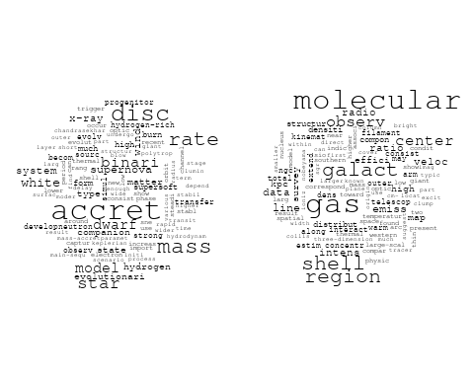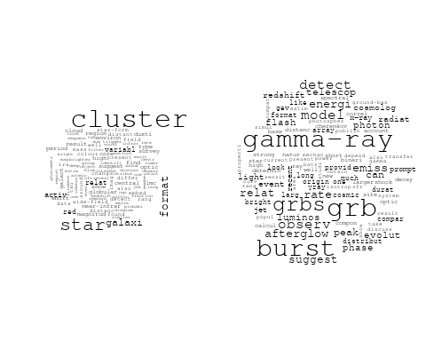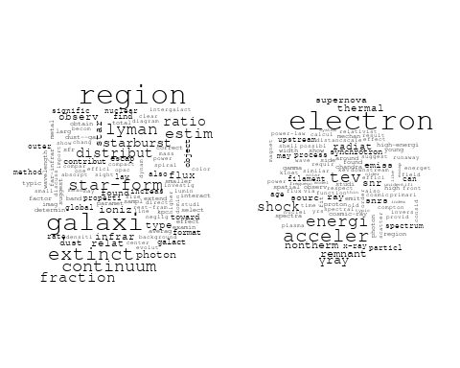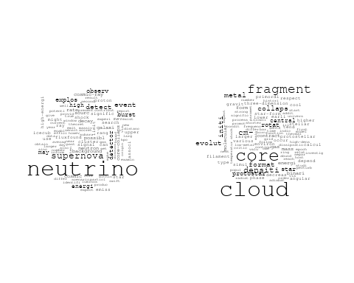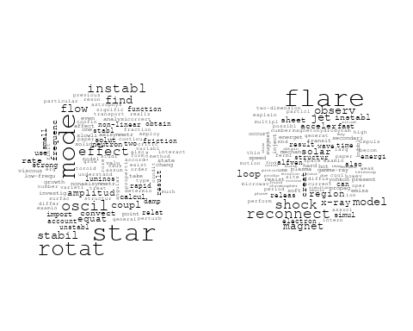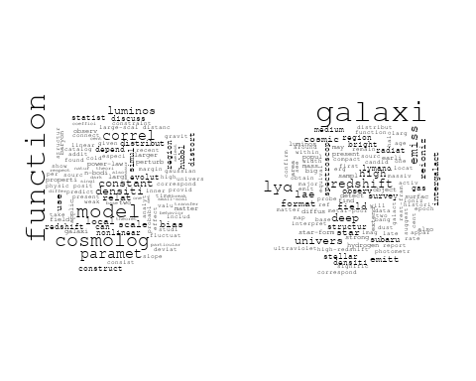

## Warning in wordcloud::wordcloud(words = vocab, freq = vec, max.words =  
## max.words, : evolut could not be fit on page. It will not be plotted.

## Warning in wordcloud::wordcloud(words = vocab, freq = vec, max.words =  
## max.words, : shock could not be fit on page. It will not be plotted.

## Warning in wordcloud::wordcloud(words = vocab, freq = vec, max.words =  
## max.words, : proto-neutron could not be fit on page. It will not be plotted.

## Warning in wordcloud::wordcloud(words = vocab, freq = vec, max.words =  
## max.words, : differ could not be fit on page. It will not be plotted.

## Warning in wordcloud::wordcloud(words = vocab, freq = vec, max.words =  
## max.words, : hydrodynam could not be fit on page. It will not be plotted.

## Warning in wordcloud::wordcloud(words = vocab, freq = vec, max.words =  
## max.words, : satellit could not be fit on page. It will not be plotted.

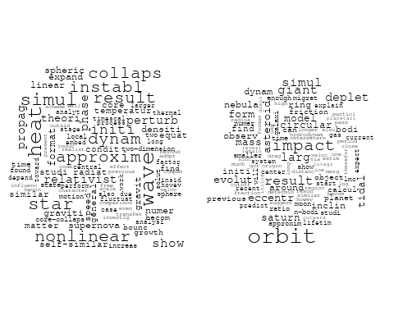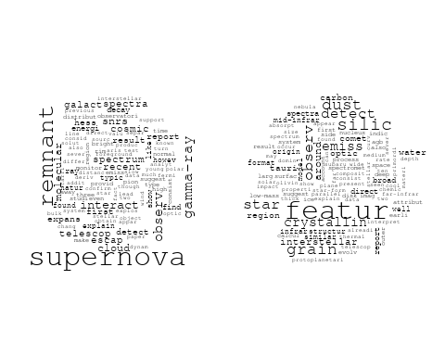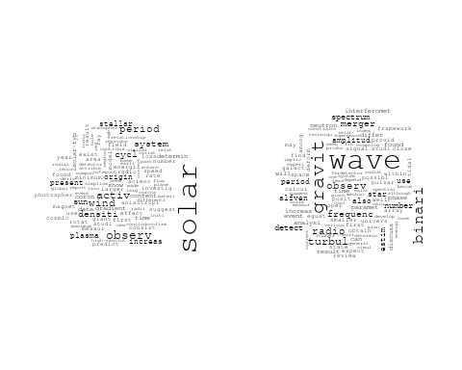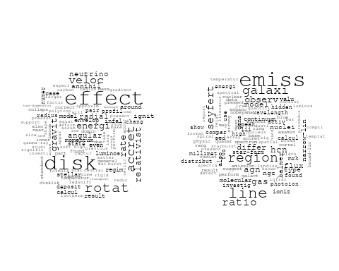

## Warning in wordcloud::wordcloud(words = vocab, freq = vec, max.words =  
## max.words, : primordi could not be fit on page. It will not be plotted.

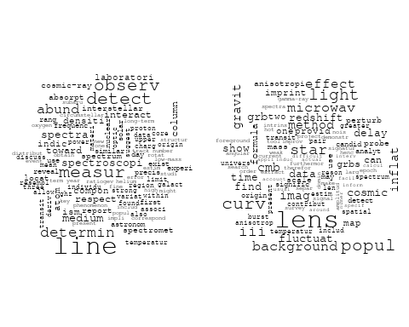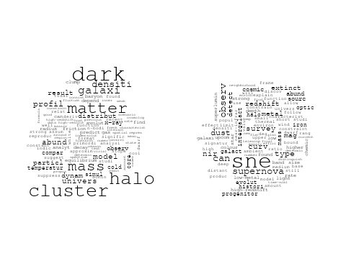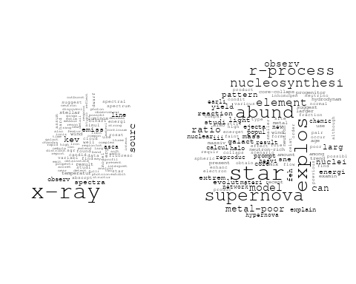

## Warning in wordcloud::wordcloud(words = vocab, freq = vec, max.words =  
## max.words, : radio could not be fit on page. It will not be plotted.

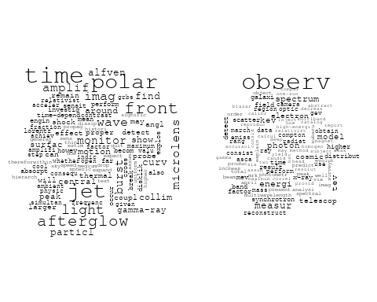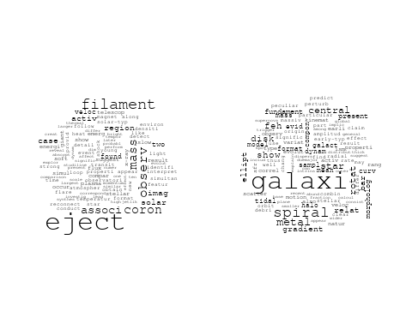

## Warning in wordcloud::wordcloud(words = vocab, freq = vec, max.words =  
## max.words, : variabl could not be fit on page. It will not be plotted.

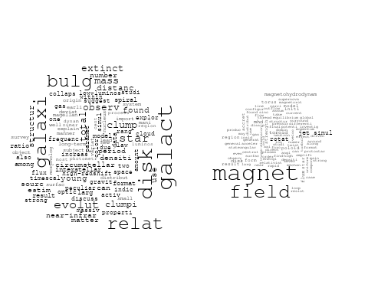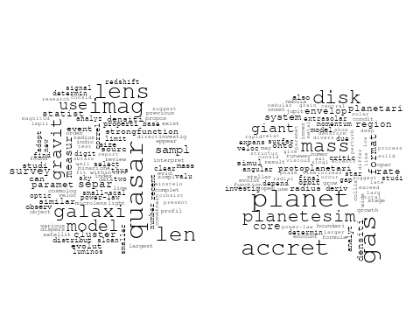

# Get the topic proportions for each document  
topic_proportions <- Research_topics$theta  
  
# Find the index of the topic with the highest proportion for each document  
# This will be the topic that each document is most likely to belong to  
max_topic_idx <- apply(topic_proportions, 1, which.max)  
  
# Add this as a new column to your data  
data_independent$topic <- max_topic_idx  
  
  
  
# Define the intervals  
intervals <- c('1824_1899', '1900_1964', '1965_1974', '1975_1984', '1985_1994', '1995_1999', '2000_2004', '2005_2009', '2010_2014', '2015_2019', '2020_2022')  
colors <- c('pink', 'blue', 'purple', 'yellow', 'green', 'pink', 'orange', 'violet', 'green', 'blue', 'pink')  
  
# Loop through the intervals and plot  
for(i in seq_along(intervals)){  
 # Filter data for when the pub_interval is equal to 1  
 data_filtered <- data_independent[data_independent[[paste0('pub_interval_', intervals[i])]] == 1,]  
   
 # Make the histogram  
   
 p <- ggplot(data_filtered, aes(x = topic)) +  
 geom_histogram(binwidth = 1, fill = colors[i], color = "black") +  
 xlab("Topic") +  
 ylab("Count") +  
 ggtitle(paste0("Topics from year ", gsub("_", " to ", intervals[i])))  
   
 print(p)  
}

